Additional file 1: Figure S1. Kaplan Meier survival curves for patients with VR equal to or below 2 vs. those with VR above 2. The outcome measured was 90-day survival. Left, 90-day survival for baseline VR values (n= 874, p=NS, log-rank test), Right, 90-day survival for Day 1 VR. Values (n=808, p<0.01, log-rank test).
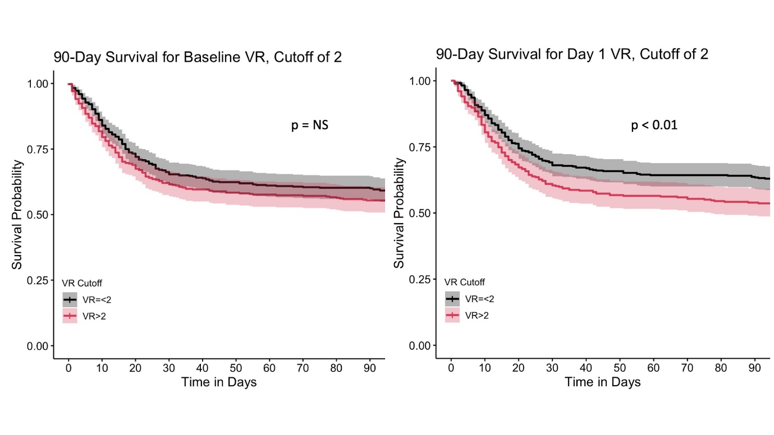

Additional file 1: Table S1. Interaction term analysis, baseline VR (n=790)
 | 28-Day Mortality |  |  | 90-Day Mortality
 | OR | CI | p | OR | CI | p
Baseline VR | 2.66 | 1.18 – 5.94 | <0.05 | 2.38 | 1.08 – 5.22 | <0.05
APACHE-III | 1.04 | 1.03 – 1.06 | <0.001 | 1.04 | 1.03 – 1.06 | <0.001
VR x APACHE-III | 0.99 | 0.98 – 1.00 | <0.05 | 0.99 | 0.98 – 1.00 | <0.05

