Electronic supplementary material (ESM)
Oxygen and 6 months outcome after out of hospital cardiac arrest: a preplanned sub-analysis of the Targeted Hypothermia versus Targeted Normothermia after Out-of-Hospital Cardiac Arrest (TTM2) trial

Chiara Robba, Rafael Badenes, Denise Battaglini, Lorenzo Ball, Iole Brunetti, Filippo Sanfilippo, Janus C Jakobsen, Gisela Lilja, Hans Friberg, Pedro D Wendel-Garcia, Paul J Young, Glenn Eastwood, Michelle S Chew, Johan Unden, Matthew Thomas, Michael Joannidis, Alistair Nichol, Andreas Lundin, Jacob Hollenberg, Naomi Hammond, Manoj Saxena, Annborn Martin, Miroslav Solar, Fabio Silvio Taccone, Josef Dankiewicz, Niklas Nielsen, Anders Grejs, Florian Ebner and Paolo Pelosi

Table of content
Table S1. Strengthening the Reporting of Observational Studies in Epidemiology (STROBE)” statement guidelines [page 3-5].
Table S2. Patients’ clinical outcomes in the overall population and stratified according to oxygen values according to conventional thresholds [page 6].
Table S3. Ventilatory settings, respiratory mechanics and gas exchange at admission stratified according to oxygen values according to conventional thresholds [page 7].
Table S4. Characteristics of the patients, in the overall population and stratified according to the best threshold of oxygen values for mortality [page 8-9].
Table S5. Patients’ clinical outcomes in the overall population and stratified according to the new oxygen thresholds [page 10].
Table S6. Ventilatory setting, respiratory mechanics and gas exchange at ICU admission stratified according to the new oxygen thresholds [page 11].
Figure S1. Hourly oxygen trajectories in the overall population, and by survival status (survivors and non survivors) [page 12].
Figure S2 a, b. Kaplan-Meier curve considering conventional and new thresholds. Most deaths occurred during the first 30 days of the follow-up [page 13-14].
Figure S3. Hypoxemia and hyperoxemia mortality risk difference considering the dose of oxygen (exposure over time, area under the curve, PaO₂-AUC) [page 15].
Figure S4. Interaction between PaO₂ (continuous) and TTM2-arms [page 16].
Figure S5. Frequency distribution of modified Rankin Score (mRS) among partial pressure of oxygen, PaO₂ classes [page 17].
Figure S6. Analysis for the definition of the best cut off point of oxygen values for the prediction of poor neurological outcome [page 18].
Figure S7. Predicted probability of achieving a modified Rankin Score (mRS) 4 or 5 according to PaO₂ values [page 19].

Further details on statistical analysis methods
Using ordinal logistic regression, we estimated the probability that specific value of PaO₂ (or PaO₂_class) was associated with poor neurological outcome. Using relative distribution analysis, we searched for the best cut-point along the continuum of the PaO₂ that separated 6-months survivors from non-survivors. To account for interdependence among repeated measures, the models included a cluster-based adjustment of the standard error estimation. Linear mixed regression was used to compare the longitudinal trajectories of hourly measured PaO₂ among survival status. For this longitudinal analysis, a repeated measure dataset (included hourly ventilatory markers collected every 4 hours during the first 72 hours after ICU admission) was used and included 18716 observations, after excluding missing values on survival status and PaO₂. A similar set of covariates as in the Cox model, were used for building the adjusted model. To account for the longitudinal nature of the data (interdependence among repeated measures), the model included a random effect (intercept) on patient ID and a random coefficient on the time elicited between PaO₂ measures. CR and RB had full access to all the data in the study and takes responsibility for its integrity and the data analysis.

Table S1. “Strengthening the Reporting of Observational Studies in Epidemiology (STROBE)” statement guidelines.

 | Item No. | Recommendation | Page  No. | Relevant text from manuscript
Title and abstract | 1 | (a) Indicate the study’s design with a commonly used term in the title or the abstract | 1
Title and abstract | 1 | (b) Provide in the abstract an informative and balanced summary of what was done and what was found | 4
Introduction
Background/rationale | 2 | Explain the scientific background and rationale for the investigation being reported | 8
Objectives | 3 | State specific objectives, including any prespecified hypotheses | 9-10
Methods
Study design | 4 | Present key elements of study design early in the paper | 10-12
Setting | 5 | Describe the setting, locations, and relevant dates, including periods of recruitment, exposure, follow-up, and data collection | 10-12
Participants | 6 | (a) Cohort study—Give the eligibility criteria, and the sources and methods of selection of participants. Describe methods of follow-up | 10-12
Variables | 7 | Clearly define all outcomes, exposures, predictors, potential confounders, and effect modifiers. Give diagnostic criteria, if applicable | 9-10
Data sources/ measurement | 8* | For each variable of interest, give sources of data and details of methods of assessment (measurement). Describe comparability of assessment methods if there is more than one group | 9-12
Bias | 9 | Describe any efforts to address potential sources of bias | 9-12
Study size | 10 | Explain how the study size was arrived at | 9-12

Quantitative variables | 11 | Explain how quantitative variables were handled in the analyses. If applicable, describe which groupings were chosen and why | 12-13
Statistical methods | 12 | (a) Describe all statistical methods, including those used to control for confounding | 12-13
Statistical methods | 12 | (b) Describe any methods used to examine subgroups and interactions
Statistical methods | 12 | (c) Explain how missing data were addressed
Statistical methods | 12 | (d) Describe any sensitivity analyses | NA
Results
Participants | 13* | (a) Report numbers of individuals at each stage of study—eg numbers potentially eligible, examined for eligibility, confirmed eligible, included in the study, completing follow-up, and analyzed | 9-12
Participants | 13* | (b) Give reasons for non-participation at each stage
Participants | 13* | (c) Consider use of a flow diagram
Descriptive data | 14* | (a) Give characteristics of study participants (eg demographic, clinical, social) and information on exposures and potential confounders | 9-12
Descriptive data | 14* | (b) Indicate number of participants with missing data for each variable of interest
Descriptive data | 14* | (c) Cohort study—Summaries follow-up time (eg, average and total amount)
Outcome data | 15* | Cohort study—Report numbers of outcome events or summary measures over time | 9-12
Outcome data | 15* | Case-control study—Report numbers in each exposure category, or summary measures of exposure
Outcome data | 15* | Cross-sectional study—Report numbers of outcome events or summary measures
Main results | 16 | (a) Give unadjusted estimates and, if applicable, confounder-adjusted estimates and their precision (eg, 95% confidence interval). Make clear which confounders were adjusted for and why they were included | 14-18
Main results | 16 | (b) Report category boundaries when continuous variables were categorized
Main results | 16 | (c) If relevant, consider translating estimates of relative risk into absolute risk for a meaningful time period
Other analyses | 17 | Report other analyses done—eg analyses of subgroups and interactions, and sensitivity analyses | ESM
Discussion
Key results | 18 | Summaries key results with reference to study objectives | 18
Limitations | 19 | Discuss limitations of the study, taking into account sources of potential bias or imprecision. Discuss both direction and magnitude of any potential bias | 21
Interpretation | 20 | Give a cautious overall interpretation of results considering objectives, limitations, multiplicity of analyses, results from similar studies, and other relevant evidence | 18-21
Generalizability | 21 | Discuss the generalizability (external validity) of the study results | 18-21
Other information
Funding | 22 | Give the source of funding and the role of the funders for the present study and, if applicable, for the original study on which the present article is based. | 23

*Give information separately for cases and controls in case-control studies and, if applicable, for exposed and unexposed groups in cohort and cross-sectional studies.
Note: An Explanation and Elaboration article discusses each checklist item and gives methodological background and published examples of transparent reporting. The STROBE checklist is best used in conjunction with this article (freely available on the Web sites of PLoS Medicine at http://www.plosmedicine.org/, Annals of Internal Medicine at http://www.annals.org/, and Epidemiology at http://www.epidem.com/). Information on the STROBE Initiative is available at www.strobe-statement.org

Table S2. Patients’ clinical outcomes in the overall population and stratified according to oxygen values according to conventional thresholds. Data are expressed as median (interquartile range, IQR). ICU, intensive care unit; STEMI, ST elevation myocardial infarction; LOS, length of stay; mRS, modified Rankin Scale. mRS binary defined as poor outcome if points 4-6, good outcome if points 1-3.

 | Overall  (n=1418, 100.0%) | PaO₂ <60 mmHg  (n=79, 5.6%) | PaO₂ 60-300 mmHg  (n=1239, 87.4%) | PaO₂ >300 mmHg  (n=100, 7.1%) | p-  value
Neurologic aloutcome
mRS at 6 months, points, median (IQR) | 6.0 (1.0; 6.0) | 6.0 (2.0; 6.0) | 6.0 (1.0; 6.0) | 6.0 (2.0; 6.0) | 0.180
Poor neurological outcome, n (%) | 756 (54.3) | 46 (59.7) | 650 (53.4) | 60 (60.6) | 0.235
Hospital / ICU admission
Shock diagnosis on admission, yes, n (%) | 424 (29.9) | 34 (43.0) | 364 (29.4) | 26 (26.0) | 0.025
STEMI diagnosis on admission, yes, n (%) | 553 (39.0) | 32 (40.5) | 488 (39.4) | 33 (33.0) | 0.003
ICU LOS, days, median (IQR) | 5.1 (3.0; 8.7) | 5.0 (2.7; 8.9) | 5.1 (3.0; 8.7) | 5.0 (3.1; 7.6) | 0.881
Hospital LOS, days, median (IQR) | 9.5 (5.0; 17.0) | 9.6 (3.0; 19.0) | 9.6 (5.0; 17.4) | 8.0 (4.0; 14.9) | 0.197
Time to extubation, days, median (IQR) | 3.6 (1.9; 6.0) | 3.3 (1.9; 6.0) | 3.6 (1.9; 6.1) | 3.7 (2.0; 5.5) | 0.905
Ventilator free days at 30 days, days, median (IQR) | 26.4 (23.8; 28.1) | 26.7 (23.6; 28.1) | 26.4 (23.8; 28.1) | 26.5 (24.4; 28.1) | 0.847
Ventilator free days before ICU discharge, days, median (IQR) | 1.0 (0.0; 2.0) | 0.0 (0.0; 1.5) | 1.0 (0.0; 2.0) | 0.0 (0.0; 1.3) | 0.530
Discharged alive from ICU, n (%) | 893 (63.0) | 48 (60.8) | 789 (63.7) | 56 (56.0) | 0.284

Table S3. Ventilatory settings, respiratory mechanics and gas exchange at admission stratified according to oxygen values according to conventional thresholds. Data are expressed as median (interquartile range, IQR). Table legend: PBW, predicted body weight; PaO₂, arterial partial pressure of oxygen; PaCO₂, arterial partial pressure of carbon dioxide; FiO₂, fraction of inspired oxygen. Ventilatory ratio was calculated as = (minute ventilation × PaCO₂) / (PBW × 100 × 37.5).

 | Overall  (n=1418, 100.0%) | PaO₂ <60 mmHg  (n=79, 5.6%) | PaO₂ 60-300 mmHg  (n=1239, 87.4%) | PaO₂ >300 mmHg  (n=100, 7.1%) | p-  value
Ventilatory setting and pulmonary mechanics at admission
Respiratory rate, breaths/min, median (IQR) | 16.0 (14.0; 20.0) | 16.0 (14.0; 18.5) | 16.0 (15.0; 20.0) | 16.0 (14.0; 18.0) | 0.227
Positive end-expiratory pressure, cmH₂O, median (IQR) | 6.0 (5.0; 8.0) | 7.0 (5.0; 10.0) | 6.0 (5.0; 8.0) | 6.0 (5.0; 8.0) | 0.101
Plateau pressure, cmH₂O, median (IQR) | 20.0 (17.0; 24.0) | 21.0 (19.0; 26.3) | 20.0 (17.0; 23.0) | 20.0 (15.0; 25.0) | 0.075
Tidal volume, mL, median (IQR) | 500 (445; 560) | 508 (462; 600) | 500 (440; 560) | 500 (450; 600) | 0.245
Tidal volume, mL/kg PBW, median (IQR) | 7.2 (6.4; 8.2) | 7.4 (6.4; 9.3) | 7.1 (6.4; 8.2) | 7.5 (6.7; 8.5) | 0.071
Driving pressure, cmH₂O, median (IQR) | 13.0 (10.0; 16.0) | 14.5 (12.3; 16.0) | 13.0 (10.0; 16.0) | 12.0 (10.0; 17.0) | 0.265
Compliance of the respiratory system, mL/cmH₂O, median (IQR) | 40 (31; 50) | 36 (30; 47) | 40 (31; 50) | 41 (29; 59) | 0.368
Mechanical Power, j/min, median (IQR) | 16.2 (12.5; 21.6) | 17.0 (15.0; 23.5) | 16.2 (12.5; 21.5) | 15.3 (12.1; 24.4) | 0.201
Ventilatory ratio, median (IQR) | 1.5 (1.2; 1.8) | 1.6 (0.9; 2.1) | 1.5 (1.2; 1.8) | 1.4 (1.1; 1.9) | 0.854
Gas exchange
Fraction of inspired oxygen (FiO₂), %, median (IQR) | 60 (50; 88) | 70 (50; 100) | 60 (50; 80) | 100 (50; 100) | 0.000
PaO₂, mmHg, median (IQR) | 108.7 (83.2; 163.0) | 51.0 (39.7; 56.2) | 108.0 (85.5; 148.5) | 363.3 (330.5; 433.6) | 0.000
PaO₂/ FiO₂ ratio, mmHg, median (IQR) | 195.0 (122.8; 307.3) | 56.2 (45.7; 83.6) | 192.8 (130.1; 284.9) | 474.7 (373.4; 670.8) | 0.000
PaCO₂, mmHg, median (IQR) | 45.7 (39.7; 53.2) | 48.8 (37.7; 58.1) | 45.7 (39.8; 53.0) | 42.7 (37.0; 51.7) | 0.020
pHa, median (IQR) | 7.3 (7.2; 7.3) | 7.2 (7.1; 7.3) | 7.3 (7.2; 7.3) | 7.2 (7.2; 7.3) | 0.003
Base excess, mEq/L, median (IQR) | -6.5 (-10.0; -3.7) | -8.0 (-10.5; -4.9) | -6.2 (-9.8; -3.5) | -7.4 (-12.4; -4.3) | 0.005

Table S4. Characteristics of the patients, in the overall population and stratified according to the best threshold of oxygen values for mortality. Table legend: data are reported as median (interquartile range, IQR), and number (percentage, %). n=number of patients; BMI, body mass index; IBW, ideal body weight; ROSC, return of spontaneous circulation; CPR, cardio-pulmonary resuscitation; TTM, target temperature management.

 | Overall  (n=1418, 100.0%) | PaO₂<69 mmHg  (n=165, 11.6%) | PaO₂ 69-195 mmHg  (n=990, 69.8%) | PaO₂ >195 mmHg  (n=263, 18.5%) | p-  value
Baseline patient characteristics
Age, years, median (IQR) | 65 (55; 74) | 66 (58; 75) | 65 (55; 74) | 65 (55; 74) | 0.291
Gender, female, n (%) | 292 (20.6) | 29 (17.6) | 190 (19.2) | 73 (27.8) | 0.006
Height, cm, median (IQR) | 175 (170; 180) | 175 (170; 180) | 175 (170; 180) | 174 (167; 180) | 0.001
Weight, kg, median (IQR) | 80 (73; 90) | 84 (75; 92) | 81 (75; 93) | 78 (69; 88) | 0.000
BMI, kg/m², median (IQR) | 26.3 (24.1; 29.7) | 27.0 (24.7; 30.0) | 26.6 (24.2; 30.1) | 25.2 (22.9; 28.1) | 0.000
Chronic comorbidities
Hypertension, yes, n (%) | 504 (44.8) | 63 (47.7) | 365 (46.9) | 76 (35.5) | 0.009
Diabetes mellitus, yes, n (%) | 266 (18.8) | 35 (21.2) | 1818 (18.3) | 50 (19.0) | 0.667
Myocardial infarction, yes, n (%) | 230 (27.3) | 31 (31.0) | 163 (28.5) | 36 (20.9) | 0.099
Percutaneous coronary intervention, yes, n (%) | 210 (25.3) | 28 (28.9) | 146 (26.1) | 36 (20.7) | 0.246
Coronary artery bypass graft, yes, n (%) | 112 (15.3) | 16 (18.8) | 79 (16.1) | 17 (11.0) | 0.194
Heart failure, yes, n (%) | 145 (19.0) | 20 (22.5) | 104 (20.2) | 21 (13.2) | 0.098
Charlson comorbidity index, points, median (IQR) | 4.0 (2.0; 5.0) | 4.0 (3; 6.0) | 4.0 (2.0; 5.0) | 4.0 (2.0; 5.0) | 0.160
Pre-hospital setting / interventions
Location of cardiac arrest, n (%)
Home | 741 (52.3) | 86 (52.1) | 505 (51.0) | 150 (57.0)
Public place | 509 (35.9) | 58 (35.2) | 372 (37.6) | 79 (30.0)
Other | 168 (11.8) | 21 (12.7) | 113 (11.4) | 34 (12.9) | 0.259
Witnessed cardiac arrest, yes, n (%) | 1295 (91.3) | 155 (93.9) | 899 (90.8) | 241 (91.6) | 0.409
Bystander performed CPR, yes, n (%) | 1148 (81.0) | 132 (80.0) | 810 (81.8) | 206 (78.3) | 0.416
Type of rhythm, n (%)
Not shockable | 390 (27.5) | 55 (33.3) | 266 (26.9) | 69 (26.2)
Shockable | 1028 (72.5) | 110 (66.7) | 724 (73.1) | 194 (73.8) | 0.199
Time to ROSC, minutes, median (IQR) | 25.0 (17.0; 39.0) | 26.0 (18.5; 40.0) | 25.0 (17.0; 40.0) | 25.0 (15.0; 34.0) | 0.024
TTM randomization treatment, n (%)
Normothermia | 712 (50.2) | 88 (53.3) | 496 (50.1) | 128 (48.7)
Hypothermia | 706 (49.8) | 77 (46.7) | 494 (49.9) | 135 (51.3) | 0.638

Table S5. Patients’ clinical outcomes in the overall population and stratified according to the new oxygen thresholds. Data are expressed as median (interquartile range, IQR). ICU, intensive care unit; STEMI, ST elevation myocardial infarction; LOS, length of stay; mRS, modified Rankin Scale; mRS binary defined as poor outcome if points 4-6, good outcome if points 1-3.

 | Overall  (n=1418, 100.0%) | PaO₂ <69 mmHg  (n=165, 11.6%) | PaO₂ 69-195 mmHg  (n=990, 69.8%) | PaO₂ >195 mmHg  (n=263, 18.5%) | p-  value
Neurologic outcome
mRS at 6 months, points, median (IQR) | 6.0 (1.0; 6.0) | 6.0 (2.0; 6.0) | 6.0 (1.0; 6.0) | 6.0 (2.0; 6.0) | 0.192
mRS poor outcome (4-6), n (%) | 740 (55.9) | 95 (62.1) | 508 (54.9) | 137 (55.9) | 0.254
Hospital / ICU admission
Shock diagnosis on admission, yes, n (%) | 424 (29.9) | 65 (39.4) | 294 (29.7) | 65 (24.7) | 0.005
STEMI diagnosis on admission, yes, n (%) | 553 (39.4) | 62 (39.0) | 396 (40.2) | 95 (36.7) | 0.583
ICU LOS, days, median (IQR) | 5.1 (3.0; 8.7) | 5.0 (2.9; 8.8) | 5.1 (3.0; 8.9) | 4.8 (3.0; 7.4) | 0.166
Hospital LOS, days, median (IQR) | 9.5 (5.0; 17.0) | 8.0 (3.0; 16.8) | 10.0 (5.0; 18.0) | 9.0 (5.0; 14.0) | 0.036
Time to extubation, days, median (IQR) | 3.6 (1.9; 6.0) | 3.7 (2.0; 5.9) | 3.8 (1.9; 6.5) | 3.3 (1.9; 5.1) | 0.288
Ventilator free days at 30 days, days, median (IQR) | 26.4 (23.8; 28.1) | 26.3 (24.1; 28.0) | 26.3 (23.5; 28.1) | 26.7 (24.8; 28.1) | 0.396
Ventilator free days before ICU discharge, days, median (IQR) | 1.0 (0.0; 2.0) | 0.0 (0.0; 2.0) | 1.0 (0.0; 2.0) | 1.0 (0.0; 2.0) | 0.511
Discharged alive from ICU, yes, n (%) | 893 (63.0) | 92 (55.8) | 637 (634.3) | 164 (62.4) | 0.104
Discharged alive from Hospital, n (%) | 766 (54.0) | 77 (46.7) | 550 (55.6) | 139 /52.9) | 0.097

Table S6. Ventilatory setting, respiratory mechanics and gas exchange at ICU admission stratified according to the new oxygen thresholds. Table legend: Data are expressed as median (interquartile range, IQR). PBW, predicted body weight; PaO₂, arterial partial pressure of oxygen; PaCO₂, arterial partial pressure of carbon dioxide; FiO₂, fraction of inspired oxygen. Ventilatory ratio was calculated as = (minute ventilation × PaCO₂) / (PBW × 100 × 37.5).

 | Overall  (n=1418, 100.0%) | PaO₂  <69 mmHg  (n=165, 11.6%) | PaO₂  69-195 mmHg  (n=990, 69.8%) | PaO₂  >195 mmHg  (n=263, 18.5%) | p-  value
Ventilatory setting and pulmonary mechanics at ICU admission
Respiratory rate, breaths/min, median (IQR) | 16.0 (14.0; 20.0) | 16.0 (15.0; 20.0) | 16.0 (15.0; 20.0) | 16.0 (14.0; 18.0) | 0.010
Positive end-expiratory pressure, cmH₂O, median (IQR) | 6.0 (5.0; 8.0) | 7.0 (5.0; 10.0) | 6.0 (5.0; 8.0) | 6.0 (5.0; 8.0) | 0.010
Plateau pressure, cmH₂O, median (IQR) | 20.0 (17.0; 24.0) | 22.0 (19.0; 25.0) | 20.0 (17.0; 23.0) | 20.0 (16.0; 22.5) | 0.004
Tidal volume, mL, median (IQR) | 500 (445; 560) | 500 (437; 582) | 500 (444; 559) | 500 (450; 560) | 0.919
Tidal volume, mL/kg PBW, median (IQR) | 7.2 (6.4; 8.2) | 7.3 (6.4; 8.6) | 7.1 (6.3; 8.1) | 7.6 (6.6; 8.5) | 0.022
Driving pressure, cmH₂O, median (IQR) | 13.0 (10.0; 16.0) | 14.0 (12.0; 16.0) | 13.0 (10.0; 16.0) | 12.0 (10.0; 16.0) | 0.142
Compliance of the respiratory system, mL/cmH₂O, median (IQR) | 40.0 (31.0; 50.0) | 36.0 (30.0; 46.0) | 40.0 (31.0; 50.0) | 42.0 (32.0; 53.0) | 0.071
Mechanical Power, j/min, median (IQR) | 16.2 (12.7; 21.6) | 18.3 (14.4; 22.9) | 16.0 (12.5; 21.5) | 15.2 (11.5; 20.6) | 0.006
Ventilatory ratio, median (IQR) | 1.45 (1.16; 1.83) | 1.60 (1.24; 2.18) | 1.46 (1.18; 1.81) | 1.32 (1.03; 1.75) | 0.001
Gas exchange
Fraction of inspired oxygen (FiO₂), %, median (IQR) | 60 (50; 88) | 70 (50; 100) | 60 (46; 80) | 70 (50; 100) | 0.000
PaO₂, mmHg, median (IQR) | 108.7 (83.2; 163.0) | 60.0 (51.7; 65.2) | 105.0 (87.0; 133.0) | 273.0 (231.7; 342.7) | 0.000
PaO₂/ FiO₂ ratio, mmHg, median (IQR) | 195.0 (122.8; 307.3) | 75.0 (57.6; 113.6) | 180.0 (130.0; 256.9) | 410.0 (318.4; 521.9) | 0.000
PaCO₂, mmHg, median (IQR) | 45.7 (39.7; 53.2) | 49.5 (41.2; 59.2) | 46.0 (40.5; 53.2) | 42.0 (36.7; 49.2) | 0.000
pHa, median (IQR) | 7.3 (7.2; 7.3) | 7.2 (7.1; 7.3) | 7.3 (7.2; 7.3) | 7.3 (7.2; 7.3) | 0.001
Base excess, mEq/L, median (IQR) | -6.5 (-10.0; -3.7) | -7.3 (-10.1; -4.5) | -6.2 (-9.7; -3.5) | -6.6 (-10.5; -4.0) | 0.204

Figure S1. Hourly oxygen trajectories in the overall population, and by survival status (survivors and non survivors). Partial pressure of oxygen (PaO₂) trajectories over the first 72-h after ICU admission are summarized as medians. PaO₂ values decreased significantly during the first 40 hours and then leveled-off afterwards with median values ranging from 80 to 85 mmHg. shows the frequency distribution of the episodes of PaO₂ <60 mmHg and > 300 mmHg in the whole population during the first 72 hours of mechanical ventilation.

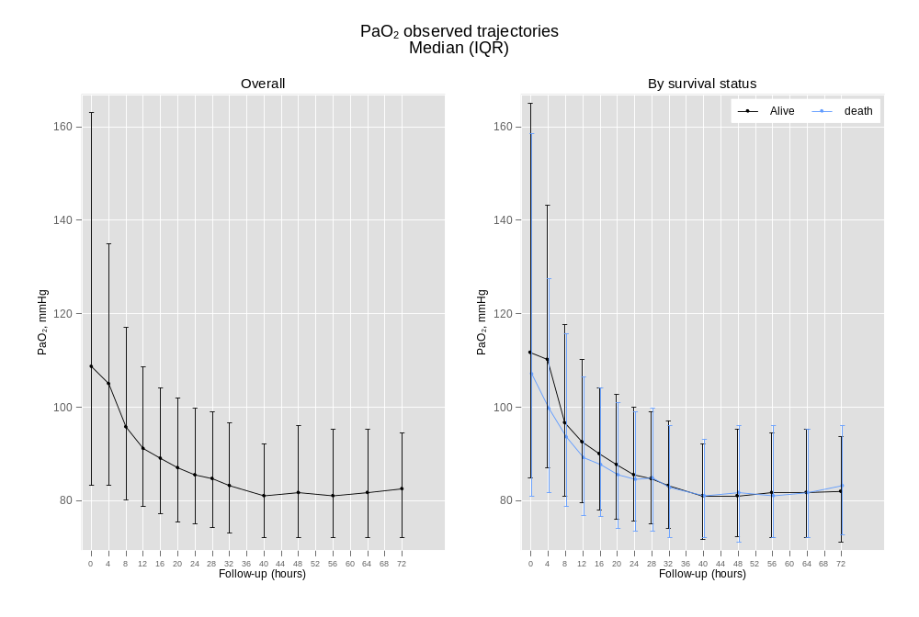

Figure S2 a. Kaplan-Meier curve considering conventional and new thresholds (mmHg). Most deaths occurred during the first 30 days of the follow-up. The log-rank test p-value did not achieve significance (p = 0.140).

Figure S3. Hypoxemia and hyperoxemia mortality risk difference considering the dose of oxygen (exposure over time, area under the curve, PaO₂-AUC). Repeated measures of PaO₂ were considered as a single time point reflecting the cumulative effect over time of PaO₂. PaO₂-AUC represents the numerical integration of PaO₂ values and the time between measurements, and as such, provides the cumulative effect over time of PaO₂. The higher/lower the value of PaO₂, indeed influence the AUC in that direction; however, it also includes the time interval between measurements as a function. The narrower is the interval, the higher is the AUC, independently of PaO₂ raw values, or vice versa. We tested the interaction between PaO₂ categorical levels using traditional cut-points (hypo/normo/hyperoxemia) with the PaO₂-AUC and determining the risk difference among hypo vs normoxemia and hyperoxemia vs normoxemia along the PaO₂ -AUC continuum. Left and right panel depicts the differences in mortality risk (expressed as Hazard ratios, HRs) between PaO₂-AUC in the hypoxemia and hyperoxemia groups, respectively with normoxemia as a reference category. In this Cox regression, PaO₂-AUC was modelled with a fractional polynomial of second-degree FP [1 1], and included the following covariates: TTM2 randomization group, age (years), cardiac arrest witnessed, ROSC (min), bystander performed CPR, shockable rhythm, cardiac arrest location (home, public place, other), shock diagnosis on admission, and STEMI diagnosis on admission.

Figure S4. Interaction between PaO₂ (continuous) and TTM2-arms. Difference in mortality risk (expressed as HRs - interaction p-value = 0.9974) for hypothermia (with normothermia as a reference category) with estimates listed for each value of PaO₂. We tested the interaction between PaO2 categorical levels using Hypo/normothermia as the interacting factor. In this Cox regression, PaO₂ was modelled with a fractional polynomial of second-degree FP [1 1], and included the following covariates: TTM2 randomization group, age (years), cardiac arrest witnessed, time to return to spontaneous circulation, ROSC (min), bystander performed cardiopulmonary resuscitation, CPR, shockable rhythm, cardiac arrest location (home, public place, other), shock diagnosis on admission, and ST-elevated myocardial infarction, STEMI diagnosis on admission.
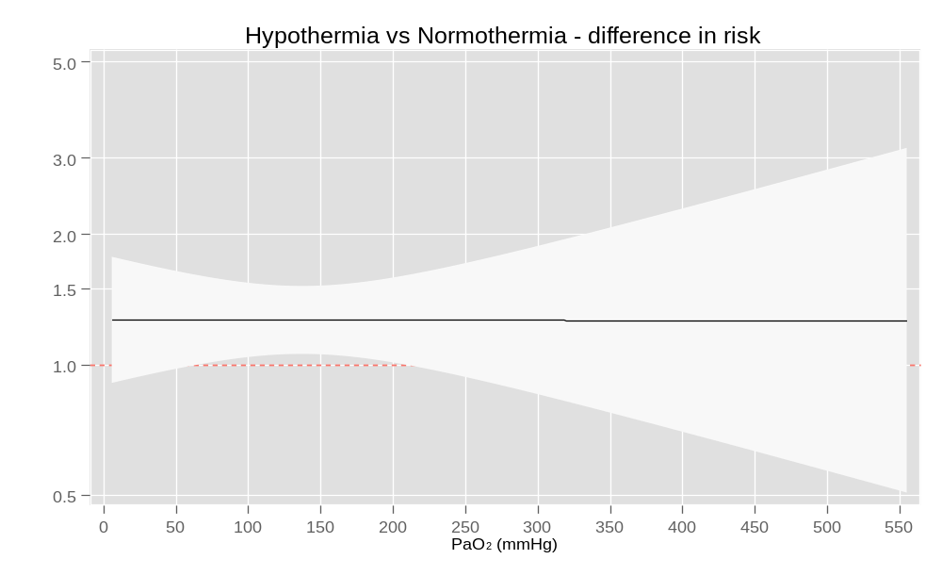

Figure S5. Frequency distribution of modified Rankin Score (mRS) among partial pressure of oxygen, PaO₂ classes.

Figure S6. Predicted probability of achieving a modified Rankin Score (mRS) 4 or 5 according to PaO₂ values. Left and right panel of this figure depicts the predicted probability of achieving a mRS score 4 and 5, respectively, according to PaO₂ values. Considering only mRS score 4 and 5, no significant differences among PaO₂ classes were observed (the estimates for score 4 were: hypoxemia vs normoxemia, probability = +0.0005; p=0.59 and hyperoxemia vs normoxemia, probability = −0.0003; p=0.79. The estimates for mRS score 5 were: hypoxemia vs normoxemia, probability = +0.0002; p=0.62 and hyperoxemia vs normoxemia, probability = −0.00017; p=0.79). Similarly, modeling PaO₂ as continuous we found no association between PaO₂ and mRS score 4 (left panel) and score 5 (right panel of ESM figure S6).

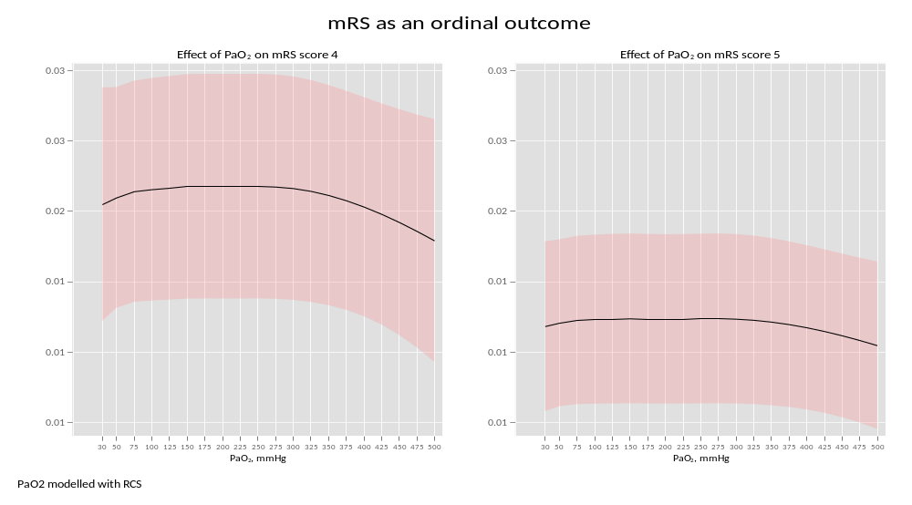

Figure S7. Analysis for the definition of the best cut off point of oxygen values for the prediction of poor neurological outcome.
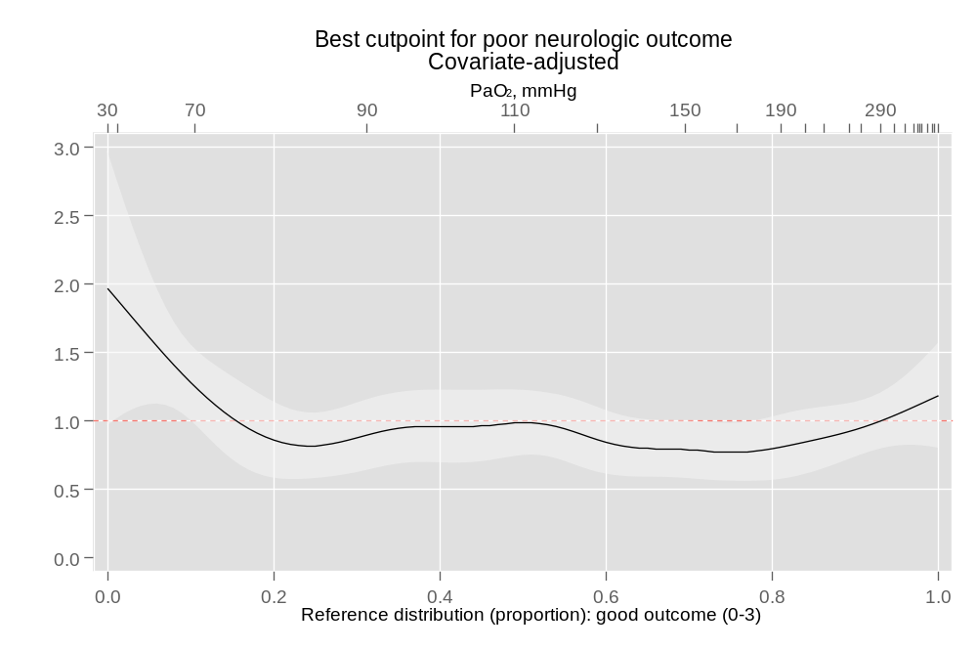

ESM Appendix. Sensitivity analysis modelling PaO₂ categorical using a90 mmHg as cut-point of hyperoxemia, in a Cox regression for 6-m mortality and using the same set of covariates as the main model. Hyperoxemia did not achieve statistical significance as compare with normoxemia group.

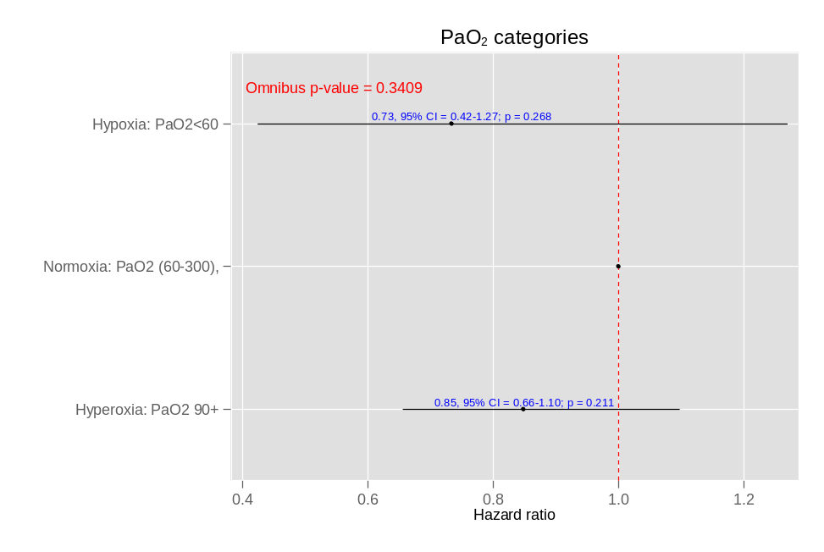

Comparison of baseline characteristics/ventilatory markers/outcomes among those with and without missing values in PaO₂, as an indirect approach to uncover a potential selection bias. No significative difference in outcomes and characteristics was found. Data are reported as mean (standard deviation, SD) and number (percentage, %). Legend: n=number of patients, BMI, body mass index, IBW, ideal body weight, ROSC, return of spontaneous circulation, CPR, cardio-pulmonary resuscitation, PaO2,partial pressure of oxygen, Hx, history, TTM, target temperature management.

Indicator for PaO2 missingness | PaO2 complete | PaO2 missing | P-value
n (%) | 1418 (76.2) | 443 (23.8)
Baseline patient characteristics ********** | ********** | ********** | **********
Age, years, mean (SD) | 64 (14) | 64 (13) | 0.943
Categories of PaO2, n (%)
<30 | 30 (2.1) | 10 (2.3)
30-49 | 185 (13.0) | 49 (11.1)
50-69 | 656 (46.3) | 223 (50.3)
>= 70 | 547 (38.6) | 161 (36.3) | 0.437
Gender, n (%)
Male | 1126 (79.4) | 351 (79.2)
Female | 292 (20.6) | 92 (20.8) | 0.937
Height, cm, mean (SD) | 175 (9) | 174 (10) | 0.204
Weight, Kg, mean (SD) | 83 (17) | 83 (18) | 0.995
BMI - original variable, mean (SD) | 27.4 (5.8) | 27.6 (5.7) | 0.477
Categories of BMI, n (%)
1. Severe thinness | 8 (0.6) | 1 (0.2)
2. Moderate thinness | 8 (0.6) | 1 (0.2)
3. Mild thinness | 8 (0.6) | 5 (1.2)
4. Normal range | 491 (35.5) | 137 (32.4)
5. Pre-obese | 535 (38.7) | 175 (41.4)
6. Obese class I | 224 (16.2) | 66 (15.6)
7. Obese class II | 71 (5.1) | 25 (5.9)
8. Obese class III | 39 (2.8) | 13 (3.1) | 0.639
Ideal body weight, mean (SD) | 69 (9) | 69 (10) | 0.254
Prior Hx. of hypertension, n (%)
No | 620 (55.2) | 203 (59.4)
Yes | 504 (44.8) | 139 (40.6) | 0.171
Prior Hx. of diabetes, n (%)
No | 1152 (81.2) | 369 (83.3)
Yes | 266 (18.8) | 74 (16.7) | 0.329
Prior Hx. of MI, n (%)
No | 614 (72.7) | 201 (76.1)
Yes | 230 (27.3) | 63 (23.9) | 0.276
Prior Hx. of PCI, n (%)
No | 620 (74.7) | 203 (77.2)
Yes | 210 (25.3) | 60 (22.8) | 0.415
Prior Hx. of CABG, n (%)
No | 620 (84.7) | 203 (84.6)
Yes | 112 (15.3) | 37 (15.4) | 0.965
Hx. of heart failure, n (%)
No | 618 (81.0) | 198 (83.9)
Yes | 145 (19.0) | 38 (16.1) | 0.314
Charlson comorbidity index, median (IQR) | 4.00 (2.00; 5.00) | 4.00 (2.00; 5.00) | 0.176
Pre-hospital settings/interventions ********** | ********** | ********** | **********
Location of cardiac arrest, n (%)
1. Home | 741 (52.3) | 237 (53.5)
2. Other | 168 (11.8) | 57 (12.9)
3. Public place | 509 (35.9) | 149 (33.6) | 0.645
Was cardiac arrest witnessed?, n (%)
No | 123 (8.7) | 36 (8.1)
Yes | 1295 (91.3) | 407 (91.9) | 0.719
Bystander performed CPR, n (%)
No | 270 (19.0) | 104 (23.5)
Yes | 1148 (81.0) | 339 (76.5) | 0.052
Type of rhytm, n (%)
not shockable | 390 (27.5) | 100 (22.6)
shockable | 1028 (72.5) | 343 (77.4) | 0.040
Time to return of spontaneous circulation (ROSC), min, median (IQR) | 25.0 (17.0; 39.0) | 27.0 (16.0; 42.3) | 0.281
Previous RCT ********** | ********** | ********** | **********
TTM2: randomization treatment, n (%)
Normothermia | 712 (50.2) | 219 (49.4)
Hypothermia | 706 (49.8) | 224 (50.6) | 0.776
tympanic temperature at admission, centigrades, mean (SD) | 35.4 (1.1) | 35.3 (1.1) | 0.265
Modified Rankin Scale (mRS) at 6 months ********** | ********** | ********** | **********
Modified Rankin Scale (mRS): scale defining the neurological outcome at 6 months, median (IQR) | 6.00 (1.00; 6.00) | 6.00 (1.00; 6.00) | 0.570
Modified Rankin Scale (mRS): scale defining the neurological outcome at 6 months, n (%)
0 | 218 (16.5) | 70 (16.5)
1 | 120 (9.1) | 47 (11.1)
2 | 201 (15.2) | 58 (13.7)
3 | 44 (3.3) | 22 (5.2)
4 | 28 (2.1) | 8 (1.9)
5 | 16 (1.2) | 4 (0.9)
6 | 696 (52.6) | 215 (50.7) | 0.504
mRS binary: poor outcome (4-6) and good outcome (1-3), n (%)
Good | 583 (44.1) | 197 (46.5)
Poor | 740 (55.9) | 227 (53.5) | 0.388
Hospital/ICU admission ********** | ********** | ********** | **********
Shock diagnosis on admission, n (%)
FALSE | 994 (70.1) | 331 (74.7)
TRUE | 424 (29.9) | 112 (25.3) | 0.061
STEMI diagnosis on admission, n (%)
No | 850 (60.6) | 240 (55.0)
Yes | 553 (39.4) | 196 (45.0) | 0.040
Hospital LOS, days, median (IQR) | 9.5 (5.0; 17.0) | 10.0 (4.0; 17.5) | 0.495
Was the patient mechanically ventilated?, n (%)
No | 7 (0.5) | 5 (1.1)
Yes | 1411 (99.5) | 438 (98.9) | 0.145
Ventilator free days before ICU discharge, median (IQR) | 1.00 (0.00; 2.00) | 1.00 (0.00; 2.00) | 0.904
Was the patient discharged alive from the ICU?, n (%)
No | 525 (37.0) | 177 (40.0)
Yes | 893 (63.0) | 266 (60.0) | 0.267
Was the patient discharged alive from the hospital?, n (%)
No | 652 (46.0) | 207 (46.7)
Yes | 766 (54.0) | 236 (53.3) | 0.783
Survival status since hosp/ICU admission, n (%)
Alive | 722 (50.9) | 228 (53.0)
Died | 696 (49.1) | 202 (47.0) | 0.444
Days to death/censored up to 180 days (end of study), median (IQR) | 168 (5; 187) | 167 (4; 187) | 0.233

Indicator for PaO2 missingness | PaO2 complete | PaO2 missing | P-value
n (%) | 1418 (76.2) | 443 (23.8)
Ventilatory markers at ICU admission ********** | ********** | ********** | **********
Positive end-expiratory pressure, cmH{subscript:2}O, median (IQR) | 6.00 (5.00; 8.00) | 6.00 (5.00; 8.00) | 0.451
Tidal Volume, (ml*kg−1 per PBW), mean (sd) | 7.59 (5.76) | 7.02 (1.72) | 0.249
Driving pressure, cmH{subscript:2}O, median (IQR) | 13.0 (10.0; 16.0) | 12.0 (10.0; 16.0) | 0.288
Compliance of respiratory system, median (IQR) | 40 (31; 50) | 39 (26; 51) | 0.521
Mechanical power, j/min, median (IQR) | 16.2 (12.7; 21.6) | 16.6 (12.1; 22.3) | 0.950
Ventilator ratio at baseline, median (IQR) | 1.45 (1.16; 1.83) | 2.19 (1.53; 3.11) | 0.051
fraction of inspired O2, %, median (IQR) | 60 (50; 88) | 60 (45; 90) | 0.505
Partial pressure of carbon dioxide (PaCO{subscript:2}), mmHg, median (IQR) | 45.7 (39.7; 53.2) | 48.8 (39.5; 51.9) | 0.665
pH, mean (SD) | 7.24 (0.12) | 7.22 (0.11) | 0.446
Base excess, mEq/L, median (IQR) | -6.5 (-10.0; -3.7) | -7.2 (-9.2; -5.1) | 0.549

