Figure S1. Scatterplot of polymyxin B AUC_{ss,24h} versus dosage. AUC_{ss,24h}, the area under the plasma concentration-time curve across 24 hours at steady state.
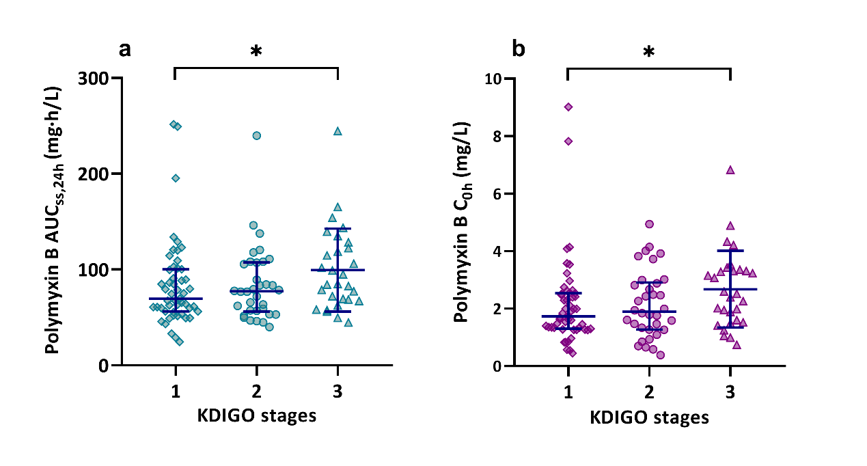
Figure S2. Scatterplot of polymyxin B AUC_{ss,24h} (a) and C_{0h} (b) stratified for different stages of acute kidney injury. AUC_{ss,24h}, the area under the plasma concentration-time curve across 24 hours at steady state; C_{0h}, trough concentration.

Figure S3. Kaplan-Meier estimates of survival to 30 days after administration of polymyxin B. Stratified by AUC_{ss,24h} (a) and C_{0h} (b). AUC_{ss,24h}, the area under the plasma concentration-time curve across 24 hours at steady state; C_{0h}, trough concentration.

