Supplementary Materials: e-Appendix 1

Table of Contents
e-Table 1: Embase and Medline Search Results
e-Table 2: Cochrane Central Search Results
e-Table 3: Excluded Studies
e-Table 4: Risk of Bias Table
e-Figure 1: Forest plot of change in PaO₂
e-Figure 2: Forest plot change in PaCO₂
e-Figure 3: Forest plot of change in comfort - subgroup analysis by AECOPD studies alone
e-Figure 4: Forest plot of change in dyspnea - subgroup analysis by AECOPD studies alone
e-Figure 5: Forest plot of change in respiratory rate - subgroup analysis by AECOPD studies alone
e-Figure 6: Forest plot of change in PaCO₂ - subgroup analysis by AECOPD studies alone
e-Figure 7: Forest plot of mortality - subgroup analysis by risk of bias
e-Figure 8: Forest plot of intubation - subgroup analysis by risk of bias
e-Figure 9: Forest plot of ICU Length of Stay - subgroup analysis by risk of bias
e-Figure 10: Forest plot of Hospital Length of Stay - subgroup analysis by risk of bias
e-Figure 11: Forest plot of respiratory rate - subgroup analysis by risk of bias
e-Figure 12: Forest plot of change in PaO₂ - subgroup analysis by risk of bias
e-Figure 13: Forest plot of change in PaCO₂ - subgroup analysis by risk of bias
e- Figure 14: Forest plot of mortality - subgroup analysis excluding Wang et al.
e-Figure 15: Forest plot of intubation - subgroup analysis excluding Wang et al.
e-Figure 16: Forest plot of ICU Length of Stay - subgroup analysis excluding Wang et al.
e-Figure 17: Trial sequential analysis for mortality
e-Figure 18: Trial sequential analysis for intubation
e-Figure 19: Trial sequential analysis for ICU length of stay

e-Table 1: Embase and Medline Search Results (April 16 search, updates were completed on August 4 2020, January 6, and October 5 2021)

Concept #1: High-Flow Nasal Cannula
Oxygen Inhalation Therapy/ use ppez
Oxygen Therapy/ use oemezd
(high-flow* OR highflow* OR high velocit* OR highvelocit*).mp.
(cannula?).mp.
exp Nasal Cannula/ use oemezd
*Nasal Cannula/ use oemezd
((high-flow* OR highflow* OR high velocit* OR highvelocit*) ADJ3 (nasal cannula* OR nasal insufflation* OR nasal oxygen* OR nasal therap* OR oxygen therap*)).mp,dv.
((high-flow* OR highflow* OR high velocit* OR highvelocit*) ADJ (cannula? OR insufflation* OR nasal OR oxygen* OR therap*)).mp,dv.
(HFNC OR HHFNC OR HFNO OR HHFN OR Airvo* OR Optiflow).mp,dv.
((trans-nasal* OR transnasal*) ADJ humidified rapid insufflation ventilatory exchang*).mp,dv.

Ovid
Database(s): Embase 1974 to 2020 April 14, OVID Medline Epub Ahead of Print, In-Process & Other Non-Indexed Citations, Ovid MEDLINE(R) Daily and Ovid MEDLINE(R) 1946 to Present
Search Strategy:
# | Searches | Results
1 | Oxygen Inhalation Therapy/ use ppez | 14203
2 | Oxygen Therapy/ use oemezd | 28628
3 | (high-flow* or highflow* or high velocit* or highvelocit*).mp. | 27883
4 | cannula?.mp. | 57199
5 | (1 or 2) and 3 and 4 | 1257
6 | exp Nasal Cannula/ use oemezd | 4103
7 | 3 and 6 | 1814
8 | *Nasal Cannula/ use oemezd | 907
9 | ((high-flow* or highflow* or high velocit* or highvelocit*) adj3 (nasal cannula* or nasal insufflation* or nasal oxygen* or nasal therap* or oxygen therap*)).mp,dv. | 3750
10 | ((high-flow* or highflow* or high velocit* or highvelocit*) adj (cannula? or insufflation* or nasal or oxygen* or therap*)).mp,dv. | 4800
11 | (HFNC or HHFNC or HFNO or HHFN or Airvo* or Optiflow).mp,dv. | 1912
12 | ((trans-nasal* or transnasal*) adj humidified rapid insufflation ventilatory exchang*).mp,dv. | 136
13 | or/5,7-12 | 5336
14 | remove duplicates from 13 | 3756

e-Table 2: Cochrane Library Search Results (April 16 search, updates were completed on August 4 2020, January 6, and October 5 2021)

The Cochrane Library (CENTRAL)

ID Search Hits
#1 MeSH descriptor: [Oxygen Inhalation Therapy] this term only 1116
#2 (high-flow* OR highflow* OR high velocit* OR highvelocit*):ti,ab,kw AND (cannula?):ti,ab,kw 774
#3 #1 AND #2 80
#4 (("high-flow" OR highflow OR "high velocitity") NEAR/3 (nasal cannula* OR nasal insufflation* OR nasal oxygen* OR nasal therap* OR oxygen therap*)):ti,ab,kw OR (("high-flow" OR highflow OR "high velocitity") NEXT (cannula? OR insufflation* OR nasal OR oxygen* OR therap*)):ti,ab,kw OR (HFNC OR HHFNC OR HFNO OR HHFN OR Airvo OR Optiflow):ti,ab,kw OR (("trans-nasal" OR transnasal) NEXT "humidified rapid insufflation ventilatory exchange"):ti,ab,kw in Trials 873
#5 #3 OR #4 with Publication Year from 2006 to 2020, in Trials 612

e-Table 3: Excluded Studies
Study number | Publication Year | First Author | Title | Exclusion Reason | Notes
3282 | 2019 | Adi, O. | Preliminary report: A randomized controlled trial comparing helmet continuous positive airway pressure (CPAP) vs high flow nasal cannula (HFNC) for treatment of acute cardiogenic pulmonary oedema in the emergency department | Wrong indication | CPAP vs HFNC for CHF
3261 | 2019 | Sun | High flow nasal cannula oxygen therapy versus non-invasive ventilation for chronic obstructive pulmonary disease with acute-moderate hypercapnic respiratory failure: an observational cohort study [Corrigendum] | Wrong study design | Retrospective observational
3653 | 2020 | Thille | Effect of postextubation high-flow nasal oxygen with noninvasive ventilation vs high-flow nasal oxygen alone on reintubation among patients at high risk of extubation failure: a randomized clinical trial | Wrong indication | Post extubation
1700 | 2016 | Ansari | A Randomized Controlled Trial of High-Flow Nasal Oxygen (Optiflow) as Part of an Enhanced Recovery Program After Lung Resection Surgery | Wrong indication | Post lung resection
2271 | 2017 | Arman | Effects of direct extubation to high-flow nasal cannula compared to standard nasal cannula in patients in the intensive care unit | Wrong indication | HFNC vs COT for post-extubation in hypoxic resp failure
3616 | 2019 | Artaud-Macari | High-flow oxygen therapy vs non-invasive ventilation a prospective cross-over physiological study of alveolar recruitment in acute respiratory failure | Wrong indication | HFNC vs NIV for hypoxic resp failure, outcome - recruitment/lung volumes
192 | 2010 | Austin | Effect of high flow oxygen on mortality in chronic obstructive pulmonary disease patients in prehospital setting: randomised controlled trial | Wrong comparator | HFNC vs COT for COPDE in prehospital setting
338 | 2012 | Austin | Effect of high flow oxygen on mortality in chronic obstructive pulmonary disease patients in prehospital setting: Randomized controlled trial | Duplicate | Duplicate (#192)
1346 | 2015 | Azevedo | High flow nasal cannula oxygen (HFNC) versus non-invasive positive pressure ventilation (NIPPV) in acute hypoxemic respiratory failure. A pilot randomized controlled trial | Wrong indication | HFNC vs NIV for hypoxic respiratory failure
2580 | 2018 | Azoulay | Effect of High-Flow Nasal Oxygen vs Standard Oxygen on 28-Day Mortality in Immunocompromised Patients With Acute Respiratory Failure: The HIGH Randomized Clinical Trial | Wrong comparator | HFNC vs COT for hypoxic respiratory failure
3649 | 2020 | Bae | High-Flow Nasal Cannula Oxygen Therapy Can Be Effective for Patients in Acute Hypoxemic Respiratory Failure with Hypercapnia: a Retrospective, Propensity Score-Matched Cohort Study | Wrong study design | HFNC for hypercapnic vs not hypercapnic in hypoxic resp failure, retrospective cohort
1108 | 2015 | Bell | Randomised control trial of humidified high flow nasal cannulae versus standard oxygen in the emergency department | Wrong comparator | HFNC vs COT in pts with dyspnea in ED
2236 | 2017 | Blaudzun | A randomised controlled trial of high flow nasal oxygen (OptiflowTM) in high risk cardiac surgical patients | Wrong indication | HFNC vs COT for postop cardiac surgery pts
2230 | 2017 | Brainard | Heated humidified high-flow nasal cannula oxygen after thoracic surgery - A randomized prospective clinical pilot trial | Wrong indication | HFNC vs COT post thoracic surgery
2135 | 2016 | Brainard | Heated high-flow nasal cannula oxygen after thoracic surgery: A pilot randomized controlled trial | Duplicate | Duplicate (#2230)
3994 | 2020 | Cho | Comparison of Post-extubation Outcomes Associated with High-Flow Nasal Cannula vs. Conventional Oxygen Therapy in Patients at High Risk of Reintubation: a Randomized Clinical Trial | Wrong comparator | HFNC vs COT for post-extubation (prevent reintubation)
1088 | 2015 | Corley | Direct extubation onto high-flow nasal cannulae post-cardiac surgery versus standard treatment in patients with a BMI >=30: a randomised controlled trial | Wrong comparator | HFNC vs COT in obese pts post cardiac surgery
560 | 2011 | Cuquemelle | Heated and humidified high flow oxygen therapy reduces discomfort during hypoxemic respiratory failure | Wrong comparator | HFNC vs COT in hypoxemic respiratory failure
319 | 2012 | Cuquemelle | Heated and humidified high-flow oxygen therapy reduces discomfort during hypoxemic respiratory failure | Duplicate | Duplicate (#560)
2175 | 2017 | Delorme | Effects of High-Flow Nasal Cannula on the Work of Breathing in Patients Recovering From Acute Respiratory Failure | Wrong study type | HFNC at increasing flow rates for symptom relief in hypoxic and hypercapnic resp failure, non-randomized observational
3980 | 2020 | Devraj | Effect on oxygenation with high flow nasal cannula (HFNC) vs conventional oxygen therapy (Venturi mask) after extubation in patients undergoing cardiac surgery | Wrong comparator | HFNC vs Venturi mask in cardiac surgery pts post extubation
2774 | 2018 | DiMussi | Physiological evaluation of high flow oxygen therapy versus standard oxygen therapy effects in tracheostomized patients | Wrong population | HFNC vs COT for WOB in tracheostomized pts
3489 | 2019 | DoCampo | Implementation of HFNO and reduction in the number of AECOPD needing NIV in a rural hospital | Wrong study type | Retrospective observational
2768 | 2018 | Doshi | High-Velocity Nasal Insufflation in the Treatment of Respiratory Failure: A Randomized Clinical Trial | Wrong population | HFNC vs NIV for all respiratory failure
4399 | 2020 | Fakharian | Comparison of high-flow oxygenation to noninvasive ventilation in COPD exacerbation | Duplicate | Duplicate (#4625)
1067 | 2015 | Fernandez | High-flow oxygen therapy for extubation failure prevention in high-risk critically ill patients: A randomized multicenter trial | Wrong comparator | HFNC vs COT for post-extubation resp failure
2147 | 2017 | Fernandez | High-flow nasal cannula to prevent postextubation respiratory failure in high-risk non-hypercapnic patients: a randomized multicenter trial | Duplicate | Duplicate (#1067)
3224 | 2019 | Ferrando | High-flow nasal cannula oxygenation reduces postoperative hypoxemia in morbidly obese patients: a randomized controlled trial | Wrong comparator | HFNC vs COT post- extubation in bariatric pts
1301 | 2016 | Frat | High-flow oxygen therapy through a nasal cannula in immunocompromised patients with acute hypoxemic respiratory failure | Wrong population | HFNC vs COT vs NIV for hypoxic resp failure immunocompromised
1300 | 2016 | Frat | Effect of non-invasive oxygenation strategies in immunocompromised patients with severe acute respiratory failure: a post-hoc analysis of a randomised trial | Duplicate | Duplicate (#1301)
1062 | 2015 | Frat | High-flow oxygen through nasal cannula in acute hypoxemic respiratory failure | Wrong population | HFNC vs COT vs NIV for hypoxic resp failure
1299 | 2016 | Futier | Effect of early postextubation high-flow nasal cannula vs conventional oxygen therapy on hypoxaemia in patients after major abdominal surgery: a French multicentre randomised controlled trial (OPERA) | Wrong comparator | HFNC vs COT for hypoxic resp failure post-extubation
3203 | 2019 | Gandino | Conventional oxygen-therapy vs HFNC in hypercapnic ARF: Rates of upgrade to NIV | Wrong comparator | HFNC vs COT for hypercapnic respiratory failure
3460 | 2020 | Geng | High-Flow Nasal Cannula: A Promising Oxygen Therapy for Patients with Severe Bronchial Asthma Complicated with Respiratory Failure | Wrong comparator | HFNC vs COT in severe asthma
3449 | 2020 | Grieco | Physiological Comparison of High-Flow Nasal Cannula and Helmet Noninvasive Ventilation in Acute Hypoxemic Respiratory Failure | Wrong indication | HFNC vs Helmet NIV for hypoxic respiratory failure
477 | 2013 | Grieco | Comfort during high-flow oxygen therapy through nasal cannula in critically ill patients: Effect of gas temperature and flow | Wrong study type | Observational study - HFNC in increasing flows for comfort in patients requiring oxygen
2428 | 2018 | Guoqiang | Comparison of high flow nasal cannula with noninvasive ventilation in facilitating weaning COPD from invasive ventilation: A prospective randomized controlled study | Wrong population | HFNC vs NIV for post-extubation mgmt in AECOPD
1267 | 2016 | Hernandez | Effect of Postextubation High-Flow Nasal Cannula vs Noninvasive Ventilation on Reintubation and Postextubation Respiratory Failure in High-Risk Patients: A Randomized Clinical Trial | Wrong population | HFNC vs NIV post-extubation in high-risk patients
1042 | 2015 | Hernandez | High flow conditioned oxygen therapy for prevention of reintubation in critically ill patiets at high risk for extubation failure: A multicenter randomised controlled trial | Duplicate | Duplicate (#1257)
1266 | 2016 | Hernandez | Effect of Postextubation High-Flow Nasal Cannula vs Conventional Oxygen Therapy on Reintubation in Low-Risk Patients: A Randomized Clinical Trial | Wrong population | HFNC vs COT post-extubation in low risk patients
3434 | 2020 | Hu | Effect of high-flow nasal oxygen vs. Conventional oxygen therapy on extubation outcomes and physiologic changes for patients with high risk of extubation failure in the medical ICU: A tertiary center, randomized, controlled trial | Wrong population | HFNC vs COT post-extubation in high risk
468 | 2013 | Hui | High-flow oxygen and bilevel positive airway pressure for persistent dyspnea in patients with advanced cancer: a phase II randomized trial | Wrong population | HFNC vs NIV for palliation of dyspnea
4816 | 2020 | Fakharian | Comparison of the Efficacy of High-Flow Nasal Oxygen Therapy and Noninvasive Ventilation in patients with COPD Exacerbation | Duplicate | Duplicate (#4625)
3124 | 2019 | Ischaki | Nasal high flow versus non-invasive ventilation in patients with acute exacerbation of chronic obstructive pulmonary disease | Results not published | HFNC vs NIV in hypercapnic resp failure - still recruiting
3106 | 2019 | Jing | Comparison of high flow nasal cannula with noninvasive ventilation in chronic obstructive pulmonary disease patients with hypercapnia in preventing postextubation respiratory failure: A pilot randomized controlled trial | Wrong population | HFNC vs NIV for postextubation in hypercapnic patients
1240 | 2016 | Jones | Randomized Controlled Trial of Humidified High-Flow Nasal Oxygen for Acute Respiratory Distress in the Emergency Department: The HOT-ER Study | Wrong indication | HFNC vs COT for hypoxic respiratory failure
1241 | 2016 | Jones | Randomized Controlled Trial of Humidified High-Flow Nasal Oxygen for Acute Respiratory Distress in the Emergency Department: The HOT-ER Study | Duplicate | Duplicate (#1240)
171 | 2010 | Kernick | HiNoon – high flow nasal oxygen or nonrebreather: a pilot randomised crossover trial | Wrong Comparator | HFNC vs COT for hypoxic respiratory failure (CO2 reported)
2363 | 2018 | Kim | Effectiveness of high-flow nasal cannula oxygen therapy for acute respiratory failure with hypercapnia | Wrong study type | Retrospective study - HFNC for hypercapnia
3922 | 2020 | Ko | Benefits of High-Flow Nasal Cannula Therapy for Acute Pulmonary Edema in Patients with Heart Failure in the Emergency Department: A Prospective Multi-Center Randomized Controlled Trial | Wrong indication | HFNC vs COT for pulmonary edema
3004 | 2019 | Lee | Reduction of PaCO2 by high-flow nasal cannula in acute hypercapnic respiratory failure patients receiving conventional oxygen therapy | Wrong study type | Retrospective observational HFNC for hypercapnic vs non hypercapnic patients
1195 | 2016 | Lee | The efficacy of high-flow nasal cannulae oxygen therapy in severe acute exacerbation of chronic obstructive pulmonary disease: A randomized controlled trial | Duplicate | Duplicate (#2324)
1009 | 2015 | Lemiale | The effects of a 2-h trial of high-flow oxygen by nasal cannula versus Venturi mask in immunocompromised patients with hypoxemic acute respiratory failure: a multicenter randomized trial | Wrong indication | HFNC vs VM for hypoxic resp failure
1556 | 2017 | Lemiale | High-Flow Nasal Cannula Oxygenation in Immunocompromised Patients With Acute Hypoxemic Respiratory Failure: A Groupe de Recherche Respiratoire en Reanimation Onco-Hematologique Study | Wrong indication | HFNC vs VM for hypoxic resp failure (subgroup analysis)
1193 | 2016 | Lemiale | High-flow nasal cannula for acute respiratory failure in immunocompromised patients | Duplicate | Duplicate (#1556)
2978 | 2019 | Liu | High-Flow Oxygen Therapy to Speed Weaning From Mechanical Ventilation: A Prospective Randomized Study | Wrong population | HFNC for pts on IMV for weaning
2976 | 2019 | Longhini | High-Flow Oxygen Therapy After Noninvasive Ventilation Interruption in Patients Recovering From Hypercapnic Acute Respiratory Failure: A Physiological Crossover Trial | Wrong population | HFNC for patients post 24h NIV, recovering from acute hypercapnic resp failure
1575 | 2017 | Longhini | High-flow oxygen therapy in hypercapnic patients recovering from an episode of acute on-chronic respiratory failure | Duplicate | Duplicate (#2976)
714 | 2014 | Maggiore | Nasal high-flow versus Venturi mask oxygen therapy after extubation. Effects on oxygenation, comfort, and clinical outcome | Wrong population | HFNC vs VM post extubation
1534 | 2017 | Makdee | High-Flow Nasal Cannula Versus Conventional Oxygen Therapy in Emergency Department Patients With Cardiogenic Pulmonary Edema: A Randomized Controlled Trial | Wrong indication | HFNC vs COT for pulmonary edema
1533 | 2017 | Makdee | Efficacy of nasal high flow in emergency patients with cardiogenic pulmonary edema: A randomized controlled trial | Duplicate | Duplicate (#1534)
3386 | 2020 | Matsuda | High-Flow Nasal Cannula May Not Reduce the Re-Intubation Rate after Extubation in Respiratory Failure Compared With a Large-Volume Nebulization-Based Humidifier | Wrong population | HFNC vs COT post extubation
1522 | 2017 | Mauri | Optimum support by high-flow nasal cannula in acute hypoxemic respiratory failure: effects of increasing flow rates | Wrong indication | HFNC at different flow rates for hypoxemic respiratory failure
2291 | 2018 | Mauri | Impact of flow and temperature on patient comfort during respiratory support by high-flow nasal cannula | Wrong indication | HFNC at different flow rates for hypoxemic respiratory failure effect on comfort
2290 | 2018 | Mauri | Effects of temperature and flow on patients' comfort during respiratory support by high flow nasal cannula | Duplicate | Duplicate (#2291)
1519 | 2017 | Mauri | Physiologic Effects of High-Flow Nasal Cannula in Acute Hypoxemic Respiratory Failure | Wrong indication | HFNC at different flow rates for hypoxemic respiratory failure
2287 | 2018 | McKinstry | RCT of NHF therapy compared with NIV in hypercapnic COPD | Wrong population | HFNC vs NIV in stable hypercapnia
3735 | 2019 | Mendil | The effect of high flow nasal oxygen in hematological malignancy patients with acute hypoxemic respiratory insufficiency: Prospective, single center, randomized controlled trial | Wrong indication | HFNC vs COT for hypoxemic resp failure in hematological malignancy patients
2934 | 2019 | Menga | Helmet non-invasive ventilation versus high flow nasal oxygen in acute hypoxemic respiratory failure: Physiological effects | Wrong indication | HFNC vs helmet NIV for hypoxemic resp failure
2890 | 2019 | Norkiene | Effectiveness of high-flow nasal oxygen therapy in management of acute hypoxemic and hypercapnic respiratory failure | Wrong study type | Retrospective study HFNC for hypercapnic resp failure vs hypoxemic
2877 | 2019 | Pandya | Tolerance and safety of humidified high-flow nasal cannula oxygen therapy in patients hospitalized with an acute exacerbation of chronic obstructive pulmonary disease (COPD) | Wrong study type | Prospective observational HFNC for hypercapnic resp failure
1876 | 2017 | Papachatzakis | High flow nasal cannula with warm humidified air versus non-invasive mechanical ventilation in respiratory failure type II | Wrong study type | Observational, no randomization described HFNC vs NIV for hypercapnia
222 | 2011 | Parke | A preliminary randomized controlled trial to assess effectiveness of nasal high-flow oxygen in intensive care patients | Wrong indication | HFNC vs NIV for hypoxemic respiratory failure
402 | 2013 | Parke | Open-label, phase II study of routine high-flow nasal oxygen therapy in cardiac surgical patients | Wrong population | HFNC vs NIV post extubation in cardiac surgery patients
625 | 2012 | Parke | Randomised controlled trial of prophylactic nasal high flow oxygen after cardiac surgery | Duplicate | Duplicate (#402)
2867 | 2019 | Pennisi | Early nasal high-flow versus Venturi mask oxygen therapy after lung resection: a randomized trial | Wrong population | HFNC vs VM post extubation after lung resection
682 | 2014 | Perbet | High-flow nasal oxygen cannula versus conventional oxygen therapy to prevent postextubation lung aeration loss: A multicentric randomized control lung ultrasound study | Wrong population | HFNC vs COT post extubation
1855 | 2017 | Pietzsch | Resource utilization and costs of high velocity nasal insufflation compared to non-invasive positive pressure ventilation for respiratory failure | Wrong outcome | Cost and resource utilization of HFNC
1853 | 2017 | Pilcher | Physiological effects of titrated oxygen via nasal high-flow cannulae in COPD exacerbations: A randomized controlled cross-over trial | Wrong comparator | HFNC vs COT for hypercapnic resp failure
3351 | 2020 | Pisani | Effects of high-flow nasal cannula in patients with persistent hypercapnia after an acute COPD exacerbation: a prospective pilot study | Wrong population | HFNC post-acute exacerbation
2836 | 2019 | Raeisi | Value and Safety of High Flow Oxygenation in the Treatment of Inpatient Asthma: A Randomized, Double-blind, Pilot Study | Wrong population | HFNC vs COT for asthma exacerbation
1831 | 2017 | Rittayamai | High-flow nasal oxygen cannula in patients with chronic obstructive pulmonary disease requiring ventilator support | Duplicate | Duplicate (#2812)
2812 | 2019 | Rittayamai | Effects of high-flow nasal cannula and non-invasive ventilation on inspiratory effort in hypercapnic patients with chronic obstructive pulmonary disease: a preliminary study | Wrong study type | Prospective observational - HFNC vs NIV for hypercapnia after stabilization of AECOPD
1456 | 2016 | Rittayamai | A randomized cross-over physiological study of high flow nasal oxygen cannula versus non-invasive ventilation in adult patients with cystic fibrosis: The HIFEN study | Duplicate | Duplicate (#1968)
934 | 2015 | Rittayamai | Use of High-Flow Nasal Cannula for Acute Dyspnea and Hypoxemia in the Emergency Department | Wrong indication | HFNC vs COT for dyspnea and hypoxemia
669 | 2014 | Rittayamai | High-flow nasal cannula versus conventional oxygen therapy after endotracheal extubation: a randomized crossover physiologic study | Wrong population | HFNC vs COT post extubation
2805 | 2019 | Ruangsomboon | High-Flow Nasal Cannula Versus Conventional Oxygen Therapy in Relieving Dyspnea in Emergency Palliative Patients With Do-Not-Intubate Status: A Randomized Crossover Study | Wrong population | HFNC vs COT in palliative hypoxemic patients
925 | 2015 | Saeed | Evaluation of nasal optiflow device in management of COPD patients in acute exacerbations | Wrong comparator | HFNC vs COT/VM for hypercapnic respiratory failure
2012 | 2018 | Sahin | Comparison of Mask Oxygen Therapy and High-Flow Oxygen Therapy after Cardiopulmonary Bypass in Obese Patients | Wrong population | HFNC vs COT in post-extubation CABG patients
656 | 2014 | Schwabbauer | Nasal high-flow oxygen therapy in patients with hypoxic respiratory failure: effect on functional and subjective respiratory parameters compared to conventional oxygen therapy and non-invasive ventilation (NIV) | Wrong indication | HFNC vs COT for hypoxic respiratory failure
1991 | 2018 | Selim | Nasal High Flow Therapy Versus Oxygen Supplementation in Postoperative Care of Obstructive Sleep Apnea Patients with CPAP Non-Compliance: A Pilot Randomized Study | Wrong population | FHNC vs COT in postop OSA patients
1981 | 2018 | Shebl | High-flow nasal oxygen therapy versus noninvasive ventilation in chronic interstitial lung disease patients with acute respiratory failure | Wrong indication | HFNC vs NIV for hypoxic failure in ILD patients
1788 | 2017 | Sklar | A randomized cross-over physiological study of high flow nasal oxygen cannula versus non-invasive ventilation in adult patients with cystic fibrosis | Duplicate | Duplicate (#1968)
1782 | 2017 | Song | The value of high-flow nasal cannula oxygen therapy after extubation in patients with acute respiratory failure | Wrong population | HFNC vs COT/VM post-extubation
1781 | 2017 | Song | Clinical efficacy of high-flow nasal cannula in patients with acute exacerbation of chronic obstructive pulmonary disease | Wrong study design | Retrospective observational of HFNC for hypercapnic respiratory failure
865 | 2015 | Spoletini | Better comfort and dyspnea scores with high-flow nasal cannula (HFNC) vs standard oxygen (SO) during breaks off noninvasive ventilation (NIV) | Wrong comparator | HFNC vs COT as a break for NIV
1957 | 2018 | Spoletini | High-flow nasal therapy vs standard oxygen during breaks off noninvasive ventilation for acute respiratory failure: A pilot randomized controlled trial | Duplicate | Duplicate (#865)
863 | 2015 | Stephan | High-Flow Nasal Oxygen vs Noninvasive Positive Airway Pressure in Hypoxemic Patients After Cardiothoracic Surgery: A Randomized Clinical Trial | Wrong population | HFNC vs COT post-extubation cardiac surgery
1775 | 2017 | Stephan | High-Flow Nasal Cannula Therapy Versus Intermittent Noninvasive Ventilation in Obese Subjects After Cardiothoracic Surgery | Wrong population | HFNC vs COT for obese patients post-extubation cardiac surgery
1953 | 2018 | Stoever | Safety and efficacy of high flow nasal cannula oxygen therapy in acute hypercapnic respiratory failure: A pilot study | Wrong study design | Retrospective observational HFNC vs NIV for hypercapnia
2718 | 2019 | Sun | High flow nasal cannula oxygen therapy versus non-invasive ventilation for chronic obstructive pulmonary disease with acute-moderate hypercapnic respiratory failure: an observational cohort study | Wrong comparator | HFNC vs COT for hypercapnic resp failure
3319 | 2020 | Tatsuishi | High-Flow Nasal Cannula Therapy With Early Extubation for Subjects Undergoing Off-Pump Coronary Artery Bypass Graft Surgery | Wrong population | HFNC vs COT post-extubation cardiac surgery
1763 | 2017 | Theerawit | The efficacy of the Whispherflow CPAP system versus high flow nasal cannula in patients at high risk for postextubation failure | Wrong population | HFNC vs Whisperflow CPAP post-extubation
2696 | 2019 | Thille | Effect of Postextubation High-Flow Nasal Oxygen With Noninvasive Ventilation vs High-Flow Nasal Oxygen Alone on Reintubation Among Patients at High Risk of Extubation Failure: A Randomized Clinical Trial | Wrong population | HFNC vs HFNC + NIV post-extubation
140 | 2010 | Tiruvoipati | High-flow nasal oxygen vs high-flow face mask: a randomized crossover trial in extubated patients | Wrong population | Combination of HFNC and VM post extubation
2685 | 2019 | Tseng | The efficacy of heated humidifier high-flow nasal cannula compared with noninvasive positive-pressure ventilation in prevention of reintubation in patients with prolonged mechanical ventilation | Wrong population | HFNC vs NIV post extubation in prolonged mechanical ventilation
2683 | 209 | Twose | Comparison of high-flow oxygen therapy with standard oxygen therapy for prevention of postoperative pulmonary complications after major head and neck surgery involving insertion of a tracheostomy: a feasibility study | Wrong population | HFNC vs COT after off MV with tracheotomy
3303 | 2020 | Vourc'h | High-Flow Therapy by Nasal Cannulae Versus High-Flow Face Mask in Severe Hypoxemia After Cardiac Surgery: A Single-Center Randomized Controlled Study-The HEART FLOW Study | Wrong indication | HFNC vs COT for hypoxemia after cardiac surgery
3300 | 2020 | Wang | The experience of high-flow nasal cannula in hospitalized patients with 2019 novel coronavirus-infected pneumonia in two hospitals of Chongqing, China | Wrong study design | Retrospective study HFNC vs NIV for respiratory failure due to COVID
2639 | 2019 | Yang | [Effect of high-flow nasal cannula oxygen therapy on diaphragmatic function in patients with acute exacerbation of chronic obstructive pulmonary disease: a prospective randomized controlled trial] | Wrong comparator | HFNC vs COT in AECOPD
2634 | 2019 | Yu | Efficacy and safety of humidified high flow nasal cannula in chronic obstructive pulmonary disease complicated with type 2 respiratory failure patients after extubation: A randomized controlled trial. [Chinese] | Wrong population | HFNC vs NIV post extubation AECOPD
1891 | 2018 | Zhang | [A study on the effects and safety of sequential humidified high flow nasal cannula oxygenation therapy on the COPD patients after extubation] | Wrong Population | HFNC vs NIV post extubation AECOPD
1889 | 2018 | Zochios | The effect of high-flow nasal oxygen on hospital length of stay in cardiac surgical patients at high risk for respiratory complications: a randomised controlled trial | Wrong Population | HFNC vs COT in post cardiac surgery patients
3659 | 2020 | Adiyeke | The Impact of High-Flow Nasal Cannula on Olfactory Function | Wrong outcomes | Impact of HFNC on olfactory function
3651 | 2020 | Au | Determining the effective pre-oxygenation interval in obstetric patients using high-flow nasal oxygen and standard flow rate facemask: a biased-coin up-down sequential allocation trial | Wrong Population | Healthy obstetric patients, effect of HFNC on oxygenation
2967 | 2019 | Luo | High flow nasal cannula compared with conventional oxygen therapy for acute hypoxemic respiratory failure | Wrong study design | Letter on another review
1001 | 2015 | Ma | High-flow nasal cannula may save lives in acute hypoxemic respiratory failure | Wrong study design | Summary of FLORALI trial
2524 | 2018 | Nagata | Domiciliary High-Flow Nasal Cannula Oxygen Therapy for Patients with Stable Hypercapnic Chronic Obstructive Pulmonary Disease. A Multicenter Randomized Crossover Trial | Wrong Population | HFNC for stable hypercapnic COPD
817 | 2014 | Besch | Comparison of the alveolar recruiting effect between non-invasive mechanical ventilation and optiflow | Wrong Population | HFNC in postoperative hypoxemic respiratory failure assessing aeration
3593 | 2019 | BengLeong | High flow nasal cannula oxygen versus noninvasive ventilation in adult acute respiratory failure: a systematic review of randomized-controlled trials | Wrong study design | Systematic review of HFNC vs NIV in acute respiratory failure
2418 | 2018 | Hatipoglu | The use of high-flow nasal cannula during extubation | Wrong study design | Letter on another study
1086 | 2015 | DelSorbo | High-Flow Nasal Cannulae or Noninvasive Ventilation for Management of Postoperative Respiratory Failure | Wrong study design | Editorial on another study
3392 | 2020 | Littleton | High-Flow Nasal Cannula After Surgery-A Lateral Move From Conventional Oxygen Therapy? | Wrong study design | Comment on another study
1285 | 2016 | Gupta | High flow nasal cannula (HFNC) as an alternative to noninvasive ventilation (NIV) in acute respiratory failure (ARF) in immunosuppressed patients-an Indian post liver transplant experience | Wrong Population | HFNC for postoperative hypoxic respiratory failure
2445 | 2018 | Girault | High-flow nasal oxygen therapy: Recent physiological data and application to hypercapnic acute respiratory failure | Wrong study design | Review article
1697 | 2016 | Attebery | High-Flow Oxygen as Noninvasive Ventilation May Complicate Timely Intubation in Patients With Acute Respiratory Distress Syndrome | Wrong study design | Letter to the editor on another study
2579 | 2018 | Azoulay | High-flow nasal oxygen vs. standard oxygen therapy in immunocompromised patients with acute respiratory failure: study protocol for a randomized controlled trial | Wrong comparator | HFNC compared to COT in immunocompromised patients, study protocol
2250 | 2017 | BengLeong | High flow nasal cannula oxygen versus non-invasive ventilation in acute respiratory failure? A systematic analysis of available literature | Wrong study design | Systematic review of HFNC vs NIV in acute respiratory failure
3575 | 2019 | Birnbaum | Understanding the benefits of early high-flow nasal cannula therapy for adults with acute hypoxemic respiratory failure in the ED | Wrong study design | Letter to the editor on another study
824 | 2014 | Beneton | Acute hypoxemia after cardiac surgery: Evaluation of a high-flow nasal cannula oxygen device. [French] | Wrong study design | Prospective observational HFNC for hypoxic respiratory failure
2285 | 2018 | McKinstry | Nasal high flow therapy and PtCO₂ in stable COPD: A randomized controlled cross-over trial | Wrong Population | HFNC in stable COPD
2264 | 2017 | Azoulay | Acute hypoxemic respiratory failure in immunocompromised patients: the Efraim multinational prospective cohort study | Wrong study design | Prospective observational, interventions to prevent intubation in hypoxemic respiratory failure immunocompromised patients
1356 | 2015 | Agarwal | Evaluation of the use and indications of high flow nasal therapy in adult critical care | Wrong study design | Prospective observational HFNC for respiratory failure
3610 | 2019 | Azoulay | High-Flow Oxygen Therapy for Respiratory Failure in Immunocompromised Patients-Reply | Wrong study design | Letter to the editor on another study
2557 | 2018 | Bocchile | The effects of high-flow nasal cannula on intubation and re-intubation in critically ill patients: a systematic review, meta-analysis and trial sequential analysis | Wrong study design | Systematic review on effect of HFNC on intubation and reintubation
3570 | 2019 | Bonnevie | Nasal High Flow for Stable Patients with Chronic Obstructive Pulmonary Disease: A Systematic Review and Meta-Analysis | Wrong study design | Systematic review HFNC for stable COPD
2270 | 2018 | Dodge | High velocity nasal insufflation in hypercapneic respiratory failure: Secondary analysis of randomized clinical trial | Duplicate | Duplicate (#3481)
2165 | 2017 | Doshi | High velocity nasal insufflation compared to non-invasive positive pressure ventilation in the treatment of respiratory failure in the emergency department: A randomized clinical trial | Duplicate | Duplicate (#2768)
2096 | 2016 | Delorme | Short-term physiological effects of nasal high flow in patients with respiratory distress. Impact of flow rates on the work of breathing | Duplicate | Duplicate (#2175)
899 | 2014 | Stephan | Bilevel positive airway pressure versus optiflow in hypoxemic patients after cardiothoracic surgery (the BiPOP study): A multicenter, randomized, noninferiority, open trial | Duplicate | Duplicate (#863)
3564 | 2019 | Bruni | High Flow Through Nasal Cannula in Stable and Exacerbated Chronic Obstructive Pulmonary Disease Patients | Wrong study design | Review article
838 | 2015 | Yildirim | High-flow nasal oxygen vs noninvasive positive airway pressure in hypoxemic patients after cardiothoracic surgery: A randomized clinical trial. [Turkish] | Wrong study design | Comment on another study
902 | 2014 | Sowho | Usability of high flow therapy in COPD patients | Wrong Population | HFNC for chronic hypercapnia in COPD
1476 | 2017 | Nishimura | High-flow nasal cannula is superior to noninvasive ventilation to prevent reintubation? | Wrong study design | Editorial letter
2523 | 2018 | Nakamura | Highflow nasal cannula therapy has the effectiveness for acute respiratory failure including hypercapnic status: a single-centered retrospective study | Wrong outcomes | HFNC for respiratory failure, retrospective study, limited outcomes reported
2079 | 2018 | Patel | Nasal high-flow oxygen therapy for sleep-related hypoventilation in acute on chronic respiratory failure | Wrong study design | Case report of HFNC for acute on chronic hypercapnic respiratory failure
1631 | 2017 | Hernandez | Preventing reintubation: Role of stratification of high-risk for reintubation in the selection of appropriate therapy a post HOC analysis | Wrong study design | Posthoc analysis of an excluded trial (#1267) - HFNC vs NIV post-extubation
2508 | 2018 | Omote | High-Flow nasal cannula therapy for acute respiratory failure in patients with interstitial pneumonia: A retrospective observational study | Wrong study design | Retrospective study of HFNC for interstitial pneumonia
413 | 2013 | Nilius | Nasal high flow oxygen therapy attenuates nocturnal hypoventilation in COPD patients with hypercapnic respiratory failure | Wrong Population | HFNC for chronic hypercapnia in COPD
2656 | 2019 | Wang | [Progress in the application of high-flow nasal cannula oxygenation in immunosuppressed patients with acute respiratory failure] | Wrong study design | Review of the role of HFNC in immunosuppressed patients with respiratory failure
2123 | 2016 | Cadier | High-Flow vs Conventional Oxygen Therapy and Risk of Reintubation | Wrong study design | Letter about another study
1052 | 2015 | Girault | High-Flow Nasal Oxygen Therapy for Postextubation Acute Hypoxemic Respiratory Failure | Wrong study design | Letter to the editor on another study
1525 | 2017 | MartinsTomazini | High-Flow Oxygen vs Noninvasive Ventilation for Postextubation Respiratory Failure | Wrong study design | Letter to the editor on another study
1087 | 2015 | Curley | Noninvasive respiratory support for acute respiratory failure-high flow nasal cannula oxygen or non-invasive ventilation? | Wrong study design | Editorial letter
3005 | 2019 | Lazo | High Flow Versus Standard Oxygen Therapy After Noninvasive Ventilation Withdrawal | Wrong study design | Letter to the editor
1192 | 2016 | Lepere | High-flow nasal cannula oxygen supply as treatment in hypercapnic respiratory failure | Wrong study design | Case report of HFNC for acute hypercapnic respiratory failure
2998 | 2019 | Leung | Comparison of high-flow nasal cannula versus oxygen face mask for environmental bacterial contamination in critically ill pneumonia patients: a randomized controlled crossover trial | Wrong outcomes | Assessing environmental contamination with HFNC vs COT
1741 | 2017 | Watler | Postextubation High-Flow Nasal Cannula Oxygen, Randomized Trial of an ICU Quality Improvement Intervention, and Midodrine during Recovery from Septic Shock | Wrong study design | Letter to the editor on another study
180 | 2010 | Hernandez | Noninvasive ventilation reduces intubation in chest trauma-related hypoxemia: a randomized clinical trial | Wrong intervention | Facemask vs NIV in trauma associated hypoxemia
47 | 2006 | Woodhead | Comparing two methods of delivering high-flow gas therapy by nasal cannula following endotracheal extubation: a prospective, randomized, masked, crossover trial | Wrong Population | Pediatric population
3630 | 2020 | Crimi | High Flow Nasal Therapy Use in Patients with Acute Exacerbation of COPD and Bronchiectasis: A Feasibility Study | Duplicate | Duplicate ( #2188)
2843 | 2019 | Prieur | Acute effects of nasal high-flow during exercise in COPD patients after an exacerbation: a randomized controlled cross-over trial | Wrong Population | HFNC for patients now stable after AECOPD
2550 | 2018 | Braunlich | Effectiveness of nasal high flow in hypercapnic COPD patients is flow and leakage dependent | Wrong Population | HFNC in stable hypercapnic respiratory failure
3120 | 2019 | Jabbari | Clinical usage of high-flow oxygenation in postcardiac surgery patients | Wrong study design | Letter to the editor
2465 | 2018 | Francois | High flow nasal oxygen therapy for management acute hypercapnic respiratory failure in emergency department | Wrong study design | Observational study of HFNC for hypercapnic respiratory failure
3569 | 2019 | Branick | Use of nasal high flow oxygen on the general medical floor can prevent ICU admission and escalation of care in COPD patients | Wrong study design | Observational study of HFNC for hypoxic respiratory failure in COPD patients
1170 | 2016 | Mauri | Correlation between improvement of physiological variables and increasing flow rates during High Flow Nasal Cannula (HFNC) therapy | Wrong comparator | Comparing different HFNC settings in hypoxic respiratory failure
3493 | 2019 | DiMauro | High-flow nasal canula not noninferior to nasal CPAP | Wrong Population | Pediatric population
2781 | 2018 | David | Treatments and outcomes of hypoxemia in immunosuppressed patients compare to immunocompetent patients in French speaking ICU: A sub-study from the SPECTRUM study | Wrong outcomes | NIV vs HFNC in hypoxemic patients, immunosuppressed population
2640 | 2019 | Yang | Evaluation of the effect of two active warming and humidifying high-flow oxygen therapy systems in patients with tracheotomy | Wrong Population | Tracheostomized patients, comparing humidified and non-humidified HFNC
2467 | 2018 | Fingleton | Feasibility of NHF for acute hypercapnic respiratory failure in COPD | Wrong outcomes | Comparing rates of ABG sampling in patients with hypercapnic respiratory failure
1952 | 2018 | Storgaard | Long-term effects of oxygen-enriched high-flow nasal cannula treatment in COPD patients with chronic hypoxemic respiratory failure | Wrong Population | HFNC in patients with chronic hypoxemia in COPD
2013 | 2013 | Hui | High-flow oxygen (HFO) and bilevel positive airway pressure (BiPAP) for refractory dyspnea in patients with advanced cancer: A randomized controlled trial | Wrong Population | HFNC vs NIV in palliative setting for refractory dyspnea
2134 | 2016 | Braunlich | Nasal highflow improves ventilation in patients with COPD | Wrong Population | HFNC for hypercapnia in stable COPD
810 | 2014 | Brotfain | Comparison of the effectiveness of high flow nasal oxygen cannula vs. standard non-rebreather oxygen face mask in post-extubation intensive care unit patients | Wrong study design | Observational study HFNC vs COT post-extubation
561 | 2011 | Corley | Oxygen delivery through high-flow nasal cannulae increase end-expiratory lung volume and reduce respiratory rate in post-cardiac surgical patients | Wrong study design | Observational study of HFNC in post-cardiac surgery patients
1845 | 2017 | Prieur | Effect of high-flow nasal therapy during acute aerobic exercise in patients with chronic obstructive pulmonary disease after exacerbation: protocol for a randomised, controlled, cross-over trial | Wrong Population | HFNC Stable chronic hypercapnic respiratory failure after recovery from an extubation (remote)
2760 | 2018 | Eaton Turner | Cost-effectiveness analysis of the use of high-flow oxygen through nasal cannula in intensive care units in NHS England | Wrong study design | Cost-effectiveness of HFNC in ICUs
1937 | 2018 | Thille | High-flow nasal cannula oxygen therapy alone or with non-invasive ventilation during the weaning period after extubation in ICU: the prospective randomised controlled HIGH-WEAN protocol | Duplicate | Duplicate (#2696)
193 | 2010 | Austin | High flow oxygen increases mortality in COPD patients in a pre-hospital setting: A RCT | Duplicate | Duplicate (#192)
1683 | 2017 | Anonymous | Erratum: Effect of postextubation high-flow nasal cannula vs noninvasive ventilation on reintubation and postextubation respiratory failure in high-risk patients: A randomized clinical trial (JAMA - Journal of the American Medical Association (2016) 316:15 (1565-1574)) | Wrong study design | Correction note for a trial
3162 | 2019 | Haywood | HVNI vs NIPPV in the treatment of acute decompensated heart failure: Subgroup analysis of a multi-center trial in the ED | Duplicate | Duplicate (#2414)
2195 | 2017 | Corley | High-flow oxygen via tracheostomy improves oxygenation in patients weaning from mechanical ventilation: a randomised crossover study | Wrong Population | HFNC for tracheostomized patients weaning from mechanical ventilation
231 | 2011 | Murphy | A randomised controlled study suggesting equivalence between full face vs. nasal high flow oxygen delivery on health outcomes | Wrong study design | Review of another study
2112 | 2016 | Cirio | Effects of heated and humidified high flow gases during high-intensity constant-load exercise on severe COPD patients with ventilatory limitation | Wrong Population | HFNC for patients with stable hypercapnia
1863 | 2017 | Pavlov | Nasal high-flow therapy for type II respiratory failure in COPD: A report of four cases | Wrong study design | Case series HFNC for hypercapnic respiratory failure
3361 | 2020 | Nori | Can High-Flow Oxygen Overstep Low-Flow Oxygen Therapy in Weaning From Noninvasive Ventilation in Patients With Acute Respiratory Failure Due to Chronic Obstructive Pulmonary Disease Exacerbation? | Wrong study design | Letter to the editor
1227 | 2016 | Kim | Can a high-flow nasal cannula substitute for noninvasive positive pressure ventilation in post-extubation respiratory failure? | Wrong study design | Narrative review HFNC in post-extubation setting
2966 | 2019 | Luo | High-flow nasal cannula oxygen therapy versus conventional oxygen therapy in patients after planned extubation | Wrong study design | Letter about another study
2311 | 2018 | Long | Is High-Flow Nasal Cannula More Effective Than Conventional Oxygen Therapy for Preventing Escalation of Respiratory Support in Patients With Acute Respiratory Failure? | Wrong study design | Review of another study
962 | 2015 | Ntoumenopoulos | In acute exacerbation of chronic obstructive pulmonary disease, the use of low-flow oxygen therapy and not high-flow saves lives | Wrong study design | Commentary
228 | 2011 | Ntoumenopoulos | Using titrated oxygen instead of high flow oxygen during an acute exacerbation of chronic obstructive pulmonary disease (COPD) saves lives | Wrong study design | Review of another study
3213 | 2019 | Frat | High-Flow Oxygen Therapy for Respiratory Failure in Immunocompromised Patients | Wrong study design | Letter to the editor
2461 | 2018 | Frat | Predictors of Intubation in Patients With Acute Hypoxemic Respiratory Failure Treated With a Noninvasive Oxygenation Strategy | Wrong outcomes | Posthoc analysis of an RCT, assessing intubation predictors
2744 | 2019 | Segovia | Combination Therapy in Patients with Acute Respiratory Failure: High-Flow Nasal Cannula and Non-Invasive Mechanical Ventilation | Wrong study design | Case study
3468 | 2020 | Fiorentino | Unconventional use of high-flow nasal cannula in acute exacerbation of idiopathic pulmonary fibrosis with high levels of hypercapnia | Wrong study design | Case study
1886 | 2017 | Achaiah | Does enhanced respiratory support affect clinical outcomes in ILD Patients with acute Respiratory failure? | Wrong study design | Retrospective study outcomes for ILD patients and acute respiratory failure
1737 | 2017 | Weinreich | Long term high flow heated oxygen treatment in COPD-lung function and physical ability | Wrong Population | HFNC for chronic hypercapnia in COPD
1736 | 2016 | Weinreich | Long-term nasal high flow treatment with oxygen in COPD-exacerbations, admissions and mortality | Wrong Population | HFNC for chronic hypercapnia in COPD
2573 | 2018 | Barneche | High flow nasal cannula improves exercise capacity in COPD patients: Crossover trial | Wrong Population | HFNC for chronic hypercapnia in COPD
324 | 2012 | Cleven | Effect of transnasal "high-flow oxygen insufflation" in patients with severe COPD | Wrong Population | HFNC for chronic hypercapnia in COPD
2188 | 2017 | Crimi | High-flow oxygen therapy for treatment of acute exacerbation of copd with bronchiectasis | Wrong study design | HFNC for AECOPD, no control group
2421 | 2018 | Hanci | High flow nasal oxygen therapy in patients with acute exacerbations of COPD | Wrong study design | HFNC for AECOPD without hypercapnia
805 | 2014 | Canovas | Comparison between high-flow devices with active oxygen humidification and ventilation not invasive in hypoxemic respiratory failure | Wrong Population | Case control of HFNC and NIV for hypoxic respiratory failure
1849 | 2017 | Plotnikow | High-flow nasal cannula oxygen for reverting severe acute exacerbation of chronic obstructive pulmonary disease: A case report | Wrong study design | Case study
1013 | 2015 | Lee | Feasibility of high-flow nasal cannula oxygen therapy for acute respiratory failure in patients with hematologic malignancies: A retrospective single-center study | Wrong study design | Prospective observational of HFNC for respiratory failure in pts with hematologic malignancies
2961 | 2019 | Macari | High-flow oxygen therapy vs non invasive ventilation: A prospective randomized cross-over physiological study of alveolar recruitment in acute respiratory failure | Wrong Population | Randomized crossover of alveolar recruitment in hypoxemic respiratory failure
1242 | 2016 | Jones | High-flow nasal cannula is superior to conventional oxygen delivery after extubation | Wrong study design | Review of another study
2468 | 2018 | Fimognari | High-flow nasal cannula oxygen therapy for acute respiratory failure in a non-intensive geriatric setting | Wrong study design | Case series
230 | 2011 | Nicolet | [High-flow nasal oxygen for severe hypoxemia after cardiac surgery] | Wrong study design | Prospective observational of HFNC for hypoxic respiratory failure
3516 | 2019 | Cortegiani | High-flow nasal therapy versus noninvasive ventilation in COPD patients with mild-to-moderate hypercapnic acute respiratory failure: study protocol for a noninferiority randomized clinical trial | Duplicate | Duplicate (#4445)
2773 | 2018 | DiMussi | High-flow nasal cannula oxygen therapy decreases postextubation neuroventilatory drive and work of breathing in patients with chronic obstructive pulmonary disease | Wrong study design | Non-randomized crossover trial of HFNC post-extubation in COPD patients for work of breathing assessment
2456 | 2018 | Fulton | High flow nasal oxygen after bariatric surgery (OXYBAR), prophylactic post-operative high flow nasal oxygen versus conventional oxygen therapy in obese patients undergoing bariatric surgery: study protocol for a randomised controlled pilot trial | No results published | No results published
6239 | 2021 | Ruangsomboon | Nasal High Flow Oxygen Versus Non Invasive Positive Pressure Ventilation in Emergency Department Patients With Cardiogenic Pulmonary Edema: a Randomized Non-inferiority Trial | No results published | No results published
5009 | 2021 | Plotnikow | Erratum: High-Flow Oxygen Therapy Application in Chronic Obstructive Pulmonary Disease Patients With Acute Hypercapnic Respiratory Failure: A Multicenter Study: Erratum | Wrong study design | Observational case series
6379 | 2021 | Xu | Sequential treatment of chronic obstructive pulmonary disease concurrent with respiratory failure by high-flow nasal cannula therapy | Wrong Population | Post-extubation
5695 | 2021 | Long | High flow nasal cannula in acute exacerbation of chronic obstructive pulmonary disease | Wrong study design | Letter to the editor
1064 | 2015 | Frat | Sequential application of oxygen therapy via high-flow nasal cannula and noninvasive ventilation in acute respiratory failure: an observational pilot study | Wrong study design | Observational pilot study
2106 | 2016 | Coudroy | High-flow oxygen therapy through a nasal cannula versus noninvasive ventilation versus in immunocompromised patients with acute respiratory failure | Wrong study design | Observational study
3514 | 2019 | Coudroy | High-flow nasal oxygen therapy alone or with non-invasive ventilation in immunocompromised patients admitted to ICU for acute hypoxemic respiratory failure: the randomised multicentre controlled FLORALI-IM protocol | No results published | No results published
485 | 2013 | Futier | The OPERA trial - comparison of early nasal high flow oxygen therapy with standard care for prevention of postoperative hypoxemia after abdominal surgery: study protocol for a multicenter randomized controlled trial | Wrong outcomes | HFNC vs COT for hypoxemia post extubation
3417 | 2020 | Koga | Comparison of high-flow nasal cannula oxygen therapy and non-invasive ventilation as first-line therapy in respiratory failure: a multicenter retrospective study | Wrong study design | Retrospective study
3483 | 2020 | Ding | Efficacy and safety of early prone positioning combined with HFNC or NIV in moderate to severe ARDS: a multi-center prospective cohort study | Wrong intervention | Effect of prone positioning
1312 | 2016 | Emlet | High-Flow Oxygen through Nasal Cannula in Acute Hypoxemic Respiratory Failure: The FLORALI study | Wrong study design | Letter to the editor
1520 | 2017 | Mauri | Setting high flow nasal cannula to maximize physiologic benefits | Duplicate | Duplicate (#1519)
1789 | 2017 | Sklar | A randomized cross-over physiological study of high flow nasal oxygen cannula versus non-invasive ventilation in adult patients with cystic fibrosis: The HIFEN study | Duplicate | Duplicate (31968)
2976 | 2019 | Lockstone | Non-Invasive Positive airway Pressure thErapy to Reduce Postoperative Lung complications following Upper abdominal Surgery (NIPPER PLUS): protocol for a single-centre, pilot, randomised controlled trial | No results published | Protocol only
881 | 2014 | Yuko | Nasal high-flow oxygen therapy vs non-invasive ventilation for postoperative respiratory failure | Wrong study design | Observational study
613 | 2012 | Rittayamai | Benefits of high flow nasal oxygen cannula therapy after endotracheal extubation | Duplicate | Duplicate (#669)
2029 | 2018 | Ricard | Comparison of high flow nasal cannula oxygen and conventional oxygen therapy on ventilatory support duration during acute-on-chronic respiratory failure: study protocol of a multicentre, randomised, controlled trial. The 'HIGH-FLOW ACRF' study | No results published | Protocol only
3230 | 2019 | Fakharian | Value and safety of high flow oxygenation in the treatment of inpatient asthma, a randomized, double-blind, clinical trial | Wrong Population | HFNC for acute asthma exacerbation
2582 | 2018 | Attaway | Safety and efficacy of oxygen delivery via high flow nasal cannula (HFNC) in patients with structural lung disease and chronic respiratory failure | Wrong Population | Chronic respiratory failure
2160 | 2017 | Dumas | Initial ventilation strategy and risk for intubation in immunocompromised patients with acute respiratory failure | Wrong study design | Observational study
995 | 2015 | Mauri | Effects of high-flow nasal cannula therapy on oxygenation, lung volumes and CO<inf>2</inf> removal in critically ill hypoxemic patients: Preliminary results | Duplicate | Duplicate (#1519)
578 | 2011 | Atwood | Effect of high flow highly humidified air via nasal cannula on respiratory effort in patients with advanced COPD | Wrong Population | HFNC for chronic, stable COPD
2266 | 2017 | Atwood | Impact of Heated Humidified High Flow Air via Nasal Cannula on Respiratory Effort in Patients with Chronic Obstructive Pulmonary Disease | Duplicate | Same study as #578
3198 | 2019 | Gaspari | Use of high-flow nasal cannula vs standard oxygen therapy via venturi mask in liver transplantation after extubation to prevent the hypoxemia: A matched-controlled study | Wrong study design | Observational, matched control study
2782 | 2018 | D'Espiney | Critical care extubation in Type II respiratory failure with nasal high flow therapy | Wrong study design | Retrospective observational study of HFNC vs NIV post extubation
3568 | 2018 | Braunlich | Nasal high-flow versus noninvasive ventilation in patients with chronic hypercapnic COPD | Wrong Population | HFNC for chronic, stable COPD
2761 | 2018 | Dumas | Oxygenation/non-invasive ventilation strategy and risk for intubation in immunocompromised patients with hypoxemic acute respiratory failure | Wrong study design | Retrospective database analysis
2414 | 2018 | Haywood | High velocity nasal insufflation vs noninvasive positive pressure ventilation in heart failure | Wrong Population | HFNC vs NIV in heart failure
2936 | 2019 | Mckinstry | Nasal high-flow therapy compared with non-invasive ventilation in COPD patients with chronic respiratory failure: A randomized controlled cross-over trial | Wrong Population | HFNC for chronic, stable COPD
175 | 2010 | Idone | Nasal high-flow oxygen therapy vs. standard oxygen therapy via venturi mask after extubation: Preliminary results of a randomized, controlled trial | Duplicate | Duplicate (#714)
2549 | 2018 | Braunlich | Nasal high-flow in acute hypercapnic exacerbation of COPD | Wrong study design | Non-randomized observational study
3843 | 2020 | Remy | High-flow nasal cannula may be no safer than non-invasive positive pressure ventilation for COVID-19 patients | Wrong study design | Letter to the editor
4043 | 2015 | Coudroy | High-flow nasal cannula oxygen therapy versus noninvasive ventilation versus in immunocompromised patients with acute respiratory failure | Wrong study design | Retrospective observational study
4713 | 2020 | Miller | High-Flow Nasal Cannula Use in the Management of Acute Hypercapnic Respiratory Failure Due to Cardiogenic Pulmonary Edema: Heavyweight or Light Heavyweight? | Wrong study design | Editorial
4067 | 2019 | Anonymous | 44th Annual Meeting of the European Society for Blood and Marrow Transplantation: Physicians Award Winners | Wrong intervention | No HFNC studies identified in abstracts
4303 | 2020 | James | Non-invasive ventilation for acute respiratory failure (in COVID-19 patients): the non-ending story? | Wrong study design | Commentary
3981 | 2020 | Despres | Prone positioning combined with high-flow nasal or conventional oxygen therapy in severe Covid-19 patients | Wrong comparator | HFNC vs COT
4421 | 2020 | Demoule | High-Flow Nasal Cannula in Critically III Patients with Severe COVID-19 | Wrong study design | Retrospective chart review
4919 | 2020 | Shanqun | Clinical therapeutic effect of high flow oxygen inhalation (hfnc) combined with respiratory rehabilitation on patients with acute attack of COPD: a multicenter prospective randomized controlled clinical study | No results published | Study in progress
4438 | 2020 | Curtis | High-flow nasal cannula can't be considered non-inferior to noninvasive ventilation in patients with chronic obstructive pulmonary disease who develop respiratory failure after extubation | Wrong study design | Letter to the editor
4920 | 2020 | He | High-flow nasal oxygen versus NIV in solid organ transplantation patients with acute respiratory failure: a randomized controlled trial | No results published | Study in progress
4005 | 2020 | Casey | Effect of protocolized post-extubation respiratory support on reintubation: A randomized clinical trial | Wrong Population | Post-extubation intervention
4892 | 2020 | Bhardwaj | Comparing two oxygen delivery techniques in patients with breathing difficulty | No results published | Not yet recruiting
1724 | 2017 | Yu | Effect of High-Flow Nasal Cannula versus Conventional Oxygen Therapy for Patients with Thoracoscopic Lobectomy after Extubation | Wrong Population | HFNC vs COT Post extubation after lobectomy
3956 | 2020 | Geng | High flow nasal cannula is a good treatment option for COVID-19 | Wrong study design | Case series HFNC for COVID-19
3953 | 2020 | Gonzalez-Castro | High-flow oxygen therapy with spontaneous breathing prono position in SARS-CoV-2 pneumonia | Wrong study design | Case report HFNC for COVID-19
3917 | 2020 | Lalla | The utility of high-flow nasal cannula oxygen therapy in the management of respiratory failure secondary to COVID-19 pneumonia | Wrong study design | Letter to the Editor HFNC for COVID-19
2089 | 2018 | Miyakawa | The role of high flow nasal oxygen in the immunocompromised patient with acute hypoxemic respiratory failure | Wrong study design | Retrospective chart review HFNC for acute respiratory failure
3848 | 2020 | Rali | High-flow Nasal Cannula Oxygenation Revisited in COVID-19 | Wrong study design | Letter to the Editor, Case report HFNC for COVID-19
3798 | 2020 | Tu | Prone positioning in high-flow nasal cannula for COVID-19 patients with severe hypoxemia: a pilot study | Wrong study design | Letter to the Editor, prospective observational HFNC for COVID-19
3790 | 2020 | Vianello | High-flow nasal cannula oxygen therapy to treat patients with hypoxemic acute respiratory failure consequent to SARS-CoV-2 infection | Wrong study design | Prospective observational HFNC for COVID-19
3778 | 2020 | Xu | Early awake prone position combined with high-flow nasal oxygen therapy in severe COVID-19: a case series | Wrong study design | Case series, HFNC for COVID-19

e-Table 4: Risk of Bias Table

Low risk of bias | Probably low risk of bias | Probably high risk of bias | High risk of bias

Mortality | Random Sequence Generation | Allocation Concealment | Blinding of participants and personnel | Blinding of outcome assessors | Incomplete outcome data | Selective reporting | Other Bias
Lee | Probably Low  (Randomization performed but method not described) | Probably low (Method of allocation concealment not documented but baseline characteristics are evenly distributed between control and intervention) | Probably low (blinding not described but objective outcome) | Probably low (Ethics section states that data was “treated anonymously during analysis”) | High (Greater than 10% dropout rate following randomization that was not accounted for during analysis - per-protocol analysis performed) | Probably high (no description of protocol publication, blood gas endpoints are reported but not outlined in methods) | Probably low (no funding or COI reported but study reporting unclear on methodology with randomization of patients performed but study described as an observational trial)
Wang | Probably low  (Randomization performed but method not described in available abstract) | Probably low  (Method of allocation concealment not described in available abstract) | Probably low  (Blinding not possible due to nature of intervention but mortality is an objective outcome) | Probably low  (Not discussed in available abstract but mortality is an objective outcome) | Probably low  (ITT not described in available abstract) | Probably low  (Trial registration and predetermined outcomes not described in available abstract) | Probably low  (No funding reported in available abstract)
Papachatzakis | Probably low  (Stated “Randomized”, but method not reported) | Probably low  (Method of allocation concealment not documented, but baseline characteristics fairly even between intervention and control group) | Probably low (Not possible to blind NIV vs HFNC, but objective outcome) | Probably low (Not discussed however mortality is an objective outcome) | Probably low (Did not define if analysis was ITT, but no reported loss of patients) | Probably low (Did not describe trial registration, however a trial protocol was submitted a priori to their ethics board) | Low  (No funding or COI reported)
Cortegiani | Low  (Computer generated randomization sequence) | Low  (Sequentially numbered, sealed, opaque envelopes) | Probably low (Patients and personnel not blinded however mortality is an objective outcome) | Probably low (Data collectors were not blinded, however statisticians were blinded and mortality is an objective outcome) | Probably low  (ITT and per-protocol analysis reported, very low loss to follow-up) | Low (All pre-specified outcomes reported, protocol published and trial registered on clinical trials.gov) | Low  (No funding, some device support from Fisher and Paykel however it was stated they played no role in protocol design, data management, interpretation or analysis)
Intubation | Random Sequence Generation | Allocation Concealment | Blinding of participants and personnel | Blinding of outcome assessors | Incomplete outcome data | Selective reporting | Other Bias
Lee | Probably Low  (Randomization performed but method not described) | Probably low (Method of allocation concealment not documented but baseline characteristics are evenly distributed between control and intervention) | Probably low (blinding not described but objective outcome) | Probably low (Ethics section states that data was “treated anonymously during analysis”) | High (Greater than 10% dropout rate following randomization that was not accounted for during analysis - per-protocol analysis performed) | Probably high (no description of protocol publication, blood gas endpoints are reported but not outlined in methods) | Probably low (no funding or COI reported but study reporting unclear on methodology with randomization of patients performed but study described as an observational trial)
Wang | Probably low  (Randomization performed but method not described in available abstract) | Probably low  (Method of allocation concealment not described in available abstract) | Probably low  (Blinding not possible due to nature of intervention but intubation is an objective outcome) | Probably low  (Not discussed in available abstract but intubation is an objective outcome) | Probably low  (ITT not described in available abstract) | Probably low  (Trial registration and predetermined outcomes not described in available abstract) | Probably low  (No funding reported in available abstract)
Doshi | Low (Computer generated randomization schedule) | Probably low  (Sealed, sequentially numbered, envelopes-did not mention if opaque) | Probably low (Patients and personnel not blinded however intubation is an objective outcome) | Probably low (Did not describe if outcome assessors were blinded to intervention, however intubation is an objective outcome) | Definitely no  (ITT analysis with pre-specified plan for analysis of crossovers, no loss to follow-up) | Low (All pre-specified outcomes were reported and trial was registered) | Probably high (Vapotherm was involved with trial design, selection of sites, and site management)
Cortegiani | Low  (Computer generated randomization sequence) | Low (Sequentially numbered, sealed, opaque envelopes) | Probably low (Patients and personnel not blinded however intubation is an objective outcome) | Probably low (Research collectors were not blinded, however statisticians were blinded and intubation is an objective outcome) | Probably low (ITT and per-protocol analysis reported, very low loss to follow-up | Low (All pre-specified outcomes reported, protocol published and trial registered on clinical trials.gov) | Low (No funding, some device support from Fisher and Paykel however it was stated they played no role in protocol design, data management, interpretation or analysis)
ICU LOS | Random Sequence Generation | Allocation Concealment | Blinding of participants and personnel | Blinding of outcome assessors | Incomplete outcome data | Selective reporting | Other Bias
Wang | Probably low  (Randomization performed but method not described in available abstract) | Probably low  (Method of allocation concealment not described in available abstract) | Probably low  (Blinding not possible due to nature of intervention but length of stay is an objective outcome) | Probably low  (Not discussed in available abstract but length of stay is an objective outcome) | Probably low  (ITT not described in available abstract) | Probably low  (Trial registration and predetermined outcomes not described in available abstract) | Probably low  (No funding reported in available abstract)
Doshi | Low (Computer generated randomization schedule) | Probably low  (Sealed, sequentially numbered, envelopes-did not mention if opaque) | Probably low (Patients and personnel not blinded however LOS is an objective outcome) | Probably low (Did not describe if outcome assessors were blinded to intervention, however LOS is an objective outcome) | Low  (ITT analysis with pre-specified plan for analysis of crossovers, no loss to follow-up) | Low (All pre-specified outcomes were reported and trial was registered) | Probably high (Vapotherm was involved with trial design, selection of sites, and site management)
Hospital LOS | Random Sequence Generation | Allocation Concealment | Blinding of participants and personnel | Blinding of outcome assessors | Incomplete outcome data | Selective reporting | Other Bias
Cong | Probably low  (Randomization planned but method not described) | Probably low (Allocation concealment not documented, but baseline characteristics fairly even) | Probably low (Cannot blind patients/personnel but LOS is an objective outcome) | Probably low (Described as single blind, statisticians most likely group to be blinded; LOS is an objective outcome) | Probably low (Unknown if analysis ITT or per-protocols, but no reported loss to follow-up) | Probably low (No documented trial registration but protocol was approved by the local ethics committee) | Low (No funding or COI reported).
Cortegiani | Low  (Computer generated randomization sequence) | Low  (Sequentially numbered, sealed, opaque envelopes) | Probably low (Patients and personnel not blinded however LOS is an objective outcome) | Probably low (Research collectors were not blinded, however statisticians were blinded and LOS is an objective outcome) | Probably low  (ITT and per-protocol analysis reported, very low loss to follow-up) | Low (All pre-specified outcomes reported, protocol published and trial registered on clinical trials.gov) | Low  (No funding, some device support from Fisher and Paykel however it was stated they played no role in protocol design, data management, interpretation or analysis)
Doshi | Low (Computer generated randomization schedule) | Probably low  (Sealed, sequentially numbered, envelopes-did not mention if opaque) | Probably low (Patients and personnel not blinded however LOS is an objective outcome) | Probably low (Did not describe if outcome assessors were blinded, however LOS is an objective outcome) | Low  (ITT analysis with pre-specified plan for analysis of crossovers, no loss to follow-ups) | Low (All pre-specified outcomes were reported and trial was registered) | Probably high (Vapotherm was involved with trial design, selection of sites, and site management)
Papachatzakis | Probably low  (Stated “Randomized” but method not reported) | Probably low  (Method of allocation concealment not documented, but baseline characteristics fairly even) | Probably low (Not possible to blind NIV vs HFNC, but objective outcome) | Probably low (Not discussed however LOS is an objective outcome) | Probably low (Did not define if ITT, but no reported loss of patients). | Probably low (did not describe trial registration, however a trial protocol was submitted a priori to the local research ethics boards) | Low  (No funding or COI reported)
Comfort | Random Sequence Generation | Allocation Concealment | Blinding of participants and personnel | Blinding of outcome assessors | Incomplete outcome data | Selective reporting | Other Bias
Sklar | Probably low (Patients enrolled in random order but method of randomization not described) | Probably low (Opaque, sealed envelope but not sequential numbering not described) | High (Patients and personnel not blinded, comfort is a subjective outcome) | High (No blinding described, comfort is a subjective outcome) | Low  (Crossover trial with no loss to follow up in comfort outcome) | High (All pre-specified outcomes reported, but comfort and dyspnea outcomes added; trial registered on clinicaltrials.gov) | Probably high (there was industry funding to complete the study, role in trial design and implementation not described)
Cortegiani | Low  (Computer generated randomization sequence) | Low (Sequentially numbered, sealed, opaque envelopes) | High (Patients and personnel not blinded, comfort is a subjective outcome) | High (Research collectors were not blinded, comfort is a subjective outcome) | Probably low (ITT and per-protocol analysis reported, very low loss to follow-up) | Low (All pre-specified outcomes reported, protocol published and trial registered on clinical trials.gov) | Low (No funding, some device support from Fisher and Paykel however it was stated they played no role in protocol design, data management, interpretation or analysis
Dyspnea | Random Sequence Generation | Allocation Concealment | Blinding of participants and personnel | Blinding of outcome assessors | Incomplete outcome data | Selective reporting | Other Bias
Cortegiani | Low  (Computer generated randomization sequence) | Low (Sequentially numbered, sealed, opaque envelopes) | High (Patients and personnel not blinded, dyspnea is a subjective outcome) | High (Research collectors were not blinded, dyspnea is a subjective outcome) | Probably low (ITT and per-protocol analysis reported, very low loss to follow-up) | Low (All pre-specified outcomes reported, protocol published and trial registered on clinical trials.gov) | Low (No funding, some device support from Fisher and Paykel however it was stated they played no role in protocol design, data management, interpretation or analysis)
Doshi | Low (Computer generated randomization schedule) | Probably low  (Sealed, sequentially numbered, envelopes-did not mention if opaque) | High (Patients and personnel not blinded; dyspnea is a subjective outcome) | Probably high (Did not describe if outcome assessors were blinded to intervention, dyspnea is a subjective outcome) | Definitely low  (ITT analysis with pre-specified plan for analysis of crossovers, no loss to follow-up) | Low (All pre-specified outcomes were reported and trial was registered) | Probably high (Vapotherm was involved with trial design, selection of sites, and site management)
Rezaei | Low (Computer generated randomization) | Probably low (Allocation concealment not described; baseline characteristics fairly similar, baseline PaCO2 higher in group B but does not reach significance) | High (Patients and personnel not blinded; dyspnea is a subjective outcome) | Probably low (States investigators and data analyzers blinded, presuming investigators assessed the outcomes, risk of bias low) | Probably low (crossover trial, no losses to follow-up) | High (All pre-specified outcomes reported but more added from trial registration; trial registered on Iranian clinical trial registry) | Low (No COI or funding reported)
Sklar | Probably low (Patients enrolled in random order but method of randomization not described) | Probably low (Opaque, sealed envelope but not sequential numbering not described) | High (Patients and personnel not blinded, dyspnea is a subjective outcome) | High (No blinding described, dyspnea is a subjective outcome) | Low  (Crossover trial with no loss to follow up in dyspnea outcome) | High (All pre-specified outcomes reported, but comfort and dyspnea outcomes added; trial registered on clinicaltrials.gov) | Probably high (There was industry funding to complete the study, role in trial design and implementation not described)
PO2 | Random Sequence Generation | Allocation Concealment | Blinding of participants and personnel | Blinding of outcome assessors | Incomplete outcome data | Selective reporting | Other Bias
Lee | Probably Low  (Randomization performed but method not described) | Probably low (Method of allocation concealment not documented but baseline characteristics are evenly distributed between control and intervention) | Probably low (blinding not described but objective outcome) | Probably low (Ethics section states that data was “treated anonymously during analysis”) | High (Greater than 10% dropout rate following randomization that was not accounted for during analysis - per-protocol analysis performed) | Probably high (no description of protocol publication, blood gas endpoints are reported but not outlined in methods) | Probably low (no funding or COI reported but study reporting unclear on methodology with randomization of patients performed but study described as an observational trial)
Cong | Probably Low  (Randomization planned but method not described) | Probably Low (Allocation concealment not documented, but baseline characteristics fairly even) | Probably low (Described as single blind but unlikely to apply to patients and personnel given intervention, however PO2 is an objective outcome) | Probably low (Described as single blind, statisticians most likely group to be blinded and PO2 is an objective outcome) | Probably low (Unknown if ITT or per-protocol analysis, but no reported loss to follow-up) | Probably low (No documented trial registration but protocol was approved by the local ethics committee) | Low (No funding or COI reported)
Doshi | Low (Computer generated randomization schedule) | Probably low  (Sealed, sequentially numbered, envelopes-did not mention if opaque) | Probably low (Patients and personnel not blinded however PO2 is an objective outcome) | Probably low (Did not describe if outcome assessors were blinded to intervention, however PO2 is an objective outcome) | Definitely no  (ITT analysis with pre-specified plan for analysis of crossovers, no losses) | Low (All pre-specified outcomes were reported and trial was registered) | Probably high (Vapotherm was involved with trial design, selection or sites, and site management)
Cortegiani | Low  (Computer generated randomization sequence) | Low  (Sequentially numbered, sealed, opaque envelopes) | Probably low (Patients and personnel not blinded however PO2 is an objective outcome) | Probably low (Research collectors were not blinded, however statisticians were blinded and PO2 is an objective outcome) | Probably low  (ITT and per-protocol analysis reported, very low loss to follow-up) | Low (All pre-specified outcomes reported, protocol published and trial registered on clinical trials.gov) | Low  (No funding, some device support from Fisher and Paykel however it was stated they played no role in protocol design, data management, interpretation or analysis)
Papachatzakis | Probably low  (Stated “Randomized”, but method not reported) | Probably low  (Method of allocation concealment not documented, but baseline characteristics fairly even) | Probably low (Not possible to blind NIV vs HFNC, however PCO2 is an objective outcome) | Probably low (Not discussed however PCO2 is an objective outcome) | Probably low (-Did not define if ITT, but no reported loss of patients) | Probably low (Did not describe trial registration, however a trial protocol was submitted a priori to the local research ethics board/REB) | Low  (No funding or COI reported)
PCO2 | Random Sequence Generation | Allocation Concealment | Blinding of participants and personnel | Blinding of outcome assessors | Incomplete outcome data | Selective reporting | Other Bias
Lee | Probably Low  (Randomization performed but method not described) | Probably low (Method of allocation concealment not documented but baseline characteristics are evenly distributed between control and intervention) | Probably low (blinding not described but objective outcome) | Probably low (Ethics section states that data was “treated anonymously during analysis”) | High (Greater than 10% dropout rate following randomization that was not accounted for during analysis - per-protocol analysis performed) | Probably high (no description of protocol publication, blood gas endpoints are reported but not outlined in methods) | Probably low (no funding or COI reported but study reporting unclear on methodology with randomization of patients performed but study described as an observational trial)
Sklar | Probably low (Patients enrolled in random order but method of randomization not described) | Probably low (Opaque, sealed envelope but not sequential numbering not described) | Probably low (Patients and personnel not blinded, but PCO2 is an objective outcome) | Probably low (no blinding described, but PCO2 is an objective outcome) | Low  (Crossover trial with low loss to follow up in PCO2 outcome) | Low (Pre-specified outcomes including PCO2 reported, there were subjective outcomes added; trial registered on clinicaltrials.gov) | Probably high (There was industry funding to complete the study, role in trial design and implementation not described)
Papachatzakis | Probably low  (Stated “Randomized”, but method not reported) | Probably low  (Method of allocation concealment not documented, but baseline characteristics fairly even) | Probably low (Not possible to blind NIV vs HFNC, however PCO2 is an objective outcome) | Probably low (Not discussed however PCO2 is an objective outcome) | Probably low (Did not define if ITT, but no reported loss of patients) | Probably low (Did not describe trial registration, however a trial protocol was submitted a priori to the local research ethics board) | Low  (No funding or COI reported)
Cortegiani | Low  (Computer generated randomization sequence) | Low  (Sequentially numbered, sealed, opaque envelopes) | Probably low (Patients and personnel not blinded however PCO2 is an objective outcome) | Probably low (Research collectors were not blinded, however statisticians were blinded and PCO2 is an objective outcome) | Probably low  (ITT and per-protocol analysis reported, very low loss to follow-up) | Low (All pre-specified outcomes reported, protocol published and trial registered on clinical trials.gov) | Low  (No funding, some device support from Fisher and Paykel however it was stated they played no role in protocol design, data management, interpretation or analysis)
Cong | Probably Low  (Randomization planned but method not described) | Probably Low (Allocation concealment not documented, but baseline characteristics fairly even) | Probably low (Described as single blind but unlikely to apply to patients and personnel given intervention, however PCO2 is an objective outcome) | Probably low (Described as single blind, statisticians most likely group to be blinded and PCO2 is an objective outcome) | Probably low (Unknown if ITT or per-protocol analyses performed, but no reported loss to follow-up) | Probably low (No documented trial registration but protocol was approved by the local ethics committee) | Low (No funding or COI reported).
Doshi | Low (Computer generated randomization schedule) | Probably low  (Sealed, sequentially numbered, envelopes-did not mention if opaque) | Probably low (Patients and personnel not blinded however PCO2 is an objective outcome) | Probably low (Did not describe if outcome assessors were blinded to intervention, however PCO2 is an objective outcome) | Definitely no  (ITT analysis with pre-specified plan for analysis of crossovers, no loss to follow-up) | Low (All pre-specified outcomes were reported and trial was registered) | Probably high (Vapotherm was involved with trial design, selection or sites, and site management)
Rezaei | Low (Computer generated randomization) | Probably low (Allocation concealment not described; baseline characteristics fairly similar, baseline PaCO2 higher in group B but does not reach significance) | Probably low (Patients and personnel not blinded but PCO2 is an objective outcome) | Probably low (Investigators and data analyzers blinded and PCO2 is an objective outcome) | Probably low (Crossover trial, no losses to follow up) | Low (Pre-specified outcomes including PCO2 reported but more added from trial registration; trial registered on Iranian clinical trial registry) | Low (No COI or funding reported)
Respiratory Rate | Random Sequence Generation | Allocation Concealment | Blinding of participants and personnel | Blinding of outcome assessors | Incomplete outcome data | Selective reporting | Other Bias
Lee | Probably Low  (Randomization performed but method not described) | Probably low (Method of allocation concealment not documented but baseline characteristics are evenly distributed between control and intervention) | Probably low (blinding not described but objective outcome) | Probably low (Ethics section states that data was “treated anonymously during analysis”) | High (Greater than 10% dropout rate following randomization that was not accounted for during analysis - per-protocol analysis performed) | Probably high (no description of protocol publication, blood gas endpoints are reported but not outlined in methods) | Probably low (no funding or COI reported but study reporting unclear on methodology with randomization of patients performed but study described as an observational trial)
Doshi | Low (Computer generated randomization schedule) | Probably low  (Sealed, sequentially numbered, envelopes-did not mention if opaque) | Probably low (Patients and personnel not blinded however RR is an objective outcome) | Probably low (Did not describe if outcome assessors were blinded to intervention, however RR is an objective outcome) | Definitely no  (ITT analysis with pre-specified plan for analysis of crossovers, no losses) | Low (All pre-specified outcomes were reported and trial was registered) | Probably high (Vapotherm was involved with trial design, selection or sites, and site management)
Papachatzakis | Probably low  (Stated “Randomized”, but method not reported) | Probably low  (Method of allocation concealment not documented, but baseline characteristics fairly even) | Probably low (Not possible to blind NIV vs HFNC, however RR is an objective outcome) | Probably low (Not discussed however RR is an objective outcome) | Probably low (Did not define if ITT, but no reported loss of patients | Probably low (Did not describe trial registration, however a trial protocol was submitted a priori to REB) | Low  (No funding or COI reported)
Cortegiani | Low  (Computer generated randomization sequence) | Low  (Sequentially numbered, sealed, opaque envelopes) | Probably low (Patients and personnel not blinded however RR is an objective outcome) | Probably low (Research collectors were not blinded, however statisticians were blinded and RR is an objective outcome) | Probably low  (ITT and per-protocol analysis reported, very low loss to follow-up) | Low (All pre-specified outcomes reported, protocol published and trial registered on clinical trials.gov) | Low  (No funding, some device support from Fisher and Paykel however it was stated they played no role in protocol design, data management, interpretation or analysis)
Sklar | Probably low (Patients enrolled in random order but method of randomization not described) | Probably low (Opaque, sealed envelope but not sequential numbering not described) | Probably low (Patients and personnel not blinded, but RR is an objective outcome) | Probably low (No blinding described, but RR is an objective outcome) | Low  (Crossover trial with no loss to follow up in RR outcome) | Low (Pre-specified outcomes including RR reported, there were subjective outcomes added; trial registered on clinicaltrials.gov) | Probably high (There was industry funding to complete the study, role in trial design and implementation not described)
Rezaei | Low (Computer generated randomization) | Probably low (Allocation concealment not described; baseline characteristics fairly similar, baseline PaCO2 higher in group B but does not reach significance) | Probably low (Patients and personnel not blinded but RR is an objective outcome) | Probably low (States investigators and data analyzers blinded and RR is an objective outcome) | Probably low (Crossover trial, no losses to follow up) | High (Pre-specified outcomes reported but more added from trial registration; trial registered on Iranian clinical trial registry) | Low (No COI or funding reported)

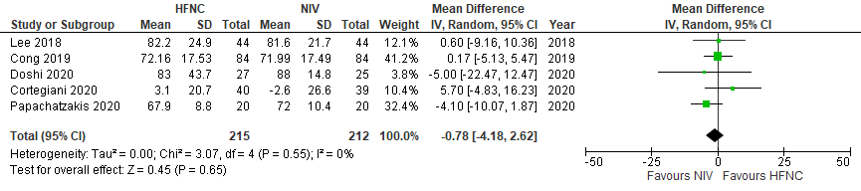
e-Figure 1 Forest plot of change in PaO₂
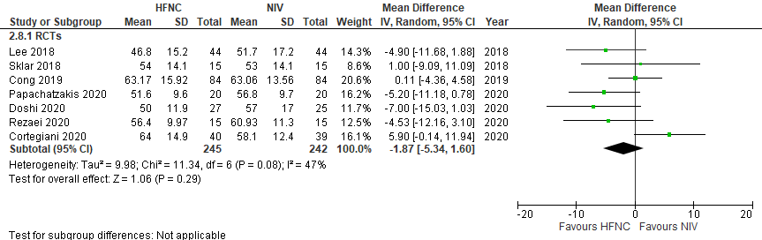
e-Figure 2 Forest plot of change in PCO₂
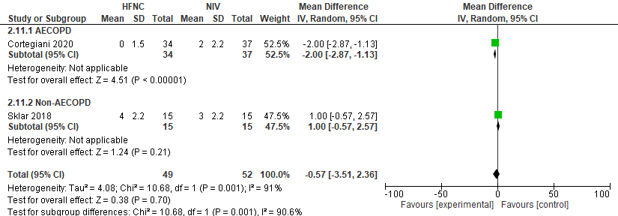
e-Figure 3 Forest plot of change in comfort - subgroup analysis by AECOPD studies alone
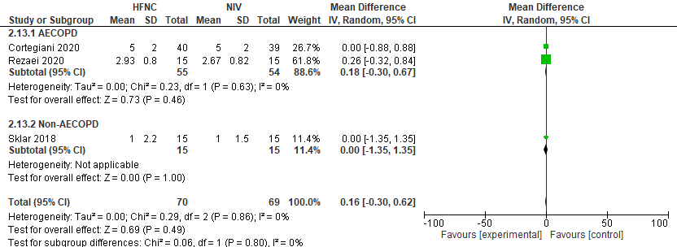
e-Figure 4 Forest plot of change in dyspnea - subgroup analysis by AECOPD studies alone
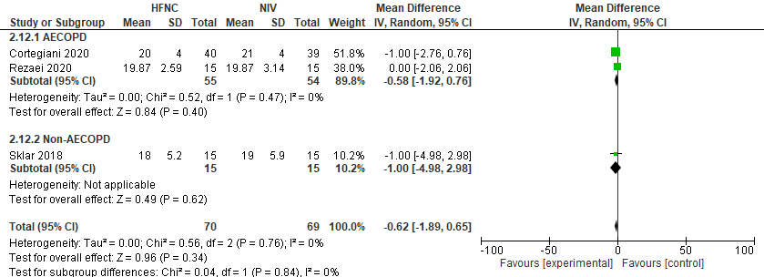
e-Figure 5 Forest plot of change in respiratory rate - subgroup analysis by AECOPD studies alone
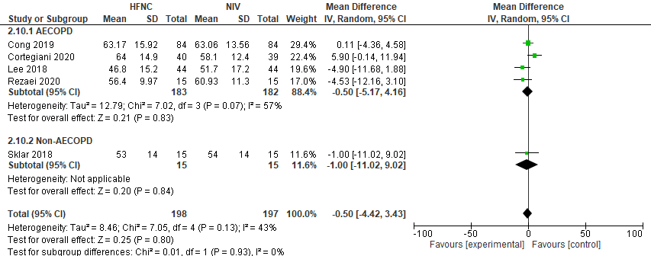
e-Figure 6 Forest plot of change in PaCO₂ - subgroup analysis by AECOPD studies alone

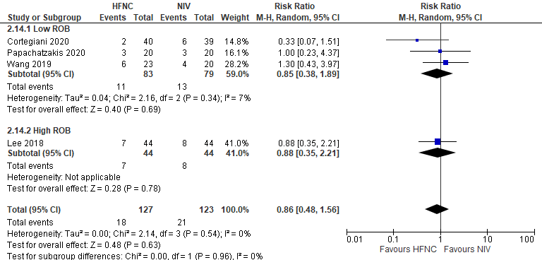
e-Figure 7 Forest plot of mortality - subgroup analysis by risk of bias
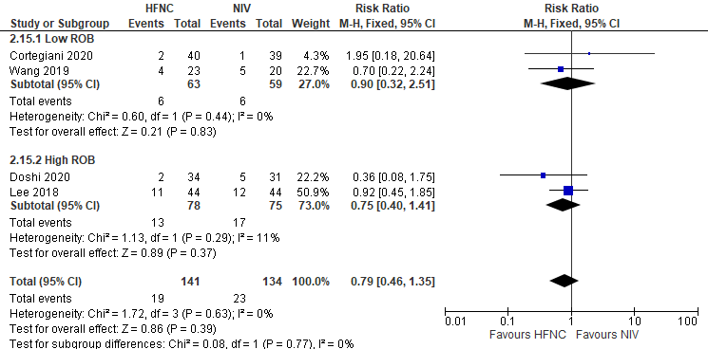
e-Figure 8 Forest plot of intubation - subgroup analysis by risk of bias
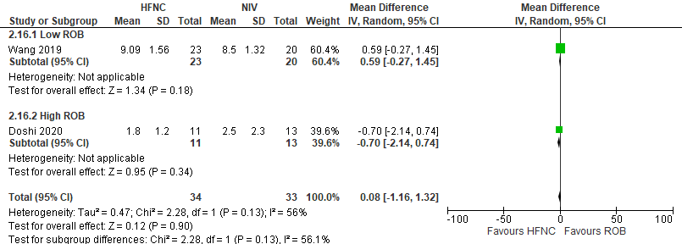
e-Figure 9 Forest plot of ICU Length of Stay - subgroup analysis by risk of bias
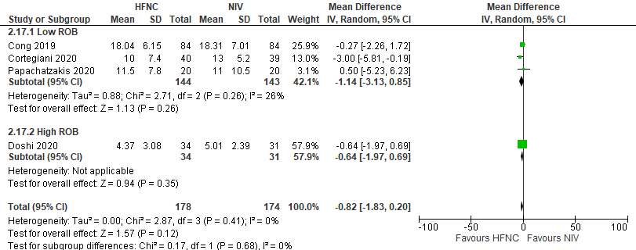

e-Figure 10 Forest plot of Hospital Length of Stay - subgroup analysis by risk of bias
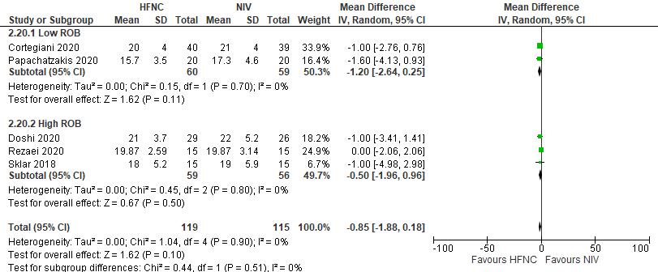
e-Figure 11 Forest plot of respiratory rate - subgroup analysis by risk of bias
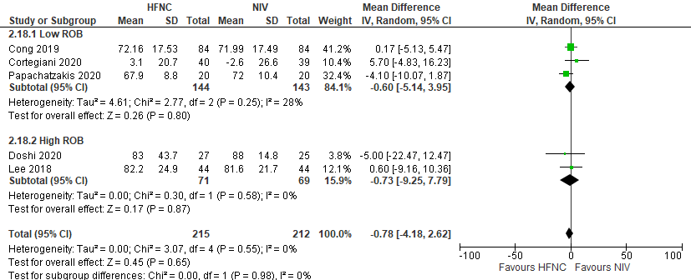
e-Figure 12 Forest plot of change in PaO₂ - subgroup analysis by risk of bias
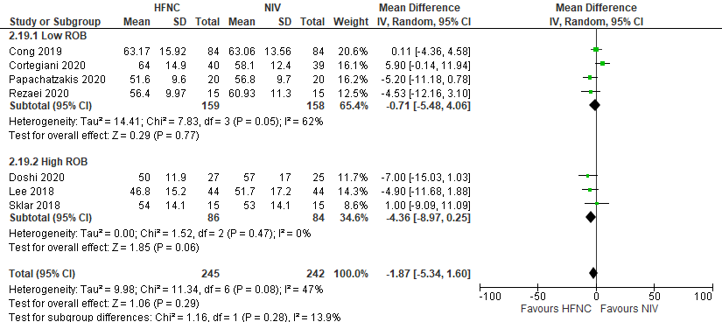
e-Figure 13 Forest plot of change in PaCO₂ - subgroup analysis by risk of bias
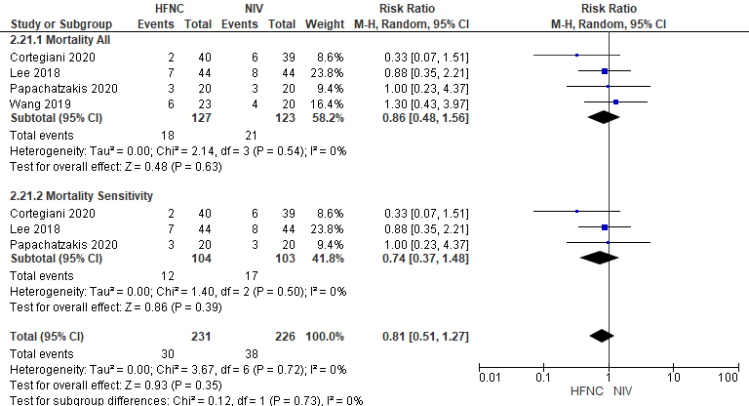
e- Figure 14 Forest plot of mortality - subgroup analysis excluding Wang et al.
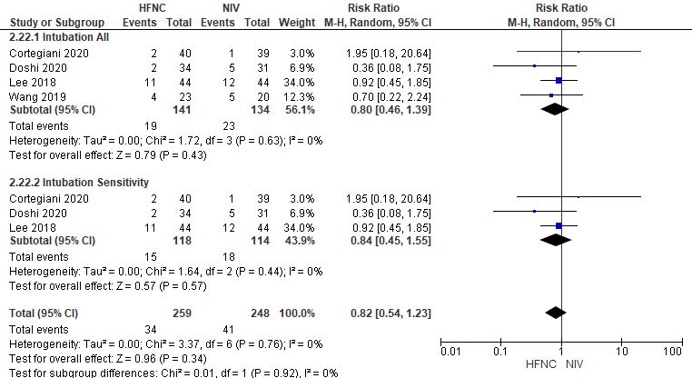
e-Figure 15 Forest plot of intubation - subgroup analysis excluding Wang et al.
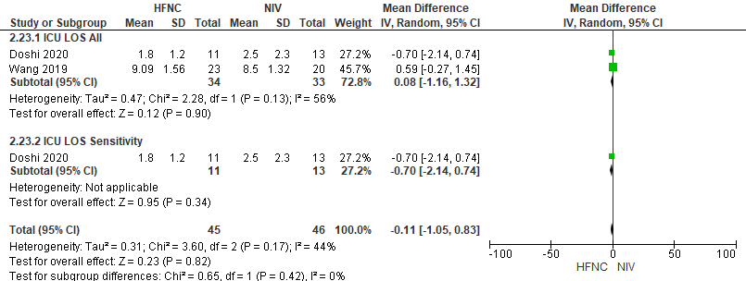
e-Figure 16 Forest plot of ICU Length of Stay - subgroup analysis excluding Wang et al
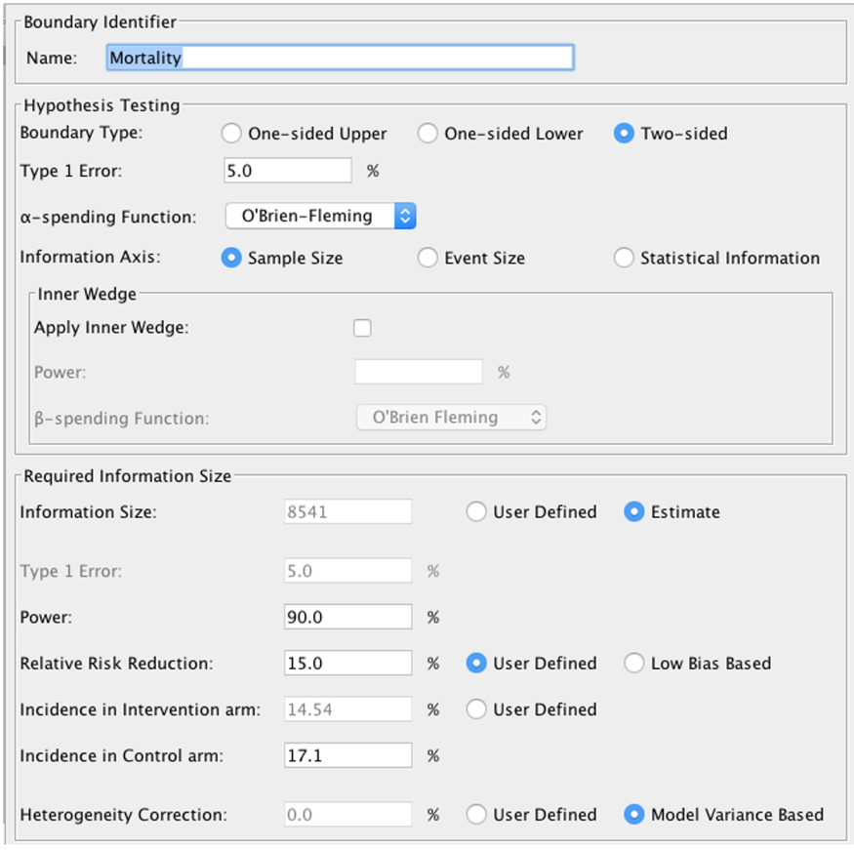
e-Figure 17: Trial sequential analysis for mortality
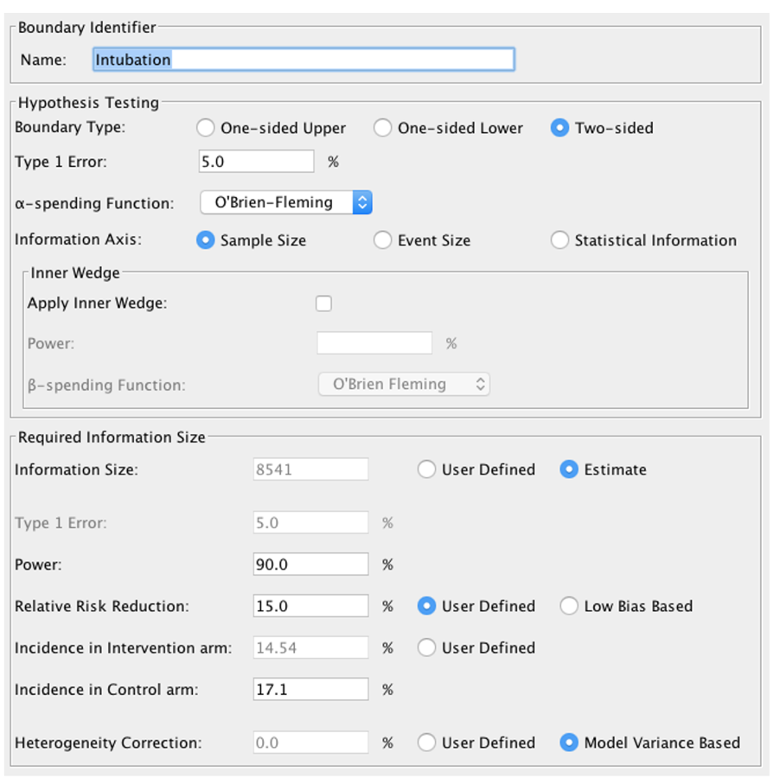
e-Figure 18: Trial sequential analysis for intubation

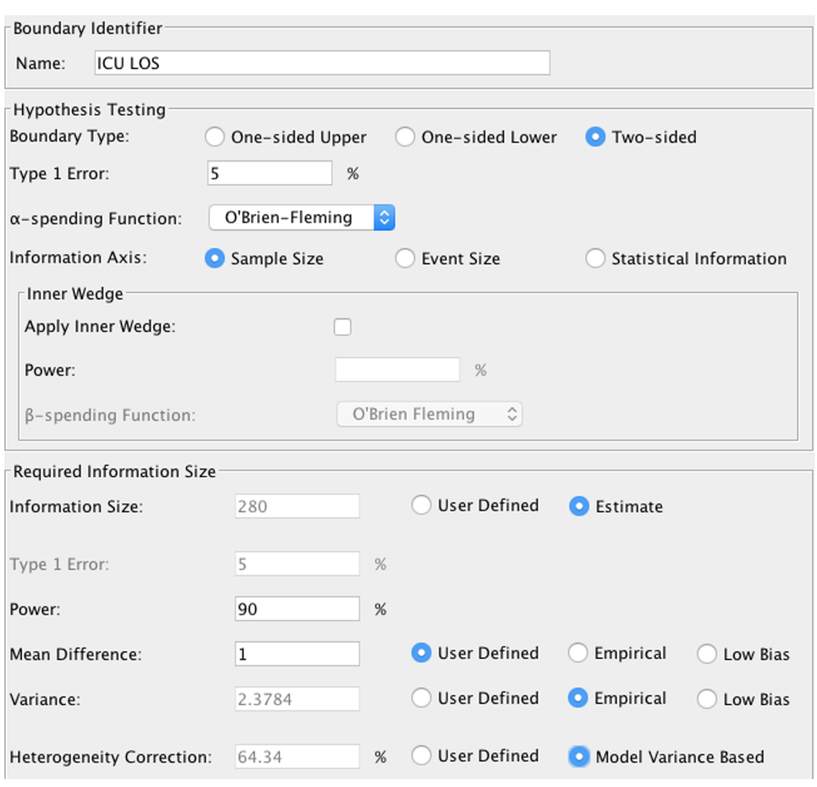
e-Figure 19: Trial sequential analysis for ICU length of stay

