Supplementary materials

Table 1. Quality and risk of bias assessment using the Newcastle-Ottawa Scale (NOS) for observational studies assessing muscle wasting.

Study ID | Selection |  |  |  | Comparability | Outcome |  |  | Total  (9*)
Study ID | Representativeness of the exposed cohort (*) | Selection of non-exposed cohort (*) | Ascertainment of exposure (*) | Demonstration that outcome of interest was not present at start of study (*) | Comparability of cohorts (**) | Assessment of outcome (*) | Follow up long enough for outcomes to occur (*) | Adequacy of follow up (*) | Total  (9*)
Lambell, 2021 | * |  | * | * |  | * | * | * | 6
Lee, 2021 | * |  | * | * |  | * | * | * | 6
Toledo, 2021 | * |  | * | * |  | * | * | * | 6
Zhang, 2021 | * |  | * | * |  | * | * | * | 6
Borges, 2020 | * |  | * | * |  | * | * | * | 6
Dimopoulos, 2020 | * |  | * | * |  | * | * | * | 6
Kemp, 2020 | * |  | * | * |  | * | * | * | 6
Mayer, 2020 | * |  | * | * |  | * | * | * | 6
Nakanishi, 2020 (a) | * |  | * | * |  | * | * | * | 6
Nakanishi, 2020 (b) | * |  | * | * |  | * | * | * | 6
Borges, 2019 | * |  | * | * |  | * | * | * | 6
Dusseaux, 2019 | * |  | * | * |  | * | * | * | 6
Haines, 2019 | * |  | * | * |  | * | * | * | 6
Nakanishi, (c) 2019 | * |  | * | * |  | * | * | * | 6
Trung, 2019 | * |  | * | * |  | * | * | * | 6
Vivier, 2019 | * |  | * | * |  | * | * |  | 6
Wandrag, 2019 | * |  | * | * |  | * | * | * | 6
Hadda, 2018 | * |  | * | * |  | * | * | * | 6
Hayes, 2018 | * |  | * | * |  | * | * | * | 6
Katari, 2018 | * |  | * | * |  | * | * | * | 6
Nakanishi, (d) 2018 | * |  | * | * |  | * | * | * | 6
Palakshappa,  2018 | * |  |  | * |  | * | * | * | 6
Pardo, 2018 | * |  | * | * |  | * | * | * | 6
Silva, 2018 | * |  | * | * |  | * | * | * | 6
Annetta, 2017 | * |  | * | * | * | * | * | * | 7
Puthucheary,  2017 | * |  | * | * | * | * | * | * | 7
Segaran, 2016 | * |  | * | * | * | * | * | * | 7
Turton,  2016 | * |  | * | * | * | * | * | * | 7
Parry, 2015 | * |  | * | * | * | * | * | * | 7
Jung, 2014 | * |  | * | * | * | * | * | * | 7
Puthucheary, 2013 | * |  | * | * | * | * | * | * | 7
Reid, 2004 | * |  | * | * | * | * | * | * | 7

Table 2. Quality and risk of bias assessment using the Newcastle-Ottawa Scale (NOS) for observational studies assessing ICU-acquired weakness.

Study ID | Selection |  |  |  | Comparability | Outcome |  |  | Total  (9*)
Study ID | Representativeness of the exposed cohort (*) | Selection of non-exposed cohort (*) | Ascertainment of exposure (*) | Demonstration that outcome of interest was not present at start of study (*) | Comparability of cohorts (**) | Assessment of outcome (*) | Follow up long enough for outcomes to occur (*) | Adequacy of follow up (*) | Total  (9*)
1. Van Aerde et al. 2020 | * |  | * | * |  | * | * | * | 6
2. Ballve et al. 2017 | * |  | * | * |  | * | * | * | 6
3. Nguyen et al. 2015 | * |  | * | * |  | * | * | * | 6
4. Parry et al. 2015 | * |  | * | * |  | * | * | * | 6
5. Hough et al. 2011 | * |  | * | * |  | * | * | * | 6
6. Brunello et al. 2010 | * |  | * | * |  | * | * | * | 6
7. Carstens et al. 2009 | * |  | * | * |  | * | * | * | 6
8. Sharshar et al. 2009 | * |  | * | * |  | * | * | * | 6
9. Nanas et al. 2008 | * |  | * | * |  | * | * | * | 6
10. Ali et al.  2008 | * |  | * | * |  | * | * | * | 6
11. Latronico et al. 2007 | * |  | * | * |  | * | * | * | 6
12. Villar et al. 2005 | * |  | * | * |  | * | * | * | 6
13. Bedranik et al.  2005 | * |  | * | * |  | * | * | * | 6
14. Montero et al.  2005 | * |  | * | * |  | * | * | * | 6
15. Bercker et al.  2005 | * |  | * | * |  | * | * | * | 6
16. Jonghe et al.  2002 | * |  | * | * |  | * | * | * | 6
17. Letter et al.  2001 | * |  | * | * |  | * | * | * | 6
18. Druschky et al.  2001 | * |  | * | * |  | * | * | * | 6
19. Montero et al.  2001 | * |  | * | * |  | * | * | * | 6
20. Tepper et al.  2000 | * |  | * | * |  | * | * | * | 6

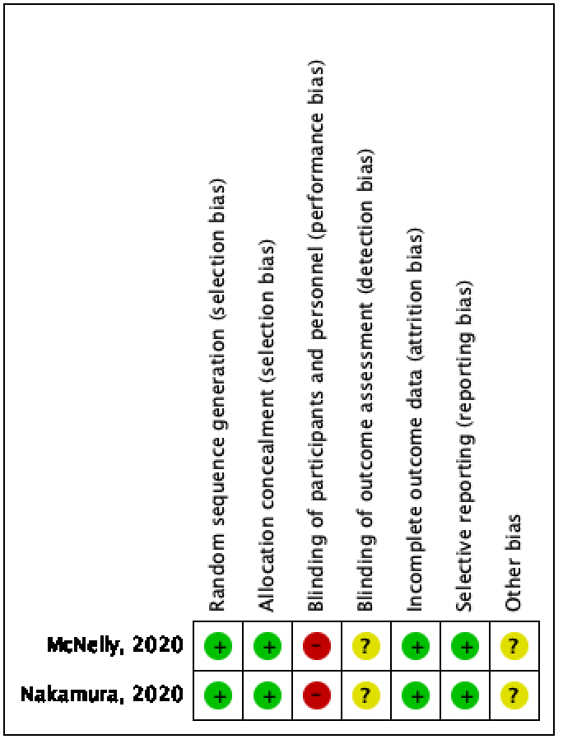
Figure 1. Risk of Bias

