Supplementary materials

- Table S1. Parameters of six severity scores.
- Table S2. Sensitivity, specificity, PPV, NPV, and accuracy for the prediction of in-hospital death.
- Table S3. Sensitivity, specificity, PPV, NPV, and accuracy for the prediction of no return to baseline.
- Table S4. Comparisons of sensitivity.
- Table S5. Comparisons of specificity.
- Table S6. Comparisons of positive predive value.
- Table S7. Comparisons of negative predictive value.
- Table S8. Comparisons of accuracy.
- Table S9. Sensitivity for the prediction of in-hospital death at cutoff values yielding a specificity close to 90%.
- Table S10. Sensitivity for the prediction of no return to baseline at cutoff values yielding a specificity close to 90%.
- Figure S1. ROC curves of STESS, EMSE, GCS, modified APACHE 2, modified SAPS 2, modified SOFA.

Table S1. Measurements of six severity scores.
Parameters | STESS | EMSE-EACE | INCNS | APACHE-2 | SAPS-2 | SOFA
Consciousness | Alert or somnolent/ confused; stuporous or comatose | - | Arousal and awareness | GCS | GCS | GCS
Worst seizure type | SP or CP; GC; NCSEC | - | - | - | - | -
Age | <65 or ≥ 65 years | 7 categories | 4 categories | 5 categories | 6 categories | -
History of seizures | Yes | - | - | - | - | -
Etiology | - | 15 categories | - | Elective / emergency surgery or not | Elective / emergency surgery or not | -
Comorbidity | - | Yes | - | - | Yes | -
Electroencephalography | - | Yes | - | - | - | -
Brainstem reflexes | - | - | Pupillary and corneal | - | - | -
Verbal and motor responses | - | - | Yes | GCS | GCS | GCS
Swallowing function | - | - | Yes | - | - | -
Respiration rate | - | - | Yes | Yes | - | -
Heart rate | - | - | Yes | Yes | Yes | -
Blood pressure | - | - | SBP | MAP | SBP | MAP
Temperature | - | - | Yes | Yes | Yes | -
White blood cells | - | - | Yes | Yes | Yes | -
Blood glucose | - | - | Yes | - | - | -
Serum albumin | - | - | Yes | - | - | -
Serum sodium | - | - | Yes | Yes | Yes | -
Serum creatinine | - | - | Yes | Yes | - | Yes
Serum bilirubin | - | - | Yes | - | Yes | Yes
Oxygenation | - | - | - | Yes | Yes | Yes
Arterial PH | - | - | - | Yes | - | -
Bicarbonate | - | - | - | Yes | Yes | -
Serum potassium | - | - | - | Yes | Yes | -
Hematocrit | - | - | - | Yes | - | -
Urinary output | - | - | - | - | Yes | Yes
Blood urea nitrogen | - | - | - | - | Yes | -
Platelets | - | - | - | - | - | Yes
CP, complex partial; GC, generalized convulsive; GCS, Glasgow coma scale; MAP, mean arterial pressure; NCSEC, nonconvulsive status epilepticus with coma; SP, simple partial; SBP, systolic blood pressure.

Table S2. Sensitivity, specificity, PPV, NPV, and accuracy for the prediction of in-hospital death.
Scores | Sensitivity | Specificity | PPV | NPV | Accuracy
STESS ≥ 4 | 44.3% | 74.0% | 55.4% | 64.6% | 61.5%
EMSE ≥ 70 | 62.9% | 70.8% | 61.1% | 72.3% | 67.5%
INCNS ≥ 18 | 54.4% | 68.1% | 55.2% | 67.4% | 62.4%
APACHE Ⅱ ≥ 18 | 95.7% | 35.9% | 52.8% | 91.7% | 61.5%
SAPS Ⅱ ≥ 56 | 73.5% | 66.7% | 62.5% | 76.9% | 69.6%
SOFA ≥ 10 | 55.7% | 79.2% | 66.1% | 71.0% | 69.3%
PPV, positive predictive value; NPV, negative predictive value.

Table S3. Sensitivity, specificity, PPV, NPV, and accuracy for the prediction of no return to baseline.
Scores | Sensitivity | Specificity | PPV | NPV | Accuracy
STESS ≥ 3 | 60.9% | 55.3% | 82.1% | 29.6% | 59.6%
EMSE ≥ 56 | 63.3% | 76.3% | 90.0% | 38.2% | 66.3%
INCNS ≥ 23 | 17.1% | 97.4% | 95.5% | 26.6% | 36.0%
APACHE Ⅱ ≥ 20 | 74.4% | 66.7% | 88.6% | 42.9% | 72.7%
SAPS Ⅱ ≥ 45 | 77.1% | 50.0% | 83.9% | 39.1% | 70.9%
SOFA ≥ 10 | 41.4% | 84.2% | 89.8% | 29.9% | 51.2%
PPV, positive predictive value; NPV, negative predictive value.

Table S4. Comparisons of Sensitivity*.
 | No return to baseline
In-hospital death | STESS | P = 0.7914ª | P < 0.0001^{b} | P = 0.0175^{c} | P = 0.0019^{d} | P = 0.0026ª
In-hospital death | P = 0.0410ª | EMSE | P < 0.0001^{b} | P = 0.0444^{c} | P = 0.0114^{d} | P = 0.0003ª
In-hospital death | P = 0.2863^{b} | P = 0.3915^{b} | INCNS | P < 0.0001^{d} | P < 0.0001e | P = 0.0001^{b}
In-hospital death | P < 0.0001^{c} | P < 0.0001^{c} | P < 0.0001^{d} | APACHE-2 | P = 0.8555^{f} | P < 0.0001^{c}
In-hospital death | P = 0.0002^{d} | P = 0.1849^{d} | P = 0.0106e | P < 0.0001^{f} | SAPS-2 | P < 0.0001^{d}
In-hospital death | P = 0.2153ª | P = 0.4731ª | P = 1.0000^{b} | P < 0.0001^{c} | P = 0.0192^{d} | SOFA
*The significance level is 0.0033. ªIn 166 patients. ^{b}In 162 patients. ^{c}In 161 patients. ^{d}In 158 patients. ^{e}In 155 patients. ^{f}In 156 patients.

Table S5. Comparisons of Specificity*.
 | No return to baseline
In-hospital death | STESS | P = 0.0574ª | P = 0.0001^{b} | P = 0.3877^{c} | P = 0.7539^{d} | P = 0.0074ª
In-hospital death | P = 0.7283ª | EMSE | P = 0.0215^{b} | P = 0.5488^{c} | P = 0.0225^{d} | P = 0.5488ª
In-hospital death | P = 0.4583^{b} | P = 0.8714^{b} | INCNS | P = 0.0010^{d} | P < 0.0001e | P = 0.0625^{b}
In-hospital death | P < 0.0001^{c} | P < 0.0001^{c} | P < 0.0001^{d} | APACHE-2 | P = 0.1797^{f} | P = 0.1094^{c}
In-hospital death | P = 0.1892^{d} | P = 0.8642^{d} | P = 0.6900e | P < 0.0001^{f} | SAPS-2 | P = 0.0005^{d}
In-hospital death | P = 0.4583ª | P = 0.2295ª | P = 0.1102^{b} | P < 0.0001^{c} | P = 0.0639^{d} | SOFA
*The significance level is 0.0033. ªIn 166 patients. ^{b}In 162 patients. ^{c}In 161 patients. ^{d}In 158 patients. ^{e}In 155 patients. ^{f}In 156 patients.

Table S6. Comparisons of Positive predive value*.
 | No return to baseline
In-hospital death | STESS | P = 0.0290ª | P = 0.0199^{b} | P = 0.0633^{c} | P = 0.5120^{d} | P = 0.0723ª
In-hospital death | P = 0.3823ª | EMSE | P = 0.2695^{b} | P = 0.7321^{c} | P = 0.0821^{d} | P = 0.9681ª
In-hospital death | P = 0.9821^{b} | P = 0.3958^{b} | INCNS | P = 0.1265^{d} | P = 0.0397e | P = 0.1937^{b}
In-hospital death | P = 0.6058^{c} | P = 0.0894^{c} | P = 0.4418^{d} | APACHE-2 | P = 0.1280^{f} | P = 0.7679^{c}
In-hospital death | P = 0.2750^{d} | P = 0.6503^{d} | P = 0.3360e | P = 0.0092^{f} | SAPS-2 | P = 0.0807^{d}
In-hospital death | P = 0.1192ª | P = 0.4386ª | P = 0.1049^{b} | P = 0.0145^{c} | P = 0.4766^{d} | SOFA
*The significance level is 0.0033. ªIn 166 patients. ^{b}In 162 patients. ^{c}In 161 patients. ^{d}In 158 patients. ^{e}In 155 patients. ^{f}In 156 patients.

Table S7. Comparisons of Negative predictive value*.
 | No return to baseline
In-hospital death | STESS | P = 0.0752ª | P = 0.3428^{b} | P = 0.0099^{c} | P = 0.0703^{d} | P = 0.9369ª
In-hospital death | P = 0.0701ª | EMSE | P = 0.0009^{b} | P = 0.2335^{c} | P = 0.7170^{d} | P = 0.0330ª
In-hospital death | P = 0.5247^{b} | P = 0.2831^{b} | INCNS | P = 0.0003^{d} | P = 0.0142e | P = 0.0693^{b}
In-hospital death | P < 0.0001^{c} | P = 0.0014^{c} | P < 0.0001^{d} | APACHE-2 | P = 0.4615^{f} | P = 0.0038^{c}
In-hospital death | P = 0.0016^{d} | P = 0.1964^{d} | P = 0.0183e | P = 0.0008^{f} | SAPS-2 | P = 0.0868^{d}
In-hospital death | P = 0.0940ª | P = 0.7600ª | P = 0.3487^{b} | P = 0.0002^{c} | P = 0.1046^{d} | SOFA
*The significance level is 0.0033. ªIn 166 patients. ^{b}In 162 patients. ^{c}In 161 patients. ^{d}In 158 patients. ^{e}In 155 patients. ^{f}In 156 patients.

Table S8. Comparisons of Accuracy*.
 | No return to baseline
In-hospital death | STESS | P = 0.6353a | P < 0.0001^{b} | P = 0.1034^{c} | P = 0.0022^{d} | P = 0.0001ª
In-hospital death | P = 0.0681ª | EMSE | P < 0.0001^{b} | P = 0.0273^{c} | P = 0.0006^{d} | P = 0.0002ª
In-hospital death | P = 0.1608^{b} | P = 0.7239^{b} | INCNS | P < 0.0001^{d} | P < 0.0001e | P < 0.0001^{b}
In-hospital death | P < 0.0001^{c} | P < 0.0001^{c} | P < 0.0001^{d} | APACHE-2 | P = 0.3368^{f} | P < 0.0001^{c}
In-hospital death | P = 0.0001^{d} | P = 0.2529^{d} | P = 0.0293e | P < 0.0001^{f} | SAPS-2 | P < 0.0001^{d}
In-hospital death | P = 0.7982ª | P = 0.1360ª | P = 0.2976^{b} | P < 0.0001^{c} | P = 0.0019^{d} | SOFA
*The significance level is 0.0033. ªIn 166 patients. ^{b}In 162 patients. ^{c}In 161 patients. ^{d}In 158 patients. ^{e}In 155 patients. ^{f}In 156 patients.

Table S9. Sensitivity for the prediction of in-hospital death at cutoff values yielding a specificity close to 90%.

Scores | Specificity (95% CI) | Sensitivity (95% CI)
STESS ≥ 5 | 88.5% (80.4% - 94.1%) | 14.3% (7.1% - 24.7%)
EMSE ≥ 98 | 90.6% (82.9% - 95.6%) | 20.0% (11.4% - 31.3%)
INCNS ≥ 23 | 92.5% (85.3% - 97.0%) | 23.5% (14.1% - 35.4%)
APACHE Ⅱ ≥ 28 | 90.2% (82.2% - 95.4%) | 33.3% (22.4% - 45.7%)
SAPS Ⅱ ≥ 69 | 91.1% (83.2% - 96.1%) | 30.9% (20.2% - 43.3%)
SOFA ≥ 12 | 91.7% (84.2% - 96.3%) | 32.9% (22.2% - 45.1%)

Table S10. Sensitivity for the prediction of no return to baseline at cutoff values yielding a specificity close to 90%.
Scores | Specificity (95% CI) | Sensitivity (95% CI)
STESS ≥ 5 | 89.5% (75.2% - 97.1%) | 13.3% (7.9% - 20.4%)
EMSE ≥ 82 | 89.5% (75.2% - 97.1%) | 33.6% (25.5% - 42.5%)
INCNS ≥ 22 | 84.2% (68.7% - 94.0%) | 25.0% (17.7% - 33.6%)
APACHE Ⅱ ≥ 26 | 88.9% (73.9% - 96.9%) | 37.6% (29.1% - 46.7%)
SAPS Ⅱ ≥ 67 | 88.9% (73.9% - 96.9%) | 27.9% (20.1% - 36.7%)
SOFA ≥ 11 | 89.5% (75.2% - 97.1%) | 32.0% (24.1% - 40.9%)

Figure S1. ROC curves of STESS, EMSE, GCS, modified APACHE 2, modified SAPS 2, modified SOFA.*
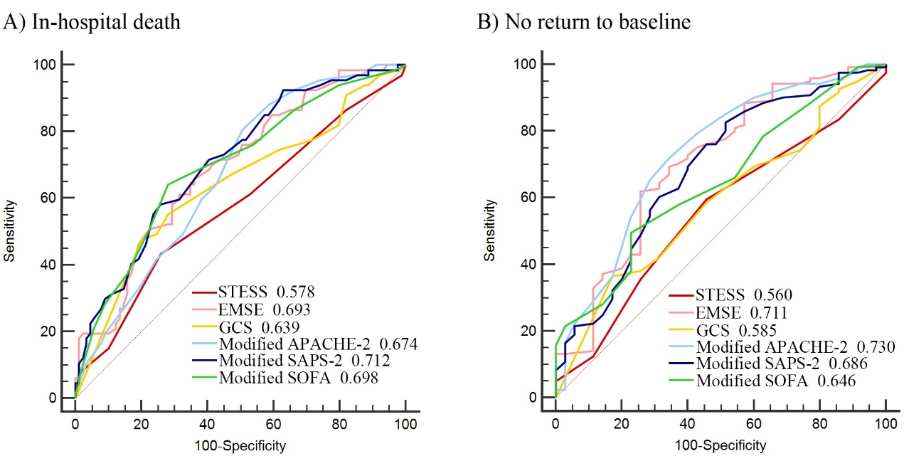
*Modified APACHE-2: APACHE-2 without GCS. Modified SAPS-2: SAPS-2 without GCS. Modified SOFA: SOFA without GCS. For the prediction of in-hospital death, GCS ≤ 3, modified APACHE-2 ≥ 12, modified SAPS-2 ≥ 43, SOFA ≥ 6 are best cut-off values determined by the Youden index. For the prediction of no return to baseline status, GCS ≤ 3, modified APACHE-2 ≥ 12, modified SAPS-2 ≥ 31, SOFA ≥ 6 are best cut-off values determined by the Youden index.

