Supplementary figure 3. Adjusted RR for 30-day survival in complete cases

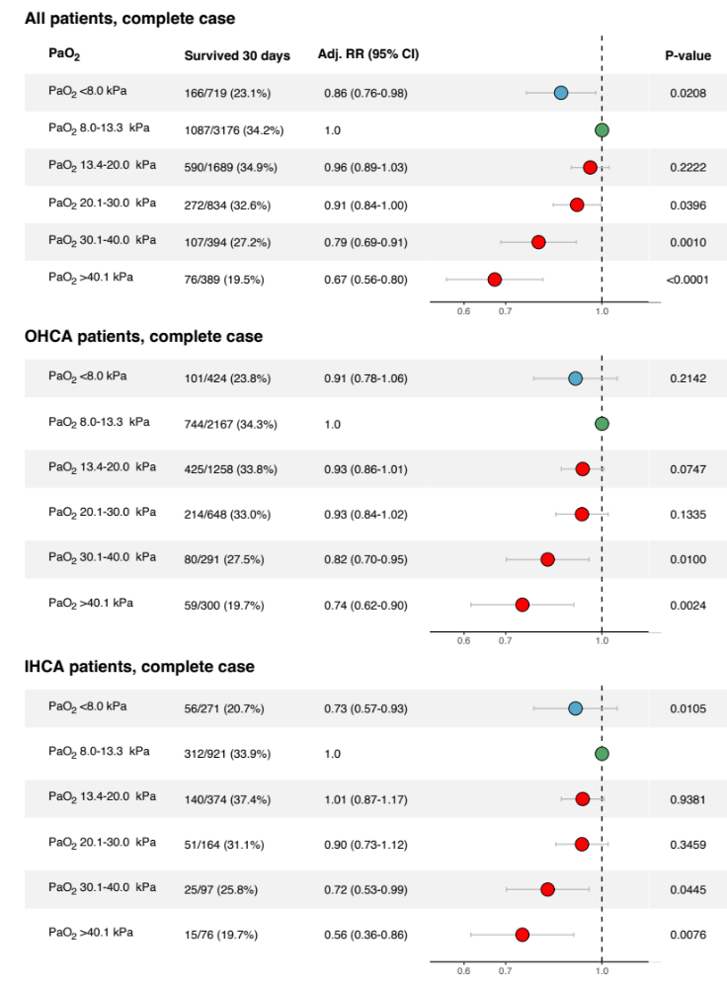

Adjusted for sex, age, witnessed status, bystander CPR, location, EMS/Rapid response team-response time, initial rhythm, Charlson comorbidity index, SAPS 3 score.

