Supplementary figure 5. Adjusted RR for 30-day survival in patients with non-shockable rhythms

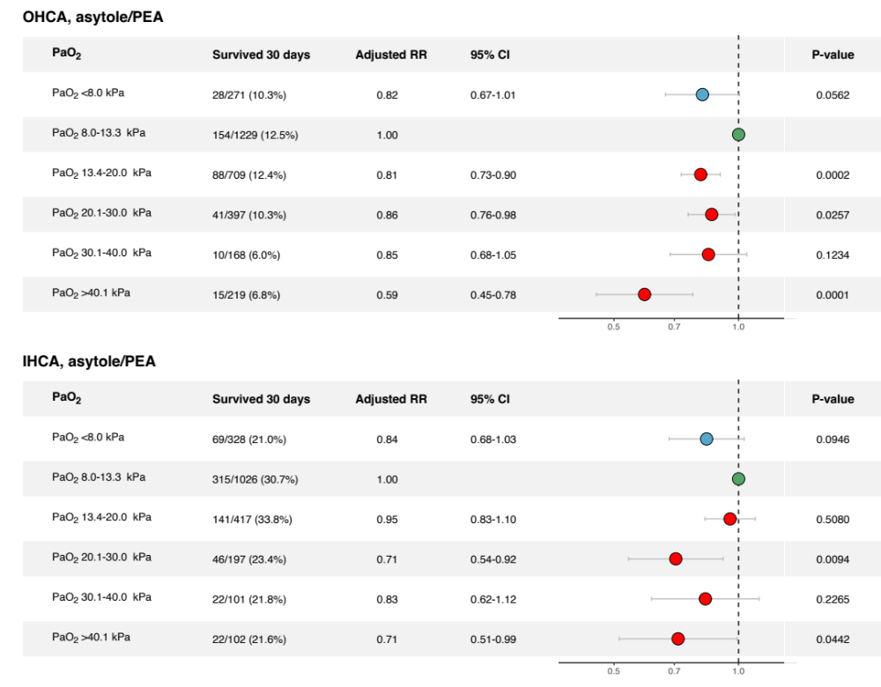

Adjusted for sex, age, witnessed status, bystander CPR, location, EMS/Rapid response team-response time, initial rhythm, Charlson comorbidity index, SAPS 3 score.

