Appendix Material

Appendix Figure 1. PRISMA Study Flowchart
Appendix Figure 2. Forest plot for sepsis, comparing aggressive (intervention) and non-aggressive (control) protocols for acute pancreatitis
Appendix Figure 3. Forest plot for acute respiratory failure, comparing aggressive (intervention) and non-aggressive (control) protocols for acute pancreatitis
Appendix Figure 4. Forest plot for acute kidney injury, comparing aggressive (intervention) and non-aggressive (control) protocols for acute pancreatitis
Appendix Figure 5. Forest plot for pancreatic necrosis, comparing aggressive (intervention) and non-aggressive (control) protocols for acute pancreatitis
Appendix Figure 6. Forest plot for SIRS subsiding within 48 hours, comparing aggressive (intervention) and non-aggressive (control) protocols for acute pancreatitis
Appendix Figure 7. Forest plot for SIRS persisting >48 hours, comparing aggressive (intervention) and non-aggressive (control) protocols for acute pancreatitis
Appendix Figure 8. Forest plot for persistent organ failure, comparing aggressive (intervention) and non-aggressive (control) protocols for acute pancreatitis
Appendix Figure 9. Forest plot for BUN changes within 48 hours, comparing aggressive (intervention) and non-aggressive (control) protocols for acute pancreatitis
Appendix Figure 10. Forest plot for Hct changes within 48 hours, comparing aggressive (intervention) and non-aggressive (control) protocols for acute pancreatitis Appendix Figure 11. Forest plot for total hospitalization days, comparing aggressive (intervention) and non-aggressive (control) protocols for acute pancreatitis
Appendix Figure 12. Forest plot for the sensitivity analysis: Mortality risk, comparing aggressive (intervention) and non-aggressive (control) protocols for acute pancreatitis
Appendix Figure 13. Forest plot for the sensitivity analysis: Fluid-related complication risk, comparing aggressive (intervention) and non-aggressive (control) protocols for acute pancreatitis
Appendix Figure 14. Forest plot for the sensitivity analysis: Clinical improvement, comparing aggressive (intervention) and non-aggressive (control) protocols for acute pancreatitis
Appendix Figure 15. Forest plot for the sensitivity analysis: APACHE II score changes within 48 hours, comparing aggressive (intervention) and non-aggressive (control) protocols for acute pancreatitis
Appendix Figure 16. Forest plot for the sensitivity analysis: Sepsis, comparing aggressive (intervention) and non-aggressive (control) protocols for acute pancreatitis
Appendix Figure 17. Forest plot for the sensitivity analysis: Acute respiratory failure, comparing aggressive (intervention) and non-aggressive (control) protocols for acute pancreatitis
Appendix Figure 18. Forest plot for the sensitivity analysis: Acute kidney injury, comparing aggressive (intervention) and non-aggressive (control) protocols for acute pancreatitis
Appendix Figure 19. Forest plot for the sensitivity analysis: Pancreatic necrosis, comparing aggressive (intervention) and non-aggressive (control) protocols for acute pancreatitis
Appendix Figure 20. Forest plot for the sensitivity analysis: SIRS subsiding within 48 hours, comparing aggressive (intervention) and non-aggressive (control) protocols for acute pancreatitis
Appendix Figure 21. Forest plot for the sensitivity analysis: SIRS persisting >48 hours, comparing aggressive (intervention) and non-aggressive (control) protocols for acute pancreatitis
Appendix Figure 22. Forest plot for the sensitivity analysis: Persistent organ failure, comparing aggressive (intervention) and non-aggressive (control) protocols for acute pancreatitis
Appendix Figure 23. Forest plot for the sensitivity analysis: BUN changes within 48 hours, comparing aggressive (intervention) and non-aggressive (control) protocols for acute pancreatitis
Appendix Figure 24. Forest plot for the sensitivity analysis: Hct changes within 48 hours, comparing aggressive (intervention) and non-aggressive (control) protocols for acute pancreatitis
Appendix Figure 25. Forest plot for the sensitivity analysis: Total hospitalization days, comparing aggressive (intervention) and non-aggressive (control) protocols for acute pancreatitis
Appendix Table 1. PRISMA Checklist
Appendix Table 2. Search strategy
Appendix Table 3. Reasons for exclusion of records after full-text review
Appendix Table 4. Other study characteristics of included studies
Appendix Table 5. RoB
Appendix Table 6. Subgroup analyses: Mortality
Appendix Table 7. Subgroup analyses: Clinical improvement
Appendix Table 8. Subgroup analyses: APACHE II score changes
Appendix Table 9. Subgroup analyses: Fluid-related complications
Appendix Table 10. Subgroup analyses: Acute respiratory failure
Appendix Table 11. Subgroup analyses: Sepsis
Appendix Table 12. Subgroup analyses: Acute kidney injury
Appendix Table 13. Subgroup analyses: Pancreatic necrosis
Appendix Table 14. Subgroup analyses: SIRS subsiding within 48 hours
Appendix Table 15. Subgroup analyses: SIRS persisting >48 hours
Appendix Table 16. Subgroup analyses: Persistent organ failure
Appendix Table 17. Subgroup analyses: BUN changes within 48 hours
Appendix Table 18. Subgroup analyses: Hct changes within 48 hours
Appendix Table 19. Subgroup analyses: Total hospitalization days
Appendix Table 20. Subgroup analyses of sensitivity analyses: Mortality
Appendix Table 21. Subgroup analyses of sensitivity analyses: Clinical improvement
Appendix Table 22. Subgroup analyses: APACHE II score changes
Appendix Table 23. Subgroup analyses of sensitivity analyses: Fluid-related complications
Appendix Table 24. Subgroup analyses of sensitivity analyses: Acute respiratory failure
Appendix Table 25. Subgroup analyses of sensitivity analyses: Sepsis
Appendix Table 26. Subgroup analyses of sensitivity analyses: Acute kidney injury
Appendix Table 27. Subgroup analyses of sensitivity analyses: Pancreatic necrosis
Appendix Table 28. Subgroup analyses of sensitivity analyses: SIRS subsiding within 48 hours
Appendix Table 29. Subgroup analyses of sensitivity analyses: SIRS persisting >48 hours
Appendix Table 30. Subgroup analyses of sensitivity analyses: Persistent organ failure
Appendix Table 31. Subgroup analyses of sensitivity analyses: BUN changes within 48 hours
Appendix Table 32. Subgroup analyses of sensitivity analyses: Hct changes within 48 hours
Appendix Table 33. Subgroup analyses of sensitivity analyses: Total hospitalization days
Appendix Table 34. GRADE assessment on study outcomes from included RCTs
Records from Cochrane Library, N= 72
Records from Embase, N= 122
Records from PubMed, N= 45

Other records from reference lists, previous review articles and treatment guidelines, N= 7

Records screened, N= 246

- Duplicate records, N= 85
- Not related to the research questions, N= 115

Full-text articles assessed for eligibility, N= 46

Full-text articles excluded:
- Not RCTs, N= 25
- Not focusing on adults with acute pancreatitis, N= 1
- Not focusing on aggressive vs. non-aggressive hydration protocols, N= 11
- No data of mortality, N=0

Studies included in qualitative synthesis, N= 9

Studies included in quantitative synthesis (meta-analysis), N= 9

Appendix Figure 1. PRISMA Study Flowchart

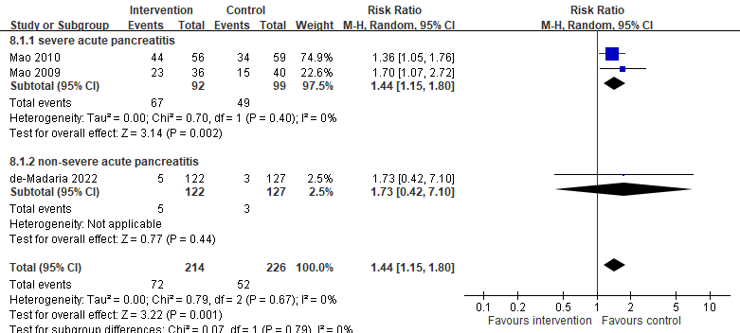

Appendix Figure 2. Sepsis, comparing aggressive (intervention) and non-aggressive (control) protocols for acute pancreatitis

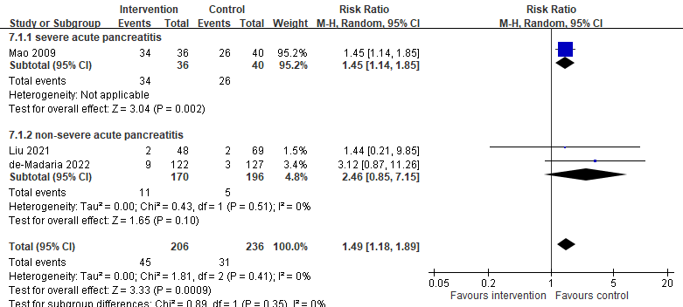

Appendix Figure 3. Acute respiratory failure, comparing aggressive (intervention) and non-aggressive (control) protocols for acute pancreatitis

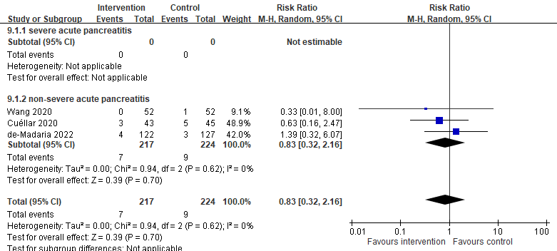

Appendix Figure 4. Acute kidney injury, comparing aggressive (intervention) and non-aggressive (control) protocols for acute pancreatitis

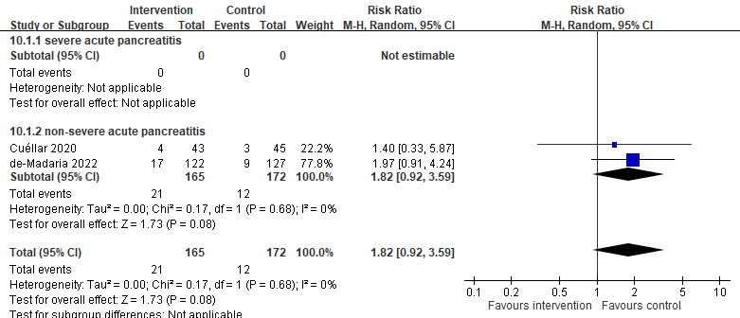
Appendix Figure 5. Pancreatic necrosis, comparing aggressive (intervention) and non-aggressive (control) protocols for acute pancreatitis
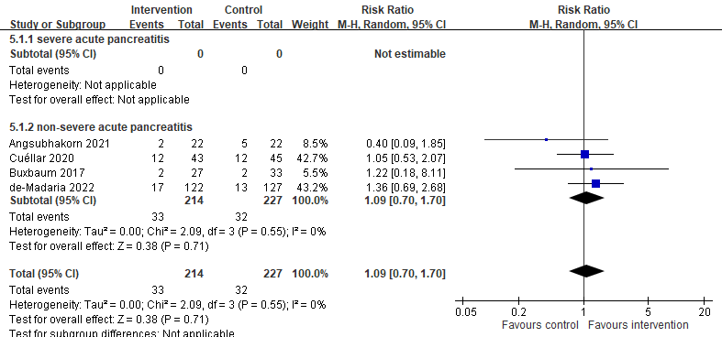

Appendix Figure 6. SIRS subsiding within 48 hours, comparing aggressive (intervention) and non-aggressive (control) protocols for acute pancreatitis

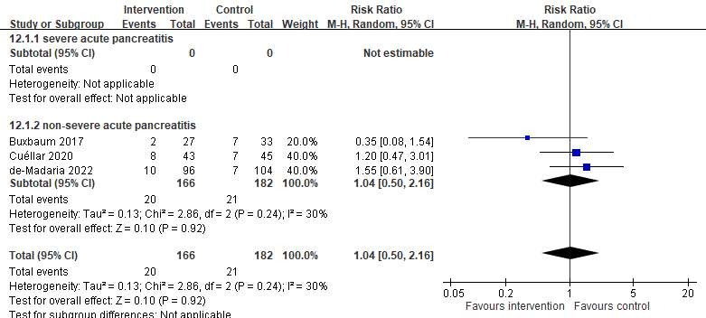

Appendix Figure 7. SIRS persisting >48 hours, comparing aggressive (intervention) and non-aggressive (control) protocols for acute pancreatitis

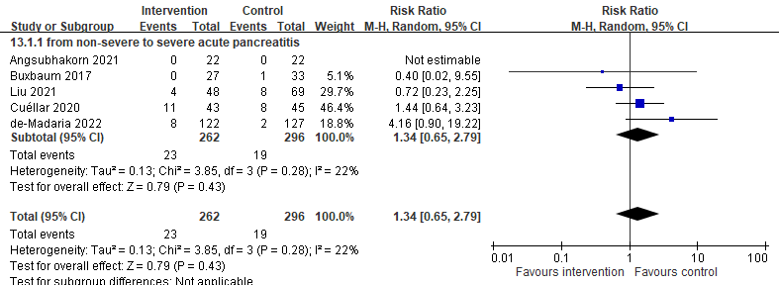

Appendix Figure 8. Persistent organ failure, comparing aggressive (intervention) and non-aggressive (control) protocols for acute pancreatitis

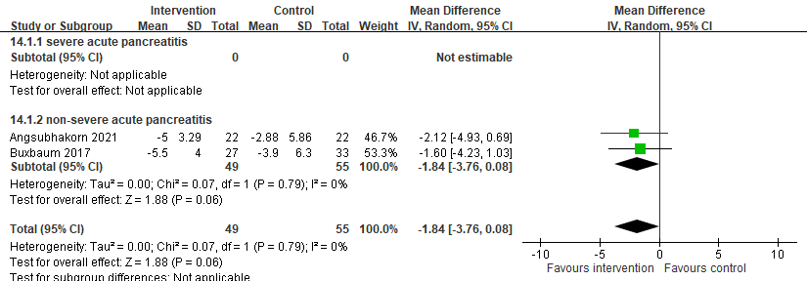

Appendix Figure 9. BUN changes within 48 hours, comparing aggressive (intervention) and non-aggressive (control) protocols for acute pancreatitis

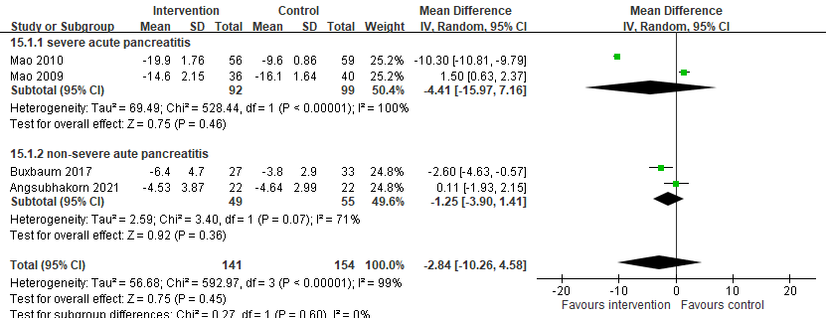

Appendix Figure 10. Hct changes within 48 hours, comparing aggressive (intervention) and non-aggressive (control) protocols for acute pancreatitis

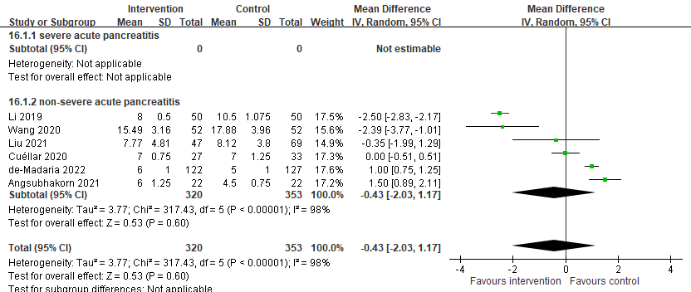

Appendix Figure 11. Total hospitalization days, comparing aggressive (intervention) and non-aggressive (control) protocols for acute pancreatitis
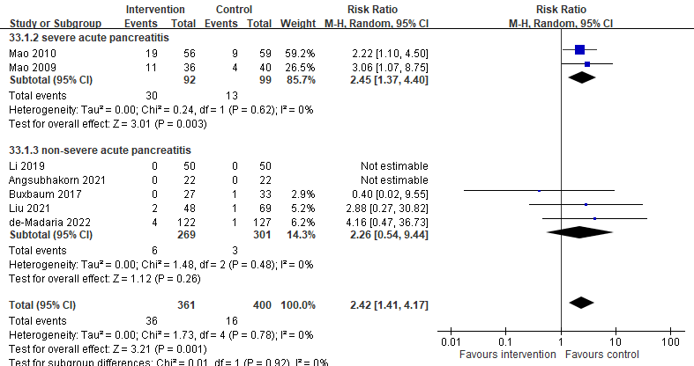

Appendix Figure 12. Sensitivity analysis: Mortality risk, comparing aggressive (intervention) and non-aggressive (control) protocols for acute pancreatitis

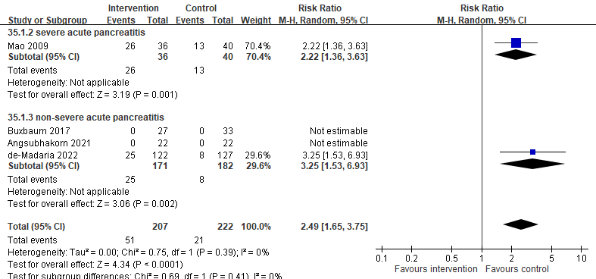

Appendix Figure 13. Sensitivity analysis: Fluid-related complication risk, comparing aggressive (intervention) and non-aggressive (control) protocols for acute pancreatitis

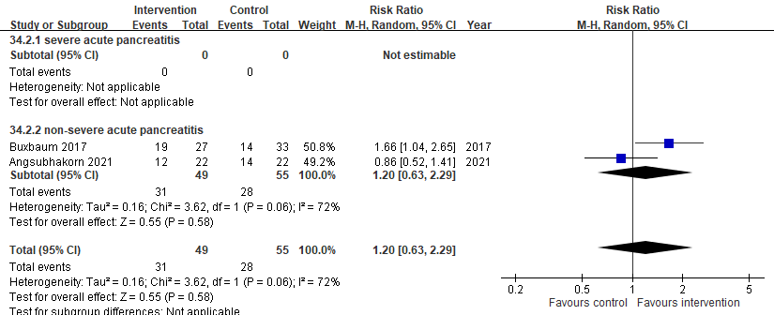

Appendix Figure 14. Sensitivity analysis: Clinical improvement, comparing aggressive (intervention) and non-aggressive (control) protocols for acute pancreatitis

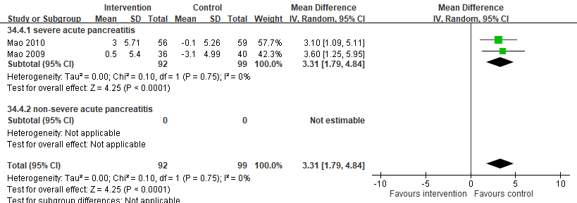

Appendix Figure 15. Sensitivity analysis: APACHE II score changes within 48 hours, comparing aggressive (intervention) and non-aggressive (control) protocols for acute pancreatitis

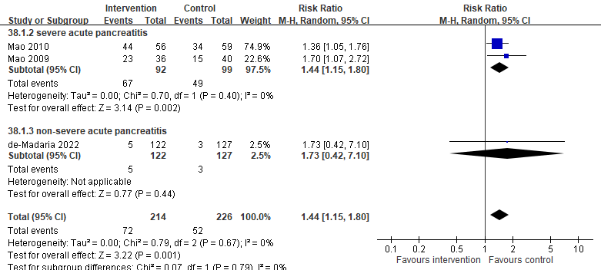

Appendix Figure 16. Sensitivity analysis: Sepsis, comparing aggressive (intervention) and non-aggressive (control) protocols for acute pancreatitis

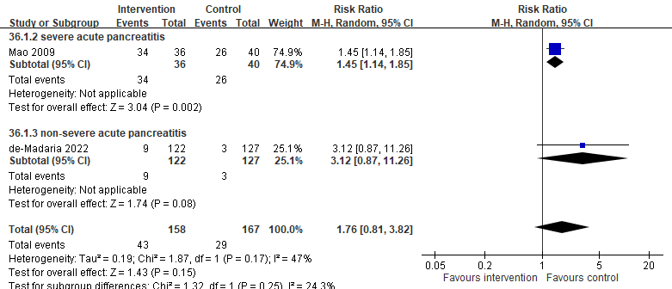

Appendix Figure 17. Sensitivity analysis: Acute respiratory failure, comparing aggressive (intervention) and non-aggressive (control) protocols for acute pancreatitis

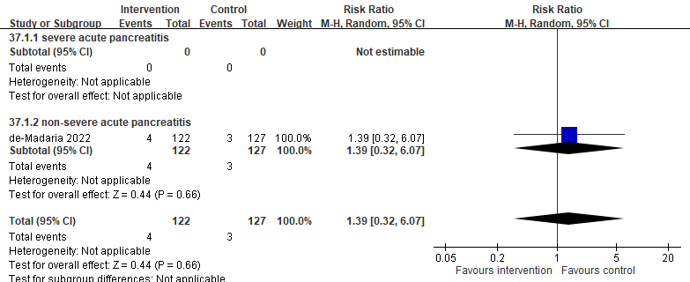

Appendix Figure 18. Sensitivity analysis: Acute kidney injury, comparing aggressive (intervention) and non-aggressive (control) protocols for acute pancreatitis

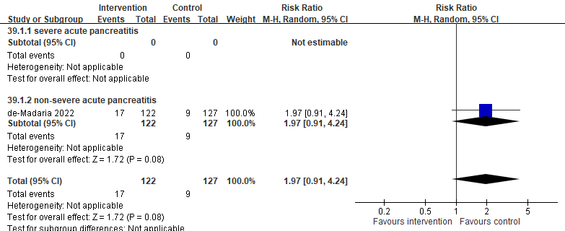

Appendix Figure 19. Sensitivity analysis: Pancreatic necrosis, comparing aggressive (intervention) and non-aggressive (control) protocols for acute pancreatitis

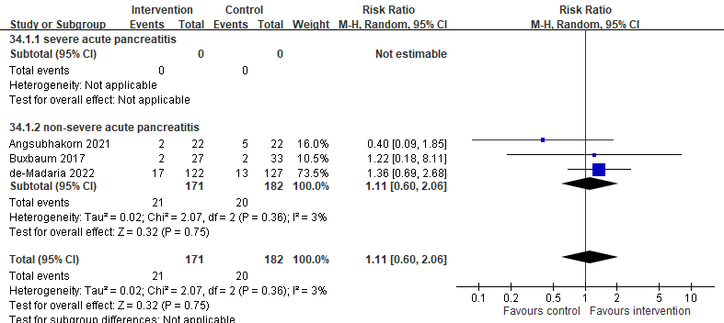

Appendix Figure 20. Sensitivity analysis: SIRS subsiding within 48 hours, comparing aggressive (intervention) and non-aggressive (control) protocols for acute pancreatitis

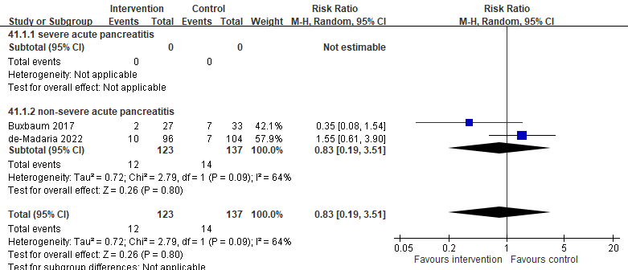

Appendix Figure 21. Sensitivity analysis: SIRS persisting >48 hours, comparing aggressive (intervention) and non-aggressive (control) protocols for acute pancreatitis

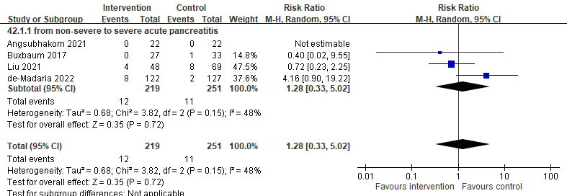

Appendix Figure 22. Sensitivity analysis: Persistent organ failure, comparing aggressive (intervention) and non-aggressive (control) protocols for acute pancreatitis

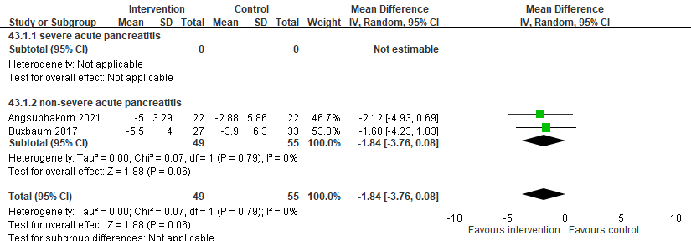

Appendix Figure 23. Sensitivity analysis: BUN changes within 48 hours, comparing aggressive (intervention) and non-aggressive (control) protocols for acute pancreatitis

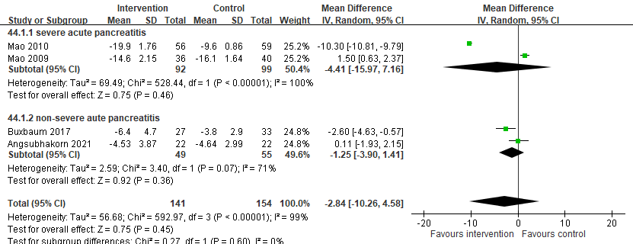

Appendix Figure 24. Sensitivity analysis: Hct changes within 48 hours, comparing aggressive (intervention) and non-aggressive (control) protocols for acute pancreatitis

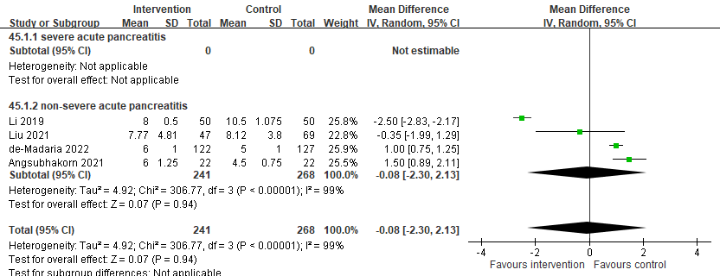

Appendix Figure 25. Sensitivity analysis: Total hospitalization days, comparing aggressive (intervention) and non-aggressive (control) protocols for acute pancreatitis

Appendix Table 1. PRISMA Checklist
Section and Topic | Item # | Checklist item | Location where item is reported
TITLE
Title | 1 | Identify the report as a systematic review. | 1
ABSTRACT
Abstract | 2 | See the PRISMA 2020 for Abstracts checklist. | 3-4
INTRODUCTION
Rationale | 3 | Describe the rationale for the review in the context of existing knowledge. | 5-6
Objectives | 4 | Provide an explicit statement of the objective(s) or question(s) the review addresses. | 6
METHODS
Eligibility criteria | 5 | Specify the inclusion and exclusion criteria for the review and how studies were grouped for the syntheses. | 7-8
Information sources | 6 | Specify all databases, registers, websites, organisations, reference lists and other sources searched or consulted to identify studies. Specify the date when each source was last searched or consulted. | 7
Search strategy | 7 | Present the full search strategies for all databases, registers and websites, including any filters and limits used. | 7
Selection process | 8 | Specify the methods used to decide whether a study met the inclusion criteria of the review, including how many reviewers screened each record and each report retrieved, whether they worked independently, and if applicable, details of automation tools used in the process. | 7-8
Data collection process | 9 | Specify the methods used to collect data from reports, including how many reviewers collected data from each report, whether they worked independently, any processes for obtaining or confirming data from study investigators, and if applicable, details of automation tools used in the process. | 9-10
Data items | 10a | List and define all outcomes for which data were sought. Specify whether all results that were compatible with each outcome domain in each study were sought (e.g. for all measures, time points, analyses), and if not, the methods used to decide which results to collect. | 8-9
Data items | 10b | List and define all other variables for which data were sought (e.g. participant and intervention characteristics, funding sources). Describe any assumptions made about any missing or unclear information. | 8-9
Study risk of bias assessment | 11 | Specify the methods used to assess risk of bias in the included studies, including details of the tool(s) used, how many reviewers assessed each study and whether they worked independently, and if applicable, details of automation tools used in the process. | 10
Effect measures | 12 | Specify for each outcome the effect measure(s) (e.g. risk ratio, mean difference) used in the synthesis or presentation of results. | 10
Synthesis methods | 13a | Describe the processes used to decide which studies were eligible for each synthesis (e.g. tabulating the study intervention characteristics and comparing against the planned groups for each synthesis (item #5)). | 10
Synthesis methods | 13b | Describe any methods required to prepare the data for presentation or synthesis, such as handling of missing summary statistics, or data conversions. | 10
Synthesis methods | 13c | Describe any methods used to tabulate or visually display results of individual studies and syntheses. | 10
Synthesis methods | 13d | Describe any methods used to synthesize results and provide a rationale for the choice(s). If meta-analysis was performed, describe the model(s), method(s) to identify the presence and extent of statistical heterogeneity, and software package(s) used. | 10
Synthesis methods | 13e | Describe any methods used to explore possible causes of heterogeneity among study results (e.g. subgroup analysis, meta-regression). | 10
Synthesis methods | 13f | Describe any sensitivity analyses conducted to assess robustness of the synthesized results. | 11
Reporting bias assessment | 14 | Describe any methods used to assess risk of bias due to missing results in a synthesis (arising from reporting biases). | NA
Certainty assessment | 15 | Describe any methods used to assess certainty (or confidence) in the body of evidence for an outcome. | 11
RESULTS
Study selection | 16a | Describe the results of the search and selection process, from the number of records identified in the search to the number of studies included in the review, ideally using a flow diagram. | 12
Study selection | 16b | Cite studies that might appear to meet the inclusion criteria, but which were excluded, and explain why they were excluded. | 12
Study characteristics | 17 | Cite each included study and present its characteristics. | Table 1
Risk of bias in studies | 18 | Present assessments of risk of bias for each included study. | Appendix Table 5
Results of individual studies | 19 | For all outcomes, present, for each study: (a) summary statistics for each group (where appropriate) and (b) an effect estimate and its precision (e.g. confidence/credible interval), ideally using structured tables or plots. | Figure 1-3
Syntheses | 20a | For each synthesis, briefly summarise the characteristics and risk of bias among contributing studies. | 12-14
Syntheses | 20b | Present results of all statistical syntheses conducted. If meta-analysis was done, present for each the summary estimate and its precision (e.g. confidence/credible interval) and measures of statistical heterogeneity. If comparing groups, describe the direction of the effect. | 12-14
Syntheses | 20c | Present results of all investigations of possible causes of heterogeneity among study results. | 15
Syntheses | 20d | Present results of all sensitivity analyses conducted to assess the robustness of the synthesized results. | 16
Reporting biases | 21 | Present assessments of risk of bias due to missing results (arising from reporting biases) for each synthesis assessed. | NA
Certainty of evidence | 22 | Present assessments of certainty (or confidence) in the body of evidence for each outcome assessed. | Appendix Table 34
DISCUSSION
Discussion | 23a | Provide a general interpretation of the results in the context of other evidence. | 17
Discussion | 23b | Discuss any limitations of the evidence included in the review. | 20
Discussion | 23c | Discuss any limitations of the review processes used. | 20
Discussion | 23d | Discuss implications of the results for practice, policy, and future research. | 21
OTHER INFORMATION
Registration and protocol | 24a | Provide registration information for the review, including register name and registration number, or state that the review was not registered. | 2
Registration and protocol | 24b | Indicate where the review protocol can be accessed, or state that a protocol was not prepared. | 2
Registration and protocol | 24c | Describe and explain any amendments to information provided at registration or in the protocol. | 2
Support | 25 | Describe sources of financial or non-financial support for the review, and the role of the funders or sponsors in the review. | 2
Competing interests | 26 | Declare any competing interests of review authors. | 2
Availability of data, code and other materials | 27 | Report which of the following are publicly available and where they can be found: template data collection forms; data extracted from included studies; data used for all analyses; analytic code; any other materials used in the review. | 25

Appendix Table 2. Search strategy
Pubmed | ("pancreatitis"(MeSH Terms) OR "pancreatitis"(All Fields) OR ("acute"(All Fields) AND "pancreatitis"(All Fields)) OR "acute pancreatitis"(All Fields)) AND ("saline solution"(MeSH Terms) OR ("saline"(All Fields) AND "solution"(All Fields)) OR "saline solution"(All Fields) OR ("normal"(All Fields) AND "saline"(All Fields)) OR "normal saline"(All Fields) OR ("ringer s lactate"(MeSH Terms) OR ("ringer s"(All Fields) AND "lactate"(All Fields)) OR "ringer s lactate"(All Fields) OR ("ringer s"(All Fields) AND "lactate"(All Fields) AND "solution"(All Fields)) OR "ringer s lactate solution"(All Fields)) OR ("ringer s lactate"(MeSH Terms) OR ("ringer s"(All Fields) AND "lactate"(All Fields)) OR "ringer s lactate"(All Fields) OR ("lactated"(All Fields) AND "ringer s"(All Fields) AND "solution"(All Fields)) OR "lactated ringer s solution"(All Fields))) AND "Randomized Controlled Trial"(Publication Type)
Embase | ('acute pancreatitis'/exp OR 'acute pancreatitis' OR 'pancreatitis acuta') AND ('ringer lactate solution'/exp OR 'sodium chloride'/exp) AND  ('randomized controlled trial'/de OR ('randomi?ed controlled' NEXT/1 trial*) OR rct OR 'randomly allocated' OR 'allocated randomly' OR 'random allocation' OR (allocated NEAR/2 random))
Cochrane | #1: (acute pancreatitis):ti,ab,kw  #2: MeSH descriptor: (Pancreatitis) explode all trees  #3: #1 or #2  #4: MeSH descriptor: (Saline Solution) explode all trees  #5: (normal saline solution):ti,ab,kw  #6: MeSH descriptor: (Ringer's Lactate) explode all trees  #7: Lactated Ringer's solution  #8: Ringer's Lactate solution  #9: #4 or #5 or #6 or #7 or #8  #10: #3 and #9

Appendix Table 3. Reasons for exclusion of records after full-text review
Study title | Citation | Excluded reason
A Prospective Trial of Aggressive Hydration Strategy to Reduce Post-ERCP Pancreatitis | CENTRAL  2020;Issue 01. | 1
Aggressive intravenous hydration protocol of Lactated Ringer's solution benefits patients with mild acute pancreatitis: A meta-analysis of 5 randomized controlled trials | Front Med (Lausanne). 2022;9:966824. | 1
Aggressive Versus Non-aggressive Goal-directed Fluid Resuscitation in Acute Pancreatitis | CENTRAL  2020;Issue 05. | 1
Comparison of Acetate Ringer's Solution Versus Ringer's Lactated Solution for Fluid Resuscitation in Patients with Acute Pancreatitis | CENTRAL  2019;Issue 3. | 1
Comprehensive meta-analysis of randomized controlled trials of Lactated Ringer's versus Normal Saline for acute pancreatitis | Pancreatology. 2021;21(8):1405-1410. | 1
Does choice of intravenous fluids in acute pancreatitis really matter? An outcomes-based retrospective analysis of 20,000 military veterans | Gastroenterology.  2022;162(7):S98-S99. | 1
Does the type of fluid used in resuscitation matter in the clinical course of acute pancreatitis? | Indian journal of gastroenterology.  2013; 32(SUPPL1):A110. | 1
Early Fluid Resuscitation in Acute Pancreatitis: A Lot More Than Just Fluids | Clin Gastroenterol Hepatol.  2011;9(8):633-4. | 1
Early treatment of acute pancreatitis: Do not forget the need for water | JOP.  2011;12(5):495-6. | 1
Evaluation & safety of lactated ringer’s solution on prevention of acute pancreatitis | CENTRAL  2019;Issue 3. | 1
Fluid therapy in acute pancreatitis: Anybody's guess | Ann Surg. 2013;257(2):182-8. | 1
High Volume Lactated Ringer's Solution and Pancreatitis | CENTRAL  2018;Issue 5. | 1
Intravenous fluid resuscitation in the management of acute pancreatitis | Curr Opin Gastroenterol.  2020;36(5):409-416. | 1
Lactate Ringer's Versus Normal Saline in the Management of Acute Pancreatitis: A Systematic Review and Meta-Analysis of Randomized Controlled Trials | Dig Dis Sci.  2022;67(8):4131-4139. | 1
Lactated Ringer Solution Is Superior to Normal Saline Solution in Managing Acute Pancreatitis: An Updated Meta-analysis of Randomized Controlled Trials | J Clin Gastroenterol.  2022;56(2):e114-e120. | 1
Lactated Ringer's Decreases Moderately Severe/Severe Pancreatitis: Comprehensive Meta-Analysis Of Randomized Controlled Trials | Gastroenterology.  2021;160(6): S-295. | 1
Lactated Ringers Does Not Reduce SIRS in Acute Pancreatitis Compared to Normal Saline: An Updated Meta-Analysis. | Dig Dis Sci.  2022;67(7):3265-3274. | 1
Lactated ringer's solution does not reduce inflammation in acute pancreatitis-a meta-analysis | Pancreatology.  2021;21(S1):S24. | 1
Lactated Ringer's vs normal saline for acute pancreatitis: An updated systematic review and meta-analysis | Pancreatology.  2021;21(7):1217-1223. | 1
Normal Saline Versus Lactated Ringer's Solution for Fluid Resuscitation in Patients with Acute Pancreatitis: A Meta-Analysis | Gastroenterology.  154(6):S712. | 1
Ringer's lactate versus normal saline in acute pancreatitis: A systematic review and meta-analysis | J Dig Dis.  2018;19(6):335-341. | 1
Saline solution versus Ringer Lactate solution in the acute pancreatitis | CENTRAL  2019;Issue 3. | 1
Specific crystalloid solutions versus normal saline for acute pancreatitis (AP) – meta-analysis with trial sequential analysis | Pancreatology.  2019;19(S1):S42. | 1
Systematic review and meta-analysis of fluid therapy protocols in acute pancreatitis: type, rate and route | HPB.  2021;23(11):1629-1638. | 1
The effect of aggressive Hydration in prevention of pancreatitis | CENTRAL  2019;Issue 3. | 1
Use of Lactated Ringers Solution Compared With Normal Saline Is Associated With Shorter Length of Stay in Pediatric Acute Pancreatitis | Pancreas.  2020;49(3):375-380. | 2
835 Lactated ringer’s solution versus normal saline in the management of acute pancreatitis: A double-blind randomized controlled trial | Gastroenterology.  2020;158(6):S166. | 3
Comparison of normal saline and plasmalyte in the management of acute pancreatitis | Am J Gastroenterol.  2019;114():p S2. | 3
Comparison of normal saline versus lactated Ringer's solution for fluid resuscitation in patients with acute pancreatitis, a randomized controlled trial | Pancreatology.  2018;18(5):507-512. | 3
Early resuscitation with lactated ringer's reduces systemic inflammation in acute pancreatitis: A multi-center randomized-controlled trial 2010 ACG governors award recipient for excellence in clinical research | Am J Gastroenterol.  2010;105:S70. | 3
Effects of different resuscitation fluid on severe acute pancreatitis | Gastroenterol. 2013;19(13):2044-52. | 3
In response to fluid resuscitation with lactated Ringer's solution vs. normal saline in acute pancreatitis: A triple-blind, randomized, controlled trial | United European Gastroenterol J. 2018;6(3):480-481. | 3
Fluid resuscitation with lactated Ringer? solution vs normal saline in acute pancreatitis: A triple-blind, randomized, controlled trial | United European Gastroenterol J.  2018;6(1):63-72. | 3
Fluid resuscitation with lactated ringer's versus normal saline in acute pancreatitis: A double-blind, randomised controlled trial | Pancreatology.  2016;16(3):S50. | 3
Intravenous Ringers lactate versus normal saline for predominantly mild acute pancreatitis in a Nepalese Tertiary Hospital | PLoS One.  2022;17(1):e0263221. | 3
Lactated Ringers vs Normal Saline Resuscitation for Mild Acute Pancreatitis: A Randomized Trial | Gastroenterology.  2021;160(3):955-957 | 3
Lactated Ringer's solution reduces systemic inflammation compared with saline in patients with acute pancreatitis | Clin Gastroenterol Hepatol.  2011;9(8):710-717. | 3
1 = Not RCTs; 2 = Not focusing on adults with acute pancreatitis; 3 = Not focusing on aggressive vs. non-aggressive hydration protocols; 4 = No mortality outcome (primary outcome of study interest)

Appendix Table 4. Other characteristics of included studies
First author  (year) | Type of fluids | SIRS on admission, n (%) |  | BUN, mean±SD (mg/dl) |  | Etiology, n (%)
 |  |  |  |  |  | alcohol |  | gallstone |  | hyperlipidemia
First author  (year) | Type of fluids | aggressive | non-aggressive | aggressive | non-aggressive | aggressive | non-aggressive | aggressive | non-aggressive | aggressive | non-aggressive
de‑Madaria  (2022) | Lactated Ringer's solution | 35 (28.7) | 29 (22.8) | 32±N/A | 36±N/A | N/A | N/A | 80 (65.6) | 71 (55.9) | N/A | N/A
Angsubhakorn  (2021) | Lactated Ringer's solution | 3 (13.6) | 8 (36.3) | 12.0±4.6 | 12.5±4.4 | 9(40.91) | 5(22.73) | 11 (50.0) | 10 (45.5) | 1 (4.6) | 2 (9.1)
Liu  (2021) | Lactated Ringer's solution | 15 (21.7) | 9 (18.8) | 11.1±3.8 | 11.0±4.6 | N/A | N/A | 6 (12.5) | 9 (13.0) | 17 (35.4)) | 29 (42.0)
Wang  (2020) | Lactated Ringer's solution | N/A | N/A | 13.4±2.5 | 13.6±2.6 | 10(19.2) | 9(17.3) | 15 (28.9) | 17 (32.7) | 16 (30.8) | 15 (28.9)
Cuéllar  (2020) | Hartmann's solutionª | 18 (40) | 17 (39.5) | 12.3±6.5 | 11.6±5.9 | N/A | N/A | 33 (76.7) | 37 (82.2) | N/A | N/A
Li  (2019) | Lactated Ringer's solution | N/A | N/A | 15.1±5.7 | 16.4±4.9 | 7(14) | 8(16) | 24 (48.0) | 26 (52.0) | 13 (26.0) | 11 (22.0)
Buxbaum  (2017) | Lactated Ringer's solution | 0 | 0 | 13.6±4.4 | 14.7±6.2 | 10(37) | 13(39) | N/A | N/A | N/A | N/A
MAO  (2010) | Crystalloid: colloid=2:1^{b} | N/A | N/A | N/A | N/A | 1(1.8) | 2(3.4) | 37 (66.1) | 45 (76.3) | 18 (32.1) | 12 (20.3)
MAO  (2009) | Crystalloid: colloid=2:1^{b} | N/A | N/A | N/A | N/A | N/A | N/A | N/A | N/A | N/A | N/A
ª Hartmann's solution is considered similar to Lactated Ringer's solution.
^{b} The crystalloid fluid used was either Lactated Ringer’s solution or normal saline solution; the colloid fluid was either plasma or 6% hydroxyethyl starch.

Appendix Table 4. Other characteristics of included studies (continued)
First author (year) | Definitions of fluid-related complications
de‑Madaria (2022) | This study reported a total of 33 events of fluid-related complications which were defined by at least two of the following criteria: (1) symptoms (e.g., dyspnea); (2) physical signs (e.g., peripheral edema, pulmonary rales, increased jugular venous pressure, hepatojugular reflux, or both); or (3) imaging evidence of hypervolemia.
Angsubhakorn (2021) | This study reported 0 event of fluid-related complications, and authors did not mention the definitions of fluid-related complications.
Liu (2021) | Did not evaluate the fluid-related complications.
Wang (2020) | Did not evaluate the fluid-related complications.
Cuéllar (2020) | This study reported 0 event of fluid-related complications, and authors did not mention the definitions of fluid-related complications.
Li (2019) | Did not evaluate the fluid-related complications.
Buxbaum (2017) | This study reported 0 event of fluid-related complications, defined as incident peripheral edema, pulmonary rales and ascites.
MAO (2010) | Did not evaluate the fluid-related complications.
MAO (2009) | This study reported a total of 39 events of abdominal compartment syndrome.

Appendix Table 5. Summary of risk of bias assessment among the included studies
 | Bias arising from the randomization process | Bias due to deviations from intended interventions | Bias due to missing outcome data | Bias in measurement of the outcome | Bias in selection of the reported result | Overall bias*
Mao 2009 | Some concerns | Low | Low | Low | Some concerns | High
Mao 2010 | Highª | High^{b} | High^{c} | Low | Some concerns | High
Buxbaum 2017 | Low | Low | Low | Low | Some concerns | Some concerns
Cuéllar 2020 | Some concerns | Low | Low | Low | High^{d} | High
Angsubhakorn 2021 | Some concerns | Low | Low | Low | Some concerns | High
de-Madaria 2021 | Low | Low | Low | Low | Low | Low
Wang 2020 | Some concerns | Low | Low | Low | Some concerns | High
Li 2019 | Some concerns | Low | Low | Low | Some concerns | High
Liu 2021 | Some concerns | Low | Low | Low | High^{d} | High
*The overall bias is judged to be at low risk of bias for all domains for this result. The overall bias is judged to raise some concerns in at least one domain for this result, but not to be at high risk of bias for any domain. The overall bias is judged to be at high risk of bias in at least one domain for this result or to have some concerns for multiple domains in a way that substantially lowers confidence in the result.
- Unknown allocated sequence concealment, but imbalanced patient characteristics
- Unknown number of trial participants for data analysis in some outcomes
- Unknown number of trial participants for data analysis in some outcomes, and data absence may have depended on true value
- Results selected from multiple outcomes during different time points

Appendix Table 6. Subgroup analyses: Mortality
 | Number of studies | Number of participants | Relative risk (95% CI) | I² value
1. Countries
Severe acute pancreatitis
Asian | 2 | 191 | 2.45 (1.37, 4.40) | 0%
Non-Asian | - | - | - | -
Non-severe acute pancreatitis
Asian | 4 | 365 | 2.88 (0.27, 30.82) | Not applicable
Non-Asian | 3 | 397 | 1.74 (0.19, 15.88) | 29%
2. Mean age
Severe acute pancreatitis
<50 years old | 1 | 115 | 2.22 (1.10, 4.50) | Not applicable
<50 years old | 1 | 76 | 3.06 (1.07, 8.75) | Not applicable
Non-severe acute pancreatitis
<50 years old | 6 | 513 | 1.42 (0.21, 9.46) | 0%
<50 years old | 1 | 249 | 4.16 (0.47, 36.73) | Not applicable

Appendix Table 7. Subgroup analyses: Clinical improvement
 | Number of studies | Number of participants | Relative risk (95% CI) | I² value
1. Countries
Severe acute pancreatitis
Asian | - | - | - | -
Non-Asian | - | - | - | -
Non-severe acute pancreatitis
Asian | 1 | 44 | 0.86 (0.52, 1.41) | Not applicable
Non-Asian | 1 | 60 | 1.66 (1.04, 2.65) | Not applicable
2. Mean age
Severe acute pancreatitis
<50 years old | 2 | 104 | 1.20 (0.63, 2.29) | 72%
>50 years old | - | - | - | -
Non-severe acute pancreatitis
<50 years old | - | - | - | -
>50 years old | - | - | - | -

Appendix Table 8. Subgroup analyses: APACHE II score changes
 | Number of studies | Number of participants | Mean difference (95% CI) | I² value
1. Countries
Severe acute pancreatitis
Asian | 2 | 191 | 3.31 (1.79, 4.84) | 0%
Non-Asian | - | - | - | -
Non-severe acute pancreatitis
Asian | - | - | - | -
Non-Asian | - | - | - | -
2. Mean age
Severe acute pancreatitis
<50 years old | 1 | 115 | 3.10 (2.40, 3.80) | Not applicable
>50 years old | 1 | 76 | 3.60 (2.80, 4.40) | Not applicable
Non-severe acute pancreatitis
<50 years old | - | - | - | -
>50 years old | - | - | - | -

Appendix Table 9. Subgroup analyses: Fluid-related complications
 | Number of studies | Number of participants | Relative risk (95% CI) | I² value
1. Countries
Severe acute pancreatitis
Asian | 1 | 76 | 2.22 (1.36, 3.63) | Not applicable
Non-Asian | - | - | - | -
Non-severe acute pancreatitis
Asian | - | - | - | -
Non-Asian | 3 | 353 | 3.25 (1.53, 6.93) | Not applicable
2. Mean age
Severe acute pancreatitis |  |  |  | Not applicable
<50 years old | - | - | - | -
>50 years old | 1 | 76 | 2.22 (1.36, 3.63) | Not applicable
Non-severe acute pancreatitis
<50 years old | 2 | 104 | Not estimable | Not applicable
>50 years old | 1 | 249 | 3.25 (1.53, 6.93) | Not applicable

Appendix Table 10. Subgroup analyses: Acute respiratory failure
 | Number of studies | Number of participants | Relative risk (95% CI) | I² value
1. Countries
Severe acute pancreatitis
Asian | 1 | 76 | 1.45 (1.14, 1.85) | Not applicable
Non-Asian | - | - | - | -
Non-severe acute pancreatitis
Asian | 1 | 117 | 1.44 (0.21, 9.85) | Not applicable
Non-Asian | 1 | 249 | 3.12 (0.87, 11.26) | Not applicable
2. Mean age
Severe acute pancreatitis
<50 years old | - | - | - | -
>50 years old | 1 | 76 | 1.45 (1.14, 1.85) | Not applicable
Non-severe acute pancreatitis
<50 years old | - | - | - | -
>50 years old | 1 | 249 | 3.12 (0.87, 11.26) | Not applicable

Appendix Table 11. Subgroup analyses: Sepsis
 | Number of studies | Number of participants | Relative risk (95% CI) | I² value
1. Countries
Severe acute pancreatitis
Asian | 2 | 191 | 1.44 (1.15, 1.80) | 0%
Non-Asian | - | - | - | -
Non-severe acute pancreatitis
Asian | - | - | - | -
Non-Asian | 1 | 249 | 1.73 (0.42, 7.10) | Not applicable
2. Mean age
Severe acute pancreatitis
<50 years old | 1 | 115 | 1.36 (1.05, 1.76) | Not applicable
>50 years old | 1 | 76 | 1.70 (1.07, 2.72) | Not applicable
Non-severe acute pancreatitis
<50 years old | - | - | - | -
>50 years old | 1 | 249 | 1.73 (0.42, 7.10) | Not applicable

Appendix Table 12. Subgroup analyses: Acute kidney injury
 | Number of studies | Number of participants | Relative risk (95% CI) | I² value
1. Countries
Severe acute pancreatitis
Asian | - | - | - | -
Non-Asian | - | - | - | -
Non-severe acute pancreatitis
Asian | 1 | 104 | 0.33 (0.01, 8.00) | Not applicable
Non-Asian | 2 | 337 | 0.91 (0.33, 2.47) | 0%
2. Mean age
Severe acute pancreatitis
<50 years old | - | - | - | -
>50 years old | - | - | - | -
Non-severe acute pancreatitis
<50 years old | 2 | 192 | 0.57 (0.16, 2.00) | 0%
>50 years old | 1 | 249 | 1.39 (0.32, 6.07) | Not applicable

Appendix Table 13. Subgroup analyses: Pancreatic necrosis
 | Number of studies | Number of participants | Relative risk (95% CI) | I² value
1. Countries
Severe acute pancreatitis
Asian | - | - | - | -
Non-Asian | - | - | - | -
Non-severe acute pancreatitis
Asian | - | - | - | -
Non-Asian | 2 | 337 | 1.82 (0.92, 3.59) | 0%
2. Mean age
Severe acute pancreatitis
<50 years old | - | - | - | -
>50 years old | - | - | - | -
Non-severe acute pancreatitis
<50 years old | 1 | 88 | 1.40 (0.33, 5.87) | Not applicable
>50 years old | 1 | 249 | 1.97 (0.91, 4.24) | Not applicable

Appendix Table 14. Subgroup analyses: SIRS subsiding within 48 hours
 | Number of studies | Number of participants | Relative risk (95% CI) | I² value
1. Countries
Severe acute pancreatitis
Asian | - | - | - | -
Non-Asian | - | - | - | -
Non-severe acute pancreatitis
Asian | 1 | 44 | 0.40 (0.09, 1.85) | Not applicable
Non-Asian | 3 | 397 | 1.20 (0.75, 1.91) | 0%
2. Mean age
Severe acute pancreatitis
<50 years old | - | - | - | -
>50 years old | - | - | - | -
Non-severe acute pancreatitis
<50 years old | 3 | 192 | 0.92 (0.51, 1.66) | 0%
>50 years old | 1 | 249 | 1.36 (0.69, 2.68) | Not applicable

Appendix Table 15. Subgroup analyses: SIRS persisting >48 hours
 | Number of studies | Number of participants | Relative risk (95% CI) | I² value
1. Countries
Severe acute pancreatitis
Asian | - | - | - | -
Non-Asian | - | - | - | -
Non-severe acute pancreatitis
Asian | - | - | - | -
Non-Asian | 3 | 348 | 1.04 (0.50, 2.16) | 30%
2. Mean age
Severe acute pancreatitis
<50 years old | - | - | - | -
>50 years old | - | - | - | -
Non-severe acute pancreatitis
<50 years old | 2 | 148 | 0.74 (0.23, 2.43) | 48%
>50 years old | 1 | 200 | 1.55 (0.61, 3.90) | Not applicable

Appendix Table 16. Subgroup analyses: Persistent organ failure
 | Number of studies | Number of participants | Relative risk (95% CI) | I² value
1. Countries
Severe acute pancreatitis
Asian | - | - | - | -
Non-Asian | - | - | - | -
Non-severe acute pancreatitis
Asian | 2 | 161 | 0.72 (0.23, 2.25) | Not applicable
Non-Asian | 3 | 397 | 1.73 (0.76, 3.98) | 13%
2. Mean age
Severe acute pancreatitis
<50 years old | - | - | - | -
>50 years old | - | - | - | -
Non-severe acute pancreatitis
<50 years old | 4 | 309 | 1.09 (0.57, 2.09) | 0%
>50 years old | 1 | 249 | 4.16 (0.90, 19.22) | Not applicable

Appendix Table 17. Subgroup analyses: BUN changes within 48 hours.
 | Number of studies | Number of participants | Mean difference (95% CI) | I² value
1. Countries
Severe acute pancreatitis
Asian | - | - | - | -
Non-Asian | - | - | - | -
Non-severe acute pancreatitis
Asian | 1 | 44 | -2.12 (-4.93, 0.69) | Not applicable
Non-Asian | 1 | 60 | -1.60 (-4.23, 1.03) | Not applicable
2. Mean age
Severe acute pancreatitis
<50 years old | - | - | - | -
>50 years old | - | - | - | -
Non-severe acute pancreatitis
<50 years old | 2 | 104 | -1.84 (-3.76, 0.08) | 0%
>50 years old | - | - | - | -

Appendix Table 18. Subgroup analyses: Hct changes within 48 hours
 | Number of studies | Number of participants | Mean difference (95% CI) | I² value
1. Countries
Severe acute pancreatitis
Asian | 2 | 191 | -4.41 (-15.97, 7.16] | 100%
Non-Asian | - | - | - | -
Non-severe acute pancreatitis
Asian | 1 | 44 | 0.11 (-1.93, 2.15) | Not applicable
Non-Asian | 1 | 60 | -2.60 (-4.63, -0.57) | Not applicable
2. Mean age
Severe acute pancreatitis
<50 years old | 1 | 114 | -10.30 (-10.81, -9.79] | Not applicable
>50 years old | 1 | 76 | 1.50 (0.63, 2.37] | Not applicable
Non-severe acute pancreatitis |  |  |  | Not applicable
<50 years old | 2 | 104 | -1.25 (-3.90, 1.41) | 71%
>50 years old | - | - | - | -

Appendix Table 19. Subgroup analyses: Total hospitalization days
 | Number of studies | Number of participants | Mean difference (95% CI) | I² value
1. Countries
Severe acute pancreatitis
Asian | - | - | - | -
Non-Asian | - | - | - | -
Non-severe acute pancreatitis
Asian | 4 | 364 | -0.93 (-3.39, 1.53) | 98%
Non-Asian | 2 | 309 | 0.53 (-0.45, 1.51) | 92%
2. Mean age
Severe acute pancreatitis
<50 years old | - | - | - | -
>50 years old | - | - | - | -
Non-severe acute pancreatitis
<50 years old | 5 | 424 | -0.73 (-2.56, 1.09) | 97%
>50 years old | 1 | 249 | 1.00 (0.75, 1.25) | Not applicable

Appendix Table 20. Subgroup analyses of sensitivity analyses: Mortality
 | Number of studies | Number of participants | Relative risk (95% CI) | I² value
1. Countries
Severe acute pancreatitis
Asian | 2 | 191 | 2.45 (1.37, 4.40) | 0%
Non-Asian | - | - | - | -
Non-severe acute pancreatitis
Asian | 3 | 261 | 2.88 (0.27, 30.82) | Not applicable
Non-Asian | 2 | 309 | 1.74 (0.19, 15.88) | 29%
2. Mean age
Severe acute pancreatitis
<50 years old | 1 | 115 | 2.22 (1.10, 4.50) | Not applicable
>50 years old | 1 | 76 | 3.06 (1.07, 8.75) | Not applicable
Non-severe acute pancreatitis
<50 years old | 4 | 321 | 1.42 (0.21, 9.46) | 0%
>50 years old | 1 | 249 | 4.16 (0.47, 36.73) | Not applicable

Appendix Table 21. Subgroup analyses of sensitivity analyses: Clinical improvement
 | Number of studies | Number of participants | Relative risk (95% CI) | I² value
1. Countries
Severe acute pancreatitis
Asian | - | - | - | -
Non-Asian | - | - | - | -
Non-severe acute pancreatitis
Asian | 1 | 44 | 0.86 (0.52, 1.41) | Not applicable
Non-Asian | 1 | 60 | 1.66 (1.04, 2.65) | Not applicable
2. Mean age
Severe acute pancreatitis
<50 years old | - | - | - | -
>50 years old | - | - | - | -
Non-severe acute pancreatitis
<50 years old | 2 | 104 | 1.20 (0.63, 2.29) | 72%
>50 years old | - | - | - | -

Appendix Table 22. Subgroup analyses: APACHE II score changes
 | Number of studies | Number of participants | Mean difference (95% CI) | I² value
1. Countries
Severe acute pancreatitis
Asian | 2 | 191 | 3.31 (1.79, 4.84) | 0%
Non-Asian | - | - | - | -
Non-severe acute pancreatitis
Asian | - | - | - | -
Non-Asian | - | - | - | -
2. Mean age
Severe acute pancreatitis
<50 years old | 1 | 115 | 3.10 (2.40, 3.80) | Not applicable
>50 years old | 1 | 76 | 3.60 (2.80, 4.40) | Not applicable
Non-severe acute pancreatitis
<50 years old | - | - | - | -
>50 years old | - | - | - | -

Appendix Table 23. Subgroup analyses of sensitivity analyses: Fluid-related complications
 | Number of studies | Number of participants | Relative risk (95% CI) | I² value
1. Countries
Severe acute pancreatitis
Asian | 1 | 76 | 2.22 (1.36, 3.63) | Not applicable
Non-Asian | - | - | - | -
Non-severe acute pancreatitis
Asian | 1 | 44 | Not estimable | Not applicable
Non-Asian | 2 | 309 | 3.25 (1.53, 6.93) | Not applicable
2. Mean age
Severe acute pancreatitis
<50 years old | - | - | - | -
>50 years old | 1 | 76 | 2.22 (1.36, 3.63) | Not applicable
Non-severe acute pancreatitis |  |  |  | Not applicable
<50 years old | 2 | 104 | Not estimable | Not applicable
>50 years old | 1 | 249 | 3.25 (1.53, 6.93) | Not applicable

Appendix Table 24. Subgroup analyses of sensitivity analyses: Acute respiratory failure
 | Number of studies | Number of participants | Relative risk (95% CI) | I² value
1. Countries
Severe acute pancreatitis
Asian | 1 | 76 | 1.45 (1.14, 1.85) | Not applicable
Non-Asian | - | - | - | -
Non-severe acute pancreatitis
Asian | - | - | - | -
Non-Asian | 1 | 249 | 3.12 (0.87, 11.26) | Not applicable
2. Mean age
Severe acute pancreatitis
<50 years old | - | - | - | -
>50 years old | 1 | 76 | 1.45 (1.14, 1.85) | Not applicable
Non-severe acute pancreatitis
<50 years old | - | - | - | -
>50 years old | 1 | 249 | 3.12 (0.87, 11.26) | Not applicable

Appendix Table 25. Subgroup analyses of sensitivity analyses: Sepsis
 | Number of studies | Number of participants | Relative risk (95% CI) | I² value
1. Countries
Severe acute pancreatitis
Asian | 2 | 191 | 1.44 (1.15, 1.80) | 0%
Non-Asian | - | - | - | -
Non-severe acute pancreatitis
Asian | - | - | - | -
Non-Asian | 1 | 249 | 1.73 (0.42, 7.10) | Not applicable
2. Mean age
Severe acute pancreatitis
<50 years old | 1 | 115 | 1.36 (1.05, 1.76) | Not applicable
>50 years old | 1 | 76 | 1.70 (1.07, 2.72) | Not applicable
Non-severe acute pancreatitis
<50 years old | - | - | - | -
>50 years old | 1 | 249 | 1.73 (0.42, 7.10) | Not applicable

Appendix Table 26. Subgroup analyses of sensitivity analyses: Acute kidney injury
 | Number of studies | Number of participants | Relative risk (95% CI) | I² value
1. Countries
Severe acute pancreatitis
Asian | - | - | - | -
Non-Asian | - | - | - | -
Non-severe acute pancreatitis
Asian | - | - | - | -
Non-Asian | 1 | 249 | 1.11 (0.29, 4.24) | Not applicable
2. Mean age
Severe acute pancreatitis
<50 years old | - | - | - | -
>50 years old | - | - | - | -
Non-severe acute pancreatitis
<50 years old | - | - | - | -
>50 years old | 1 | 249 | 1.39 (0.32, 6.07) | Not applicable

Appendix Table 27. Subgroup analyses of sensitivity analyses: Pancreatic necrosis
 | Number of studies | Number of participants | Relative risk (95% CI) | I² value
1. Countries
Severe acute pancreatitis
Asian | - | - | - | -
Non-Asian | - | - | - | -
Non-severe acute pancreatitis
Asian | - | - | - | -
Non-Asian | 1 | 249 | 1.97 (0.91, 4.24) | Not applicable
2. Mean age
Severe acute pancreatitis
<50 years old | - | - | - | -
>50 years old | - | - | - | -
Non-severe acute pancreatitis
<50 years old | - | - | - | -
>50 years old | 1 | 249 | 1.97 (0.91, 4.24) | Not applicable

Appendix Table 28. Subgroup analyses of sensitivity analyses: SIRS subsiding within 48 hours
 | Number of studies | Number of participants | Relative risk (95% CI) | I² value
1. Countries
Severe acute pancreatitis
Asian | - | - | - | -
Non-Asian | - | - | - | -
Non-severe acute pancreatitis
Asian | 1 | 44 | 0.40 (0.09, 1.85) | Not applicable
Non-Asian | 2 | 309 | 1.34 (0.71, 2.55) | 0%
2. Mean age
Severe acute pancreatitis
<50 years old | - | - | - | -
>50 years old | - | - | - | -
Non-severe acute pancreatitis
<50 years old | 2 | 104 | 0.62 (0.19, 2.04) | 0%
>50 years old | 1 | 249 | 1.36 (0.69, 2.68) | Not applicable

Appendix Table 29. Subgroup analyses of sensitivity analyses: SIRS persisting >48 hours
 | Number of studies | Number of participants | Relative risk (95% CI) | I² value
1. Countries
Severe acute pancreatitis
Asian | - | - | - | -
Non-Asian | - | - | - | -
Non-severe acute pancreatitis
Asian | - | - | - | -
Non-Asian | 2 | 260 | 0.83 (0.19, 3.51) | 64%
2. Mean age
Severe acute pancreatitis
<50 years old | - | - | - | -
>50 years old | - | - | - | -
Non-severe acute pancreatitis
<50 years old | 1 | 60 | 0.35 (0.08, 1.54) | Not applicable
>50 years old | 1 | 200 | 1.55 (0.61, 3.90) | Not applicable

Appendix Table 30. Subgroup analyses of sensitivity analyses: Persistent organ failure
 | Number of studies | Number of participants | Relative risk (95% CI) | I² value
1. Countries
Severe acute pancreatitis
Asian | - | - | - | -
Non-Asian | - | - | - | -
Non-severe acute pancreatitis
Asian | 2 | 161 | 0.72 (0.23, 2.25) | Not applicable
Non-Asian | 2 | 309 | 1.99 (0.24, 16.68) | 41%
2. Mean age
Severe acute pancreatitis
<50 years old | - | - | - | -
>50 years old | - | - | - | -
Non-severe acute pancreatitis
<50 years old | 3 | 221 | 0.67 (0.23, 1.97) | 0%
>50 years old | 1 | 249 | 4.16 (0.90, 19.22) | Not applicable

Appendix Table 31. Subgroup analyses of sensitivity analyses: BUN changes within 48 hours.
 | Number of studies | Number of participants | Mean difference (95% CI) | I² value
1. Countries
Severe acute pancreatitis
Asian | - | - | - | -
Non-Asian | - | - | - | -
Non-severe acute pancreatitis
Asian | 1 | 44 | -2.12 (-4.93, 0.69) | Not applicable
Non-Asian | 1 | 60 | -1.60 (-4.23, 1.03) | Not applicable
2. Mean age
Severe acute pancreatitis
<50 years old | - | - | - | -
>50 years old | - | - | - | -
Non-severe acute pancreatitis
<50 years old | 2 | 104 | -1.84 (-3.76, 0.08) | 0%
>50 years old | - | - | - | -

Appendix Table 32. Subgroup analyses of sensitivity analyses: Hct changes within 48 hours.
 | Number of studies | Number of participants | Mean difference (95% CI) | I² value
1. Countries
Severe acute pancreatitis
Asian | 2 | 191 | -4.41 (-15.97, 7.16) | 100%
Non-Asian | - | - | - | -
Non-severe acute pancreatitis
Asian | 1 | 44 | 0.11 (-1.93, 2.15) | Not applicable
Non-Asian | 1 | 60 | -2.60 (-4.63, -0.57) | Not applicable
2. Mean age
Severe acute pancreatitis
<50 years old | 1 | 114 | -10.30 (-10.81, -9.79) | Not applicable
>50 years old | 1 | 76 | 1.50 (0.63, 2.37) | Not applicable
Non-severe acute pancreatitis |  |  |  | Not applicable
<50 years old | 2 | 104 | -1.25 (-3.90, 1.41) | 71%
>50 years old | - | - | - | -

Appendix Table 33. Subgroup analyses of sensitivity analyses: Total hospitalization days
 | Number of studies | Number of participants | Mean difference (95% CI) | I² value
1. Countries
Severe acute pancreatitis
Asian | - | - | - | -
Non-Asian | - | - | - | -
Non-severe acute pancreatitis
Asian | 3 | 260 | -0.46 (-3.51, 2.59) | 98%
Non-Asian | 1 | 249 | 1.00 (0.75, 1.25) | Not applicable
2. Mean age
Severe acute pancreatitis
<50 years old | - | - | - | -
>50 years old | - | - | - | -
Non-severe acute pancreatitis
<50 years old | 3 | 260 | -0.46 (-3.51, 2.59) | 98%
>50 years old | 1 | 249 | 1.00 (0.75, 1.25) | Not applicable

Appendix Table 34. GRADE assessment on study outcomes of the included RCTs
 | Risk of biasª | Inconsistency^{b} | Indirectness | Imprecision^{c} | Publication bias^{d} | Certainty of evidence
Mortality
Severe acute pancreatitis | Serious | No concern | No concern | Very serious | Not available | Very Low
Non-severe acute pancreatitis | Serious | No concern | No concern | Very serious | Not available | Very Low
Clinical improvement
Non-severe acute pancreatitis | Serious | Serious | No concern | Serious | Not available | Very Low
APACHE II score changes
Severe acute pancreatitis | Serious | No concern | No concern | Very serious | Not available | Very Low
Fluid-related complications
Severe acute pancreatitis | Serious | No concern | No concern | Very serious | Not available | Very Low
Non-severe acute pancreatitis | Serious | No concern | No concern | Very serious | Not available | Very Low
Acute respiratory failure
Non-severe acute pancreatitis | Serious | No concern | No concern | Serious | Not available | Low
Sepsis
Severe acute pancreatitis | Serious | No concern | No concern | Serious | Not available | Low
Non-severe acute pancreatitis | Serious | No concern | No concern | Serious | Not available | Low
SIRS subsiding
Non-severe acute pancreatitis | Serious | No concern | No concern | Serious | Not available | Low
Acute kidney injury
Non-severe acute pancreatitis | Serious | No concern | No concern | Serious | Not available | Low
Pancreatic necrosis
Non-severe acute pancreatitis | Serious | No concern | No concern | Serious | Not available | Low
Clinical progression by Atlanta classification
Severe acute pancreatitis | Serious | No concern | No concern | Serious | Not available | Low
SIRS persisting >48 hours
Non-severe acute pancreatitis | Serious | No concern | No concern | Serious | Not available | Low
Persistent organ failure
From mild to severe acute pancreatitis | Serious | No concern | No concern | Serious | Not available | Low
Hct changes within 48 hours
Non-severe acute pancreatitis | Serious | Serious | No concern | Serious | Not available | Very Low
BUN changes within 48 hours
Non-severe acute pancreatitis | Serious | Serious | No concern | Serious | Not available | Very Low
Total hospitalization days
Non-severe acute pancreatitis | Serious | Serious | No concern | Serious | Not available | Very Low
ªWe downgraded the certainty of evidence if the study biases substantially reduced the confidence in a point estimate.
^{b}We referred to the I² value as a measure of inconsistency.
^{c}We referred to the minimal clinically important difference and confidence intervals of the absolute effect to rate imprecision.
^{d}We could not perform the analysis of publication bias due to the number of included RCTs being less than 10.

