Supplemental materials

Supplemental Fig. 1: Method to analyze the flowmetry and iontophoresis data offline

Supplemental Figure 1 Legend. (A) shows the forearm area where the iontophoresis was applied and the skin microvascular flow recorded. (B) shows a typical recording of microvascular skin blood flow recorded by laser doppler flowmetry baseline and following 3 successive iontophoretic applications of Acetylcholine (Healthy volunteer). Abbreviations: AUC, area under curve; Ach, Acetylcholine.

Supplemental table 1: iTTP initial presentation, treatments and ICU stay characteristics

iTTP initial treatment and ICU stay characteristics | (n=18)
iTTP-related organ injury (n.%)
Neurological | 10 (55)
Cardiac | 9 (50)
AKI | 5 (27.8)
Treatments
Plasma exchange (1.5PM -100% FFP) (Nb. Median [IQR]) | 4 [2-5]
Caplacizumab (n.%) | 16 (88.9)
Corticosteroids (n.%) | 18 (100)
Rituximab (n.%) | 17 (94.4)
Mechanical ventilation (n.%) | 1 (5.5)
Vasopressors (n.%) | 1 (5.5)
RRT (n.%) | 0 (0)
Outcome
ICU LOS (Median [IQR]) | 6.4 [4.8-8]
In ICU mortality (n.%) | 1 (5.5)
In hospital mortality (n.%) | 1 (5.5)

Supplemental Table 1 abbreviations. iTTP, immune-mediated thrombocytopenic thrombotic purpura; ICU, intensive care unit; AKI, acute kidney injury; PM, plasmatic mass; FFP, frozen fresh plasma; IQR, interquartile range; RRT, renal replacement therapy; LOS, length of stay.

Supplemental table 2: Laser Doppler flowmetry and Ach iontophoresis raw values

Microvascular laser doppler value | (Mean ± SD) | Baseline Perfusion index (PU) | Peak Perfusion index value (PU) | AUC
Controls (n=34) |  | 10.1 ± 6.3 | 67.7 ± 39.9 | 16475 ± 11738
iTTP (n=18) | Admission (n=16) | 5.97 ± 4.5 | 31.9 ± 19.1 | 9627 ± 8122
iTTP (n=18) | P (Vs. CTR) | 0.03 | 0.001 | 0.03
iTTP (n=18) | Post-PE1 (n=16) | 11.38 ± 8.6 | 59.9 ± 46.7 | 16558 ± 10699
iTTP (n=18) | P (Vs. Admission) | 0.027 | 0.1 | 0.07
iTTP (n=18) | Post-PE2 (n=11) | 12.89 ± 6.9 | 92.8 ± 66.7 | 26431 ± 23181
iTTP (n=18) | P (Vs. Admission) | 0.008 | 0.04 | 0.04

Supplemental Table 2 abbreviations. PU, perfusion index; CTR, controls; iTTP, immune-mediated thrombocytopenic thrombotic purpura; PE, plasma exchange; PU, perfusion index; AUC, area under curve; Ach, Acetylcholine.

Supplemental figure 2: Biological variations during ICU stay and bivariate correlations
Supplemental Figure 2 legends. Variations of biomarkers in iTTP patients during the first days in ICU and correlation between platelet count and microvascular perfusion and reactivity flowmetry values. *** P < 0.0001, versus admission value, paired Wilcoxon signed-rank test at each time point. Abbreviations: iTTP, immune-mediated thrombocytopenic thrombotic purpura; PE, plasma exchange; LDH, lactate dehydrogenase; PU, perfusion unit; D2, day 2.

Supplemental figure 3: Individual microvascular reactivity before and after PE.
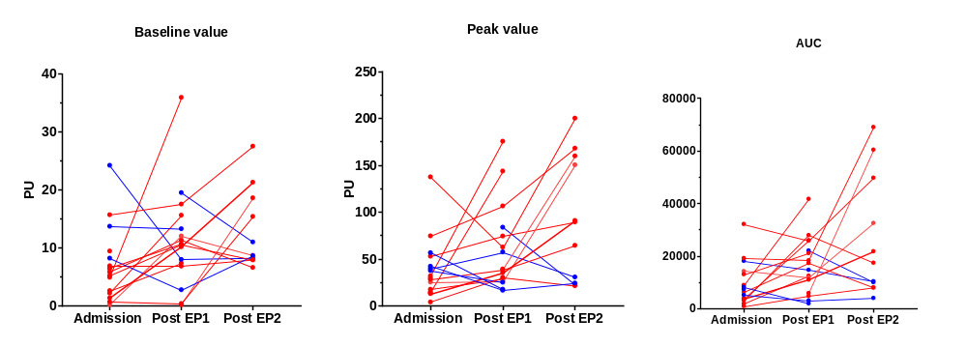
Supplemental figure 3: Individual microvascular endothelium-mediated reactivity at baseline and after PE. Red, microvascular reactivity improvement after PE; blue no improvement. Abbreviations: PE, plasma exchange; AUC, area under curve.

