Supplemental Table S1: Distribution of screened (i.e. adult patients with an acute brain injury requiring external ventricular device placement) and recruited patients, according to participating centers.

 | Screened | Excluded | Reasons for exclusion | Included  N=219 | Intervention  N=115 | Control  N=104
Brussels | 133 | 18 | EVD not draining: 8  Missed: 3  EVD implanted after 24 hours from admission: 7 | 115 | 61 | 54
Cesena | 12 | 8 | EVD not draining: 2 patients  EVD positioned due to chronic hydrocephalus: 4  Missed: 2 | 3 | 1 | 2
Tournai | 14 | 10 | EVD not draining: 1  Absent CSF samples:8  Bacterial Meningitis: 1 | 4 | 2 | 2
Genova | 55 | 31 | No Informed Consent: 31 | 12 | 12 | 0
Monza | 36 | 35 | Missed: 35 | 1 | 1 | 0
Bologna | 32 | 13 | Brain Tumor: 5  No Informed Consent: 5  EVD implanted after 24 hours from admission: 3 | 19 | 2 | 17
Roma I | 60 | 50 | Missed:5  No Informed Consent: 45 | 10 | 5 | 5
Roma II | 183 | 176 | Early removal of EVD: 62  Missed: 43  No Informed Consent: 71 | 7 | 4 | 3
Madrid | 36 | 13 | Imminent Death: 13 | 23 | 13 | 10
Ferrara | 35 | 25 | Chronic Hydrocephalus: 10  Missed: 5  EVD not draining: 5  Absent CSF samples: 5 | 10 | 4 | 6
Charleroi | 23 | 14 | No Informed Consent: 3  EVD installed after 72 hours from admission: 5  Absent CSF samples: 3  Imminent Death: 2  COVID-19: 1 | 9 | 6 | 3
Valencia | 38 | 32 | Less than 18 years of age: 1  EVD inserted after 24 hours frm admission: 31 | 6 | 4 | 2

Supplemental Table S2: Main physiological and cerebrospinal fluid data of the study population at the two time-points. Data are presented as median and interquartile range (IQR) or count (%).

 | Baseline | 2 hours | p-value
Temperature, °C | 36.8 (36.3-37.4) | 36.9 (36.4-37.3) | 0.43
MAP, mmHg | 94 (86-104) | 93 (86-103) | 0.65
ICP, mmHg | 14 (8-22) | 11 (7-15) | 0.001
CPP, mmHg | 79 (70-89) | 83 (74-92) | 0.001
PaCO₂, mmHg | 37 (35-41) | 37 (35-41) | 0.50
Hb, g/dL | 11.6 (10.6-12.9) | 11.4 (10.4-12.6) | 0.001
CSF RBC, 10³/mm³ | 15.2 (2.3-79.2) | 12.0 (2.0-54.0) | 0.03
CSF WBC, /mm³ | 68 (13-220) | 73 (18-250) | 0.88
CSF Proteins, mg/dL | 94 (55-170) | 80 (51-164) | 0.02
CSF Glucose, mg/dL | 79 (67-89) | 80 (69-91) | 0.99
Blood glucose, mg/dL | 142 (126-156) | 138 (122-155) | 0.55
Glucose CSF/blood | 0.57 (0.48-0.66) | 0.59 (0.49-0.66) | 0.16
CSF lactate, mEq/L | 3.5 (2.7-4.9) | 3.3 (2.6-4.5) | 0.14
Blood lactate, mEq/L | 1.1 (0.8-1.5) | 1.0 (0.8-1.2) | 0.001
Lactate CSF/blood | 3.1 (2.1-4.4) | 3.3 (2.4-4.5) | 0.07
CGLR | 1.27 (0.85-1.68) | 1.45 (0.97-1.89) | 0.001
Insulin, n (%) | 66 (30) | 67 (30) | 0.99
Noradrenaline, n (%) | 117 (54) | 116 (53) | 0.99

CGLR: cerebral spinal fluid glucose to lactate ratio; CSF: cerebral spinal fluid; RBC: red blood cells; WBC: white blood cells; MAP: mean arterial pressure; ICP: intracranial pressure; CPP: cerebral perfusion pressure; PaCO₂: arterial partial pressure of carbon dioxide; Hb: hemoglobin.

Supplemental table S3: Main physiological and cerebrospinal fluid data of the control and intervention groups at the two time-points. Data are presented as median and interquartile range (IQR) or count (%).

 | Control group  N= 104 | Intervention group  N=115 | p- value
Baseline
Temperature, °C | 36.8 (36.2-37.4) | 36.8 (36.3-37.4) | 0.43
MAP, mmHg | 92 (85-104) | 96 (89-104) | 0.100
ICP, mmHg | 9 (6-12) | 21 (15-25) | 0.001
CPP, mmHg | 81 (76-93) | 77 (67-86) | 0.001
PaCO₂, mmHg | 38 (36-42) | 37 (35-40) | 0.12
Hb, g/dL | 11.9 (10.8-12.9) | 11.3 (10.4-12.7) | 0.16
CSF RBC, 10³/mm³ | 11.2 (2.0-50.6) | 30.5 (3.1-88.4) | 0.03
CSF WBC, /mm³ | 31 (10-140) | 101 (24-342) | 0.002
CSF Proteins, mg/dL | 72 (50-160) | 98 (63-180) | 0.09
CSF Glucose, mg/dL | 79 (66-92) | 79 (68-89) | 0.56
Blood glucose, mg/dL | 142 (119-154) | 143 (129-157) | 0.08
Glucose CSF/blood | 0.59 (0.51-0.67) | 0.55 (0.46-0.64) | 0.03
CSF lactate, mEq/L | 3.1 (2.6-4.2) | 4.2 (2.9-5.5) | 0.001
Blood lactate, mEq/L | 1.0 (0.8-1.3) | 1.2 (0.9-1.8) | 0.01
Lactate CSF/blood | 3.0 (2.0-4.1) | 3.2 (2.3-4.6) | 0.09
CGLR | 1.47 (1.04-1.83) | 1.04 (0.76-1.41) | 0.001
Insulin, n (%) | 32 (31) | 34 (30) | 0.88
Noradrenaline, n (%) | 41 (39) | 70 (67) | 0.001
2 hours
Temperature, °C | 36.8 (36.3-37.2) | 37.0 (36.5-37.5) | 0.18
MAP, mmHg | 91 (86-104) | 97 (88-103) | 0.12
ICP, mmHg | 8 (6-11) | 14 (9-18) | 0.001
CPP, mmHg | 83 (75-95) | 83 (72-90) | 0.18
PaCO2, mmHg | 38 (35-40) | 37 (35-40) | 0.33
Hb, g/dL | 11.8 (10.5-12.6) | 11.3 (10.2-12.4) | 0.17
CSF RBC, 10³/mm³ | 12.1 (1.8-68.3) | 22.5 (3.6-93.9) | 0.07
CSF WBC, /mm³ | 35 (12-158) | 105 (24-380) | 0.003
CSF Proteins, mg/dL | 76 (46-153) | 85 (57-167) | 0.26
CSF Glucose, mg/dL | 81 (69-92) | 80 (68-90) | 0.72
Blood glucose, mg/dL | 138 (118-152) | 139 (126-164) | 0.09
Glucose CSF/blood | 0.61 (0.48-0.65) | 0.57 (0.49-0.66) | 0.68
CSF lactate, mEq/L | 3.0 (2.4-3.9) | 3.8 (2.8-5.0) | 0.001
Blood lactate, mEq/L | 1.0 (0.8-1.2) | 1.0 (0.8-1.3) | 0.25
Lactate CSF/blood | 3.0 (2.1-4.1) | 3.6 (2.6-5.0) | 0.005
CGLR | 1.62 (1.15-1.98) | 1.34 (0.80-1.83) | 0.005
Insulin, n (%) | 35 (34) | 31 (27) | 0.38
Noradrenaline, n (%) | 40 (39) | 70 (67) | 0.001
CGLR: cerebral spinal fluid glucose to lactate ratio; CSF: cerebral spinal fluid; RBC: red blood cells; WBC: white blood cells; MAP: mean arterial pressure; ICP: intracranial pressure; CPP: cerebral perfusion pressure; PaCO₂: arterial partial pressure of carbon dioxide; Hb: hemoglobin.

Supplemental Table S4: Linear regression model of factors associated with the percentage of change in the cerebral spinal fluid glucose to lactate ratio (ΔCGLR).

 | Univariate β-coefficient (95% CI)  P value | Multivariable β-coefficient (95% CI)  P value
Non traumatic vs. traumatic etiology | 12.98 (-5.83 to 31.80)  p=0.18 | 14.35 (-4.49 to 33.19)  p=0.14
Interventional group vs. controls | 21.66 (9.98 to 33.34)  p=0.001 | 27.47 (11.71 to 43.23)  p=0.001
Glasgow coma scale on admission | -0.16 (-1.55 to 1.23)  p=0.83 | 0.26 (-1.35 to 1.40)  p=0.97
CGLR value on baseline | -3.77 (-12.29 to 4.76)  p=0.39 | 1.03 (-7.69 to 9.75)  p=0.82
ICP value on baseline | 0.41 (-0.24 to 1.06)  p=0.21 | -0.40 (-1.28 to 0.47)  p=0.36

ICP: intracranial pressure. CGLR: cerebral spinal fluid glucose lactate ratio.

Supplemental Table S5: Characteristics of the population according to ICU survival. Data are presented as mean (±SD), median (IQRs) and count (%), as appropriate.

 | Survivors  (N=164) | Non-survivors  (N=55) | P value
Age, years | 56 (±15) | 60 (±11) | 0.03
Male gender, n (%) | 77 (47) | 35 (64) | 0.04
GCS on admission, median (IQR) | 8 (5-13) | 5 (3-10) | 0.001
Etiology, n (%) |  |  | 0.36
Subarachnoid Hemorrhage | 89 (54) | 30 (55)
Intracerebral Hemorrhage | 57 (35) | 16 (29)
Traumatic Brain Injury | 17 (10) | 8 (15)
Others | 1 (1) | 1 (2)
Comorbidities, n (%)
Arterial Hypertension | 86 (55) | 30 (57) | 0.87
Diabetes mellitus | 26 (17) | 7 (13) | 0.67
Heart disease | 21 (14) | 12 (23) | 0.13
COPD | 11 (7) | 6 (11) | 0.38
Liver Cirrhosis | 4 (3) | 4 (8) | 0.12
Chronic Kidney Disease | 6 (4) | 4 (8) | 0.28
Previous neurological disease | 12 (8) | 9 (17) | 0.07
Malignancies | 10 (6) | 6 (11) | 0.24
Immunosuppression | 4 (3) | 2 (4) | 0.99
EVD placement to sample collection, days | 2 (1-3) | 1 (1-3) | 0.79
Baseline variables
ICP, mmHg | 12 (8-18) | 17 (9-24) | 0.007
CPP, mmHg | 84 (74-96) | 82 (72-88) | 0.19
Glucose, mg/dL | 79 (67-90) | 78 (66-89) | 0.56
Lactate, mmol/L | 3.1 (2.6-4.4) | 4.5 (3.5-6.3) | 0.001
CGLR | 1.39 (0.93-1.78) | 0.90 (0.65-1.28) | 0.001
After 2 hours
ICP, mmHg | 10 (7-13) | 12 (7-16) | 0.001
CPP, mmHg | 81 (72-91) | 78 (70-86) | 0.19
Glucose, mg/dL | 80 (69-90) | 81 (69-92) | 0.99
Lactate, mmol/L | 3.0 (2.5-4.4) | 4.0 (3.3-6.0) | 0.001
CGLR | 1.55 (1.03-1.96) | 1.23 (0.69-1.54) | 0.001
Increase in CGLR, n (%) | 101 (62) | 38 (69) | 0.34
Percentage of change in CGLR, median (IQR) | 6.46 (-5.55 to 32.43) | 9.96 (-5.19 to 43.68) | 0.34
ICU length of stay, days | 19 (13-30) | 14 (10-19) | 0.001

GCS: Glasgow coma scale; GOS: Glasgow outcome scale; CGLR: cerebral spinal fluid glucose to lactate ratio; CSF: cerebral spinal fluid; RBC: red blood cells; WBC: white blood cells; MAP: mean arterial pressure; ICP: intracranial pressure; CPP: cerebral perfusion pressure; PaCO₂: arterial partial pressure of carbon dioxide; Hb: hemoglobin; ICU: intensive care unit; EVD: external ventricular drain; COPD: chronic obstructive pulmonary disease.

Supplemental Table S6: Characteristics of the population according to the neurological outcome at 3 months. Data are presented as mean (±SD), median (IQRs) and count (%), as appropriate.

 | Favorable outcome  (N=98) | Unfavorable outcome  (N=111) | P value
Age, years | 55 (±15) | 59 (±13) | 0.07
Male gender, n (%) | 50 (47) | 62 (55) | 0.28
GCS on admission | 9 (7-14) | 6 (3-11) | 0.001
Etiology, n (%) |  |  | 0.45
Subarachnoid Hemorrhage | 60 (57) | 59 (52)
Intracerebral Hemorrhage | 32 (30) | 41 (36)
Traumatic Brain Injury | 13 (12) | 12 (11)
Others | 1 (1) | 1 (1)
Comorbidities, n (%)
Arterial Hypertension | 58 (59) | 58 (52) | 0.33
Diabetes mellitus | 17 (17) | 716(14) | 0.58
Heart disease | 11 (11) | 22 (20) | 0.13
COPD | 5 (5) | 12 (11) | 0.20
Liver Cirrhosis | 0 | 8 (7) | 0.008
Chronic Kidney Disease | 1 (1) | 9 (8) | 0.02
Previous neurological disease | 9 (9) | 12 (11) | 0.82
Malignancies | 10 (6) | 6 (11) | 0.24
Immunosuppression | 3 (3) | 4 (4) | 0.99
EVD placement to sample collection, days | 2 (1-2) | 1 (1-3) | 0.99
Baseline variables
ICP, mmHg | 13 (8-20) | 17 (12-24) | 0.02
CPP, mmHg | 80 (70-90) | 77 (72-86) | 0.11
Glucose, mg/dL | 79 (67-89) | 80 (66-91) | 0.58
Lactate, mmol/L | 3.0 (2.5-4.2) | 4.1 (3.1-5.5) | 0.001
CGLR | 1.41 (0.99-1.92) | 1.05 (0.77-1.51) | 0.001
After 2 hours
ICP, mmHg | 10 (7-14) | 14 (9-18) | 0.03
CPP, mmHg | 83 (74-94) | 80 (72-89) | 0.05
Glucose, mg/dL | 81 (69-89) | 80 (68-92) | 0.88
Lactate, mmol/L | 2.9 (2.2-3.9) | 3.8 (2.9-5.0) | 0.001
CGLR | 1.6 (1.01-1.99) | 1.36 (0.82-1.86) | 0.04
Increase in CGLR, n (%) | 62 (59) | 77 (68) | 0.16
Percentage of change in CGLR, median (IQR) | 7.26 (-5.25 to 34.84) | 9.80 (-4.72 to 44.0) | 0.33
ICU length of stay, days | 18 (12-25) | 18 (12-26) | 0.94

GCS: Glasgow coma scale; GOS: Glasgow outcome scale; CGLR: cerebral spinal fluid glucose to lactate ratio; CSF: cerebral spinal fluid; RBC: red blood cells; WBC: white blood cells; MAP: mean arterial pressure; ICP: intracranial pressure; CPP: cerebral perfusion pressure; PaCO₂: arterial partial pressure of carbon dioxide; Hb: hemoglobin; ICU: intensive care unit; EVD: external ventricular drain; COPD: chronic obstructive pulmonary disease.

Supplemental Table S7: Logistic regression of baseline factors associated with ICU mortality. Data are presented as odds ratio (OR) and 95% confidence interval (CI).

 | Univariable OR (95% CI) | Multivariable OR (95% CI)
Age | 1.02 (1.0-1.04) | 1.03 (1.01- 1.06)
Glasgow coma scale on admission | 0.86 (0.80-0.93) | 0.86 (0.78-0.94)
Previous neurological disease | 2.46 (0.97- 6.21) | 1.55 (0.56-2.31)
Traumatic Brain Injury | 1.47 (0.60 - 3.63) | 2.28 (0.78-6.68)
Baseline ICP | 1.05 (1.01-1.08) | 1.03 (0.99-1.07)
Baseline CGLR | 0.28 (0.15-0.52) | 0.34 (0.18 -0.65)
ICP: intracranial pressure; CGLR: cerebral spinal fluid glucose to lactate ratio.

Supplemental Table S8: Logistic regression of baseline factors associated with unfavorable neurological outcome at 3 months. Data are presented as odds ratio (OR) and 95% confidence interval (CI).

 | Univariable OR (95% CI) | Multivariable OR (95% CI)
Age | 1.02 (1.0-1.04) | 1.03 (1.01- 1.05)
Glasgow coma scale on admission | 0.86 (0.80-0.93) | 0.85 (0.79-0.91)
Traumatic Brain Injury | 0.85 (0.37-1.96) | 1.04 (0.39 – 2.75)
Chronic kidney failure | 8.56 (1.06-68.83) | 9.38 (1.05-84.08)
ICP | 1.04 (1.01-1.07) | 1.03 (0.99-1.06)
CGLR | 0.28 (0.15-0.52) | 0.47 (0.29 -0.75)

ICP: intracranial pressure; CGLR: cerebral spinal fluid glucose to lactate ratio.

Supplemental Figure S1: Receiver operator curve (ROC) of baseline cerebral spinal fluid glucose to lactate ratio (CGLR) to predict hospital mortality. Area under the ROC: 0.73 (95% CI 0.623-0.782).

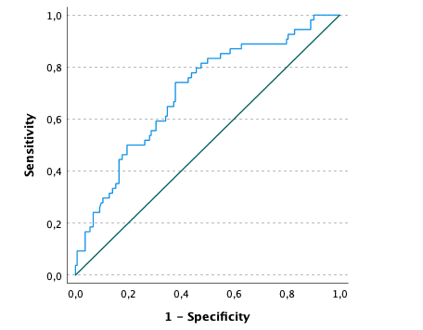

Supplemental Figure S2: Receiver operator curve (ROC) of baseline cerebral spinal fluid glucose to lactate ratio (CGLR) ability to predict poor outcome at 3 months. Area under the ROC: 0.66 (0.59-0.74).

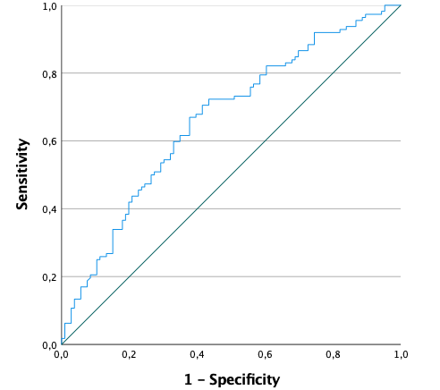

Supplemental Figure S3: Changes over time of CGLR between study groups in traumatic brain injury patients (n=25)

P values represent the comparison of trend over time in the two groups (time-group interaction) and were calculated using a mixed model.
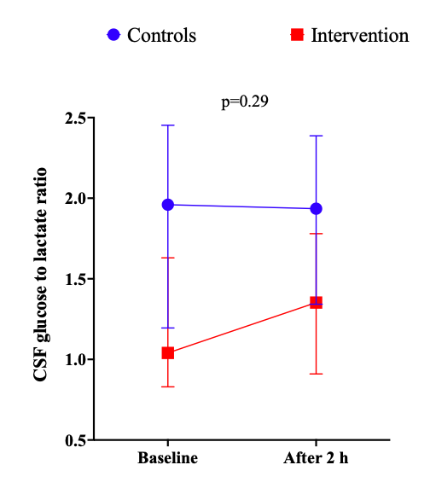

Supplemental Figure S4: Changes over time of CGLR between study groups in intracerebral hemorrhage patients (n=73)

P values represent the comparison of trend over time in the two groups (time-group interaction) and were calculated using a mixed model.
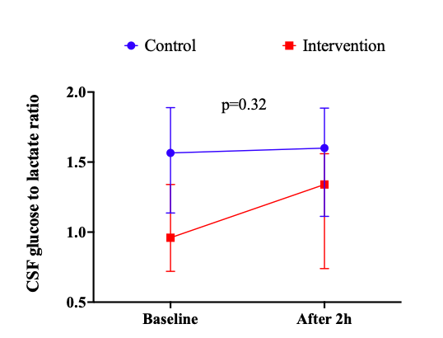
Supplemental Figure S5: Changes over time of CGLR between study groups in subarachnoid hemorrhage patients (n=119).

P values represent the comparison of trend over time in the two groups (time-group interaction) and were calculated using a mixed model.
