SUPPLEMENTAL TABLES AND FIGURES:
Figure S1: CONSORT Flow Diagram.

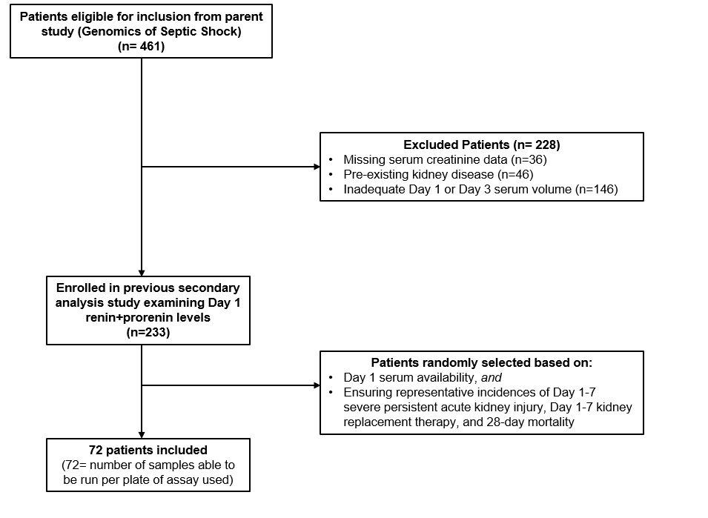

Table S1: Patient outcomes by ACE activity and ACE concentration-derived phenotypes.

Variable | (-) ACE Activity  ACE > Median | (-) ACE Activity  ACE < Median | (+) ACE Activity  ACE > Median | (+) ACE Activity  ACE < Median | p-value
N (% cohort) | 24 (33.3) | 26 (36.1) | 12 (16.7) | 10 (13.9) | --
Day 1-7 Severe Persistent AKI, n (%) | 13 (54.2) | 4 (15.4) | 3 (25) | 0 (0) | 0.003
Day 1-7 KRT, n (%) | 8 (33.3) | 2 (7.7) | 2 (16.7) | 0 (0) | 0.04
28 Day Mortality, n (%) | 9 (37.5) | 7 (26.9) | 3 (25) | 0 (0) | 0.16
Composite Outcome | 14 (58.3) | 9 (34.6) | 4 (33.3) | 0 (0) | 0.014
28 Day ICU Free Days | 6.5 (0-21) | 17.5 (0-24) | 21.5 (0.25-25) | 15 (3.75-25) | 0.40
Note: ACE Median= 104 ng/ml

