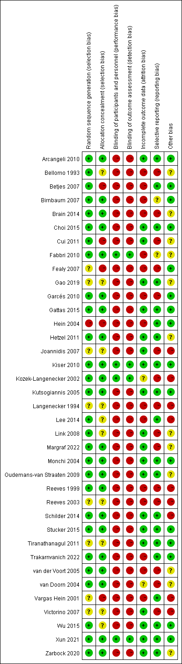
Figure 1. Potential risk of bias of each included randomized controlled trials.
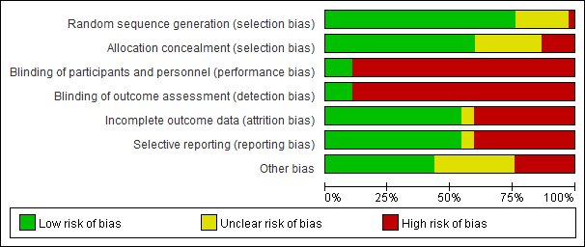
Figure 2. Summarized risk of the included randomized controlled trials.

