Supplementary information for:

Targeted therapy using Polymyxin B hemadsorption in patients with sepsis:
A post-hoc analysis of the JSEPTIC-DIC study and the EUPHRATES trial

Itsuki Osawa, MD ¹
Tadahiro Goto, MD, MPH, PhD ^{2,3}
Daisuke Kudo, MD, PhD ⁴
Mineji Hayakawa, MD, PhD ⁵
Kazuma Yamakawa, MD, PhD ⁶
Shigeki Kushimoto, MD, PhD ⁴
Debra M Foster ⁷
John A Kellum, MD, MCCM ^{7,8}
Kent Doi, MD, PhD ¹

Affiliations:
- Department of Emergency and Critical Care Medicine, The University of Tokyo Hospital, Tokyo, Japan.
- Department of Clinical Epidemiology and Health Economics, School of Public Health, The University of Tokyo, Tokyo, Japan.
- TXP Medical Co. Ltd., Tokyo, Japan.
- Division of Emergency and Critical Care Medicine, Tohoku University Graduate School of Medicine, Miyagi, Japan.
- Department of Emergency Medicine, Hokkaido University Hospital, Hokkaido, Japan.
- Department of Emergency and Critical Care Medicine, Osaka Medical and Pharmaceutical University, Osaka, Japan.
- Spectral Medical, Toronto, Ontario, Canada.
- Center for Critical Care Nephrology, Department of Critical Care Medicine, University of Pittsburgh, PA, USA.

Supplementary information content

Supplemental Table 1. The rate of missingness of covariates in the derivation (the JSEPTIC-DIC study) cohort 3
Supplemental Table 2. Baseline characteristics of patients in the derivation (the JSEPTIC-DIC study) cohort 4
Supplemental Table 3. Baseline characteristics of patients in the validation (the EUPHRATES trial) cohort 5
Supplemental Table 4. Patient characteristics of PMX-HA targeted patients in the derivation (the JSEPTIC-DIC study) cohort 6
Supplemental Table 5. Patient characteristics of PMX-HA targeted patients in the validation (the EUPHRATES trial) cohort 7
Supplemental Figure 1. Analytic workflow of our analyses 8
Supplemental Figure 2. Predicted treatment effects of PMX-HA on 28-day survival across the levels of four candidate determinants of treatment effects 9
Supplemental Figure 3. Identification of the potential PMX-HA indication using the policytree algorithm 10

Supplemental Table 1. The rate of missingness of covariates in the derivation (the JSEPTIC-DIC study) cohort

Characteristic | Derivation cohort  (n = 1,911)
 | Missing, n (%)
Patient demographics
Age | 0 (0)
Female sex | 0 (0)
Patient severity
APACHE II score | 1 (0.0)
SOFA score | 2 (0.0)
Respiratory | 2 (0.0)
Coagulation | 0 (0)
Liver | 0 (0)
Cardiovascular | 0 (0)
Central nervous system | 0 (0)
Renal | 0 (0)
Laboratory tests
White blood cells | 7 (0.4)
Platelet | 7 (0.4)
PT-INR | 116 (6)
Fibrinogen | 419 (22)
FDP | 577 (30)
Lactate | 285 (15)

Abbreviations: APACHE II score = Acute Physiology and Chronic Health Enquiry II score, SOFA score = Sequential Organ Failure Assessment score, PT-INR = Prothrombin Time and International Normalized Ratio, FDP = Fibrin Degradation Products

Supplemental Table 2. Baseline characteristics of patients in the derivation (the JSEPTIC-DIC study) cohort

Characteristics | PMX-HA use  (n = 350) | Control  (n = 1,561)
Patient demographics
Age | 72 (62 - 80) | 74 (63 - 82)
Female sex, n (%) | 164 (47%) | 653 (42%)
Infection site, n (%)
Lung | 28 (8%) | 461 (30%)
Abdominal | 238 (68%) | 404 (26%)
Others | 84 (24%) | 696 (44%)
Blood culture positive, n (%) | 255 (73%) | 1,175 (75%)
Patient severity
APACHE II score | 21 (16 - 27) | 21 (16 - 27)
SOFA score | 9 (7 - 12) | 8 (6 - 11)
Respiratory | 2 (1 - 3) | 2 (1 - 3)
Coagulation | 1 (0 - 2) | 1 (0 - 2)
Liver | 0 (0 - 1) | 0 (0 - 1)
Cardiovascular | 3 (2 - 4) | 2 (0 - 3)
Central nervous system | 1 (0 - 2) | 1 (0 - 3)
Renal | 1 (0 - 2) | 1 (0 - 2)
Laboratory tests
White blood cells [x10³/μL] | 6 (2 - 16) | 12 (6 - 18)
Platelet [x10⁴/μL] | 12 (7 – 18) | 14 (8 - 22)
PT-INR | 1.47 (1.26 - 1.72) | 1.29 (1.15 - 1.49)
Fibrinogen [mg/dL] | 346 (214 - 469) | 430 (324 - 541)
FDP [μg/mL] | 23 (12 - 42) | 22 (13 - 37)
Lactate [mmol/L] | 3.9 (2.4 - 6.4) | 2.8 (1.8 – 5.0)
Concomitant treatments
Antithrombin III use | 167 (48%) | 400 (26%)
rhTM use | 113 (32%) | 341 (22%)
Heparin use | 29 (8.3%) | 170 (11%)
Outcome
28-day mortality, n (%) | 53 (15%) | 286 (18%)

Values represent median (IQR), unless otherwise indicated.
Abbreviations: PMX-HA = Polymyxin B Hemadsorption, APACHE II score = Acute Physiology and Chronic Health Enquiry II score, SOFA score = Sequential Organ Failure Assessment score, PT-INR = Prothrombin Time and International Normalized Ratio, FDP = Fibrinogen/Fibrin Degradation Products, rhTM = recombinant human soluble thrombomodulin

Supplemental Table 3. Baseline characteristics of patients in the validation (the EUPHRATES trial) cohort

Characteristic | PMX-HA use  (n = 132) | Control  (n = 154)
Patient demographics
Age | 62 (52 - 70) | 58 (48 - 69)
Female sex, n (%) | 54 (41%) | 61 (40%)
Infection site, n (%)
Lung | 39 (30%) | 62 (40%)
Abdominal | 35 (27%) | 38 (25%)
Others | 58 (44%) | 54 (35%)
Blood culture positive, n (%) | 47 (36%) | 43 (28%)
Patient severity
APACHE II score | 30 (25 - 34) | 29 (23 - 34)
SOFA score | 12 (10 - 14) | 12 (11 - 14)
MODS | 10 (8 – 12) | 10 (8 – 12)
EAA | 0.79 (0.69 – 0.87) | 0.75 (0.66 – 0.85)
Kidney status
AKIN stage

Stage 0 | 35 (27%) | 44 (29%)
Stage 1 | 22 (17%) | 20 (13%)
Stage 2  S | 17 (13%) | 20 (13%)
Stage 3 | 58 (44%) | 70 (45%)
RRT at randomization | 23 (17%) | 39 (25%)
Laboratory tests
White blood cells [x10³/μL] | 14 (8 - 24) | 14 (7 - 21)
Platelet [x10⁴/μL] | 12 (7 – 19) | 12 (8 - 21)
PT-INR | 1.50 (1.31 - 1.79) | 1.47 (1.22 - 1.75)
Lactate [mmol/L] | 2.9 (1.7 – 5.0) | 2.8 (1.6 – 5.3)
Outcome

Renal replacement therapy over 28 days | 68 (52%) | 78 (51%)
28-day mortality, n (%) | 40 (30%) | 58 (38%)

Values represent median (IQR), unless otherwise indicated.
Abbreviations: PMX-HA = Polymyxin B Hemadsorption, APACHE II score = Acute Physiology and Chronic Health Enquiry II score, SOFA score = Sequential Organ Failure Assessment score, MODS = Multiple Organ Dysfunction Score, EAA = Endotoxin Activity Assay, AKIN stage = Acute Kidney Injury Network stage, PT-INR = Prothrombin Time and International Normalized Ratio, FDP = Fibrinogen/Fibrin Degradation Products

Supplemental Table 4. Patient characteristics of PMX-HA targeted patients in the derivation (the JSEPTIC-DIC study) cohort

Characteristic | Targeted population  (n = 1,203) | Non-targeted population  (n = 708)
Patient demographics
Age | 74 (63 - 82) | 72 (62 - 80)
Female sex, n (%) | 519 (43%) | 298 (58%)
Infection site, n (%)
Lung | 275 (23%) | 214 (30%)
Abdominal | 464 (39%) | 178 (25%)
Others | 464 (39%) | 316 (45%)
Blood culture positive, n (%) | 911 (76%) | 519 (73%)
Patient severity
APACHE II score | 23 (17 - 28) | 18 (14 - 23)
SOFA score | 9 (7 - 12) | 7 (4 - 9)
Respiratory | 2 (1 - 3) | 2 (1 - 3)
Coagulation | 1 (0 - 2) | 0 (0 - 2)
Liver | 0 (0 - 1) | 0 (0 - 1)
Cardiovascular | 3 (1 - 4) | 1 (0 - 3)
Central nervous system | 1 (1 - 3) | 1 (0 - 2)
Renal | 1 (0 - 2) | 0 (0 - 1)
Laboratory tests
White blood cells [x10³/μL] | 11 (3 - 18) | 12 (7 - 19)
Platelet [x10⁴/μL] | 13 (7 – 19) | 15 (9 - 24)
PT-INR | 1.46 (1.25 - 1.70) | 1.20 (1.10 - 1.29)
Fibrinogen [mg/dL] | 378 (262 - 485) | 481 (393 - 589)
FDP [μg/mL] | 26 (13 - 47) | 20 (12 - 28)
Lactate [mmol/L] | 4.4 (3.2 - 6.8) | 1.8 (1.2 – 2.3)
Outcome
28-day mortality, n (%) | 275 (23%) | 64 (9%)

Values represent median (IQR), unless otherwise indicated.
Abbreviations: PMX-HA = Polymyxin B Hemadsorption, APACHE II score = Acute Physiology and Chronic Health Enquiry II score, SOFA score = Sequential Organ Failure Assessment score, PT-INR = Prothrombin Time and International Normalized Ratio, FDP = Fibrinogen/Fibrin Degradation Products

Supplemental Table 5. Patient characteristics of PMX-HA targeted patients in the validation (the EUPHRATES trial) cohort

Characteristic | Targeted population  (n = 214) | Not-targeted population  (n = 72)
Patient demographics
Age | 61 (49 - 71) | 58 (51 - 66)
Female sex, n (%) | 85 (40%) | 30 (42%)
Infection site, n (%)
Lung | 75 (35%) | 26 (36%)
Abdominal | 13 (18%) | 13 (18%)
Others | 126 (59%) | 33 (46%)
Blood culture positive, n (%) | 75 (35%) | 15 (21%)
Patient severity
APACHE II score | 30 (25 - 35) | 27 (20 - 32)
SOFA score | 13 (11 - 14) | 12 (10 - 13)
MODS | 10 (9 – 13) | 10 (7 – 11)
EAA | 0.78 (0.67 – 0.87) | 0.74 (0.65 – 0.83)
EAA of 0.6-0.9, n (%) | 177 (83%) | 63 (88%)
EAA of >0.9, n (%) | 37 (17%) | 9 (12%)
Kidney status
AKIN stage

Stage 0 | 27 (38%) | 52 (24%)
Stage 1 | 8 (11%) | 34 (16%)
Stage 2  S | 12 (17%) | 25 (12%)
Stage 3 | 25 (35%) | 103 (48%)
RRT at randomization | 8 (11%) | 54 (25%)
Laboratory tests
White blood cells [x10³/μL] | 14 (7 - 23) | 13 (8 - 18)
Platelet [x10⁴/μL] | 14 (10 – 22) | 11 (6 - 19)
PT-INR | 1.59 (1.44 - 1.89) | 1.17 (1.04 - 1.28)
Lactate [mmol/L] | 3.8 (2.3 – 6.4) | 1.4 (1.1 – 2.1)
Outcome

Renal replacement therapy over 28 days | 120 (56%) | 26 (36%)
28-day mortality, n (%) | 86 (40%) | 12 (17%)

Values represent median (IQR), unless otherwise indicated.
Abbreviations: PMX-HA = Polymyxin B Hemadsorption, APACHE II score = Acute Physiology and Chronic Health Enquiry II score, SOFA score = Sequential Organ Failure Assessment score, MODS = Multiple Organ Dysfunction Score, EAA = Endotoxin Activity Assay, AKIN stage = Acute Kidney Injury Network stage, PT-INR = Prothrombin Time and International Normalized Ratio, FDP = Fibrinogen/Fibrin Degradation Products

Supplemental Figure 1. Analytic workflow of our analyses

Abbreviations: PMX-HA = Polymyxin B Hemadsorption

Supplemental Figure 2. Predicted treatment effects of PMX-HA on 28-day survival across the levels of four candidate determinants of treatment effects

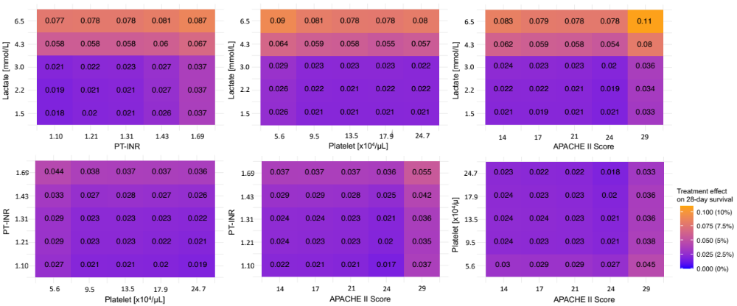

The heatmaps indicate the predicted therapeutic effect of PMX-HA on 28-day survival while changing the levels of APACHE II score, platelet, PT-INR, and lactate based on the developed causal forest model. The closer the color is to orange, the more effective PMX-HA is; the closer the color is to blue, the less effective PMX-HA is.

Abbreviations: PMX-HA = Polymyxin B Hemadsorption, APACHE II score = Acute Physiology and Chronic Health Enquiry II score, PT-INR = Prothrombin Time and International Normalized Ratio

Supplemental Figure 3. Identification of the potential PMX-HA indication using the policytree algorithm
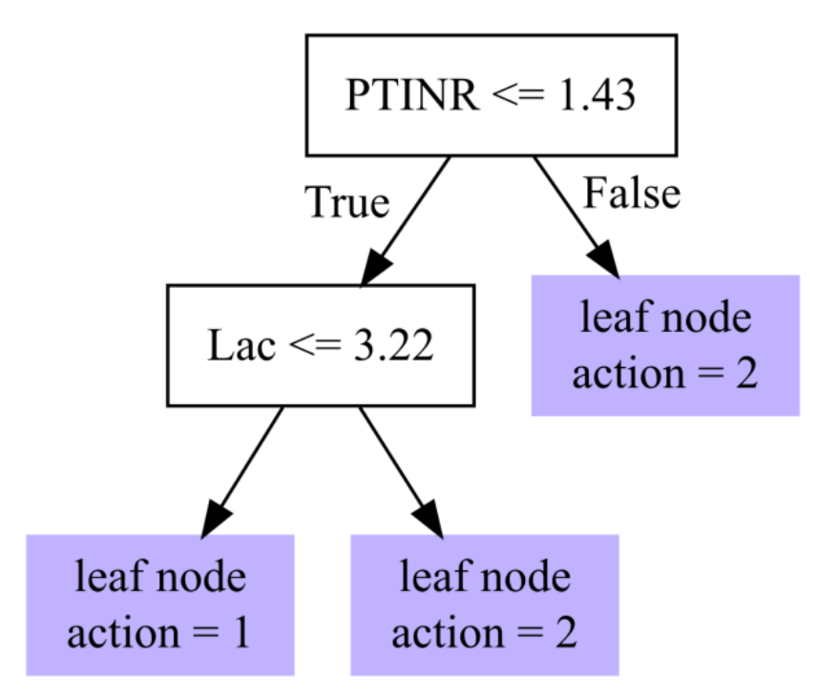

Applying the policytree algorithm to the derivation cohort, we attempted to determine the potential indication of PMX-HA using the candidate determinants of treatment effects (i.e., APACHE II score, platelet count, PT-INR, and lactate). We show a tree indicating optimal targets of PMX-HA. “Leaf node action = 1” refers to patients for whom PMX-HA is not recommended, and “leaf node action = 2” refers to patients for whom PMX-HA is recommended. The policytree algorithm showed that identifying the optimal target of PMX-HA using a combination of PT-INR and lactate could be useful. We identified patients with PT-INR > 1.43 or (PT-INR ≤ 1.43 and lactate > 3.22 mmol/L) as a potential target of PMX-HA. For simplicity, we defined the optimal target as patients with PT-INR > 1.4 or lactate > 3 mmol/L.

Abbreviations: PMX-HA = Polymyxin B Hemadsorption, PT-INR = Prothrombin Time and International Normalized Ratio, Lac = Lactate

