SUPPLEMENTARY MATERIALS

1. Methodology
2. Supplementary tables and figures

1. Methodology
Laboratory analysis
1) Metabolites related to energy metabolism, amino acids, ceramide, sphingomyelin, plasmalogen, phosphatidylcholine, and phosphatidylethanolamine
Materials
Metabolite standards and internal standards were purchased from Sigma–Aldrich (St Louis, MO, USA) and Avanti Polar Lipids (Alabaster, AL, USA). All solvents, including water, were purchased from J. T. Baker Chemicals (Mumbai, India). For amino acids, the internal standards and derivatization reagents were purchased from Sigma–Aldrich or CDN Isotopes Inc. (Pointe-Claire, QC, Canada).
Sample Preparation
To 50 μL of human serum, we added 50 μL of internal standard solutions (10 μM ¹³C₅-glutamine, 0.4 μM serotonine-d₄, 0.6 μM dopamine-d₄, and 2 μM tryptophan-d₅ for energy metabolism- and amino acid-related analyses; 50 nM C17 ceramide for ceramide-related analysis; 200 nM 18:0 D70 phosphatidylinositol (PC) and 1 μM 16:0 D31-18:1 phosphatidylethanolamine (PE) for plasmalogen and PC/PE profiling) were added. Metabolites were extracted from aqueous and organic phases by liquid–liquid extraction. Sample solutions were prepared by using commonly used liquid-liquid extaction procedure known as Bligh/Dyer mthod with minor modifications (Can.J.Biochem.Physiol. 37:911-917). Briefly, 400 μL of chloroform/methanol (1/2, v/v) was added to each sample solution and mixed well. The solution was centrifuged for 15 min at 14000 rpm. After centrifugation, a thick precipitate containing macromolecules was found between the aqueous upper layer and the organic lower layer. Nonpolar metabolites containing lipids were contained in the lower organic phase, and polar metabolites were contained in the upper aqueous phase. We carefully withdrew ~90% of each phase, making sure to avoid interface. The collected volume from each layer were generally the same, however sometimes any specific sample had thicker interface between organic and aqueous layer, which resulted in little variation of the recovered volumes. However, internal standards added prior to sample preparation should correct this variation.The aqueous and organic phases were dried under vacuum and stored at -20℃ until further analysis. The dried matter from the aqueous phase was reconstituted with 50 μL of H₂O/MeOH (50/50 v/v) and the dried matter from organic phase was reconstituted with MeOH, prior to liquid chromatography–tandem mass spectrometry (LC-MS/MS) analysis. For amino acids, 10 μL out of the total 50 μL reconstituted aqueous phase was used for chemical derivatization of amino acids using phenylisothiocyanate. The remaining 40 μL reconstituted aqueous phase was used to measure metabolites of energy metabolism. After the reaction, the derivatized amino acids were extracted with 100 μL of 5 mM ammonium acetate in MeOH and were then subjected to LC-MS/MS analysis.
Liquid Chromatography–Tandem Mass Spectrometry
Metabolites were analyzed with an LC-MS/MS device equipped with a 1290 high-performance liquid chromatography device (HPLC; Agilent Technologies, Santa Clara, CA, USA), Qtrap 5500 (ABSciex, Framingham, MA, USA), and an LC column. For each type of analysis, 3 μL of each sample solution was injected into the LC-MS/MS system and ionized with a turbo spray ionization source.
For metabolites related to energy metabolism, a Synergi fusion-RP (50 × 2 mm; Phenomenex, Torrance, CA, USA) HPLC column was used. As mobile phases A and B, 5 mM ammonium acetate in H₂O and 5 mM ammonium acetate in MeOH were used, respectively. The separation gradient was as follows: hold at 0% B for 5 min, 0% to 90% B for 2 min, hold at 90% for 8 min, 90% to 0% B for 1 min, then hold at 0% B for 9 min. The LC flow rate was 70 μL/min except for 140 μL/min during minutes 7–15, and the column temperature was kept at 23°C. Multiple reaction monitoring (MRM) was used in negative ion mode.
For amino acid-related analyses, a Zorbax Eclipse XDB-C18 (100 × 2mm; Agilent Technologies) column was used. As mobile phases A and B, 0.2% formic acid in H₂O and 0.2% formic acid in acetonitrile were used, respectively. The separation gradient was as follows: hold at 0% B for 0.5 min, 0–95% B for 5 min, 95% B for 1 min, and 95–0% B for 0.5 min, then hold at 0% B for 2.5 min. The LC flow rate was 500 μL/min, and the column temperature was kept at 50°C. MRM was used in positive ion mode.
For ceramide and sphingomyelin, a Pursuit5 C18 (150 × 2.1 mm; Agilent Technologies) was used with mobile phase A (5 mM ammonium formate/MeOH/tetrahydrofuran, 500/200/300) and mobile phase B (5 mM ammonium formate/MeOH/ tetrahydrofuran, 100/200/700). The LC rate was 200 µL/min, and the column temperature was kept at 35°C. The LC gradient was as follows: 50% A for 0 min, 50% A for 5 min, 50–30% A for 3 min, 30% A for 7 min, 30–10% A for 7 min, 10% A for 3 min, 10–50% A for 0.1 min, and 50% A for 4.9 min. MRM was used in positive ion mode.
For plasmalogen, a Zorbax Eclipse C18 (50 × 2.1 mm) was used with mobile phase A (10 mM ammonium acetate in MeOH/isopropanol/H2O, 900/50/50) and mobile phase B (10 mM ammonium acetate in MeOH/isopropanol/H2O, 940/50/10). The LC run was performed with the isocratic condition of 60% B at 400 µl/min for 20 min. MRM was used in positive ion mode.
For PC and PE profiling, flow injection analysis–tandem mass spectrometry (FIA-MS/MS) was performed. The same mobile phases as in the ceramide analysis were used to profile PC (precursor ion scan of 184) and PE (neutral loss scan of 141) with the isocratic condition of 50% B at 70 µl/min for 3 min. Extracted ion chromatograms were reconstructed with masses corresponding to each PC or PE species and were used for quantitation.
Data analysis was performed using Analyst 1.5.2 software (Sciex). Extracted ion chromatograms (EIC) corresponding to each metabolite were used for quantitation. The area under the curve of each EIC was normalized to that of the internal standard. For metabolites related to energy metabolism and PC/PE profiling, the peak area ratio of each metabolite to that of the internal standard was used for a relative comparison. For amino acid-related analyses, the calibration curves ranged from 1 nM to 600 μM, with R² > 0.98. For ceramide- and plasmalogen-related analyses, the calibration range was generally 0.1 nM to 10 μM, with R² > 0.99.
2) Sphingosine-1-phosphate
Sample preparation
50 μL of human serum were mixed well with 50 μl internal standard solution (1 μM C17 sphingosine-1-phosphate [S1P] solution) before extraction. Then, 75 μL of chloroform, 50 μL of MeOH, 12.5 μL of H₂O, and 2.5 μL of 10 N NaOH were added to each sample and mixed well. After centrifugation, the upper alkaline phase was collected. Next, 100 μL of chloroform and 5 μL of 10 N HCl were added to the alkaline phase and the samples were mixed well. After phase separation by centrifugation, the lower organic phase was collected. The organic solutions containing S1P were dried under vacuum and stored at -20°C until LC-MS/MS analysis. The dried matter was reconstituted with MeOH and injected into the LC-MS/MS system. The lipid standards were purchased from Avanti Polar Lipids.
Liquid chromatography-tandem mass spectrometry
Lipid levels were determined using an LC-MS/MS system equipped with an Ultimate3000 HPLC (Dionex, Bayern, Germany) and OrbitrapXL (ABSciex, Toronto, ON, Canada). A reverse-phase column (Jupiter 5-µm C4, 50 × 1.0 mm) was used with mobile phase A (0.1% formic acid in H₂O) and mobile phase B (0.1% formic acid in MeOH). The LC was run at 300 µL/min and 35°C. The LC gradient was as follows: 10% B for 0 min, 10–90% B for 5 min, 90% B for 10 min, 90–10% B for 0.1 min, and 10% B for 4.9 min. Extracted ion chromatograms corresponding to the specific transition (phosphate/S1P) was used for quantification in the negative ion mode. Data analysis was performed using Xcaliber 2.2 software (ThermoFisher Scientific; Waltham, MA, USA).
3) Free fatty acids
Sample preparation
We mixed 50 μL of human serum with 200 μL of cold MeOH and 50 μL of internal standard solution (0.1 mg/mL myristic acid-d₁₄). Glass vials were used for preparing sample preparation. Sample solutions were acidified with HCl to a 25 mM final concentration and centrifuged. Supernatants were collected into fresh tubes, and 4 mL of iso-octane were added. The upper phase was collected after the liquid–liquid extraction process and then dried under vacuum. The dried sample was reacted with 200 μL of BCl₃-MeOH and 12% w/w (Sigma–Aldrich) at 60°C for 30 min. Next, 100 μL of H₂O and 100 μL of hexane were added sequentially, and the sample was mixed vigorously. The upper phase was collected after resting the sample for 5 min. Then, 10–20 mg of anhydrous sodium sulfate were added, at which point the supernatant was ready for gas chromatography–mass spectrometry (GC-MS) analysis. Commercially available fatty acid methyl esters (Sigma–Aldrich) were used to generate calibration curves without derivatization.
Gas chromatography-mass spectrometry
Fatty acid methyl esters were analyzed with a GC-MS system (Agilent 7890A/5975C) using a capillary column (HP-5MS, 30 m × 0.25 mm × 0.2 µm). Electron impact (EI) ionization was used in positive ion mode. A 1-μL injection volume and split mode (ratio 10:1) were used. The total analysis time was 73.7 min, and the temperature gradient was as follows: hold at 50°C for 2 min, 50–120°C at 10°C/min, 120–250°C at 3°C/min, hold at 250°C for 15 min, 250–300°C at 35°C/min, hold at 300°C for 5 min. Extracted ion chromatograms, according to the specific fragment ion for each fatty acid, were used for quantification. Data analysis was performed using MSD Chemstation software (Agilent E02.02.1431).

2. Supplementary tables and figures
Supplementary Table 1. Metabolites that differed significantly between the sepsis-induced ARDS patients and non-ARDS control.
Metabolites | t.stat | p-value | -log10(p) | FDR
C18(Plasm)LPE | 13.839 | 3.71E-23 | 22.43 | 6.50E-21
PC 33:6 | -12.407 | 1.64E-20 | 19.784 | 1.44E-18
C18(Plasm)20:4 PE | 12.014 | 9.12E-20 | 19.04 | 5.32E-18
PC 32:0 | -11.624 | 5.08E-19 | 18.294 | 2.22E-17
C18(Plasm)22:6 PE | 10.123 | 4.26E-16 | 15.37 | 1.49E-14
Docosahexaenoic acid | 9.9877 | 7.89E-16 | 15.103 | 2.30E-14
24:0 SM | 9.7879 | 1.96E-15 | 14.707 | 4.90E-14
PC 34:0 | -9.6372 | 3.90E-15 | 14.409 | 8.53E-14
C18(Plasm) LPC | 9.2789 | 2.01E-14 | 13.698 | 3.79E-13
PC 31:0 | -9.2624 | 2.16E-14 | 13.665 | 3.79E-13
Arachidonic acid | 8.9602 | 8.64E-14 | 13.064 | 1.37E-12
C18(Plasm) 22:6 PC | 8.9164 | 1.06E-13 | 12.977 | 1.54E-12
LysoPC 18:0 | 8.5556 | 5.51E-13 | 12.259 | 6.94E-12
PC 34:1 | -8.554 | 5.55E-13 | 12.255 | 6.94E-12
LysoPC 19:6 | 8.5152 | 6.63E-13 | 12.178 | 7.74E-12
S1P | 8.2634 | 2.10E-12 | 11.678 | 2.30E-11
PC 33:1 | -8.0648 | 5.20E-12 | 11.284 | 5.35E-11
PC 33:0 | -7.929 | 9.66E-12 | 11.015 | 9.39E-11
Tryptophan | 7.8827 | 1.19E-11 | 10.924 | 1.10E-10
C24 Ceramide | 7.8608 | 1.32E-11 | 10.88 | 1.15E-10
Kynurenine | -7.8265 | 1.54E-11 | 10.813 | 1.28E-10
C18(Plasm)18:1 PE | 7.8019 | 1.72E-11 | 10.764 | 1.37E-10
PC 32:1 | -7.7484 | 2.20E-11 | 10.658 | 1.67E-10
PC 32:6 | -7.7243 | 2.45E-11 | 10.611 | 1.79E-10
LysoPC 16:0 | 7.3642 | 1.25E-10 | 9.9028 | 8.75E-10
PC 30:0 | -7.204 | 2.57E-10 | 9.5897 | 1.73E-09
18:1 SM | 7.0775 | 4.54E-10 | 9.3434 | 2.94E-09
C16 Ceramide | -6.9543 | 7.87E-10 | 9.1043 | 4.92E-09
LysoPC 18:2 | 6.9281 | 8.84E-10 | 9.0535 | 5.33E-09
LysoPC 17:6 | 6.8277 | 1.38E-09 | 8.8595 | 8.06E-09
PC 31:6 | -6.7733 | 1.76E-09 | 8.7546 | 9.93E-09
PC 30:1 | -6.7445 | 2.00E-09 | 8.6993 | 1.09E-08
C18(Plasm) 20:4 PC | 6.4759 | 6.52E-09 | 8.1855 | 3.46E-08
LysoPC 18:1 | 6.3377 | 1.19E-08 | 7.9233 | 6.14E-08
PC 30:2 | -6.2618 | 1.66E-08 | 7.7801 | 8.30E-08
PC 31:1 | -6.1959 | 2.21E-08 | 7.6562 | 1.07E-07
PC 34:2 | -6.1079 | 3.23E-08 | 7.4914 | 1.53E-07
PC 42:0 | -6.0809 | 3.62E-08 | 7.441 | 1.67E-07
PC 35:0 | -6.0386 | 4.34E-08 | 7.3621 | 1.95E-07
PC 36:0 | -5.9872 | 5.41E-08 | 7.2666 | 2.37E-07
Glucose | -5.9797 | 5.59E-08 | 7.2528 | 2.38E-07
PC 36:1 | -5.9404 | 6.61E-08 | 7.1798 | 2.75E-07
Serotonin | 5.7551 | 1.45E-07 | 6.8388 | 5.90E-07
16:0 SM | 5.73 | 1.61E-07 | 6.7928 | 6.29E-07
PC 42:1 | -5.729 | 1.62E-07 | 6.7911 | 6.29E-07
PC 35:6 | -5.7059 | 1.78E-07 | 6.7488 | 6.78E-07
Lactate | -5.6701 | 2.07E-07 | 6.6836 | 7.71E-07
18:0 SM | 5.6356 | 2.39E-07 | 6.6209 | 8.73E-07
PC 37:0 | 5.1546 | 1.73E-06 | 5.7631 | 6.16E-06
24:1 SM | 5.1462 | 1.78E-06 | 5.7484 | 6.25E-06
PC 30:3 | -5.0529 | 2.59E-06 | 5.586 | 8.90E-06
Pyruvate | -4.943 | 4.01E-06 | 5.3964 | 1.35E-05
PC 36:2 | -4.8689 | 5.37E-06 | 5.2697 | 1.77E-05
Linoleic acid | 4.788 | 7.37E-06 | 5.1326 | 2.39E-05
PC 29:0 | -4.7382 | 8.94E-06 | 5.0486 | 2.85E-05
Stearic acid | 4.6573 | 1.22E-05 | 4.9132 | 3.82E-05
Taurine | 4.5184 | 2.07E-05 | 4.6835 | 6.36E-05
C18(Plasm)18:1 PC | 4.3786 | 3.50E-05 | 4.456 | 0.000106
Palmitic acid | 4.3461 | 3.95E-05 | 4.4038 | 0.000117
PC 29:1 | -4.1745 | 7.40E-05 | 4.131 | 0.000216
PE 36:1 | -4.0428 | 0.000119 | 3.9258 | 0.00034
PC 35:1 | -4.0275 | 0.000125 | 3.9022 | 0.000354
PC 39:0 | 3.9314 | 0.000176 | 3.7553 | 0.000488
Acetylornithine | 3.656 | 0.000451 | 3.3458 | 0.001233
Phenylalanine | -3.6327 | 0.000488 | 3.312 | 0.001313
Methionine sulfoxide | -3.5768 | 0.000587 | 3.2314 | 0.001556
Oleic acid | 3.5518 | 0.000637 | 3.1956 | 0.001665
Malate | -3.5448 | 0.000652 | 3.1856 | 0.001679
Asymmetric dimethylarginine | -3.5119 | 0.000726 | 3.1388 | 0.001843
Citrulline | 3.5018 | 0.000751 | 3.1245 | 0.001877
PC 43:4 | -3.4356 | 0.000931 | 3.0313 | 0.002294
PC 31:2 | -3.417 | 0.000988 | 3.0053 | 0.002401
PC 43:6 | -3.3844 | 0.001096 | 2.96 | 0.002607
PC 38:2 | -3.3813 | 0.001107 | 2.9557 | 0.002607
PC 29:2 | -3.3784 | 0.001118 | 2.9518 | 0.002607
PE 36:2 | -3.3057 | 0.001407 | 2.8518 | 0.00324
Serine | 3.2895 | 0.00148 | 2.8296 | 0.003344
PC 34:3 | -3.2873 | 0.001491 | 2.8267 | 0.003344
PC 43:5 | -3.2609 | 0.001619 | 2.7908 | 0.003586
PC 35:2 | -3.1667 | 0.002165 | 2.6645 | 0.004737
symmetric dimethylarginine | -3.1388 | 0.002358 | 2.6274 | 0.005095
Myristic acid | 2.9993 | 0.003583 | 2.4458 | 0.007608
PC 38:6 | 2.9949 | 0.00363 | 2.4401 | 0.007608
Leucine | 2.9928 | 0.003652 | 2.4375 | 0.007608
PC 34:4 | 2.9438 | 0.004217 | 2.375 | 0.008599
Isoleucine | 2.943 | 0.004226 | 2.3741 | 0.008599
Fumarate | -2.8888 | 0.004945 | 2.3059 | 0.009946
PC 41:4 | -2.8644 | 0.005305 | 2.2754 | 0.010549
PC 36:6 | 2.8489 | 0.005546 | 2.2561 | 0.010904
C18 Ceramide | -2.8299 | 0.005853 | 2.2326 | 0.011381
PC 38:5 | 2.7704 | 0.006923 | 2.1597 | 0.013314
PC 28:1 | -2.7613 | 0.007103 | 2.1485 | 0.013512
PC 33:2 | -2.7536 | 0.007257 | 2.1392 | 0.013656
PC 39:3 | -2.7433 | 0.00747 | 2.1267 | 0.013906
Succinate | -2.5078 | 0.014122 | 1.8501 | 0.026015
Glutamine | 2.4985 | 0.014469 | 1.8396 | 0.026376
PC 42:6 | 2.4183 | 0.017807 | 1.7494 | 0.032125
PC 41:5 | -2.412 | 0.018097 | 1.7424 | 0.032316
PC 35:3 | -2.3957 | 0.018864 | 1.7244 | 0.033346
Palmitoleic acid | 2.3691 | 0.020181 | 1.6951 | 0.035317
PC 28:0 | -2.3016 | 0.023897 | 1.6217 | 0.041406
PE 38:4 | -2.263 | 0.026277 | 1.5804 | 0.045083

Supplementary Table 2. List of the metabolites used for pathway analysis.
Metabolites | HMDB ID | P-value | FDR
C18(Plasm)LPE | N/A | 3.71E-23 | 6.53E-21
PC 33:6 | N/A | 1.64E-20 | 1.45E-18
C18(Plasm)20:4 PE | HMDB0005779 | 9.12E-20 | 5.35E-18
PC 32:0 | HMDB0000564 | 5.08E-19 | 2.23E-17
C18(Plasm)22:6 PE | HMDB0011394 | 4.26E-16 | 1.50E-14
Docosahexaenoic acid | HMDB0002183 | 7.89E-16 | 2.32E-14
24:0 SM | HMDB0011697 | 1.96E-15 | 4.93E-14
PC 34:0 | HMDB0007878 | 3.90E-15 | 8.58E-14
C18(Plasm) LPC | HMDB0011149 | 2.01E-14 | 3.81E-13
PC 31:0 | HMDB0007935 | 2.16E-14 | 3.81E-13
Arachidonic acid | HMDB0001043 | 8.64E-14 | 1.38E-12
C18(Plasm) 22:6 PC | HMDB0011262 | 1.06E-13 | 1.55E-12
LysoPC 18:0 | HMDB0010384 | 5.51E-13 | 6.98E-12
PC 34:1 | HMDB0007879 | 5.55E-13 | 6.98E-12
LysoPC 19:6 | N/A | 6.63E-13 | 7.78E-12
S1P | HMDB0000277 | 2.10E-12 | 2.31E-11
PC 33:1 | HMDB0007938 | 5.20E-12 | 5.38E-11
PC 33:0 | HMDB0007937 | 9.66E-12 | 9.44E-11
Tryptophan | HMDB0000929 | 1.19E-11 | 1.10E-10
C24 Ceramide | HMDB0004956 | 1.32E-11 | 1.16E-10
Kynurenine | HMDB0000684 | 1.54E-11 | 1.29E-10
C18(Plasm)18:1 PE | HMDB0011375 | 1.72E-11 | 1.38E-10
PC 32:1 | HMDB0007872 | 2.20E-11 | 1.68E-10
PC 32:6 | N/A | 2.45E-11 | 1.80E-10
LysoPC 16:0 | HMDB0010382 | 1.25E-10 | 8.80E-10
PC 30:0 | HMDB0007869 | 2.57E-10 | 1.74E-09
18:1 SM | HMDB0012101 | 4.54E-10 | 2.96E-09
C16 Ceramide | HMDB0004949 | 7.87E-10 | 4.94E-09
LysoPC 18:2 | HMDB0010386 | 8.84E-10 | 5.37E-09
LysoPC 17:6 | N/A | 1.38E-09 | 8.11E-09
PC 31:6 | N/A | 1.76E-09 | 9.99E-09
PC 30:1 | HMDB0007870 | 2.00E-09 | 1.10E-08
C18(Plasm) 20:4 PC | HMDB0011253 | 6.52E-09 | 3.48E-08
LysoPC 18:1 | HMDB0002815 | 1.19E-08 | 6.18E-08
PC 30:2 | HMDB0007903 | 1.66E-08 | 8.34E-08
PC 31:1 | HMDB0007936 | 2.21E-08 | 1.08E-07
PC 34:2 | HMDB0007880 | 3.23E-08 | 1.53E-07
PC 42:0 | HMDB0008058 | 3.62E-08 | 1.68E-07
PC 35:0 | HMDB0007944 | 4.34E-08 | 1.96E-07
PC 36:0 | HMDB0007886 | 5.41E-08 | 2.38E-07
Glucose | HMDB0000122 | 5.59E-08 | 2.40E-07
PC 36:1 | HMDB0007887 | 6.61E-08 | 2.77E-07
Serotonin | HMDB0000259 | 1.45E-07 | 5.93E-07
16:0 SM | HMDB0010169 | 1.61E-07 | 6.33E-07
PC 42:1 | HMDB0008059 | 1.62E-07 | 6.33E-07
PC 35:6 | N/A | 1.78E-07 | 6.82E-07
Lactate | HMDB0000190 | 2.07E-07 | 7.76E-07
18:0 SM | HMDB0001348 | 2.39E-07 | 8.78E-07
PC 37:0 | HMDB0007953 | 1.73E-06 | 6.20E-06
24:1 SM | HMDB0012107 | 1.78E-06 | 6.28E-06
PC 30:3 | N/A | 2.59E-06 | 8.95E-06
Pyruvate | HMDB0000243 | 4.01E-06 | 1.36E-05
PC 36:2 | HMDB0000593 | 5.37E-06 | 1.78E-05
Linoleic acid | HMDB0000673 | 7.37E-06 | 2.40E-05
PC 29:0 | HMDB0007868 | 8.94E-06 | 2.86E-05
Stearic acid | HMDB0000827 | 1.22E-05 | 3.84E-05
Taurine | HMDB0000251 | 2.07E-05 | 6.40E-05
C18(Plasm)18:1 PC | HMDB0011243 | 3.50E-05 | 0.000106
Palmitic acid | HMDB0000220 | 3.95E-05 | 0.000118
PC 29:1 | HMDB0007901 | 7.40E-05 | 0.000217
PE 36:1 | HMDB0008993 | 0.000119 | 0.000342
PC 35:1 | HMDB0007945 | 0.000125 | 0.000356
PC 39:0 | HMDB0007959 | 0.000176 | 0.000491
Acetylornithine | HMDB0012175 | 0.000451 | 0.00124
Phenylalanine | HMDB0000159 | 0.000488 | 0.00132
Methionine sulfoxide | HMDB0002005 | 0.000587 | 0.001565
Oleic acid | HMDB0000207 | 0.000637 | 0.001674
Malate | HMDB0000156 | 0.000652 | 0.001688
Asymmetric dimethylarginine | HMDB0001539 | 0.000726 | 0.001853
Citrulline | HMDB0000904 | 0.000751 | 0.001888
PC 43:4 | N/A | 0.000931 | 0.002307
PC 31:2 | N/A | 0.000988 | 0.002415
PC 43:6 | N/A | 0.001096 | 0.002622
PC 38:2 | HMDB0007927 | 0.001107 | 0.002622
PC 29:2 | N/A | 0.001118 | 0.002622
PE 36:2 | HMDB0008994 | 0.001407 | 0.003258
Serine | HMDB0062263 | 0.00148 | 0.003363
PC 34:3 | HMDB0007881 | 0.001491 | 0.003363
PC 43:5 | N/A | 0.001619 | 0.003607
PC 35:2 | HMDB0007946 | 0.002165 | 0.004764
symmetric dimethylarginine | HMDB0003334 | 0.002358 | 0.005124
Myristic acid | HMDB0000806 | 0.003583 | 0.007651
PC 38:6 | HMDB0007991 | 0.00363 | 0.007651
Leucine | HMDB0000687 | 0.003652 | 0.007651
PC 34:4 | HMDB0007883 | 0.004217 | 0.008648
Isoleucine | HMDB0000172 | 0.004226 | 0.008648
Fumarate | HMDB0000134 | 0.004945 | 0.010003
PC 41:4 | N/A | 0.005305 | 0.010609
PC 36:6 | HMDB0007892 | 0.005546 | 0.010966
C18 Ceramide | HMDB0004950 | 0.005853 | 0.011446
PC 38:5 | HMDB0007989 | 0.006923 | 0.01339
PC 28:1 | HMDB0007867 | 0.007103 | 0.013589
PC 33:2 | HMDB0007940 | 0.007257 | 0.013734
PC 39:3 | N/A | 0.00747 | 0.013985
Succinate | HMDB0000254 | 0.014122 | 0.026163
Glutamine | HMDB0000148 | 0.014469 | 0.026527
PC 42:6 | HMDB0008288 | 0.017807 | 0.032309
PC 41:5 | N/A | 0.018097 | 0.0325
PC 35:3 | HMDB0007947 | 0.018864 | 0.033536
Palmitoleic acid | HMDB0003229 | 0.020181 | 0.035519
PC 28:0 | HMDB0007866 | 0.023897 | 0.041643
PE 38:4 | HMDB0009003 | 0.026277 | 0.04534
C18:1 Ceramide | HMDB0004948 | 0.033154 | 0.056651
Nicotinamide Adenine Dinucleotide | HMDB0000902 | 0.037004 | 0.062623
PC 36:5 | HMDB0007890 | 0.038696 | 0.064861
Valine | HMDB0000883 | 0.039113 | 0.064943
PC 32:2 | HMDB0007874 | 0.041689 | 0.068573
PC 38:3 | HMDB0008020 | 0.046607 | 0.075953
Glutamate | HMDB0000148 | 0.049416 | 0.079792
Nicotinamide Adenine Dinucleotide Phosphate | HMDB0000217 | 0.050158 | 0.080252
Arginine | HMDB0000517 | 0.06292 | 0.099765
Threonine | HMDB0000167 | 0.081946 | 0.12877
PC 40:2 | HMDB0008053 | 0.091287 | 0.14218
PC 40:6 | HMDB0008057 | 0.1075 | 0.16502
PE 38:5 | HMDB0011358 | 0.10851 | 0.16502
PC 39:2 | N/A | 0.10876 | 0.16502
PC 41:1 | N/A | 0.11095 | 0.16689
PC 40:5 | HMDB0008055 | 0.11617 | 0.17327
PC 34:6 | HMDB0007918 | 0.13238 | 0.19579
C24:1 Ceramide | HMDB0004953 | 0.13864 | 0.20271
alpha-aminoadipic acid | HMDB0000510 | 0.13936 | 0.20271
PC 37:4 | HMDB0007955 | 0.15165 | 0.21726
C20 Ceramide | HMDB0004951 | 0.15183 | 0.21726
PC 42:2 | HMDB0008092 | 0.17419 | 0.24724
Proline | HMDB0000162 | 0.20065 | 0.28251
PC 28:2 | HMDB0007900 | 0.20821 | 0.29083
PC 32:3 | HMDB0007875 | 0.21085 | 0.2922
Sphingosine | HMDB0000252 | 0.21659 | 0.29782
PC 36:3 | HMDB0007921 | 0.22228 | 0.30185
PC 37:3 | N/A | 0.22296 | 0.30185
PC 37:5 | HMDB0007956 | 0.23981 | 0.32219
Ornithine | HMDB0000214 | 0.24366 | 0.32477
PC 40:1 | HMDB0008052 | 0.24542 | 0.32477
PE 40:6 | HMDB0011392 | 0.25285 | 0.33211
PC 38:4 | HMDB0007988 | 0.29153 | 0.38007
PC 39:4 | N/A | 0.30329 | 0.3925
PC 39:6 | N/A | 0.31985 | 0.41081
trans-4-hydroxy-L-proline | HMDB0000725 | 0.32211 | 0.41081
PC 40:0 | HMDB0008051 | 0.33593 | 0.42535
PC 40:3 | HMDB0008086 | 0.35776 | 0.44976
PC 40:4 | HMDB0008054 | 0.37348 | 0.46618
PC 37:6 | HMDB0007958 | 0.4178 | 0.51783
PC 35:4 | HMDB0007949 | 0.43725 | 0.53816
PC 38:1 | HMDB0007894 | 0.44278 | 0.54118
PC 39:1 | HMDB0007960 | 0.46707 | 0.56693
Glucose-6-phosphate / Fructose-6-phosphate | N/A | 0.49829 | 0.60067
Aspartate | HMDB0000191 | 0.51853 | 0.62082
Spermidine | HMDB0001257 | 0.52687 | 0.62655
PC 41:3 | N/A | 0.54859 | 0.648
Tyrosine | HMDB0000158 | 0.55557 | 0.65186
PC 36:4 | HMDB0007889 | 0.58331 | 0.67988
Citrate / Iso citrate | N/A | 0.60249 | 0.69762
PC 41:2 | N/A | 0.60899 | 0.70053
PE 38:6 | HMDB0009102 | 0.61411 | 0.70184
C14 Ceramide | HMDB0011773 | 0.62387 | 0.7084
PC 41:0 | N/A | 0.63008 | 0.71086
Ribose-1,5-bisphosphate | HMDB0011688 | 0.64068 | 0.71822
Glycine | HMDB0000123 | 0.69089 | 0.7696
PC 38:0 | HMDB0007893 | 0.74116 | 0.81356
Sedoheptulose-7-phosphate | HMDB0001068 | 0.7431 | 0.81356
PC 39:5 | N/A | 0.74422 | 0.81356
PC 33:3 | HMDB0007941 | 0.76036 | 0.82514
Putrescine | HMDB0001414 | 0.76419 | 0.82514
PC 37:1 | HMDB0007952 | 0.77072 | 0.82711
PC 37:2 | HMDB0007954 | 0.80372 | 0.8573
Sphinganine | HMDB0000269 | 0.83288 | 0.88306
PC 42:5 | HMDB0008257 | 0.84713 | 0.88846
PC 35:5 | HMDB0007951 | 0.84808 | 0.88846
Ribulose-5-phosphate | HMDB0000618 | 0.8859 | 0.9148
Asparagine | HMDB0000168 | 0.88829 | 0.9148
Alanine | HMDB0000161 | 0.88881 | 0.9148
6-phosphogluconate | HMDB0001316 | 0.8993 | 0.92021
Fructose-1,6-bisphosphate | N/A | 0.95289 | 0.96942
alpha ketoglutarate | HMDB0000208 | 0.95913 | 0.97016
PC 41:6 | N/A | 0.96955 | 0.97509
Histidine | HMDB0000177 | 0.99152 | 0.99152

Supplementary Figure 1. Principal component analysis (PCA) score plot of serum metabolome data obtained for sepsis-induced ARDS patients and non-ARDS controls: 12 QC samples were included.
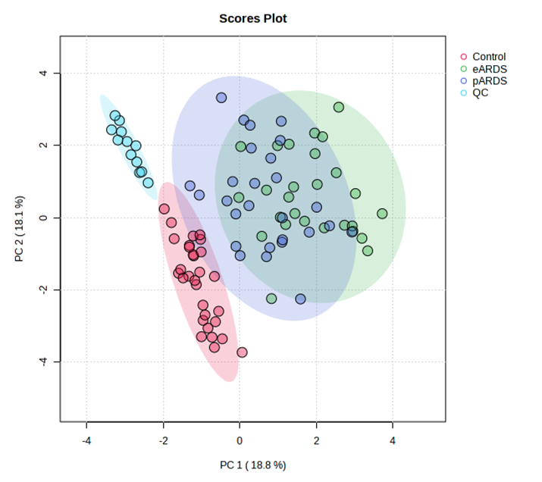
Supplementary Figure 2. Statistical analysis of the data obtained for sepsis-induced ARDS patients and non-ARDS controls: PLS-DA cross-validation
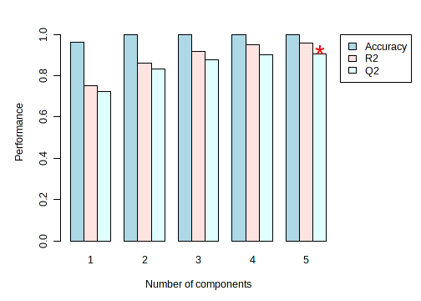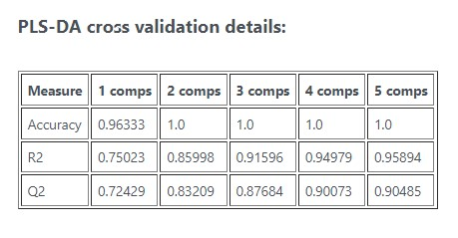
Supplementary Figure 3. Pathway affected in sepsis-induced ARDS subphenotype
A. Direct ARDS compared to non-ARDS control
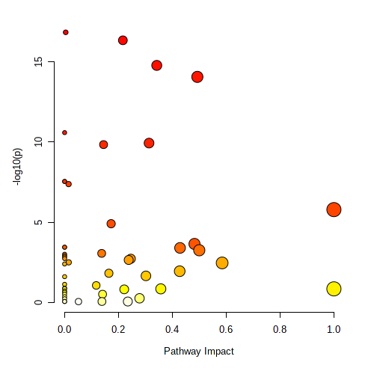
Glycolysis and gluconeogenesis
D-Glutamine and D-glutamate metabolism
Arginine biosynthesis
Fatty acid biosynthesis
Fatty acid degradation
Biosynthesis of unsaturated fatty acids
Ether lipid metabolism
Phenylalanine, tyrosine, and tryptophan biosynthesis
Linoleic acid metabolism
Arachidonic acid metabolism
Tryptophan metabolism
Sphingolipid metabolism
Glycerophospholipid metabolism
Glycosylphosphatidylinositol (GPI)-anchor biosynthesis
B. Indirect ARDS compared to non-ARDS control
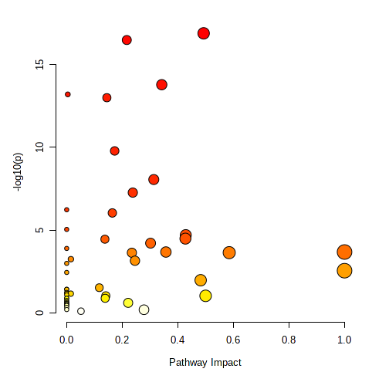
Phenylalanine, tyrosine, and tryptophan biosynthesis
Linoleic acid metabolism
Arachidonic acid metabolism
Tryptophan metabolism
Cysteine and methionine metabolism
Pyruvate metabolism
Tyrosine metabolism
Alanine, aspartate, and glutamate metabolism
Glycolysis and gluconeogenesis
Ether lipid metabolism
Glycosylphosphatidylinositol (GPI)-anchor biosynthesis
Glycerophospholipid metabolism
Sphingolipid metabolism
C. Venn diagram for top 10 significant pathways for sepsis-induced direct and indirect ARDS compared to non-ARDS control
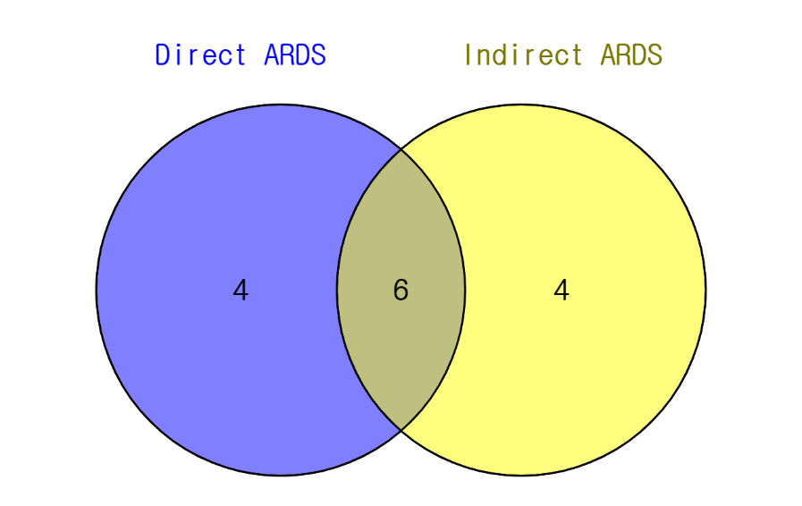
4 exclusively in "Indirect ARDS"
Glycolysis / Gluconeogenesis
Pyruvate metabolism
Cysteine and methionine metabolism
Tyrosine metabolism

4 exclusively in "Direct ARDS"
Biosynthesis of unsaturated fatty acids
Fatty acid elongation
Fatty acid degradation
Fatty acid biosynthesis

6 common elements in "Direct ARDS" and "Indirect ARDS":
Glycosylphosphatidylinositol (GPI)-anchor biosynthesis
Glycerophospholipid metabolism
Tryptophan metabolism
Sphingolipid metabolism
Arachidonic acid metabolism
Ether lipid metabolism

