Supplemental material

- Search strategy

Search performed 11 OCT 22 256 results
Deduplicated 11 OCT 22 194 results
Title and abstract screening 12 OCT 22 12 to full text screening
Snowballing completed 01 NOV 22 6 added 18 total
- 2 studies were excluded because they were case reports / case series
- 6 studies were excluded because they could only be used when individual patient level data was available; authors were contacted if contact information was available, but no response was received
Final included articles 10 total
- 7 studies that reported individual patient level data in the original article
- 1 study from which we received individual patient level data from the authors
- 2 studies that only reported group level data; authors were contacted for group level data, but no response was received

- Search protocols for Medline and Embase

Medline
# | Searches
1 | exp Iatrogenic Disease/
2 | exp Medical Errors/ or exp Diagnostic Errors/
3 | Patient Harm/
4 | (iatrogenic* or error* or "hospital acquired condition*" or harm* or acciden*).ti,ab,kf.
5 | 1 or 2 or 3 or 4
6 | Embolism, Air/
7 | ((air adj3 embol*) or (gas adj3 embol*)).ti,ab,kf.
8 | 6 or 7
9 | exp Central Nervous System/
10 | ("central nerv*" or cerebr* or CNS or "C.N.S." or brain*).ti,ab,kf.
11 | 9 or 10
12 | exp Oxygen Inhalation Therapy/
13 | ("hyperbaric oxygen*" or HBO or HBO2 or HBOT or hyperbar* or "HBO-therap*" or "high tension oxygen*" or "high tension O2").ti,ab,kf.
14 | 12 or 13
15 | 5 and 8 and 11 and 14

Embase
# | Searches
1 | exp iatrogenic disease/
2 | exp medical error/
3 | patient harm/
4 | (iatrogenic* or error* or "hospital acquired condition*" or harm* or acciden*).ti,ab,kf.
5 | 1 or 2 or 3 or 4
6 | air embolism/
7 | ((air adj3 embol*) or (gas adj3 embol*)).ti,ab,kf.
8 | 6 or 7
9 | exp central nervous system/
10 | ("central nerv*" or cerebr* or CNS or "C.N.S." or brain*).ti,ab,kf.
11 | 9 or 10
12 | 8 and 11
13 | 5 or 12
14 | exp oxygen therapy/
15 | ("hyperbaric oxygen*" or HBO or HBO2 or HBOT or hyperbar* or "HBO-therap*" or "high tension oxygen*" or "high tension O2").ti,ab,kf.
16 | 14 or 15
17 | 5 and 8 and 11 and 16

- Assessment of study quality using Newcastle-Ottawa Quality Assessment Scale for cohort studies

Author | S1 | S2 | S3 | S4 | C1 | O1 | O2 | O3
Beevor
Benson
Blanc
Kol | Note 1 |  |  |  |  | Note 2 | Note 3
Massey |  |  |  |  |  |  | Note 3
Muller
Murphy | Note 1 |  |  |  |  | Note 2 | Note 3
Takahashi | Note 1 |  |  |  |  | Note 2 | Note 3
Tekle |  |  |  |  |  |  | Note 4
Ziser

The abbreviations in the column headers refer to the eight questions of the Newcastle-Ottawa scale (see next page). No study includes a non-exposed cohort, i.e. a group of patients that did not experience cerebral gas embolism. Therefore, questions S2 and C1 cannot be answered, these are marked yellow.
Notes:
- In these studies, it is not clear how the included patients were identified. The text merely mentions a period of inclusion, but not how patients were identified (e.g. through checking of medical records).
- In these studies, it is not clear how the outcome was assessed. It is assumed from the text that this was through the medical records, but this cannot be concluded with certainty.
- The timepoint of determination of outcome is not mentioned.
- Outcome is determined at 24 h, which is suboptimal for determining neurological outcome, and should preferably be longer.

- Newcastle-Ottawa scale

As downloaded from https://www.ohri.ca/programs/clinical_epidemiology/nosgen.pdf.

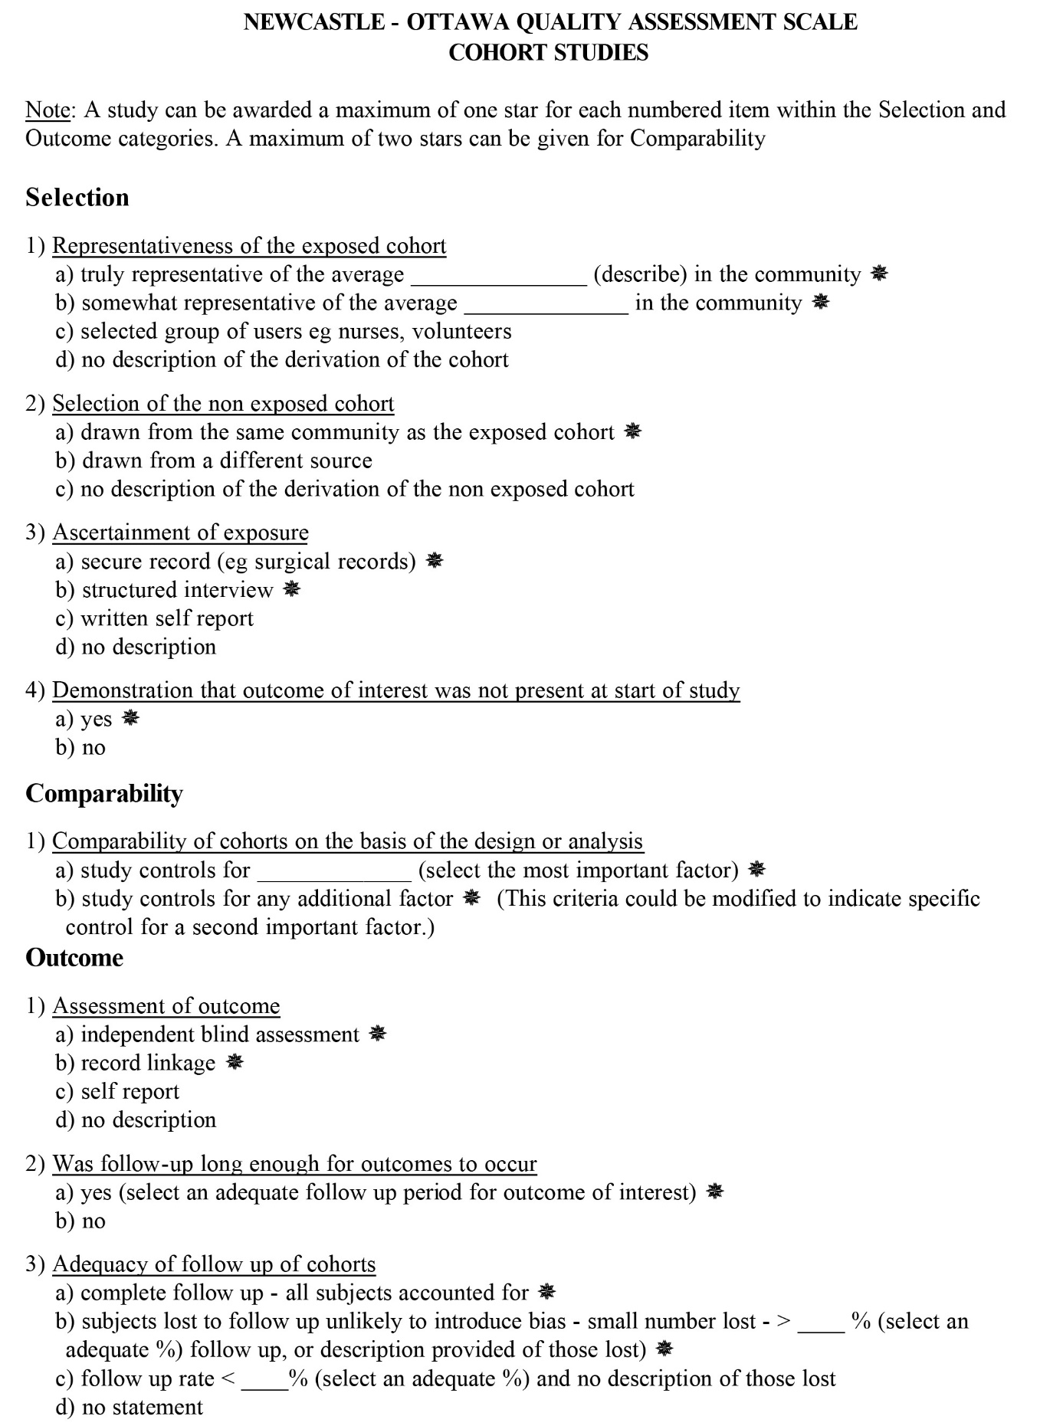
- Additional study information

Author | Cohort period | Causative procedures | Symptom severity | Timepoint of outcome determination
Studies with only group data
Beevor | 1998-2014 | cardiac surgery: 24 (53%); central venous catheter: 8 (18%); trauma: 5 (11%); other surgery: 4 (8.9%); interventional radiology: 4 (8.9%) | cannot be reliably determined from the article; two patients were in circulatory arrest | hospital discharge
Blanc | 1980-1999 | central venous catheter: 52 (60%); extracorporeal circulation: 14 (16%); arteriography: 5 (5.8%); dialysis: 4 (4.7%); neurosurgery: 4 (4.7); others: 7 (8.1%) | cannot be reliably determined from the article | at least 2 months
Studies with individual patient data
Benson | 1987-1999 | A: 9 (47%); B: 2 (11%); E: 4 (21%); F: 3 (16%); G: 1 (5.3%) | 0: 2 (11%); 1: 4 (21%); 2: 8 (42%); 3: 2 (11%); 4: 3 (16%) | 1 month
Kol | > 1985 | E: 6 (100%) | 3: 6 (100%) | not mentioned
Massey | “9 year period” | A: 3 (21%); B: 1 (7.1%); C: 2 (14%); E: 5 (36%); H: 3 (21%) | 5: 14 (100%) | not mentioned
Muller | 2016-2020 | A: 2 (20%); B: 1 (10%); D: 1 (10%); F: 4 (40%); G: 1 (10%); H: 1 (10%) | 1: 4 (40%); 3: 6 (60%) | median 5 months
Murphy | 1970-1984 | A: 7 (50%); B: 1 (7,1%); C: 1 (7.1%); D: 1 (7.1%); E: 2 (14%); F: 2 (14%) | 1: 5 (36%); 2: 2 (14%); 3: 7 (50%) | not mentioned
Takahashi | 1970-1985 | A: 2 (11%); C: 7 (39%); D: 2 (11%); E: 7 (39%) | 5: 18 (100%) | not mentioned
Tekle | 1987-2010 | A: 15 (44%); B: 4 (12%); C: 2 (5.9%); E: 7 (21%); F: 2 (5.9%); G: 2 (5.9%); H: 1 (2.9%); I: 1 (2.9%) | 0: 2 (5.9%); 1: 11 (32%); 2: 10 (29%); 3: 8 (24%); 4: 3 (8.8%) | 24 h
Ziser | 1985-1998 | E: 17 (100%) | 5: 17 (100%) | hospital discharge

In the two studies that did not report individual patient data, causative procedures and symptom severity could not be determined in the same way and to the same level of detail as in the remaining studies. For the studies that report individual patient data, the letters A-I in the third column and numbers 0-5 in the fourth column correspond to the letters and numbers in the table below.

Causative procedures categories  A – venous / central venous gas entry  B – aortic / carotid / cerebral gas entry  C – coronary / cardiac catheterization  D – peripheral arterial gas entry  E – cardiac surgery  F – lung procedures (including chest drain)  G – pulmonary barotrauma (non-diving related)  H – other  I – unknown | Symptom severity categories  0 – nonspecific symptoms  1 – focal neurological symptoms  2 – altered mental status  3 – coma  4 – circulatory arrest  5 – unknown

