Supplementary Appendix

Supplemental Figure 1

Protein received in the first 28 days after randomization
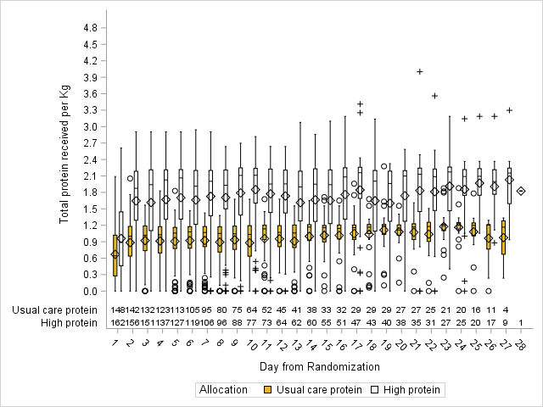

Supplemental Figure 2

Energy received for the first 12 days after randomization
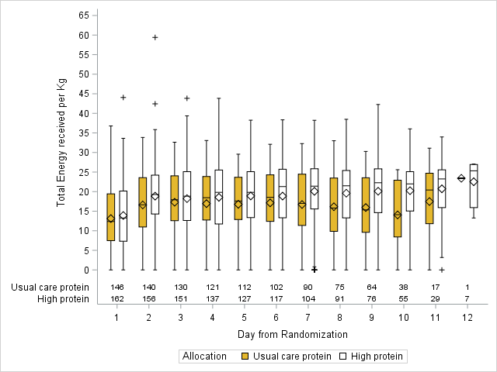

Supplemental Figure 3

Comparison of Urea levels between the treatment groups during the observation period
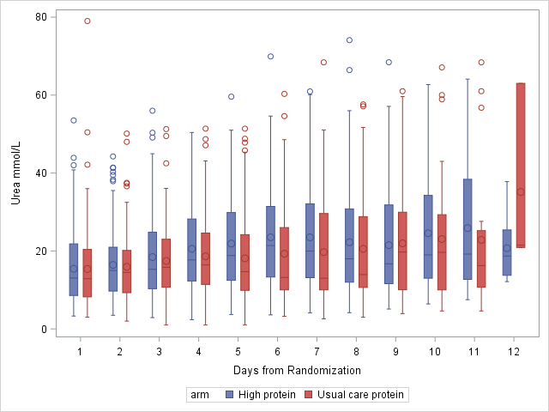
Supplemental Table 1 - Urea Levels (mmol/L) over Study Days by Treatment Arms
Day # | 1 | 2 | 3 | 4 | 5 | 6 | 7 | 8 | 9 | 10 | 11 | 12
High Protein | (142) 15.4±15.4 | (139) 15.9±15.9 | (129) 17.4±17.4 | (119) 18.6±18.6 | (115) 18.1±18.1 | (97) 19.3±19.3 | (90) 19.7±19.7 | (76) 20.5±20.5 | (56) 22±22 | (37) 23.1±23.1 | (18) 22.8±22.8 | (3) 35.1±35.1
Usual Care | (156) 15.4±15.4 | (153) 16.4±16.4 | (150) 18.4±18.4 | (131) 20.5±20.5 | (120) 21.9±21.9 | (106) 23.5±23.5 | (99) 23.5±23.5 | (87) 22.2±22.2 | (69) 21.5±21.5 | (55) 24.5±24.5 | (27) 25.9±25.9 | (8) 20.7±20.7
(n) mean±sd
 | p values
Arm (Group) | 0.82
Days after randomization (Time) | <0.0001
Interaction (Group*Time) | 0.02

