Figure S1: Sensitivity and specificity of CRT in individual studies
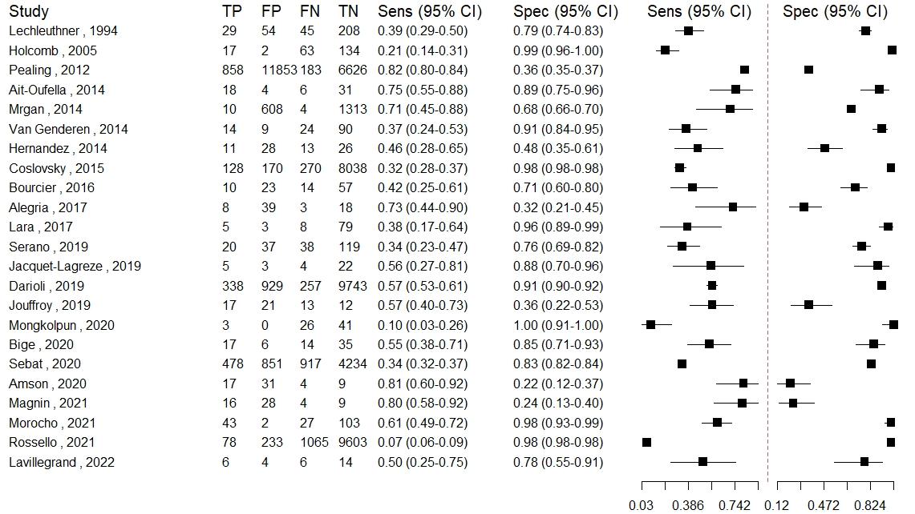
FN: False negative, FP: False positive, Sens: sensitivity , Spec: Specificity, TP: True positive, TN: True negative.

Figure S2: Influence analysis; leave-one-out meta-analysis.
A
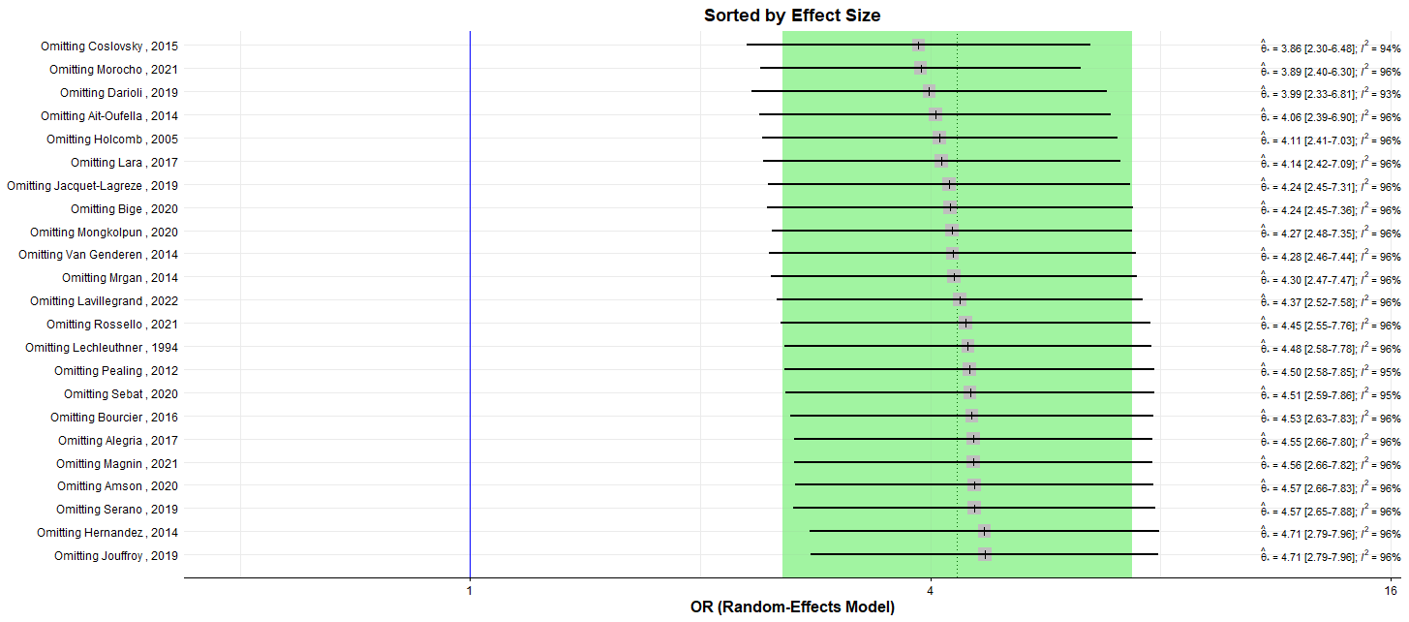
B

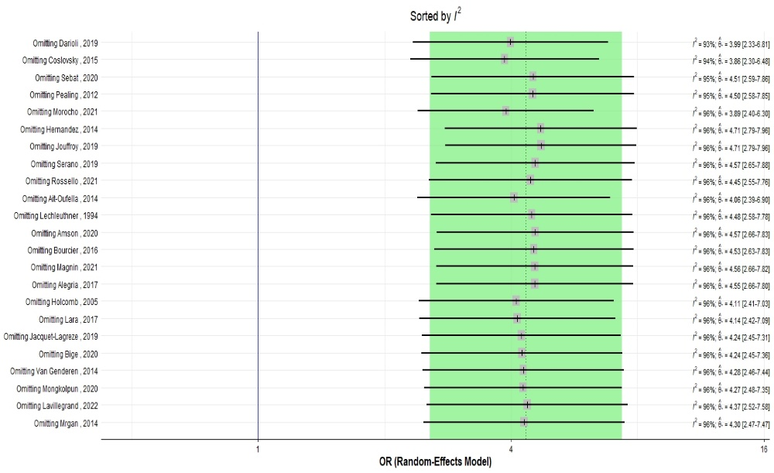
In Forest plot A and B are displayed the effect size ($\hat{θ}$); grey squares with 95% confidence intervals (black horizontal line) and the heterogeneity (I²) with one study omitted each time. In plot (A), the meta-analyses are sorted by effect size, in plot B the meta-analyses are sorted by I². The dashed line and the shaded green area represent the initial effect size and the 95% confidence intervals of the pooled effect, before the leave-one-out method is applied.

Figure S3: Drapery plot
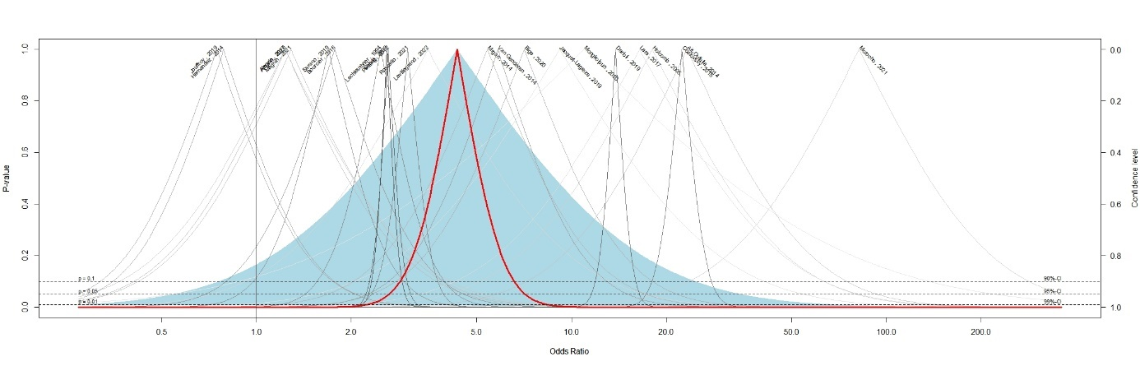
Drapery plot presents the P-value function as a curve for each individual studies. The thick red line represents the P-Value function of the pooled estimates according to the random-effects model which cross the OR 1 under the threshold P-Value 0.05. The blue shaded area represents the prediction interval, which cross the OR 1 above the P-Value 0.05.

