Interventions to promote cost-effectiveness in adult Intensive care units: consensus statement and considerations for best practice from a multidisciplinary and multinational eDelphi study

Supplementary Figures 1 and 2 (B & W)

Supplementary Figure 1
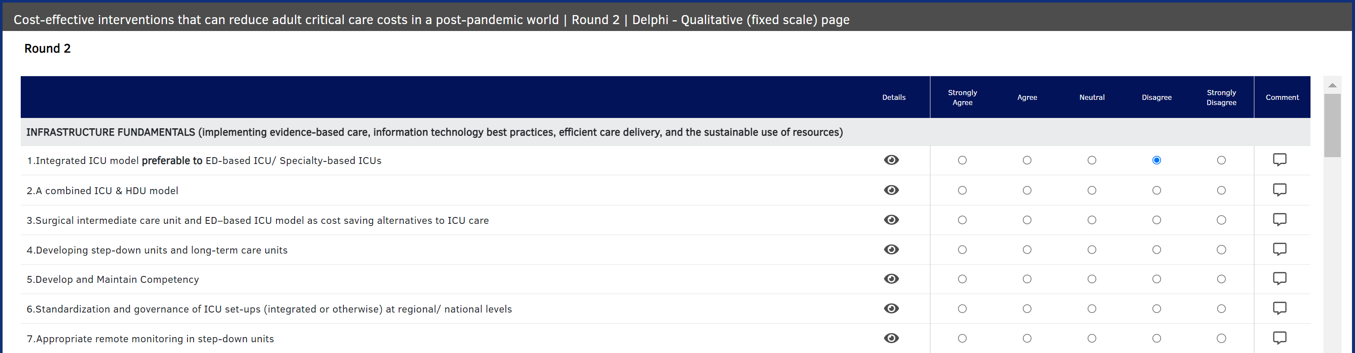
Figure 1 - The experts were able to see all the anonymized comments from the previous round for each of the interventions, by clicking on the ‘details’ section

Supplementary Figure 2
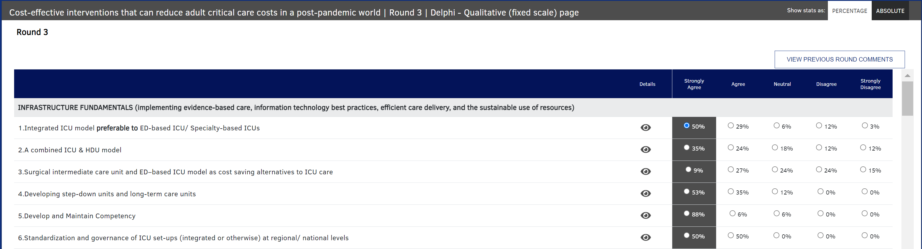

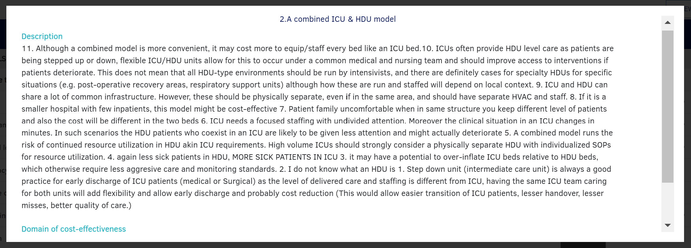
Figure 2 - The experts were able to see all the anonymized comments from the previous round for each of the interventions, by clicking on the ‘details’ section

