Additional information
qSOFA COMBINED WITH suPAR FOR EARLY RISK DETECTION AND GUIDANCE OF ANTIBIOTIC TREATMENT IN THE EMERGENCY DEPARTMENT: A RANDOMISED CONTROLLED TRIAL

Supplementary Figure S1

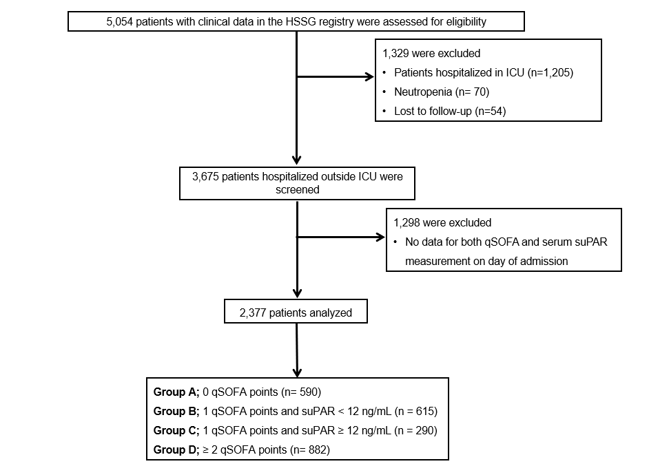

Supplementary Figure1: Flow chart of the prospective cohort study. Abbreviations:HSSG, Hellenic Sepsis Study Group;ICU, intensive care unit; qSOFA, quick Sequential Organ Failure Assessment Score; n, number of patients; suPAR, soluble urokinase plasminogen activator receptor

