Additional information
qSOFA COMBINED WITH suPAR FOR EARLY RISK DETECTION AND GUIDANCE OF ANTIBIOTIC TREATMENT IN THE EMERGENCY DEPARTMENT: A RANDOMISED CONTROLLED TRIAL

Supplementary Figure S2

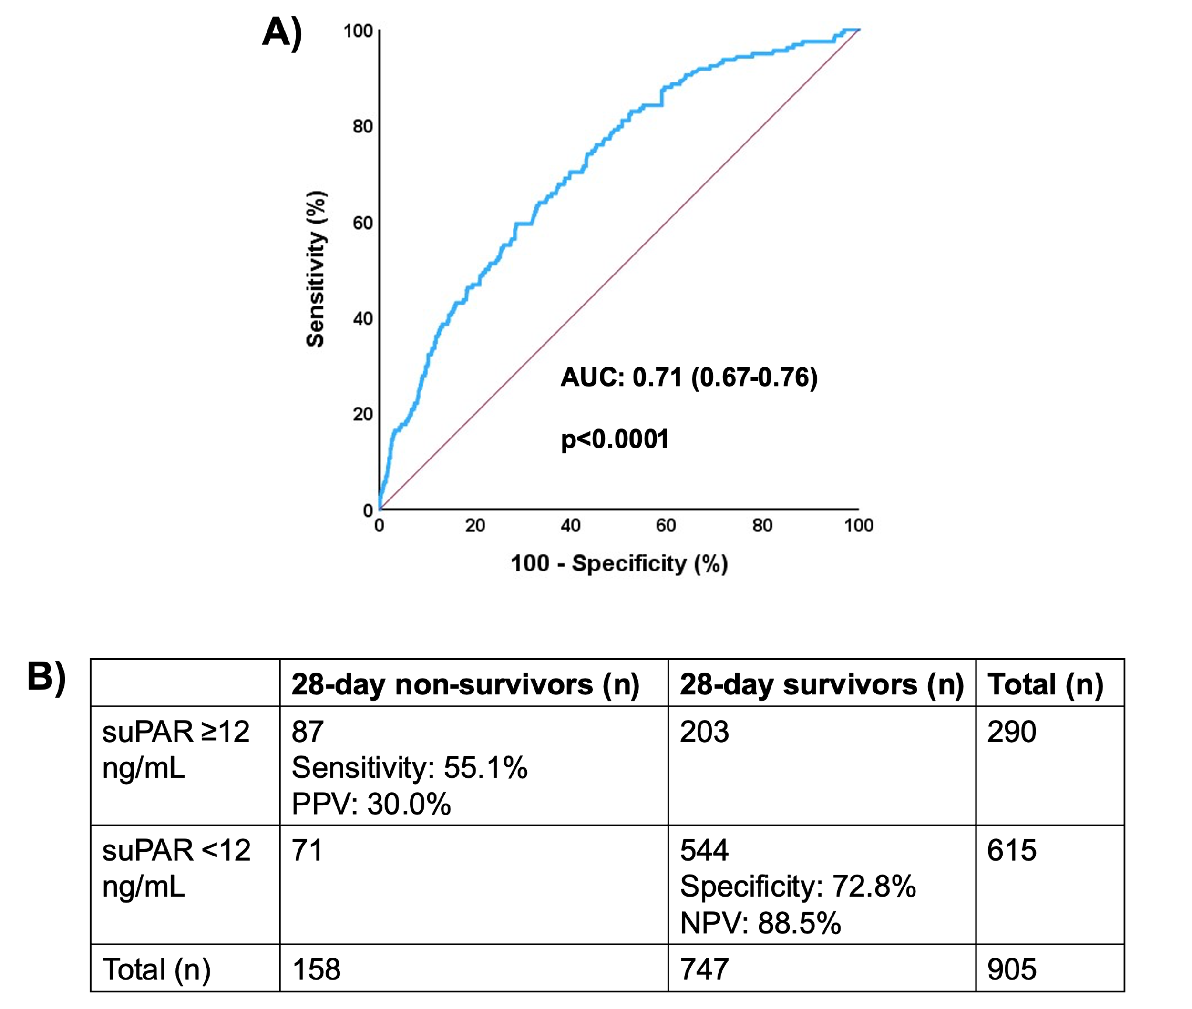
Supplementary Figure2: Development of the cut-off of 12ng/mL of suPAR for risk prediction among patients with qSOFA= 1.
A)Receiver operator characteristics curve of suPAR to predict 28-day mortality among patients outside the ICU with qSOFA equal to one.
B)Prognostic performance of suPAR 12ng/mL or more to predict 28-day mortality.

Abbreviations: AUC, area under the curve; ICU, intensive care unit; MPV, negative predictive value; PPV, positive predictive value; qSOFA, quick Sequential Organ Failure Assessment Score; suPAR, soluble urokinase plasminogen activator receptor

