Additional information

qSOFA COMBINED WITH suPAR FOR EARLY RISK DETECTION AND GUIDANCE OF ANTIBIOTIC TREATMENT IN THE EMERGENCY DEPARTMENT: A RANDOMISED CONTROLLED TRIAL

Supplementary Figure S3

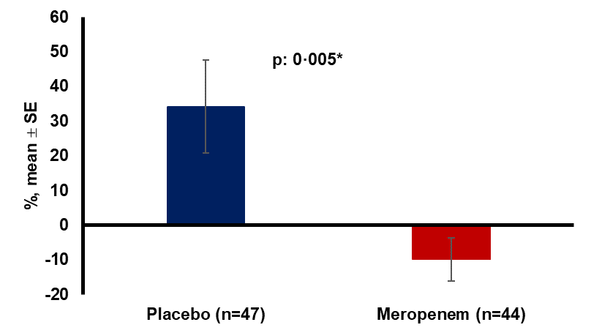

Supplementary Figure3: SOFA changes the first 24 hours
Abbreviations: n, number of patients; SE, standard error

