Table S2. Risk of bias assessment of included studies.

ROB-2 tool for randomized controlled trials
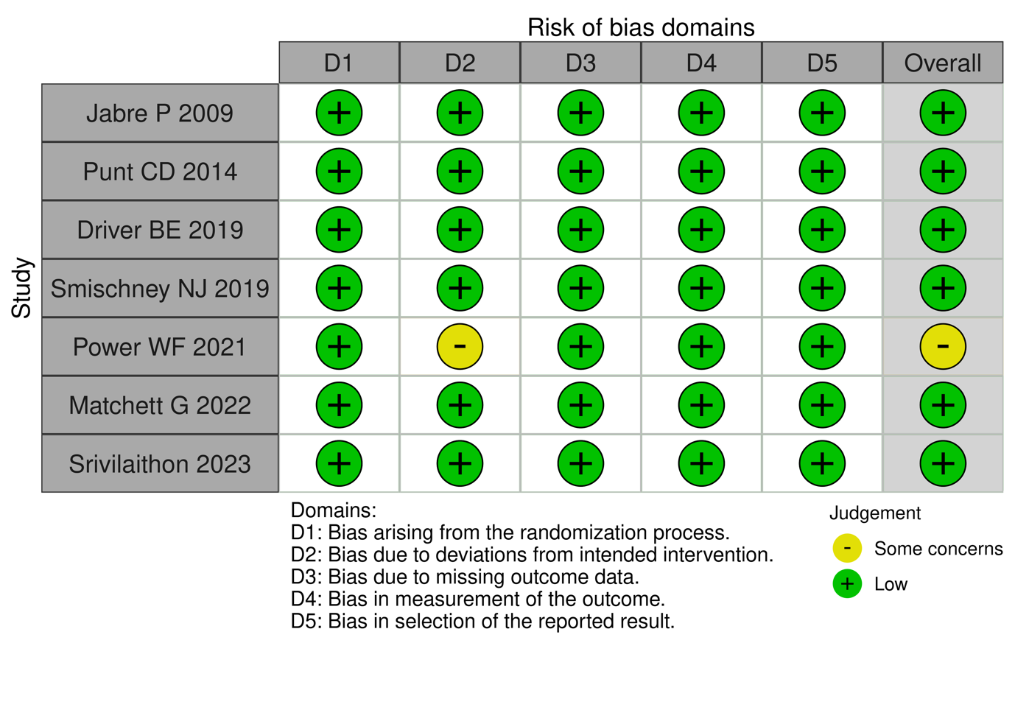
ROBINS-2 tool for non-randomized studies
