Supplements:
18 admissions meeting criteria
5 excluded for missing ultrasound measurements

13 Historical controls
23 patients enrolled for intervention
7 were excluded
1 withdrew consent for all data
6 received no robotic mobilization, as too ill for robotic mobilization
16 patients with robotic mobilization
Supplemental figure 1: Flowchart of in and exclusion of patients

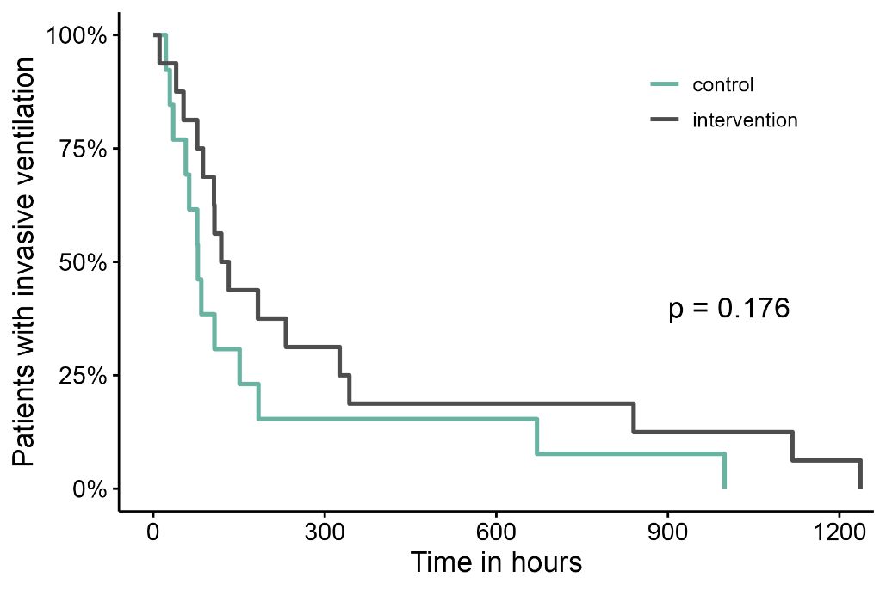
Supplemental figure 2: Kaplan–Meier curves displaying the duration of invasive ventilation in the intervention and control groups.
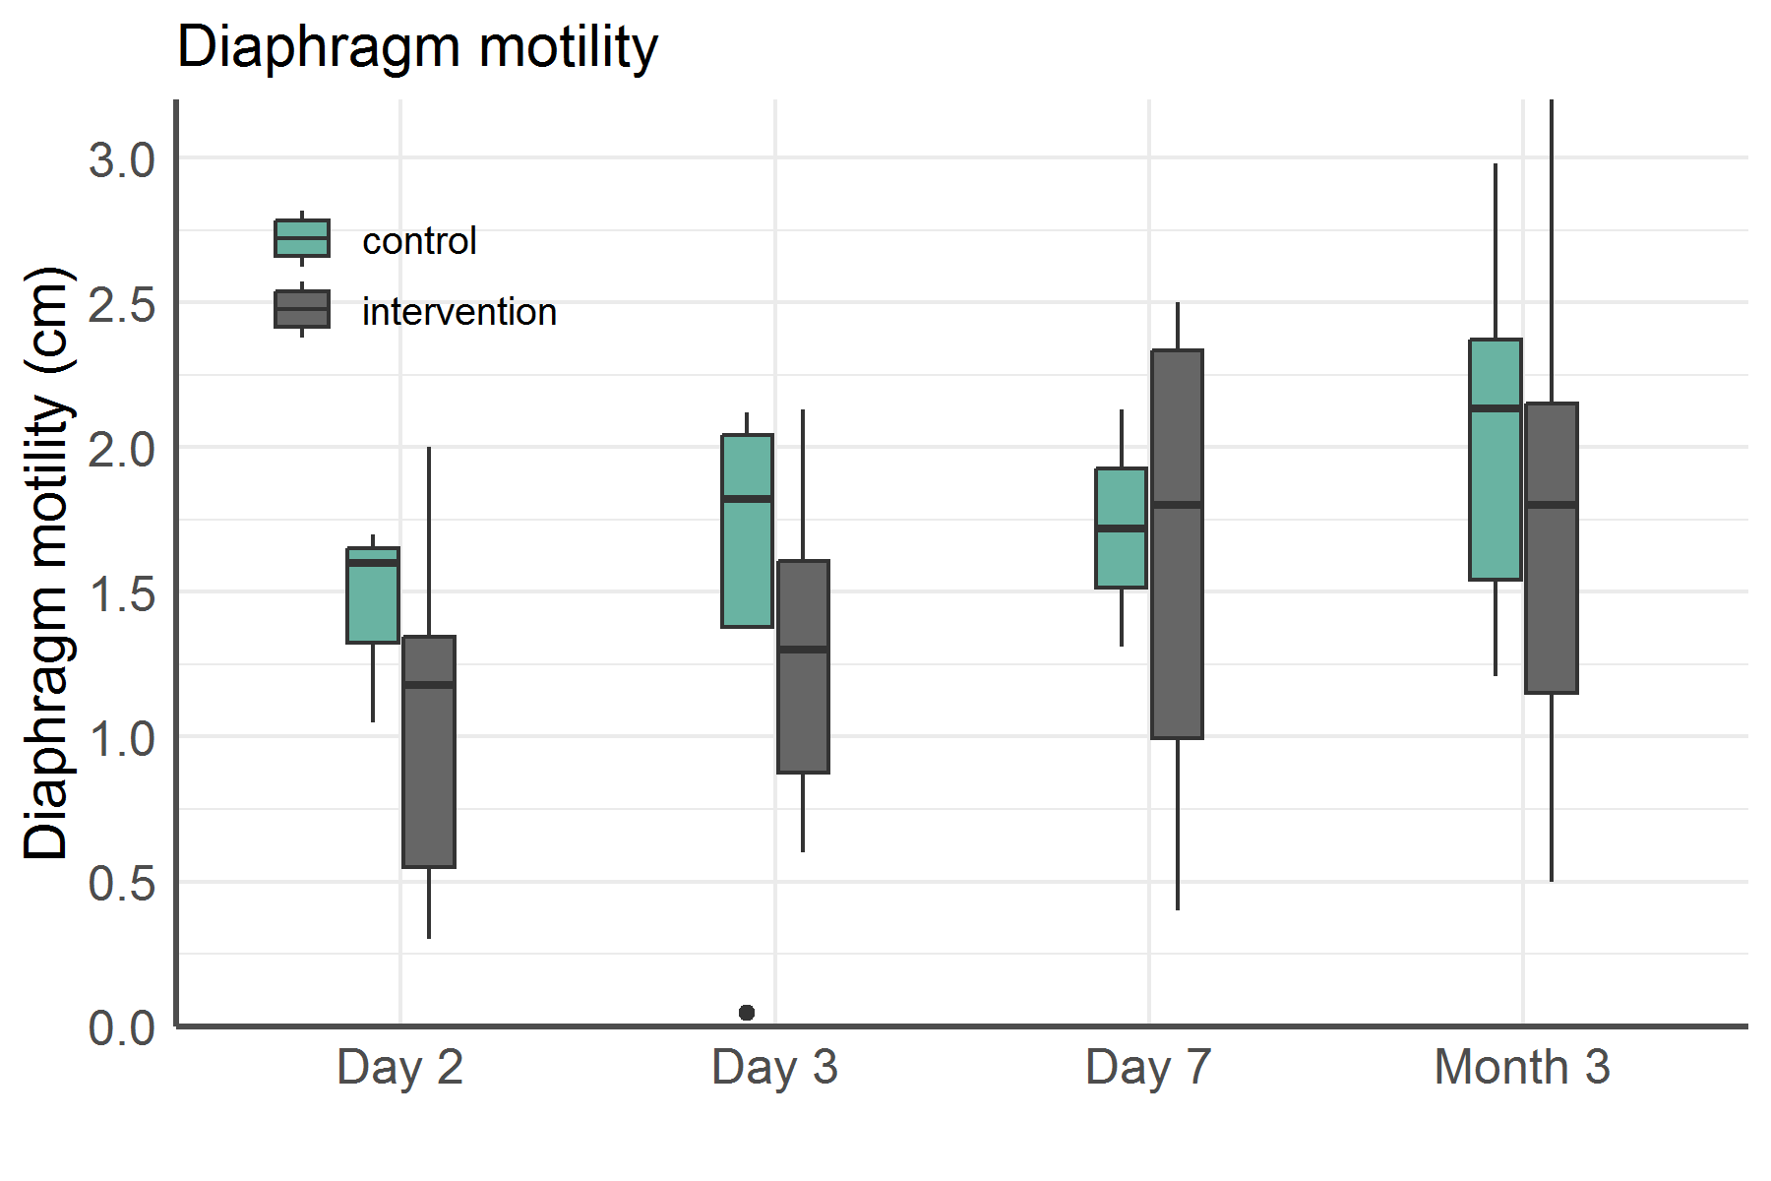
Supplemental figure 3: Diaphragm motility in non-invasively ventilated patients
Diaphragm motility of conventionally and robotically assisted mobilized, non-invasively ventilated patients over time.
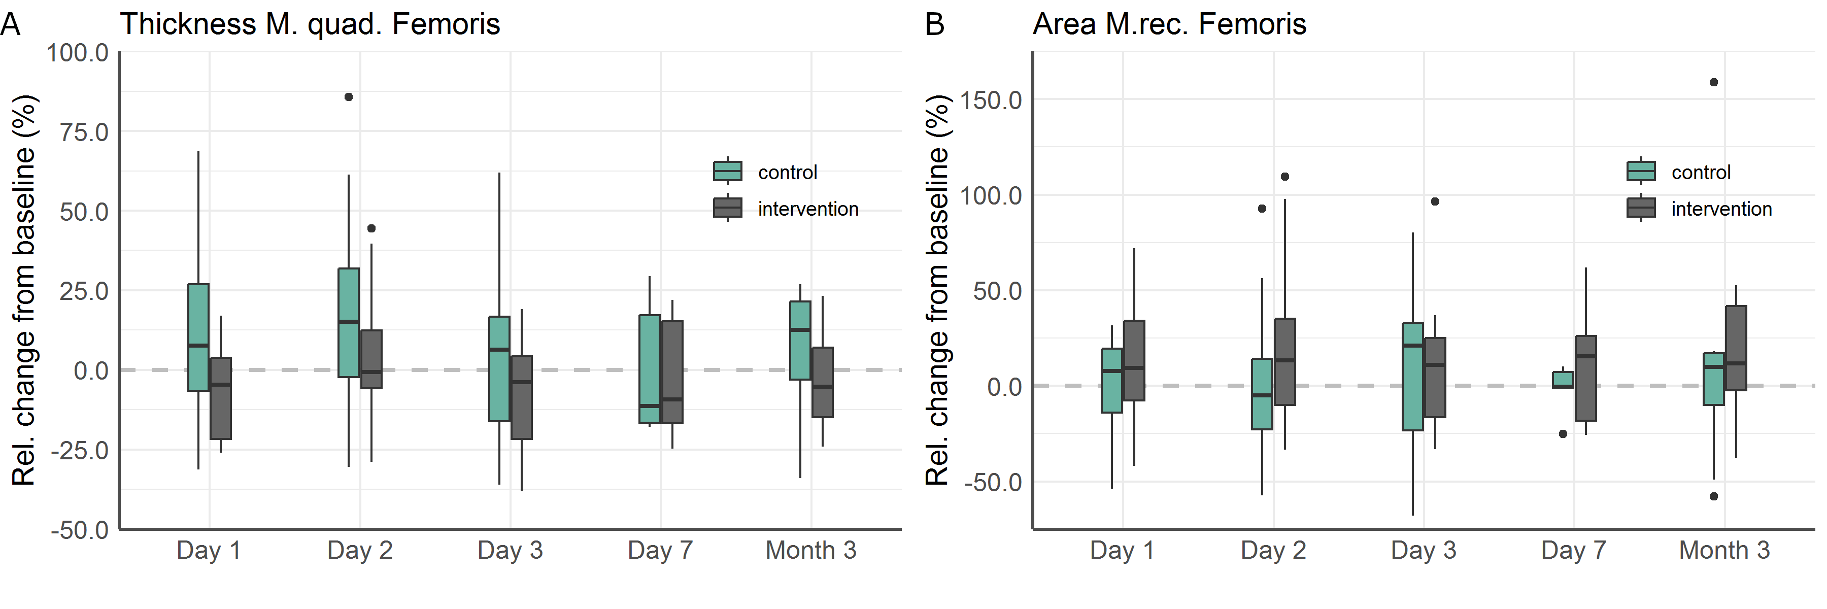
Supplemental figure 4: Relative change in the thickness of M. quadriceps femoris (A) and cross-sectional area of M. rectus femoris (B). (Normalized to preoperative Measurements)
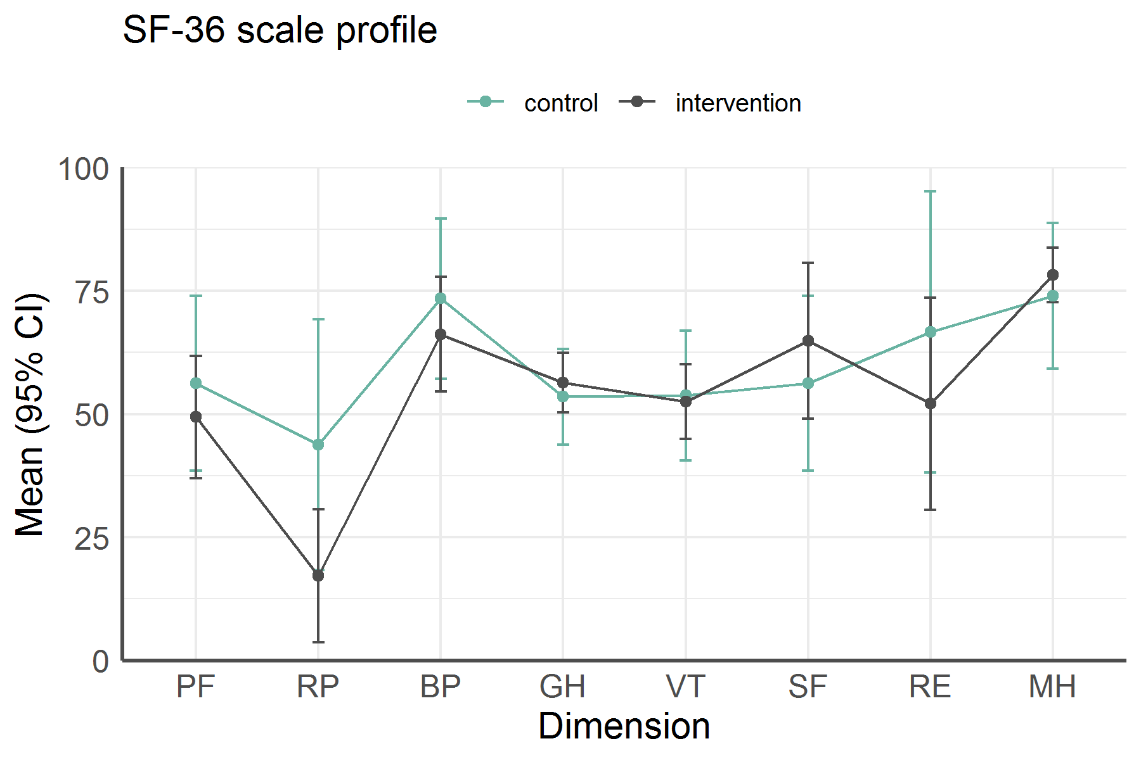Supplemental figure 5: Quality of life: Scale profile of the SF-36 questionnaire after three months
Means are presented as dots, standard deviations as vertical bars. Abbreviations: PF: Physical Functioning, RP: Role: Physical, BP: Bodily Pain, GH: General Health, VT: Vitality, SF: Social Functioning, RE: Role: Emotional, MH: Mental Health.
Supplemental table 1: Cumulative drug consumption during days 0 to 7 per drug and group
 | All  (n=29) | Intervention  (n=16) | Control  (n=13) | p
Sufentanil (µg) | 1045  (607 – 2508) | 1063  (643 – 2409) | 1045  (588 – 2508) | 0.983
Piritramide (mg) | 15  (0 – 38) | 14  (0 – 38) | 15  (9 – 41) | 0.722
Propofol (mg) | 8524  (3814 – 17489) | 7181  (4008 – 18477) | 9508  (2736 – 14984) | 0.913
Midazolam (mg) | 0  (0 – 0) | 0  (0 - 0) | 0  (0 – 235) | 0.183
Dexmedetomidine (mg) | 0.2  (0.0 – 3.3) | 2.7  (0.0 – 4.3) | 0.0  (0.0 – 0.2) | 0.006
Naloxone (mg) | 160  (96 – 216) | 184  (112 – 224) | 152  (96 – 208) | 0.282
Movicol (bags) | 6  (4 – 10) | 7  (5 – 9) | 6  (4 – 11) | 0.642
Sodium picosulfate (mg) | 23  (15 – 45) | 30  (15 – 47) | 23  (8 – 45) | 0.354
Neostigmine (mg) | 0.9  (0 – 1.5) | 0.9  (0.0 – 1.5) | 0  (0 – 1.5) | 0.798
Insulin (IE) | 85  (27 – 126) | 89  (21 – 123) | 44  (28 – 180) | 0.913
Median (minimum - maximum). The p-value refers to the comparison of the intervention group vs. control group. Statistically significant p-values are printed in bold.

