Supplemental material
The Association of Arterial Partial Oxygen Pressure with Mortality in Critically Ill Sepsis Patients: A nationwide observational cohort study

Dong-gon Hyun, MD, Jee Hwan Ahn, MD, Jin Won Huh, MD, Ph.D., Sang-Bum Hong, MD, Ph.D., Younsuck Koh, MD, Ph.D., FCCM, Dong Kyu Oh, MD, Su Yeon Lee, MD, Mi Hyeon Park, and Chae-Man Lim, MD, Ph.D., FCCM* on behalf of the Korean Sepsis Alliance (KSA) Investigators

Fig. S1 Absolute standardized mean differences between liberal and conservative PaO₂ groups before and after propensity score matching. The horizontal axis represents the standardized mean differences, and the dashed line indicates the absolute standardized mean difference of 0.1. Open dots reflect values prior to matching, and black dots reflect values after matching. Matching succeeded in reducing the standardized mean difference within an absolute value of 0.1.

Fig. S2 The daily median value of the lowest partial pressure of oxygen in arterial blood (PaO₂) in matched cohorts during the first three days of ICU management in liberal and conservative PaO₂ groups.

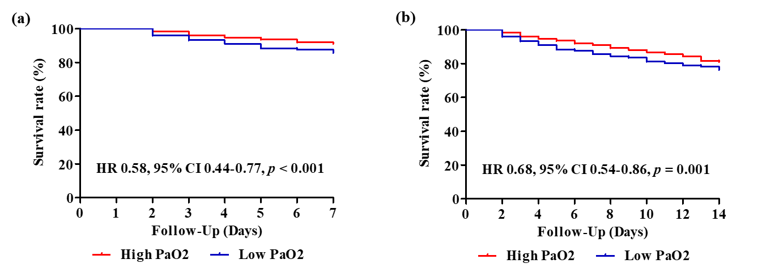
Fig. S3 Kaplan-Meier analysis of survival censored at 7 days (a) and 14 days (b). PaO2, partial pressure of oxygen in the arterial blood; HR, hazard ratio; CI, confidence interval.

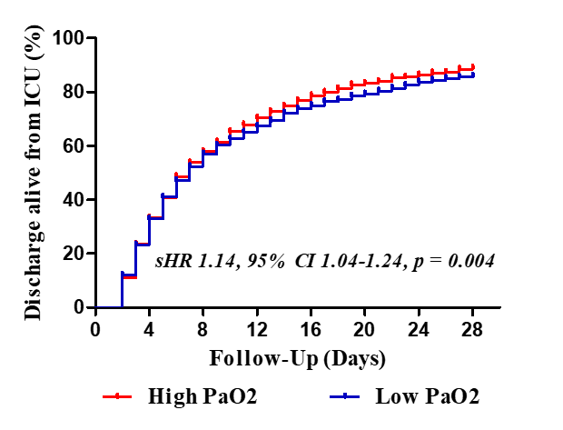
Fig. S4 Cumulative ICU discharge at day 28 between the two groups. PaO2, partial pressure of oxygen in the arterial blood; sHR, subhazard ratio; CI, confidence interval.

Table S1 Baseline characteristics of all included patients
Characteristic | Conservative PaO2 (n = 2,536) | Liberal PaO2 (n = 1,611) | p-value
Female, n (%) | 1,022 (40.3) | 662 (41.1) | 0.635
Age, yr, median [IQR] | 74.0 [64.0–82.0] | 72.0 [61.0–80.0] | <0.001
Comorbidities, n (%)
Cardiac | 478 (18.9) | 331 (20.6) | 0.192
Lung | 314 (12.4) | 155 (9.6) | 0.007
Neurologic | 891 (35.1) | 558 (34.6) | 0.769
Liver | 232 (9.2) | 145 (9.0) | 0.916
Diabetes mellitus | 946 (37.3) | 611 (37.9) | 0.710
Renal disease | 350 (13.8) | 20 (13.7) | 0.931
Connective tissue disease | 74 (2.9) | 43 (2.7) | 0.707
Immunocompromised | 95 (3.8) | 67 (4.2) | 0.557
Hematologic malignancy | 183 (7.2) | 103 (6.4) | 0.339
Solid cancer | 674 (26.6) | 479 (29.7) | 0.030
Sepsis type, n (%) |  |  | <0.001
Community-acquired sepsis | 2,011 (79.3) | 1,196 (74.2)
Hospital-acquired sepsis | 525 (20.7) | 415 (25.8)
Severity
SOFA score, median [IQR] | 7.0 [5.0–9.0] | 7.0 [5.0–9.0] | 0.573
Site of infection, n (%)
Respiratory | 1,319 (52.0) | 667 (41.4) | <0.001
Abdominal | 612 (24.1) | 481 (29.9) | <0.001
Urinary tract | 516 (20.4) | 324 (20.1) | 0.885
Others* | 323 (12.7) | 258 (16.0) | 0.004
Laboratory findings, median [IQR]
White blood cell count * 10³/L | 11.5 [6.5–17.1] | 11.9 [6.6–18.0] | 0.163
C-reactive protein, mg/dL | 12.6 [5.4–22.1] | 11.3 [4.5–20.0] | <0.001
Lactic acid, mmol/L | 3.2 [1.9–5.9] | 3.2 [1.8–5.6] | 0.124
Adjunct interventions, n (%)
Steroids | 579 (22.8) | 358 (22.2) | 0.675
Mechanical ventilation | 1,123 (44.3) | 876 (54.4) | <0.001
CRRT | 457 (18.0) | 278 (17.3) | 0.558
ECMO | 18 (0.7) | 13 (0.8) | 0.866
Vasopressors | 2,009 (79.2) | 1,275 (79.1) | 0.985
Microbiologic pathogen, n (%) | 1,611 (63.5) | 1,034 (64.2) | 0.691
Bacteria | 1,510 (93.7) | 967 (93.5) | 0.893
Virus | 94 (5.8) | 53 (5.1) | 0.490
Fungus | 96 (6.0) | 83 (8.0) | 0.047
*Others included skin/soft tissue infection, catheter-associated infection, neurologic infection, and unknown.
PaO_{2,} partial pressure of oxygen in arterial blood; IQR, interquartile range; SOFA, sequential organ failure assessment; CRRT, continuous renal replacement therapy; ECMO, extracorporeal membrane oxygenation; MDR, multi-drug resistance

Table S2 Distribution of patients according to PaO2 values for the first three days in the ICU
 | Conservative PaO2 (n = 1,211) | Liberal PaO2 (n = 1,211) | p-value
PaO2 at ICU Day 1 |  |  | < 0.001
≥ 80 mm Hg | 556 (45.9) | 0 (0.0)
< 80 mm Hg | 655 (54.1) | 1,211 (100.0)
PaO2 at ICU Day 2 |  |  | < 0.001
≥ 80 mm Hg | 606 (50.0) | 0 (0.0)
< 80 mm Hg | 605 (49.9) | 1,211 (100.0)
PaO2 at ICU Day 3 |  |  | < 0.001
≥ 80 mm Hg | 694 (57.3) | 0 (0.0)
< 80 mm Hg | 517 (42.7) | 1,211 (100.0)
PaO_{2,} partial pressure of oxygen in arterial blood; ICU, intensive care unit.

Table S3 Subgroup analysis of clinical outcomes based on PaO₂ by ICU date
 | Conservative PaO2 | Liberal PaO2 | HR (95% CI)* | p-value
ICU Day 1, n (%) | n = 556 | n = 1,866
Death at 7 days | 57 (10.3) | 161 (8.6) | 0.78 (0.58-1.06) | 0.111
Death at 14 days | 74 (13.3) | 229 (12.3) | 0.84 (0.65-1.10) | 0.205
Death at 28 days | 97 (17.4) | 314 (16.8) | 0.87 (0.69-1.09) | 0.232
ICU Day 2, n (%) | n = 606 | n =1,816
Death at 7 days | 71 (11.7) | 147 (8.1) | 0.65 (0.49-0.87) | 0.004
Death at 14 days | 96 (15.8) | 207 (11.4) | 0.70 (0.55-0.90) | 0.005
Death at 28 days | 123 (20.3) | 288 (15.9) | 0.82 (0.66-1.02) | 0.068
ICU Day 3, n (%) | n = 694 | n = 1,728
Death at 7 days | 99 (14.3) | 119 (6.9) | 0.45 (0.35-0.60) | < 0.001
Death at 14 days | 124 (17.9) | 179 (10.4) | 0.54 (0.42-0.68) | < 0.001
Death at 28 days | 156 (22.5) | 255 (14.8) | 0.60 (0.49-0.73) | < 0.001
PaO_{2,} partial pressure of oxygen in arterial blood; HR, hazards ratio; CI, confidence interval; ICU, intensive care unit.
* Adjusted for age, sex, comorbidities (Lung, Neurology, Liver, Kidney, and Hematology malignancy), infection site, initial sequential organ failure assessment score, lactate level, treatments (steroid and source control), organ support at ICU Day 1 (mechanical ventilation, continuous renal replacement therapy, and vasopressor).

Table S4 Cox proportional hazards model of factors associated with mortality at 28 days.
 | Univariable analysis
Variable | OR | 95% CI | p-value
Female | 1.12 | 0.92-1.36 | 0.266
Age, yr, | 1.00 | 1.00-1.01 | 0.410
Comorbidities
Cardiac | 1.07 | 0.84-1.35 | 0.580
Lung | 1.32 | 0.99-1.75 | 0.056
Neurologic | 0.78 | 0.63-0.96 | 0.020
Liver | 1.41 | 1.04-1.90 | 0.028
Diabetes mellitus | 1.08 | 0.89-1.32 | 0.431
Renal disease | 1.34 | 1.04-1.72 | 0.022
Connective tissue disease | 1.16 | 0.68-1.98 | 0.576
Immunocompromised | 0.99 | 0.64-1.53 | 0.949
Hematologic malignancy | 1.69 | 1.24-2.31 | 0.001
Solid cancer | 1.05 | 0.85-1.30 | 0.632
Sepsis type
Hospital-acquired sepsis | 0.98 | 0.79-1.23 | 0.886
Severity
SOFA score | 1.08 | 1.05-1.11 | <0.001
Site of infection
Respiratory | 0.83 | 0.69-1.01 | 0.067
Abdominal | 1.15 | 0.92-1.43 | 0.213
Urinary tract | 0.78 | 0.58-1.03 | 0.083
Others* | 1.38 | 1.08-1.75 | 0.009
Laboratory findings
White blood cell count * 10³/L | 1.00 | 0.99-1.01 | 0.925
C-reactive protein, mg/dL | 0.99 | 0.99-1.00 | 0.217
Lactic acid, mmol/L | 1.07 | 1.05-1.10 | <0.001
Adjunct interventions
Steroids | 1.23 | 0.99-1.53 | 0.056
Mechanical ventilation | 1.30 | 1.05-1.61 | 0.016
CRRT | 1.64 | 1.32-2.03 | <0.001
ECMO | 0.94 | 0.35-2.52 | 0.898
Vasopressors | 1.40 | 1.07-1.83 | 0.014
Microbiologic pathogen
Bacteria | 0.97 | 0.61-1.53 | 0.891
Virus | 1.14 | 0.73-1.78 | 0.563
Fungus | 1.11 | 0.72-1.70 | 0.638
PaO2 value
PaO2 at ICU Day 1 | 1.00 | 1.00-1.00 | 0.013
PaO2 at ICU Day 2 | 1.00 | 1.00-1.00 | 0.500
PaO2 at ICU Day 3 | 1.00 | 0.99-1.00 | 0.006
*Others included skin/soft tissue infection, catheter-associated infection, neurologic infection, and unknown.
PaO₂, partial pressure of oxygen in arterial blood; SOFA, sequential organ failure assessment; CRRT, continuous renal replacement therapy; ECMO, extracorporeal membrane oxygenation.

