SUPPLEMENTARY MATERIAL

Extracorporeal cardiopulmonary resuscitation versus standard treatment for refractory out-of-hospital cardiac arrest: A Bayesian meta-analysis

Samuel Heuts, MD, PhD¹, Hans Ubben, MD, Michal J. Kawczynski, MD, Andrea Gabrio, PhD, Martje M. Suverein, MD, Thijs S.R. Delnoij, MD, Petra Kavalkova, PhD, Daniel Rob, MD, PhD, Arnošt Komárek, PhD, Iwan C.C. van der Horst, MD, PhD, Jos G. Maessen, MD, PhD, Demetris Yannopoulos, MD, Jan Bělohlávek, MD, PhD, Roberto Lorusso, MD, PhD, Marcel van de Poll, MD, PhD

Content Page
Supplementary Material 1 – Detailed search 2
Supplementary Material 2 – Predefined worksheet 7
Supplementary Material 3 – Formulas for calculation 8
Supplementary Material 4 – Prior specification and rationale 10
Supplementary Material 5 – Risk of bias assessment 11
Supplementary Material 6 – Publication bias assessment 12

Supplementary Material 1. Detailed search for PubMed, EMBASE, and Cochrane Library.

Overview
Database | MEDLINE & PubMed Central
Platform | PubMed
Date of search | 21.11.2023
Number of results | 877
Syntax guide
[MeSH] | Medical subject headings
Free search terms | Terms entered as “All fields”
Search | Query | Items found
Disease associated search terms
#1 | Out-of-hospital cardiac arrest[MeSH] | 7.265
#2 | Out-of-hospital cardiac arrest | 12.868
#3 | OHCA | 4,440
#4 | Ventricular fibrillation[MeSH] | 17,942
#5 | Ventricular fibrillation | 46.941
#6 | VF | 17.540
#7 | #1 OR #2 OR #3 OR #4 OR #5 OR #6 | 69.665
Intervention associated search terms
#8 | Extracorporeal cardiopulmonary resuscitation | 2.476
#9 | ECPR | 865
#10 | Extracorporeal CPR | 2.542
#11 | Extracorporeal membrane oxygenation[MeSH] | 15.551
#12 | Extracorporeal membrane oxygenation | 22.670
#13 | ECMO | 24.224
#14 | Veno arterial extracorporeal membrane oxygenation | 22.670
#15 | Veno arterial ECMO | 1.971
#16 | V-A ECMO | 255
#17 | VA ECMO | 2.422
#18 | #8 OR #9 OR #10 OR #11 OR #12 OR #13 OR #14 OR #15 OR #16 OR #17 | 24.921
Control treatment associated terms
#19 | Cardiopulmonary resuscitation[MeSH] | 22.602
#20 | Cardiopulmonary resuscitation | 33.123
#21 | Conventional cardiopulmonary resuscitation | 1.020
#22 | CPR | 39.960
#23 | Advanced Life support | 78.099
#24 | ALS | 58.319
#25 | #19 OR #20 OR #21 OR #22 OR #23 OR #24 | 171.896
Combined search term
#26 | #7 AND #18 AND #25 | 877

Overview
Database | Cochrane Library
Platform | Cochrane Library
Date of search | 21.11.2023
Number of results | 51
Syntax guide
[MeSH] | Medical subject headings
Free search terms | Terms entered as “All fields”
Search | Query | Items found
Disease associated search terms
#1 | Out-of-hospital cardiac arrest[MeSH] | 665
#2 | Out-of-hospital cardiac arrest | 1.614
#3 | OHCA | 618
#4 | Ventricular fibrillation[MeSH] | 630
#5 | Ventricular fibrillation | 4.424
#6 | VF | 2.476
#7 | #1 OR #2 OR #3 OR #4 OR #5 OR #6 | 7.777
Intervention associated search terms
#8 | Extracorporeal cardiopulmonary resuscitation | 104
#9 | ECPR | 99
#10 | Extracorporeal CPR | 49
#11 | Extracorporeal membrane oxygenation[MeSH] | 303
#12 | Extracorporeal membrane oxygenation | 1.001
#13 | ECMO | 1.010
#14 | Veno arterial extracorporeal membrane oxygenation | 78
#15 | Veno arterial ECMO | 95
#16 | V-A ECMO | 7
#17 | VA ECMO | 117
#18 | #8 OR #9 OR #10 OR #11 OR #12 OR #13 OR #14 OR #15 OR #16 OR #17 | 1.495
Control treatment associated terms
#19 | Cardiopulmonary resuscitation[MeSH] | 1.484
#20 | Cardiopulmonary resuscitation | 3.021
#21 | Conventional cardiopulmonary resuscitation | 229
#22 | CPR | 2.848
#23 | Advanced Life support | 4.143
#24 | ALS | 3.263
#25 | #19 OR #20 OR #21 OR #22 OR #23 OR #24 | 11.208
Combined search term
#26 | #7 AND #18 AND #25 | 58
#27 | Filter: clinical trials | 51

Overview
Database | Embase
Platform | Embase library
Date of search | 21.11.2023
Number of results | 1.153
Syntax guide
.af | Search term for all fields
Search | Query | Items found
Disease associated search terms
#1 | Out-of-hospital cardiac arrest.af | 17.870
#2 | OHCA.af | 8.201
#3 | Ventricular fibrillation.af | 28.860
#4 | VF.af | 39.026
#5 | #1 OR #2 OR #3 OR #4 | 74.530
Intervention associated search terms
#6 | Extracorporeal cardiopulmonary resuscitation.af | 1.586
#7 | ECPR.af | 1.907
#8 | Extracorporeal CPR.af | 151
#9 | Extracorporeal membrane oxygenation.af | 27.294
#10 | ECMO.af | 29.939
#11 | Veno arterial extracorporeal membrane oxygenation.af | 2.039
#12 | Veno arterial ECMO.af | 5.203
#13 | V-A ECMO.af | 486
#14 | VA ECMO.af | 4.486
#15 | #6 OR #7 OR #8 OR #9 OR #10 OR #11 OR #12 OR #13 OR #14 | 39.493
Control treatment associated terms
#16 | Cardiopulmonary resuscitation.af | 28.858
#17 | Conventional cardiopulmonary resuscitation.af | 304
#18 | CPR.af | 31.255
#19 | Advanced Life support.af | 5.039
#20 | ALS.af | 84.856
#21 | #16 OR #17 OR #18 OR #19 OR #20 | 133.682
Combined search term
#22 | #5 AND #15 AND #21 | 1.153

Supplementary Material 2. Predefined worksheet
First author
Study year
Country of study
Study design (single-center, multi-center)
Timing of randomization (pre-hospital, in-hospital)
OHCA type (shockable, non-shockable)
Number of patients (n)
Age (years, mean, SD)
Sex (female, n, %)
OHCA cause (AMI, other, n, %)
Bystander CPR (n, %)
Shockable rhythm (n, %)
Mechanical CPR (n,%)
Presenting lactate (mmol/L)
30-day neurologically favorable survival (CPC 1-2, n, %)
6-month neurologically favorable survival (CPC 1-2, n, %)

AMI: acute myocardial infarction, CPC: cerebral performance category, CPR: cardiopulmonary resuscitation, OHCA: out-of-hospital cardiac arrest, SD: standard deviation.

Supplementary Material 3. Formulas to calculate RRs, 95% CI, log RR, SD, ARD, and NNT.

a= counts of those with event in ECPR
b= counts of those with no event in CCPR
c= counts of those with event in ECPR
d= counts of those with no event in CCPR
- RR = (a/(a+b))/(c/(c+d))
- Log RR = ln (RR)
- Lower bound 95% CI = exp(ln(RR) – 1.96*sqrt(1/a+1/c-1/(a+b)-1/(c+d)))
- Upper bound = exp(ln(RR) + 1.96*sqrt(1/a+1/c-1/(a+b)-1/(c+d)))
- Standard deviation: (upper limit-mean)/1.96
- $NNT= \frac{1}{ACR x (1-RR)}$ (ref³⁴)*
- $ARD=100 x ACR x (1-RR)$(ref³⁴)*
- $RR= \frac{OR}{1-p + (p x OR)}$ (ref)**

*ACR was derived from the weighted pooled 6-month survival prevalence in the control group (CCPR) ³⁴.**In case the RR of the prior needed to be calculated from studies that only reported ORs, we applied the formulas as proposed by Grant et al.⁴⁷.
ACR: assumed control risk**, ARD: absolute risk difference, CCPR: conventional cardiopulmonary resuscitation, CI: confidence interval, ECPR: extracorporeal cardiopulmonary resuscitation, log: logarithmic function, NNT: number needed to treat, RR: relative risk, SD: standard deviation.
Supplementary Material 4. Prior specification and rationale.
Priors | Mean log RR | SD log RR | Rationale | Corresponding to RR | Corresponding to 95% CrI
Primary analyses
Vague | 0 | 2 | Based entirely on the findings from the pooled data | 1.00 | 0.02 – 50.00
Secondary analysis (shockable OHCA)
Vague | 0 | 2 | Based entirely on the findings from the pooled data | 1.00 | 0.02 – 50.00

CrI: credible interval, RR: relative risk, SD: standard deviation.

Supplementary Material 5. Risk of bias assessment using the RoB 2.0 tool for randomized
trials.
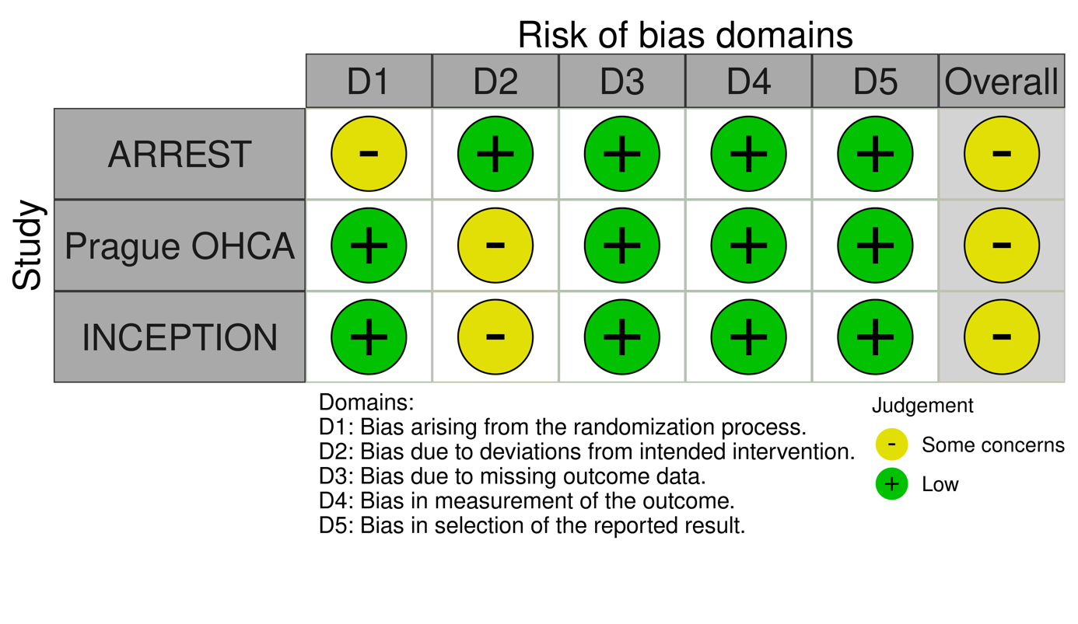
Supplementary Material 6. Funnel plot facilitating publication bias assessment with the result of the Egger’s test.
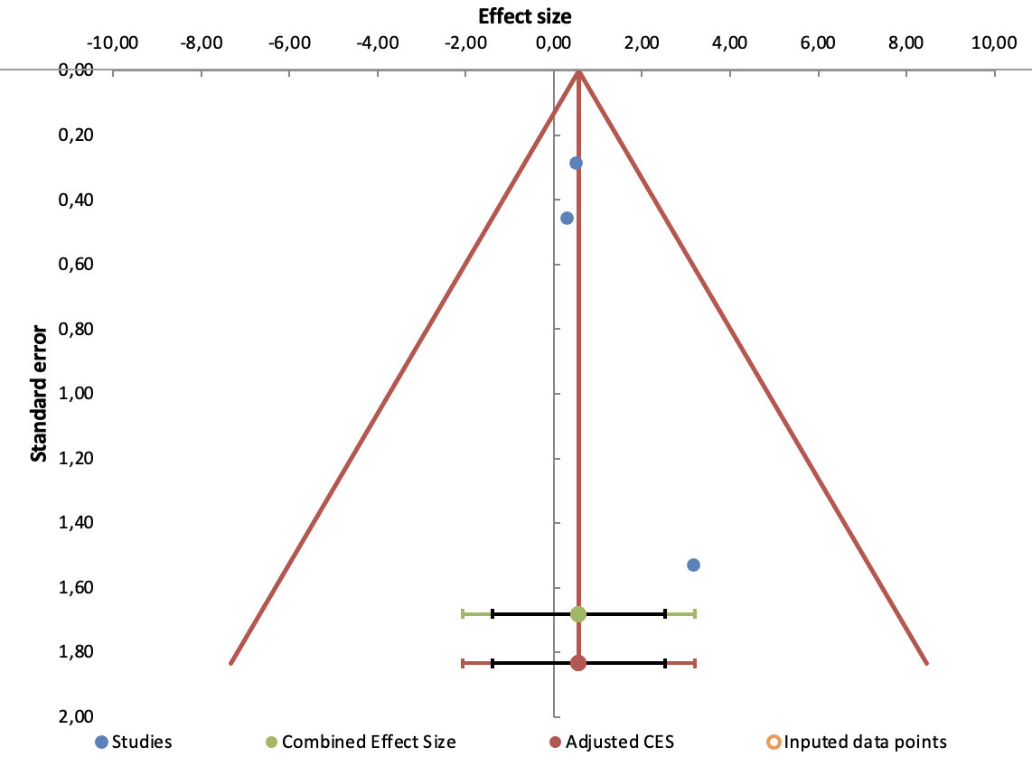
Egger’s test: p-value=0.239.
CES: combined effect size.

