Supplementary Information

Supplementary Table 1. Unmatched and propensity score-matched groups within ‘early MV’ population.

 | Unmatched  (n=1824) | Matched  (n=295) | p | SMD
Age | 73.00 [63.00, 80.00] | 71.00 [61.00, 80.00] | 0.320 | 0.071
Sex |  |  | 0.764 | 0.023
Male | 1164 ( 63.8) | 185 ( 62.7)
Female | 660 ( 36.2) | 110 ( 37.3)
BMI | 21.94 [19.20, 24.79] | 21.71 [18.72, 24.80] | 0.545 | 0.038
Septic shock
Vasopressor | 777 ( 42.6) | 91 ( 30.8) | <0.001 | 0.246
Lactate >2 mmol/L | 1328 ( 72.8) | 202 ( 68.5) | 0.141 | 0.095
Comorbidities
Cardiovascular disease | 435 ( 23.8) | 78 ( 26.4) | 0.373 | 0.060
Chronic lung disease | 320 ( 17.5) | 30 ( 10.2) | 0.002 | 0.215
Chronic neurologic disease | 463 ( 25.4) | 67 ( 22.7) | 0.362 | 0.063
Chronic liver disease | 174 ( 9.5) | 32 ( 10.8) | 0.550 | 0.043
Diabetes mellitus | 710 ( 38.9) | 108 ( 36.6) | 0.488 | 0.048
Chronic kidney disease | 263 ( 14.4) | 48 ( 16.3) | 0.456 | 0.051
Connective tissue disease | 49 ( 2.7) | 9 ( 3.1) | 0.870 | 0.022
Immunosuppressed | 65 ( 3.6) | 18 ( 6.1) | 0.054 | 0.119
Hematologic malignancy | 133 ( 7.3) | 23 ( 7.8) | 0.851 | 0.019
Solid malignant tumor | 562 ( 30.8) | 81 ( 27.5) | 0.274 | 0.074
Respiratory infection | 1140 ( 62.5) | 116 ( 39.3) | <0.001 | 0.477
Vital signs
SBP (mmHg) | 105.00 [86.00, 126.00] | 102.00 [87.50, 120.00] | 0.235 | 0.070
DBP (mmHg) | 61.00 [51.00, 73.00] | 60.00 [50.00, 72.00] | 0.679 | 0.001
HR (beats/min) | 109.00 [91.00, 126.00] | 110.00 [90.50, 124.00] | 0.664 | 0.040
RR (breaths/min) | 22.00 [18.00, 26.00] | 24.00 [20.00, 29.00] | <0.001 | 0.323
Lactate (mmol/L) | 3.80 [2.00, 7.00] | 3.60 [1.70, 5.91] | 0.061 | 0.190
SOFA score | 8.00 [5.00, 10.00] | 6.00 [5.00, 9.00] | <0.001 | 0.331
ICU mortality | 707 ( 38.8) | 107 ( 36.3) | 0.453 | 0.051
In-hospital mortality | 878 ( 48.1) | 132 ( 44.7) | 0.308 | 0.068
Hospital duration (days) | 19.00 [8.00, 37.00] | 18.00 [8.00, 35.50] | 0.674 | 0.052
ICU duration (days) | 7.00 [3.00, 15.00] | 7.00 [3.00, 14.00] | 0.511 | 0.054
MV duration (days) | 5.00 [2.00, 13.00] | 4.00 [2.00, 10.50] | 0.063 | 0.074

Supplementary Table 2. Unmatched and propensity score-matched groups within ‘delayed MV’ population.

 | Unmatched  (n=26) | Matched  (n=295) | p | SMD
Age | 64.00 [55.25, 67.75] | 71.00 [59.50, 79.00] | 0.010 | 0.471
Sex |  |  | 0.452 | 0.195
Male | 14 ( 53.8) | 187 ( 63.3)
Female | 12 ( 46.2) | 108 ( 36.6)
BMI | 21.11 [19.89, 24.02] | 22.01 [18.82, 24.84] | 0.750 | 0.006
Septic shock
Vasopressor | 7 ( 26.9) | 101 ( 34.2) | 0.589 | 0.159
Lactate >2 mmol/L | 17 ( 65.4) | 189 ( 64.1) | 1.000 | 0.028
Comorbidities
Cardiovascular disease | 3 ( 11.5) | 70 ( 23.7) | 0.239 | 0.324
Chronic lung disease | 1 ( 3.8) | 38 ( 12.9) | 0.299 | 0.331
Chronic neurologic disease | 3 ( 11.5) | 56 ( 19.0) | 0.499 | 0.208
Chronic liver disease | 3 ( 11.5) | 35 ( 11.9) | 1.000 | 0.010
Diabetes mellitus | 2 ( 7.7) | 100 ( 33.9) | 0.011 | 0.682
Chronic kidney disease | 1 ( 3.8) | 47 ( 15.9) | 0.171 | 0.413
Connective tissue disease | 1 ( 3.8) | 12 ( 4.1) | 1.000 | 0.011
Immunosuppressed | 1 ( 3.8) | 15 ( 5.1) | 1.000 | 0.060
Hematologic malignancy | 4 ( 15.4) | 29 ( 9.8) | 0.577 | 0.168
Solid malignant tumor | 5 ( 19.2) | 86 ( 29.2) | 0.396 | 0.233
Respiratory infection | 1 ( 3.8) | 125 ( 42.4) | <0.001 | 1.028
Vital signs
SBP (mmHg) | 112.50 [93.50, 131.50] | 105.00 [91.00, 123.00] | 0.158 | 0.335
DBP (mmHg) | 68.50 [54.25, 95.00] | 62.00 [52.50, 71.00] | 0.130 | 0.401
HR (beats/min) | 106.50 [92.00, 118.75] | 109.00 [93.50, 124.00] | 0.808 | 0.052
RR (breaths/min) | 32.00 [27.00, 37.75] | 25.00 [20.00, 30.00] | <0.001 | 0.861
Lactate (mmol/L) | 3.00 [1.90, 3.88] | 3.11 [1.80, 6.05] | 0.258 | 0.461
SOFA score | 5.00 [4.00, 6.75] | 7.00 [5.00, 9.00] | 0.003 | 0.662
ICU mortality | 8 ( 30.8) | 137 ( 46.4) | 0.182 | 0.326
In-hospital mortality | 11 ( 42.3) | 165 ( 55.9) | 0.257 | 0.275
Hospital duration (days) | 29.50 [15.25, 54.50] | 23.00 [12.00, 48.50] | 0.274 | 0.064
ICU duration (days) | 15.00 [7.00, 24.25] | 12.00 [6.00, 20.00] | 0.414 | 0.107
MV duration (days) | 7.50 [3.00, 17.25] | 6.00 [2.00, 13.50] | 0.427 | 0.161

Supplementary Table 3. Propensity score matching using available variables on the day of MV initiation.
 | Early MV  (n=214) | Delayed MV  (n=214) | p | SMD
Age | 71.50 [60.00, 79.00] | 69.50 [60.00, 78.00] | 0.446 | 0.072
Sex |  |  | 0.040 | 0.209
Male | 153 (71.5) | 132 (61.7)
Female | 61 (28.5) | 82 (38.3)
 | 21.98 [19.47, 24.61] | 21.74 [18.82, 24.60] | 0.742 | 0.015
Comorbidities
Cardiovascular disease | 50 (23.4) | 48 (22.4) | 0.908 | 0.022
Chronic lung disease | 26 (12.1) | 26 (12.1) | 1.000 | <0.001
Chronic neurologic disease | 35 (16.4) | 33 (15.4) | 0.895 | 0.026
Chronic liver disease | 32 (15.0) | 28 (13.1) | 0.676 | 0.054
Diabetes mellitus | 69 (32.2) | 70 (32.7) | 1.000 | 0.01
Chronic kidney disease | 28 (13.1) | 28 (13.1) | 1.000 | <0.001
Connective tissue disease | 8 ( 3.7) | 7 ( 3.3) | 1.000 | 0.025
Immunosuppressed | 12 ( 5.6) | 11 ( 5.1) | 1.000 | 0.021
Hematologic malignancy | 13 ( 6.1) | 19 ( 8.9) | 0.358 | 0.107
Solid malignant tumor | 65 (30.4) | 66 (30.8) | 1.000 | 0.01
Vasopressor | 89 (41.6) | 79 (36.9) | 0.373 | 0.096
Initial lactate (mmol/L) | 4.60 [2.32, 7.68] | 3.45 [1.90, 6.36] | 0.026 | 0.236
Site of Infection |  |  | 0.921 | 0.019
Respiratory | 86 (40.2) | 84 (39.3)
Other than respiratory | 128 (59.8) | 130 (60.7)
Initial SOFA score | 8.00 [5.25, 11.00] | 7.00 [4.00, 9.00] | <0.001 | 0.452
SOFA score on ICU day 1 | 12.00 [10.00, 15.00] | 9.00 [6.00, 11.00] | <0.001 | 1.082
SOFA score on MV initiation day | 12.00 [10.00, 15.00] | 12.00 [10.00, 15.00] | 0.433 | 0.087
Lactate on MV initiation day | 4.50 [2.00, 8.47] | 3.95 [1.96, 7.72] | 0.431 | 0.103
Vasopressor on MV initiation day | 188 (87.9) | 188 (87.9) | 1.000 | <0.001
Outcome
ICU mortality | 94 (43.9) | 95 (44.4) | 1.000 | 0.009

When the patients who received MV on ICU day 1 was compared to those who received MV on ICU day 2 and 3, no significant difference was observed in ICU mortality (43.9% vs. 44.4%; odds ratio, 0.98; 95% confidence interval, 0.66–1.46; p=1.000).

The vital sign information was not available on day 1, 2, and 3 of ICU stay and was omitted from the variables for propensity score matching. All other methods remained the same as the primary analysis.
Supplementary Figure 1. Survival plot showing 28-day mortality of ‘early MV’ and ‘delayed MV’ groups. P-value was calculated using log-rank test.

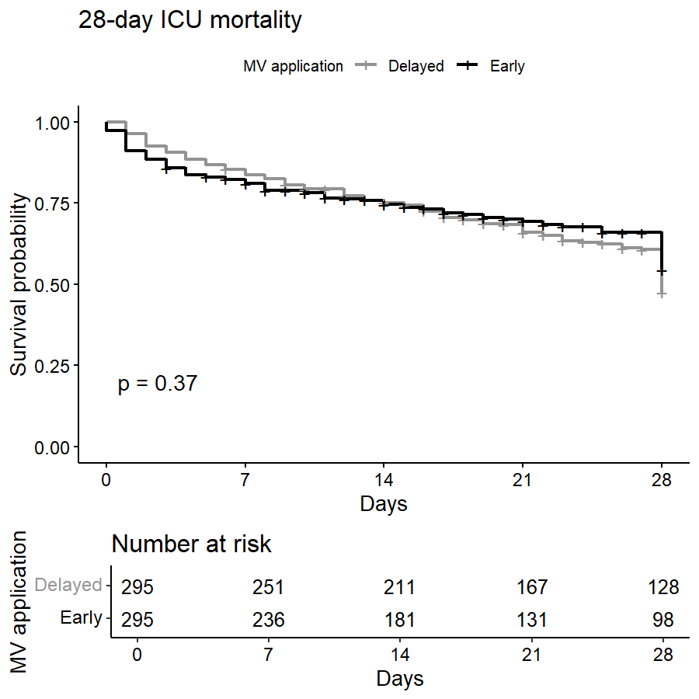

MV; mechanical ventilation, ICU; intensive care unit

