Testing preload responsiveness by the tidal volume challenge assessed by the plethysmographic perfusion index

Chiara BRUSCAGNIN ^{1,2}, Rui SHI ¹, Daniela ROSALBA ¹, Gaelle FOUQUE ¹, Julien HAGRY ¹, Christopher LAI ¹, Katia DONADELLO ², Jean-Louis TEBOUL ¹, Xavier MONNET ¹

Supplemental data

Supplemental table 1. Baseline characteristics of patients excluded because of an unstable perfusion index signal in preload responsive and non-responsive patients, as defined by the effects of the PLR test
 |  | All patients (n=14) | Preload responders (n=4) | Preload non-responders (n=10) | p value
Age (years) |  | 64 ± 11 | 60 ± 14 | 65 ± 10 | 0.46
Sex (M/F) |  | 12 (86%)/2 (14%) | 3 (75%)/1 (25%) | 9 (90%)/1 (10%) | 0.49
SAPS II |  | 55 ± 16 | 52 ± 11 | 56 ± 20 | 0.69
SOFA |  | 15 ± 2 | 15 ± 1 | 15 ± 2 | 0.64
Lactate (mmol/L) |  | 3.0 ± 2.2 | 5.6 ± 7.6 | 2.0 ± 1.0 | 0.16
LV ejection fraction (%) |  | 40 ± 8 | 60 ± 0 | 43 ± 12 | —
Origin of shock
 | Septic | 13 (93%) | 3 (75%) | 10 (100%) | 0.11
 | Hypovolaemic | 1 (7%) | 1 (25%) | 0 (0%) | 0.11
 | Cardiogenic | 0 (0%) | 0 (0%) | 0 (0%) | —
 | Vasoplegic non-septic | 0 (0%) | 0 (0%) | 0 (0%) | —
Norepinephrine infusion |  | 14 (100%) | 4 (100%) | 10 (100%) | —
Dose of norepinephrine (µg/kg/min) |  | 0.50 [0.49] | 0.37 [0.19] | 0.62 [0.52] | 0.47
Vasopressin infusion |  | 2 (14%) | 2 (50%) | 0 (0%) | 0.02
ARDS |  | 11 (79%) | 4 (100%) | 7 (70%) | 0.23
Vt (mL/kg PBW) |  | 378 ± 33 | 375 ± 38 | 381 ± 34 | 0.58
Respiratory rate (breaths/min) |  | 26 ± 3 | 27 ± 2 | 26 ± 3 | 0.36
Plateau pressure (cmH₂O) |  | 20 ± 4 | 21 ± 4 | 20 ± 4 | 0.51
PEEP (cmH₂O) |  | 11 ± 4 | 11 ± 2 | 11 ± 5 | 0.94
PaO₂/FiO₂ (mmHg) |  | 188 ± 55 | 162 ± 31 | 198 ± 60 | 0.29
GEDVI (mL/m²) |  | 851 ± 119 | 865 ± 126 | 845 ± 124 | 0.79
EVLWI (mL/kg PBW) |  | 15 ± 7 | 17 ± 10 | 14 ± 6 | 0.44
PVPI |  | 2.5 ± 1.2 | 3 ± 1.6 | 2.3 ± 1.0 | 0.36
ICU mortality |  | 3 (21%) | 0 (0%) | 3 (30%) | 0.23
Values are expressed as mean±SD.
ARDS: acute respiratory distress syndrome, EVLWI: extravascular lung water indexed for ideal body weight, GEDVI: global end-diastolic volume indexed for body surface, ICU: intensive care unit, LV: left ventricular, PaO₂/FiO₂: ratio of the arterial oxygen partial pressure over the inspired fraction of oxygen, PEEP: positive end-expiratory pressure, PI: perfusion index, PPV: pulse pressure variation, PVI: pleth variability index, SAPS: simplified acute physiology score, SOFA: sequential organ failure score, Vt: tidal volume,

Supplemental table 2. Haemodynamic and photoplethysmography variables at different study times in the whole population.

 | Baseline 1 | Vt challenge | Baseline 2 | PLR
Heart rate (beats/min) | 89 ± 16 | 88 ± 16 | 88 ± 17 | 86 ± 18
Systolic arterial pressure (mmHg) | 123 ± 22 | 123 ± 23 | 124 ± 25 | 131 ± 26
Mean arterial pressure (mmHg) | 82 ± 13 | 81 ± 14 | 81 ± 13 | 87 ± 13
Diastolic arterial pressure (mmHg) | 61 ± 11 | 61 ± 11 | 61 ± 10 | 65 ± 10
Central venous pressure (mmHg) | 10 ± 4 | 11 ± 4 | 10 ± 4 | 13 ± 5
Intra-abdominal pressure (mmHg) | 8 ± 4 | 9 ± 3 | 8 ± 4 | 8 ± 4
PPV (%) | 9 ± 8 | 10 ± 8 | 6 ± 5 | 5 ± 5
Cardiac index (L/min/m²) | 2.81 ± 0.85 | 2.88 ± 0.97 | 3.05 ± 1.08 | 3.10 ± 1.21
PI (%) | 1.6 ± 1.96 | 1.59 ± 1.90 | 2.10 ± 2.08 | 2.08 ± 2.19
PVI (%) | 13 ± 10 | 14 ± 10 | 13 ± 9 | 14 ± 9
Values are expressed as mean±SD.
PI: perfusion index, PPV: pulse pressure variation, PVI: pleth variability index.

Supplemental figure 1 Correlation between changes (in percent) between perfusion (PI, measured on the forehead) and cardiac index (CI)

Supplemental figure 2 Correlation between changes (in percent) between perfusion (PI, measured on the fingertip) and cardiac index (CI)

Supplemental figure 3 Correlation between pleth variability index (PVI, measured on the forehead) and pulse pressure variation (PPV)

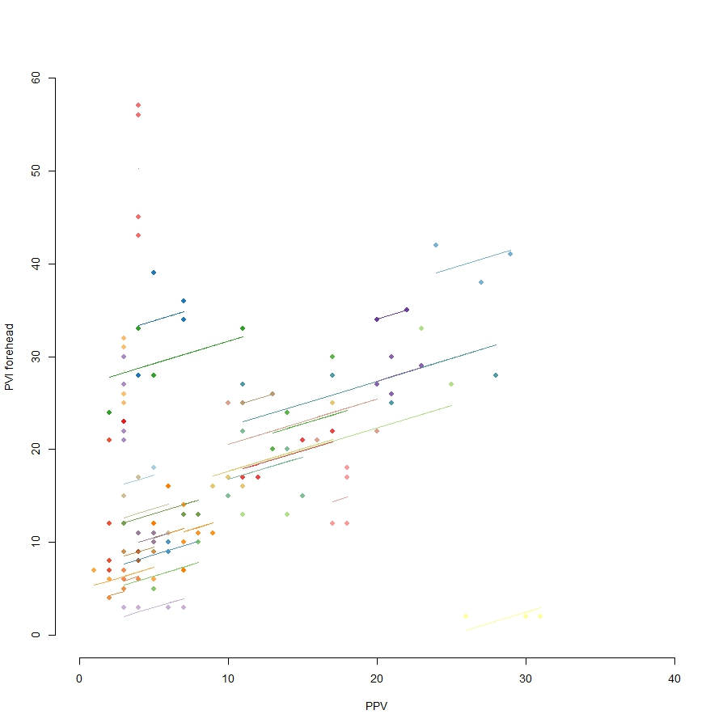

Supplemental figure 4: Sensitivity and specificity of the changes in perfusion index (PI) measured at the forehead induced by the tidal volume (Vt) challenge depending on the test result.
The gray zone represents the uncertain zone with cut-off values with a sensitivity of < 90% or a specificity of < 90%.

