Online Data Supplement

The Pleural Gradient Does Not Reflect The Superimposed Pressure In Patients with Class III Obesity

Stefano Spina; Lea Mantz; Yi Xin; David C. Moscho; Roberta Ribeiro De Santis Santiago; Luigi Grassi; Alice Nova; Sarah E. Gerard; Edward A Bittner; Florian J. Fintelmann; Lorenzo Berra; Maurizio Cereda

Respiratory mechanics calculations
Partitioned respiratory mechanics was assessed through an esophageal balloon (CooperSurgical, Trumbull, Connecticut, or AVEA ventilator nasogastric pressure monitoring tube set; CareFusion, San Diego, California), with proper position checked as previously described (1). Figure E1 provides an illustrative esophageal manometry tracing. The following variables were calculated.
- $Respiratory system elastance \left(E_{rs}\right)=\frac{Pplat-PEEP}{Tidal volume (TV)}$, where $Pplat-PEEP$ is the driving pressure.
- $Lung elastance \left(E_{lung}\right)=\frac{P_{L_insp}-P_{L_exp}}{TV}$, where $P_{L_insp}-P_{L_exp}$ is the driving transpulmonary pressure. The transpulmonary pressure (P_{L}) is calculated at end-inspiration (P_{L_insp}=Pplat-Pes _{end-inspiration}), and end-expiration (P_{L_exp}=PEEP-Pes _{end-expiration}).
- $Chest wall elastance \left(E_{cw}\right)=\frac{Pes end-inspiration \left({Pes}_{insp}\right) - Pes end-expiration \left({Pes}_{exp}\right)}{TV}$
- Transpulmonary pressure calculated through the elastance ratio method (2):
$$Transpulmonary pressure elastance ratio \left(P_{L_er}\right)=\left(PPlat*\frac{E_{lung}}{E_{rs}}\right)$$

Pleural pressure (Ppl) in the non-dependent lung regions:

${Ppl}_{nd}=PPlat-P_{L_er}$
- Vertical Ppl gradient: $Ppl gradient=Pes_{insp}-{Ppl}_{nd}$

Computed tomography image analysis
- Superimposed pressure measurement. The superimposed pressure (SP) was assessed using two different approaches (Figure E2, online data supplement). The first measurement was performed at the highest anteroposterior section of the lungs using the following equation (3, 4):
${SP}_{global}=lung density×lung height$ , where:
$$lung density =1- \frac{CT numbers (HU)}{-1,000}$$
$$lung height =distance between the ventral border and the esophageal level$$
Each voxel is characterized by a CT number expressed in Hounsfield units (HU), ranging from +1000 (bone) to zero (water) and to -1000 (air). The CT number is referred to as the mean HU per level.
In the second approach, the superimposed pressure was also measured at a regional level to analyze its distribution along the entire length of the lungs. This was done by dividing the lung into ten equal vertical sections craniocaudally:
${SP}_{regional 1, 2, …, 10}=lung density×lung height$ , where:
$$lung density =1- \frac{CT numbers (HU)}{-1,000}$$
$$lung height =highest ventrodorsal distance in each specific section$$
The thickness of each section was on average 2 ± 0.2 cm, calculated by dividing the entire longitudinal length of the lungs of each subjects by ten.

- Quantification of subcutaneous adipose tissue and muscle on axial images. Body composition analysis was performed at the level of the T5, T8, and T10 thoracic vertebral level using a fully automated deep learning image analysis pipeline (Figure E3, online data supplement). The pipeline combines validated slice-selection and segmentation networks to accurately quantify and characterize subcutaneous adipose tissue and skeletal muscle on chest CT scans (5). For each T5, T8, and T10 vertebral body level, subcutaneous adipose tissue and muscle cross sectional area in cm² were assessed. Field of view or CT quality issues affecting the segmentation were identified in a subsequent manual segmentation quality assessment. Unilateral segmentation issues led to duplication (i.e., multiplication of the cross-sectional area by two) of the unaffected side of the corresponding body composition compartment. Subcutaneous adipose tissue or muscle with bilateral segmentation issues could not be quantified. Correlation analyses were performed only with T10 data, as image analysis at that level was least prone to field of view issues and was fully available for all patients.

- Intrathoracic adipose tissue volume. A trained analyst measured the total volume of intrathoracic adipose tissue (cm³) on CT using semi-automated threshold-based segmentation (-190HU to -30HU) 3D Slicer version 4.10 (Figure E3, online data supplement). Intrathoracic adipose tissue was defined as adipose tissue within the endothoracic fascia from the top of the sternal manubrium to the caudal border of the diaphragm. An independent second analyst repeated this assessment on a random sample of five subjects (28%).

Figure E1
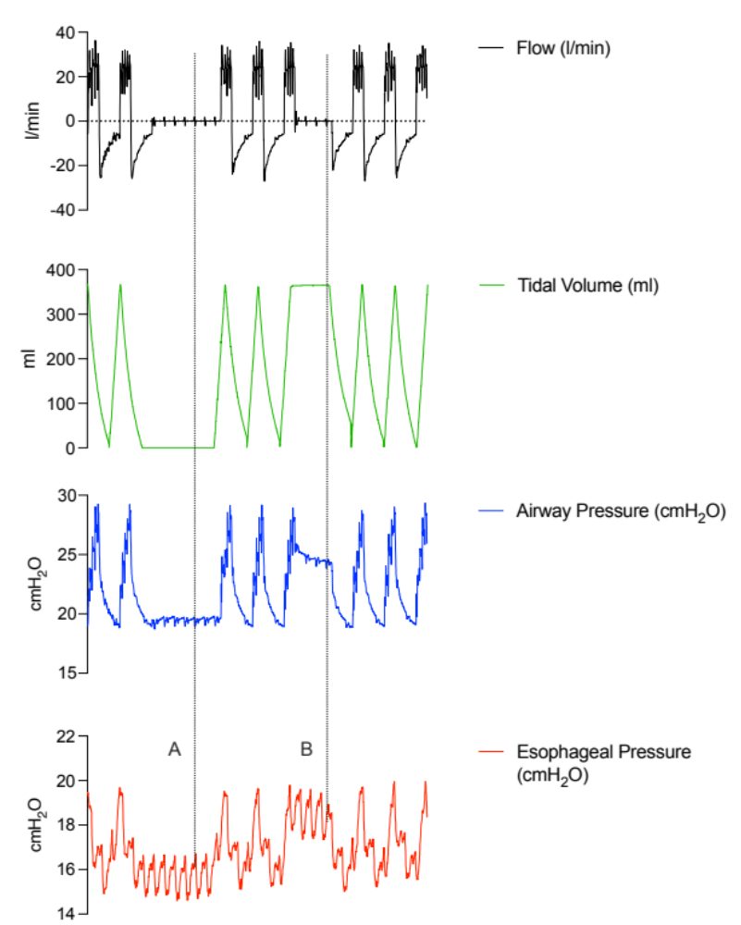

Representative tracings of flow (black), tidal volume (green), airway pressure (blue), and esophageal pressure (red) from a study patient. These tracings illustrate the methodology for recording and offline analysis of respiratory mechanics variables. Line A marks measurements taken at end-expiration, while Line B marks measurements taken at end-inspiration. Units are given as follows: flow in liters per minute (l/min), tidal volume in milliliters (ml), airway and esophageal pressure in cmH₂O.

Figure E2
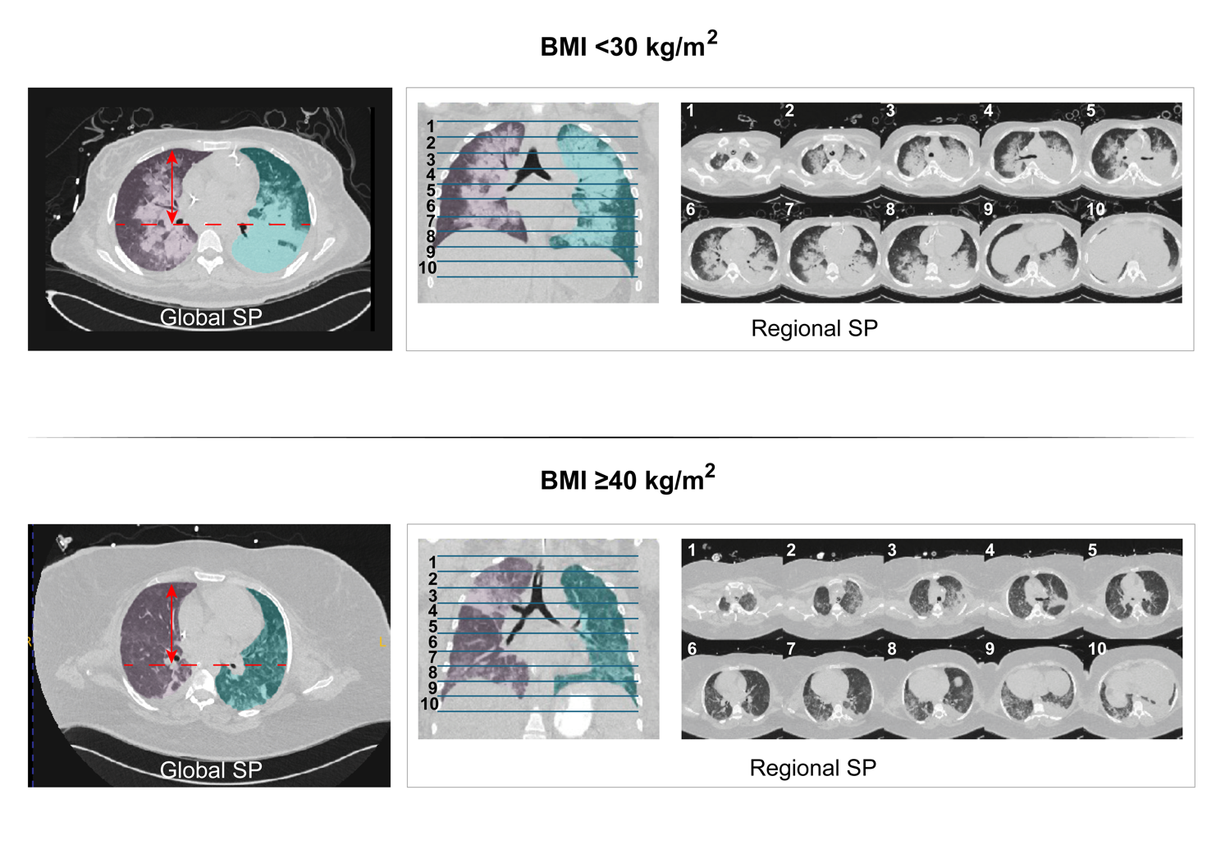
Superimposed pressure (SP) measurements in patients with BMI <30 kg/m² (top row) and BMI ≥40 kg/m² (bottom row). The left panels depict global SP measurements at the highest anteroposterior section of the lungs, calculated using lung density (derived from CT numbers in Hounsfield units, HU) and lung height (distance between the ventral border and the esophageal level, red arrows). Middle panels illustrate the division of the lungs into ten equal vertical sections for regional SP measurements, which analyze SP distribution along the craniocaudal axis. The right panels show CT images of these sections. For regional SP, lung height was the highest ventrodorsal distance in each specific section. Each section’s thickness was approximately 2 ± 0.2 cm. Color coding distinguishes different lung regions, after segmentation.

Figure E3
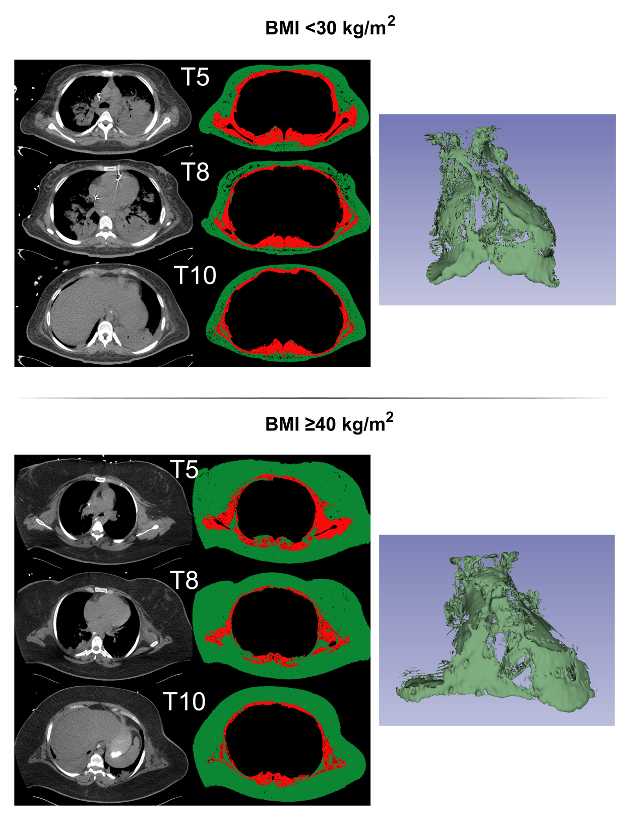
Segmentation images for muscle and adipose tissue in patients with BMI <30 kg/m² (top panel) and BMI ≥40 kg/m² (bottom panel).
For each group, the left panel illustrates the segmentation at T5, T8, and T10 thoracic vertebral levels, with skeletal muscle tissue cross sectional area depicted in red and subcutaneous adipose tissue cross sectional area in green. The right panel presents the 3D distribution of intrathoracic adipose tissue volume, which demonstrates how adipose tissue is distributed within the thoracic cavity, offering a comprehensive view of its spatial arrangement and volume in individuals with different BMI levels.

Table E1
Demographics characteristics of the overall population
 | n=18
Age, years | 60 [30-66]
Male, n (%) | 9 (50)
Race, n (%)
White | 10 (56)
Black or African American | 5 (28)
Asian | 1 (5)
Not reported | 2 (11)
Ethnicity, n (%)
Not hispanic or latino | 15 (84)
Hispanic | 1 (5)
Not reported | 2 (11)
Height, cm | 168.4 ± 11.5
Actual body weight, kg | 105.8 ± 39.9
Ideal body weight, kg | 63.8 ± 11.4
BMI, kg/m² | 35 [25-48]
Intensive care unit LOS, days | 24.5 [16-40]
Hospital LOS, days | 35 [22-45]
Ventilation days | 23 [13-37]
Ventilator free days | 0 [0-15]
Alive at hospital discharge, n (%) | 8 (44)
SAPS II | 40.9 ± 9.4
APACHE II | 18.9 ± 8.9
Reason for intensive care unit admission, n (%)
Medical | 12 (67)
Surgical | 6 (33)
Days between chest CT scan and study day | 0 (0-2)
PEEP during chest CT scan, cmH₂O | 11 ± 5
PEEP during study, cmH₂O | 11 ± 5

Data reported as mean ±SD (standard deviation) or median [IQR] (interquartile range). BMI=body mass index; LOS= length of stay; SAPS= Simplified Acute Physiology Score; APACHE= Acute Physiology and Chronic Health Evaluation; CT= computed tomography; PEEP= positive end-expiratory pressure.

Table E2
Clinical characteristics of the overall population on study day
 | n=18
FiO₂ on study day | 0.73 ± 0.23
PaO₂/FiO₂ on study day, mmHg | 171 ± 67
Tidal volume, ml | 342 ± 61
Tidal volume/Ideal body weight, ml/kg | 5.5 ± 1.1
Respiratory rate, breaths/min | 26 ± 6
Minute volume, l/min | 8.7 ± 2.1
Total PEEP, cmH₂O | 12 ± 5
Driving pressure, cmH₂O | 13 ± 4.7
Inspiratory transpulmonary pressure, cmH₂O | 10 ± 4.9
Expiratory transpulmonary pressure, cmH₂O | 0 ± 4.7
Driving transpulmonary pressure, cmH₂O | 10 ± 4.5
Elastance, cmH₂O/l
Respiratory system | 40.3 ± 19.2
Lung | 31.3 ± 18.2
Chest wall | 8.9 ± 4.3
pH | 7.34 ± 0.09
PaO₂ | 101.5 [86-115]
PaCO₂ | 47 ± 9
Base excess, mEq/l | 0.5 ± 5.6
Ventilatory ratio | 1.8 ± 0.6
SpO₂, % | 97 ± 3
Heart rate, beats/min | 86 ± 23
Systolic arterial blood pressure, mmHg | 115 ± 19
Diastolic arterial blood pressure, mmHg | 52 ± 8
Mean arterial blood pressure, mmHg | 73 ± 10

Data reported as mean ±SD (standard deviation) or median [IQR] (interquartile range).
FiO₂= Fraction of inspired oxygen; PaO₂= partial pressure of oxygen in the arterial blood;
PEEP= positive end-expiratory pressure; PaCO₂₌ partial pressure of carbon dioxide in the arterial blood; SpO₂= peripheral oxygen saturation.

Table E3
Subject ID | BMI | PEEP during CT scan | PEEP during esophageal manometry | Difference PEEP (esophageal manometry - CT scan) | Days between esophageal manometry and CT scan
#1 | 44 | 10 | 12 | 2 | -1
#2 | 62 | 10 | 12 | 2 | 2
#3 | 40 | 8 | 12 | 4 | 3
#4 | 59 | 16 | 15 | -1 | -3
#5 | 28 | 8 | 8 | 0 | 3
#6 | 50 | 12 | 10 | -2 | 3
#7 | 23 | 3 | 3 | 0 | -1
#8 | 42 | 16 | 16 | 0 | -3
#9 | 48 | 16 | 16 | 0 | -1
#10 | 24 | 10 | 10 | 0 | 1
#11 | 22 | 13 | 13 | 0 | -2
#12 | 25 | 5 | 5 | 0 | 1
#13 | 54 | 18 | 20 | 2 | -2
#14 | 22 | 12 | 8 | -4 | 0
#15 | 28 | 10 | 10 | 0 | 1
#16 | 29 | 0 | 3 | 3 | 2
#17 | 42 | 18 | 18 | 0 | -2
#18 | 25 | 15 | 15 | 0 | 0

For each subject included in the analysis, the table provides the body mass index (BMI), the value of positive end-expiratory pressure (PEEP) in cmH₂O during CT scan and during esophageal manometry, the difference between these two values, and the number of days between imaging and esophageal manometry.
Figure E4

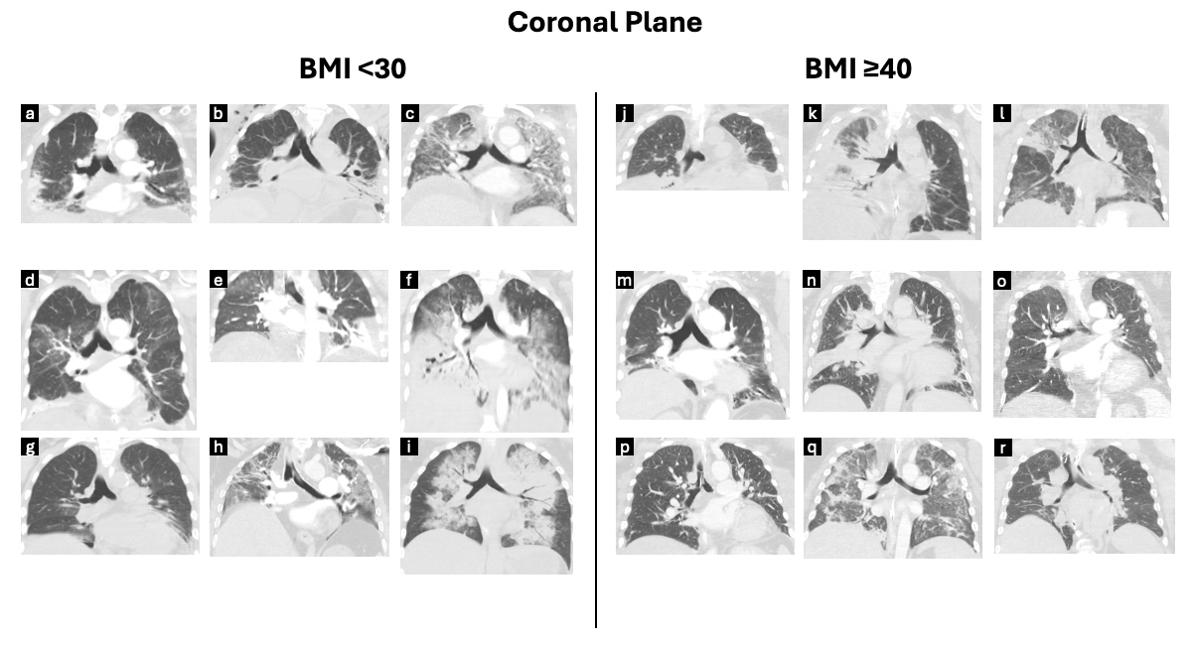
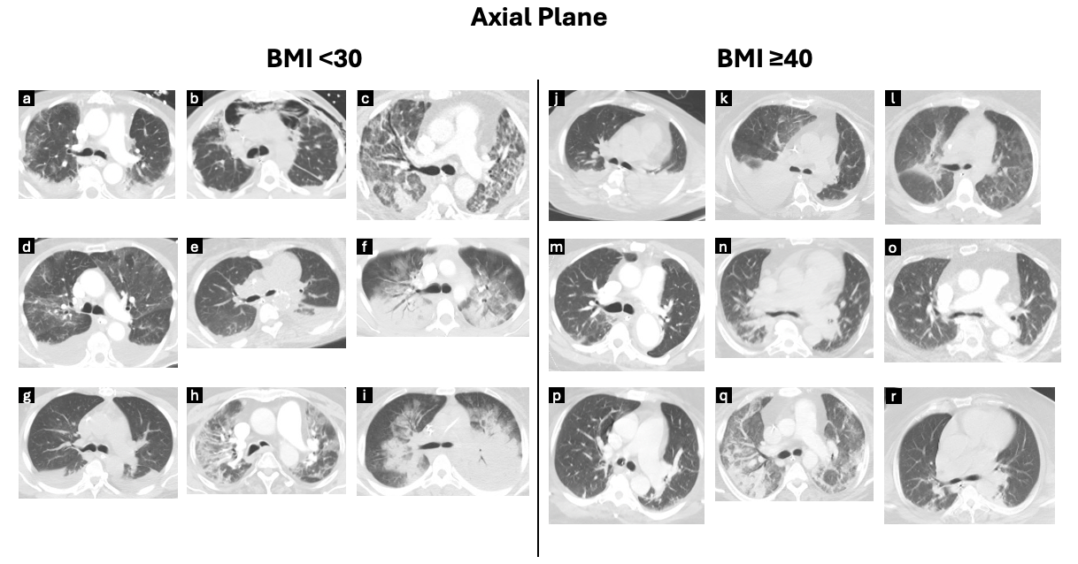

Chest computed tomography (CT) images in the coronal and axial planes demonstrating lung morphology and degree of injury in subjects with BMI <30 (left panels) and BMI ≥40 kg/m² (right panels). Each subpanel (labeled a–r) represents each subject included in the two study groups. Images were selected to show differences in lung aeration patterns and tissue characteristics among individuals. BMI=body mass index.

Figure E5
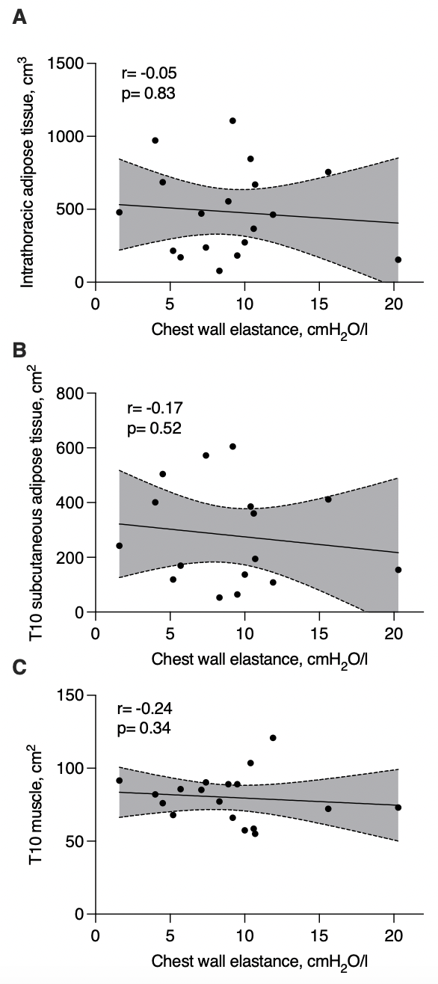
A) Correlation between the volume of intrathoracic adipose tissue and chest wall elastance. B) Correlation between subcutaneous adipose tissue cross sectional area at T10 and chest wall elastance. C) Correlation between muscle cross sectional area at T10 and chest wall elastance. For each correlation, r and p values are reported in the graphs, along with linear regression line and 95% confidence intervals.
Table E4
End-expiratory Pes | Coefficient | Standard error | t | p-value | [95% CI]
Subcutaneous adipose tissue area at T10 | 0.02 | 0.01 | 3.39 | 0.01 | 0.01 | 0.03
Sex | -2.19 | 2.16 | -1.01 | 0.33 | -6.89 | 2.51
SAPS II | 0.15 | 0.15 | 1.01 | 0.33 | -0.18 | 0.49
Intercept | 2.96 | 8.29 | 0.36 | 0.73 | -15.10 | 21.01

The table presents the coefficients, standard errors, t-values, and p-values for each independent variable in the regression model predicting end-expiratory esophageal pressure (Pes). The model is statistically significant (F(3, 12) = 5.2, p = 0.016), indicating that at least one independent variable significantly explains the variance in the outcome. Among the variables, subcutaneous adipose tissue cross sectional area at T10 is statistically significant (p = 0.01), suggesting a positive association with the outcome. The other variables do not show significant associations. SAPS= Simplified Acute Physiology Score.

Table E5
End-expiratory Pes | Coefficient | Standard error | t | p-value | [95% CI]
Intrathoracic adipose tissue volume | 0.01 | 0.00 | 2.38 | 0.03 | 0.00 | 0.02
Sex | -3.70 | 2.39 | -1.55 | 0.14 | -8.83 | 1.43
SAPS II | 0.07 | 0.13 | 0.56 | 0.58 | -0.21 | 0.35
Intercept | 10.30 | 7.74 | 1.33 | 0.20 | -6.30 | 26.89

The table presents the coefficients, standard errors, t-values, and p-values for each independent variable in the regression model predicting end-expiratory esophageal pressure (Pes). F(3, 14) = 3.03, p = 0.06. Among the variables, intrathoracic adipose tissue volume is statistically significant (p = 0.03), suggesting a positive association with the outcome. The other variables do not show significant associations. SAPS= Simplified Acute Physiology Score.

Table E6
End-expiratory Pes | Coefficient | Standard error | t | p-value | [95% CI]
Muscle area at T10 | 0.07 | 0.09 | 0.87 | 0.40 | -0.11 | 0.26
Sex | -4.07 | 2.89 | -1.41 | 0.18 | -10.26 | 2.12
SAPS II | 0.02 | 0.16 | 0.12 | 0.91 | -0.33 | 0.37
Intercept | 11.38 | 9.24 | 1.23 | 0.24 | -8.45 | 31.20

The table presents the coefficients, standard errors, t-values, and p-values for each independent variable in the regression model predicting end-expiratory esophageal pressure (Pes). The model is not statistically significant (F(3, 14) = 1.1 , p = 0.38), indicating that no variable significantly explains the variance in the outcome. SAPS= Simplified Acute Physiology Score.

References
1. Baydur A, Behrakis PK, Zin WA, Jaeger M, Milic-Emili J. A simple method for assessing the validity of the esophageal balloon technique. Am Rev Respir Dis 1982;126:788–791.
2. Gattinoni L, Chiumello D, Carlesso E, Valenza F. Bench-to-bedside review: Chest wall elastance in acute lung injury/acute respiratory distress syndrome patients. Crit Care 2004;8:350.
3. Pelosi P, D’Andrea L, Vitale G, Pesenti A, Gattinoni L. Vertical gradient of regional lung inflation in adult respiratory distress syndrome. Am J Respir Crit Care Med 1994;149:8–13.
4. Gattinoni L, Caironi P, Pelosi P, Goodman LR. What Has Computed Tomography Taught Us about the Acute Respiratory Distress Syndrome? Am J Respir Crit Care Med 2001;164:1701–1711.
5. Bridge CP, Best TD, Wrobel MM, Marquardt JP, Magudia K, Javidan C, et al. A Fully Automated Deep Learning Pipeline for Multi–Vertebral Level Quantification and Characterization of Muscle and Adipose Tissue on Chest CT Scans. Radiol Artif Intell 2022;4:e210080.

