SUPPLEMENTARY MATERIAL
Rezafungin versus caspofungin for patients with candidaemia or invasive candidiasis in the intensive care unit: pooled analyses of the ReSTORE and STRIVE randomised trials
Patrick M. Honoré^{1∗}, Massimo Girardis², Marin Kollef³, Oliver A. Cornely⁴, George R. Thompson III⁵, Matteo Bassetti⁶, Alex Soriano⁷, Haihui Huang⁸, Jose Vazquez⁹, Bart Jan Kullberg¹⁰, Peter G. Pappas¹¹, Nick Manamley¹², Taylor Sandison¹³, John Pullman¹⁴ and Saad Nseir¹⁵
¹ ICU Department, CHU UCL Godinne Namur, UCL Louvain Medical School, Namur, Belgium; ² Department of Anaesthesiology and Intensive Care, University of Modena and Reggio Emilia and University Hospital of Modena, Largo del Pozzo, Modena, Italy; ³ Washington University, St. Louis, MO, USA; ⁴ University of Cologne, Faculty of Medicine and University Hospital Cologne, Institute of Translational Research, Cologne Excellence Cluster on Cellular Stress Responses in Aging-Associated Diseases (CECAD) and University of Cologne, Faculty of Medicine and University Hospital Cologne, Department I of Internal Medicine, Center for Integrated Oncology Aachen Bonn Cologne Duesseldorf (CIO ABCD) and Excellence Center for Medical Mycology (ECMM) and German Centre for Infection Research (DZIF), Partner Site Bonn-Cologne and University of Cologne, Faculty of Medicine and University Hospital Cologne, Clinical Trials Centre Cologne (ZKS Köln), Cologne, Germany; ⁵ University of California Davis Medical Center, Davis, CA, USA; ⁶ University of Genoa, Genoa, Italy; ⁷ Hospital Clínic de Barcelona, IDIBAPS, University of Barcelona, CIBER of Infectious Diseases (CIBERINFEC), Barcelona, Spain; ⁸ Institute of Antibiotics, Huashan Hospital, Fudan University, Shanghai, China; ⁹ Medical College of Georgia/Augusta University, Augusta, GA, USA; ¹⁰ Radboudumc Center of Infectious Diseases and Department of Medicine, Radboud University Medical Center, Nijmegen, Netherlands; ¹¹ University of Alabama at Birmingham, Birmingham, AL, USA; ¹² Mundipharma Research Ltd, Cambridge, UK; ¹³ Cidara Therapeutics, Inc., San Diego, CA, USA; ¹⁴ Mercury Street Medical, Butte, MT, USA; ¹⁵ Médecine Intensive Réanimation, Hôpital R. Salengro, CHU de Lille, and Inserm U1285, Université de Lille, CNRS, UMR 8576-UGSF, F-59000, Lille, France

Supplementary Methods

Definition of candidaemia and/or invasive candidiasis

The mycological diagnosis of candidaemia and/or invasive candidiasis was established by one of the following test results from a blood or normally sterile site sample collected ≤4 days (96 hours) before randomisation:

≥1 blood culture positive for yeast or Candida spp.

positive test for Candida spp. from a rapid in vitro diagnostic test (eg, T2Candida Panel, Septifast)

positive gram stain (or other method of direct microscopy) for yeast or positive culture for Candida spp. from a specimen obtained from a normally sterile site.
For the diagnosis of invasive candidiasis, cultures were to be obtained from purulent fluid or necrotic tissues from normally sterile sites.
To be included in the studies, patients also had to have one or more systemic signs attributable to candidaemia and/or invasive candidiasis (eg, fever, hypothermia, hypotension, tachycardia, tachypnoea).

Outcome definitions
The primary outcome in this analysis, Day 30 all-cause mortality, was defined as patients who died irrespective of cause or had an unknown survival status up to Day 30. The secondary outcome, mycological response (eradication) within patients with a positive baseline blood culture, was defined as a negative blood culture with no change in antifungal therapy on or before the day of assessment (i.e., Days 5 and 14), with no subsequent positive cultures. The exploratory outcome of time to negative blood culture within those with a positive baseline blood culture was defined as the time (in hours) from first study drug dose to the time of first negative culture, with no subsequent positive cultures. For assessment of mycological response and time to negative blood culture, blood cultures were repeated either daily or every other day until the first negative blood culture result, with no subsequent positive culture. For the analysis of time to negative blood culture, patients were censored if they received an alternative antifungal for the treatment of candidaemia or invasive candidiasis, died or were lost to follow-up before a negative blood culture was reported.

Table S1 Baseline fungal pathogens presentª and MIC distribution of rezafungin, by treatment group (mITT population, patients in the ICU at randomisation)
Candida spp. | Rezafungin 400/200 mg (n=46), n (%) | Caspofungin 70/50 mg (n=67),  n (%)
C. albicans | 19 (41.3) | 24 (35.8)
MIC, µg/mL
0.004 | 0 (0) | 1 (1.5)
0.008 | 3 (6.5) | 5 (7.5)
0.015 | 7 (15.2) | 5 (7.5)
0.03 | 2 (4.3) | 5 (7.5)
0.06 | 4 (8.7) | 8 (11.9)
0.12 | 3 (6.5) | 0 (0)
C. glabrata | 17 (37.0) | 11 (16.4)
MIC, µg/mL
0.03 | 4 (8.7) | 2 (3.0)
0.06 | 9 (19.6) | 8 (11.9)
0.12 | 4 (8.7) | 0 (0)
0.5 | 0 (0) | 1 (1.5)
C. parapsilosis | 4 (8.7) | 18 (26.9)
MIC, µg/mL
0.5 | 0 (0) | 1 (1.5)
1 | 2 (4.3) | 14 (20.9)
2 | 2 (4.3) | 3 (4.5)
C. tropicalis | 9 (19.6) | 11 (16.4)
MIC, µg/mL
0.015 | 1 (2.2) | 2 (3.0)
0.03 | 2 (4.3) | 2 (3.0)
0.06 | 4 (8.7) | 5 (7.5)
0.12 | 2 (4.3) | 2 (3.0)
C. dubliniensis | 1 (2.2) | 1 (1.5)
MIC, µg/mL
0.03 | 1 (2.2) | 0 (0)
0.12 | 0 (0) | 1 (1.5)
C. krusei | 1 (2.2) | 0 (0)
MIC, µg/mL
0.06 | 1 (2.2) | 0 (0)
C. kefyr | 0 (0) | 1 (1.5)
MIC, µg/mL
0.03 | 0 (0) | 1 (1.5)
C. lusitaniae | 0 (0) | 1 (1.5)
MIC, µg/mL
0.12 | 0 (0) | 1 (1.5)
C. metapsilosis | 1 (2.2) | 0 (0)
MIC, µg/mL
0.5 | 1 (2.2) | 0 (0)
None specified | 0 (0) | 5 (7.5)
ICU, intensive care unit; MIC, minimum inhibitory concentration; mITT, microbiological intent-to-treat
Some patients had multiple Candida species present at baseline
ª Antifungal susceptibility MIC breakpoints have been published for these pathogens by the US Clinical and Laboratory Standards (CLSI): CLSI M27M44S. Performance Standards for Antifungal Susceptibility Testing of Yeasts, 3rd Edition. August 3, 2022

Table S2 Laboratory parameters (mITT population, patients in the ICU at randomisation)
 | Rezafungin 400/200 mg  (n=55) | Caspofungin 70/50 mg  (n=71)
Albumin, g/L
Baseline | 26.1 (15.1, 41.0) | 26.0 (15.3, 41.0)
Day 4 | 25.9 (14.6, 36.7) | 25.9 (15.8, 41.0)
Day 14 | 26.5 (20.3, 36.7) | 25.9 (13.5, 40.0)
EOT | 29.2 (13.8, 41.0) | 26.3 (11.7, 46.4)
Day 30 | 28.1 (23.8, 71.3) | 32.2 (21.1, 47.5)
Follow-up | 36.9 (15.1, 54.0) | 32.4 (14.1, 51.8)
Aspartate aminotransferase, U/L
Baseline | 28.2 (9.7, 371.5) | 28.1 (9.4, 395.5)
Day 4 | 24.3 (4.6, 81.0) | 29.6 (8.3, 195.3)
Day 14 | 20.4 (8.7, 118.2) | 29.8 (10.1, 393.6)
EOT | 26.0 (8.7, 294.5) | 27.3 (5.5, 695.7)
Day 30 | 23.3 (11.7, 92.3) | 26.2 (8.3, 306.8)
Follow-up | 16.5 (6.8, 106.4) | 20.8 (4.9, 108.4)
Alanine aminotransferase, U/L
Baseline | 25.5 (3.4, 425.0) | 26.3 (3.6, 245.7)
Day 4 | 22.6 (1.0, 230.0) | 25.3 (3.6, 128.9)
Day 14 | 20.5 (6.0, 56.0) | 30.3 (1.0, 587.0)
EOT | 18.0 (6.4, 137.0) | 35.3 (2.9, 742.0)
Day 30 | 15.1 (7.9, 125.9) | 20.0 (5.0, 170.8)
Follow-up | 15.1 (1.0, 132.4) | 17.5 (2.7, 113.5)
Alkaline phosphatase, U/L
Baseline | 130.8 (59.0, 347.1) | 148.1 (37.6, 2491.0)
Day 4 | 153.7 (50.2, 425.1) | 153.2 (55.3, 2325.8)
Day 14 | 168.3 (80.4, 389.6) | 167.5 (45.6, 1139.5)
EOT | 194.5 (55.0, 546.0) | 167.0 (49.0, 1987.3)
Day 30 | 184.0 (59.7, 359.9) | 202.1 (76.9, 1729.4)
Follow-up | 154.2 (68.4, 520.6) | 166.4 (57.9, 949.0)
Bilirubin, µmol/L
Baseline | 16.7 (2.5, 1118.2) | 20.3 (5.4, 255.92)
Day 4 | 15.0 (2.5, 1277.9) | 17.6 (5.7, 136.2)
Day 14 | 13.5 (6.2, 200.9) | 17.9 (5.1, 123.8)
EOT | 13.3 (3.4, 1042.4) | 18.6 (4.1, 118.3)
Day 30 | 14.6 (6.2, 71.3) | 16.9 (3.8, 46.4)
Follow-up | 12.2 (4.8, 46.9) | 11.8 (3.0, 439.5)
Potassium, mmol/L
Baseline | 4.2 (3.1, 7.0) | 3.9 (2.5, 6.8)
Day 4 | 4.1 (2.9, 5.9) | 4.0 (3.0, 5.7)
Day 14 | 4.1 (3.6, 5.5) | 4.0 (2.9, 445.6)
EOT | 4.2 (3.2, 6.2) | 4.2 (3.1, 5.6)
Day 30 | 4.2 (3.5, 4.9) | 4.1 (3.2, 8.2)
Follow-up | 4.1 (3.4, 5.1) | 4.1 (2.6, 5.2)
Magnesium, mmol/L
Baseline | 0.7 (0.1, 1.3) | 0.8 (0.4, 1.5)
Day 4 | 0.7 (0.5, 0.9) | 0.7 (0.5, 1.6)
Day 14 | 0.6 (0.6, 0.8) | 0.7 (0.5, 1.3)
EOT | 0.7 (0.5, 1.1) | 0.7 (0.3, 1.4)
Day 30 | 0.7 (0.6, 0.9) | 0.8 (0.6, 1.4)
Follow-up | 0.6 (0.6, 1.2) | 0.6 (0.4, 1.2)
Platelets, 10⁹/L
Baseline | 230.4 (35.0, 892.1) | 209.4 (11.0, 790.6)
Day 4 | 240.6 (14.1, 1146.4) | 252.7 (20.0, 866.3)
Day 14 | 291.4 (33.8, 960.8) | 310.5 (65.3, 946.1)
EOT | 282.1 (35.8, 1243.1) | 258.8 (9.0, 883.5)
Day 30 | 257.6 (110.0, 1372.5) | 294.8 (80.6, 479.4)
Follow-up | 280.3 (53.0, 1608.8) | 322.7 (75.0, 592.9)
EOT, end of therapy; ICU, intensive care unit; L, litre; U, units
All data are shown as median values (minimum, maximum)

Table S3 Pharmacokinetics of rezafungin after the first 400-mg loading doseª (pharmacokinetic analysis population)
Parameter | Patients in the ICU at randomisation  (n=50) | Patients not in the ICU at randomisation  (n=117)
AUC_{0–168h}, µg*h/mL
Mean (SD) | 759.95 (351.52) | 811.28 (267.39)
Median | 658.54 | 787.87
Range (minimum, maximum) | 287.42, 2014.31 | 370.98, 2040.37
Geometric mean (geometric CV, %) | 699.69 (41.12) | 772.09 (32.20)
C_{max}, µg/mL
Mean (SD) | 18.55 (7.79) | 18.58 (5.82)
Median | 17.13 | 17.85
Range (minimum, maximum) | 7.04, 44.82 | 5.19, 35.26
Geometric mean (geometric CV, %) | 17.21 (39.96) | 17.65 (33.78)
C_{min}, µg/mL
Mean (SD) | 2.19 (1.26) | 2.36 (0.99)
Median | 1.90 | 2.31
Range (minimum, maximum) | 0.59, 6.95 | 0.98, 8.28
Geometric mean (geometric CV, %) | 1.94 (51.75) | 2.19 (38.97)
AUC_{0–168h}, area under the plasma concentration‒time curve from 0 to 168 hours; C_{max}, maximum plasma concentration; C_{min}, minimum plasma concentration; CV, coefficient of variation;
ICU, intensive care unit; SD, standard deviation
ª In STRIVE, blood samples for pharmacokinetic sampling were obtained on Day 1 (within 10 minutes before the end of infusion, between 15 minutes and 1 hour after the end of infusion, and between 2 and 12 hours after the end of infusion), Day 2 (random draw), Day 4 (random draw) and Day 8 (predose). In ReSTORE, blood samples for pharmacokinetic sampling were obtained on Day 1 (within 10 minutes before the end of infusion, and between the end of infusion and 12 hours after the end of infusion), on Days 2, 3, 4 or 5 (one sample taken on one day only), and on Day 8 (predose)

Fig. S1 Patient disposition in the pooled population ICU subgroup

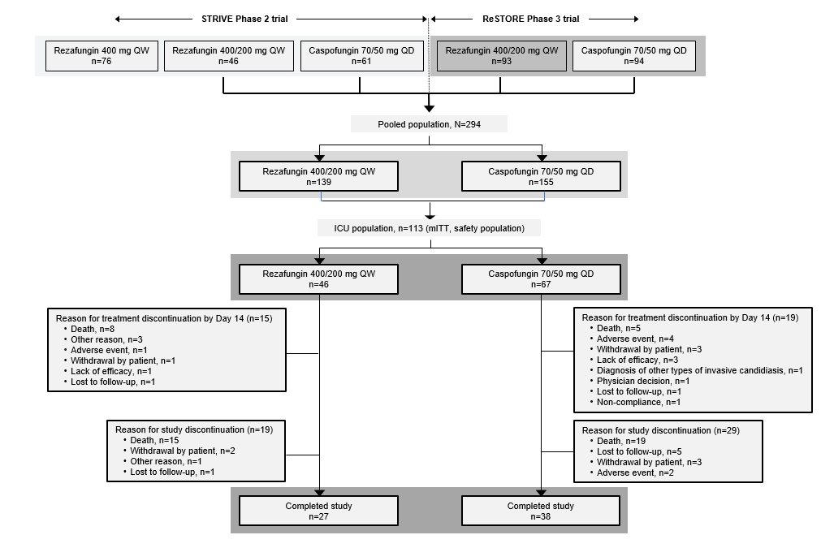
ICU, intensive care unit; mITT, modified intent-to-treat; QD, once daily; QW, once weekly
Patients who discontinued treatment by Day 14 could continue in the study

∗Correspondence: Patrick M. Honoré, patrick.honore@chuuclnamur.uclouvain.be

