Additional file
The efficacy of fiber-supplemented enteral nutrition in critically ill patients: a systematic review and meta-analysis of randomized controlled trials with trial sequential analysis
Jana Larissa Koch^{1, 2}, Charles Chin Han Lew, PhD^{3, 4}, PD Dr. med. Felix Kork², Prof. Dr. med. Alexander Koch⁵, Prof. Dr. med. Christian Stoppe^{6, 7}, Prof. Daren K. Heyland⁸, Dr. troph. Ellen Dresen⁶, Zheng-Yii Lee, PhD, MSc^{7, 9, a}, Dr. med. Aileen Hill^{2, 10, a, b}
¹ Medical Faculty RWTH Aachen University, Aachen, Germany
² Department of Anaesthesiology, University Hospital RWTH Aachen, Aachen, Germany
³ Department of Dietetics & Nutrition, Ng Teng Fong General Hospital, Singapore
⁴ Faculty of Health and Social Sciences, Singapore Institute of Technology, Singapore, Singapore
⁵ Department of Gastroenterology, Metabolic Diseases and Internal Intensive Care Medicine, University Hospital RWTH Aachen, Aachen, Germany
⁶ University Hospital Würzburg, Department of Anaesthesiology, Intensive Care, Emergency and Pain Medicine, Würzburg, Germany
⁷ Department of Cardiac Anaesthesiology and Intensive Care Medicine, Charité Berlin, Berlin, Germany
⁸ Department of Critical Care Medicine, Queen's University, Kingston, Ontario, Canada
⁹ Department of Anaesthesiology, University of Malaya, Kuala Lumpur, Malaysia
¹⁰ Department of Intensive Care Medicine, University Hospital RWTH Aachen, Aachen, Germany

ª Joint last author
^{b} Corresponding author:
Dr. med. Aileen Hill
University Hospital RWTH Aachen
Table of contents
PART 1: Methods (additional description) 1
1. Search strategies 1
2. Critical Care Nutrition (CCN) methodological quality scoring system 11
3. Trial Sequential Analysis 12
3. PRISMA 2020 Checklist 13
PART 2: Details of the characteristics, intervention, outcomes, and quality scoring of the included studies, and the list of excluded studies 16
Table S1: Characteristics of included studies and patients 17
Table S2: Funding source 20
Table S3: Feeding information 21
Table S4: Clinical outcomes 25
Table S5: Metabolic and nutritional outcomes 29
Table S6: Diarrheal outcome 31
Table S7: Adverse events and serious adverse events 32
Table S8: Clinical Trial Registry of ongoing or unpublished studies 32
Table S9: List of excluded studies after full-text review with reasons 33
Table S10: Canadian Critical Care Nutrition Methodological Scoring 37
Figure S1: ROB2 traffic light and summary plots 38
1a) Overall mortality 38
1b) Diarrhea 39
1c) Other GI complications 40
1d) ICU LOS 40
1e) Hospital LOS 41
1f) Infectious complications 41
1g) Duration of mechanical ventilation 42
1h) Time to reach target energy needs 42
PART 3: Results of the meta-analyses and subgroup analyses 43
PART 3A: Subgroup analyses 44
Table S11: Summary of the results of subgroup analyses 44
Table S12: Calculation of daily fiber doses 46
Figure S2: Overall mortality (subgroup analyses) 47
2a) Publication date 47
2b) Fermentability 47
2c) Viscosity 48
2d) Solubility 48
2e) Daily fiber dose 49
2f) Age 49
2g) Disease severity 50
2h) ICU admission type 50
2i) Intervention start 51
2j) Minimum duration of intervention 51
2k) Co-intervention with immunonutrition 52
2l) Funding source 52
2m) Type of control group 53
Figure S3: Diarrhea incidence (subgroup analyses) 54
3a) Publication date 54
3b) Fermentability 54
3c) Viscosity 55
3d) Solubility 55
3e) Daily fiber dose 56
3f) Age 56
3g) Disease severity 57
3h) ICU admission type 57
3i) Intervention start 58
3j) Minimum duration of intervention 58
3k) Co-intervention with immunonutrition 59
3l) Funding source 59
3m) Type of control group 60
PART 3B: Overall meta-analyses 61
Figure S4: Diarrhea score 61
Figure S5: Other GI complications 61
5a) Patients with at least one GI complication 61
5b) Abdominal distension 61
5c) Vomiting 61
5d) Regurgitation 62
5e) GI bleeding 62
5f) Constipation 62
Figure S6: Infectious complications 62
6a) Patients with at least 1 infectious complication 62
6b) Pneumonia 62
6c) Urinary tract infection 63
6d) Intra-abdominal infection 63
6e) Sepsis 63
6f) Vascular infection 63
6g) Wound infection 63
6h) Bacteremia 63
Figure S7: Duration of mechanical ventilation 64
Figure S8: Time to reach target energy needs 64
PART 3C: Funnel plots 65
Figure S9: Mortality 65
Figure S10: Diarrhea 65
10a) Diarrhea incidence 65
10b) Diarrhea score 66
Figure S11: Other GI complications 66
11a) Patients with at least 1 GI complication 66
11b) Abdominal distension 67
11c) Vomiting 67
11d) Constipation 68
11e) GI bleeding 68
11f) Regurgitation 69
Figure S12: ICU length of stay 69
Figure S13: Hospital length of stay 70
Figure S14: Infectious complications 70
14a) Patients with at least 1 infectious complication 70
14b) Pneumonia 71
14c) Urinary tract infection 71
14d) Intra-abdominal infection 72
14e) Sepsis 72
14f) Vascular infection 73
14g) Wound infection 73
14h) Bacteremia 74
Figure S15: Duration of mechanical ventilation 74
Figure S16: Time to reach target energy needs 75
PART 4: Trial Sequential Analysis 76
Fig. S17: Diarrhea incidence 76
a) RRR = 25% 76
b) sensitivity analysis – RRR = 15% 77
c) sensitivity analysis – RRR = 35% 77
Fig. S18: ICU LOS with sensitivity analyses 78
a) MIREDIF = 1 day 78
b) sensitivity analysis – MIREDIF = 2 days 78
c) sensitivity analysis – MIREDIF = 3 days 79
Fig. S19: Hospital LOS with sensitivity analyses 79
a) MIREDIF = 1 day 79
b) sensitivity analysis – MIREDIF = 2 days 80
c) sensitivity analysis – MIREDIF = 3 days 80
References 81

PART 1: Methods (additional description)

1. Search strategies
- Embase Classic+Embase <1947 to 2024 January 09>
# | Query | Results from 11 Jan 2024
1 | Critical illness/ | 36,387
2 | Intensive care/ | 151,692
3 | Artificial ventilation/ | 194,908
4 | Invasive ventilation/ | 9,292
5 | Invasive positive pressure ventilation/ | 99
6 | Intensive care medicine/ | 1,643
7 | Critically ill patient/ | 68,222
8 | Intensive care unit/ | 236,159
9 | Medical intensive care unit/ | 4,345
10 | Surgical Intensive care unit/ | 2,935
11 | Endotracheal intubation/ | 67,086
12 | Multiple organ failure/ | 51,168
13 | Sepsis/ | 211,264
14 | Bacteremia/ | 54,074
15 | Anaerobic bacteremia/ | 21
16 | Catheter-related bacteremia/ | 106
17 | Gram negative sepsis/ | 4,397
18 | Gram positive sepsis/ | 69
19 | Polymicrobial bacteremia/ | 28
20 | Fungemia/ | 4,411
21 | Candidemia/ | 5,518
22 | Cryptococcemia/ | 22
23 | Septic complication/ | 41
24 | Sepsis-associated encephalopathy/ | 669
25 | Sepsis-associated coagulopathy/ | 253
26 | Sepsis-induced acute lung injury/ | 86
27 | Sepsis-induced myocardial injury/ | 88
28 | Septicemia/ | 24,466
29 | Severe sepsis/ | 213
30 | Urosepsis/ | 4,404
31 | Hemorrhagic septicemia/ | 401
32 | Endotoxemia/ | 12,461
33 | shock/ | 43,744
34 | Septic shock/ | 70,100
35 | Toxic shock syndrome/ | 4,436
36 | Endotoxic shock/ | 122
37 | staphylococcal toxic shock syndrome/ | 43
38 | streptococcal toxic shock syndrome/ | 179
39 | capillary leak syndrome/ | 3,834
40 | cardiogenic shock/ | 39,631
41 | dengue shock syndrome/ | 559
42 | hemorrhagic shock/ | 21,780
43 | hypovolemic shock/ | 6,420
44 | ischemic shock/ | 12
45 | traumatic shock/ | 4,351
46 | vasodilatory shock/ | 526
47 | Systemic inflammatory response syndrome/ | 16,617
48 | Hyperinflammatory syndrome/ | 377
49 | Cytokine storm/ | 8,743
50 | Cytokine release syndrome/ | 9,005
51 | Adult respiratory distress syndrome/ | 57,372
52 | Acute lung injury/ | 18,588
53 | Transfusion related acute lung injury/ | 2,661
54 | Severe acute respiratory syndrome/ | 11,639
55 | Heart infarction/ | 343,148
56 | Heart arrest/ | 95,583
57 | cardiopulmonary arrest/ | 6,989
58 | out of hospital cardiac arrest/ | 15,331
59 | Extracorporeal oxygenation/ | 39,557
60 | arterio-venous ECMO/ | 126
61 | veno-arterial ECMO/ | 4,869
62 | veno-venous ECMO/ | 3,419
63 | Multiple trauma/ | 17,967
64 | brain injury/ | 104,039
65 | acquired brain injury/ | 2,830
66 | brain concussion/ | 8,491
67 | brain contusion/ | 4,704
68 | brain damage/ | 48,276
69 | brain stem injury/ | 2,959
70 | cerebellum injury/ | 2,701
71 | diffuse brain injury/ | 208
72 | traumatic brain injury/ | 67,978
73 | Acute liver failure/ | 11,894
74 | Acute on chronic liver failure/ | 5,691
75 | Fulminant hepatic failure/ | 2,536
76 | Acute pancreatitis/ | 40,439
77 | Acute hemorrhagic pancreatitis/ | 6,095
78 | Hemorrhagic pancreatitis/ | 618
79 | Acute kidney failure/ | 132,446
80 | Continuous renal replacement therapy/ | 9,018
81 | continuous hemodiafiltration/ | 2,761
82 | continuous hemodiafiltration/ | 2,761
83 | continuous hemodialysis/ | 1,713
84 | continuous hemofiltration/ | 3,108
85 | modified ultrafiltration/ | 280
86 | slow continuous ultrafiltration/ | 120
87 | intermittent renal replacement therapy/ | 120
88 | Burn/ | 73,321
89 | Burn shock/ | 702
90 | Electric burn/ | 2,876
91 | Burn unit/ | 3,287
92 | critical care.mp. | 76,744
93 | intensive care.mp. | 499,435
94 | critical illness.mp. | 45,368
95 | critically ill.mp. | 108,501
96 | ICU.ti,ab,kw. | 173,590
97 | Mechanical*2 ventilat*3.ti,ab,kw. | 116,741
98 | intubat*3.ti,kw. | 26,472
99 | Sepsis.mp. | 285,388
100 | Septicemia.mp. | 35,967
101 | Septic shock.mp. | 78,867
102 | Shock.ti,ab,kw. | 298,762
103 | Multiple organ failure.ti,ab,kw. | 12,493
104 | Multiple organ dysfunction syndrome.ti,ab,kw. | 3,852
105 | MODS.ti,ab,kw. | 3,908
106 | Systemic inflammatory response syndrome.ti,ab,kw. | 9,414
107 | Acute respiratory distress syndrome.mp. | 33,813
108 | ARDS.ti,ab,kw. | 33,137
109 | Acute lung injury.ti,ab,kw. | 25,550
110 | Myocardial infarction.ti,ab,kw. | 336,929
111 | Cardiac arrest.ti,ab,kw. | 75,336
112 | Extracorporeal Membrane Oxygenation.ti,ab,kw. | 26,316
113 | ECMO.ti,ab,kw. | 27,600
114 | Multiple trauma.ti,ab,kw. | 4,598
115 | Polytrauma.ti,ab,kw. | 6,472
116 | Multitrauma.ti,ab,kw. | 431
117 | Brain injur*3.ti,ab,kw. | 123,488
118 | Traumatic brain injury.ti,ab,kw. | 70,031
119 | TBI.ti,ab,kw. | 53,313
120 | Acute Liver failure.ti,ab,kw. | 14,286
121 | Acute pancreatitis.ti,ab,kw. | 43,792
122 | Acute kidney injury.ti,ab,kw. | 67,785
123 | AKI.ti,ab,kw. | 42,930
124 | Continuous renal replacement therapy.ti,ab,kw. | 6,656
125 | CRRT.ti,ab,kw. | 5,614
126 | Sustained low efficiency dialysis.ti,ab,kw. | 335
127 | SLED.ti,ab,kw. | 1,624
128 | Intermittent h?emodialysis.ti,ab,kw. | 2,638
129 | Burn unit.ti,ab,kw. | 2,104
130 | Burn patient.ti,ab,kw. | 1,725
131 | dietary fiber/ | 27,476
132 | prebiotic agent/ | 13,199
133 | resistant starch/ | 653
134 | arabinoxylan/ | 1,508
135 | beta glucan/ | 7,356
136 | cellulose/ | 46,566
137 | dextrin/ | 2,462
138 | guar gum/ | 3,640
139 | Hemicellulose/ | 7,849
140 | Inulin/ | 13,163
141 | Pectin/ | 12,511
142 | galactomannan/ | 4,815
143 | fructose oligosaccharide/ | 3,036
144 | galactose oligosaccharide/ | 1,399
145 | Lignin/ | 19,805
146 | methylcellulose/ | 8,896
147 | alginic acid/ | 31,199
148 | ispagula/ | 3,354
149 | Gum Arabic/ | 3,036
150 | Fiber.mp. | 499,870
151 | Fibre.mp. | 61,625
152 | Prebiotic.ti,ab,kw. | 10,404
153 | Resistant starch.ti,ab,kw. | 3,009
154 | arabinoxylan.ti,ab,kw. | 1,563
155 | Beta glucan.ti,ab,kw. | 6,523
156 | cellulose.ti,ab,kw. | 86,776
157 | dextrin.ti,ab,kw. | 2,386
158 | Guar gum.ti,ab,kw. | 2,883
159 | hemicellulose.ti,ab,kw. | 6,363
160 | inulin.ti,ab,kw. | 13,358
161 | pectin.ti,ab,kw. | 12,317
162 | galactomannan.ti,ab,kw. | 4,210
163 | fructose oligosaccharide.ti,ab,kw. | 10
164 | Fructooligosaccharide.ti,ab,kw. | 625
165 | FOS.ti,ab,kw. | 39,750
166 | galactose oligosaccharide.ti,ab,kw. | 2
167 | galactooligosaccharide.ti,ab,kw. | 261
168 | GOS.ti,ab,kw. | 6,939
169 | lignin.ti,ab,kw. | 20,891
170 | methylcellulose.ti,ab,kw. | 9,093
171 | Alginic acid.ti,ab,kw. | 890
172 | alginate.ti,ab,kw. | 31,140
173 | ispagula.ti,ab,kw. | 8
174 | ispaghula.ti,ab,kw. | 227
175 | Psyllium.ti,ab,kw. | 1,312
176 | Acacia gum.ti,ab,kw. | 242
177 | Gum Arabic.ti,ab,kw. | 1,808
178 | Artificial feeding/ | 3,277
179 | Enteric feeding/ | 41,731
180 | Nose feeding/ | 4,627
181 | Digestive tract intubation/ | 4,499
182 | Duodenum intubation/ | 487
183 | Stomach intubation/ | 1,805
184 | Dietary supplement/ | 24,558
185 | Nutrition supplement/ | 6,620
186 | Enteral nutrition.mp. | 19,790
187 | Enteral feeding.mp. | 9,973
188 | Enteric feeding.mp. | 41,802
189 | Enteral formula.mp. | 728
190 | Enteral product.mp. | 34
191 | (nutrition*2 adj3 support).mp. | 35,410
192 | EN.ti,ab,kw. | 114,739
193 | EN modular product.ti,ab,kw. | 0
194 | Dietary supplement.ti,ab,kw. | 9,922
195 | Nutrition supplement.ti,ab,kw. | 383
196 | or/1-130 | 2,433,924
197 | or/131-177 | 798,780
198 | or/178-195 | 233,695
199 | 196 and 197 and 198 | 687
200 | Clinical trial/ or Randomized controlled trial/ or Randomization/ or Single blind procedure/ or Double blind procedure/ or Crossover procedure/ or Placebo/ or Randomi?ed controlled trial$.tw. or Rct.tw. or Random allocation.tw. or Randomly allocated.tw. or Allocated randomly.tw. or (allocated adj2 random).tw. or Single blind$.tw. or Double blind$.tw. or ((treble or triple) adj blind$).tw. or Placebo$.tw. or Prospective study/ | 2,855,272
201 | Case study/ or Case report.tw. or Abstract report/ or letter/ | 1,987,705
202 | 200 not 201 | 2,788,218
203 | 199 and 202 | 201
204 | (exp adolescence/ or exp adolescent/ or exp child/ or exp childhood disease/ or exp infant disease/ or (adolescen* or babies or baby or boy? or boyfriend or boyhood or girlfriend or girlhood or child* or girl? or infan* or juvenil* or juvenile* or kid? or minors or minors* or neonat* or neonat* or neo-nata* or newborn* or new-born* or paediatric* or peadiatric* or pediatric* or perinat* or preschool* or puber* or pubescen* or school or school child* or school* or schoolchild* or schoolchild* or teen* or toddler? or underage? or under-age? or youth*).ti,ab,kw.) not exp adult/ | 4,601,691
205 | 203 not 204 | 161
206 | (exp animal/ or exp invertebrate/ or nonhuman/ or animal experiment/ or animal tissue/ or animal model/ or exp plant/ or fungus/) not (exp human/ or human tissue/) | 8,589,070
207 | 205 not 206 | 158

- Ovid MEDLINE(R) and Epub Ahead of Print, In-Process, In-Data-Review & Other Non-Indexed Citations and Daily <1946 to January 09, 2024>
# | Query | Results from 11 Jan 2024
1 | Critical Care/ | 61,453
2 | Critical Illness/ | 39,846
3 | Intensive Care Units/ | 71,957
4 | intubation, intratracheal/ | 40,081
5 | respiration, artificial/ | 57,535
6 | sepsis/ | 72,677
7 | Bacteremia/ | 28,273
8 | Endotoxemia/ | 4,811
9 | Hemorrhagic Septicemia/ | 241
10 | Fungemia/ | 3,176
11 | Candidemia/ | 1,595
12 | shock/ | 18,583
13 | multiple organ failure/ | 12,155
14 | shock, cardiogenic/ | 11,018
15 | shock, hemorrhagic/ | 12,389
16 | shock, surgical/ | 1,061
17 | shock, traumatic/ | 4,385
18 | systemic inflammatory response syndrome/ | 7,597
19 | cytokine release syndrome/ | 2,284
20 | shock, septic/ | 25,294
21 | Respiratory Distress Syndrome/ | 25,264
22 | Acute lung injury/ | 8,771
23 | Transfusion-related acute lung injury/ | 141
24 | Myocardial infarction/ | 181,165
25 | Heart Arrest/ | 32,851
26 | Out-of-Hospital Cardiac Arrest/ | 7,373
27 | Extracorporeal Membrane Oxygenation/ | 15,766
28 | Multiple Trauma/ | 13,535
29 | Brain Injuries/ | 56,872
30 | Brain Hemorrhage, Traumatic/ | 240
31 | Brain Injuries, Diffuse/ | 62
32 | Brain Injuries, Traumatic/ | 13,680
33 | Liver Failure, Acute/ | 6,226
34 | Acute-On-Chronic Liver Failure/ | 1,437
35 | Pancreatitis, Acute Hemorrhagic/ | 5
36 | Pancreatitis, Acute Necrotizing/ | 3,872
37 | Acute Kidney Injury/ | 55,763
38 | Continuous Renal Replacement Therapy/ | 872
39 | Hemofiltration/ | 4,816
40 | Hemodiafiltration/ | 2,642
41 | Hybrid renal replacement therapy/ | 33
42 | Intermittent renal replacement therapy/ | 33
43 | Burns/ | 49,129
44 | Burns, Chemical/ | 6,767
45 | Burns, Electric/ | 2,492
46 | Burn units/ | 2,994
47 | critical care.mp. | 91,150
48 | intensive care.mp. | 236,527
49 | critical illness.mp. | 46,916
50 | critically ill.mp. | 62,163
51 | ICU.ti,ab,kw. | 87,343
52 | Mechanical*2 ventilat*3.ti,ab,kw. | 71,312
53 | intubat*3.ti,kw. | 20,153
54 | Sepsis.mp. | 154,159
55 | Septicemia.mp. | 16,126
56 | Septic shock.mp. | 28,400
57 | Shock.ti,ab,kw. | 208,885
58 | Multiple organ failure.ti,ab,kw. | 8,481
59 | Multiple organ dysfunction syndrome.ti,ab,kw. | 2,784
60 | MODS.ti,ab,kw. | 2,473
61 | Systemic inflammatory response syndrome.ti,ab,kw. | 6,133
62 | Acute respiratory distress syndrome.mp. | 23,764
63 | ARDS.ti,ab,kw. | 19,926
64 | Acute lung injury.ti,ab,kw. | 17,503
65 | Myocardial infarction.ti,ab,kw. | 213,853
66 | Cardiac arrest.ti,ab,kw. | 44,349
67 | Extracorporeal Membrane Oxygenation.ti,ab,kw. | 17,678
68 | ECMO.ti,ab,kw. | 13,126
69 | Multiple trauma.ti,ab,kw. | 3,475
70 | Polytrauma.ti,ab,kw. | 4,564
71 | Multitrauma.ti,ab,kw. | 323
72 | Brain injur*3.ti,ab,kw. | 85,960
73 | Traumatic brain injury.ti,ab,kw. | 48,183
74 | TBI.ti,ab,kw. | 32,291
75 | Acute Liver failure.ti,ab,kw. | 8,245
76 | Acute pancreatitis.ti,ab,kw. | 28,166
77 | Acute kidney injury.ti,ab,kw. | 39,623
78 | Acute kidney injury.ti,ab,kw. | 39,623
79 | AKI.ti,ab,kw. | 22,295
80 | Continuous renal replacement therapy.ti,ab,kw. | 3,777
81 | CRRT.ti,ab,kw. | 2,586
82 | Sustained low efficiency dialysis.ti,ab,kw. | 178
83 | SLED.ti,ab,kw. | 1,294
84 | Intermittent h?emodialysis.ti,ab,kw. | 1,549
85 | Burn unit.ti,ab,kw. | 1,399
86 | Burn patient.ti,ab,kw. | 1,153
87 | dietary fiber/ | 19,863
88 | prebiotics/ | 4,378
89 | resistant starch/ | 309
90 | Alginates/ | 15,109
91 | Alginic acid/ | 96
92 | beta glucan/ | 5,134
93 | Cellulose/ | 34,569
94 | Methylcellulose/ | 4,837
95 | Lignin/ | 14,042
96 | Dextrin/ | 1,114
97 | Inulin/ | 7,510
98 | Pectin/ | 7,172
99 | Mannans/ | 6,538
100 | Oligosaccharides, Branched-Chain/ | 134
101 | Xylans/ | 3,742
102 | Psyllium/ | 744
103 | Gum Arabic/ | 998
104 | Fiber.mp. | 218,188
105 | Fibre.mp. | 45,548
106 | Prebiotic.ti,ab,kw. | 9,306
107 | Resistant starch.ti,ab,kw. | 2,718
108 | Alginic acid.ti,ab,kw. | 691
109 | alginate.ti,ab,kw. | 25,714
110 | Beta glucan.ti,ab,kw. | 5,795
111 | cellulose.ti,ab,kw. | 75,359
112 | dextrin.ti,ab,kw. | 1,654
113 | Guar gum.ti,ab,kw. | 2,120
114 | hemicellulose.ti,ab,kw. | 6,504
115 | inulin.ti,ab,kw. | 9,793
116 | pectin.ti,ab,kw. | 11,372
117 | galactomannan.ti,ab,kw. | 2,728
118 | lignin.ti,ab,kw. | 21,529
119 | methylcellulose.ti,ab,kw. | 6,223
120 | fructose oligosaccharide.ti,ab,kw. | 5
121 | Fructooligosaccharide.ti,ab,kw. | 512
122 | FOS.ti,ab,kw. | 33,130
123 | galactose oligosaccharide.ti,ab,kw. | 4
124 | galactooligosaccharide.ti,ab,kw. | 207
125 | GOS.ti,ab,kw. | 4,668
126 | arabinoxylan.ti,ab,kw. | 1,513
127 | ispagula.ti,ab,kw. | 5
128 | ispaghula.ti,ab,kw. | 152
129 | Psyllium.ti,ab,kw. | 913
130 | Acacia gum.ti,ab,kw. | 174
131 | Gum Arabic.ti,ab,kw. | 1,616
132 | Nutritional support/ | 7,222
133 | Enteral nutrition/ | 22,146
134 | Intubation, Gastrointestinal/ | 10,297
135 | Food, formulated/ | 6,225
136 | Dietary Supplements/ | 76,010
137 | Enteral nutrition.mp. | 26,633
138 | Enteral feeding.mp. | 6,373
139 | Enteric feeding.mp. | 90
140 | Enteral formula.mp. | 506
141 | Enteral product.mp. | 22
142 | (nutrition*2 adj3 support).mp. | 19,595
143 | EN.ti,ab,kw. | 113,624
144 | EN modular product.ti,ab,kw. | 0
145 | Dietary supplement.ti,ab,kw. | 7,584
146 | Nutrition supplement.ti,ab,kw. | 235
147 | or/1-86 | 1,397,472
148 | or/87-131 | 475,490
149 | or/132-146 | 245,516
150 | 147 and 148 and 149 | 322
151 | Randomized controlled trials as Topic/ or Randomized controlled trial/ or Random allocation/ or Double blind method/ or Single blind method/ or Clinical trial/ or exp Clinical Trials as Topic/ | 1,336,810
152 | ((clinic$ adj trial$1) or ((singl$ or doubl$ or treb$ or tripl$) adj (blind$3 or mask$3))).tw. or Placebos/ or Placebo$.tw. or Randomly allocated.tw. or (allocated adj2 random).tw. | 805,409
153 | 151 or 152 | 1,712,825
154 | Case report.tw. or Letter/ or Historical article/ or Review of reported cases.pt. or Review, multicase.pt. | 2,003,756
155 | 153 not 154 | 1,673,140
156 | 150 and 155 | 96
157 | (exp adolescent/ or exp child/ or exp infant/ or (infant disease* or childhood disease*).ti,ab,kf. or (adolescen* or babies or baby or boy? or boyfriend or boyhood or girlfriend or girlhood or child* or girl? or infan* or juvenil* or kid? or minors or minors* or neonat* or neo-nat* or newborn* or new-born* or paediatric* or peadiatric* or pediatric* or perinat* or preschool* or puber* or pubescen* or school* or teen* or toddler? or underage? or under-age? or youth*).ti,ab,kf. or (pediatric* or paediatric* or infan* or child* or adolescen* or young).jn,jw. or (pediatric* or paediatric* or infan* or child* or adolescen* or young).in.) not exp adult/ | 3,696,273
158 | 156 not 157 | 71
159 | (exp animal/ or exp invertebrate/ or animal experiment/ or animal model/ or exp plant/ or exp fungus/) not exp human/ | 5,619,584
160 | 158 not 159 | 66

- EBM Reviews - Cochrane Central Register of Controlled Trials <December 2023>
# | Query | Results from 11 Jan 2024
1 | Critical Care/ | 2,269
2 | Critical Illness/ | 3,254
3 | Intensive Care Units/ | 3,302
4 | intubation, intratracheal/ | 4,459
5 | respiration, artificial/ | 4,297
6 | sepsis/ | 3,423
7 | Bacteremia/ | 962
8 | Endotoxemia/ | 335
9 | Hemorrhagic Septicemia/ | 0
10 | Fungemia/ | 78
11 | Candidemia/ | 49
12 | shock/ | 759
13 | multiple organ failure/ | 629
14 | shock, cardiogenic/ | 413
15 | shock, hemorrhagic/ | 158
16 | shock, surgical/ | 10
17 | shock, traumatic/ | 61
18 | systemic inflammatory response syndrome/ | 541
19 | cytokine release syndrome/ | 114
20 | shock, septic/ | 1,269
21 | Respiratory Distress Syndrome/ | 1,941
22 | Acute lung injury/ | 713
23 | Transfusion-related acute lung injury/ | 8
24 | Myocardial infarction/ | 13,057
25 | Heart Arrest/ | 1,581
26 | Out-of-Hospital Cardiac Arrest/ | 719
27 | Extracorporeal Membrane Oxygenation/ | 300
28 | Multiple Trauma/ | 292
29 | Brain Injuries/ | 2,301
30 | Brain Hemorrhage, Traumatic/ | 7
31 | Brain Injuries, Diffuse/ | 3
32 | Brain Injuries, Traumatic/ | 1,020
33 | Liver Failure, Acute/ | 103
34 | Acute-On-Chronic Liver Failure/ | 129
35 | Pancreatitis, Acute Hemorrhagic/ | 0
36 | Pancreatitis, Acute Necrotizing/ | 168
37 | Acute Kidney Injury/ | 2,006
38 | Continuous Renal Replacement Therapy/ | 95
39 | Hemofiltration/ | 441
40 | Hemodiafiltration/ | 356
41 | Hybrid renal replacement therapy/ | 0
42 | Intermittent renal replacement therapy/ | 0
43 | Burns/ | 1,775
44 | Burns, Chemical/ | 46
45 | Burns, Electric/ | 15
46 | Burn units/ | 49
47 | critical care.mp. | 5,044
48 | intensive care.mp. | 30,611
49 | critical illness.mp. | 4,572
50 | critically ill.mp. | 8,729
51 | ICU.ti,ab,kw. | 17,802
52 | Mechanical*2 ventilat*3.ti,ab,kw. | 15,121
53 | intubat*3.ti,kw. | 11,227
54 | Sepsis.mp. | 13,430
55 | Septicemia.mp. | 713
56 | Septic shock.mp. | 3,745
57 | Shock.ti,ab,kw. | 12,562
58 | Multiple organ failure.ti,ab,kw. | 1,077
59 | Multiple organ dysfunction syndrome.ti,ab,kw. | 278
60 | MODS.ti,ab,kw. | 333
61 | Systemic inflammatory response syndrome.ti,ab,kw. | 916
62 | Acute respiratory distress syndrome.mp. | 2,397
63 | ARDS.ti,ab,kw. | 2,676
64 | Acute lung injury.ti,ab,kw. | 1,058
65 | Myocardial infarction.ti,ab,kw. | 32,885
66 | Cardiac arrest.ti,ab,kw. | 4,456
67 | Extracorporeal Membrane Oxygenation.ti,ab,kw. | 735
68 | ECMO.ti,ab,kw. | 932
69 | Multiple trauma.ti,ab,kw. | 432
70 | Polytrauma.ti,ab,kw. | 191
71 | Multitrauma.ti,ab,kw. | 19
72 | Brain injur*3.ti,ab,kw. | 7,379
73 | Traumatic brain injury.ti,ab,kw. | 4,422
74 | TBI.ti,ab,kw. | 3,084
75 | Acute Liver failure.ti,ab,kw. | 254
76 | Acute pancreatitis.ti,ab,kw. | 2,183
77 | Acute kidney injury.ti,ab,kw. | 3,908
78 | Acute kidney injury.ti,ab,kw. | 3,908
79 | AKI.ti,ab,kw. | 2,338
80 | Continuous renal replacement therapy.ti,ab,kw. | 529
81 | CRRT.ti,ab,kw. | 480
82 | Sustained low efficiency dialysis.ti,ab,kw. | 35
83 | SLED.ti,ab,kw. | 124
84 | Intermittent h?emodialysis.ti,ab,kw. | 177
85 | Burn unit.ti,ab,kw. | 123
86 | Burn patient.ti,ab,kw. | 279
87 | dietary fiber/ | 2,130
88 | prebiotics/ | 409
89 | resistant starch/ | 32
90 | Alginates/ | 295
91 | Alginic acid/ | 40
92 | beta glucan/ | 194
93 | Cellulose/ | 481
94 | Methylcellulose/ | 141
95 | Lignin/ | 12
96 | Dextrin/ | 42
97 | Inulin/ | 290
98 | Pectin/ | 19
99 | Mannans/ | 286
100 | Oligosaccharides, Branched-Chain/ | 0
101 | Xylans/ | 43
102 | Psyllium/ | 210
103 | Gum Arabic/ | 35
104 | Fiber.mp. | 11,226
105 | Fibre.mp. | 3,228
106 | Prebiotic.ti,ab,kw. | 1,427
107 | Resistant starch.ti,ab,kw. | 472
108 | Alginic acid.ti,ab,kw. | 67
109 | alginate.ti,ab,kw. | 878
110 | Beta glucan.ti,ab,kw. | 488
111 | cellulose.ti,ab,kw. | 1,942
112 | dextrin.ti,ab,kw. | 292
113 | Guar gum.ti,ab,kw. | 282
114 | hemicellulose.ti,ab,kw. | 32
115 | inulin.ti,ab,kw. | 1,216
116 | pectin.ti,ab,kw. | 349
117 | galactomannan.ti,ab,kw. | 103
118 | lignin.ti,ab,kw. | 43
119 | methylcellulose.ti,ab,kw. | 310
120 | fructose oligosaccharide.ti,ab,kw. | 54
121 | Fructooligosaccharide.ti,ab,kw. | 131
122 | FOS.ti,ab,kw. | 489
123 | galactose oligosaccharide.ti,ab,kw. | 26
124 | galactooligosaccharide.ti,ab,kw. | 62
125 | GOS.ti,ab,kw. | 884
126 | arabinoxylan.ti,ab,kw. | 96
127 | ispagula.ti,ab,kw. | 18
128 | ispaghula.ti,ab,kw. | 72
129 | Psyllium.ti,ab,kw. | 395
130 | Acacia gum.ti,ab,kw. | 24
131 | Gum Arabic.ti,ab,kw. | 57
132 | Nutritional support/ | 494
133 | Enteral nutrition/ | 2,136
134 | Intubation, Gastrointestinal/ | 743
135 | Food, formulated/ | 815
136 | Dietary Supplements/ | 14,102
137 | Enteral nutrition.mp. | 5,080
138 | Enteral feeding.mp. | 1,690
139 | Enteric feeding.mp. | 1,852
140 | Enteral formula.mp. | 255
141 | Enteral product.mp. | 11
142 | (nutrition*2 adj3 support).mp. | 3,155
143 | EN.ti,ab,kw. | 8,445
144 | EN modular product.ti,ab,kw. | 0
145 | Dietary supplement.ti,ab,kw. | 3,777
146 | Nutrition supplement.ti,ab,kw. | 232
147 | or/1-86 | 133,355
148 | or/87-131 | 21,064
149 | or/132-146 | 34,115
150 | 147 and 148 and 149 | 139

2. Critical Care Nutrition (CCN) methodological quality scoring system
 | Score
 | 0 |  | 1 |  |  | 2
Randomization |  |  | Not concealed or not sure |  |  | Concealment of allocation*
Analysis | Other |  |  |  |  | Intention to treat
Blinding | Not blinded |  | Single blinded  Check who was blinded:  Health Care Professionals  Outcomes Assessors |  |  | Double blinded
Patient selection | Selected patients or unable to tell |  | Consecutive eligible patients
Comparability of groups at baseline | No or not sure |  | Yes
Extent of follow-up | < 100% |  | 100%
Treatment protocol | Poorly described |  | Reproducibly described
Co-interventions** | Not described |  | Described but not equal or not sure |  |  | Well described and all equal
Outcomes | Not described |  | Partially described |  |  | Objectively defined
* Concealment of allocation means the person enrolling the patients is unaware of the next treatment assignment (e.g. phone in randomization, computer generated).
** Extent to which antibiotics, ventilation, oxygen, transfusions, etc were applied equally across groups

3. Trial Sequential Analysis
Type I and type II errors can influence a SRMA, resulting in incorrect conclusions and inappropriate clinical practices. In conventional meta-analyses, the practice of maintaining a universal statistical threshold at p < 0.05 regardless of the total sample size and number of multiple testing can lead to false-positive results. To minimize type I error, a TSA imposes a high threshold for statistical significance (p-value much smaller than 0.05) in earlier trials and becomes less restrictive as the sample size increases with each additional trial. To achieve this, TSA boundaries are constructed. Crossing these boundaries indicates a high certainty of the presence of either a positive or negative effect. Futility boundaries are also constructed to control type II error. Crossing the futility boundaries indicates evidence of an absence of effect, suggesting that continuing to collect data might be futile in terms of finding a significant effect. Not crossing both the futility and TSA boundaries implies that the evidence is inconclusive and that more trials are needed to confirm the presence or absence of an effect [1].

We performed TSA with the following parameters: alpha 5%, beta 10%, and the DerSimonian-Laird random-effect model with a constant continuity correction of 0.5 per group for zero-event studies. Between-trial heterogeneity was adjusted by the diversity-estimate (D²). For overall mortality and diarrhea incidence, event rates in the control group were estimated from the pooled observed event rate in the current meta-analysis. For ICU and hospital LOS the variance was based on the pooled observed standard deviation in the current meta-analysis. We pre-specified the relative risk reduction (RRR) for overall mortality (10%) and diarrhea incidence (25%), and the minimally relevant difference (MIREDIF) for ICU and hospital LOS (both 1 day) on a clinically meaningful magnitude. Post-hoc, we performed sensitivity analyses for a RRR of 20% and 30% for mortality and 15% and 35% for diarrhea incidence. Additionally, we conducted sensitivity analyses for a MIREDIF of 2 and 3 days for ICU and hospital LOS.

3. PRISMA 2020 Checklist
Section and Topic | Item # | Checklist item | Location where item is reported
TITLE
Title | 1 | Identify the report as a systematic review. | Page 1
ABSTRACT
Abstract | 2 | See the PRISMA 2020 for Abstracts checklist. | Page 2
INTRODUCTION
Rationale | 3 | Describe the rationale for the review in the context of existing knowledge. | Page 4-5
Objectives | 4 | Provide an explicit statement of the objective(s) or question(s) the review addresses. | Page 5
METHODS
Eligibility criteria | 5 | Specify the inclusion and exclusion criteria for the review and how studies were grouped for the syntheses. | Page 5-6
Information sources | 6 | Specify all databases, registers, websites, organisations, reference lists and other sources searched or consulted to identify studies. Specify the date when each source was last searched or consulted. | Page 6
Search strategy | 7 | Present the full search strategies for all databases, registers and websites, including any filters and limits used. | Suppl. file, Part 1
Selection process | 8 | Specify the methods used to decide whether a study met the inclusion criteria of the review, including how many reviewers screened each record and each report retrieved, whether they worked independently, and if applicable, details of automation tools used in the process. | Page 6
Data collection process | 9 | Specify the methods used to collect data from reports, including how many reviewers collected data from each report, whether they worked independently, any processes for obtaining or confirming data from study investigators, and if applicable, details of automation tools used in the process. | Page 6-7
Data items | 10a | List and define all outcomes for which data were sought. Specify whether all results that were compatible with each outcome domain in each study were sought (e.g. for all measures, time points, analyses), and if not, the methods used to decide which results to collect. | Page 6
Data items | 10b | List and define all other variables for which data were sought (e.g. participant and intervention characteristics, funding sources). Describe any assumptions made about any missing or unclear information. | Page 6-7
Study risk of bias assessment | 11 | Specify the methods used to assess risk of bias in the included studies, including details of the tool(s) used, how many reviewers assessed each study and whether they worked independently, and if applicable, details of automation tools used in the process. | Page 7
Effect measures | 12 | Specify for each outcome the effect measure(s) (e.g. risk ratio, mean difference) used in the synthesis or presentation of results. | Page 7
Synthesis methods | 13a | Describe the processes used to decide which studies were eligible for each synthesis (e.g. tabulating the study intervention characteristics and comparing against the planned groups for each synthesis (item #5)). | Page 6
Synthesis methods | 13b | Describe any methods required to prepare the data for presentation or synthesis, such as handling of missing summary statistics, or data conversions. | Page 6-7
Synthesis methods | 13c | Describe any methods used to tabulate or visually display results of individual studies and syntheses. | Page 7
Synthesis methods | 13d | Describe any methods used to synthesize results and provide a rationale for the choice(s). If meta-analysis was performed, describe the model(s), method(s) to identify the presence and extent of statistical heterogeneity, and software package(s) used. | Page 7-8
Synthesis methods | 13e | Describe any methods used to explore possible causes of heterogeneity among study results (e.g. subgroup analysis, meta-regression). | Page 7-8
Synthesis methods | 13f | Describe any sensitivity analyses conducted to assess robustness of the synthesized results. | N/A
Reporting bias assessment | 14 | Describe any methods used to assess risk of bias due to missing results in a synthesis (arising from reporting biases). | Page 7
Certainty assessment | 15 | Describe any methods used to assess certainty (or confidence) in the body of evidence for an outcome. | Page 8
RESULTS
Study selection | 16a | Describe the results of the search and selection process, from the number of records identified in the search to the number of studies included in the review, ideally using a flow diagram. | Page 9-10
Study selection | 16b | Cite studies that might appear to meet the inclusion criteria, but which were excluded, and explain why they were excluded. | Page 9; Suppl. file, Table S9
Study characteristics | 17 | Cite each included study and present its characteristics. | Page 11; Suppl. file, Table S1
Risk of bias in studies | 18 | Present assessments of risk of bias for each included study. | Page 10; Suppl. file, Table S9 and Fig. S1
Results of individual studies | 19 | For all outcomes, present, for each study: (a) summary statistics for each group (where appropriate) and (b) an effect estimate and its precision (e.g. confidence/credible interval), ideally using structured tables or plots. | Fig. 2 – 5; Suppl. file, Fig. S2-S8, Table S11
Results of syntheses | 20a | For each synthesis, briefly summarise the characteristics and risk of bias among contributing studies. | Fig. S1
Results of syntheses | 20b | Present results of all statistical syntheses conducted. If meta-analysis was done, present for each the summary estimate and its precision (e.g. confidence/credible interval) and measures of statistical heterogeneity. If comparing groups, describe the direction of the effect. | Page 11-19; Fig. 2 – 5; Suppl. file, Fig. S2-S8, Table S11
Results of syntheses | 20c | Present results of all investigations of possible causes of heterogeneity among study results. | Page 11-13
Results of syntheses | 20d | Present results of all sensitivity analyses conducted to assess the robustness of the synthesized results. | 15-16
Reporting biases | 21 | Present assessments of risk of bias due to missing results (arising from reporting biases) for each synthesis assessed. | Page 11-15; Fig. S9-S16
Certainty of evidence | 22 | Present assessments of certainty (or confidence) in the body of evidence for each outcome assessed. | Page 18-19; Table 2
DISCUSSION
Discussion | 23a | Provide a general interpretation of the results in the context of other evidence. | Page 19
Discussion | 23b | Discuss any limitations of the evidence included in the review. | Page 21
Discussion | 23c | Discuss any limitations of the review processes used. | Page 21
Discussion | 23d | Discuss implications of the results for practice, policy, and future research. | Page 20-21
OTHER INFORMATION
Registration and protocol | 24a | Provide registration information for the review, including register name and registration number, or state that the review was not registered. | Page 5
Registration and protocol | 24b | Indicate where the review protocol can be accessed, or state that a protocol was not prepared. | Page 5
Registration and protocol | 24c | Describe and explain any amendments to information provided at registration or in the protocol. | N/A
Support | 25 | Describe sources of financial or non-financial support for the review, and the role of the funders or sponsors in the review. | Page 3
Competing interests | 26 | Declare any competing interests of review authors. | Page 3
Availability of data, code and other materials | 27 | Report which of the following are publicly available and where they can be found: template data collection forms; data extracted from included studies; data used for all analyses; analytic code; any other materials used in the review. | Page 3

PART 2: Details of the characteristics, intervention, outcomes, and quality scoring of the included studies, and the list of excluded studies

Table S1: Characteristics of included studies and patients
Reference No | Author, year (country) | Single- or Multicenter; N | n; Patient Population | Age |  | Sex (Male/Female) |  | Disease severity |  | MV n (%) |  | Admission category n (%) |  | Weight, kg or BMI, kg/m²
 |  |  |  | Fiber | Control | Fiber | Control | Fiber | Control | Fiber | Control | Fiber | Control | Fiber | Control
[38] | Hart, 1988 (Australia) | Singlecenter | 68 (90 randomized); ICU, starting on enteral tube feeds | 47.1 ± 20.8 | 48.5 ± 18.6 | 22/13 | 21/12 | NR | NR | NR | NR | NR | NR | NR | NR
[39] | Dobb, 1990 (Australia) | Singlecenter | 91 (137 randomized); adult patients in the ICU | 47 ± 19 | 45 ± 19 | 29/16 | 32/14 | NR | NR | NR | NR | NR | NR | NR | NR
[47] | Celaya, 1992 (Spain) | Singlecenter | 35; ICU, with trauma or sepsis and stress diabetes, expected EN ≥ 14d | 48 ± 15 | 43 ± 12 | 5/12 | 7/11 | APACHE II: 23.8 ± 5.6 | APACHE II: 21.5 ± 4.7 | 9/17 (52.9) | 8/18 (44.4) | NR | NR | NR | NR
[35] | Caparrós, 2000 (Spain) | Multicenter; 15 | 220 (237 randomized); age ≥ 18, ICU, APACHE II ≥ 8, MOD ≤ 5, expected EN ≥ 7d | 51 (34-69) | 58 (37-69) | 91/31 | 92/30 | APACHE II: 17 (13-20) | APACHE II: 16 (13-21) | 118/122 (96.7) | 96/98 (98) | Medical 63/122 (52)  Surgical 11/122 (9)  Trauma 48/122 (39) | Medical 50/98 (51)  Surgical 12/98 (12)  Trauma 36/98 (37) | NR | NR
[41] | Schultz, 2000 (USA) | Singlecenter | 44 (80 randomized); age ≥ 18, ICU, antibiotics administration, need of EN | fiber + placebo 62.6 ± 14.9  fiber-free + pectin 72.8 ± 13.1  fiber + pectin 60.4 ± 16.1  pooled: 65.27 ± 14.98 | 66.5 ± 19.2 | 17/16  [fiber + placebo 6/5  fiber-free + pectin 5/6  fiber + pectin 6/5] | 7/4 | APACHE II:  fiber + placebo 17.3 ± 6.12  fiber-free + pectin 17.8 ± 4  fiber + pectin 15.4 ± 5.8  pooled: 16.83 ± 5.47  Acuity score:  fiber + placebo 5.6 ± 0.52  fiber-free + pectin 5.5 ± 0.97  fiber + pectin 5.5 ± 0.69  pooled: 5.53 ± 0.76 | APACHE II: 17.9 ± 6.33  Acuity score: 5.4 ± 0.52 | NR | NR | Surgical 5/33 (15.2)  Medical 16/33 (48.5)  Trauma 4/33 (12.1)  Neurological 7/33 (21.2) | Surgical 4/11 (36.4)  Medical 2/11 (18.2)  Trauma 2/11 (18.2)  Neurological 2/11 (18.2)  Other 1/11 (9.09) | NR | NR
[43] | Spapen, 2001 (Belgium) | Singlecenter | 25 (35 randomized); adult medical ICU, severe sepsis or septic shock | 68 ± 11 | 69 ± 15 | 7/6 | 6/6 | APACHE II: 26 ± 7 | APACHE II: 24 ± 8 | 13/13 (100) | 12/12 (100) | 100% medical | 100% medical | NR | NR
[40] | Rushdi, 2004 (Egypt) | Singlecenter | 20 (30 randomized); ICU, age ≥ 20, on EN with ≥ 3 liquid stools/day, APACHE II 16-22 | 53 ± 14 | 62 ± 12 | 6/4 | 5/5 | APACHE II: 18 ± 2  Sickness score: 7 ± 2 | APACHE II: 18 ± 2  Sickness score: 7 ± 2 | NR | NR | NR | NR | 70 ± 13 kg25.1 ± 3.1 kg/m² | 74 ± 11 kg  26 ± 2.5 kg/m²
[37] | Palmese, 2006 (Italy) | Singlecenter | 84; 18-65 years, ICU, MV, with central venous catheter and foley catheter in the bladder, antibiotics administration, expected survival > 48h (APACHE < 20) | 51 ± 13 | 50 ± 12 | 23/19 | 21/21 | APACHE II: 17.2 ± 5 | APACHE II: 16.9 ± 4 | 42/42 (100) | 42/42 (100) | Medical 29/42 (69)  Surgical 9/42 (21.4)  Trauma 3/42 (7.14)  Intoxication 1/42 (2.38) | Medical 30/42 (71.4)  Surgical 10/42 (23.8)  Trauma 2/42 (4.76) | NR | NR
[49] | Karakan, 2007 (Turkey) | Singlecenter | 30; with severe acute pancreatitis | 47.3 ± 16.8 | 44.9 ± 11.2 | 6/9 | 8/7 | APACHE II: 9.4 ± 3.7  Balthazar CT score: 8.5 ± 4.6 | APACHE II: 9.6 ± 3.8  Balthazar CT score: 9.1 ± 5.2 | NR | NR | NR | NR | 24.7 ± 7.8 kg/m² | 27.1 ± 9.5 kg/m²
[46] | Spindler-Vesel, 2007 (Slovenia) | Singlecenter | 113 (132 randomized); surgical ICU, multiple injured patients with Injury Severity Score (ISS) > 18, ICU stay ≥ 4 days | 36 (22-51) | group 1: 31 (23-50)  group 2: 41 (26-54) | NR | NR | APACHE II: 11 (4.5 - 18) | APACHE II:  group 1: 14 (11-18)  group 2: 8 (4-15) | NR | NR | 100% surgical | 100% surgical | NR | NR
[45] | Chittawatanarat, 2010 (Thailand) | Singlecenter | 34; surgical ICU; septic patients with broad spectrum antibiotics and total EN | 49.2 ± 20.5 | 51.9 ± 17.4 | 6/11 | 6/11 | APACHE II: 19.8 ± 4.2  SAP II: 39.9 ± 8.5 | APACHE II: 20.2 ± 6.6  SAP II: 40.1 ± 8.6 | NR | NR | 100% surgical | 100% surgical | 55.1 ± 9.5 kg | 56.9 ± 15.3 kg
[52] | Zavertailo, 2010 (Russia) | Singlecenter | 56; 18-60 years, ICU, traumatic brain injury and haemorrhagic stroke, MV, expected MV duration ≥ 5 days | 45.4 ± 10.7 | 40.2 ± 12.2 | 25/3 | 21/7 | APACHE II: 7.5 (14-21)  GCS: 7 (7-9) | APACHE II: 19 (11-20)  GCS: 0 (7-13) | 28/28 (100) | 28/28 (100) | NR | NR | NR | NR
[53] | Aytünür, 2012 (Turkey) | Singlecenter | 60; ICU, MV, expected MV ≥ 10d | 44.63 ± 20.52 | 46.13 ± 28.50 | 9/21 | 16/14 | APACHE II: 19 (19-21) | APACHE II: 20 (17-26) | 30/30 (100) | 30/30 (100) | NR | NR | 62.23 ± 4 kg  23.43 ± 2.43 kg/m² | 65.17 ± 14.9 kg  22.73 ± 5.53 kg/m²
[51] | Wang, 2014 (China) | Singlecenter | 86; critically ill trauma patients | 40.12 ± 8.13 | 41.57 ± 8.76 | 30/13 | 28/15 | NR | NR | NR | NR | NR | NR | NR | NR
[36] | Kamarul Zaman, 2016 (Malaysia) | Singlecenter | 88; age ≥ 18, critically ill patients, ICU, expected EN ≥ 5 days | 56 (33) | 54.5 (28) | 21/14 | 23/10 | SOFA: 8 ± 6.5  SAPS2: 37.8 ± 16.4 | SOFA: 9 ± 4.5  SAPS2: 45.3 ± 16.2 | NR | NR | NR | NR | 23.9 (10.8) kg/m² | 24.3 (10.39) kg/m²
[44] | Yagmurdur, 2016 (Turkey) | Singlecenter | 120; 35-90 years, adult medical ICU, with acute cerebrovascular disease, MV, EN | 71 ± 14 | 70 ± 15 | 24/36 | 26/34 | APACHE II: 15.7 ± 2.9 | APACHE II: 15.7 ± 2.6 | 60/60 (100) | 60/60 (100) | 100% medical | 100% medical | 76 ± 10.6 kg  27 ± 4.5 kg/m² | 76.7 ± 9.8 kg  27.2 ± 3.7 kg/m²
[54] | Xi, 2017 (China) | Singlecenter | 125 (166 randomized); age ≥ 18, ICU | 48.2 ± 13.7 | 48.7 ± 10.7 | 35/28 | 36/26 | APACHE II: 12 ± 2.36  SOFA: 8.5 ± 2.8 | APACHE II: 12.3 ± 2.75  8.4 ± 3.0 | 53/63 (84.1) | 50/62 (80.7) | NR | NR | 22 ± 2.28 kg/m² | 22.1 ± 1.58 kg/m²
[50] | Fazilaty, 2018 (Iran) | Singlecenter | 40 (68 randomized); age ≥ 18, MV, ≥ 2 organ-system traumas | 43 (29-53) | 32 (25.5-43) | 18/2 | 18/2 | APACHE III: 62 (56.25-67)  GCS: 7 (5-7) | APACHE III: 62 (53.25-64.75)  GCS 6 (5-7) | 20/20 (100) | 20/20 (100) | NR | NR | NR | NR
[42] | Freedberg, 2020 (USA) | Singlecenter | 20 (22 randomized); age ≥ 18, medical ICU, with sepsis, received a broad-spectrum IV antibiotics within the previous 24h, expected EN duration ≥ 3d | < 50 years: 4/10 (40)  50-70 years 4/10 (40)  > 70 years 2/10 (20) | < 50 years: 3/10 (30)  50-70 years 3/10 (30)  > 70 years 4/10 (40) | 5/5 | 7/3 | SOFA:  ≤ 6 points: 2/10 (20)  7-10 points: 5/10 (50)  ≥ 11 points: 3/10 (30)  GCS:  15 points 3/10 (30)  10-14 points 3/10 (30)  < 10 points 4/10 (40) | SOFA:  ≤ 6 points: 5/10 (50)  7-10 points: 3/10 (30)  ≥ 11 points: 2/10 (20)  GCS:  15 points 5/10 (50)  10-14 points 4/10 (40)  < 10 points 1/10 (10) | NR | NR | 100% medical | 100% medical | NR | NR
[48] | Chen, 2021 (China) | Singlecenter | 46 (49 randomized); age 18-70, ICU, with severe acute pancreatitis | 45 ± 9.07 | 51.1 ± 12 | 11/11 | 11/13 | APACHE II: 18.5 ± 7.71  Balthazar CT Score: 6 (4.5-8)  Modified Marshall score: 3 (2-3)  SOFA: 4.5 (4-6.75) | APACHE II: 18.6 ± 5.65  Balthazar CT Score: 6 (5.75-8)  Modified Marshall score: 3 (2-5)  SOFA: 6 (4-8) | NR | NR | NR | NR | 70 (63.8-80) kg | 70 (65-80) kg
APACHE II: acute physiology and chronic health evaluation II, BMI: body mass index, ICU: intensive care unit, Med: medical, MV: mechanical ventilation, N: number of center, n: sample size, SAPS II: simplified acute physiology score II, GCS: Glasgow Coma Scale, SOFA: sequential organ failure assessment

Table S2: Funding source
Reference No | Author, year | industry/Non-industry/Unclear/None | Grant/Company name | additional information
[38] | Hart, 1988 | Industry | Reckitt & Coleman Australia | supplied Fybogel and placebo
[39] | Dobb, 1990 | Unclear
[47] | Celaya, 1992 | Unclear
[35] | Caparrós, 2000 | Industry | Nutricia Spain, S.A
[41] | Schultz, 2000 | Industry | 1. Sigma Theta Tau International  2. Glaxo-Wellcome
[43] | Spapen, 2001 | Industry | Novartis Nutrition, the Netherlands | provided enteral feeds
[40] | Rushdi, 2004 | Industry | Novartis Nutrition GmbH, München, Germany
[37] | Palmese, 2006 | Unclear
[49] | Karakan, 2007 | Unclear
[46] | Spindler-Vesel, 2007 | Non-industry | Ministry of Science of Republic of Slovenia
[45] | Chittawatanarat, 2010 | Industry | Nestlé Ltd. | donated both enteral diet formulas free of charge, no financial support
[52] | Zavertailo, 2010 | Unclear
[53] | Aytünür, 2012 | Unclear
[51] | Wang, 2014 | Unclear
[36] | Kamarul Zaman, 2016 | Non-industry | University of Malaya
[44] | Yagmurdur, 2016 | Unclear
[54] | Xi, 2017 | Non-industry | 1. National Natural Science Foundation of China  2. Jiangsu Province Special Program of Medical Science  3. Jiangsu Province's Key Medical Talent Program  4. Scientific Research Foundation of Graduate School of Nanjing University
[50] | Fazilaty, 2018 | Non-industry | National Nutrition and Food Technology Research Institute
[42] | Freedberg, 2020 | Non-industry | Feldstein Medical Foundation and Columbia University's Irving Institute
[48] | Chen, 2021 | Unclear

Table S3: Feeding information
Reference No | Author, year | EN formula in intervention group |  |  |  | EN formula in control group |  | dosage and frequency of EN | Route of administration | Timing of start of EN/intervention | Duration of EN/intervention
Reference No | Author, year | Brand and company | description | Type and content of fiber(s) | co-intervention (if any) | Brand and company | description
[38] | Hart, 1988 | Osmolite (Abbott Laboratories, North Chicago, USA); "Fybogel" (Reckitt & Colman) | standard formula + fiber | Plantago ovata (Ispaghula husk): 7g/d | No | Osmolite (Abbott Laboratories, North Chicago, USA); "Weetbix" (Sanitarium, Australia) | standard formula + placebo (wheatbased breakfast cereal) | 1. day: 40ml/h of half-strength feed  2. day: 40ml/h of full-strength feed  ≥ 3. day: increased by 20-40ml/h/d depending on clinical assessment, to a maximum of 120ml/h or more | nasogastric tube | NR | ≥ 3 days
[39] | Dobb, 1990 | Enrich (Abbott Australia Pty Ltd.) | iso-osmolar, lactose-free, fiber-enriched | soy polysaccharide: 21g/l | No | Ensure (Abbott Australia Ptd Ltd.) | standard formula, iso-osmolar, lactose-free (fiber-free) | 1. day: 40ml/h of half-strength feed  2. day: 40ml/h of full-strength feed  ≥ 3. day: increased by 20-40ml/h/day depending on clinical assessment, to a maximum of 120ml/h | nasogastric tube | NR | ≥ 3 days until max. 18 days or discharge from ICU
[47] | Celaya, 1992 | Glucerna (Abbott Laboratories) | diet specific for glucose intolerance | soy polysaccharides: 14.4g/1000cal | No | NR | hyperproteic diet without fiber | NR | fine caliber tube (not specified) | NR | ≤ 14 days
[35] | Caparrós, 2000 | Stresson Multifibre (Nutricia Spain S.A., Madrid, Spain) | high-protein formula with fiber, arginine, medium-chain triglycerides, antioxidants | soy polysacharides: 4.2g/1500ml  cellulose: 1.65g/1500ml  resistant starch: 1.2g/1500ml  inuline: 1.65g/1500ml  oligofructose: 1.5g/1500ml  arabic gum: 3.3g/1500ml | arginine: 11.8%; 10.05g/1500ml  medium-chain triglycerides: 40%; 25.8g/1500ml  Vitamin A: 1995µg/1500ml  Vitamin C: 200mg/1500ml  Vitamin E: 73.8mg/1500ml | Nutrison Protein Plus (Nutricia Spain S.A., Madrid, Spain) | high-protein standard diet (fiber-free) | 24h at a constant rate by infusion pump; 42ml/h the first day; increase of volume of 20ml/h every 12 hours until caloric goal (25kcal/kg/day) was achieved | Enteral-gastric or enteral-jejunal tube | within 48 hours of admission | 10 (6-18) days
[41] | Schultz, 2000 | fiber-enriched: Jevity Plus (NR)  pectin: NR | fiber-enriched formula + placebo  fiber-free formula + pectin  fiber-enriched formula + pectin | fiber-enriched formula: 25% soluble fiber (not specified)  pectin (100% soluble fiber): 1.07g/d  mean daily fiber in fiber/placebo group: 17.3g  mean daily fiber in fiber/pectin group: 15.8g | No | Osmolite (Abbott, Illinois, USA) or Promote (Abbott Nutrition, Chicago, USA) | standard fiber-free formula + placebo | NR | feeding tube (not specified) | 5.8 ± 4.4; 4.6 ± 1.7; 4.7 ± 2.2 days | 6 days
[43] | Spapen, 2001 | Benefiber (Novartis Nutrition, the Netherlands) | isocaloric, isonitrogenous EN with fiber | partially hydrolyzed guar gum: 22g/l | No | NR | standard isocaloric, isonitrogenous control formula without fiber | 25ml/h for the first 24h, then increased by 25-35ml/h until at least 80% of individual energy needs were reached | nasogastric tube | within 24h after randomization | 11 ± 4 (≥ 6 days, max. 21 days or withdrawal of EN)
[40] | Rushdi, 2004 | Sandosource GI Control (Novartis Nutrition GmbH, München, Germany) + Benefiber (NR) | fiber-enriched feed | soluble guar gum: 2%, 22g/l (22-24g/day) | No | Propeptide (Prime, Nutrition Medical, Inc. USA) | standard fiber-free feed | energy administration (25-23kcal/kg/day) during 18-24h per 24h at a constant rate through pump-assisted system; 50% of required energy intake on first day, 75% on second day, 100% on third + fourth day | nasojejunal tube | NR | 4 days
[37] | Palmese, 2006 | Jevity (Abbott, Zwolle, The Netherlands) | isocaloric, isonitrogenous EN with fiber | Soluble and insoluble dietary fiber: 10.6g/l (fructooligosaccharides: 7g/l) | i.v. glutamine (both groups): 10g/day | NR | isocaloric, isonitrogenous EN without fiber + i.v. glutamine administration | all patients: bolus of 50ml of EN, both EN and PN were administered to reach target caloric intake (25-23kcal/kg/day)  intervention: 2x for 7x hours/day with 5 hours break, overall 1000ml/day | nasogastric tube | within 24h of admission | duration of ICU stay
[49] | Karakan, 2007 | NR | calorie-, lipid- and protein-identical to control formula + multifibers | soluble fibers (not specified): 0.7g/100ml  insoluble fibers (not specified): 0.8/100ml  total: 1.5g/100ml, 24g/d | No | NR | standard calorie-, lipid- and protein-identical without fiber | 30ml/h at full strength, increasing to 100ml/h over 24-48h, caloric goal 2000kcal/d  all patients received adjuvant peripheral parenteral nutrition with standard solution | nasojejunal tube | within 24h of admission | 8 ± 4 (6-12)
[46] | Spindler-Vesel, 2007 | Nova Source (Novartis Medical Nutrition, Basel, Switzerland) | EN with fiber | fermentable guar gum: 22g/l | No | group A: Alitraq (Abbott-Ross, Abott Park, IL, USA)  group C: Nutricomp peptide (B. Braun, Melsungen, Germany) | group A: EN with glutamine, arginine, linolenic acid  group C: peptide diet | 30ml/h for 4 hours, interruption for 2 hours to assess gastric intolerance, if volume < 200ml the rate was increased by 50-100%, maximum volume 160ml/h, EN was stopped during 6 night hours, target value: 0.2-0.3 gN/kg/d and 25 nonprotein kcal/kg/day at 72h of admission | intragastric tube | within 24h after injury; intervention: 12.5 (9.6-15); control group A: 15.5 (13-20.3); control group C: 12.8 (10-18) | NR
[45] | Chittawatanarat, 2010 | Nutren Fibre (Nestlé Suisse S.A., Switzerland) | mixed fiber formula | overall dietary fiber, produced by yellow pea fiber + fructo-oligosaccharide: 15.1 g/l; soluble:insoluble fiber 1:1;  soluble fiber: 35% fructo-oligosaccharide, 15% pectin;  insoluble fiber: 30% cellulose, 5% lignin, 15% hemicellulose | No | Nutren Optimum (Nestlé Suisse S.A., Switzerland) | standard formula (fiber-free) | NR | feeding tube (not specified) | NR | all patients ≥ 5 days, 8/17 vs. 10/17 14 days (≥ 5 days until max. 14 days or change to normal oral diet)
[52] | Zavertailo, 2010 | Nutricomp Intensive (Braun, Germany) + Nutricomp ADN Braun Fiber (Braun, Germany) | fluid-restricted formula + fiber-formula | NR | Erythromycin: 300mg first 3 days | NR | standard formula (isocaloric, no fiber), no erythromycin | 4x/day with 1h breaks, total feeding duration 18-20h/day; first day: 50ml/h, increase of rate each subsequent day by 25ml/h, maximum rate 125ml/h | nasogastric tube | NR | NR
[53] | Aytünür, 2012 | Jevity (Abbott, Zwolle, The Netherlands) | standard fiber iso-osmolar formula | Soluble and insoluble dietary fiber: 10.6g/l (fructooligosaccharides: 7g/l) | No | Osmolite (Abbott, Illinois, USA) | standard iso-osmolar formula (fiber-free) | initial 30ml/h; increase by 20ml/h every 8 hours in patients without complications; no enteral feeding between 24:00 and 08:00 | nasogastric tube | NR | 3 days
[51] | Wang, 2014 | fiber: (Haiyishengyuan Biological Engineering Co., Ltd.) | standard EN + fiber + glutamine | soluble dietary fiber (not specified): 3g/1000kcal | glutamine: 0.5g/kg/day | NR | standard EN | daily energy supply was calculated using a formula | nasogastric tube | NR | NR
[36] | Kamarul Zaman, 2016 | Ensure FOS (NR) | EN with fiber | fructooligosaccharide: 10g/l; 14.8g/d | No | Osmolite (Abbott, Illinois, USA) | standard EN | volumes of EN were based on each patient's total energy requirement, which was calculated by attending dietitian | nasogastric tube | 0 ± 1 vs. 0 ± 1.5 days | 14 days
[44] | Yagmurdur, 2016 | Nutrison multifibre (500ml, Nutricia Advanced Medical Nutrition, Netherlands) | fiber-enriched solution | soluble fibers: 7g/l, insoluble fibers: 8g/l  soy polysaccharides: 35%  arabic gum: 24%  inulin: 12.5%  alpha-cellulose: 12%  oligofructose: 10.5%  resistant starch: 9%  daily fiber dose: 28g/d | No | Nutrison (500ml, Nutricia Advanced Medical Nutrition, Netherlans) | standard fiber-free solution | target value: 25-35kcal/kg/day; EN 18-24h/day at constant rate; first day: 50% of required energy intake, second day: 75%, 3. day: 100%; EN startes at 20ml/h, increased at six-hour intervals to 40ml/h, 80ml/h,100-120ml/h | nasogastric tube | within 48h after admission | NR
[54] | Xi, 2017 | Peptisorb (NR) | control formula + pectin | pectin: 6g each time, 24g/day | No | Peptisorb (NR) | standard EN | both groups: 1. day 5% glucose at 25ml/; 2. day EN (31.3g Peptisorb dissolved in 250ml water) at 12.5ml/h; 3.-6. day EN (62.5g Peptisorb dissolved in 250ml) at a rate of 12.5ml/h; from 7. day EN was advanced to the goal energy target (25kcal/kg/day) as quickly as possible  fiber group: additional amount of pectin was administrated once 4 hours ahead of EN from day 2-6 (24g every day) | nasojejunal tube | within 36h after admission | ≥ 6 days
[50] | Fazilaty, 2018 | ß-glucan: (Arian Salamat Sina Company, Teheran, Iran) | hospital-prepared standard kitchen formula + ß-glucan | oat ß-glucan: 3g/d | No | None (hospital-prepared) | hospital-prepared standard kitchen formula + placebo (3g/d maltodextrin) | NR | feeding tube (not specified) | within 24-48h of admission | ≥ 10 days until 21 days or discharge from ICU
[42] | Freedberg, 2020 | Promote 1.0 with Fiber (Abbott Nutrition, Chicago, USA) | mixed fiber formula, calorie- and micronutrient-identical to control formula | oat and soy derived dietary fiber (not specified): 14.3g/l  median dose: 11g/d | No | Promote 1.0 (Abbott Nutrition, Chicago, USA) | standard formula, calorie- and micronutrient identical | NR | feeding tube (not specified) | NR | ≥ 3 days until withdrawal from study or hospital discharge or day 30 or death
[48] | Chen, 2021 | polydextrose: (Tailijie Biotech Co, Ltd, Henan, China) | Control formula + polydextrose | polydextrose (soluble dietary fiber): 20g/day | No | NR | Control formula without fiber | 1. day (first 24 hours): EN volume 250ml (= 250kcal), speed 30 ml/h  2. day (24-48 hours): EN volume 500-750ml (=500-750 kcal), speed 40-50ml/h  3. day (48-72 hours): EN volume 750-1250ml (=750-1250 kcal), speed 60-80ml/h  > 72 hours: EN volume 1250-2250ml (= 1250-2250 kcal = caloric goal), speed 80-120ml/h | nasojejunal tube | NR | NR

Table S4: Clinical outcomes
Reference No | Author, year | Mortality n (%) |  | Gastrointestinal complications (not including diarrhea) |  | Length of stays (days, mean ± SD) |  | Duration of Ventilation (days, mean ± SD) |  | Infectious complications n (%)
Reference No | Author, year | Fiber | Control | Fiber | Control | Fiber | Control | Fiber | Control | Fiber | Control
[38] | Hart, 1988 | NR | NR | abdominal distension 2/35 (5.71)  ileus or gastric stasis 4/35 11.4) | abdominal distension 0/33  ileus or gastric stasis 3/33 (9.09) | NR | NR | NR | NR | NR | NR
[39] | Dobb, 1990 | NR | NR | NR | NR | NR | NR | NR | NR | NR | NR
[47] | Celaya, 1992 | Unspecified 4/17 (22.2) | Unspecified 5/18 (29.4) | gastric distension 2/17 (11.8)  constipation 3/17 (17.6) | NR | NR | NR | NR | NR | NR | NR
[35] | Caparrós, 2000 | ICU 19/122 (15.6)  In-hospital 25/122 (20.5)  6-month 30/122 (24.6)  Medical 17/63 (27)  Surgical 4/11 (36.4)  Trauma 9/48 (18.8) | ICU 21/98 (21.4)  In-hospital 29/98 (29.6)  6-month 31/98 (31.6)  Medical 19/63 (38)  Surgical 5/11 (41.7)  Trauma 7/48 (19.4) | incidence density rates: number of episodes per 1000 days of enteral nutrition  Bronchial aspiration of gastric contents 0.7  Increased gastric residual 100.1  Vomiting 8.7  Constipation 4.7  Abdominal distension 9.3 | incidence density rates: number of episodes per 1000 days of enteral nutrition  Bronchial aspiration of gastric contents 0.9  Increased gastric residual 53.7  Vomiting 11.4  Constipation 15.9  Abdominal distension 11.4 | ICU 15 (9.8-25)  Hospital 29 (16.8-51) | ICU 13 (8.8-20.3)  Hospital 26 (17.8-42) | 10 (5-18) | 9 (5-14) | Infection density rates: number of episodes per 1000 days of ICU LOS  Overall infections 37.1  Bacteremia 6.8  Catheter-realted sepsis 0.4  Surgical infections 1.9  Urinary tract infections 6.8  Infection density rate: number of episodes per 1000 days of mechanical ventilation  Nosocomial pneumonia 32.2 | Infection density rates: number of episodes per 1000 days of ICU LOS  Overall infections 35.1  Bacteremia 6.7  Catheter-realted sepsis 5.5  Surgical infections 1.8  Urinary tract infections 3.0  Infection density rate: number of episodes per 1000 days of mechanical ventilation  Nosocomial pneumonia 24.7
[41] | Schultz, 2000 | NR | NR | NR | NR | ICU:  fiber + placebo 20.7 ± 8.5  fiber-free + pectin 17.3 ± 8.2  fiber + pectin 22.1 ± 16.4  Pooled: 20.03 ± 11.85  Hospital:  fiber + placebo 42.8 ± 32.5  fiber-free + pectin 24.4 ± 9  fiber + pectin 33.8 ± 22.1  Pooled: 33.67 ± 23.64 | ICU 28 ± 14.6  Hospital 34 ± 14.7 | NR | NR | NR | NR
[43] | Spapen, 2001 | Hospital 1/13 (7.7) | Hospital 4/12 (33.3) | NR | NR | 19 (11-51) | 17 (10-30) | 11 ± 4 | 12 ± 5 | NR | NR
[40] | Rushdi, 2004 | NR | NR | number of liquid stools:  first day 2 ± 0.9  fourth day 1 ± 0.7  severe nausea 0/10  vomiting 0/10  flatulence 2/10 (20)  constipation 0/10 | number of liquid stools:  first day 1.2 ± 0.7  fourth day 2.1 ± 0.8  severe nausea 0/10  vomiting 2/10 (20)  flatulence 4/10 (40)  constipation 1/10 (10) | NR | NR | NR | NR | NR | NR
[37] | Palmese, 2006 | Unspecified 6/42 (14.2) | Unspecified 8/42 (19.0) | patients with gastrointestinal complications: 11/42 (26.2)  Increase in gastric residual 5/42 (11.9)  Regurgitation 2/42 (4.76)  Vomiting 5/42 (11.9)  Constipation 1/42 (2.38)  Abdominal distension 5/42 (11.9) | patients with gastrointestinal complications: 15/42 (35.7)  Increase in gastric residual 6/42 (14.3)  Regurgitation 3/42 (7.14)  Vomiting 4/42 (9.52)  Constipation 1/42 (2.38)  Abdominal distension 6/42 (14.3) | ICU 12 ± 4.6 | ICU 13 ± 3.4 | 6 ± 1.7 | 5 ± 2.5 | Bacteremia 2/42 (4.76)  Pneumonia 2/42 (4.76)  urinary tract infection 6/42 (14.3)  central line infection 2/42 (4.76)  soft tissue infection 0/42  intrathoracic and/or intra-abdominal infection 1/42 (2.38)  > 1 infection: 3/42 (7.1) | Bacteremia 4/42 (9.52)  Pneumonia 6/42 (14.3)  urinary tract infection 5/42 (11.9)  central line infection 5/42 (11.9)  soft tissue infection 0/42  intrathoracic and/or intra-abdominal infection 1/42 (2.38)  > 1 infection: 6/42 (14.3)
[49] | Karakan, 2007 | Unspecified 2/15 (13.3) | Unspecified 4/15 (26.7) | bloating and gas symptoms 3/15 | bloating and gas symptoms 0/15 | ICU 6 ± 2 (5-8)  Hospital 10 ± 4 (8-14) | ICU 6 ± 2 (5-7)  Hospital 15 ± 6.0 (7-26) | NR | NR | cholangitis 1/15 (6.67)  sepsis 1/15 (6.67) | cholangitis 0/15  sepsis 2/15 (13.3)
[46] | Spindler-Vesel, 2007 | ICU 2/29 (6.90) | ICU 3/58 (5.17)  [group A 1/32 (3.13)]  [group C 2/26 (7.69)] | NR | NR | 16 (10-21) | group A: 14 (8.3-23)  group C: 11.5 (6-20) | 10 (6-16) | group A: 12 (8-15)  group C: 8 (4-15) | pneumonia 12/29 (41.4)  urinary tract 0/29  vascular 1/29 (3.45)  wound 2/29 (6.90)  positive hemocultures 2/29 (6.90)  others 0/29 | pneumonia 22/58 (37.9)  [group A 11/32 (34.4), group C 11/26 (42.3)]  urinary tract 1/58  [group A 1/32 (3.13), group C 0/26]  vascular 1/58 (1.72)  [group A 1/32 (3.13), group C 0/26]  wound 3/58 (5.17)  [group A 1/32 (3.13), group C 2/26 (7.69)  positive hemocultures 1/58 (1.72)  [group A 1/32 (3.13), group C 0/26]  others 1/58  [group A 1/32 (3.13, group C 0/26]
[45] | Chittawatanarat, 2010 | Unspecified 1/17 (5.88) | Unspecified 2/17 (11.8) | NR | NR | surviving patients:  ICU 16.8 ± 8 (6-37)  Hospital 30.9 ± 28 (6-120) | surviving patients:  ICU 25.5 ± 13 (11-50)  Hospital 36.1 ± 14.8 (15-61) | NR | NR | NR | NR
[52] | Zavertailo, 2010 | 30-day 3/28 (10.7) | 30-day 3/28 (10.7) | NR | NR | ICU 25.8 ± 14 | ICU 32.6 ± 25.4 | 20.3 ± 11 | 25.8 ± 20.2 | NR | NR
[53] | Aytünür, 2012 | NR | NR | Abdominal distension  1. day 4/30 (13.33)  2. day 7/30 (23.33)  3. day 3/30 (10)  Vomiting  1. day 0/30  2. day 2/30 (6.66)  3. day 3/30 (10)  Regurgitation  1. day 1/30 (3.33)  2. day 8/30 (26.6)  3. day 6/30 (20)  Aspiration  0/30  ≥ 1 complication: 20/30 (66.66) | Abdominal distension  1. day 4/30 (13.33)  2. day 2/30 (6.66)  3. day 3/30 (10)  Vomiting  1. day 0/30  2. day 2/30 (6.66)  3. day 4/30 (13.33)  Regurgitation  1. day 0/30  2. day 8/30 (26.6)  3. day 6/30 (20)  Aspiration  0/30  ≥ 1 complication: 17/30 (56.66) | NR | NR | NR | NR | NR | NR
[51] | Wang, 2014 | NR | NR | constipation 6/43 (13.95)  nausea 0/43  vomiting 0/43  digestive bleeding 0/43 | constipation 13/43 (30.23)  nausea 0/43  vomiting 0/43  digestive bleeding 0/43 | NR | NR | NR | NR | NR | NR
[36] | Kamarul Zaman, 2016 | NR | NR | NR | NR | NR | NR | NR | NR | NR | NR
[44] | Yagmurdur, 2016 | NR | NR | Regurgitation 10/60 (16.7)  Vomiting 9/60 (15)  Distension 25/60 (41.7)  Constipation 2/60 (3.33) | Regurgitation 9/60 (15)  Vomiting 10/60 (16.7)  Distension 18/60 (30)  Constipation 2/60 (3.33) | NR | NR | NR | NR | NR | NR
[54] | Xi, 2017 | 30-day 1/62 (1.61) | 30-day 3/63 (4.8) | Gastrointestinal intolerance 17/62 (27.4)  vomiting 2/62 (3.2)  abdominal distension or cramping 4/62 (6.5)  constipation 2/62 (3.2)  Regurgitation 3/62 (4.8) | Gastrointestinal intolerance 26/63 (41.3)  vomiting 3/63 (4.8)  abdominal distension or cramping 5/63 (7.9)  constipation 7/63 (11.1)  Regurgitation 5/63 (7.9) | ICU 13.8 ± 8.59  Hospital 23.4 ± 13.2 | ICU 17.9 ± 9.72  Hospital 32.9 ± 19 | NR | NR | 7/62 (11.3) | 9/63 (14.3)
[50] | Fazilaty, 2018 | Unspecified 1/20 (5.00) | Unspecified 4/20 (20.0) | NR | NR | ICU 27.55 ± 7.8 | ICU 31.2 ± 15.8 | 15 (10-22.5) | 28 (11-39.75) | infection rate 5/20 (25)  ventilator associated pneumonia 4/20 (20.0)  urinary tract 0/20  wound 2/20 (10.0)  sepsis 0/20  central nervous system 0/20 | infection rate 11/20 (55)  ventilator associated pneumonia 4/20 (20.0)  urinary tract 4/20 (20.0)  wound 4/20 (20.0)  sepsis 2/20 (10.0)  central nervous system 3/20 (15.0)
[42] | Freedberg, 2020 | Unspecified 2/10 (20.0) | Unspecified 4/10 (40.0) | NR | NR | NR | NR | NR | NR | culture-proven infections 3/10 (30.0) | culture-proven infections 3/10 (30.0)
[48] | Chen, 2021 | 28-day 0/24 (0) | 28-day 1/22 (4.55) | Feeding intolerance 6/24 (25)  Abdominal distension 7/24 (29.2)  Vomiting 2/24 (8.33)  Constipation 3/24 (12.5)  Gastrointestinal bleeding 2/24 (8.33) | Feeding intolerance 13/22 (59.1)  Abdominal distension 16/22 (72.7)  Vomiting 2/22 (9.09)  Constipation 16/22 (72.7)  Gastrointestinal bleeding 1/22 (4.55) | ICU 10 (6.25-13.8)  Hospital 17.5 (15-26) | ICU 13 (10.5-16-8)  Hospital 17.5 (15-26) | NR | NR | urinary tract infection 0/24  intra-abdominal infection 1/24 (4.17)  systemic infection 1/24 (4.17)  intravascular catheter-related infection 2/24 (8.33) | urinary tract infection 2/22 (9.09)  intra-abdominal infection 3/22 (13.6)  systemic infection 0/22  intravascular catheter-related infection 1/22 (4.55)

Table S5: Metabolic and nutritional outcomes
Reference No | Author, year | Metabolic outcomes (Blood glucose, triglyceride) |  | Nutritional indices
Reference No | Author, year | Fiber | Control | Fiber | Control
[38] | Hart, 1988 | NR | NR | mean daily feed volumes: 1537ml  1. day 688 ± 204  10. day 2066 ± 463 | mean daily feed volumes: 1605ml  1. day 628 ± 225  11. day 2010 ± 536
[39] | Dobb, 1990 | NR | NR | feed volumes  1. day 380 ± 172ml | feed volumes  1. day 494 ± 265ml
[47] | Celaya, 1992 | blood glucose (mg/dl): overall mean 156.34 ± 24  serum triglyceride (mg/dl):  1. day 154 ± 45  7. day 148 ± 36  14. day 137 ± 22 | blood glucose (mg/dl): overall mean 191.83 ± 46  serum triglyceride (mg/dl):  1. day 139 ± 28  7. day 154 ± 39  14. day 176 ± 54 | NR | NR
[35] | Caparrós, 2000 | NR | NR | administered caloric intake day 3 (kcal/day): 1625 (1137-1828)  administered caloric intake day 7 (kcal/day): 1538 (1169-1863) | administered caloric intake day 3 (kcal/day): 1625 (1314-1897)  administered caloric intake day 7 (kcal/day): 1750 (1259-1963)
[41] | Schultz, 2000 | NR | NR | NR | NR
[43] | Spapen, 2001 | NR | NR | time to reach preconceived protein/caloric goals: 5 ± 3 days | time to reach preconceived protein/caloric goals: 6 ± 3 days
[40] | Rushdi, 2004 | plasma glucose at end of study (day 5) (mg/dl): 126 ± 81 (vs. Day 1 333 ± 208)  serum cholesterol (mg/dl) at end of study (day 5): 164 ± 71 (vs. Day 1 378 ± 26) | NR | feed volumes 1. day: 1070 ± 221 ml  feed volumes 4. day: 1775 ± 450 ml | feed volumes 4. day: 1070 ± 604 ml
[37] | Palmese, 2006 | NR | NR | NR | NR
[49] | Karakan, 2007 | NR | NR | NR | NR
[46] | Spindler-Vesel, 2007 | NR | NR | average GRV first week: 740 (530-1510) ml  volume of EN first 24h: 430 (100-600) ml  total volume of EN during first 4 days: 3250 (2400-3700) ml | average GRV first week:  group A: 410 (382-1062) ml  group C: 620 (337-1190) ml  volume of EN first 24h:  group A: 250 (157-562) ml  group C: 387 (87-740)  total volume of EN during first 4 days:  group A: 2720 (2356-3700) ml  group C: 2675 (1515-3908) ml
[45] | Chittawatanarat, 2010 | NR | NR | mean caloric delivery of 1500kcal: achieved at day 6 | mean caloric delivery of 1500kcal: achieved at day 8
[52] | Zavertailo, 2010 | NR | NR | caloric delivery (kcal/kg/day) on 10. day: 31.8 ± 10.5  energy balance (kcal/day) on 10. day: -404 ± 1007  nitrogen balance (g/day) on 10. day: -5.55 ± 9.61 | caloric delivery (kcal/kg/day) on 10. day: 20.6 ± 10.1  energy balance (kcal/day) on 10. day: -1359 ± 1078  nitrogen balance (g/day) on 10. day: -10.3 ± 7.9
[53] | Aytünür, 2012 | NR | NR | time to reach target calories: 4 (3-6) days  Gastric residual volume (ml):  1. day  8:00 32.17 ± 47.61  16:00 57.67 ± 85.92  24:00 58.33 ± 69.04  2. day  8:00 54.33 ± 81.32  16:00 43 ± 97.49  24:00 47.83 ± 116.07  3. day  8:00 56.83 ± 92.80  16:00 60.83 ± 88.7  24:00 85.67 ± 168.84 | time to reach target calories: 4 (3-6) days  Gastric residual volume (ml)  1. day  8:00 34.76 ± 44.16  16:00 47.5 ± 53.27  24:00 48 ± 69.74  2. day  8:00 46.33 ± 63.87  16:00 48.83 ± 69.74  24:00 45 ± 72.08  3. day  8:00 35.33 ± 67.09  16:00 44.33 ± 64.82  24:00 30.5 ± 49.49
[51] | Wang, 2014 | NR | NR | NR | NR
[36] | Kamarul Zaman, 2016 | NR | NR | nutritional intake (kcal/day): 1465.2 ± 337.4 | nutritional intake (kcal/day): 1501.7 ± 396.7
[44] | Yagmurdur, 2016 | NR | NR | daily GRV:  1. day 113 ± 96  2. day 128 ± 116  3. day 126 ± 98  4. day 129 ± 100  5. day 122 ± 93  mean daily volume ratio (%): 84.2 ± 9.8 | daily GRV:  1. day 138 ± 100  2. day 136 ± 115  3. day 114 ± 91  4. day 117 ± 114  5. day 97 ± 72  mean daily volume ratio (%): 80.8 ± 9.6
[54] | Xi, 2017 | Episodes of hypoglycemia 13/63 (20.6) | Episodes of hypoglycemia 5/62 (8.06) | time to reach full EN: 9.99 ± 1.91 days | time to reach full EN: 13 ± 5.12 days
[50] | Fazilaty, 2018 | NR | NR | energy intake 1710.5 ± 117 kcal | energy intake 1718.2 ± 182.4 kcal
[42] | Freedberg, 2020 | NR | NR | % energy requirement achieved (day 3): 58 (24-84) | % energy requirement achieved (day 3): 33 (2-52)
[48] | Chen, 2021 | Blood glucose (mmol/l):  day 1 12.1 ± 1.8  day 4 9.7 ± 0.99  day 7 9.11 ± 1.11 | Blood glucose (mmol/l):  day 1 12.1 ± 1.57  day 4 11.9 ± 1.17  day 7 11.5 ± 1.39 | time to achieve the energy target with EN: 5 (4.25-6) days  amount of energy received (kcal/day):  day 1: 250 (mean)  day 4: 1500 (1000-1500)  day 7: 1750 (1625-1937) | time to achieve the energy target with EN: 7 (6-8.25) days  amount of energy received (kcal):  day 1: 250 (mean)  day 4: 1000 (750-1000)  day 7: 1500 (1187-1750)

Table S6: Diarrheal outcome
Reference No | Author, year | Definition | Fiber n (%) | Control n (%)
[38] | Hart, 1988 | diarrhea score ≥ 12 in a 24h period  patients with diarrhea on any day  % Diarrhea days per feeding days | 19/35 (54.3)  66/287 (23) | 19/33 (57.6)  68/297 (22.9)
[39] | Dobb, 1990 | diarrhea score based on the frequency, volume and consistency of the stool; diarrhea = daily score > 12 | 16/45 (35.6) | 13/46 (28.2)
[47] | Celaya, 1992 | NR | 3/17 (17.6) | NR
[35] | Caparrós, 2000 | ≥ 5 liquid stools in a 24-hour period or an estimated volume ≥ 2000ml/d  number of episodes per 1000 days of enteral nutrition | 5.8 | 50
[41] | Schultz, 2000 | Hart and Dobb diarrhea scale, diarrhea was defined as 2 or more days of diarrhea scores ≥ 12 during study days 3 through 8 | 11/33 (33.3)  [fiber + placebo 6/11 (54.5)]  [fiber-free + pectin 4/11 (36.3)]  [fiber + pectin 1/11 (9.09)] | 1/11 (9.09)
[43] | Spapen, 2001 | Hart and Dobb diarrhea scale, diarrhea was defined as a daily score ≥ 12  Number of patients with at least 1 day with diarrhea  Percentage of days with diarrhea per feeding days  Diarrhea score | 6/13 (46.2)  8.8 ± 10; 16/148 (10.8)  4.8 ± 6.4 | 11/12 (91.2)  32 ± 15.3; 46/146 (31.5)  9.4 ± 10.2
[40] | Rushdi, 2004 | NR | NR | NR
[37] | Palmese, 2006 | NR | 0/42 | 5/42 (11.9)
[49] | Karakan, 2007 | NR | NR | NR
[46] | Spindler-Vesel, 2007 | NR | NR | NR
[45] | Chittawatanarat, 2010 | Hart and Dobb criteria: daily accumulation score ≥ 12  number of patients with at least 1 day of diarrhea  Accumulation diarrhea score  Mean diarrhea score  Incidence rate of diarrhea (100 patient-fed day)  Probability of first diarrhea beginning at day 14th (95% CI) | 4/17 (23.5)  50.8 ± 32  3.6 ± 2.3  6.7  0.24 (0.1-0.5) | 8/17 (47.1)  87.7 ± 50.7  6.3 ± 3.6  14.8  0.47 (0.3-0.7)
[52] | Zavertailo, 2010 | NR | NR | NR
[53] | Aytünür, 2012 | ≥ 5 watery stools in 24 hours or ≥ 2000ml of watery stool | 0/30 (0) | 0/30 (0)
[51] | Wang, 2014 | NR | NR | NR
[36] | Kamarul Zaman, 2016 | Diarrhea is defined using the faecal score of the King's stool chart. A score of ≥ 15 was used to indicate diarrhea.  No of patients with at least one day of diarrhea | 18/35 (55) | 18/33 (51)
[44] | Yagmurdur, 2016 | Hart and Dobb diarrhea scale, diarrhea was defined as a daily score ≥ 12  Patients with at least 1 day with diarrhea  Daily diarrhea score, Day 1  Daily diarrhea score, Day 2  Daily diarrhea score, Day 3  Daily diarrhea score, Day 4  Daily diarrhea score, Day 5  Diarrhea score for five days | 22/60 (36.7)  7.1 ± 7.1  7.1 ± 5.6  7.6 ± 6.1  8.6 ± 6.6  7.3 ± 5.9  7.5 ± 4.7 | 38/60 (63.3)  8.5 ± 6.9  8.7 ± 7.5  10.2 ± 8  11.7 ± 7.8  12 ± 8.4  10.2 ± 5.4
[54] | Xi, 2017 | NR | 7/62 (11.3) | 16/63 (25.4)
[50] | Fazilaty, 2018 | NR | NR | NR
[42] | Freedberg, 2020 | NR | NR | NR
[48] | Chen, 2021 | >3 loose or liquid stools per day or an estimated volume > 2000ml/d | 2/24 (8.33) | 9/22 (40.9)

Table S7: Adverse events and serious adverse events
Reference No | Author, year (Country) | Adverse events |  |  | Serious adverse events
Reference No | Author, year (Country) | Definition | Fiber | Control | Definition | Fiber | Control
[38] | Hart, 1988 (Australia) | NR | - | - | NR | - | -
[39] | Dobb, 1990 (Australia) | NR | - | - | NR | - | -
[47] | Celaya, 1992 (Spain) | NR | - | - | NR | - | -
[35] | Caparros, 2000 (Spain) | NR | - | - | NR | - | -
[41] | Schultz, 2000 (USA) | NR | - | - | NR | - | -
[43] | Spapen, 2001 (Belgium) | NR | - | - | NR | - | -
[40] | Rushdi, 2004 (Egypt) | NR | - | - | NR | - | -
[37] | Palmese, 2006 (Italy) | NR | - | - | NR | - | -
[49] | Karakan, 2007 (Turkey) | NR | - | - | NR | - | -
[46] | Spindler-Vesel, 2007 (Slovenia) | NR | - | - | NR | - | -
[45] | Chittawatanarat, 2010 (Thailand) | NR | - | - | NR | - | -
[52] | Zavertailo, 2010 (Russia) | NR | - | - | NR
[53] | Aytünür, 2012 (Turkey) | NR | - | - | NR | - | -
[51] | Wang, 2014 (China) | gastrointestinal adverse reactions: nausea, vomiting, digestive bleeding, abdominal distension, diarrhea, constipation | 6/43 (13.95) | 13/43 (30.23) | NR
[36] | Kamarul Zaman, 2016 (Malaysia) | NR | - | - | NR | - | -
[44] | Yagmurdur, 2016 (Turkey) | NR | - | - | NR | - | -
[54] | Xi, 2017 (China) | NR | - | - | NR | - | -
[50] | Fazilaty, 2018 (Iran) | NR | - | - | NR | - | -
[42] | Freedberg, 2020 (USA) | ascertain untoward health events, graded in terms of severity and relatedness to the study intervention | mild: 10/25 (5 definitely unrelated, 5 unlikely related)  moderate: 8/25 (7 definitely unrelated, 1 unlikely related) | mild: 4/20 (2 definitely unrelated, 2 unlikely related)  moderate: 7/20 (7 definitely unrelated) | ascertain untoward health events, graded in terms of severity and relatedness to the study intervention | severe: 5/25 (5 definitely unrelated) life threatening: 2/25 (2 definitely unrelated) | severe: 7/20 (7 definitely unrelated)  life threatening: 3/20 (3 definitely unrelated)
[48] | Chen, 2021 (China) | No definition | 0/24 | - | NR | - | -

Table S8: Clinical Trial Registry of ongoing or unpublished studies
No | Trial Registration Number | Country | Title | Last update | Status
1 | ChiCTR-INR-17012709 | China | The effect of early enteral nutrition intervention on patients with severe infections after cardiac surgery to intestinal microflora and metabolize | October 2, 2017 | Recruiting
2 | ChiCTR1900021972 | China | Multicenter clinical study on the effects of enteral nutrition with pectin dietary fiber solution in ICU patients. | March 25, 2019 | Not yet recruiting
3 | NCT03153397 | USA | Effect of Prebiotic Fiber- Enriched (scFOS) Enteral Feeding on the Microbiome in Neurological Injury Trauma Patients (PreFEED Microbiome Trial) | June 4, 2021 | Completed, data not published yet
4 | NCT04438473 | China | Pectin Supplemented Enteral Feedings in Critically Ill Patients | July 15, 2021 | Withdrawn
5 | ChiCTR2300072211 | China | A clinical controlled study of pectin "semi-solidification" for improving tolerance to enteral nutrition | July 25, 2023 | Recruitment completed

Table S9: List of excluded studies after full-text review with reasons
No | Reason for exclusion | Reference
1 | Wrong study population (Patients < 16 years of age included) | Olguin F, Araya M, Hirsch S, Brunser O, Ayala V, Rivera R, Gotteland M. Prebiotic ingestion does not improve gastrointestinal barrier function in burn patients. Burns. 2005 Jun;31(4):482-8. doi: 10.1016/j.burns.2004.11.017
2 | Wrong intervention/control group (enteral vs. combined vs. parenteral nutrition) | Elke G, Kuhnt E, Ragaller M, Schadler D, Frerichs I, Brunkhorst FM, et al. Enteral nutrition is associated with improved outcome in patients with severe sepsis: a secondary analysis of the VISEP trial. Med Klin Intensivmed Notfallmed. (2013) 108:223–33. doi: 10.1007/s00063-013-0224-4
3 | Wrong intervention/control group (enteral vs. combined vs. parenteral nutrition) | Fan M-C,Qiao-ling W, Wei F, Yun-xia J, Lian-di L, Sun P, et al. Early enteral combined with parenteral nutrition treatment for severe traumatic brain injury: effects on immune function, nutritional status and outcomes. Chin MedSci J. (2016) 31:213–20. doi: 10.1016/S1001-9294(17)30003-2
4 | Wrong intervention and control group (many combined interventions vs. Total parenteral nutrition) | Sun B, Gao Y, Xu J, Zhou XL, Zhou ZQ, Liu C, et al. Role of individually staged nutritional support in the management of severe acute pancreatitis. Hepatobil Pancreat Dis Int. (2004) 3:458–63
5 | Wrong intervention (synbiotics) | López de Toro Martín-Consuegra I, et al. Influencia de los simbióticos en la disfunción multiorgánica: ensayo aleatorizado y controlado. Med Clin (Barc). 2014. http://dx.doi.org/10.1016/j.medcli.2013.09.046
6 | Wrong intervention (synbiotic) | Jain PK, McNaught CE, Anderson AD, MacFie J, Mitchell CJ. Influence of synbiotic containing Lactobacillus acidophilus La5, Bifidobacterium lactis Bb 12, Streptococcus thermophilus, Lactobacillus bulgaricus and oligofructose on gut barrier function and sepsis in critically ill patients: a randomised controlled trial. Clin Nutr 2004;23:467–75
7 | Wrong intervention (synbiotic) | Kanazawa H, Nagino M, Kamiya S, et al. Synbiotics reduce postoperative infectious complications: a randomized con trolled trial in biliary cancer patients undergoing hepatectomy. Langenbecks Arch Surg 2005;390:104–13
8 | Wrong intervention (synbiotic) | Rayes N, Hansen S, Seehofer D, et al. Early enteral supply of f iber and Lactobacilli versus conventional nutrition: a con trolled trial in patients with major abdominal surgery. Nutrition 2002;18:609–15
9 | Wrong intervention (synbiotic) | Rayes N, Seehofer D, Theruvath T, et al. Supply of pre- and probiotics reduces bacterial infection rates after liver trans plantation—a randomized, double-blind trial. Am J Transplant 1995;5:125–30
10 | Wrong intervention (synbiotic) | Kotzampassi K, Giamarellos-Bourboulis EJ, Voudouris A, Kazamias P, Eleftheriadis E. Benefits of a synbiotic formula (Synbiotic 2000Forte) in critically ill trauma patients: earlyresults of a randomized controlled trial. World J Surg. (2006) 30:1848–55. doi: 10.1007/s00268-005-0653-1
11 | Wrong intervention (synbiotic) | Sramek V, Dadak L, Stouracova M, Stetka P, Kyr M, Ticha A, et al. Impact of addition of synbiotics (Synbiotic (2000). Forte) to enteral nutrition on the course of MODS, occurrence of sepsis, immune status and gut function in long-term critically ill patients. Anesteziol Intenzivni Med. (2007) 18:157–63
12 | Wrong intervention (synbiotic) | Giamarellos-Bourboulis EJ, Bengmark S, Kanellakopoulou K, Kotzampassi K. Pro- and synbiotics to control inflammation and infection in patients with multiple injuries. J Trauma. (2009) 67:815–21. doi: 10.1097/TA.0b013e31819d979e
13 | Wrong intervention (synbiotic) | Hayakawa M, Asahara T, Ishitani T, Okamura A, Nomoto K, Gando S. Synbiotic therapy reduces the pathological gram-negative rods caused by an increased acetic acid concentration in the gut. Digest Dis Sci. (2012) 57:2642–9. doi: 10.1007/s10620-012-2201-9
14 | Wrong intervention (probiotic), Abstract only | Gomersall CD, Joynt GM, Leung P, Tan P, Bengmark S. Does routine administration of probiotics improve outcome of critically ill patients? ANZCA ASM 2006.
15 | Wrong intervention (probiotic), Abstract only | Malian M, Reichenbach R, Peck A, Pamukov N. Probiotic supplementation in critical care. Crit Care Med. (2012) 40:1–328. doi: 10.1097/01.ccm.0000425300.89190.4b
16 | Wrong intervention (Probiotic) | Bleichner G, Blehaut H, Mentec H, Moyse D. Saccharomyces boulardii prevents diarrhea in critically ill tube-fed patients. Intensive care medicine. 1997;23(5):517–23. https://doi.org/10.1007/s001340050367
17 | Wrong intervention (Probiotic) | Frohmader TJ, Chaboyer WP, Robertson IK, Gowardman J. Decrease in frequency of liquid stool in enterally fed critically ill patients given the multispecies probiotic VSL#3: a pilot trial. Am J Crit Care. 2010;19(3):e1–11. https://doi.org/10.4037/ajcc2010976
18 | Wrong intervention (Probiotic) | Barraud D, Blard C, Hein F, Marcon O, Cravoisy A, Nace L, et al. Probiotics in the critically ill patient: a double blind, randomized, placebo-controlled trial. Intensive Care Med. 2010;36(9):1540–7. https://doi.org/10.1007/s00134-010-1 927-0
19 | Wrong intervention (Probiotic) | Morrow LE, Kollef MH, Casale TB. Probiotic prophylaxis of ventilator associated pneumonia: a blinded, randomized, controlled trial. Am J Respir Crit Care Med. 2010;182(8):1058–64. https://doi.org/10.1164/rccm.200912-1 853OC
20 | Wrong intervention (Probiotic) | Sanaie S, Ebrahimi-Mameghani M, Hamishehkar H, Mojtahedzadeh M, Mahmoodpoor A. Effect of a multispecies Probiotic on inflammatory markers in critically ill patients: a randomized, double-blind, placebo controlled trial. J Res Med Sci. 2014;19(9):827–33
21 | Wrong intervention (Probiotic) | Malik AA, Rajandram R, Tah PC, Hakumat-Rai VR, Chin KF. Microbial cell preparation in enteral feeding in critically ill patients: A randomized, double blind, placebo-controlled clinical trial. J Crit Care. 2016;32:182–8. https://doi. org/10.1016/j.jcrc.2015.12.008
22 | Wrong intervention (Probiotic) | Shimizu K, Yamada T, Ogura H, Mohri T, Kiguchi T, Fujimi S, Asahara T, Yamada T, Ojima M, Ikeda M, Shimazu T. Synbiotics modulate gut microbiota and reduce enteritis and ventilator-associated pneumonia in patients with sepsis: a randomized controlled trial. Crit Care. 2018;22(1):239. https://doi.org/10.1186/s13054-018-2167-x
23 | Wrong intervention (probiotic) | Li, Y. M. (2007). Adjuvant therapy for probiotics in patients with severe acute pancreatitis: an analysis of 14 cases. World Chin. J. Digestol. 15, 302–304. doi: 10.3969/j.issn.1009-3079.2007.03.019
24 | Wrong intervention (probiotic) | Besselink, M. G., van Santvoort, H. C., Buskens, E., Boermeester, M. A., van Goor, H., Timmerman, H. M., et al. (2008). Probiotic prophylaxis in predicted severe acute pancreatitis: a randomised, double-blind, placebo-controlled trial. Lancet 371, 651–659. doi: 10.1016/S0140-6736(08)60207-X
25 | Wrong intervention (probiotic) | Wu, X. G., and Zhang, Q. C. (2009). Adjuvant therapy for probiotics in patients with severe acute pancreatitis with hepatic lesion: an analysis of 27 cases. Clin. Med. 29, 51–52
26 | Wrong intervention (probiotic) | Lata, J., Jurankova, J., Stiburek, O., Pribramska, V., Senkyrik, M., and Vanasek, T. (2010). Probiotics in acute pancreatitis- A randomised, placebo-controlled, double-blind study. Vnitr. Lek. 56, 111–114
27 | Wrong intervention (probiotic) | Cui, L.-H., Wang, X.-H., Peng, L.-H., Yu, L., and Yang, Y.-S. (2013). The effects of early enteral nutrition with addition of probiotics on the prognosis of patients suffering from severe acute pancreatitis, Chinese critical care medicine. Zhonghua Wei Zhong Bing Ji Jiu Yi Xue. 25, 224–228. doi: 10.3760/cma.j.issn.2095-4352.2013.04.011
28 | Wrong intervention (probiotic) | Wang, G., Wen, J., Xu, L., Zhou, S., Gong, M., Wen, P., et al. (2013). Effect of enteral nutrition and ecoimmunonutrition on bacterial translocation and cytokine production in patients with severe acute pancreatitis. J. Surg. Res. 183, 592–597. doi: 10.1016/j.jss.2012.12.010
29 | Wrong intervention (probiotic) | Zhu, Y. M., Lin, S., Dang, X. W., Wang, M., Li, L., Sun, R. Q., et al. (2014). Effects of probiotics in treatment of severe acute pancreatitis. World Chin. J. Digestol. 22, 5013–5017. doi: 10.11569/wcjd.v22.i32.5013
30 | Wrong intervention (probiotic) | Li, J., Wang, J., and Xu, Y. Q. (2014). Effect of early enteral nutrition with Bifico on levels of inflammatory mediators in plasma of patients with severe acute pancreatitis. World Chin. J. Digestol. 22, 5609–5614. doi: 10.11569/wcjd.v22.i36.5609
31 | Wrong intervention (probiotic) | Wu,P., Yu, Y., Li, L., and Sun, W. (2017). Effect and safety of probiotics combined early enteral nutrition on severe acute pancreatitis patients. Biomed. Res. 28, 1403–1407
32 | Wrong intervention (probiotic) | Klarin B, Johansson ML, Molin G, Larsson A, Jeppsson B. Adhesion of the probiotic bacterium Lactobacillus plantarum 299v onto the gut mucosa in critically ill patients: a randomised open trial. Crit Care 2005;9:R285–93
33 | Wrong intervention (probiotic) | McNaught CE, Woodcock NP, Anderson AD, MacFie J. A prospective randomised trial of probiotics in critically ill patients. Clin Nutr 2005;24:211–9
34 | Wrong intervention (probiotic) | Morrow LE, Kollef MH, Bowers JB, Casale TB. Probiotic manipulation of the native flora in critically ill patients: an opportunity for ventilator-associated pneumonia prophylaxis? Chest. (2005) 128:144S. doi: 10.1378/chest.128.4_MeetingAbstracts.144S
35 | Wrong intervention (probiotic) | Alberda C, Gramlich L, Meddings J, Field C, McCargar L, Kutsogiannis D, et al. Effects of probiotic therapy in critically ill patients: a randomized, double-blind, placebo-controlled trial. Am J Clin Nutr. (2007) 85:816–23. doi: 10.1093/ajcn/85.3.816
36 | Wrong intervention (probiotic) | Forestier C, Guelon D, Cluytens V, Gillart T, Sirot J, De Champs C. Oral probiotic and prevention of Pseudomonas aeruginosa infections: a randomized, double-blind, placebo-controlled pilot study in intensive care unit patients. Critical care. (2008) 12:R69. doi: 10.1186/cc6907
37 | Wrong intervention (probiotic) | Klarin B, Wullt M, Palmquist I, Molin G, Larsson A, Jeppsson B. Lactobacillus plantarum 299v reduces colonisation of Clostridium difficile in critically ill patients treated with antibiotics. Acta Anaesthesiol Scand. (2008) 52:1096–102. doi: 10.1111/j.1399-6576.2008.01748.x
38 | Wrong intervention (probiotic) | Tan M, Zhu JC, Du J, Zhang LM, Yin HH. Effects of probiotics on serum levels of Th1/Th2 cytokine and clinical outcomes in severe traumatic brain injured patients: a prospective randomized pilot study. Crit Care. (2011) 15:R290. doi: 10.1186/cc10579
39 | Wrong intervention (probiotic) | Tan M, Xiao-lan L, Jun-wei D, Hua P, Jing-ci Z. Effects of probiotics on blood glucose levels and clinical outcomes in patients witn severe craniocerebral trauma. Chin Crit Care Med. (2013) 25:627–30. doi: 10.3760/cma.j.issn.2095-4352.2013.10.012
40 | Wrong intervention (probiotic) | Rongrungruang Y, Krajangwittaya D, Pholtawornkulchai K, Tiengrim S, Thamlikitkul V. Randomized controlled study of probiotics containing Lactobacillus casei (Shirota strain) for prevention of ventilator-associated pneumonia. J Med Assoc Thai. (2015) 98:253–9
41 | Wrong intervention (probiotic) | Zarinfar N, Sharafkhah M, Amiri M, Rafeie M. Probiotic effects in prevention from ventilator-associated pneumonia. Koomesh. (2016) 7:803–13
42 | Wrong intervention (probiotic) | Zeng J, Wang CT, Zhang FS, Qi F, Wang SF, Ma S, et al. Effect of probiotics on the incidence of ventilator-associated pneumonia in critically ill patients: a randomized controlled multicenter trial. Intens Care Med. (2016) 42:1018 28. doi: 10.1007/s00134-016-4303-x
43 | Wrong intervention (probiotic) | Alberda C, Marcushamer S, Hewer T, Journault N, Kutsogiannis D. Feasibility of a Lactobacillus casei drink in the intensive care unit for prevention of antibiotic associated diarrhea and Clostridium difficile. Nutrients. (2018) 10:539. doi: 10.3390/nu10050539
44 | Wrong intervention (probiotic) | Mahmoodpoor A, Hamishehkar H, Asghari R, Abri R, Shadvar K, Sanaie S. Effect of a probiotic preparation on ventilator-associated pneumonia in critically ill patients admitted to the intensive care unit: a prospective double-blind randomized controlled trial. Nutr Clin Pract. (2019) 34:156–62. doi: 10.1002/ncp.10191
45 | Wrong intervention (probiotic) | Li YM. Adjuvant therapy for probiotics in patients with se vere acute pancreatitis: An analysis of 14 cases. Shijie Huaren Xiaohua Zazhi 2007; 15: 302-304
46 | Wrong intervention (probiotic) | Wu XG, Zhang QC. Adjuvant therapy for probiotics in pa tients with severe acute pancreatitis with hepatic lesion: an analysis of 27 cases. Clin Med 2009; 29: 51-52
47 | Wrong intervention (many combined interventions but no fiber) | Kudsk KA, Minard G, Croce MA, Brown RO, Lowrey TS, Pritchard FE, et al. A randomized trial of isonitrogenous enteral diets after severe trauma: an immune-enhancing diet reduces septic complications. Ann Surg. (1996) 224:531–43. doi: 10.1097/00000658-199610000-00011
48 | Wrong intervention (glutamine + probiotics) | Falcão De Arruda IS, De Aguilar-Nascimento JE. Benefits of early enteral nutrition with glutamine and probiotics in brain injury patients. Clin Sci. (2004) 106:287–92. doi: 10.1042/CS20030251
49 | Wrong control group (fiber-containing formula vs. fiber-containing formula) | van Steen SC, Rijkenberg S, Sechterberger MK, DeVries JH, van der Voort PHJ. Glycemic Effects of a Low-Carbohydrate Enteral Formula Compared With an Enteral Formula of Standard Composition in Critically Ill Patients: An Open-Label Randomized Controlled Clinical Trial. JPEN J Parenter Enteral Nutr. 2018 Aug;42(6):1035-1045. doi: 10.1002/jpen.1045
50 | Wrong control group (fiber-containing formula + fiber vs. fiber-containing formula + placebo) | Majid HA, Cole J, Emery PW, Whelan K. Additional oligofructose/inulin does not increase faecal bifidobacteria in critically ill patients receiving enteral nutrition: a randomised controlled trial. Clin Nutr. 2014 Dec;33(6):966-72. doi: 10.1016/j.clnu.2013.11.008
51 | Wrong control group (enteral vs. parenteral nutrition) | Petrov MS, Kukosh MV, Emelyanov NV. A randomized controlled trial of enteral versus parenteral feeding in patients with predicted severe acute pancreatitis shows a significant reduction in mortality and in infected pancreatic complications with total enteral nutrition. Digesti Surg. (2006) 23:336–44; discussion 344–335. doi: 10.1159/000097949
52 | Wrong control group (enteral vs. parenteral nutrition) | Abdulmeguid AM, Hassan A. Enteral versus parenteral nutrition in mechanically ventilated patients. Neurol Croatica. (2007) 56:15–24
53 | Wrong control group (enteral vs. parenteral nutrition) | Casas M, Mora J, Fort E, Farré A, Aracil C, Busquets D, et al. Total enteral nutrition vs. total parenteral nutrition in patients with severe acute pancreatitis. Rev Esp Enferm Dig. (2007) 99:264–9. doi: 10.4321/S1130-01082007000500004
54 | Wrong control group (enteral vs. parenteral nutrition) | Doley RP, Wig TDYJ, Kochhar R, Singh G, Bharathy KGS, Kudari A, et al. Enteral nutrition in severe acute pancreatitis. J Pancreas. (2009) 10:157–62. doi: 10.1115/1.1456090
55 | Wrong control group (enteral vs. parenteral nutrition) | Moses V, Mahendri NV, John G, Peter JV, Ganesh A. Early hypocaloric enteral nutritional supplementation in acute organophosphate poisoning a prospective randomized trial. Clin Toxicol. (2009) 47:419–24. doi: 10.1080/15563650902936664
56 | Wrong control group (enteral vs. parenteral nutrition) | Fu Y-H, Jian-Bo W, Gui-Liang W, Ping W, Min G, Ming H, et al. Effect of enteral nutrition on cytokine production and plasma endotoxin in patients with severe acute pancreatitis. World Chin J Digestol. (2015) 23:1174. doi: 10.11569/wcjd.v23.i7.1174
57 | Wrong control group (enteral vs. parenteral nutrition) | Kim JM, Joh JW, Kim HJ, Kim SH, Rha M, Sinn DH, et al. Early enteral feeding after living donor liver transplantation prevents infectious complications: a prospective pilot study. Medicine. (2015) 94:e1771. doi: 10.1097/MD.0000000000001771
58 | Wrong control group (enteral vs. parenteral nutrition) | Reignier J, Boisramé-Helms J, Brisard L, Lascarrou J-B, Ait Hssain A, Anguel N, et al. Enteral versus parenteral early nutrition in ventilated adults with shock: a randomised, controlled, multicentre, open label, parallel-group study (NUTRIREA-2). Lancet. (2018) 391:133–43. doi: 10.1016/S01406736(17)32146-3
59 | Wrong control group (critically ill patients vs. healthy individuals) | Hong-Guang Lu, Yu-Be Shi, Li-Ming Zhao, Chunxue Bai & Xiangdong Wang (2008) Role of enteral ebselen and ethylhydroxyethyl cellulose in pancreatitis-associated multiple-organ dysfunction in humans, Journal of Organ Dysfunction, 4:1, 43-50, DOI: 10.1080/17471060701486209
60 | Systematic review, Not critically ill patients | Gurusamy KS, Nagendran M, Davidson BR. Methods of preventing bacterial sepsis and wound complications a#er liver transplantation. Cochrane Database of Systematic Reviews 2014, Issue 3. Art. No.: CD006660. DOI: 10.1002/14651858.CD006660.pub3
61 | Systematic review, Not critically ill patients | Poropat G, Giljaca V, Hauser G, Štimac D. Enteral nutrition formulations for acute pancreatitis. Cochrane Database of Systematic Reviews 2015, Issue 3. Art. No.: CD010605. DOI: 10.1002/14651858.CD010605.pub2
62 | Systematic review - included studies are reviewed | Hajipour A, Afsharfar M, Jonoush M, et al. The effects of dietary fiber on commoncomplications in critically ill patients; with a special focus on viral infections; a systematic reveiw. Immun Inflamm Dis. 2022;10:e613. doi:10.1002/iid3.613
63 | Systematic review - included studies are reviewed | Li C, Liu L, Gao Z, Zhang J, Chen H, Ma S, Liu A, Mo M, Wu C, Chen D, Liu S, Xie J, Huang Y, Qiu H and Yang Y (2021) Synbiotic Therapy Prevents Nosocomial Infection in Critically Ill Adult Patients: A Systematic Review and Network Meta-Analysis of Randomized Controlled Trials Based on a Bayesian Framework. Front. Med. 8:693188. doi: 10.3389/fmed.2021.693188
64 | Systematic review - included studies are reviewed | Seifi N, Jafarzadeh Esfahani A, Sedaghat A, Rezvani R, Khadem-Rezaiyan M, Nematy M, Safarian M. Effect of gut microbiota modulation on feeding tolerance of enterally fed critically ill adult patients: a systematic review. Syst Rev. 2021 Apr 2;10(1):95. doi: 10.1186/s13643-021-01633-5
65 | Systematic review - included studies are reviewed | Tian X, Pi Y-P, Liu X-L, Chen H and Chen W-Q (2018) Supplemented Use of Pre-, Pro-, and Synbiotics in Severe Acute Pancreatitis: An Updated Systematic Review and Meta-Analysis of 13 Randomized Controlled Trials. Front. Pharmacol. 9:690. doi: 10.3389/fphar.2018.00690
66 | Systematic review - included studies are reviewed | Watkinson PJ, Barber VS, Dark P, Young JD. The use of pre- pro- and synbiotics in adult intensive care unit patients: systematic review. Clin Nutr. 2007 Apr;26(2):182-92. doi: 10.1016/j.clnu.2006.07.010
67 | Systematic review - included studies are reviewed | Yang G, Wu XT, Zhou Y, Wang YL. Application of dietary fiber in clinical enteral nutrition: A meta-analysis of randomized controlled trials. World J Gastroenterol 2005; 11(25): 3935-3938
68 | Systematic review - included studies are reviewed | Zhang MM, Cheng JQ, Lu YR, Yi ZH, Yang P, Wu XT. Use of pre-, pro- and synbiotics in patients with acute pancreatitis: A meta-analysis. World J Gastroenterol 2010; 16(31): 3970-3978
70 | Not RCT, not critically ill | Buil‐Cosiales P, Zazpe I, Toledo E, et al. Fiber intake and all cause mortality in the Prevención con Dieta Mediterránea (PREDIMED) study. Am J Clin Nutr. 2014;100(6):1498‐1507
71 | Not RCT, not critically ill | Berthon BS, Macdonald‐Wicks LK, Gibson PG, Wood LG. Investigation of the association between dietary intake, disease severity and airway inflammation in asthma. Respirology. 2013;18(3):447‐454
72 | Not RCT, not critically ill | Halnes I, Baines KJ, Berthon BS, MacDonald‐Wicks LK, Gibson PG, Wood LG. Soluble fibre meal challenge reduces airway inflammation and expression of GPR43 and GPR41 in asthma. Nutrients. 2017;9(1):57
73 | Not RCT, not critically ill | Katagiri R, Goto A, Sawada N, et al. Dietary fiber intake and total and cause‐specific mortality: the Japan Public Health Center‐based prospective study. Am J Clin Nutr. 2020;111(5): 1027‐1035
74 | not RCT, not critically ill | Park Y, Subar AF, Hollenbeck A, Schatzkin A. Dietary fiber intake and mortality in the NIH‐AARP diet and health study. Arch Intern Med. 2011;171(12):1061‐1068
75 | Not RCT, not critically ill | Salmean YA, Segal MS, Langkamp‐Henken B, Canales MT, Zello GA, Dahl WJ. Foods with added fiber lower serum creatinine levels in patients with chronic kidney disease. J Ren Nutr. 2013;23(2):e29‐e32
76 | Not RCT (pseudorandomized) | Tuncay P, Arpaci F, Doganay M, Erdem D, Sahna A, Ergun H, Atabey D. Use of standard enteral formula versus enteric formula with prebiotic content in nutrition therapy: A randomized controlled study among neuro-critical care patients. Clin Nutr ESPEN. 2018 Jun;25:26-36. doi: 10.1016/j.clnesp.2018.03.123
77 | Not RCT | Chittawatanarat K, Surawang S, Simapaisan  P, Judprasong K. Jerusalem Artichoke Powder Mixed in Enteral Feeding for Patients Who have Diarrhea in Surgical Intensive Care Unit: A Method of Preparation and a Pilot Study. Indian J Crit Care Med 2020;24(11):1051–1056
78 | Not RCT | FuY,Moscoso DI, Porter J, et al. Relationship between dietary fiber intake and short‐chain fatty acid‐producing bacteria during critical illness: a prospective cohort study. JPEN J Parenter Enteral Nutr. 2020;44(3):463‐471
79 | Not RCT | Kooshki AZK, Zarghi A, Rad M, Tabaraie Y. Prebiotic prophylaxis of ventilator-associated pneumonia: a randomized clinical trial. Biomed Res Ther. (2018) 5:2287–95. doi: 10.15419/bmrat.v5i5.442
80 | Not critically ill, wrong intervention and control (probiotic vs. Fiber-containing) | Oláh A, Belágyi T, Issekutz A, Gamal ME, Bengmark S. Randomized clinical trial of specific lactobacillus and fibre supplement to early enteral nutrition in patients with acute pancreatitis. Br J Surg 2002; 89: 1103-1107
81 | Not critically ill patients | Plaudis, H., Pupelis, G., Zeiza, K., and Boka, V. (2012). Early low volume oral synbiotic/prebiotic supplemented enteral stimulation of the gut in patients with severe acute pancreatitis: a prospective feasibility study. Acta Chir. Belg. 112, 131–138. doi: 10.1080/00015458.2012.11680811
82 | Not critically ill patients | Qin HL, Zheng JJ, Tong DN, Chen WX, Fan XB, Hang XM, Jiang YQ. Effect of Lactobacillus plantarum enteral feed ing on the gut permeability and septic complications in the patients with acute pancreatitis. Eur J Clin Nutr 2008; 62: 923-930
83 | Not critically ill (both ICU and general medical care units) | Belknap D, Davidson LJ, Smith CR (1997). The effects of psyllium hydrophilic mucilloid on diarrhea in enterally fed patients. Heart & Lung, 26(3), 229–237. DOI: 10.1016/s0147-9563(97)90060-1
84 | Not critically ill | Chen C, Zeng Y, Xu J, et al. Therapeutic effects of soluble dietary fiber consumption on type 2 diabetes mellitus. Exp Ther Med. 2016;12(2):1232‐1242
85 | Not critically ill | Yasukawa Z, Inoue R, Ozeki M, Okubo T, Takagi T, Honda A, Naito Y. Effect of Repeated Consumption of Partially Hydrolyzed Guar Gum on Fecal Characteristics and Gut Microbiota: A Randomized, Double-Blind, Placebo-Controlled, and Parallel-Group Clinical Trial. Nutrients. 2019 Sep 10;11(9):2170. doi: 10.3390/nu11092170
86 | not critically ill | McLoughlin R, Berthon BS, Rogers GB, et al. Soluble fibre supplementation with and without a probiotic in adults with asthma: a 7‐day randomised, double blind, three way cross over trial. EBioMedicine. 2019;46:473‐485
87 | Not critically ill | Jakobsen LH, Wirth R, Smoliner C, Klebach M, Hofman Z, Kondrup J. Gastrointestinal tolerance and plasma status of carotenoids, EPA and DHA with a fiber‐enriched tube feed in hospitalized patients initiated on tube nutrition: randomized controlled trial. Clin Nutr. 2017;36(2):380‐388
88 | Not critically ill | Homann HH, Kemen M, Fuessenich C, Senkal M, Zumtobel V. Reduction in diarrhea incidence by soluble fiber in patients receiving total or supplemental enteral nutrition. J Parenter  Enteral Nutr 1994; 18: 486-490
89 | Not critically ill | Khalil L, Ho KH, Png D, Ong CL. The effect of enteral fibre containing feeds on stool parameters in the post-surgical period. Singapore Med J 1998; 39: 156-159
90 | No relevant outcome | Lee JG, Kim YS, Lee YJ, Ahn HY, Kim M, Kim M, et al. Effect of Immune-Enhancing Enteral Nutrition Enriched with or without Beta-Glucan on Immunomodulation in Critically Ill Patients. Nutrients. 2016;8(6)
91 | Elective surgery patients, wrong intervention (many combined interventions but no fiber) | Braga M, Vignali A, Gianotti L, Cestari A, Profili M, Di Carlo V. Benefits of early postoperative enteral feeding in cancer patients. Infusionsther Transfusionsmed. (1995) 22:280–4. doi: 10.1159/000223143
92 | Elective surgery patients | Zhao R, WangY, HuangY, et al. Effects of fiber and probiotics on diarrhea associated with enteral nutrition in gastric cancer patients: a prospective randomized and controlled trial. Medicine (Baltimore). 2017;96(43):e8418

Table S10: Canadian Critical Care Nutrition Methodological Scoring
Reference No | Author, year | Concealed Randomization | Intention-to-treat Analysis | Blinding | Patient Selection | Comparability of groups at baseline | Extent of Follow-up | Description of treatment protocol | Description of treatment co-interventions | Objectivity of the definition of outcomes |  | Total score (max. 14) | Level*
[38] | Hart, 1988 | 1 | 0 | 2 | 0 | 1 | 1 | 0 | 2 | 2 |  | 9 | 2
[39] | Dobb, 1990 | 1 | 0 | 1 | 0 | 1 | 1 | 0 | 0 | 2 |  | 6 | 2
[47] | Celaya, 1992 | 1 | 2 | 0 | 0 | 1 | 1 | 0 | 0 | 0 |  | 5 | 2
[35] | Caparrós, 2000 | 2 | 0 | 0 | 0 | 1 | 1 | 1 | 0 | 2 |  | 7 | 2
[41] | Schultz, 2000 | 1 | 0 | 2 | 0 | 0 | 1 | 0 | 0 | 2 |  | 6 | 2
[43] | Spapen, 2001 | 1 | 0 | 1 | 0 | 1 | 1 | 0 | 0 | 2 |  | 6 | 2
[40] | Rushdi, 2004 | 2 | 0 | 0 | 1 | 0 | 1 | 0 | 2 | 1 |  | 7 | 2
[37] | Palmese, 2006 | 2 | 2 | 0 | 0 | 1 | 1 | 0 | 0 | 0 |  | 6 | 2
[49] | Karakan, 2007 | 1 | 2 | 2 | 1 | 1 | 1 | 0 | 0 | 0 |  | 8 | 2
[46] | Spindler-Vesel, 2007 | 1 | 0 | 0 | 0 | 0 | 1 | 0 | 0 | 0 |  | 2 | 2
[45] | Chittawatanarat, 2010 | 1 | 2 | 1 | 0 | 1 | 1 | 0 | 1 | 1 |  | 8 | 2
[52] | Zavertailo, 2010 | 2 | 2 | 0 | 0 | 1 | 1 | 0 | 1 | 2 |  | 9 | 2
[53] | Aytünür, 2012 | 1 | 2 | 0 | 0 | 0 | 1 | 0 | 1 | 2 |  | 7 | 2
[51] | Wang, 2014 | 1 | 2 | 1 | 0 | 1 | 1 | 0 | 0 | 0 |  | 6 | 2
[36] | Kamarul Zaman, 2016 | 1 | 2 | 0 | 1 | 1 | 0 | 0 | 0 | 2 |  | 7 | 2
[44] | Yagmurdur, 2016 | 2 | 2 | 1 | 0 | 1 | 1 | 1 | 0 | 2 |  | 10 | 2
[54] | Xi, 2017 | 2 | 0 | 0 | 0 | 1 | 0 | 1 | 1 | 0 |  | 5 | 2
[50] | Fazilaty, 2018 | 2 | 0 | 2 | 0 | 0 | 1 | 0 | 0 | 1 |  | 6 | 2
[42] | Freedberg, 2020 | 1 | 0 | 0 | 0 | 1 | 1 | 0 | 1 | 1 |  | 5 | 2
[48] | Chen, 2021 | 2 | 0 | 1 | 0 | 0 | 1 | 0 | 0 | 2 |  | 6 | 2
 |  |  |  |  |  |  |  |  |  |  | Median | 6
* A trial was considered a level 1 study if all the following criteria were fulfilled: 1) concealed randomization, 2) double-blinded and 3) conduction of intention-to-treat-analysis. If any one of the above characteristics was unfulfilled, it was considered as a level 2 study.

Figure S1: ROB2 traffic light and summary plots

1a) Overall mortality
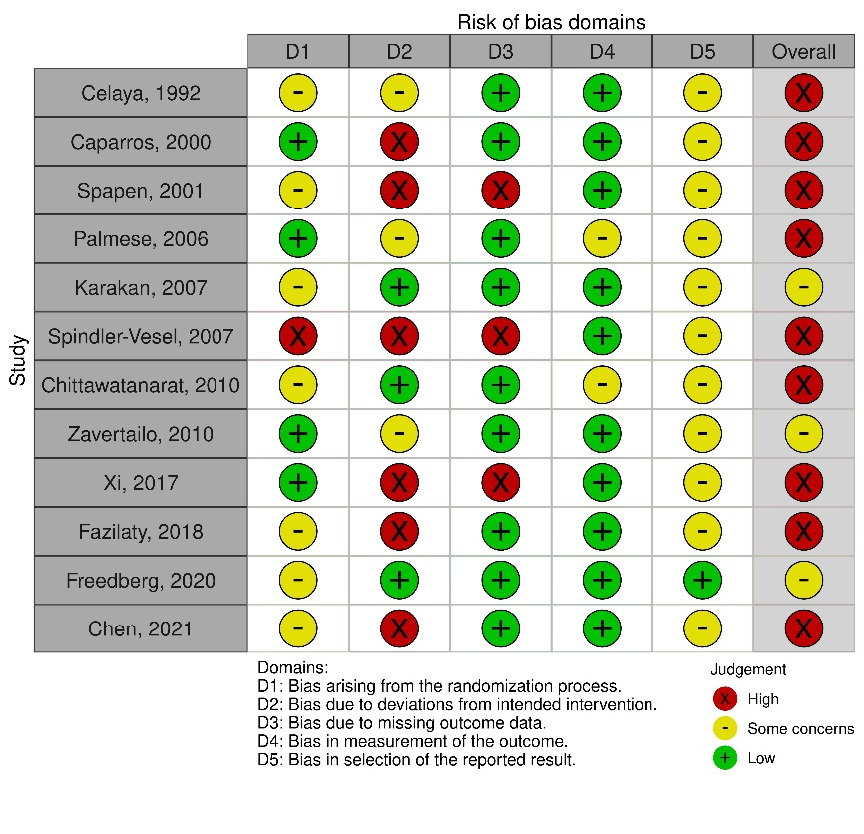 | 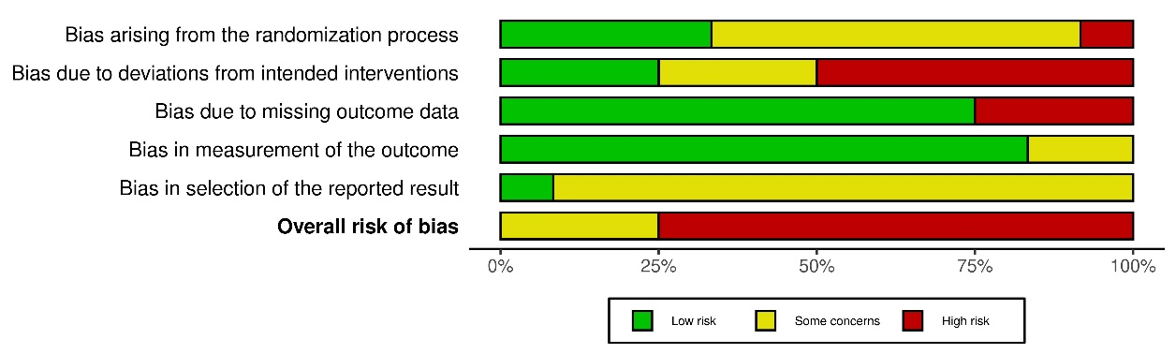

1b) Diarrhea
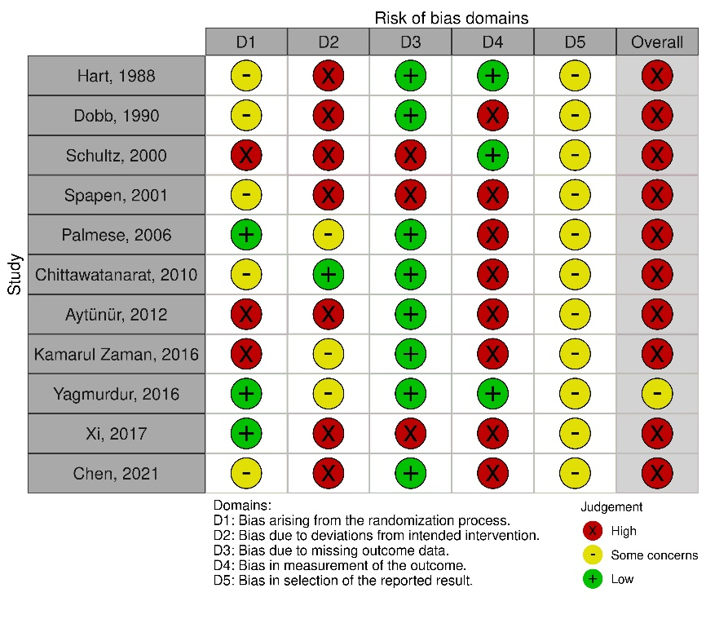 | 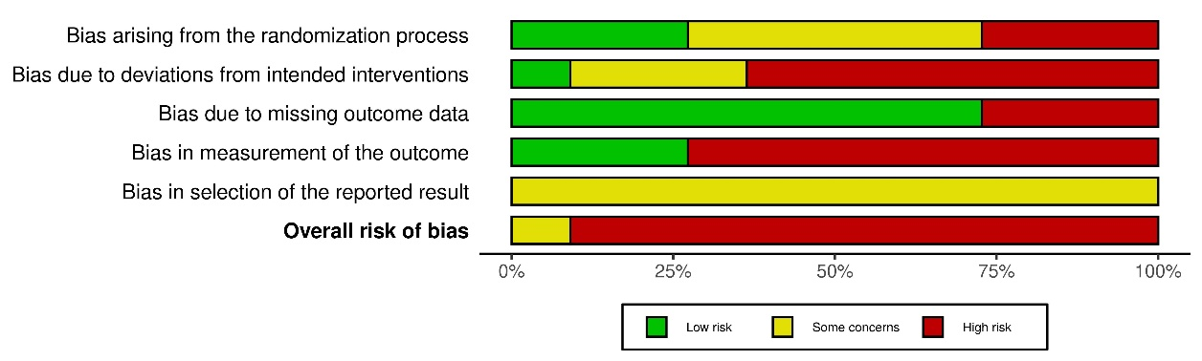

1c) Other GI complications
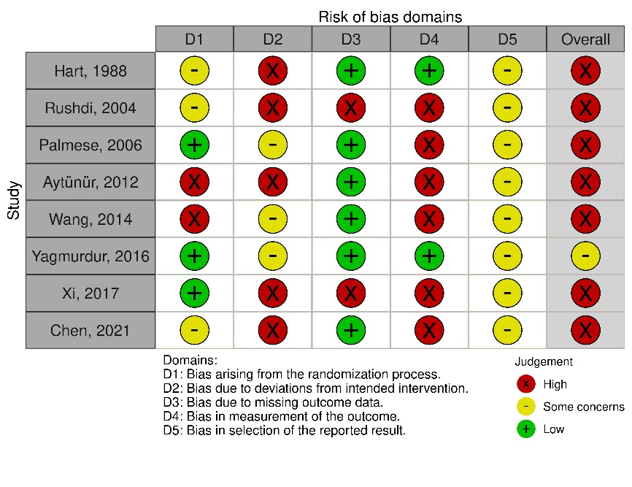 | 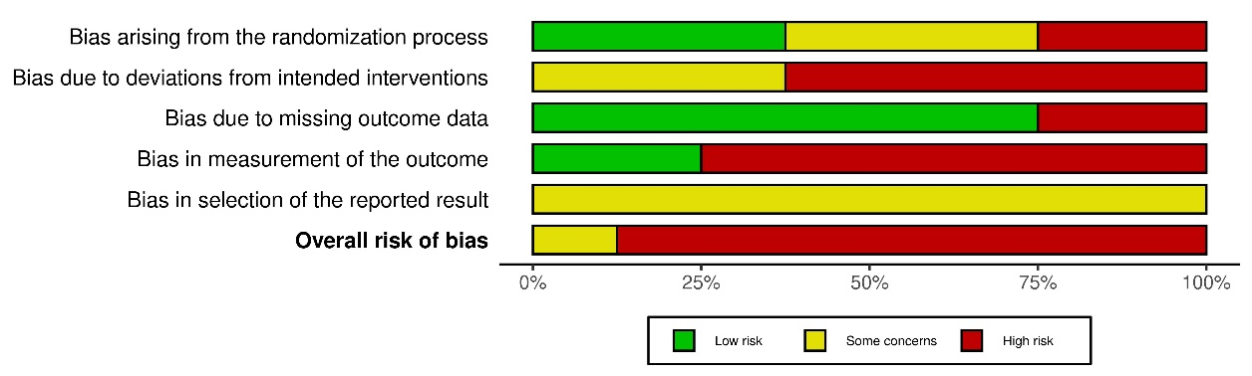

1d) ICU LOS
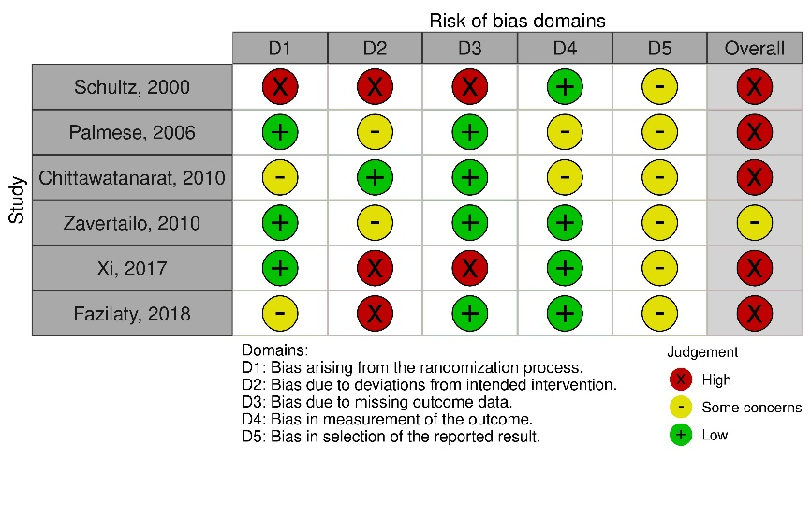 | 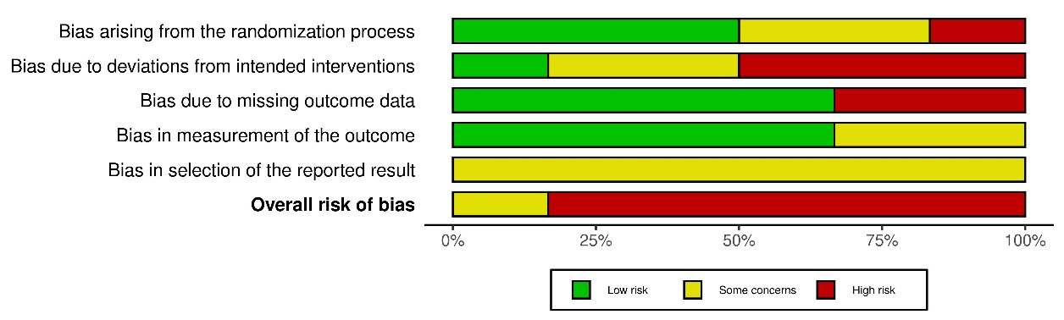

1e) Hospital LOS
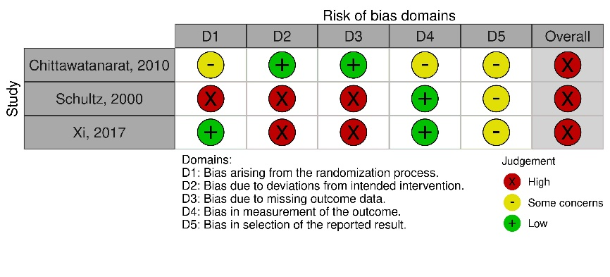 | 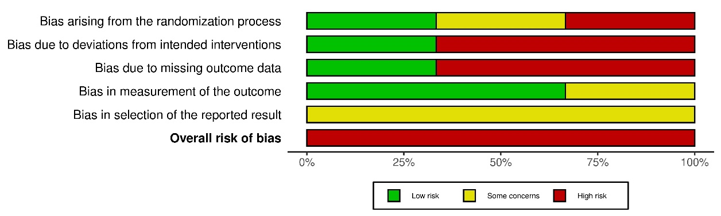

1f) Infectious complications
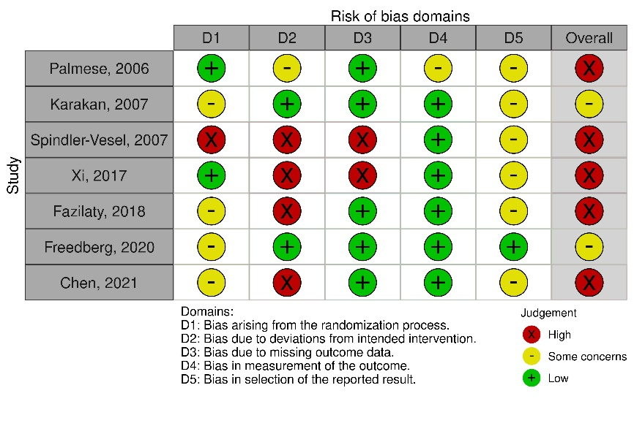 | 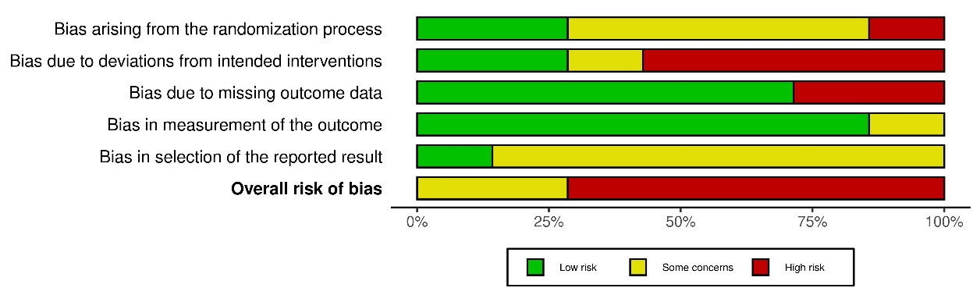

1g) Duration of mechanical ventilation
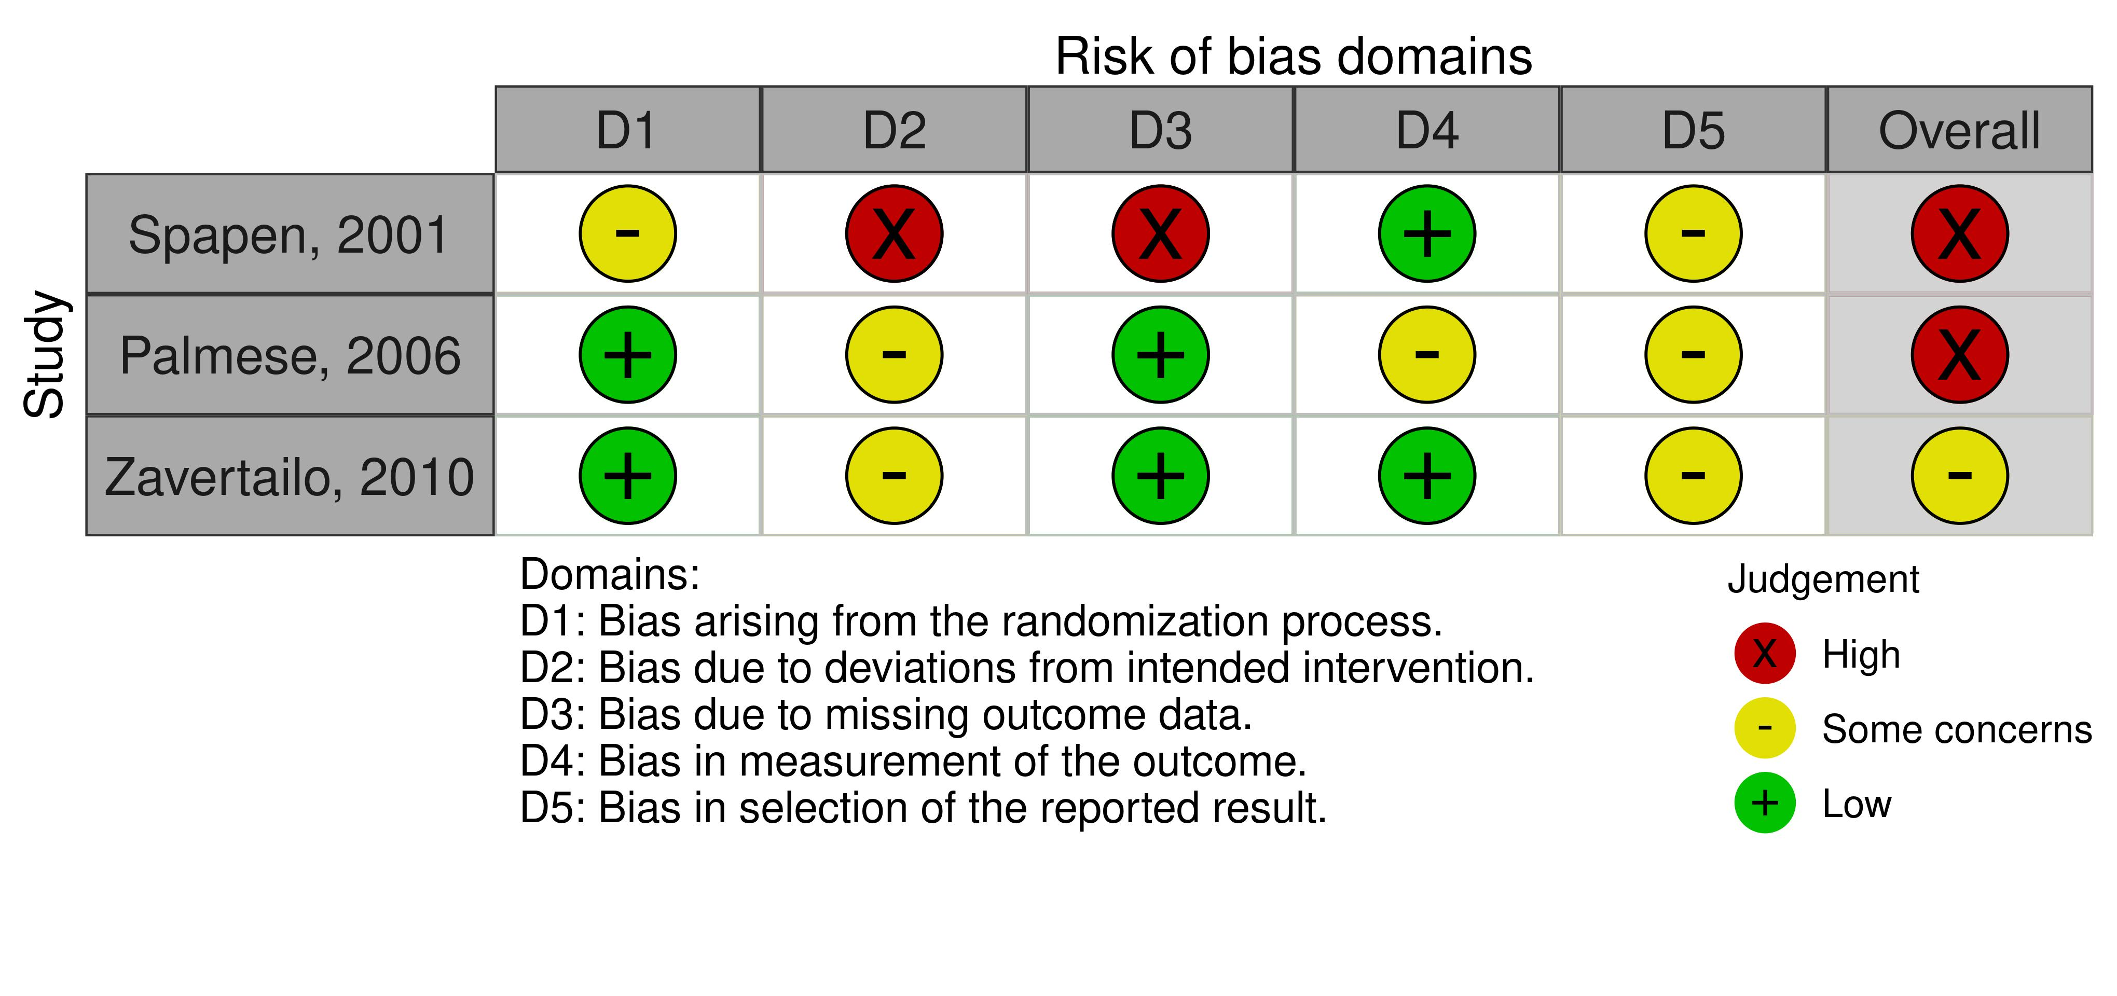 | 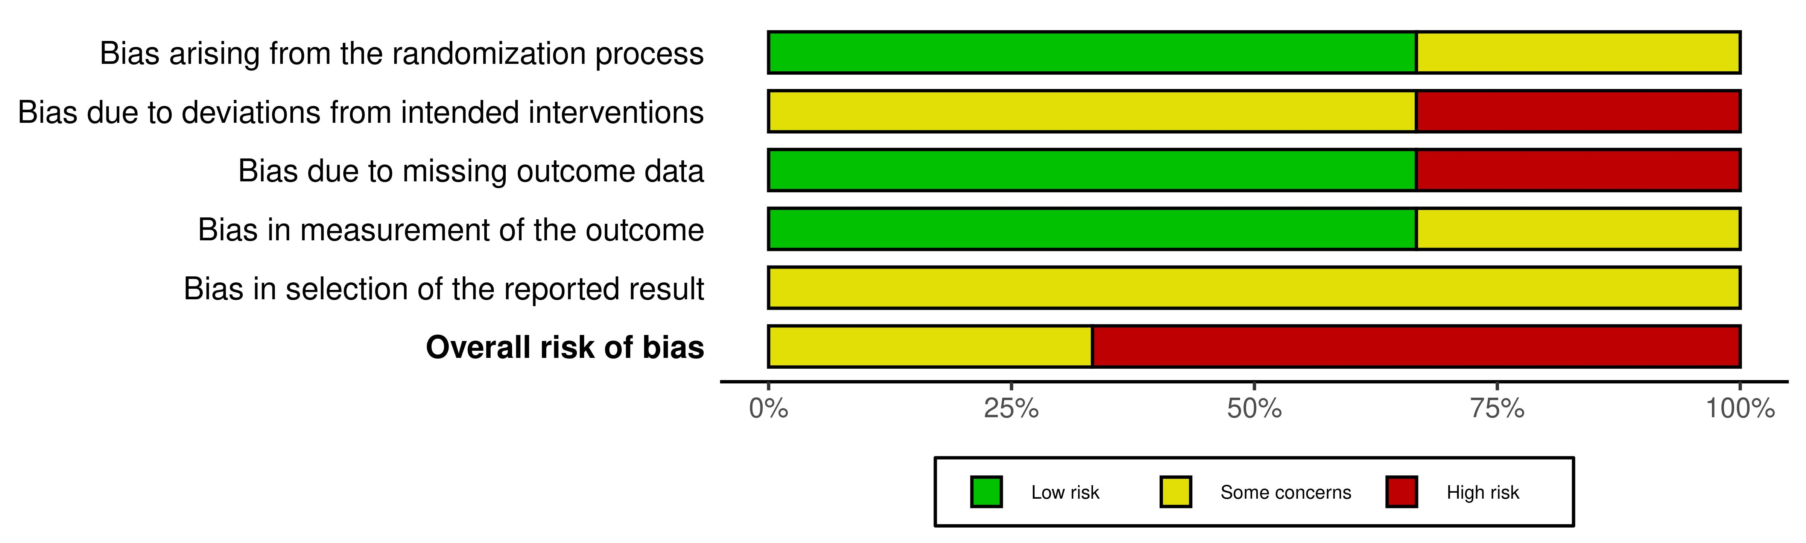

1h) Time to reach target energy needs
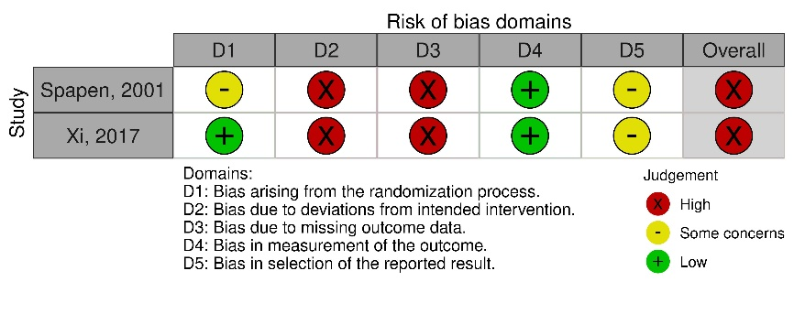 | 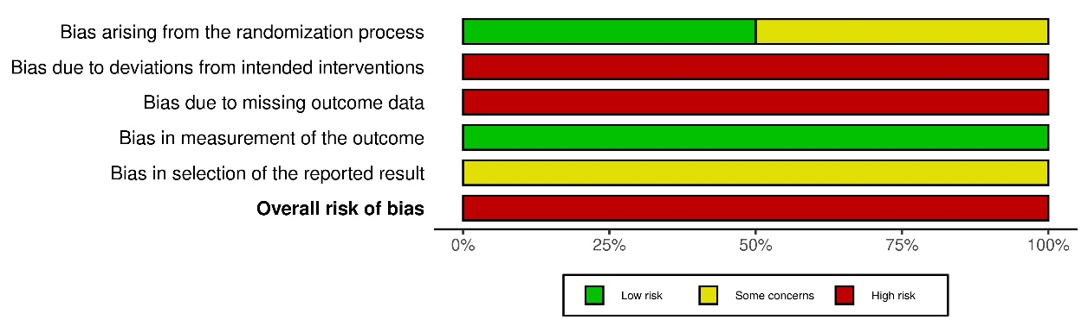

PART 3: Results of the meta-analyses and subgroup analyses

PART 3A: Subgroup analyses

Table S11: Summary of the results of subgroup analyses
Outcome/ Subgroups | Trials | N (fiber/control) | I² (%) | RR/MD (95% CI) | p-value | Test for subgroup difference
Mortality | 12 | 399/403 | 0 | 0.66 [0.47, 0.92] | 0.01
Published before 2000 | 1 | 17/18 | - | 0.85 [0.27, 2.64] | 0.77 | Chi² = 0.21, df = 1 (p = 0.65), I² = 0%
Published after 2000 | 11 | 382/385 | 0 | 0.64 [0.46, 0.91] | 0.01 | Chi² = 0.21, df = 1 (p = 0.65), I² = 0%
Fermentable fiber | 7 | 207/235 | 0 | 0.63 [0.35, 1.14] | 0.13 | Chi² = 0.18, df = 2 (p = 0.92), I² = 0%
Non-fermentable fiber | 0 | - |  |  |  | Chi² = 0.18, df = 2 (p = 0.92), I² = 0%
Mixed fiber | 4 | 177/153 | 0 | 0.69 [0.45, 1.04] | 0.08 | Chi² = 0.18, df = 2 (p = 0.92), I² = 0%
Unspecified | 1 | 15/15 | - | 0.50 [0.11, 2.33] | 0.38 | Chi² = 0.18, df = 2 (p = 0.92), I² = 0%
Viscous fiber | 2 | 82/83 | 0 | 0.29 [0.06, 1.33] | 0.11 | Chi² = 1.37, df = 3 (p = 0.71), I² = 0%
Non-viscous fiber | 5 | 125/152 | 0 | 0.72 [0.39, 1.36] | 0.32 | Chi² = 1.37, df = 3 (p = 0.71), I² = 0%
Mixed fiber | 4 | 177/153 | 0 | 0.69 [0.45, 1.04] | 0.08 | Chi² = 1.37, df = 3 (p = 0.71), I² = 0%
Unspecified | 1 | 15/15 | - | 0.50 [0.11, 2.33] | 0.38 | Chi² = 1.37, df = 3 (p = 0.71), I² = 0%
Soluble fiber | 6 | 190/217 | 0 | 0.57 [0.29, 1.13] | 0.11 | Chi² = 0.36, df = 2 (p = 0.83), I² = 0%
Insoluble fiber | 1 | 17/18 | - | 0.85 [0.27, 2.64] | 0.77 | Chi² = 0.36, df = 2 (p = 0.83), I² = 0%
Mixed fiber | 5 | 192/168 | 0 | 0.67 [0.45, 1.00] | 0.05 | Chi² = 0.36, df = 2 (p = 0.83), I² = 0%
daily fiber dose < 20 g | 4 | 194/170 | 0 | 0.66 [0.45, 0.98] | 0.04 | Chi² = 0.11, df = 2 (p = 0.95), I² = 0%
daily fiber dose ≥ 20 g | 5 | 147/175 | 0 | 0.59 [0.24, 1.44] | 0.24 | Chi² = 0.11, df = 2 (p = 0.95), I² = 0%
Unclear | 3 | 58/58 | 0 | 0.72 [0.31, 1.65] | 0.44 | Chi² = 0.11, df = 2 (p = 0.95), I² = 0%
Low risk of bias | 0
High risk of bias/ some concerns | 12
age < 50 years | 8 | 212/241 | 0 | 0.66 [0.36, 1.22] | 0.19 | Chi² = 0.00, df = 1 (p = 0.98), I² = 0%
age ≥ 50 years | 4 | 187/162 | 0 | 0.66 [0.44, 0.98] | 0.04 | Chi² = 0.00, df = 1 (p = 0.98), I² = 0%
APACHE II < 17 | 4 | 134/164 | 0 | 0.74 [0.32, 1.73] | 0.49 | Chi² = 0.77, df = 2 (p = 0.68), I² = 0%
APACHE II ≥ 17 | 6 | 235/209 | 0 | 0.68 [0.46, 0.99] | 0.04 | Chi² = 0.77, df = 2 (p = 0.68), I² = 0%
Unclear | 2 | 30/30 | 0 | 0.40 [0.12, 1.32] | 0.13 | Chi² = 0.77, df = 2 (p = 0.68), I² = 0%
Medical ICU | 2 | 23/22 | 0 | 0.39 [0.12, 1.26] | 0.12 | Chi² = 1.17, df = 3 (p = 0.76), I² = 0%
Surgical ICU | 2 | 46/75 | 0 | 0.94 [0.23, 3.74] | 0.92 | Chi² = 1.17, df = 3 (p = 0.76), I² = 0%
Mixed ICU | 2 | 164/140 | 0 | 0.70 [0.46, 1.07] | 0.10 | Chi² = 1.17, df = 3 (p = 0.76), I² = 0%
Unclear | 6 | 166/166 | 0 | 0.61 [0.31, 1.20] | 0.15 | Chi² = 1.17, df = 3 (p = 0.76), I² = 0%
intervention start ≤ 24h | 4 | 99/127 | 0 | 0.66 [0.33, 1.33] | 0.24 | Chi² = 0.04, df = 2 (p = 0.98), I² = 0%
intervention start ≤ 48h | 3 | 204/181 | 0 | 0.64 [0.41, 1.00] | 0.05 | Chi² = 0.04, df = 2 (p = 0.98), I² = 0%
Unclear | 5 | 96/95 | 0 | 0.70 [0.34, 1.42] | 0.32 | Chi² = 0.04, df = 2 (p = 0.98), I² = 0%
minimum duration of intervention < 6 days | 2 | 27/27 | 0 | 0.50 [0.15, 1.71] | 0.27 | Chi² = 0.70, df = 2 (p = 0.71), I² = 0%
minimum duration of intervention ≥ 6 days | 6 | 249/226 | 0 | 0.63 [0.43, 0.93] | 0.02 | Chi² = 0.70, df = 2 (p = 0.71), I² = 0%
Unclear | 4 | 123/150 | 0 | 0.84 [0.41, 1.73] | 0.64 | Chi² = 0.70, df = 2 (p = 0.71), I² = 0%
co-intervention with immunonutrition | 2 | 164/140 | 0 | 0.70 [0.46, 1.07] | 0.10 | Chi² = 0.24, df = 1 (p = 0.62), I² = 0%
fiber only | 10 | 235/263 | 0 | 0.59 [0.34, 1.02] | 0.06 | Chi² = 0.24, df = 1 (p = 0.62), I² = 0%
Industry funding | 3 | 152/127 | 0 | 0.65 [0.42, 1.01] | 0.06 | Chi² = 0.34, df = 2 (p = 0.84), I² = 0%
Non-industry funding | 4 | 121/151 | 0 | 0.54 [0.22, 1.33] | 0.18 | Chi² = 0.34, df = 2 (p = 0.84), I² = 0%
Unclear funding | 5 | 126/125 | 0 | 0.74 [0.41, 1.34] | 0.32 | Chi² = 0.34, df = 2 (p = 0.84), I² = 0%
Standard formula in control group | 8 | 189/187 | 0 | 0.47 [0.24, 0.90] | 0.02 | Chi² = 1.43, df = 1 (p = 0.23), I² = 29.9%
Non-standard formula in control group | 4 | 210/216 | 0 | 0.74 [0.51, 1.09] | 0.12 | Chi² = 1.43, df = 1 (p = 0.23), I² = 29.9%

Outcome/ Subgroups | Trials | N (fiber/control) | I² (%) | RR/MD (95% CI) | p-value | Test for subgroup difference
Diarrhea | 11 | 396/369 | 51 | 0.70 [0.51, 0.96] | 0.03
Published before 2000 | 2 | 80/79 | 0 | 1.04 [0.73, 1.46] | 0.84 | Chi² = 4.86, df = 1 (p = 0.03), I² = 79.4%
Published after 2000 | 9 | 316/290 | 43 | 0.59 [0.40, 0.85] | 0.005 | Chi² = 4.86, df = 1 (p = 0.03), I² = 79.4%
Fermentable fiber | 7 | 256/251 | 57 | 0.70 [0.47, 1.05] | 0.08 | Chi² = 3.75, df = 2 (p = 0.15), I² = 46.7%
Non-fermentable fiber | 0 | - |  |  |  | Chi² = 3.75, df = 2 (p = 0.15), I² = 46.7%
Mixed fiber | 2 | 77/77 | 0 | 0.57 [0.40, 0.81] | 0.002 | Chi² = 3.75, df = 2 (p = 0.15), I² = 46.7%
Unspecified | 2 | 63/41 | - | 3.67 [0.53, 25.26] | 0.19 | Chi² = 3.75, df = 2 (p = 0.15), I² = 46.7%
Viscous fiber | 2 | 97/96 | 66 | 0.70 [0.32, 1.50] | 0.36 | Chi² = 3.61, df = 3 (p = 0.31), I² = 16.8%
Non-viscous fiber | 5 | 159/155 | 64 | 0.66 [0.36, 1.19] | 0.16 | Chi² = 3.61, df = 3 (p = 0.31), I² = 16.8%
Mixed fiber | 3 | 107/107 | 0 | 0.57 [0.40, 0.81] | 0.002 | Chi² = 3.61, df = 3 (p = 0.31), I² = 16.8%
Unspecified | 1 | 33/11 | - | 3.67 [0.53, 25.26] | 0.19 | Chi² = 3.61, df = 3 (p = 0.31), I² = 16.8%
Soluble fiber | 6 | 211/205 | 58 | 0.61 [0.39, 0.97] | 0.03 | Chi² = 3.81, df = 2 (p = 0.15), I² = 47%
Insoluble fiber | 1 | 45/46 | - | 1.26 [0.69, 2.31] | 0.46 | Chi² = 3.81, df = 2 (p = 0.15), I² = 47%
Mixed fiber | 4 | 140/118 | 47 | 0.69 [0.33, 1.45] | 0.33 | Chi² = 3.81, df = 2 (p = 0.15), I² = 47%
daily fiber dose < 20 g | 5 | 175/149 | 33 | 0.96 [0.61, 1.50] | 0.84 | Chi² = 3.37, df = 2 (p = 0.19), I² = 40.7%
daily fiber dose ≥ 20 g | 5 | 208/208 | 53 | 0.59 [0.37, 0.96] | 0.04 | Chi² = 3.37, df = 2 (p = 0.19), I² = 40.7%
Unclear | 1 | 13/12 | - | 0.50 [0.27, 0.93] | 0.03 | Chi² = 3.37, df = 2 (p = 0.19), I² = 40.7%
Low risk of bias | 0
High risk of bias/ some concerns | 11
age < 50 years | 6 | 213/211 | 59 | 0.68 [0.40, 1.15] | 0.15 | Chi² = 0.00, df = 1 (p = 0.98), I² = 0%
age ≥ 50 years | 5 | 183/158 | 53 | 0.69 [0.43, 1.09] | 0.11 | Chi² = 0.00, df = 1 (p = 0.98), I² = 0%
APACHE II < 17 | 3 | 155/134 | 51 | 0.64 [0.32, 1.28] | 0.21 | Chi² = 8.77, df = 2 (p = 0.01), I² = 77.2%
APACHE II ≥ 17 | 5 | 126/123 | 6 | 0.42 [0.25, 0.71] | 0.001 | Chi² = 8.77, df = 2 (p = 0.01), I² = 77.2%
Unclear | 3 | 115/112 | 0 | 1.00 [0.76, 1.32] | 1.00 | Chi² = 8.77, df = 2 (p = 0.01), I² = 77.2%
Medical ICU | 2 | 73/72 | 0 | 0.56 [0.40, 0.77] | 0.0004 | Chi² = 10.22, df = 3 (p = 0.02), I² = 70.6%
Surgical ICU | 1 | 17/17 | - | 0.50 [0.18, 1.35] | 0.17 | Chi² = 10.22, df = 3 (p = 0.02), I² = 70.6%
Mixed ICU | 5 | 190/165 | 22 | 1.02 [0.73, 1.42] | 0.93 | Chi² = 10.22, df = 3 (p = 0.02), I² = 70.6%
Unclear | 3 | 116/115 | 0 | 0.37 [0.18, 0.74] | 0.005 | Chi² = 10.22, df = 3 (p = 0.02), I² = 70.6%
intervention start ≤ 24h | 3 | 90/87 | 60 | 0.63 [0.31, 1.29] | 0.20 | Chi² = 4.14, df = 3 (p = 0.25), I² = 27.6%
intervention start ≤ 48h | 2 | 122/123 | 0 | 0.55 [0.39, 0.78] | 0.0008 | Chi² = 4.14, df = 3 (p = 0.25), I² = 27.6%
intervention start ≥ 48h | 1 | 33/11 | - | 3.67 [0.53, 25.26] | 0.19 | Chi² = 4.14, df = 3 (p = 0.25), I² = 27.6%
Unclear | 5 | 151/148 | 57 | 0.76 [0.43, 1.34] | 0.34 | Chi² = 4.14, df = 3 (p = 0.25), I² = 27.6%
minimum duration of intervention < 6 days | 4 | 127/126 | 18 | 0.95 [0.65, 1.39] | 0.79 | Chi² = 3.43, df = 2 (p = 0.18), I² = 41.6%
minimum duration of intervention ≥ 6 days | 4 | 143/119 | 56 | 0.71 [0.41, 1.26] | 0.24 | Chi² = 3.43, df = 2 (p = 0.18), I² = 41.6%
Unclear | 3 | 126/124 | 48 | 0.35 [0.13, 0.98] | 0.05 | Chi² = 3.43, df = 2 (p = 0.18), I² = 41.6%
co-intervention with immunonutrition | 1 | 42/42 | - | 0.09 [0.01, 1.59] | 0.10 | Chi² = 1.97, df = 1 (p = 0.16), I² = 49.3%
fiber only | 10 | 354/327 | 51 | 0.72 [0.52, 0.98] | 0.04 | Chi² = 1.97, df = 1 (p = 0.16), I² = 49.3%
Industry funding | 4 | 98/73 | 52 | 0.75 [0.43, 1.31] | 0.31 | Chi² = 0.35, df = 2 (p = 0.84), I² = 0%
Non-industry funding | 2 | 97/96 | 64 | 0.70 [0.32, 1.49] | 0.35 | Chi² = 0.35, df = 2 (p = 0.84), I² = 0%
Unclear funding | 5 | 201/200 | 68 | 0.56 [0.26, 1.22] | 0.14 | Chi² = 0.35, df = 2 (p = 0.84), I² = 0%
Standard formula in control group | 10 | 354/327 | 51 | 0.72 [0.52, 0.98] | 0.04 | Chi² = 1.97, df = 1 (p = 0.16), I² = 49.3%
Non-standard formula in control group | 1 | 42/42 | 51 | 0.09 [0.01, 1.59] | 0.10 | Chi² = 1.97, df = 1 (p = 0.16), I² = 49.3%

Table S12: Calculation of daily fiber doses
Reference No | Author, year | Daily fiber dose | Variables | Calculation*
[38] | Hart, 1988 | 7 g/d | - | Fiber/d reported
[39] | Dobb, 1990 | 21 – 42 g/d | Fiber: 21g/l  Feed volumes from day 3: mean volume of 1000-2000 ml | $$Daily fiber dose1=1000 ml × \left({21g}/{1000 ml}\right)= 21 g$$  $$Daily fiber dose2=2000 ml × \left({21g}/{1000 ml}\right)= 42 g$$
[47] | Celaya, 1992 | NI | NI | -
[35] | Caparrós, 2000 | 11.7 g/d | Fiber: 13.5g/1500ml  Caloric density: 1.25kcal/ml  Administered caloric intake day 3: 1625 (1137 – 1828) kcal | $$Daily fiber dose= \frac{1625 kcal}{1.25 kcal/ml} ×13.5 g/1500ml=11.7 g$$
[41] | Schultz, 2000 | 15.8 – 17.3 g/d | - | Fiber/d reported
[43] | Spapen, 2001 | NI | NI | -
[40] | Rushdi, 2004 | 22-24 g/d | - | Fiber/d reported
[37] | Palmese, 2006 | 10.6 g/d | - | Fiber/d reported
[49] | Karakan, 2007 | 24 g/d | - | Fiber/d reported
[46] | Spindler-Vesel, 2007 | 20.68 g/d | Fiber: 22 g/l  Total feed volumes day 2 to 4: 2820 (2300 – 3100) ml | $$Daily fiber dose=\frac{2820 ml × \left({22g}/{1000 ml}\right)}{3 days}= 20.68 g$$
[45] | Chittawatanarat,  2010 | 22.65 g/d | Fiber: 15.1 g/l  Caloric density: 1000 kcal/l  Mean caloric intake day 6: 1500 kcal | $$Daily fiber dose= \frac{1500 kcal}{{1000 kcal}/l} ×15.1 g/l=22.65 g$$
[52] | Zavertailo, 2010 | NI | NI | -
[53] | Aytünür | 18 g/d | Fiber: 10.6 g/l  Caloric density: 1.1 kcal/l  Max. calories per day: 1867 ± 120.18 ml | $$Daily fiber dose= \frac{1867 kcal}{{1.1 kcal}/{ml}} ×10.6 g/l=18 g$$
[51] | Wang, 2014 | NI | NI | -
[36] | Kamarul Zaman, 2016 | 14.8 g/d | - | Fiber/d reported
[44] | Yagmurdur, 2016 | 28 g/d | - | Fiber/d reported
[54] | Xi, 2017 | 24 g/d | - | Fiber/d reported
[50] | Fazilaty, 2018 | 3 g/d | - | Fiber/d reported
[42] | Freedberg, 2020 | 11 g/d | - | Fiber/d reported
[48] | Chen, 2021 | 20 g/d | - | Fiber/d reported
Median value |  | 20 g/d
In studies reporting the evolution of feed volume or caloric intake over the study period, daily fiber dose calculations for subgroup analysis were based on maximum observed values. We associated maximum values with the achievement of caloric goals, thereby ensuring that the calculated fiber doses are valid for most of the study period.
If median (IQR) or mean + SD of caloric intake/feed volumes were given, median or mean were used for the calculation.
When a range of daily fiber dose was reported, both values were used for the calculation of the median value of all fiber doses.

Figure S2: Overall mortality (subgroup analyses)

2a) Publication date
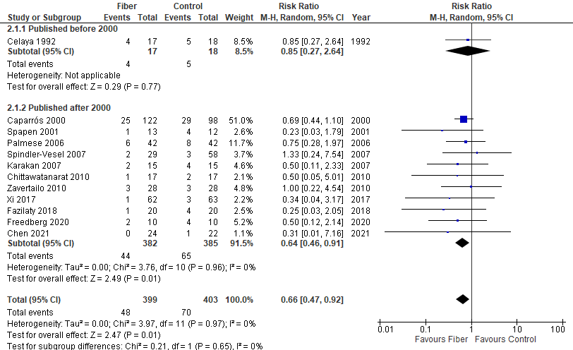

2b) Fermentability
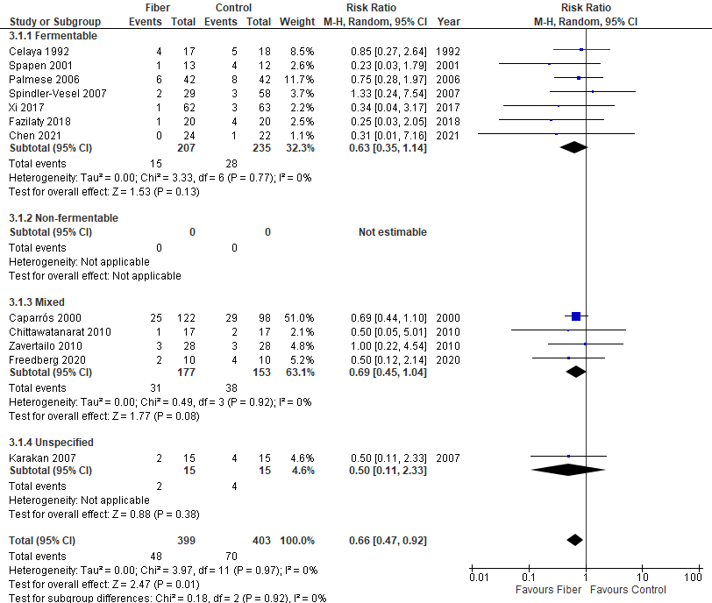

2c) Viscosity
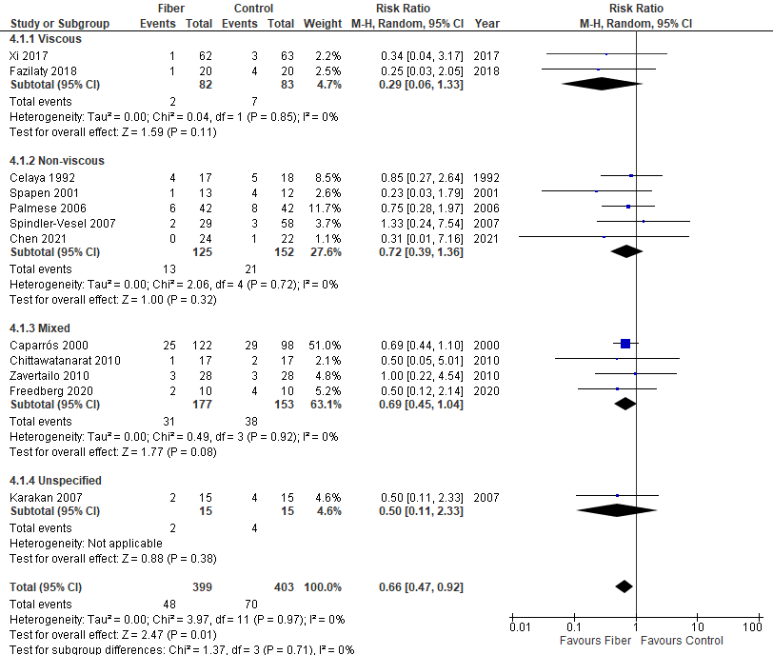

2d) Solubility
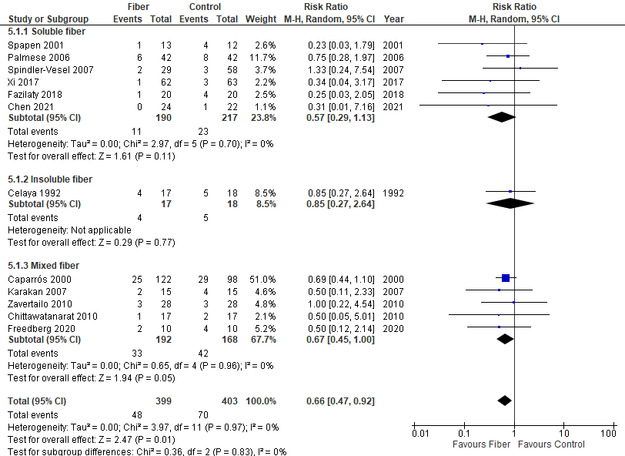

2e) Daily fiber dose
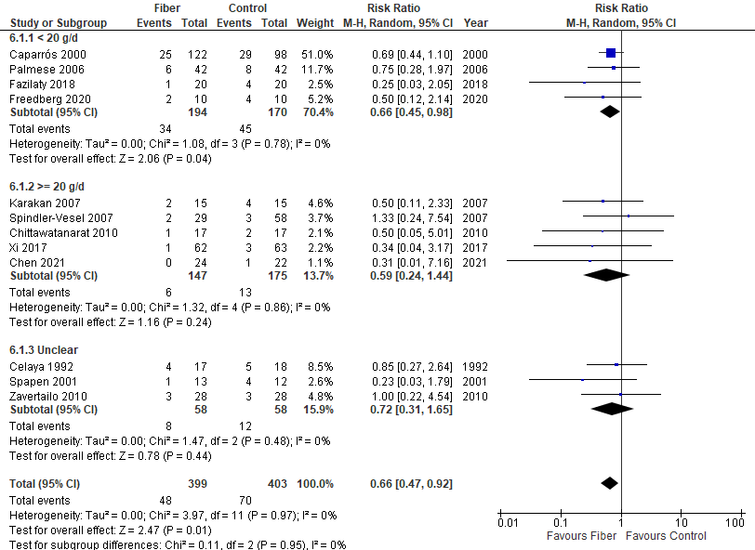

2f) Age
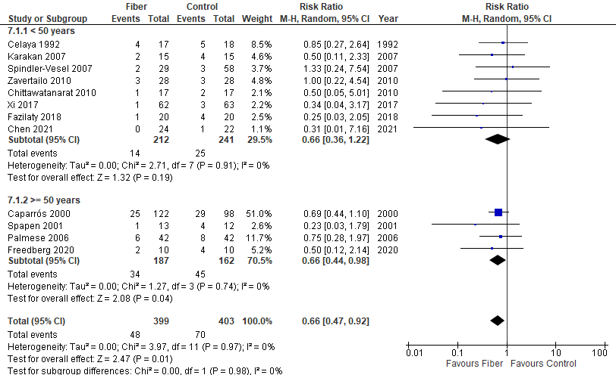

2g) Disease severity
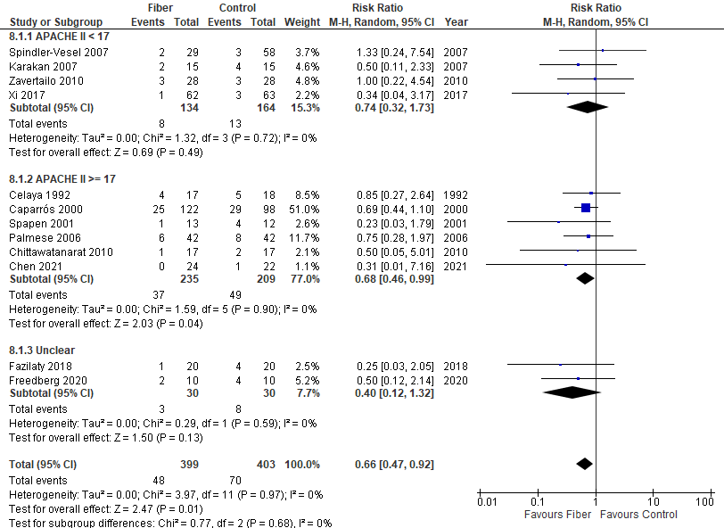

2h) ICU admission type
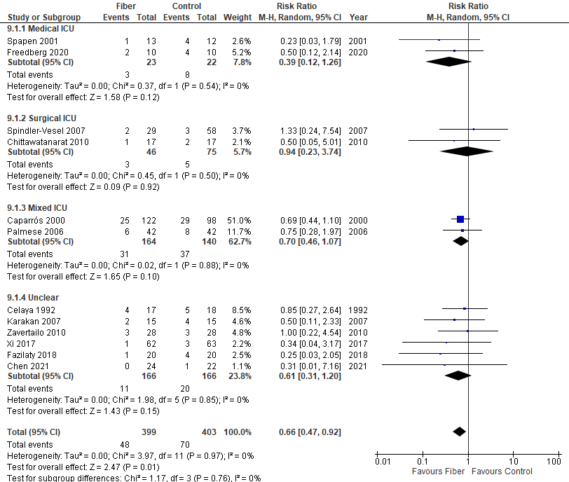

2i) Intervention start
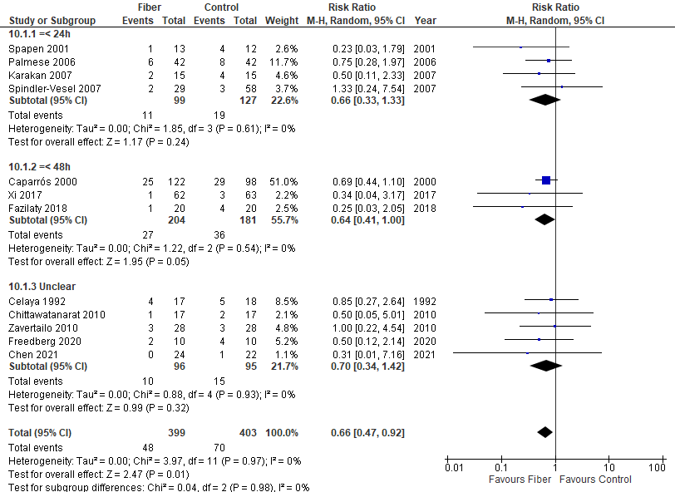

2j) Minimum duration of intervention
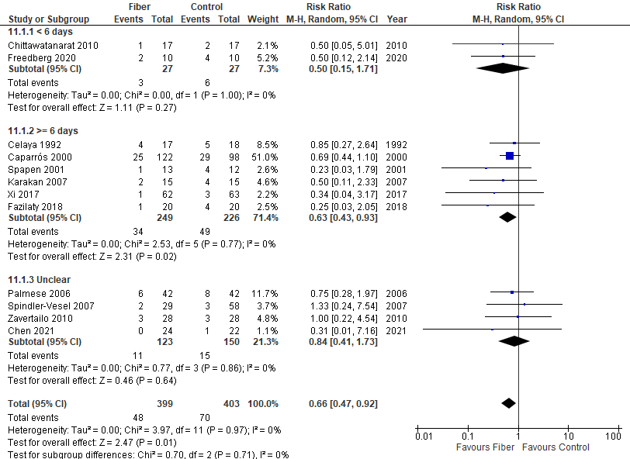

2k) Co-intervention with immunonutrition
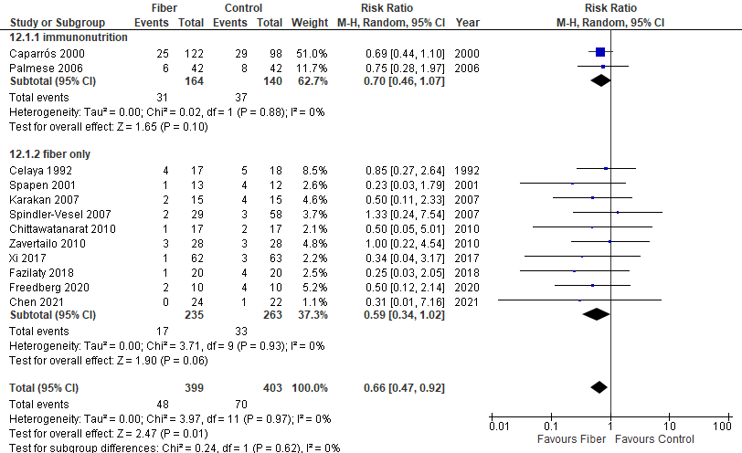

2l) Funding source
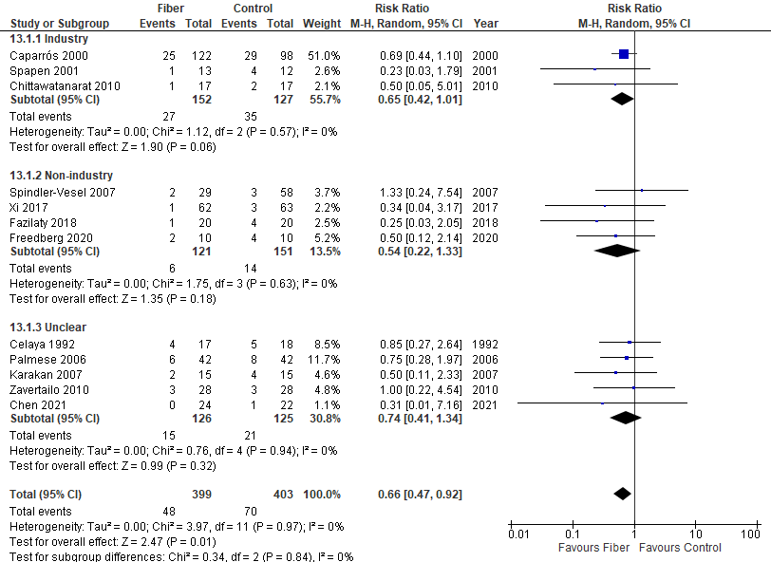

2m) Type of control group
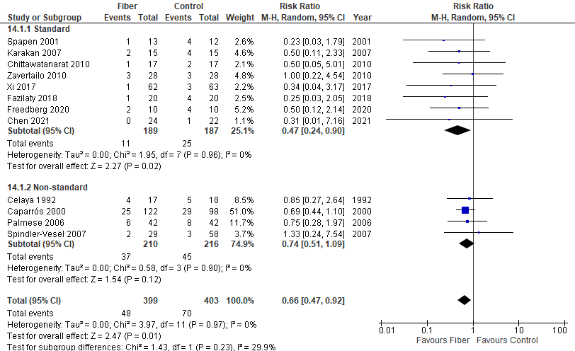

Figure S3: Diarrhea incidence (subgroup analyses)

3a) Publication date
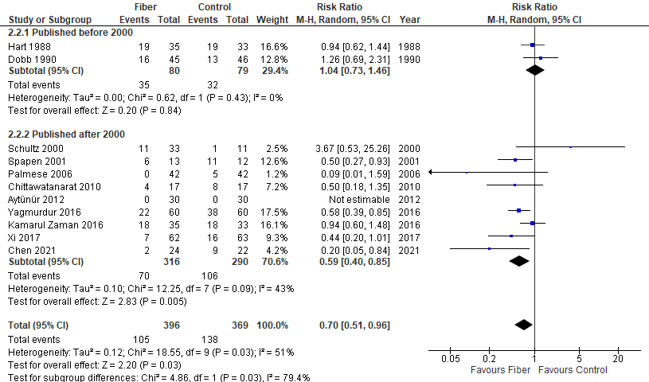

3b) Fermentability
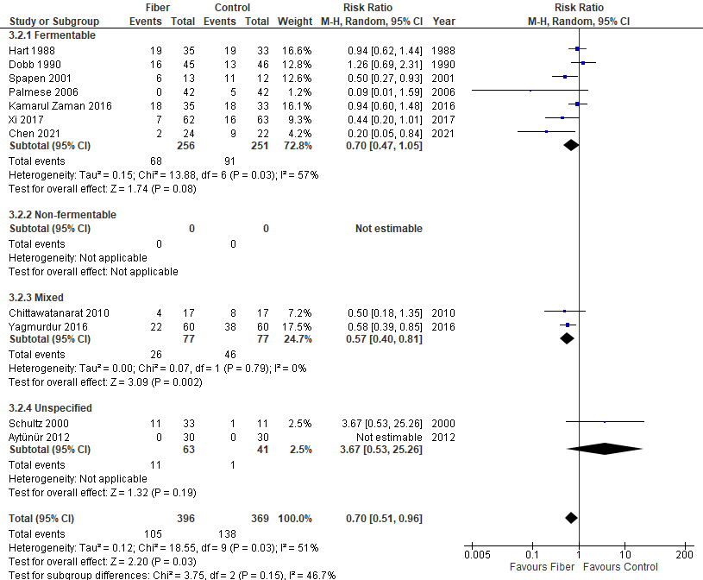

3c) Viscosity
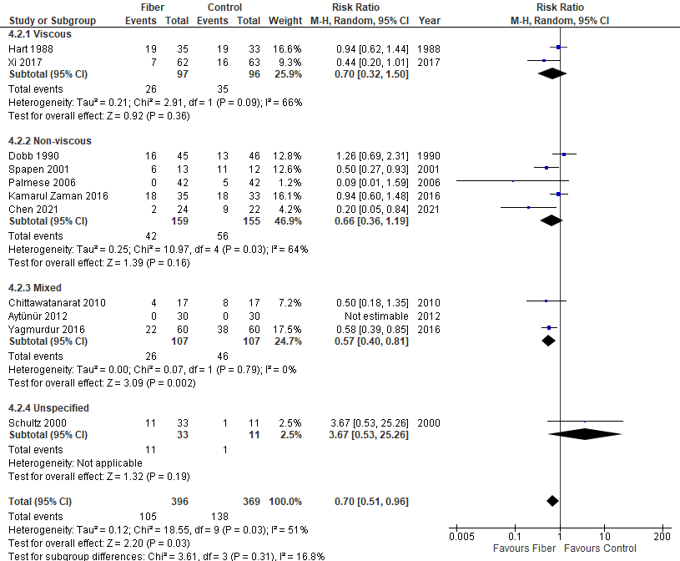

3d) Solubility
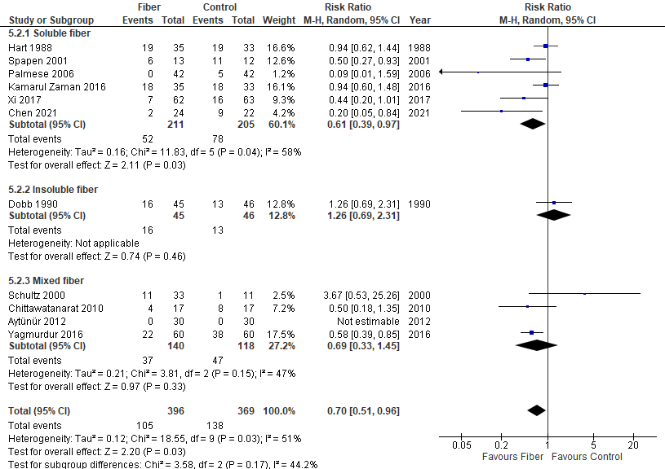

3e) Daily fiber dose
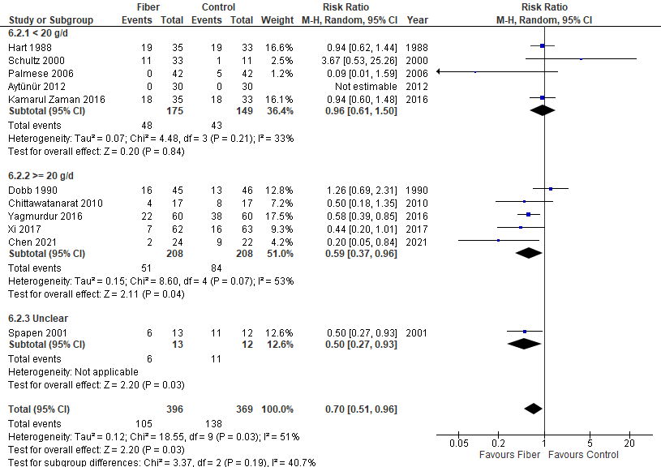

3f) Age
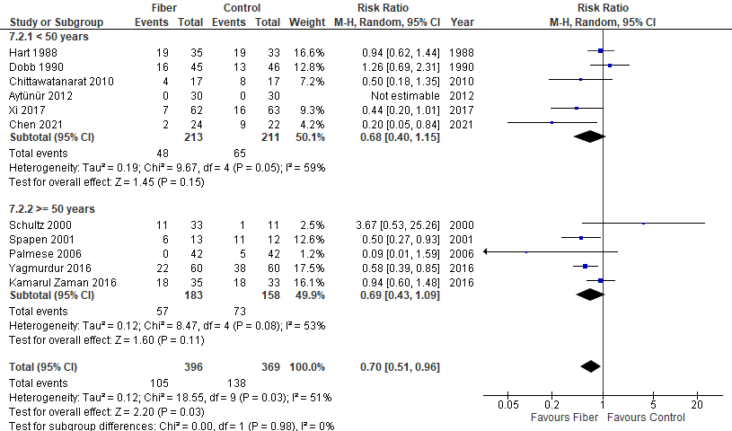

3g) Disease severity
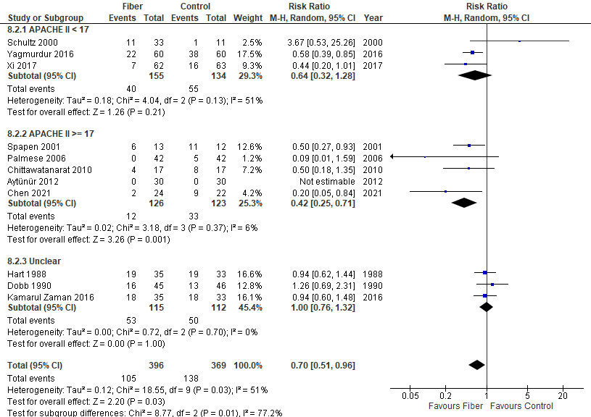

3h) ICU admission type
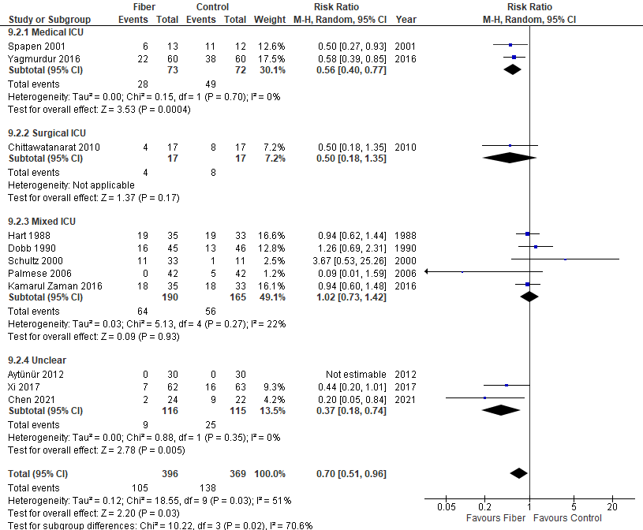

3i) Intervention start
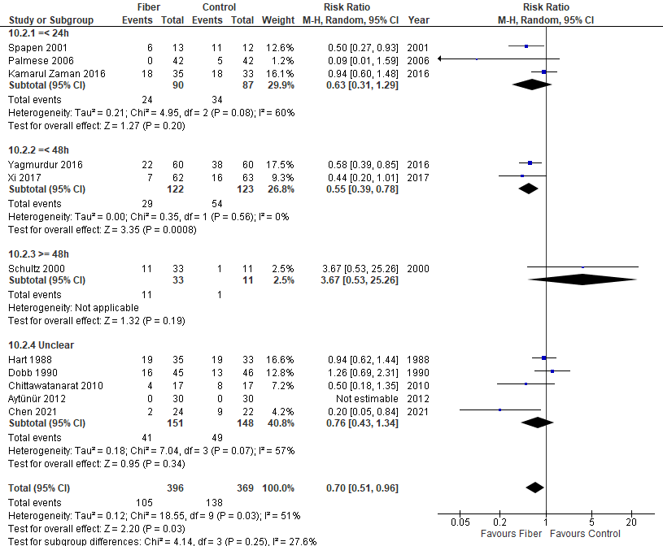

3j) Minimum duration of intervention
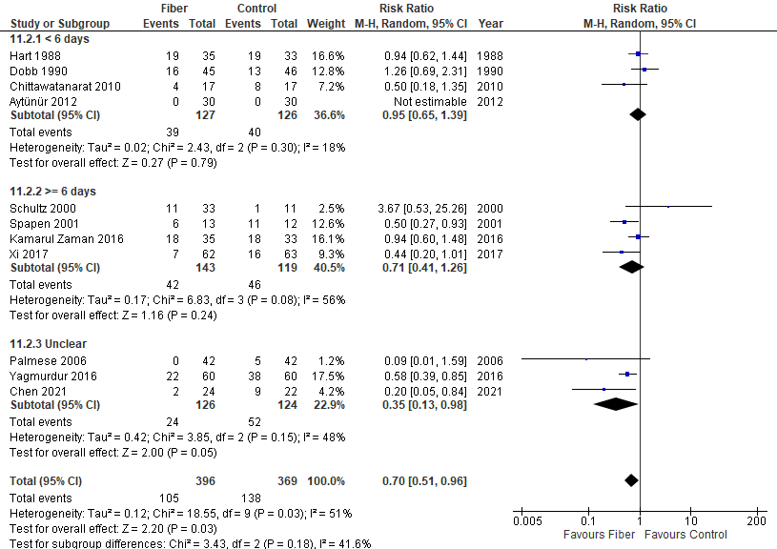

3k) Co-intervention with immunonutrition
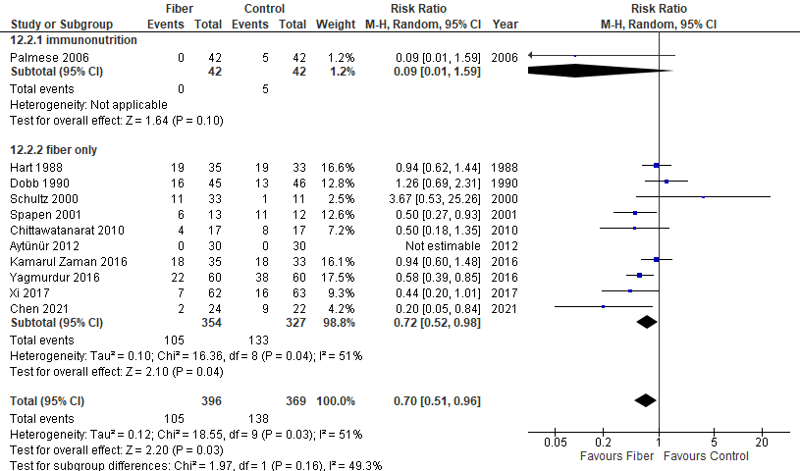

3l) Funding source
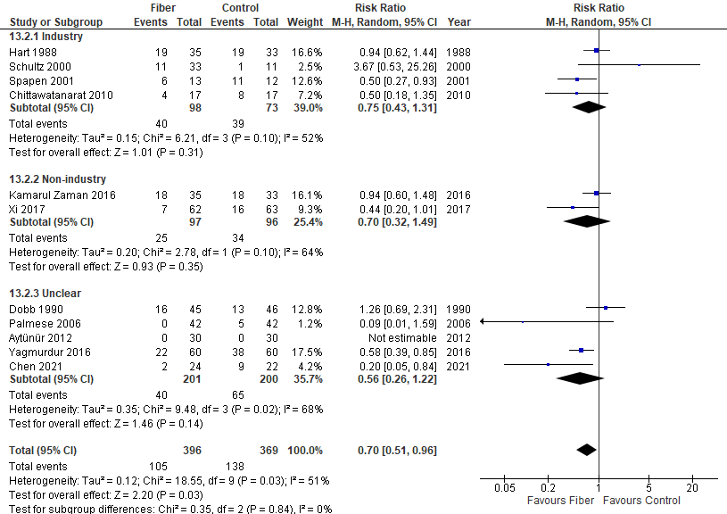

3m) Type of control group
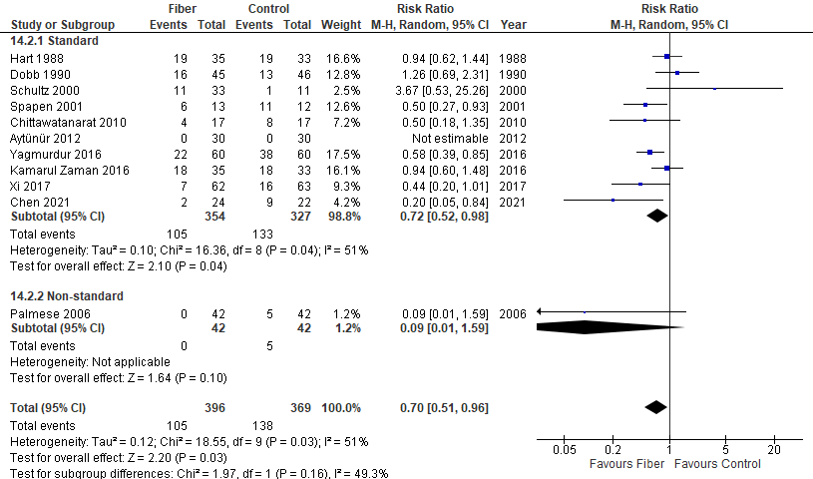

PART 3B: Overall meta-analyses

Figure S4: Diarrhea score
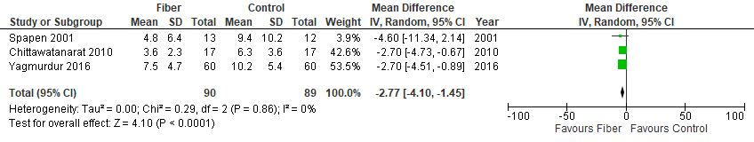

Figure S5: Other GI complications

5a) Patients with at least one GI complication
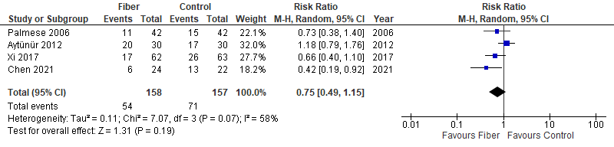

5b) Abdominal distension
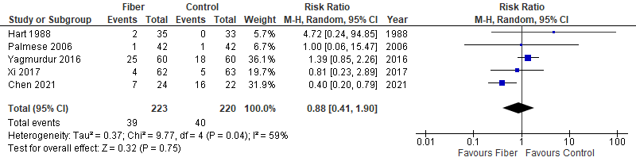

5c) Vomiting
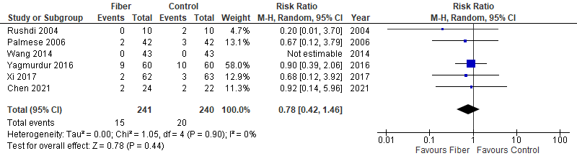

5d) Regurgitation
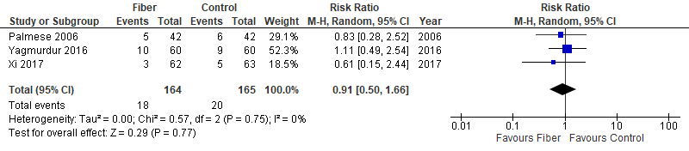

5e) GI bleeding
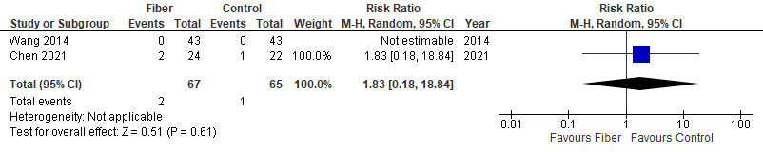

5f) Constipation
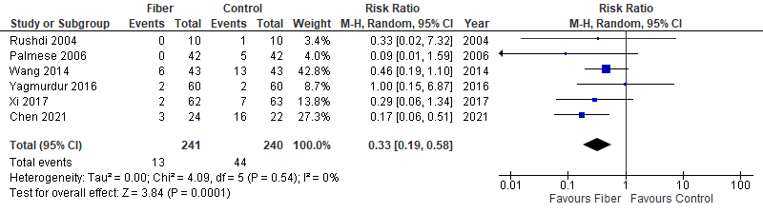

Figure S6: Infectious complications
6a) Patients with at least 1 infectious complication
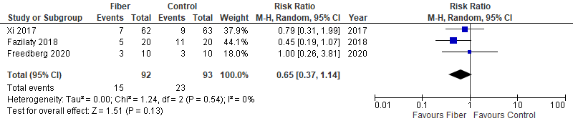

6b) Pneumonia
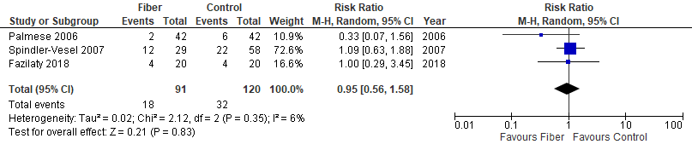

6c) Urinary tract infection
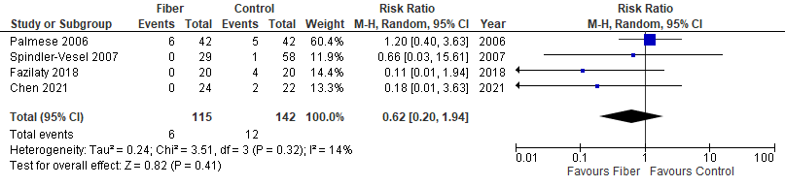

6d) Intra-abdominal infection
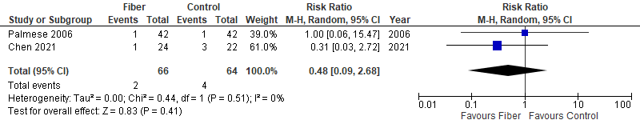

6e) Sepsis
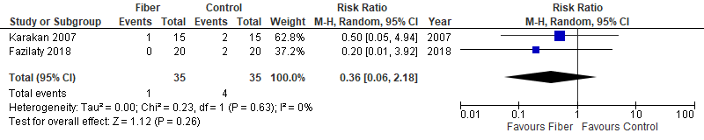

6f) Vascular infection
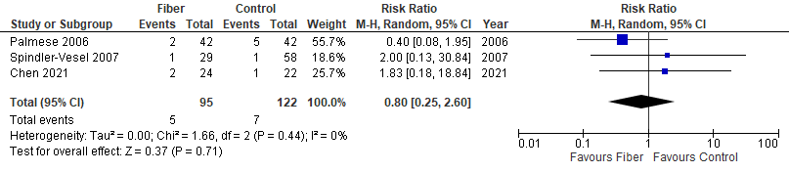

6g) Wound infection
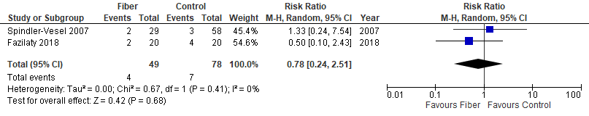

6h) Bacteremia
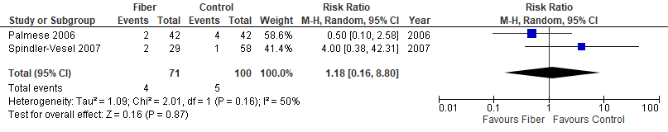

Figure S7: Duration of mechanical ventilation
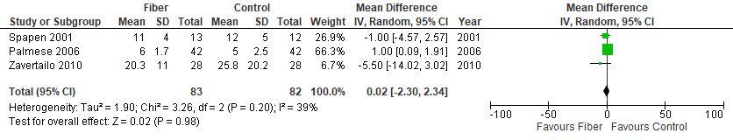

Figure S8: Time to reach target energy needs
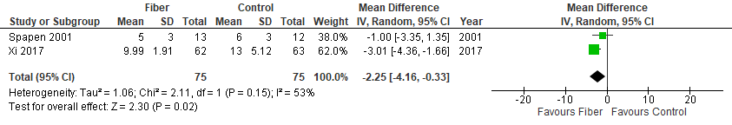

PART 3C: Funnel plots

Figure S9: Mortality
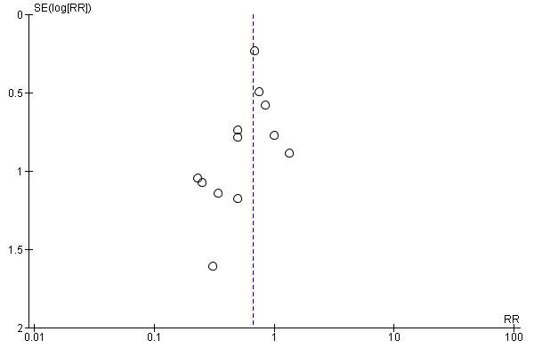
Egger’s test: p = 0.1430498

Figure S10: Diarrhea

10a) Diarrhea incidence
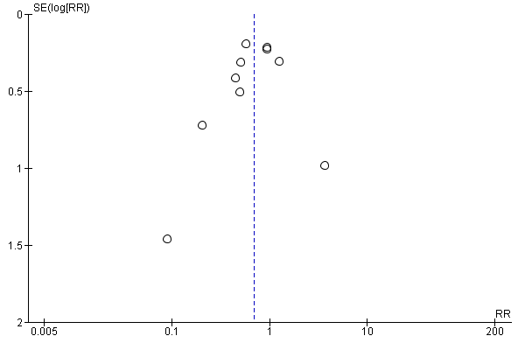
Egger’s test: p = 0.4083957

10b) Diarrhea score
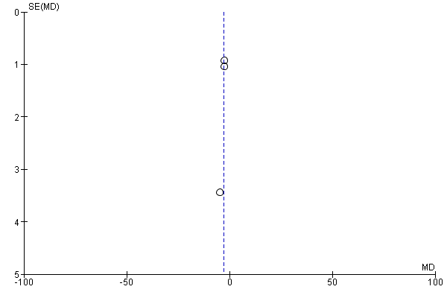

Figure S11: Other GI complications

11a) Patients with at least 1 GI complication
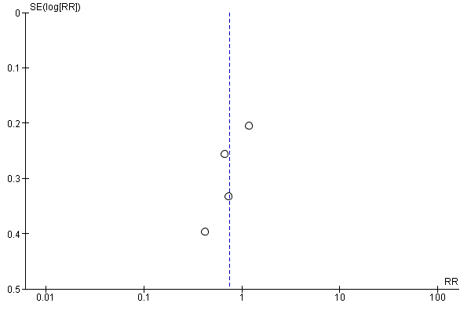

11b) Abdominal distension
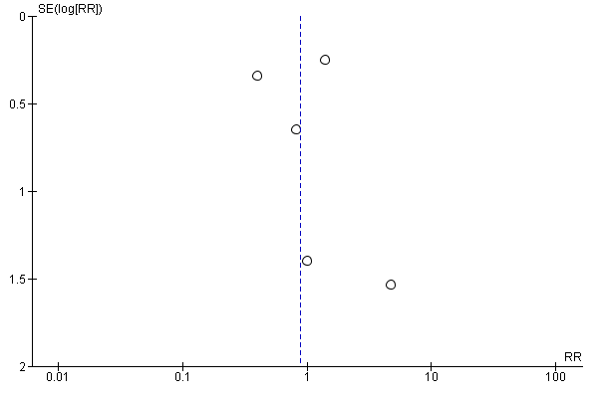

11c) Vomiting
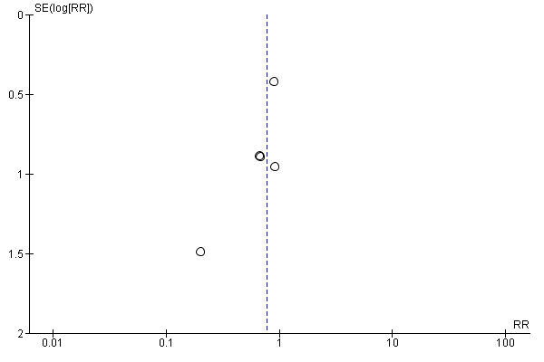

11d) Constipation
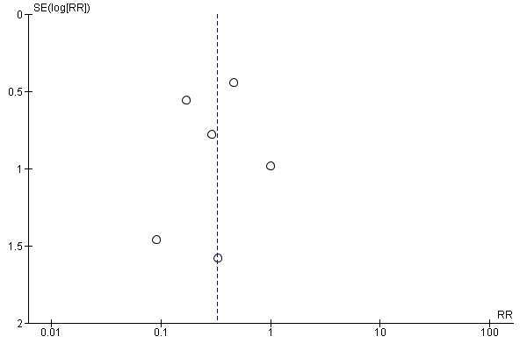

11e) GI bleeding
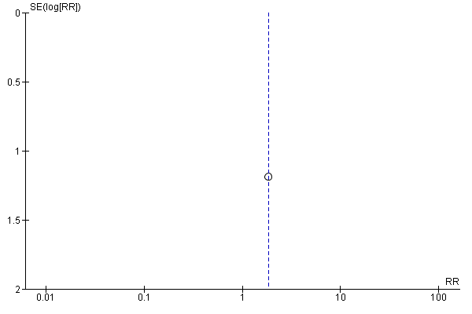

11f) Regurgitation
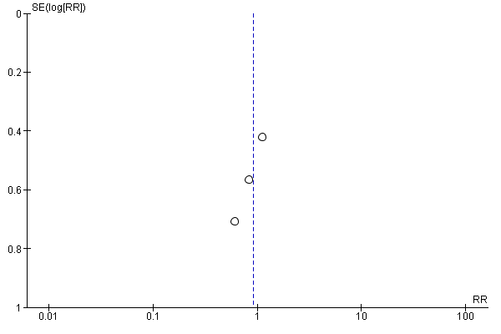

Figure S12: ICU length of stay
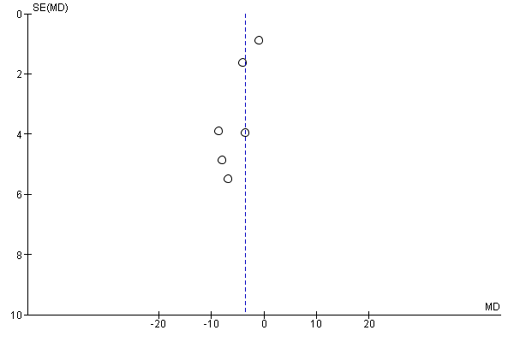

Figure S13: Hospital length of stay
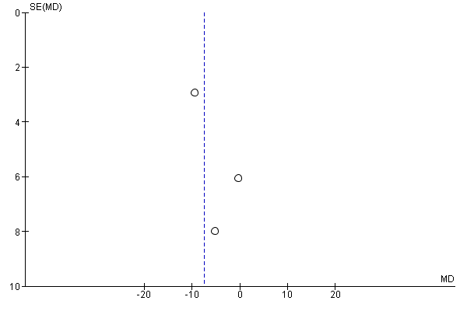

Figure S14: Infectious complications

14a) Patients with at least 1 infectious complication
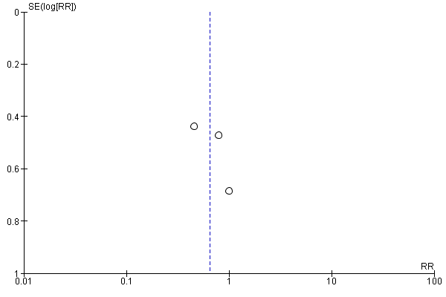

14b) Pneumonia
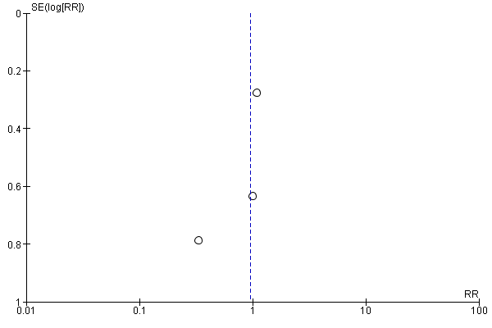

14c) Urinary tract infection
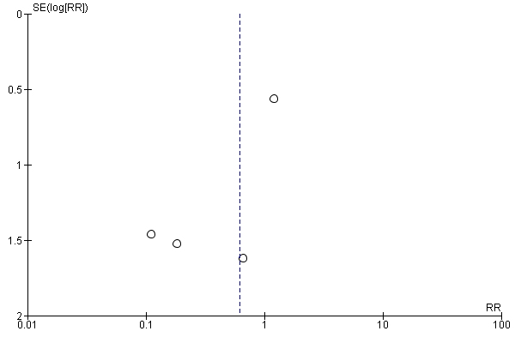

14d) Intra-abdominal infection
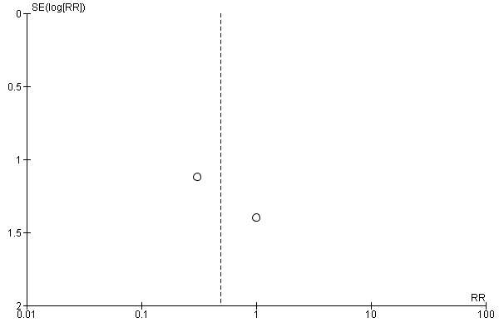

14e) Sepsis
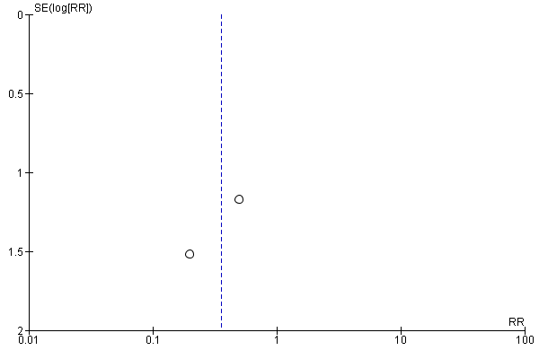

14f) Vascular infection
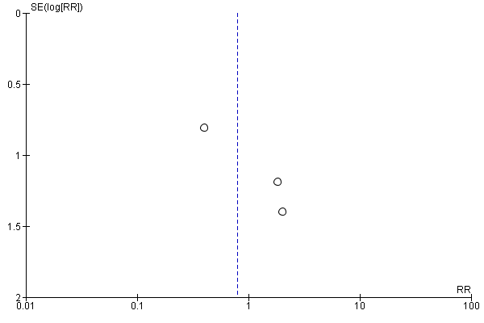

14g) Wound infection
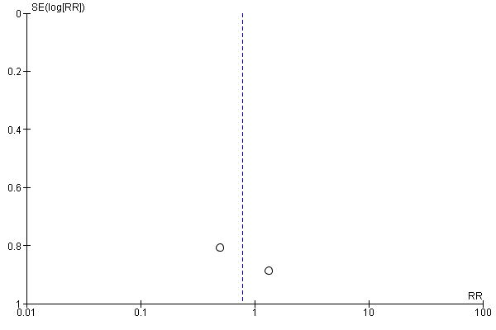

14h) Bacteremia
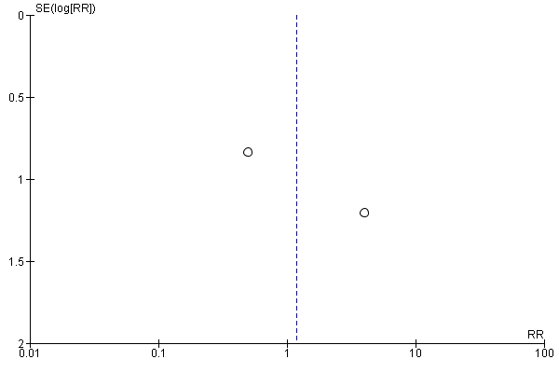

Figure S15: Duration of mechanical ventilation
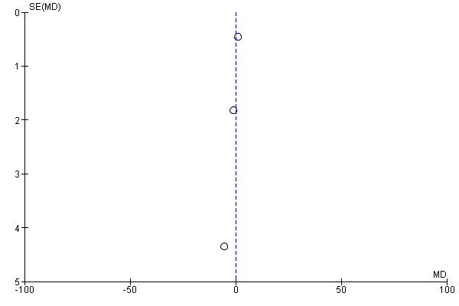

Figure S16: Time to reach target energy needs
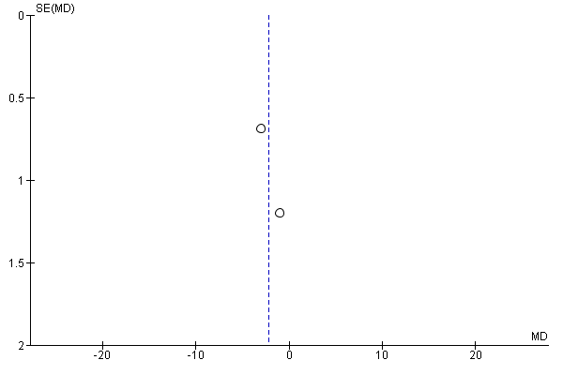

PART 4: Trial Sequential Analysis

Fig. S17: Diarrhea incidence

a) RRR = 25%
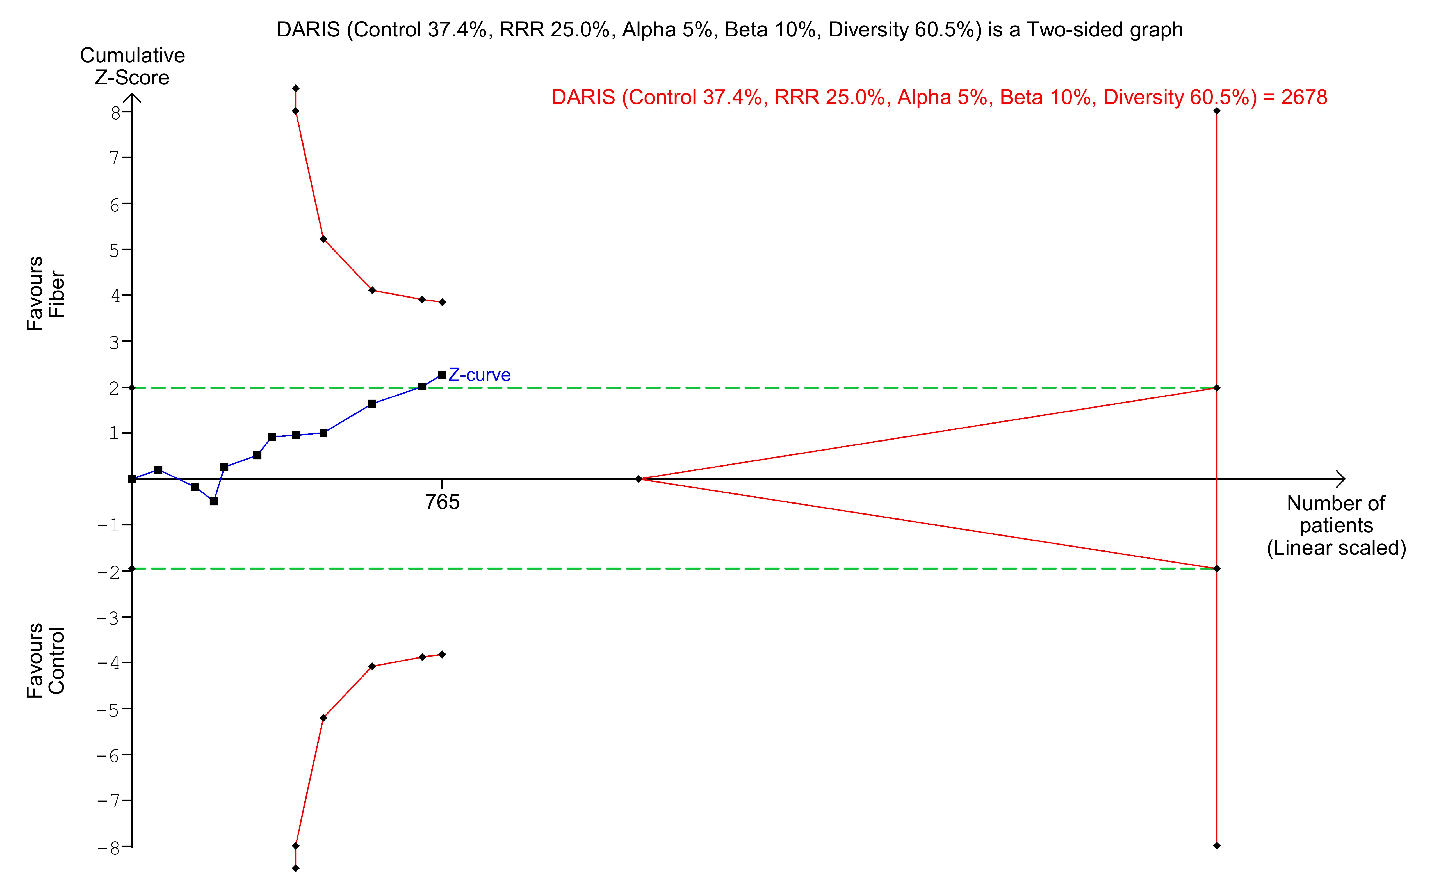

b) sensitivity analysis – RRR = 15%
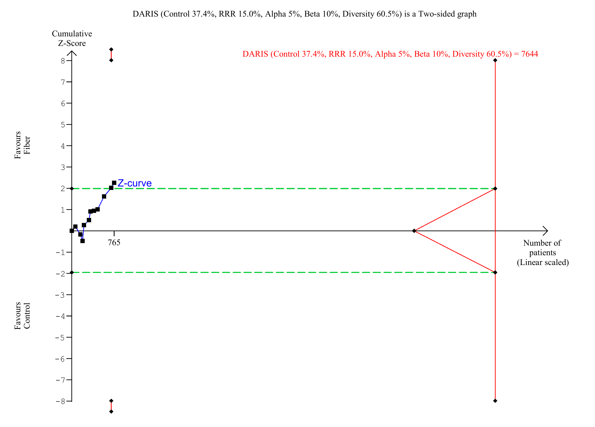

c) sensitivity analysis – RRR = 35%
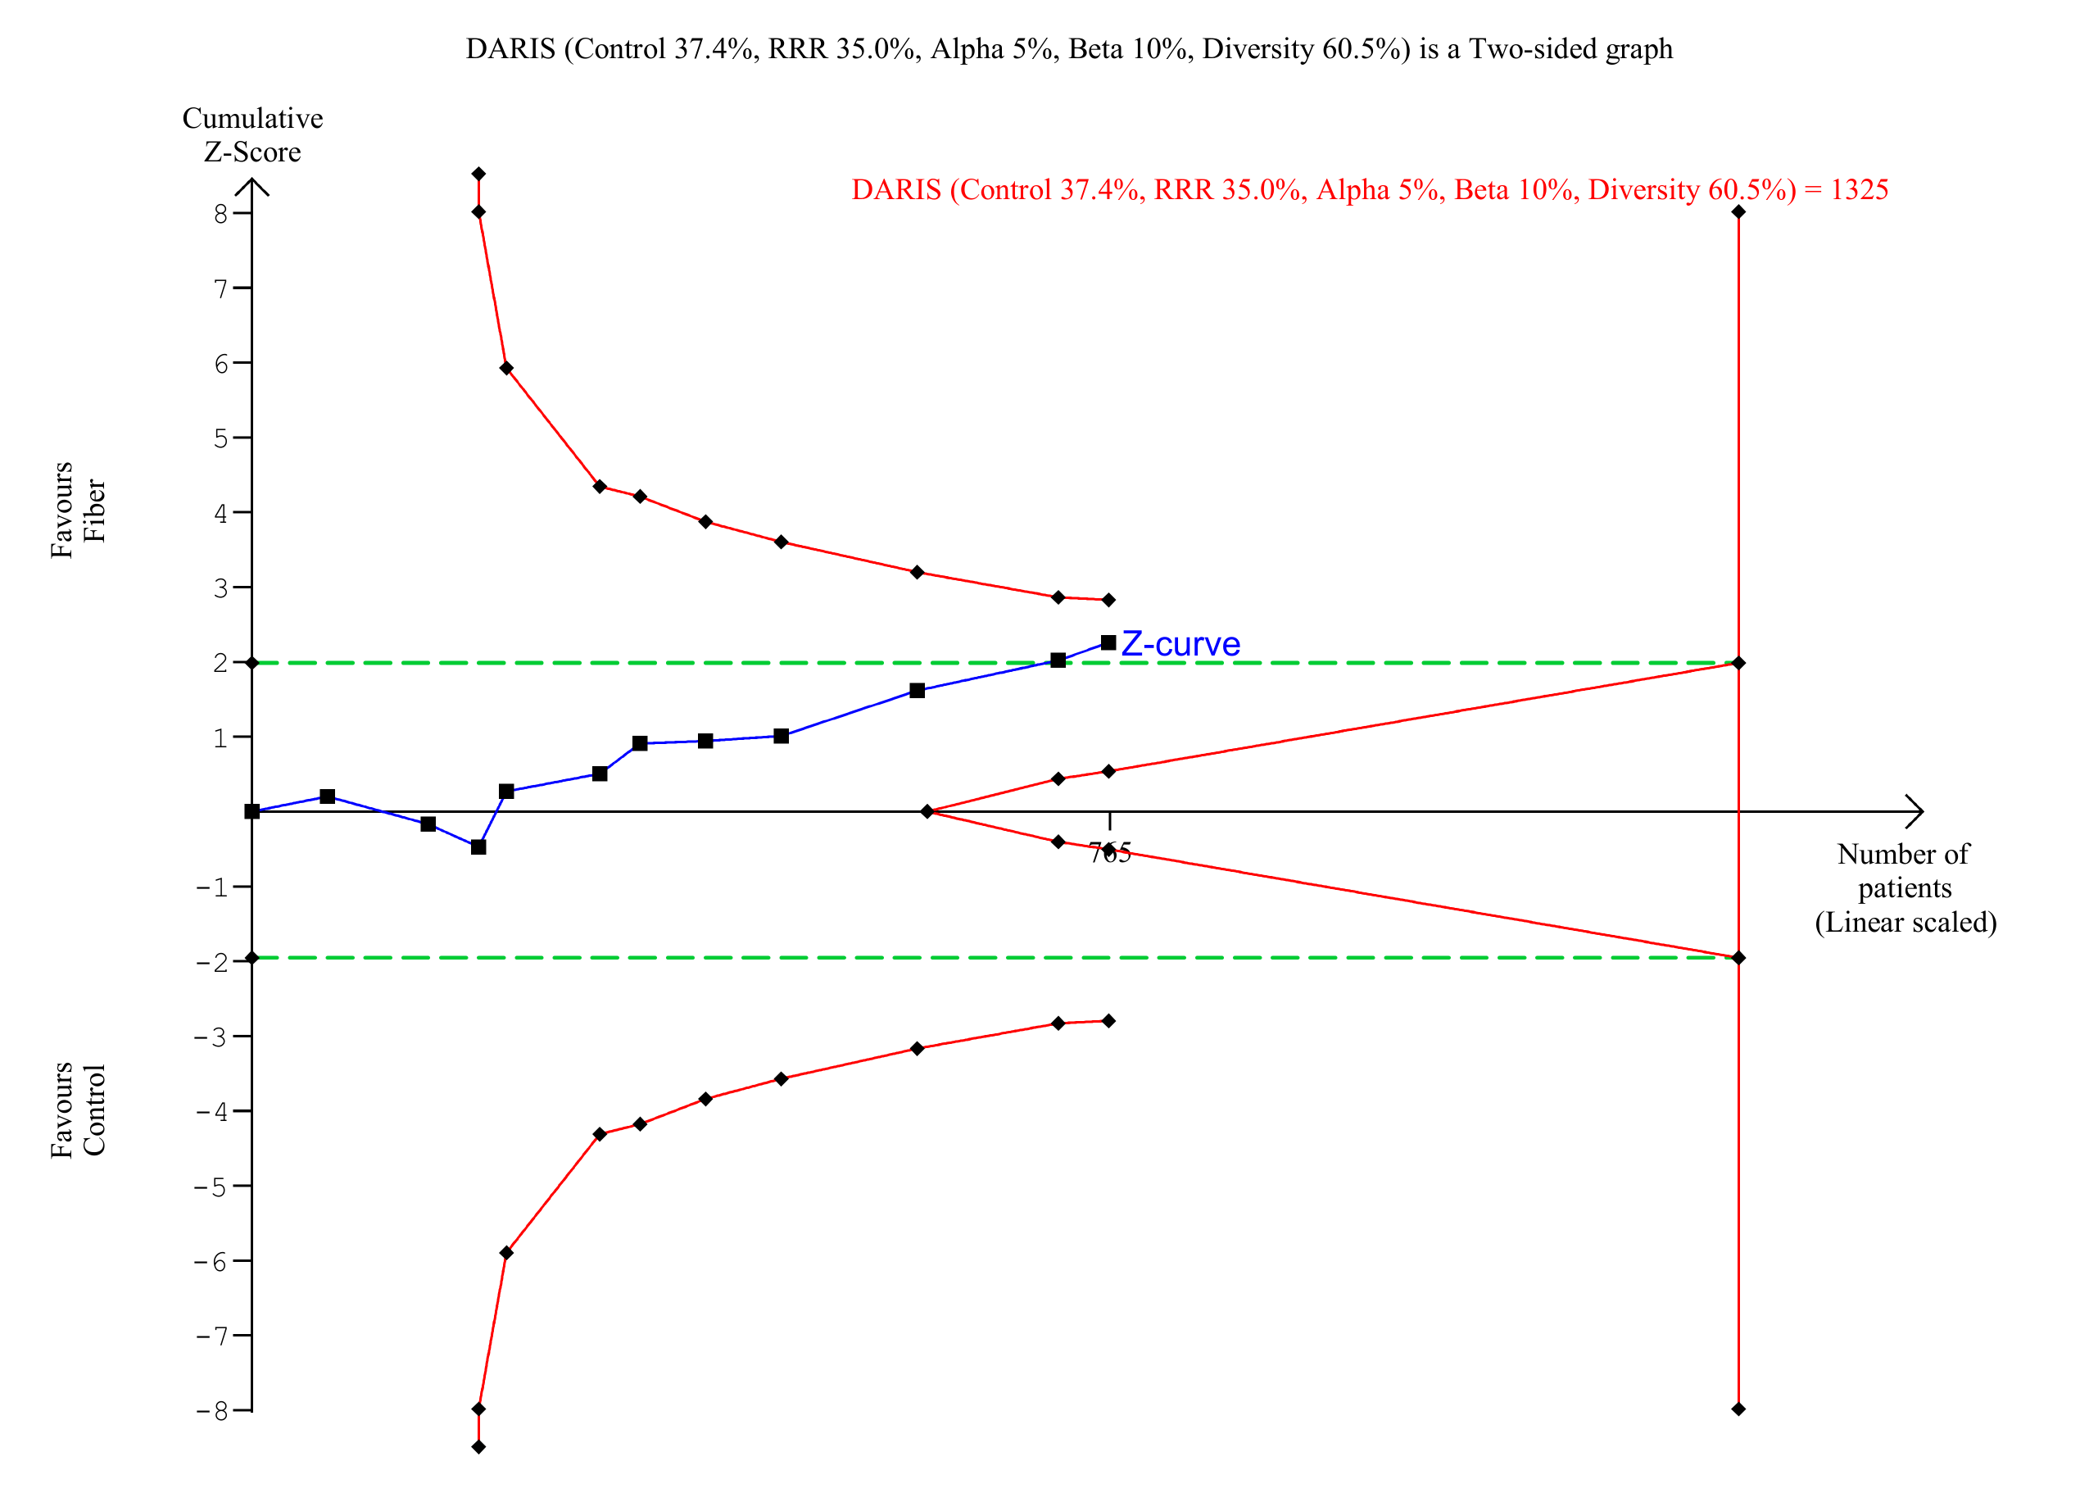

Fig. S18: ICU LOS with sensitivity analyses

a) MIREDIF = 1 day
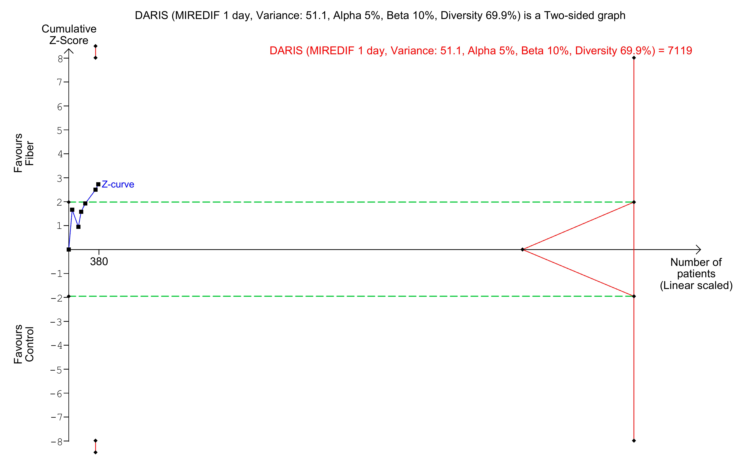

b) sensitivity analysis – MIREDIF = 2 days
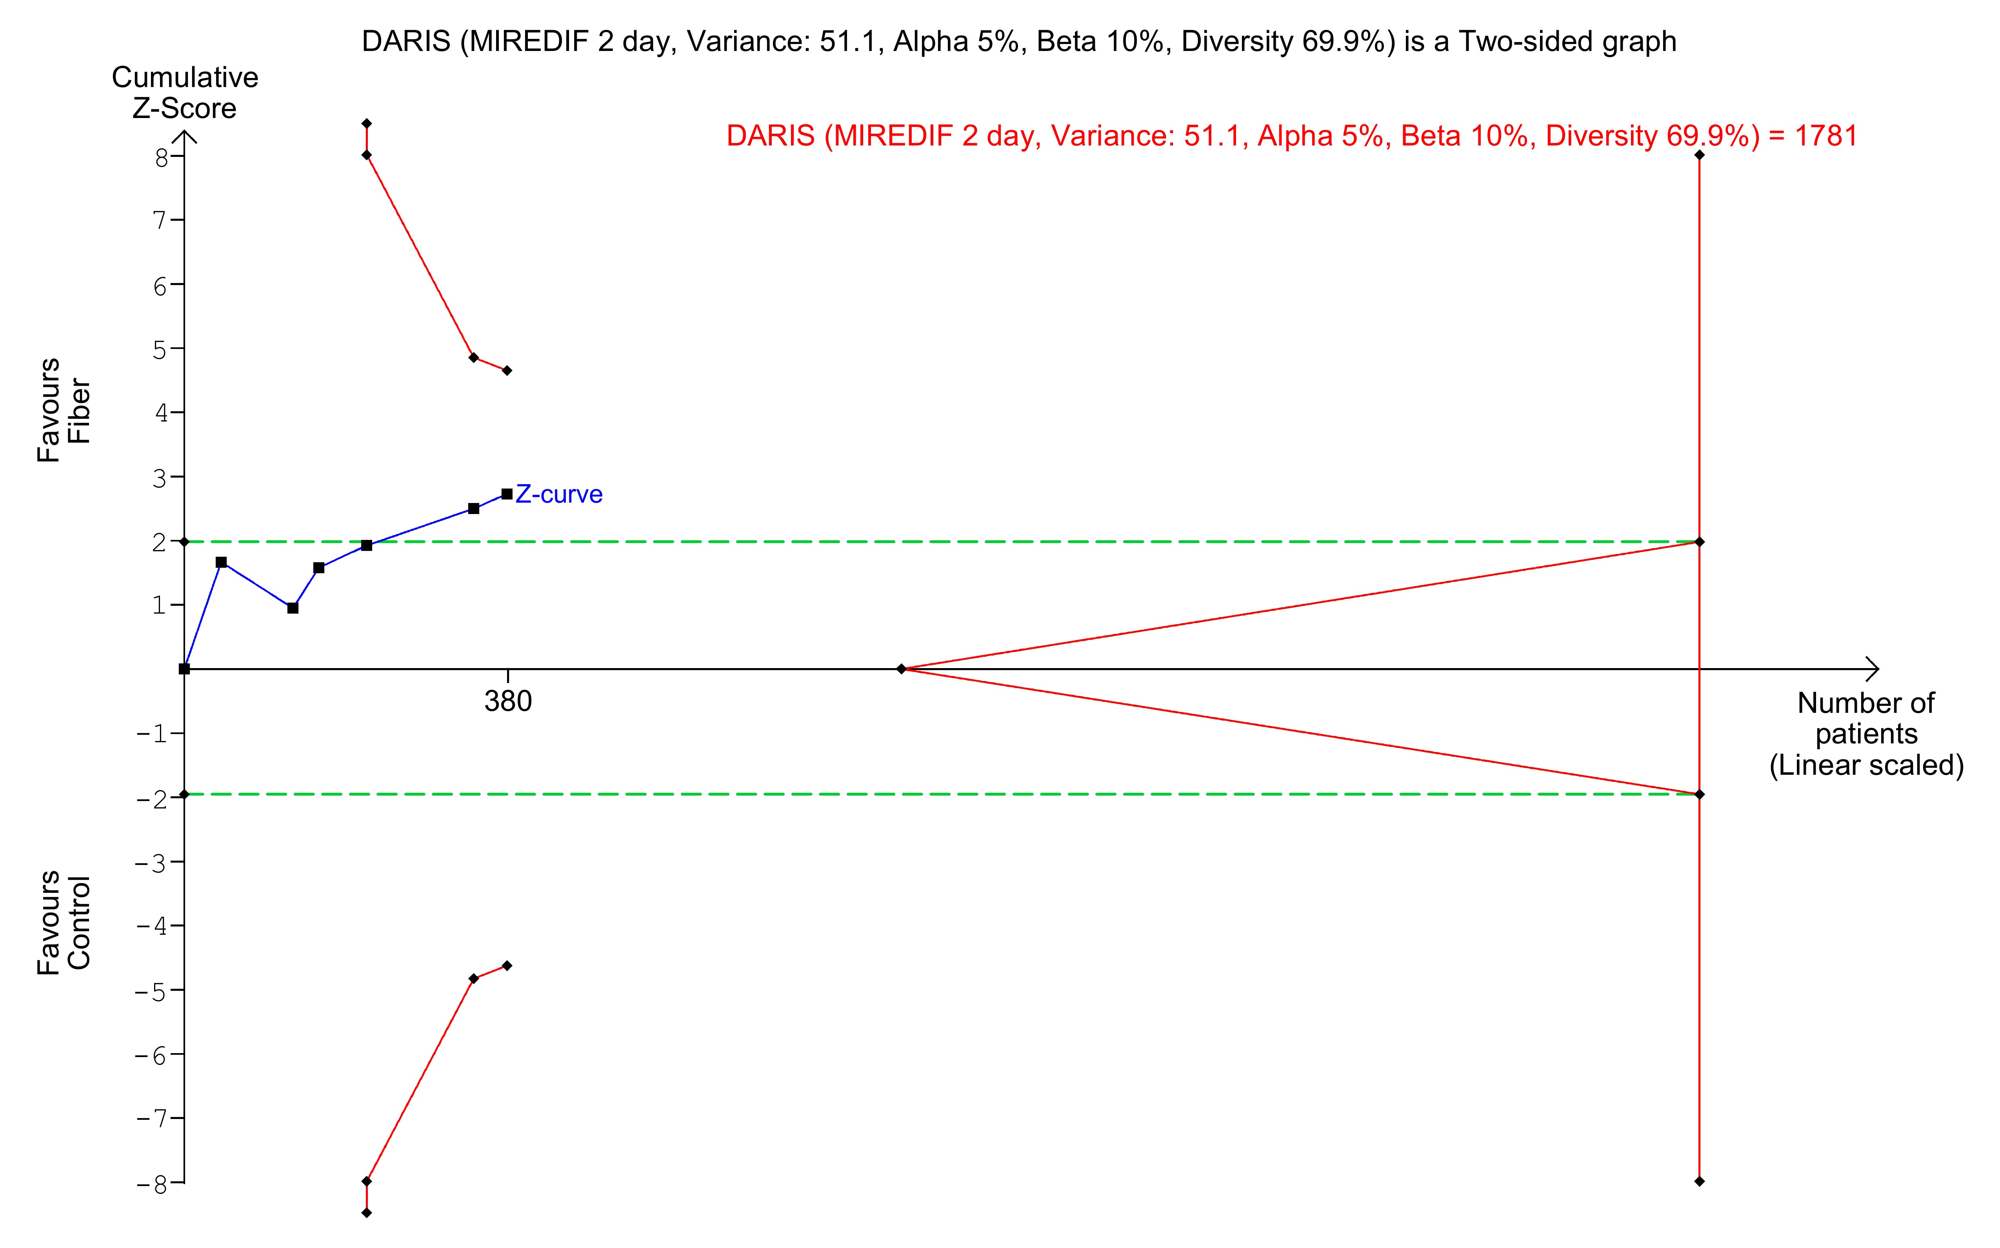

c) sensitivity analysis – MIREDIF = 3 days
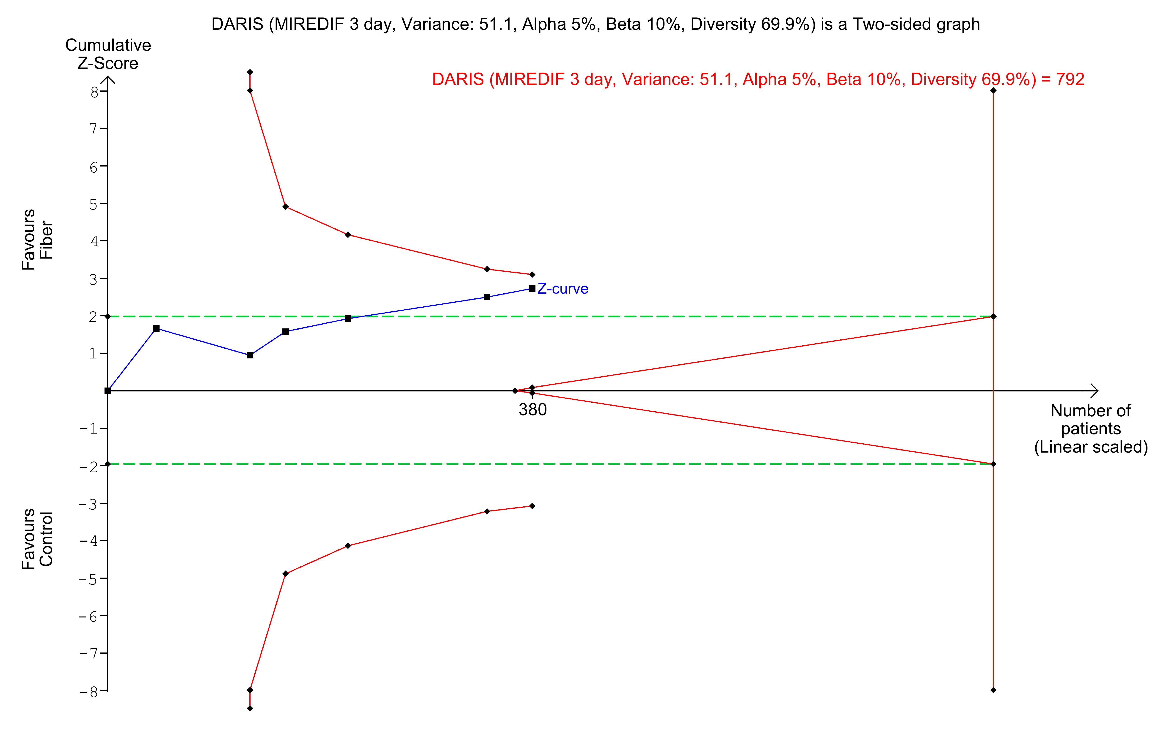

Fig. S19: Hospital LOS with sensitivity analyses

a) MIREDIF = 1 day
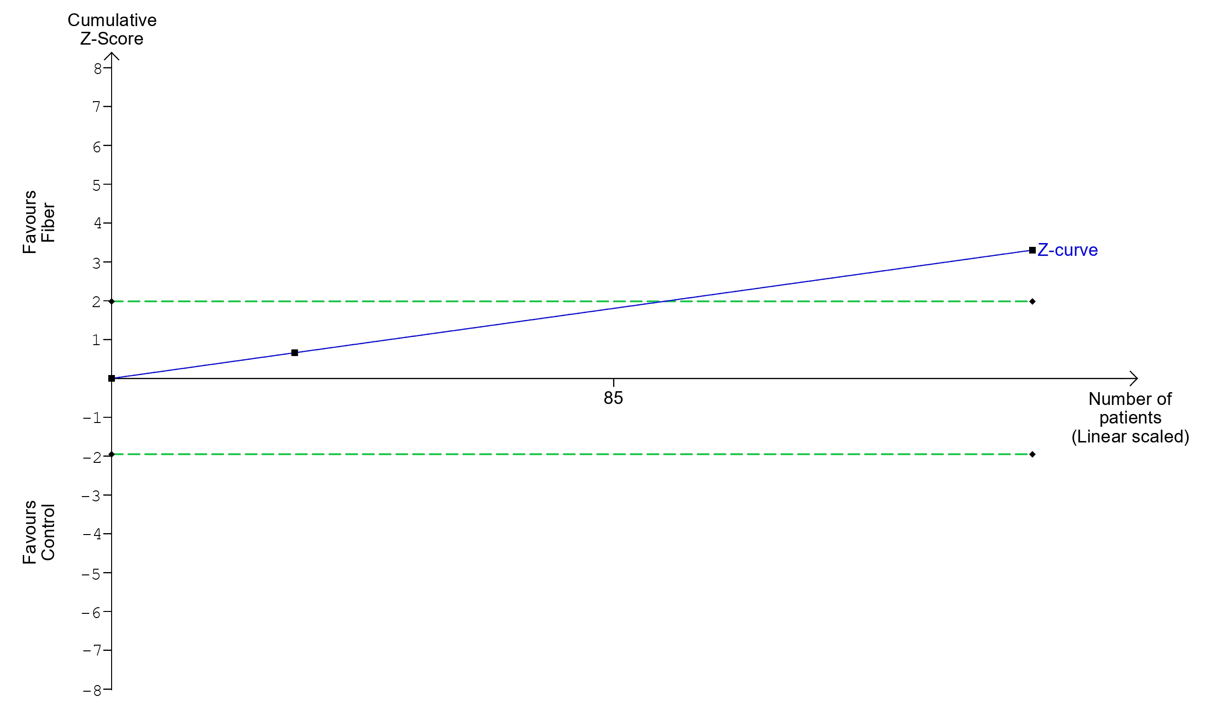

b) sensitivity analysis – MIREDIF = 2 days
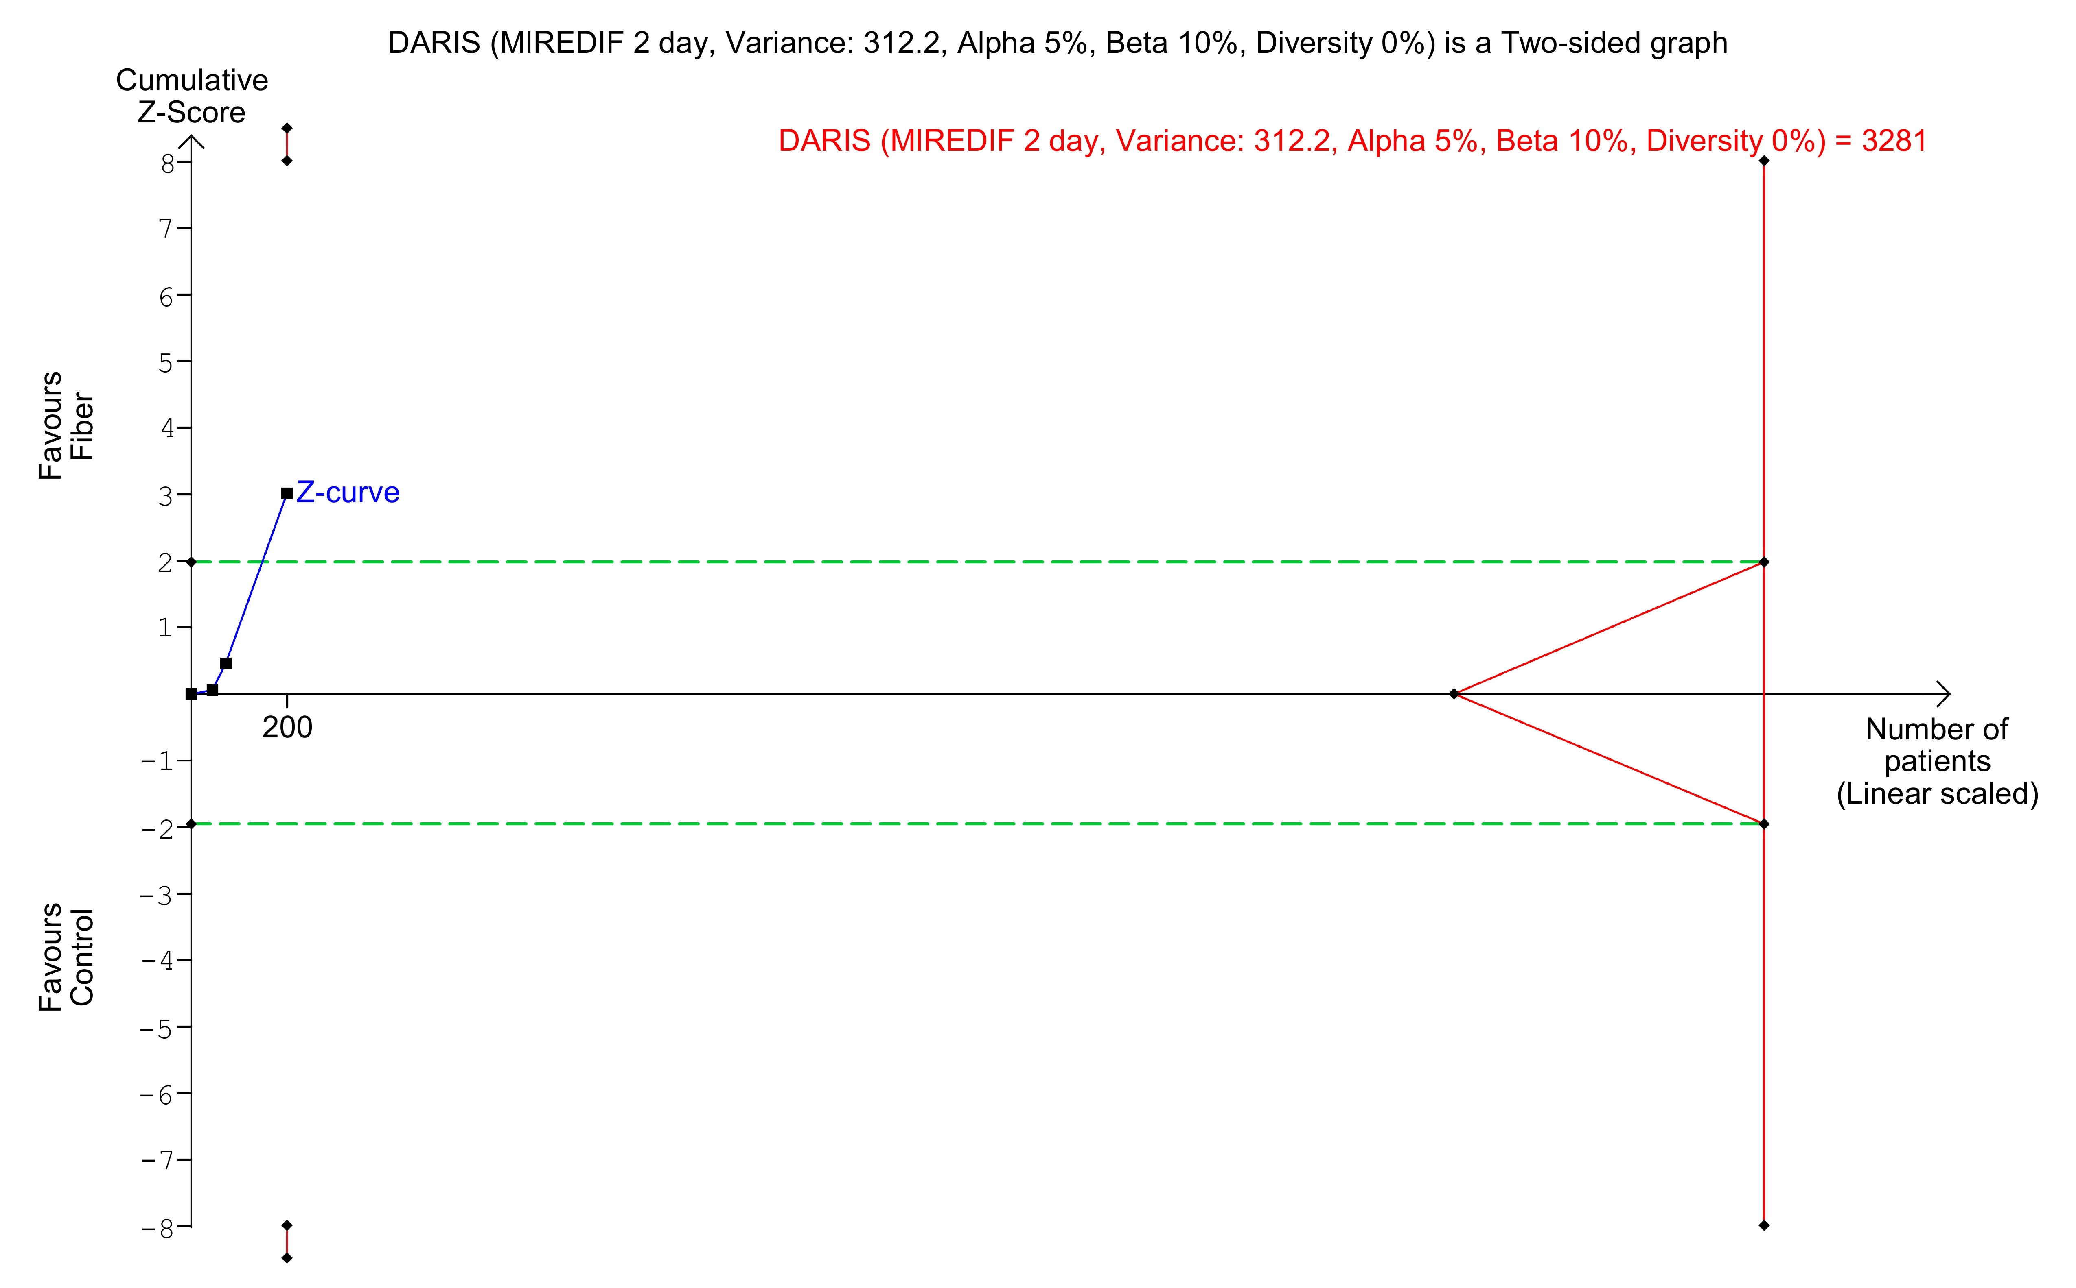

c) sensitivity analysis – MIREDIF = 3 days
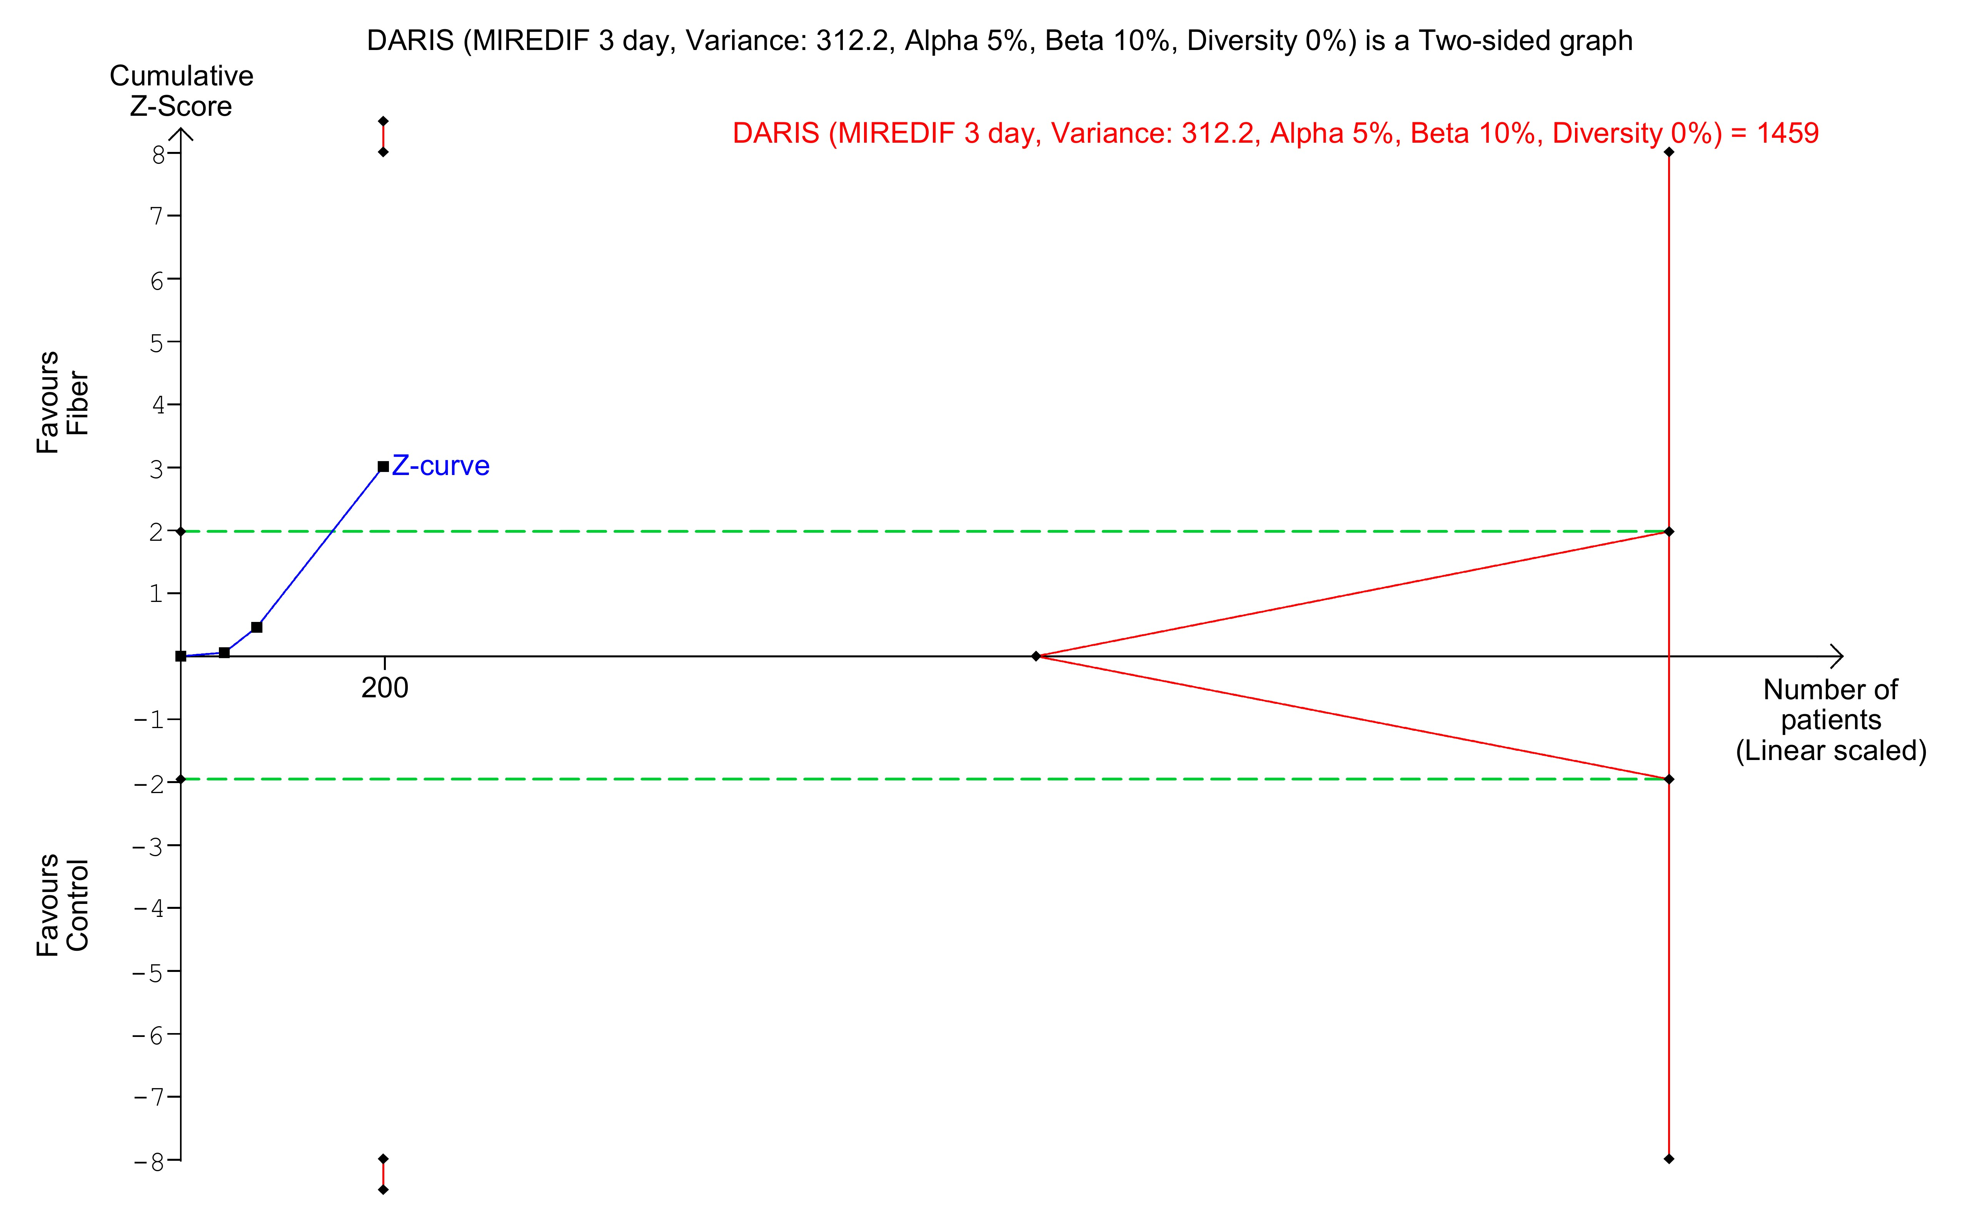

References
[1] J. Wetterslev, J. C. Jakobsen, and C. Gluud, "Trial Sequential Analysis in systematic reviews with meta-analysis," (in eng), BMC Med Res Methodol, vol. 17, no. 1, p. 39, Mar 6 2017, doi: 10.1186/s12874-017-0315-7.

