Supplementary material for

Comparison of Methods to Normalize Urine Output in Critically Ill Patients: a Multicenter Cohort Study

Authors: Céline Monard, Nicolas Tebib, Bastien Trächsel, Tatiana Kelevina, Antoine Guillaume Schneider
Corresponding Author:
Antoine Schneider
Adult Intensive Care Unit,
Centre Hospitalier Universitaire Vaudois,
1011 Lausanne, Switzerland.
E-mail: antoine.schneider@chuv.ch

Table of contents
Comparison of Methods to Normalize Urine Output in Critically Ill Patients: a Multicenter Cohort Study 1
Figure S1- Patients’ flow chart in the validation and the derivation cohort. 2
Figure S2 –Association between minimal urine output (UO) over 6 hours during ICU stay and actual body weight (panel A) or height (panel B) in critically ill patients. 3
Figure S3 –Association between maximal urine output (UO) over 6 hours during ICU stay and actual body weight (panel A) or height (panel B) in critically ill patients 4
Table S1- Differences between the derivation and validation cohort 5
Table S2- Formulas for candidate variables calculations. 6
Table S3- Accuracy of different candidate variables to predict the mean 6-jours urine output during ICU stay. 7
Table S4- Association between oliguria and outcomes according to the different types of normalization adjusted for sex, and SAPS-II 8
Table S5: Number (percentage) of patients correctly classified for 90-day mortality and acute kidney disease, according to the variable used for UO normalization and the weight category. 9
Table S6- Agreement between UO and sCr criteria for AKI diagnosis and staging according to UO normalization 10

Figure S1- Patients’ flow chart in the validation and the derivation cohort.

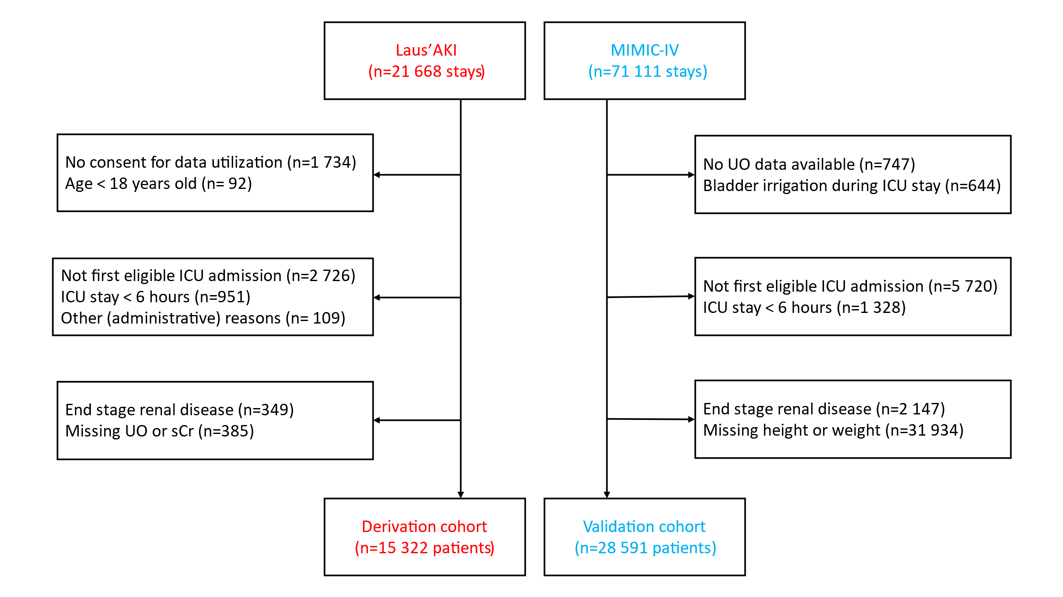

Figure S2 –Association between minimal urine output (UO) over 6 hours during ICU stay and actual body weight (panel A) or height (panel B) in critically ill patients.

Figure S3 –Association between maximal urine output (UO) over 6 hours during ICU stay and actual body weight (panel A) or height (panel B) in critically ill patients

Table S1- Differences between the derivation and validation cohort
 | Derivation cohort  (Laus’AKI) | Validation cohort  (MIMIC-IV)
Population selection
End stage renal disease (ESRD) criteria | Patients receiving maintenance dialysis only | Those with ESRD and/or receiving maintenance dialysis
Stays without sCr measurement during stay | Excluded | Included
Other |  | Exclusion of patients who received at least one vesical irrigation during ICU stay
Oliguria assessment
UO values measured during RRT | Considered | Not considered, replaced by missing values
Abnormal UO values | Hourly UO value greater than 1'000 ml after processing of missing values were considered as erroneous and replaced by the closest hourly UO value available | Hourly UO value greater than 2’500ml have been removed.  (42 measurements out of 3’250’174)
Actual body weight definition | The considered body weight is the value recorded at ICU admission. When unknown, the first quartile of all body weights measured during ICU stay is considered. If no body weights were measured during ICU stay, 60kg was assumed for women and 70kg for men. | Value available in the MIMIC-IV cohort under “Admission Weight (Kg)” in chart events
Factors’ definitions
Baseline sCr | The lowest sCr within the 12 months before ICU admission at the exception of those before an emergency admission; if such value is not available, consideration of the lowest value during ICU stay. | If the lowest sCr value during ICU stay is normal, it was considered.  Otherwise:  - If the patient was diagnosed with CKD, then the lowest sCr value during the stay was considered  - If the patient was not diagnosed with CKD, the baseline sCr was calculated using the Simplified MDRD Formula and assuming an eGFR of 75
sCr: serum creatinine; UO: urine output; CKD: chronic kidney disease

Table S2- Formulas for candidate variables calculations.

Formula | Equation
IBW
Devine formula (IBW_{Devine})  Male  Female | 50 kg + 0.9 kg × (height (cm) – 152)  45.5 kg + 0.9 kg × (height (cm) − 152)
Peterson formula | 2.2 × BMI + 3.5 × BMI × (height (cm) − 1.5 m)
Hammond formula  Male  Female | 48 kg + 1.1 kg × (height (cm) − 150 cm)  45 kg + 0.9 kg × (height (cm) − 150 cm)
Miller formula  Male  Female | 56.2 kg + 1.41 kg × (height (cm) – 152)  53.1 kg + 1.36 kg × (height (cm) − 152)
AdjBW | IBW_{Devine} + 0.4 x (ABW- IBW_{Devine})
BMI | weight (kg)/height² (m)
BSA
Mosteller formula | 0.016667 x weight (kg)^{0.5} x height (cm)^{0.5}
Dubois formula | 0.007184 x weight (kg)^{0.425} x height (cm)^{0.725}
Haycock formula | 0.024265 x weight (kg)^{0.5378} x height (cm)^{0.3964}
IBW: ideal body weight, AdjBW: adjusted body weight; ABW: actual body weight, BMI: body mass index, BSA: body surface area

Table S3- Accuracy of different candidate variables to predict the mean 6-hours urine output during ICU stay.

Variable tested | AIC | R²
ABW | 156837.2 | 0.47
IBW
Devine formula (IBW_{d}) | 127273.3 | 0.9
Peterson formula | 127318.2 | 0.54
Hammond formula | 127276.1 | 0.88
Miller formula | 127275.2 | 0.88
AdjBW | 127274.7 | 0.89
Height | 127265.6 | 0.96
BMI | 127368.6 | 0.14
BSA
Mosteller formula | 127298.5 | 0.7
Dubois formula | 127288.5 | 0.78
Haycock formula | 127302.9 | 0.66
AIC: Akaike information criteria; R²: R-squared, IBW: ideal body weight, AdjBW: adjusted body weight; ABW: actual body weight, BMI: body mass index, BSA: body surface area
For AIC, the lowest value indicates the best performance
For R², the highest value indicates the best performance

AIC values compare models considering both the goodness of fit and the number of parameters used, with lower values indicating a better model. The R² represents the percentage of variation explained by the model; a R² of 100 would mean that we could perfectly predict all deaths with the variables we have in the model, while an R² of 0 means that the variables are not useful.

Table S4- Association between oliguria and outcomes according to the different types of normalization adjusted for sex, and SAPS-II

 | 90-day mortality |  | AKD
 | AUC (95%CI) | Pseudo R² | AUC (95%CI) | Pseudo R²
All patients (n=28 591)
UO normalized by ABW | 0.74 (0.74,0.75) | 12.07 | 0.67 (0.66,0.68) | 5.67
UO normalized by IBW_{d} | 0.76 (0.75,0.76) | 13.53 | 0.68 (0.67,0.68) | 6.22
Patients with an indwelling catheter throughout ICU stay (n=17 284)
UO normalized by ABW | 0.73 (0.72,0.74) | 11.34 | 0.66 (0.65,0.67) | 4.93
UO normalized by IBW_{d} | 0.75 (0.74,0.76) | 13.37 | 0.67 (0.66,0.68) | 5.72
Patients who never received diuretics (n=12 677)
UO normalized by ABW | 0.81 (0.8,0.82) | 21.66 | 0.69 (0.68,0.71) | 7.9
UO normalized by IBW_{d} | 0.82 (0.81,0.83) | 22.83 | 0.7 (0.69,0.71) | 8.28
AKD: Acute Kidney Disease at hospital discharge, IBW_{d} : ideal body weight, ABW: actual body weight, AUC: area under the ROC curve
The results for AUC are AUC (95%CI), and the pseudo R² represents the percentage of variation explained by the model; an R² of 100 would mean that we could perfectly predict all deaths with the variables we have in the model, while an R² of 0 means that the variables are not useful.

Table S5- Number (percentage) of patients correctly classified for 90-day mortality and acute kidney disease, according to the variable used for UO normalization and the weight category.

Outcome | UO normalization by: | Low weight | Normal weight | High weight | All
90-day mortality | ABW | 3 595 (51.1%) | 5 431 (37.3%) | 1 749 (25%) | 10 775 (37.7%)
90-day mortality | IBW_{d} | 3 765 (53.5%) | 6 968 (47.9%) | 3 094 (44.2%) | 13 827 (48.4%)
AKD | ABW | 3 199 (45.5%) | 5 513 (37.9%) | 2 100 (30%) | 10 812 (37.8%)
AKD | IBW_{d} | 3 309 (47%) | 6 843 (47%) | 3 282 (46.9%) | 13 434 (47%)
AKD: Acute Kidney Disease at hospital discharge, IBW_{d} : ideal body weight, ABW: actual body weight, Low weight: <67kg of ABW, Normal weight 68-95kg of ABW, High weight >95kg of ABW; N= 28 591

Table S6- Agreement between UO and sCr criteria for AKI diagnosis and staging according to UO normalization

 |  |  | Max sCr stage
 |  |  | No AKI | Stage 1 | Stage 2 | Stage 3 | Agree-ment
Max UO stage | UO normalized  by ABW | No AKI | 5665 | 856 | 163 | 66 | 0.34
Max UO stage | UO normalized  by ABW | Stage 1 | 3954 | 1109 | 199 | 93 | 0.34
Max UO stage | UO normalized  by ABW | Stage 2 | 7045 | 3315 | 816 | 445 | 0.34
Max UO stage | UO normalized  by ABW | Stage 3 | 1404 | 1480 | 764 | 1176 | 0.34
Max UO stage | UO normalized by IBW_{D} | No AKI | 8307 | 1574 | 276 | 114 | 0.35
Max UO stage | UO normalized by IBW_{D} | Stage 1 | 4120 | 1463 | 284 | 120 | 0.35
Max UO stage | UO normalized by IBW_{D} | Stage 2 | 4830 | 2841 | 843 | 521 | 0.35
Max UO stage | UO normalized by IBW_{D} | Stage 3 | 811 | 882 | 539 | 1025 | 0.35
N= 28 550. Bold numbers correspond to patients who reached similar AKI stage with both UO or sCr criteria (11 638 (40.8%) with IBW_{D} normalization and 8 766 (30.7%) with ABW normalization). Agreement (Kendall correlation coefficient).
sCr: serum creatinine, UO: urine output, ABW: actual body weight, IBW_{D:} ideal body weight defined by the Devine formula.

