SUPPLEMENTAL TABLES

Supplemental Table 1. Taxa classified as short chain fatty acid producers in the trial.

Phylum | Class | Order | Family | Genus | Species
Firmicutes | Bacilli | Lactobacillales | Lactobacillaceae | Weissella | Weissella cibaria
Firmicutes | Clostridia | Lachnospirales | Lachnospiraceae | UC5-1-2E3 | Lachnospiraceae UC5-1-2E3
Firmicutes | Clostridia | Oscillospirales | Ruminococcaceae | UBA1819 | Ruminococcaceae UBA1819
Firmicutes | Clostridia | Lachnospirales | Lachnospiraceae | Tuzzerella | Tuzzerella sp
Firmicutes | Clostridia | Oscillospirales | Ruminococcaceae | Subdoligranulum | Subdoligranulum sp
Firmicutes | Clostridia | Lachnospirales | Lachnospiraceae | Shuttleworthia | Shuttleworthia sp
Firmicutes | Clostridia | Lachnospirales | Lachnospiraceae | Agathobacter | Agathobacter rectalis
Bacteroidota | Bacteroidia | Bacteroidales | Rikenellaceae | Alistipes | Alistipes sp
Firmicutes | Clostridia | Lachnospirales | Lachnospiraceae | Anaerostipes | Anaerostipes hadrus
Firmicutes | Clostridia | Oscillospirales | Ruminococcaceae | Anaerotruncus | Anaerotruncus massiliensis
Firmicutes | Clostridia | Oscillospirales | Ruminococcaceae | Ruminococcus | Ruminococcus bromii
Firmicutes | Clostridia | Oscillospirales | Ruminococcaceae | Ruminococcus | Ruminococcus albus
Firmicutes | Clostridia | Oscillospirales | Ruminococcaceae | Ruminococcus | Ruminococcus champanellensis
Firmicutes | Clostridia | Lachnospirales | Lachnospiraceae | Robinsoniella | Robinsoniella peoriensis
Firmicutes | Clostridia | Oscillospirales | Ruminococcaceae | CAG-352 | Ruminococcaceae CAG-352
Firmicutes | Clostridia | Lachnospirales | Lachnospiraceae | Blautia | Blautia producta
Bacteroidota | Bacteroidia | Bacteroidales | Marinifilaceae | Odoribacter | Odoribacter splanchnicus
Bacteroidota | Bacteroidia | Bacteroidales | Marinifilaceae | Odoribacter | Odoribacter laneus
Firmicutes | Clostridia | Lachnospirales | Lachnospiraceae | Blautia | Blautia sp
Firmicutes | Clostridia | Lachnospirales | Lachnospiraceae | Blautia | Blautia luti
Firmicutes | Clostridia | Lachnospirales | Lachnospiraceae | Lachnospiraceae | Lachnospiraceae sp
Firmicutes | Clostridia | Oscillospirales | Ruminococcaceae | Ruminococcaceae | Ruminococcaceae sp
Firmicutes | Clostridia | Oscillospirales | Ruminococcaceae | Negativibacillus | Negativibacillus sp
Firmicutes | Bacilli | Lactobacillales | Lactobacillaceae | Limosilactobacillus | Limosilactobacillus reuteri
Firmicutes | Clostridia | Lachnospirales | Lachnospiraceae | Blautia | Blautia faecis
Firmicutes | Clostridia | Lachnospirales | Lachnospiraceae | Blautia | Blautia wexlerae
Firmicutes | Clostridia | Lachnospirales | Lachnospiraceae | Blautia | Blautia obeum
Firmicutes | Clostridia | Lachnospirales | Lachnospiraceae | Blautia | Blautia intestinalis
Firmicutes | Bacilli | Lactobacillales | Lactobacillaceae | Leuconostoc | Leuconostoc lactis
Firmicutes | Bacilli | Lactobacillales | Lactobacillaceae | Leuconostoc | Leuconostoc gelidum
Firmicutes | Bacilli | Lactobacillales | Lactobacillaceae | Lactobacillus | Lactobacillus johnsonii
Firmicutes | Bacilli | Lactobacillales | Lactobacillaceae | Lactobacillus | Lactobacillus iners
Firmicutes | Clostridia | Lachnospirales | Lachnospiraceae | Bariatricus | Bariatricus massiliensis
Firmicutes | Clostridia | Lachnospirales | Lachnospiraceae | Eisenbergiella | Eisenbergiella massiliensis
Firmicutes | Bacilli | Lactobacillales | Lactobacillaceae | Lactobacillaceae | Lactobacillaceae sp
Firmicutes | Clostridia | Lachnospirales | Lachnospiraceae | Eisenbergiella | Eisenbergiella tayi
Firmicutes | Clostridia | Lachnospirales | Lachnospiraceae | Epulopiscium | Epulopiscium sp
Firmicutes | Clostridia | Oscillospirales | Ruminococcaceae | Faecalibacterium | Faecalibacterium prausnitzii
Firmicutes | Clostridia | Lachnospirales | Lachnospiraceae | Frisingicoccus | Frisingicoccus caecimuris
Firmicutes | Clostridia | Lachnospirales | Lachnospiraceae | Hungatella | Hungatella effluvii
Firmicutes | Clostridia | Lachnospirales | Lachnospiraceae | Hungatella | Hungatella hathewayi
Firmicutes | Clostridia | Lachnospirales | Lachnospiraceae | Lachnoclostridium | Lachnoclostridium sp
Firmicutes | Clostridia | Lachnospirales | Lachnospiraceae | Lachnospiraceae | Lachnospiraceae NK4A136 group
Firmicutes | Clostridia | Lachnospirales | Lachnospiraceae | Lachnoclostridium | Lachnoclostridium pacaense
Firmicutes | Clostridia | Lachnospirales | Lachnospiraceae | Enterocloster | Enterocloster clostridioformis
Firmicutes | Clostridia | Lachnospirales | Lachnospiraceae | Enterocloster | Enterocloster bolteae
Firmicutes | Clostridia | Lachnospirales | Lachnospiraceae | Lachnoclostridium | Lachnoclostridium urinimassiliense
Firmicutes | Clostridia | Lachnospirales | Lachnospiraceae | Eubacterium | Eubacterium sp
Firmicutes | Bacilli | Lactobacillales | Lactobacillaceae | Lacticaseibacillus | Lacticaseibacillus rhamnosus
Firmicutes | Bacilli | Lactobacillales | Lactobacillaceae | Lacticaseibacillus | Lactobacillus paracasei
Firmicutes | Clostridia | Oscillospirales | Ruminococcaceae | Incertae Sedis | Incertae Sedis
Firmicutes | Clostridia | Lachnospirales | Lachnospiraceae | Fusicatenibacter | Fusicatenibacter sp
Firmicutes | Bacilli | Lactobacillales | Lactobacillaceae | Lactiplantibacillus | Lactiplantibacillus plantarum
Firmicutes | Bacilli | Lactobacillales | Lactobacillaceae | Lactobacillus | Lactobacillus gasseri
Firmicutes | Clostridia | Oscillospirales | Ruminococcaceae | DTU089 | Ruminococcaceae DTU089
Firmicutes | Bacilli | Lactobacillales | Lactobacillaceae | Lactobacillus | Lactobacillus crispatus
Firmicutes | Clostridia | Lachnospirales | Lachnospiraceae | Dorea | Dorea formicigenerans
Firmicutes | Clostridia | Lachnospirales | Lachnospiraceae | Coprococcus | Coprococcus catus
Firmicutes | Clostridia | Lachnospirales | Lachnospiraceae | Coprococcus | Coprococcus comes
Firmicutes | Clostridia | Lachnospirales | Lachnospiraceae | Dorea | Dorea longicatena
Firmicutes | Bacilli | Lactobacillales | Lactobacillaceae | Lactobacillus | Lactobacillus kalixensis
Firmicutes | Bacilli | Lactobacillales | Lactobacillaceae | Ligilactobacillus | Ligilactobacillus salivarius
Firmicutes | Bacilli | Lactobacillales | Lactobacillaceae | Lactobacillus | Lactobacillus murinus
Firmicutes | Clostridia | Lachnospirales | Lachnospiraceae | Blautia | Blautia hydrogenotrophica
Firmicutes | Bacilli | Lactobacillales | Lactobacillaceae | Limosilactobacillus | Limosilactobacillus fermentum
Firmicutes | Bacilli | Lactobacillales | Lactobacillaceae | Lactobacillus | Lactobacillus mucosae
Bacteroidota | Bacteroidia | Bacteroidales | Marinifilaceae | Odoribacter | Odoribacter sp
Firmicutes | Clostridia | Lachnospirales | Lachnospiraceae | Blautia | Blautia hansenii
Firmicutes | Clostridia | Lachnospirales | Lachnospiraceae | Sellimonas | Sellimonas intestinalis
Firmicutes | Clostridia | Oscillospirales | Ruminococcaceae | Anaerotruncus | Anaerotruncus colihominis
Firmicutes | Clostridia | Lachnospirales | Lachnospiraceae | Anaerostipes | Anaerostipes caccae
Bacteroidota | Bacteroidia | Bacteroidales | Rikenellaceae | Alistipes | Alistipes putredinis
Bacteroidota | Bacteroidia | Bacteroidales | Rikenellaceae | Alistipes | Alistipes finegoldii
Bacteroidota | Bacteroidia | Bacteroidales | Rikenellaceae | Alistipes | Alistipes onderdonkii
Bacteroidota | Bacteroidia | Bacteroidales | Rikenellaceae | Alistipes | Alistipes shahii
Bacteroidota | Bacteroidia | Bacteroidales | Rikenellaceae | Alistipes | Alistipes indistinctus
Firmicutes | Clostridia | Lachnospirales | Lachnospiraceae | A2 | Lachnospiraceae A2
Firmicutes | Clostridia | Lachnospirales | Lachnospiraceae | Ruminococcus | [Ruminococcus] torques group
Firmicutes | Clostridia | Lachnospirales | Lachnospiraceae | Ruminococcus | [Ruminococcus] gnavus group
Firmicutes | Clostridia | Lachnospirales | Lachnospiraceae | Ruminococcus | [Ruminococcus] gauvreauii group
Firmicutes | Clostridia | Lachnospirales | Lachnospiraceae | Eubacterium | [Eubacterium] hallii group
Firmicutes | Clostridia | Lachnospirales | Lachnospiraceae | Eubacterium | [Eubacterium] fissicatena group
Classification based on Vital et al. See methods for further information.

Supplemental Table 2. ICU admission characteristics based on the Sequential Organ Failure Assessment (SOFA) score, by treatment group.
Characteristic | Placebo  (N=30) | Inulin 16 g/day  (N=30) | Inulin 32 g/day  (N=30) | p-value*
PaO₂ in mm Hg (median, IQR) | 109 (82-165) | 116 (77-154) | 123 (91-160) | 0.76
FiO₂ in mm Hg (median, IQR) | 40.5 (40-60) | 45 (40-100) | 40 (40-60) | 0.77
Mechanical ventilation including CPAP |  |  |  | 0.15
Yes | 21 (70%) | 24 (80%) | 27 (90%)
No | 9 (30%) | 6 (20%) | 3 (10%)
Glasgow coma scaleª |  |  |  | 0.47
15 | 21 (70%) | 24 (80%) | 27 (90%)
13-14 | 3 (10%) | 3 (10%) | 1 (3%)
10-12 | 1 (3%) | 0 (0%) | 1 (3%)
6-9 | 5 (17%) | 3 (10%) | 1 (3%)
<6 | 0 (0%) | 0 (0%) | 0 (0%)
Mean arterial pressure or administration of vasopressors |  |  |  | 0.83
No hypotension | 4 (13%) | 3 (10%) | 4 (13%)
MAP <70 mm Hg | 0 (0%) | 0 (0%) | 0 (0%)
Dopamine ≤5 or dobutamine (any dose) | 6 (20%) | 4 (13%) | 6 (20%)
Dopamine >5, epinephrine ≤0.1, or norepinephrine ≤0.1 | 0 (0%) | 1 (3%) | 0 (0%)
Dopamine >15, epinephrine >0.1, or norepinephrine >0.1 | 20 (67%) | 22 (73%) | 20 (67%)
Platelets x 10³/uL |  |  |  | 0.18
≥150 | 23 (77%) | 21 (70%) | 21 (70%)
100-149 | 2 (7%) | 2 (7%) | 6 (20%)
50-99 | 3 (10%) | 7 (23%) | 2 (7%)
20-49 | 2 (7%) | 0 (0%) | 1 (3%)
<20 | 0 (0%) | 0 (0%) | 0 (0%)
Bilirubin in mg/dL |  |  |  | 0.71
<1.2 | 27 (90%) | 25 (83%) | 24 (80%)
1.2-1.9 | 0 (0%) | 2 (7%) | 2 (7%)
2.0-5.9 | 2 (7%) | 2 (7%) | 3 (10%)
6.0-11.9 | 0 (0%) | 1 (3%) | 1 (3%)
≥12.0 | 1 (3%) | 0 (0%) | 0 (0%)
Creatinine in mg/dL |  |  |  | 0.45
<1.2 | 7 (23%) | 7 (23%) | 10 (33%)
1.2-1.9 | 2 (7%) | 6 (20%) | 5 (17%)
2.0-3.4 | 6 (20%) | 2 (7%) | 5 (17%)
3.5-4.9 or UOP <500 mL/day | 6 (20%) | 5 (17%) | 6 (20%)
≥5.0 or UOP <200 mL/day | 10 (33%) | 10 (33%) | 4 (13%)
ªThe Glasgow Coma Scale was formulated as per Knaus et al. with an assumption of a normal neurological exam among sedated patients (Knaus WA et al., Chest 1991; 100(6):1619-1636).
Abbreviations: ICU: intensive care unit; SOFA: Sequential Organ Failure Assessment.

Supplemental Table 3. Antibiotic classes received in the ICU, organized by initial antibiotic class.^{1,2}

Antibiotic class | All  N (%) | Placebo  (N=30) | Inulin 16 g/day  (N=30) | Inulin 32 g/day  (N=30) | p-value³
Extended-spectrum beta-lactam | 46 (51%) | 13 (43%) | 16 (53%) | 17 (57%) | 0.56
Vancomycin | 43 (48%) | 12 (40%) | 13 (43%) | 18 (60%) | 0.25
Macrolides | 26 (29%) | 9 (30%) | 7 (23%) | 10 (33%) | 0.69
Monobactams | 24 (27%) | 7 (23%) | 10 (33%) | 7 (23%) | 0.63
Cephalosporins | 21 (24%) | 9 (30%) | 6 (20%) | 6 (20%) | 0.62
Linezolid | 7 (8%) | 2 (7%) | 2 (7%) | 3 (10%) | 0.83
Aminoglycosides | 6 (7%) | 3 (10%) | 1 (3%) | 2 (7%) | 0.59
Metronidazole | 6 (7%) | 2 (7%) | 2 (7%) | 2 (7%) | ---
Βeta-lactams | 4 (4%) | 2 (7%) | 1 (3%) | 1 (3%) | 0.77
Tetracyclines | 4 (4%) | 1 (3%) | 1 (3%) | 2 (7%) | 0.77
Fluoroquinolones | 3 (3%) | 1 (3%) | 1 (3%) | 1 (3%) | ---
Sulfonamides | 3 (3%) | 1 (3%) | 1 (3%) | 1 (3%) | ---
Clindamycin | 1 (1%) | 0 | 1 (3%) | 0 | 0.36
Polymyxin B | 1 (1%) | 0 | 0 | 1 (3%) | 0.37

¹Intravenous or oral antibiotic classes received during the 30-day follow-up period (i.e., excluding topical antibiotics).
²Many participants received multiple classes of antibiotics.
³Chi-squared p-value.

Supplemental Table 4. Culture-proven infections during the study, organized by site.

Organism | Site |  |  |  | Total
Organism | Lungs | Blood | Urine | Other | Total
P. aeruginosa | 11 | 1 | 1 | 0 | 13
K. pneumoniae | 5 | 0 | 5 | 0 | 10
E. coli | 0 | 0 | 4 | 1 | 5
MSSA | 3 | 1 | 0 | 0 | 4
S. maltophilia | 4 | 0 | 0 | 0 | 4
VRE | 1 | 0 | 2 | 0 | 3
MRSA | 2 | 1 | 0 | 0 | 3
S. marcescens | 1 | 1 | 0 | 0 | 2
C. difficile | 0 | 0 | 0 | 1 | 1
Other | 17 | 4 | 5 | 0 | 26
Total | 44 | 8 | 17 | 2 | 71
Culture-proven infections occurring during the 30-day follow-up period. There were 71 infections which occurred in 39 unique individuals. The infections listed were classified based on positive cultures. Additionally, all patients were required to show appropriate signs/symptoms of infection (e.g., increased sputum production), and to be treated by the ICU team with antibiotics. Site-specific CDC criteria were used to determine the symptoms that were considered appropriate evidence for each infection type.

Supplemental Table 5. Adherence to the study intervention, by treatment group.

Measure | Placebo (N=30) |  | Inulin  16 g/day (N=30) |  | Inulin  32 g/day (N=30) |  | p-value*
Received ≥1 intervention doses (%) | 30 (100%) |  | 30 (100%) |  | 30 (100%) |  | ---
All doses |  | 13.5 (11-14) |  | 14 (14-14) |  | 14 (12-14) | 0.15
Complete doses |  | 11.5 (9-13) |  | 13 (12-14) |  | 12.5 (11-14) | 0.06
Incomplete/partial doses |  | 2 (1-3) |  | 2 (1-3) |  | 1.5 (1-2) | 0.64

Supplemental Table 6. Study-related adverse events and stool patterns, by treatment group.

Measure | Placebo (N=30) | Inulin  16 g/day (N=30) | Inulin  32 g/day (N=30) | p-value*
Gastrointestinal adverse events*
Bloating | 0 (0%) | 2 (2%) | 0 (0%) | 0.33
Stool consistency (median, IQR)** | 3.0 (2.2-3.3) | 2.5 (2.0-3.0) | 2.0 (2.0-3.0) | 0.24
Stools per day (median, IQR) | 1.0 (0.5-1.7) | 1.0 (0.7-1.3) | 1.2 (0.7-1.7) | 0.63
More than 3 stools within any 24 hour period | 12 (40%) | 11 (37%) | 15 (50%) | 0.55
Serum electrolyte abnormalities
Glucose
Glucose <75 mg/dL | 11 (37%) | 7 (23%) | 8 (27%) | 0.50
Glucose >100 mg/dL | 30 (100%) | 28 (93%) | 30 (100%) | 0.13
Calcium
Calcium <8.8 mg/dL | 27 (90%) | 28 (93%) | 28 (93%) | 0.86
Calcium >10.3 mg/dL | 1 (3%) | 1 (3%) | 1 (3%) | ---
Magnesium
Magnesium <1.6 mg/dL | 5 (17%) | 5 (17%) | 3 (10%) | 0.70
Magnesium >2.6 mg/dL | 7 (23%) | 9 (30%) | 5 (17%) | 0.48
Phosphorus
Phosphorus <2.5 mg/dL | 15 (50%) | 14 (47%) | 14 (47%) | 0.96
Phosphorus >4.5 mg/dL | 15 (50%) | 17 (57%) | 13 (43%) | 0.59
Potassium
Potassium <3.5 mmol/L | 14 (47%) | 10 (33%) | 10 (33%) | 0.47
Potassium >5.1 mmol/L | 11 (37%) | 9 (30%) | 10 (33%) | 0.86
Sodium
Sodium <137 mmol/L | 15 (50%) | 18 (60%) | 16 (53%) | 0.73
Sodium >145 mmol/L | 11 (37%) | 12 (40%) | 13 (43%) | 0.87
*P-values are chi-squared or Fisher’s exact test for categorical measures and Kruskal-Wallis for continuous measures.
*Data is reported for the 7-day study intervention period. Bloating is reported as present vs. absent during the 7-day study intervention period. Stool consistency and stools per day are reported as a median of means. For each patient, the mean consistency and mean number of stools was computed during the 7-day intervention period; shown on the table are the medians of these means, by treatment group.
**Stool consistency was rated as follows: 0=like water, 1=like porridge, 2=loose, with some solid pieces, 3=formed and soft, 4=formed and hard.

SUPPLEMENTAL FIGURES

Supplemental Figure 1. Beta diversity (unifrac distance) during the trial, in all study groups.

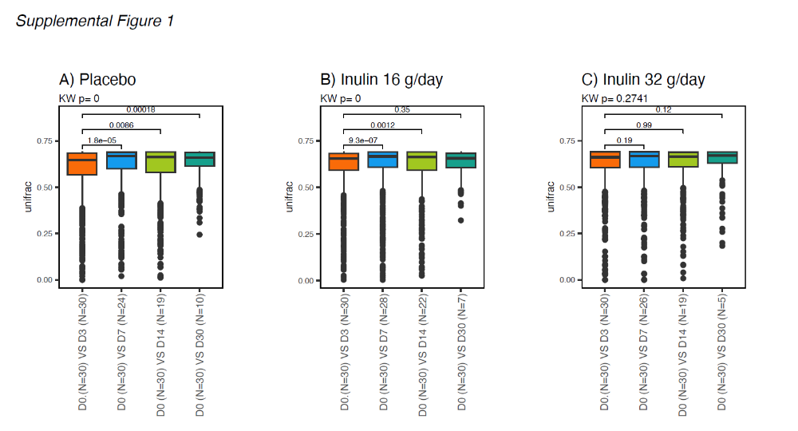

Unifrac distance was measured from the baseline sample to subsequent samples, and stratified by study group.

Supplemental Figure 2. Differentially abundant taxa, comparing placebo versus inulin 32 g/day.

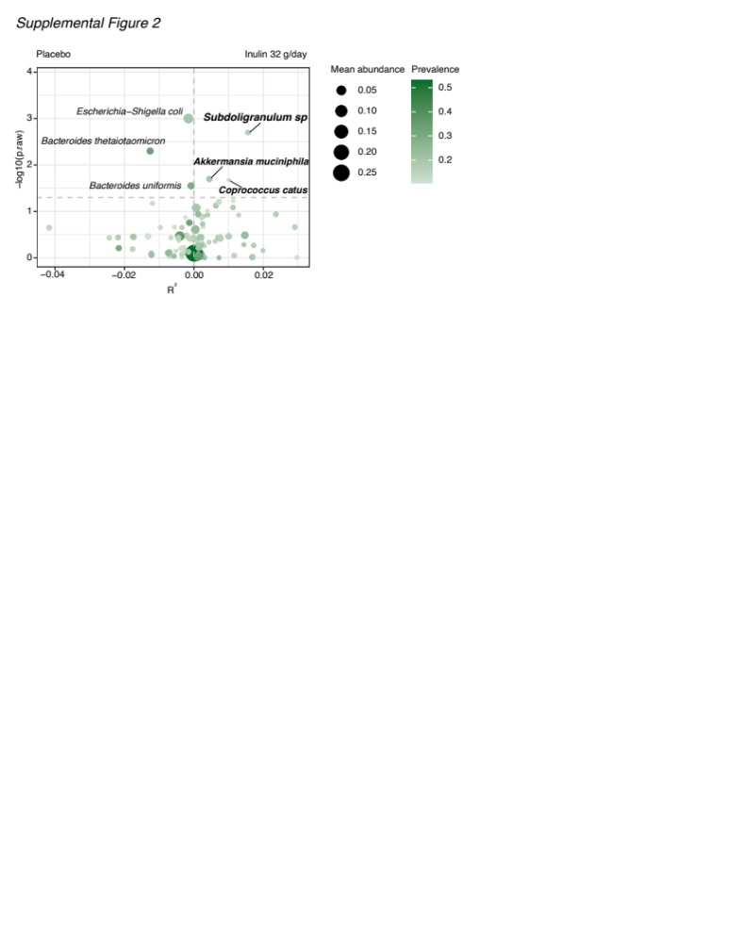

Labelled taxa are significantly different between groups based on two-sided testing at alpha 0.05, without adjusting for a false discovery.

Supplemental Figure 3. Direct measurements of fecal short-chain fatty acids, comparing placebo vs. the combined inulin groups.

SUPPLEMENTAL METHODS

Sampling logistics

Two deep rectal swabs were gathered by a study nurse on all participants at all timepoints as described in the Methods. Initial enrollment was performed on Monday, Tuesday, and Friday so that we did not need to shift the Day 3 sample because it fell on a weekend. On rare occasions (estimated <10% of samples), the Day 7 sample or subsequent samples might fall on a weekend or holiday; when this occurred, we would shift the sample forward or backward by one day.

Operationalization of infections

Our operationalized for culture-proven infection was adapted from CDC guidelines. To be classified as having a site-specific infection, patients needed to meet all of the following three criteria: (1) site-specific symptoms or signs; (2) positive corresponding culture or PCR results; and (3) initiation of appropriate antibiotics by the treating clinical team within 24 hours. Pneumonia was the most common site-specific infection. For example, to be classified as having pneumonia, a patients would need to have (1) worsening symptoms or signs such as cough or an X-ray showing a new infiltrate, (2) a positive sputum culture, and (3) initiation of an antibiotic by the team designed to treat that organism. This operationalization for culture-proven infection has been previously used by our group and is described in greater detail in Freedberg et al.[1]

16S rRNA gene sequencing

DNA was extracted from rectal swab samples using the DNeasy PowerSoil Pro Kit with a 96-well plate format (Qiagen, Germany). The extraction process incorporated both negative controls (HyPure TM Molecular Biology Grade Water, Cytiva) and positive controls comprised of defined bacterial communities (Zymo, CA).
For the DNA from swabs, the V3V4 region of the 16S rRNA gene was amplified using primers with Illumina adapters. The resulting libraries were barcoded using Illumina Nextera XT v2 indexes and sequenced on an Illumina MiSeq system with the v3 reagent kit (600 cycles) at a loading concentration of 8 pM and included a 20% phiX spike-in.
The 16S rRNA sequences were processed and analyzed using the DADA2 (version 1.12.1) pipeline [2] and R version 4.1.0. DADA2 facilitated the quality filtering, trimming, error correction, exact sequence inference, chimera removal, and generation of the amplicon sequence variant (ASV) table. No ambiguities were allowed in the overlap region, and default settings were used in the DADA2 `filterAndTrim()` function, with parameters set as follows: `truncLen=c(250,240)`, `trimLeft=c(5,5)`, `maxN=0`, `maxEE=c(2,2)`, and `truncQ=2`. Chimeric reads were identified by consensus across samples using the `removeBimeraDenovo()` function in DADA2. All samples met the minimum requirement of 7,500 reads after quality filtering to be included in this analysis. Phylogenetic trees of all ASV sequences were constructed using the MAFFT and FastTree modules in QIIME2. Taxonomic classification was conducted with a native naïve RDP Bayesian classifier against the Silva version 138 database.[3] The study also took measures to account for potential well-to-well contamination using SCRuB.[4]
Demographic data were collected, screened, and summarized using descriptive statistics for the entire cohort. The data were then imported into R version 4.1.0 for further analysis. Alpha-diversity indices such as Shannon and Chao, as well as Principal Coordinates Analysis (PCoA) using the unifrac distance matrix, were computed with the phyloseq package (version 1.36.0).[5] The alpha-diversity differences between groups were assessed using the non-parametric Wilcoxon Rank Sum test. Beta-diversity was examined through permutational multivariate analysis of variance (PERMANOVA), a non-parametric method that evaluates differences in sample centroids. The p-values obtained were adjusted using the Benjamini-Hochberg method to control the false discovery rate unless otherwise stated. Differential abundance analysis at the bacterial species level was conducted using DESeq2 [6] to identify generally differentially abundant bacteria and ZicoSeq,[7] employing the GUniFrac package to adjust for random effects in longitudinal samples. Bacteria were deemed differentially abundant if the p-value was less than 0.05 from both tests.
Complete sequencing data for the trial has been uploaded into the National Institutes of Health Short Read Archive as BioProject accession number PRJNA1128691.

Culture of multidrug-resistant organisms (MDROs)

Patient stool samples were plated on chromogenic agar selective for vancomycin resistant enterococcus (VRE), Extended-Spectrum Beta-Lactamase (ESBL) producing Gram-negative bacteria, and carbapenem-resistant Enterobacterales (CRE), and incubated overnight at 37°C. Unique ESBL and CRE colonies were subcultured onto MacConkey agar, and VRE colonies were subcultured onto blood plates. Colonies were picked in parallel for colony PCR and a Kirby-Bauer assay. The Kirby-Bauer assay was conducted using 0.5 MacFarland suspensions and antibiotic panels curated to validate MDRO positivity. Susceptibility was determined in concordance with the CLSI disc diffusion breakpoint guidelines.[8] Isolates that were identified as VRE positive in the initial culturing were tested with a Gram-positive specific antibiotic panel, and isolates that were identified as ESBL or KPC positive were tested with a Gram-negative specific antibiotic panel. Isolates that met the requirements for meropenem or ertapenem resistance were coded as carbapenem resistant, while isolates that met the requirements for ceftriaxone and/or ceftazidime resistance were coded as ESBL positive. Isolates that met the requirement for vancomycin resistance were coded as VRE positive. Susceptibility results were analyzed alongside sequencing data to ensure both datasets aligned.

Direct measurement of fecal SCFAs

Stool samples were weighed into bead blaster tubes with zircon beads and homogenized in 100% methanol to a final concentration of 10 mg/mL including deuterated SCFA internal standards (CDN Isotopes).[9] A pooled sample homogenate was created and formed into aliquots to serve as control samples. Control blanks were generated by transferring 1 mL of methanol (instrument blank).
Aliquots of pooled sample controls were then subjected to 3 successive rounds of extraction to deplete SCFAs but retain the insoluble particles to generate null matrix material. A standard curve for the cocktail of SCFAs was prepared in null matrix, and these samples were extracted side by side with the study samples and sequence blanks (either methanol or null matrix). The resulting SCFA extracts were then derivatized for liquid chromatography tandem mass spectrometry as previously described.[10]
Samples were analyzed with a QExactive HF device coupled to a Dionex Ultimate 3000 (Thermo Fisher Scientific, Waltham, Mass). A Waters BEH C18 column (2.1 3 150 mm, 1.7 mm) was used with buffer A as 0.1% formic acid in water, and with buffer B as 0.1% formic acid in acetonitrile (Waters, Milford, Mass). A gradient elution was used (15% buffer B to 55% buffer B in 9 minutes, 200 mL/min), and the mass spectrometer was operated in negative ion mode (HESI, 23.5 kV). The order of acquisition was randomized, and several control blocks including blanks and external standards were interspersed throughout the run to assess instrument performance and quality control of the derivatization protocol. All analytes were corrected to their respective internal standard, and the resulting ratio was interpolated against the matrix-controlled standard curve to quantify the level of SCFA in each sample. The limit of detection was determined from null matrix samples for each analyte, and this limit was imputed for any point falling below the limit of detection. The interpolated values were used for the downstream analyses, and the imputed ratio threshold values were used for samples below the limit of detection.

References
1. Freedberg, D.E., et al., Pathogen colonization of the gastrointestinal microbiome at intensive care unit admission and risk for subsequent death or infection. Intensive Care Med, 2018. 44(8): p. 1203-1211.
2. Callahan, B.J., et al., DADA2: High-resolution sample inference from Illumina amplicon data. Nat Methods, 2016. 13(7): p. 581-3.
3. Quast, C., et al., The SILVA ribosomal RNA gene database project: improved data processing and web-based tools. Nucleic Acids Res, 2013. 41(Database issue): p. D590-6.
4. Austin, G.I., et al., Contamination source modeling with SCRuB improves cancer phenotype prediction from microbiome data. Nat Biotechnol, 2023.
5. McMurdie, P.J. and S. Holmes, phyloseq: an R package for reproducible interactive analysis and graphics of microbiome census data. PLoS One, 2013. 8(4): p. e61217.
6. Love, M.I., W. Huber, and S. Anders, Moderated estimation of fold change and dispersion for RNA-seq data with DESeq2. Genome Biol, 2014. 15(12): p. 550.
7. Yang, L. and J. Chen, A comprehensive evaluation of microbial differential abundance analysis methods: current status and potential solutions. Microbiome, 2022. 10(1): p. 130.
8. Lewis Ii, J.S., Clinical, and I. Laboratory Standards, Performance standards for antimicrobial susceptibility testing. 33rd ed. Clinical and Laboratory Standards Institute. 2023: Clinical and Laboratory Standards Institute.
9. Zhang, L., et al., Multiscale study of the oral and gut environments in children with high- and low-threshold peanut allergy. J Allergy Clin Immunol, 2022. 150(3): p. 714-720 e2.
10. Chun, Y., et al., Longitudinal dynamics of the gut microbiome and metabolome in peanut allergy development. J Allergy Clin Immunol, 2023. 152(6): p. 1569-1580.

