Additional file 10

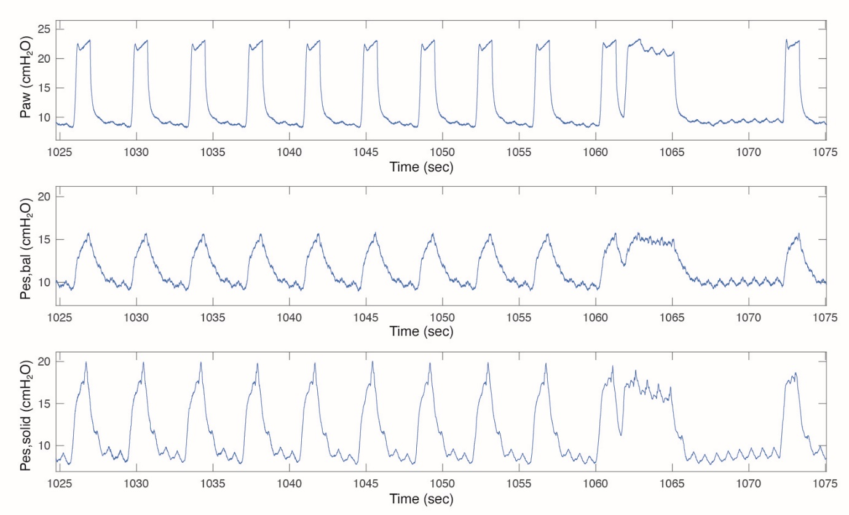
Additional figure 10. Example of a patient with very high inspiratory Pes_{solid} and thus also high ΔPes_{solid} values that we could not attribute to cardiac artifacts only.

