Additional file 4

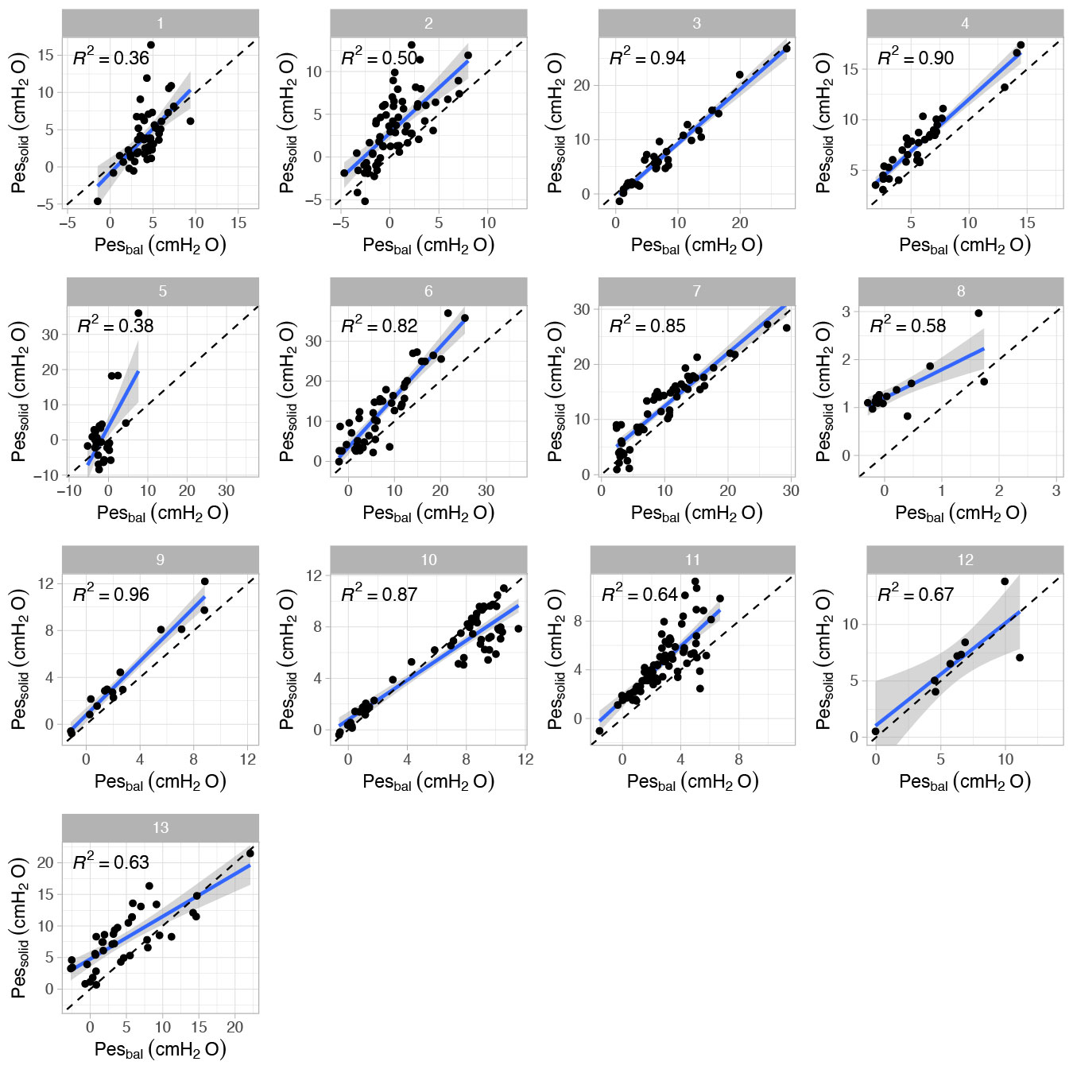

Additional figure 4. Healthy volunteers: regression analysis for Pes values at end-expiration separated per subject.

