Additional file 6

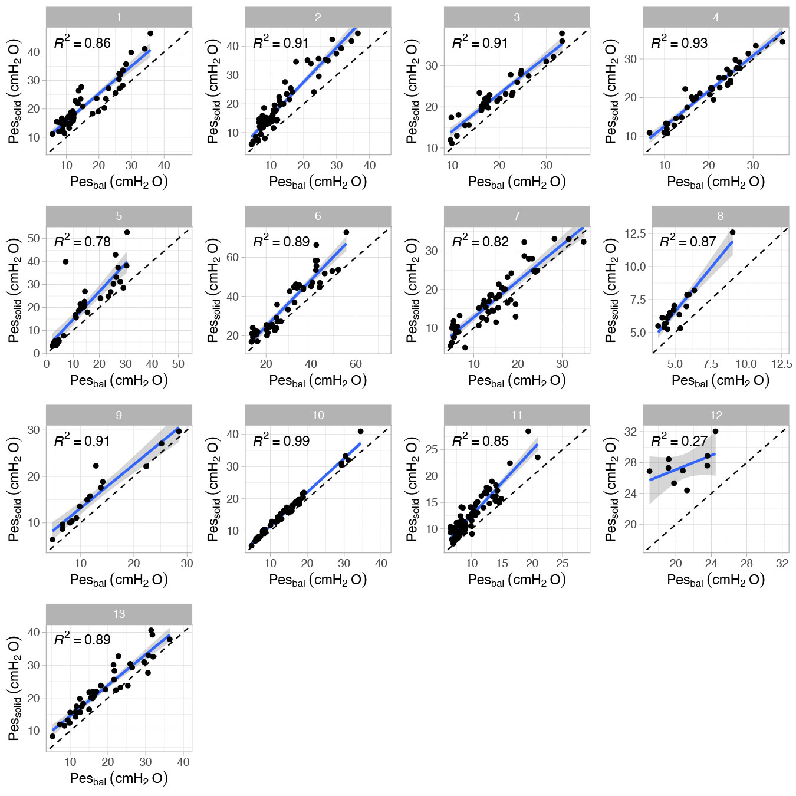

Additional figure 6. Healthy volunteers: regression analysis for ∆Pes values separated per subject.

