Additional file 7

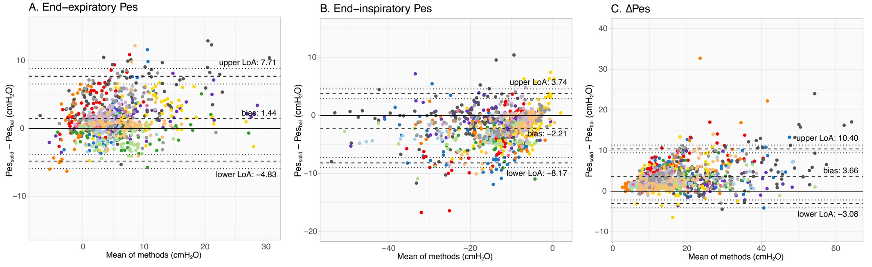

Additional figure 7. Healthy volunteers: Bland-Altman results for Baydur balloon within range 0.8-1.2. Each color represent a different subject. Dashed lines represent the bias and upper and lower limits of agreement (LoA); dotted lines represent the 95% confidence interval of the LoA obtained via bootstrapping.

