Supplementary information

Title: Effect of an Intensive Care Unit Virtual Reality Intervention on relatives´ mental health distress: a multicenter, randomized controlled trial.

Journal name: Critical Care
Authors: Denzel L. Q. Drop, MD^{1,*}; Johan H. Vlake, BSc^{1,2,*;}; Evert-Jan Wils, MD, PhD²; Jasper Van Bommel, MD, PhD¹; Christian Jung, MD, PhD^{3,4}; Denise E. Hilling, MD, PhD⁵; O. Joseph Bienvenu, MD, PhD⁶; Tim I.M. Korevaar, MD, PhD⁷; Anna F.C. Schut, MD, PhD⁸; Margo M.C. van Mol, PhD¹; Diederik Gommers, MD, PhD¹; Michel E. van Genderen, MD, PhD¹¹
*These authors contributed equally to this manuscript.
¹ Department of Adult Intensive Care, Erasmus MC, University Medical Center Rotterdam, Rotterdam, The Netherlands
² Department of Intensive Care, Franciscus Gasthuis & Vlietland, Rotterdam, The Netherlands
³ Medical Faculty and University Hospital of Düsseldorf, Cardiovascular Research Institute Düsseldorf (CARID), Heinrich-Heine University Düsseldorf, 40225 Düsseldorf, Germany
⁴ Department of Cardiology, Pulmonology and Vascular Medicine, Medical Faculty, Heinrich-Heine-University Düsseldorf, Düsseldorf, Germany
⁵ Department of Surgical Oncology and Gastrointestinal Surgery, Erasmus MC Cancer Institute, University Medical Center Rotterdam, Rotterdam, The Netherlands
⁶ Department of Psychiatry and Behavioural Sciences, Johns Hopkins University School of Medicine, Baltimore, Maryland, USA
⁷ Department of Internal Medicine, Division of Vascular Medicine and Pharmacology, Erasmus MC, University Medical Center Rotterdam, Rotterdam, The Netherlands
⁸ Department of Intensive Care, Ikazia Hospital, Rotterdam, The Netherlands
Corresponding author:
Michel E. van Genderen
m.vangenderen@erasmusmc.nl
Erasmus MC, University Medical Center Rotterdam
Department of Adult Intensive Care (internal postadress – Room Ne-403)
Doctor Molewaterplein 40, 3015 GD Rotterdam, the Netherlands

Table S1 Prevalence of psychological distress in family members – overall cohort and between time points
 | Composite score,  n (%) | Anxiety,  n (%) | Depression,  n (%) | PTSD,  n (%)
T0 | 69/158 (44) | 65/158 (41) | 48/158 (30) | -
T1 | - | - | - | 57/112 (51)
T2 | 45/110 (41) | 37/110 (34) | 23/110 (21) | 31/111 (28)
T3 | 47/113 (42) | 34/113 (30) | 27/113 (24) | 27/113 (24)
T4 | 36/104 (35) | 26/104 (25) | 20/104 (19) | 22/105 (21)
OR (95% CI), T0/T1* vs. T2 | 1.20 (0.64 – 2.24) | 0.74 (0.38 – 1.44) | 0.53 (0.24 – 1.18) | 0.09 (0.03 – 0.28)
p-value | 0.57 | 0.38 | 0.12 | <0.01
OR (95% CI), T0/T1* vs. T3 | 0.94 (0.51 – 1.74) | 0.50 (0.26 – 0.98) | 0.62 (0.28 – 1.34) | 0.03 (0.01 – 0.11)
p-value | 0.84 | <0.05 | 0.22 | <0.01
OR (95% CI), T0/T1* vs. T4 | 0.68 (0.36 – 1.31) | 0.38 (0.19 – 0.77) | 0.40 (0.17 – 0.92) | 0.02 (0.01 – 0.10)
p-value | 0.25 | <0.01 | 0.03 | <0.01
OR (95% CI), T2 vs. T3 | 0.73 (0.32 – 1.70) | 0.66 (0.28 – 1.56) | 1.34 (0.32 – 5.56) | 0.17 (0.04 – 0.70)
p-value | 0.47 | 0.34 | 0.68 | 0.01
OR (95% CI), T2 vs. T4 | 0.50 (0.20 – 1.21) | 0.47 (0.19 – 1.19) | 0.73 (0.16 – 3.41) | 0.17 (0.04 – 0.76)
p-value | 0.12 | 0.11 | 0.69 | 0.02
OR (95% CI), T3 vs. T4 | 0.56 (0.21 – 1.51) | 0.28 (0.04 – 1.87) | 0.57 (0.10 – 3.40) | 0.90 (0.15 – 5.44)
p-value | 0.26 | 0.19 | 0.54 | 0.91
T0 (retrospective), T1 (at ICU discharge), T2 (1 month), T3 (3 months), T4 (6 months).
*T0 (retrospective) for the composite score, anxiety and depression, T1 (at ICU discharge) for PTSD.

Table S2 Symptoms of anxiety, depression, and PTSD in family members – overall cohort and between time points
 | Anxiety*,  median (95% range) |  | Depression**,  median (95% range) |  | PTSD***,  median (95% range)
T0 | 6 (0 – 17) |  | 4 (0 – 17) |  | -
T1 | - |  | - |  | 24 (4 – 60)
T2 | 5 (0 – 18) |  | 3 (0 – 18) |  | 14 (0 – 47)
T3 | 5 (0 – 16) |  | 3 (0 – 16) |  | 12 (0 – 52)
T4 | 4 (0 – 15) |  | 2 (0 – 14) |  | 10 (0 – 46)
Difference (95% CI), T0 vs. T2 | -0.14 (-0.91 – 0.63) |  | 0.57 (-0.16 – 1.29) |  | -7.32 (-9.13 – -5.51)
p-value | 0.72 |  | 0.13 |  | <0.01
Difference (95% CI), T0 vs. T3 | -0.91 (-1.67 – -0.14) |  | -0.12 (-0.83 – 0.59) |  | -9.67 (-11.48 – -7.85)
p-value | 0.02 |  | 0.74 |  | <0.01
Difference (95% CI), T0 vs. T4 | -1.46 (-2.25 – -0.67) |  | -0.69 (-1.42 – 0.05) |  | -10.85 (-12.72 – -8.98)
p-value | <0.01 |  | 0.07 |  | <0.01
Difference (95% CI), T2 vs. T3 | -0.71 (-1.26 – -0.16) |  | -0.67 (-1.24 – -0.11) |  | -2.33 (-3.92 – -0.74)
p-value | 0.01 |  | 0.02 |  | 0.01
Difference (95% CI), T2 vs. T4 | -1.13 (-1.69 – -0.57) |  | -1.08 (-1.66 – -0.49) |  | -3.16 (-4.80 – -1.53)
p-value | <0.01 |  | <0.01 |  | <0.01
Difference (95% CI), T3 vs. T4 | -0.51 (-1.03 – 0.00) |  | -0.45 (-0.97 – 0.08) |  | -1.00 (-2.50 – 0.49)
p-value | 0.05 |  | 0.10 |  | 0.19
T0 (retrospective), T1 (at ICU discharge), T2 (1 month), T3 (3 months), T4 (6 months).
*Anxiety subscale sum score of the HADS questionnaire, a score ≥8 is considered prevalent anxiety.
**Depression subscale sum score of the HADS questionnaire, a score of ≥ is considered prevalent depression.
***Sum score of the IES-R questionnaire, a score ≥24 is considered prevalent PTSD.
Table S3 Mental and physical quality of life in family members – overall cohort and between time points
 |  | Mental QoL,  median (IQR) |  | Physical QoL,  median (95% range)
T0 |  | 49.6 (18.8 – 63.5) |  | 55.9 (28.8 – 64.8)
T2 |  | 44.6 (15.9 – 61.8) |  | 55.2 (26.4 – 64.6)
T3 |  | 46.7 (18.6 – 62.1) |  | 55.1 (26.3 – 64.2)
T4 |  | 51.3 (19.1 – 62.4) |  | 55.8 (27.3 – 63.4)
Difference (95% CI), T0 vs. T2 |  | -6.35 (-8.64 – -4.06) |  | -0.20 (-1.47 – 1.07)
p-value |  | <0.01 |  | 0.76
Difference (95% CI), T0 vs. T3 |  | -3.97 (-6.23 – -1.71) |  | -1.21 (-2.46 – 0.04)
p-value |  | <0.01 |  | 0.06
Difference (95% CI), T0 vs. T4 |  | -0.68 (-2.99 – 1.62) |  | -0.91 (-2.19 – 0.36)
p-value |  | 0.56 |  | 0.16
Difference (95% CI), T2 vs. T3 |  | 2.05 (0.02 – 4.08) |  | -0.89 (-2.11 – 0.33)
p-value |  | 0.05 |  | 0.15
Difference (95% CI), T2 vs. T4 |  | 5.35 (3.27 – 7.42) |  | -0.80 (-2.04 – 0.45)
p-value |  | <0.01 |  | 0.21
Difference (95% CI), T3 vs. T4 |  | 3.19 (1.42 – 4.95) |  | 0.12 (-0.98 – 1.22)
p-value |  | <0.01 |  | 0.83
T0 (retrospective), T2 (1 month), T3 (3 months), T4 (6 months).

Table S4a Univariable analysis of demographic and ICU-related risk factors for one or more mental health symptoms in relatives – overall cohort
 |  | Mental health symptoms at 1 month |  |  | Mental health symptoms at 3 months |  |  | Mental health symptoms at 6 months
 |  | Univariable OR (95% CI) | p-value |  | Univariable OR (95% CI) | p-value |  | Univariable OR (95% CI) | p-value
Family
Age |  | 0.98 (0.95 – 1.01) | 0.17 |  | 0.98 (0.95 – 1.01) | 0.17 |  | 0.98 (0.95 – 1.01) | 0.13
Gender, Female |  | 3.64 (1.51 – 8.78) | <0.01 |  | 3.82 (1.63 – 8.94) | <0.01 |  | 3.77 (1.45 – 9.80) | 0.01
Relationship to survivor
 | Other (ref)
 | Parent | 1.60 (0.48 – 5.34) | 0.45 |  | 2.54 (0.80 – 8.10) | 0.12 |  | 2.68 (0.77 – 9.31) | 0.12
 | Spouse | 2.60 (0.80 – 8.43) | 0.11 |  | 2.50 (0.77 – 8.08) | 0.13 |  | 2.48 (0.69 – 8.86) | 0.16
Educational level¹
 | Lower education (ref)
 | Higher education | 1.24 (0.58 – 2.69) | 0.58 |  | 1.00 (0.47 – 2.12 | 0.99 |  | 0.94 (0.41 – 2.13) | 0.88
Employment status, unemployed |  | 0.71 (0.33 – 1.53) | 0.38 |  | 0.91 (0.43 – 1.92) | 0.80 |  | 0.94 (0.42 – 2.13) | 0.88
History of mental illness, no |  | 0.36 (0.14 – 0.97) | 0.04 |  | 0.27 (0.10 – 0.71 | 0.01 |  | 0.19 (0.06 – 0.56) | <0.01
Intervention, control |  | 0.99 (0.46 – 2.13) | 0.99 |  | 1.27 (0.60 – 2.70) | 0.53 |  | 0.67 (0.29 – 1.55) | 0.35
Psychological well-being
Anxiety symptoms at ICU admission |  | 3.51 (1.50 – 8.22) | <0.01 |  | 2.85 (1.29 – 6.30) | 0.01 |  | 2.11 (0.91 – 4.89) | 0.08
Depression symptoms at ICU admission |  | 3.78 (1.49 - 9.58) | <0.01 |  | 2.84 (1.20 – 6.72) | 0.02 |  | 2.65 (1.10 – 6.40) | 0.03
Mental HRQoL |  | 0.96 (0.92 – 0.99) | 0.02 |  | 0.94 (0.91 – 0.97) | <0.01 |  | 0.96 (0.93 – 0.99) | 0.02
ICU patient
Age |  | 0.99 (0.97 – 1.02) | 0.60 |  | 1.00 (0.97 – 1.03) | 0.99 |  | 1.00 (0.97 – 1.03) | 0.96
Gender, male |  | 1.51 (0.69 – 3.34) | 0.30 |  | 2.05 (0.92 – 4.58) | 0.08 |  | 2.37 (0.97 – 5.79) | 0.06
APACHE-IV |  | 1.01 (1.00 – 1.02) | 0.20 |  | 1.01 (1.00 – 1.02) | 0.20 |  | 1.01 (0.99 – 1.02) | 0.41
Hospital length of stay |  | 1.00 (0.99 – 1.01) | 0.89 |  | 1.00 (0.99 – 1.01) | 0.67 |  | 1.00 (0.98 – 1.01) | 0.43
ICU length of stay |  | 1.00 (0.99 – 1.02) | 0.74 |  | 1.00 (0.99 – 1.02) | 0.83 |  | 0.99 (0.97 – 1.02) | 0.49
Mechanical ventilation |  | 1.44 (0.41 – 5.10) | 0.57 |  | 0.84 (0.24 – 2.93) | 0.79 |  | 0.77 (0.20 – 2.94) | 0.71
COVID-19 diagnosis, no |  | 1.91 (0.75 – 4.85) | 0.17 |  | 0.68 (0.30 – 1.57) | 0.37 |  | 0.70 (0.30 – 1.63) | 0.41
ICU mortality |  | 1.48 (0.28 – 7.67) | 0.64 |  | 1.85 (0.47 – 7.28) | 0.38 |  | 2.03 (0.55 – 7.55) | 0.29
¹ Higher vocational education and academic education were classified as higher education compared to lower education levels.

Table S4b Multivariable analysis of demographic and ICU-related risk factors for one or more mental health symptoms in relatvies – overall cohort
 |  | Mental health symptoms at 1 month |  |  | Mental health symptoms at 3 months |  |  | Mental health symptoms at 6 months
 |  | Multivariable OR (95% CI) | p-value |  | Multivariable OR (95% CI) | p-value |  | Multivariable OR (95% CI) | p-value
Family
Age |  | 0.97 (0.93 – 1.02) | 0.21 |  | 2.00 (0.96 – 1.05) | 0.87 |  | 0.98 (0.94 – 1.02) | 0.32
Gender, Female |  | 3.41 (1.22 – 9.54) | 0.02 |  | 2.04 (0.74 – 5.60) | 0.17 |  | 2.03 (0.68 – 6.09) | 0.21
Relationship to survivor
 | Other (ref)
 | Parent | 1.37 (0.29 – 6.50) | 0.69 |  | 3.26 (0.65 – 16.37) | 0.15 |  | 1.59 (0.35 – 7.21) | 0.55
 | Spouse | 2.07 (0.45 – 9.58) | 0.35 |  | 2.90 (0.68 – 12.41) | 0.15 |  | 2.18 (0.52 – 9.10) | 0.29
History of mental illness, no |  | 0.63 (0.19 – 2.12) | 0.46 |  | 0.41 (0.13 – 1.27) | 0.12 |  | 0.23 (0.07 – 0.81) | 0.02
Psychological well-being
Anxiety or depression symptoms at ICU admission |  | 4.99 (1.57 – 15.83) | <0.01 |  | 2.23 (0.76 – 6.58) | 0.15 |  | 1.28 (0.39 – 4.19) | 0.69
Mental HRQoL |  | 1.01 (0.96 – 1.06) | 0.83 |  | 0.97 (0.91 – 1.00) | 0.06 |  | 0.98 (0.93 – 1.02) | 0.31
ICU patient
Gender, male |  | - | - |  | 1.78 (0.66 – 4.78) | 0.25 |  | 2.47 (0.87 – 7.06) | 0.09
APACHE-IV |  | 1.01 (0.99 – 1.02) | 0.34 |  | 1.01 (0.99 – 1.02) | 0.48 |  | - | -
COVID-19 |  | 2.03 (0.67 – 6.17) | 0.21 |  | - | - |  | - | -
¹ Higher vocational education and academic education were classified as higher education compared to lower education levels.

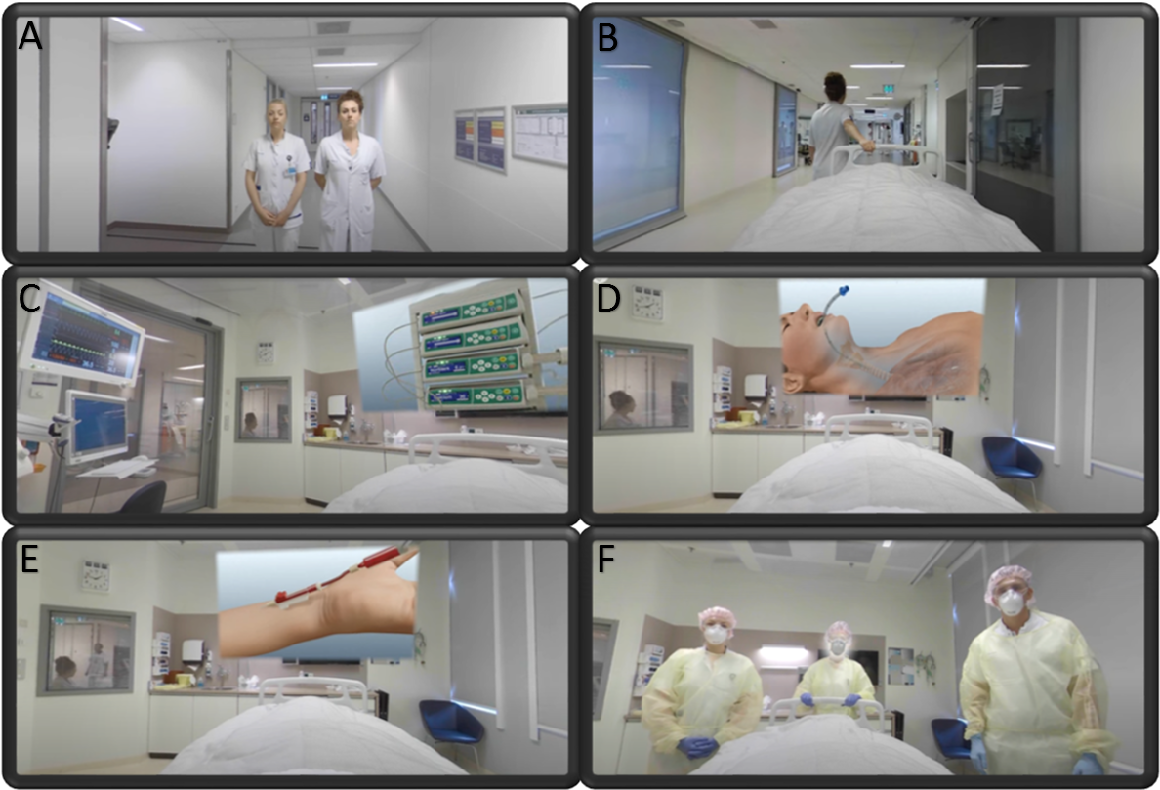
Suppl Fig 1 The Intensive Care Unit-specific Virtual Reality (ICU-VR) intervention
A-F Images of the ICU-VR video with (A) an introduction by an intensivist and ICU nurse to welcome the relative to the ICU-VR environment, (B) explaining daily movements at an ICU and the route to the ICU room, (C) explanation of monitors and noises in an ICU room, (D) information regarding airway and breathing management such as intubation and tracheal tube suction, (E) information and necessity of central/peripheral lines, (F) information and necessity of the treatment team, ICU workflow and personal protection equipment.

