Additional files D-Stop

Additional file 1. Distribution of the number of catheter free-days.
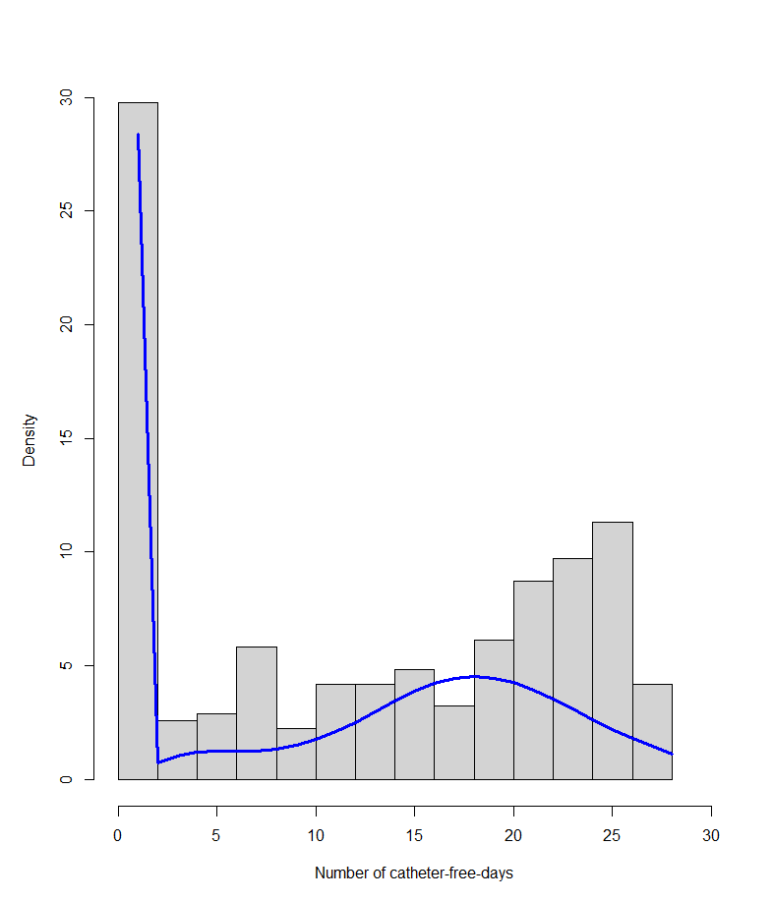
89 patients had no catheter-free days. In blue, the predicted curve by the Zero-inflated Poisson regression model.

Additional file 2. Characterization of chronic kidney disease in medical chart
 | Before cohort | After cohort
Patient with CKD | 66 (36.9%) | 32 (24.6%)
Unspecified or unknown nephropathy | 29 (43.9%) | 12 (9.2%)
Glomerular nephropathy¹ | 26 (39.4%) | 12 (9.2%)
Vascular nephropathy¹ | 9 (13.6%) | 6 (4.6%)
Tubulointerstitial nephropathy¹ | 2 (3%) | 2 (1.5%)
Other nephropathy1 | 2 (3%) | 0 (0%)
¹The nephropathy characterization was determined by the nephrologist who treated the patient after the ICU stay

Additional file 3. UUEI distribution in the after cohort
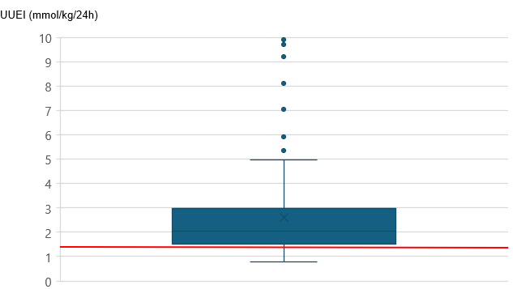
Boxplots of the UUEI (in mmol/kg/24h) are shown for 107 patients of the after cohort. No UUEI was calculated in the before cohort in which this index was not used. The redline represents the UUEI cutoff at 1.35 mmol/kg/24h. For this analysis of the after cohort, we excluded 15 patients who died before reaching UUEI >1.35 mmol/kg/24hrs and before catheter withdrawal and 8 patients who had missing data on the day of catheter withdrawal (protocol deviation). The box represents the interquartile range, the limits of the whisker represent the minimal and maximal values excluding outliers. The 7 outliers are explained by patients for whom the late initiation RRT protocol was not respected and who therefore presented with a high early ability to concentrate their urine (these patients all had RRT duration < 2 days).

Additional file 4. UUEI distribution in the after cohort in obese vs not obese patients

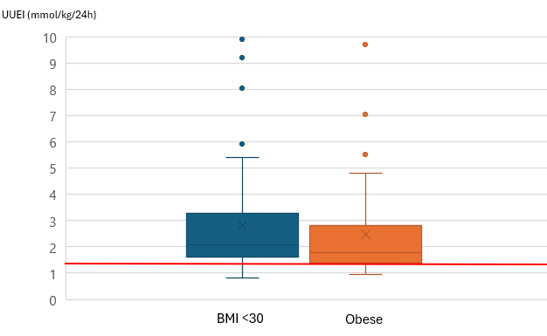

For this analysis of the after cohort, we excluded 3 patients who died before reaching UUEI >1.35 mmol/kg/24hrs and before catheter withdrawal and 4 patients who had missing data on the day of catheter withdrawal (protocol deviation). The box represents the interquartile range, the limits of the whisker represent the minimal and maximal values excluding outliers. The 7 outliers are explained by patients for whom the late initiation RRT protocol was not respected and who therefore presented with a high ability to concentrate their urine (these patients all had RRT duration < 2 days)

Additional file 5. UUEI distribution in the after cohort in obese patients according to actual vs adjusted body weight

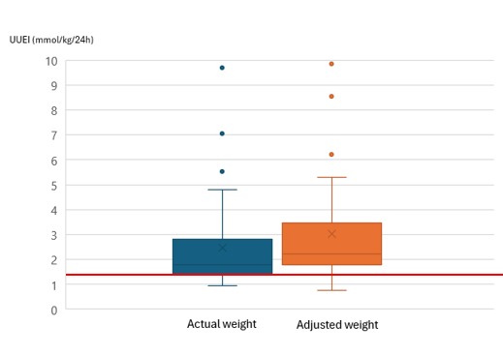

For this analysis of the after cohort, we excluded 3 patients who died before reaching UUEI >1.35 mmol/kg/24hrs and before catheter withdrawal and 4 patients who had missing data on the day of catheter withdrawal (protocol deviation). The box represents the interquartile range, the limits of the whisker represent the minimal and maximal values excluding outliers. The 7 outliers are explained by patients for whom the late initiation RRT protocol was not respected and who therefore presented with a high ability to concentrate their urine (these patients all had RRT duration < 2 days)

Additional file 6. UUEI distribution in the after cohort in obese patients according to sex
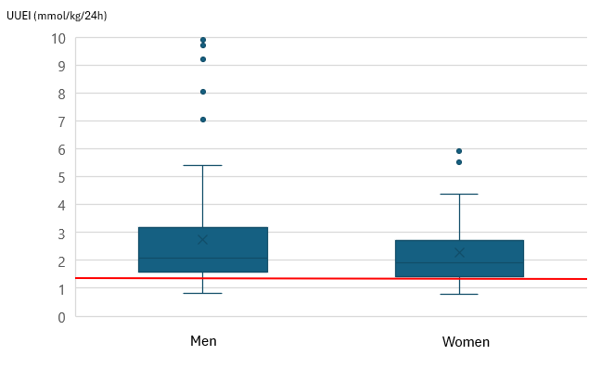
This figure represents boxplot of the UUEI (in mmol/kg/24h) in 107 patients of the after cohort. No UUEI was calculated in the before cohort in which this index was not used. The redline represents the UUEI cutoff at 1,35 mmol/kg/24h. For this analysis of the after cohort, we excluded 15 patients who died before reaching UUEI >1.35 mmol/kg/24hrs and before catheter withdrawal and 8 patients who had missing data on the day of catheter withdrawal (protocol deviation). The box represent the interquartile range, the limits of the whisker represent the minimal and maximal values excluding outliers. The 7 outliers are explained by patients for whom the late initiation RRT protocol was not respected and who therefore presented with a high ability to concentrate their urine (these patients all had RRT duration < 2 days).

Additional file 7. Protocol deviation in the after cohort (n=130)
Protocol deviation* | 19 (15%)
Removal 24-48h before urinary threshold attainment (catheter dysfunction or infection suspected)  Removal with 24h delay because of forgotten urinary analysis  Removal with 48h delay because of forgotten urinary analysis  Removal with 24h delay because of anticoagulation issues  Removal with 24h delay due to physician caution | 6 (31.6%)  8 (42.1%)  1 (5.3%)  2 (10.5%)  2 (10.5%)
*no RRT was performed during protocol deviation

Additional file 8. Allen Johnson survival analysis of the risk of catheter withdrawal according to each center
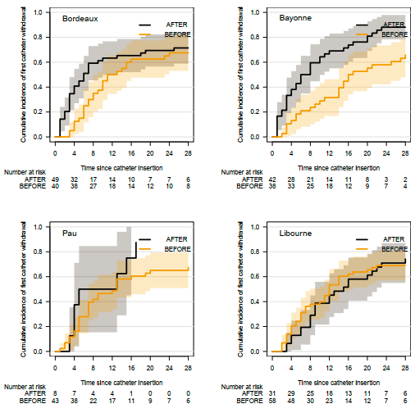

Additional file 9. Reasons for weaning failure and time to catheter reinsertion in case of weaning failure
 | Before cohort | After cohort
Weaning failure  - Encephalopathy  - Fluid overload  - New septic shock  - Anuria  - Urea | 3 (1.7%)  1  1  1  0  0 | 5 (3.9%)  0  2  0  1  2
Days after removal  - 0-3  - 4-5  - 6-7 | 1  0  2 | 1  2  2

Additional file 10. Use of diuretics and other nephrotoxic agents
 | Before cohort | After cohort
Use of diuretics*  - Maximal daily dose of furosemide (mg), mean | 122 (68.2%)  217.4 (246.8) | 94 (72.3%)  247.8 (238.4)
Other nephrotoxic agents*  - Aminoglycosides  - Vancomycin  - Iodinated contrast media  - Acyclovir  - Others (Non-steroidal anti-inflammatory drugs…) | 112 (62.6%)  84 (46.9%)  15 (8.4%)  54 (30.2%)  10 (5.6%)  5 (2.8%) | 118 (90.8%)  100 (76.9%)  10 (7.7%)  76 (58.4%)  8 (6.2%)  3 (2.3%)
* Regarding diuretics and nephrotoxic agents, we considered the period during which the catheter was in place.

Additional file 11. RRT complications (except infections)
 | Before cohort | After cohort
Complications  - Minor bleeding  - Major bleeding  - Catheter thrombosis  - Local complication  - heparin-induced thrombocytopenia  - Citrate complication  - Other | 14 (7.8%)  4 (2.2%)  1 (0.6%)  5 (2.8%)  0 (0%)  3 (1.7%)  0 (0%)  1 (0.6) | 8 (6.2%)  1 (0.8%)  1 (0.8%)  2 (1.5%)  0 (0%)  2 (1.5%)  1 (0.8%)  1 (0.8%)

