Supplementary information
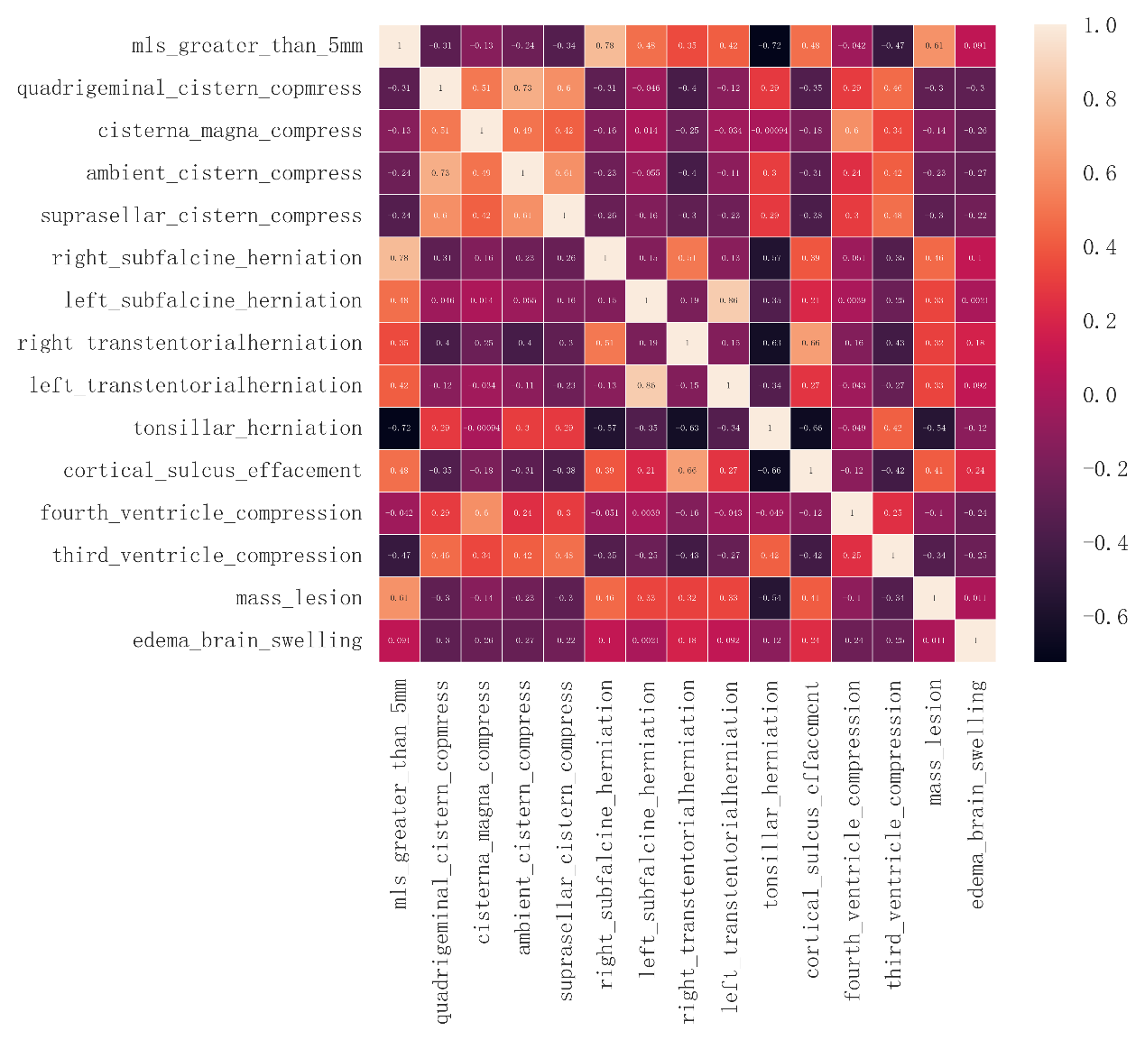
Ⅰ The correlation coefficient heatmap of imaging signs

Ⅱ The definition of each radiomics feature and the selected radiomics features

The definition of First-order features
1. Elongation: A measure of how elongated an object is. It indicates the degree of stretching or elongation of an object, which can be used to distinguish between spherical and elongated shapes.
2. Flatness: A measure of how flat an object is. It can describe the shape of an object in terms of its flatness or thickness, which can be useful in characterizing objects with varying degrees of flatness, such as planar structures.
3. LeastAxisLength: The shortest axis length of an object, which can give an indication of the object's minimum dimension and help in characterizing its shape, especially for irregular objects.
4. MajorAxisLength: The length of the major axis of an ellipse that approximates the shape of an object. It is often used to describe the shape of elongated objects, such as tumors, and helps in understanding the elongation and orientation of objects.
5. Maximum2DDiameterColumn: The largest diameter of an object measured in the column direction of a 2D image. It helps in understanding the object's size and shape in that specific dimension.
6. Maximum2DDiameterRow: The largest diameter of an object measured in the row direction of a 2D image. It provides information about the object's size and shape from another 2D perspective.
7. Maximum2DDiameterSlice: The largest diameter of an object when viewed in a 2D slice. It gives an indication of the size of the object in a particular 2D cross-section, which can be useful for analyzing structures in medical images like CT or MRI slices.
8. Maximum3DDiameter: The largest diameter of an object when considering its three-dimensional structure. It is a measure of the size of a 3D object in its longest dimension and can be used to assess the size of structures like tumors or organs.
9. MeshVolume: In 3D imaging, it refers to the volume calculated using a mesh representation of an object. It helps in quantifying the volume of a 3D structure, which can be crucial for understanding the size and spatial characteristics of objects, such as organs or tumors.
10. MinorAxisLength: The length of the minor axis of an ellipse that approximates the shape of an object. It is used in conjunction with the major axis length to describe the shape of elongated objects, providing information about the object's aspect ratio.
11. Sphericity: A measure of how closely an object resembles a sphere. It ranges from 0 (completely non-spherical) to 1 (perfectly spherical) and is useful for assessing the shape of objects, especially in 3D, helping to differentiate between spherical and non-spherical objects.
12. SurfaceArea: The total area of the surface of an object in the image. It is important for characterizing the boundary of objects, especially in 3D, and can provide information about the surface properties of structures.
13. SurfaceVolumeRatio: The ratio of the surface area to the volume of an object. It can give an indication of the object's shape complexity, as objects with a higher ratio tend to have more surface area relative to their volume, indicating a more irregular shape.
14. VoxelVolume: The volume of a single voxel, which is the smallest unit of volume in 3D imaging. Understanding the voxel volume is essential for accurate volume calculations and can help in determining the size of objects in 3D space.
15. Energy: The total amount of power or intensity associated with the image. It is often calculated by summing up the squared values of the image's intensity values. It can give an indication of the overall "strength" of the signal in the image. In medical imaging, for example, a higher energy value might suggest a more prominent feature or structure.
16. TotalEnergy: Similar to Energy, but it could imply a more comprehensive measure of the energy content, perhaps encompassing a larger region or the entire image. It might provide a broader view of the energy distribution and could be used to compare different images or regions based on their overall energy levels.
17. Entropy: A measure of disorder or randomness in the distribution of image intensity values. It quantifies the uncertainty or unpredictability of the intensity values. Higher entropy indicates a more random or heterogeneous distribution of intensities, which could suggest a more complex or varied image content, while lower entropy indicates a more uniform and predictable pattern.
18. Uniformity: A measure of how evenly the intensity values are distributed. High uniformity indicates that the intensity values are relatively consistent throughout the image, suggesting a more homogeneous image, while low uniformity indicates a more heterogeneous image with more variation in intensities.
19. Mean: The average value of the image's intensity values. It is calculated by summing all the intensity values and dividing by the number of pixels. It provides a central tendency of the intensity distribution and is a commonly used measure to describe the overall brightness of an image.
20. Median: The middle value of the sorted list of the image's intensity values. Unlike the mean, it is less affected by extreme values (outliers). It gives a more robust measure of the central tendency and can be more representative of the typical intensity value when there are outliers in the data.
21. Standard Deviation: A statistical measure that quantifies the amount of variation or dispersion of the image's intensity values from the mean. It indicates how spread out the intensity values are around the mean value. A larger standard deviation suggests greater variability and heterogeneity in the image.
22. Skewness: A measure of the asymmetry of the distribution of the image's intensity values. A positive skewness indicates that the tail of the distribution is on the right side (higher values), while a negative skewness indicates a longer tail on the left side (lower values). It helps in understanding the shape of the intensity distribution and can provide insights into the nature of the image data.
23. Kurtosis: It describes the "tailedness" of the distribution of the image's intensity values, indicating whether the distribution is more peaked (high kurtosis) or flatter (low kurtosis) than a normal distribution. It gives additional information about the shape of the distribution beyond symmetry.
24. Variance: It measures how far the intensity values are spread out from the mean, calculated as the average of the squared differences from the mean. It is another measure of the data's dispersion and gives an indication of the variability of the image's intensity values.
25. Minimum: The smallest value of the image's intensity values. It helps to identify the lowest intensity level present in the image, which can be useful in determining the darkest areas. In medical imaging, it could represent regions with low attenuation or low signal intensity.
26. Maximum: The highest value of the image's intensity values. It indicates the brightest or most intense area in the image. In medical imaging, it could highlight regions of interest, such as tumors that may have higher signal intensity compared to the surrounding tissue.
27. 10th percentile: The value below which 10% of the image's intensity values fall. It gives an idea of the lower end of the intensity distribution, helping to understand the distribution of lower-intensity pixels. This can be used to identify regions that are relatively dimmer compared to the rest of the image.
28. 90th percentile: The value below which 90% of the image's intensity values fall. It shows the upper limit of the lower 90% of the intensity distribution, useful for characterizing the brighter regions of the image and can help in identifying regions with higher intensity values.
29. Interquartile Range: The difference between the 75th percentile and the 25th percentile of the image's intensity values. It represents the spread of the middle 50% of the data, giving an indication of the variability within the central part of the distribution, which is useful for understanding the data's dispersion without being overly influenced by extreme values.
30. Range: The difference between the maximum and minimum intensity values. It shows the extent of the variation in intensity, from the darkest to the brightest part of the image, giving an idea of the overall spread of intensities.
31. Perimeter: The total length of the boundary of an object in 2D. It is useful for characterizing the outline of 2D objects and can provide information about the shape and size of objects in 2D images.
32. Mesh Surface: The surface of an object represented by a mesh. It could be related to the properties of the surface when modeled using a mesh, which can provide additional information about the object's surface characteristics.

The definition of Second-order features
1. Joint Average: A measure that combines information from multiple features or regions, perhaps by averaging their values. It could be used to obtain a unified metric that summarizes the overall characteristics of the image or region of interest, taking into account different aspects of the image data.
2. Cluster Prominence: This feature might describe how prominent certain clusters of pixels are in the image. It could help in identifying regions that stand out from the surrounding areas, which could be relevant in detecting distinct structures or abnormalities in medical images.
3. DependenceNonUniformityNormalized: A normalized measure of the non-uniformity of dependence, which could be related to the variability of certain dependencies within the image. It might help in understanding the consistency of relationships between different parts of the image data.
4. DependenceVariance: Indicates the variance of the dependence measures. It provides information about the spread of the dependence values, helping to assess the variability of the relationships between different elements of the image.
5. LargeDependenceEmphasis: Emphasizes regions where there is a large dependence. This could be useful in highlighting areas where certain interactions or dependencies are more pronounced, which may be related to specific tissue interactions or structural characteristics.
6. LargeDependenceHighGrayLevelEmphasis: Focuses on regions with both large dependence and high gray levels. It could help in detecting areas that have both strong dependencies and high intensity, which might be relevant in identifying particular tissue types or pathologies.
7. LargeDependenceLowGrayLevelEmphasis: Similar to the above, but for regions with large dependence and low gray levels. It could aid in finding structures that have significant dependencies and low signal intensity.
8. SmallDependenceEmphasis: Highlights regions with small dependence, which could be important for detecting areas where interactions are weaker or different from the rest of the image.
9. SmallDependenceHighGrayLevelEmphasis: Emphasizes regions with small dependence and high gray levels, helping to identify small, bright regions with distinct dependency characteristics.
10. SmallDependenceLowGrayLevelEmphasis: Focuses on regions with small dependence and low gray levels, useful for detecting small, dark areas with unique dependency and intensity properties.
11. LongRunEmphasis: This feature might emphasize long runs of similar pixel values. It could help in detecting elongated structures or patterns in the image, which could be relevant in identifying linear features in medical images.
12. LongRunHighGrayLevelEmphasis: Highlights long runs of pixels with high gray levels. It could be used to identify elongated bright structures, such as blood vessels or nerve fibers.
13. LongRunLowGrayLevelEmphasis: Focuses on long runs of pixels with low gray levels, useful for detecting elongated dark structures, like certain types of ducts or vessels.
14. RunEntropy: Measures the entropy of the run length information, providing information about the randomness of the run lengths. It helps in understanding the complexity of patterns in terms of the lengths of consecutive similar pixels.
15. RunLengthNonUniformity: Indicates the non-uniformity of the run lengths, which could help in detecting irregular patterns in the image, especially those related to the distribution of consecutive similar pixels.
16. RunLengthNonUniformityNormalized: The normalized version of RunLengthNonUniformity, making it easier to compare run length non-uniformity across different images or regions.
17. RunPercentage: Represents the percentage of runs (sequences of similar pixels) in the image, giving an idea of the prevalence of different run lengths and their contribution to the overall pattern.
18. RunVariance: The variance of the run lengths, indicating the spread of the run lengths. It helps in understanding the variability of the lengths of consecutive similar pixels, which could be useful in detecting irregular patterns.
19. TextureVariance: Measures the variance of texture features. It provides information about the variability of texture, helping to distinguish between different textures based on the spread of their characteristics.
20. TextureSkewness: Describes the skewness of texture features, indicating the asymmetry of the texture distribution. It could help in understanding the shape of the texture distribution and its properties.
21. TextureKurtosis: Indicates the kurtosis of texture features, showing the tailedness of the texture distribution. It gives additional information about the texture distribution beyond symmetry.
22. GrayLevelCorrelation: Measures the correlation between different gray levels in the image. It helps in understanding the relationships between different intensity levels and can be used to detect patterns in the intensity distribution.
23. GrayLevelDifference: Calculates the difference between gray levels, perhaps in a certain neighborhood or across different regions. It could help in highlighting edges or transitions in the image.
24. GrayLevelRange: The difference between the maximum and minimum gray levels, giving an indication of the overall spread of gray levels in the image.
25. GrayLevelEntropy: The entropy of the gray levels, reflecting the randomness of the gray level distribution. It helps in assessing the complexity of the gray level distribution.
26. GrayLevelContrast: Measures the contrast between different gray levels, helping to identify regions with different intensities and boundaries.
27. GrayLevelHomogeneity: Indicates the homogeneity of the gray levels, showing how similar the gray levels are within a region.
28. GrayLevelUniformity: Similar to GrayLevelHomogeneity, it describes the uniformity of the gray levels, which could be used to identify regions with consistent intensity.
29. LocalGrayLevelVariance: Measures the variance of gray levels in a local neighborhood, providing information about the local variability of the image.
30. LocalGrayLevelMean: The average gray level in a local neighborhood, giving an idea of the local brightness.
31. LocalGrayLevelMedian: The median gray level in a local neighborhood, which is less affected by outliers compared to the mean.
32. LocalGrayLevelSkewness: The skewness of the gray levels in a local neighborhood, helping to understand the local asymmetry of the intensity distribution.
33. LocalGrayLevelKurtosis: The kurtosis of the gray levels in a local neighborhood, giving information about the local tailedness of the intensity distribution.
34. LocalGrayLevelMaximum: The maximum gray level in a local neighborhood, highlighting the brightest local areas.
35. LocalGrayLevelMinimum: The minimum gray level in a local neighborhood, indicating the darkest local areas.
36. LocalTextureAnisotropy: Measures the directional dependence of texture in a local area, helping to understand if the texture has different properties in different directions locally.
37. LocalTextureCoarseness: Describes the coarseness of the texture in a local region, differentiating between fine and coarse textures locally.
38. LocalTextureRoughness: Indicates the roughness of the texture in a local area, related to the irregularity of the surface or structure locally.
39. LocalTextureSmoothness: The opposite of roughness, indicating how smooth the texture is locally.
40. LocalTextureComplexity: A general measure of the complexity of the texture in a local region, taking into account various local texture properties.

The definition of Third-order features
1. GrayLevelNonUniformity: This feature indicates the non-uniformity of the gray levels in an image. It is used to identify regions where the distribution of gray levels is not uniform, which might help in detecting different tissue types or structures by highlighting areas with varying pixel intensities.
2. GrayLevelNonUniformityNormalized: A normalized version of GrayLevelNonUniformity, making it easier to compare the non-uniformity of gray levels across different images or different parts of the same image, thus providing a more standardized measure for analysis.
3. GrayLevelVariance: This represents the variance of the gray levels in the image. It gives an indication of how spread out the gray levels are, helping to differentiate textures based on the degree of intensity variation.
4. HighGrayLevelZoneEmphasis: This feature emphasizes the zones of high-intensity regions in the image, useful for detecting areas with high signal intensities that could potentially be associated with certain pathological regions or structures.
5. LargeAreaEmphasis: It emphasizes larger areas in the image, typically computed using matrices such as the gray-level size zone matrix (GLSZM), and is helpful in identifying large anatomical structures or lesions.
6. LargeAreaHighGrayLevelEmphasis: Focuses on larger areas that have both large size and high gray levels, which can be relevant for detecting tumors or lesions that are large and have high intensity in medical imaging.
7. LargeAreaLowGrayLevelEmphasis: Similar to the above, but for larger areas with low gray levels, aiding in the detection of structures like cysts or fluid-filled regions.
8. SizeZoneNonUniformity: Indicates the non-uniformity of the size of zones (groups of pixels), which is useful for detecting irregular structures or regions with varying sizes in the image.
9. SizeZoneNonUniformityNormalized: The normalized form of SizeZoneNonUniformity, enabling better comparison of zone size non-uniformity between different images.
10. SmallAreaEmphasis: This emphasizes smaller areas in the image, useful for detecting small regions of interest, such as small nodules or micro-lesions.
11. SmallAreaHighGrayLevelEmphasis: Highlights small areas with high gray levels, which may have distinct characteristics compared to the surrounding tissue.
12. SmallAreaLowGrayLevelEmphasis: Focuses on small areas with low gray levels, which could help in detecting small, dark regions with unique features.
13. ZoneEntropy: Measures the entropy of the zone matrix, providing information about the randomness of zone distribution, which helps in understanding the texture's complexity based on the zone patterns.
14. ZonePercentage: Represents the percentage of pixels belonging to different zones, giving an idea of the zone distribution in the image and their contribution to the overall texture.
15. ZoneVariance: This is the variance of the zone sizes, indicating the spread of zone sizes and helping in detecting structures with varying zone sizes.
16. MeanIntensity: The average intensity value of the image or a region of interest, giving a general idea of the overall brightness.
17. MedianIntensity: The median value of the intensities, less affected by outliers compared to the mean, providing a more robust measure of the central tendency of intensities.
18. StandardDeviationIntensity: A measure of the dispersion of intensities around the mean, indicating the variability of intensities in the image.
19. SkewnessIntensity: Measures the asymmetry of the intensity distribution. A positive skewness indicates a longer tail on the right side, and a negative skewness indicates a longer tail on the left side.
20. KurtosisIntensity: Describes the tailedness of the intensity distribution, showing whether it is more peaked (high kurtosis) or flatter (low kurtosis) than a normal distribution.
21. MaximumIntensity: The highest intensity value in the image, often used to identify the brightest areas, which could be regions of interest in medical imaging.
22. MinimumIntensity: The lowest intensity value, representing the darkest areas in the image, perhaps indicating regions with low attenuation.
23. EntropyIntensity: The entropy of the intensity values, reflecting the randomness of the intensity distribution, which can help in assessing the complexity of the image.
24. EnergyIntensity: The total energy of the image, calculated by summing the squared intensity values, indicating the overall strength of the signal.
25. ContrastIntensity: Measures the contrast between different parts of the image, helping to identify edges or boundaries.
26. HomogeneityIntensity: A measure of how homogeneous the intensity distribution is, indicating the similarity of intensities within a region.
27. CorrelationIntensity: Indicates the correlation between intensity values in different parts of the image, showing the spatial relationship between pixels.
28. TextureAnisotropy: Measures the directional dependence of texture, helping to understand if the texture has different properties in different directions.
29. TextureCoarseness: Describes the coarseness of the texture, differentiating between fine and coarse textures.
30. TextureRoughness: Indicates the roughness of the texture, which could be related to the irregularity of the surface or structure.
31. TextureSmoothness: The opposite of roughness, indicating how smooth the texture appears.
32. TextureComplexity: A general measure of the complexity of the texture, which could be based on various factors like heterogeneity, anisotropy, and other texture properties.
33. FractalDimension: Calculates the fractal dimension of the image, providing a measure of its spatial complexity and self-similarity.
34. Lacunarity: Measures the gaps or voids in the texture, providing information about the texture's porosity.
35. SurfaceAreaToVolumeRatio: The ratio of the surface area to the volume of an object, useful for characterizing the shape and complexity of 3D objects.

Selected radiomics features

First-order | Average | Standard deviation
Elongation | 0.4609 | 0.2079
Flatness | 0.1342 | 0.0920
LeastAxisLength | 11.8795 | 7.3503
MajorAxisLength | 96.5566 | 44.2621
Maximum2DDiameterColumn | 45.7477 | 32.7014
Maximum2DDiameterRow | 74.0673 | 44.0450
Maximum2DDiameterSlice | 98.2926 | 40.7906
Maximum3DDiameter | 101.7490 | 39.6623
MeshVolume | 52.5444 | 161.3424
MinorAxisLength | 44.0967 | 26.8121
Sphericity | 0.1547 | 0.1296
SurfaceArea | 1036.9661 | 1950.7620
SurfaceVolumeRatio | -9.2223 | 307.2324
VoxelVolume | 261.1230 | 474.1127
Energy | 475.6310 | 844.0480
TotalEnergy | 261.1230 | 474.1127
Entropy | 1.9315 | 0.5771
Uniformity | 103.3577 | 146.5899

Second-order | Average | Standard deviation
Joint Average | 0.3190 | 0.1393
Cluster Prominence | 1.4607 | 1.0448
DependenceNonUniformityNormalized | 475.6310 | 844.0480
DependenceVariance | 7.2474 | 4.7440
GrayLevelNonUniformity | 7.2474 | 4.7440
LargeDependenceEmphasis | 7.2474 | 4.7440
LargeDependenceHighGrayLevelEmphasis | 0.4374 | 0.1560
LargeDependenceLowGrayLevelEmphasis | 0.4374 | 0.1560
SmallDependenceEmphasis | 0.4374 | 0.1560
SmallDependenceHighGrayLevelEmphasis | 438.1907 | 759.9082
SmallDependenceLowGrayLevelEmphasis | 1.3171 | 0.4041
GrayLevelNonUniformity | 1.3171 | 0.4041
LongRunEmphasis | 1.3171 | 0.4041
LongRunHighGrayLevelEmphasis | 0.3661 | 0.1648
LongRunLowGrayLevelEmphasis | 379.1270 | 631.4065
RunEntropy | 0.8664 | 0.0775
RunLengthNonUniformity | 0.9210 | 0.0650
RunLengthNonUniformityNormalized | 0.0931 | 0.0928
RunPercentage | 0.9329 | 0.0793
RunVariance | 0.9329 | 0.0793

Third-order | Average | Standard deviation
GrayLevelNonUniformity | 0.9329 | 0.0793
GrayLevelNonUniformityNormalized | 170.6706 | 217.2412
GrayLevelVariance | 22.9383 | 60.2579
HighGrayLevelZoneEmphasis | 22.9383 | 60.2579
LargeAreaEmphasis | 22.9383 | 60.2579
LargeAreaHighGrayLevelEmphasis | 64.4896 | 80.3142
LargeAreaLowGrayLevelEmphasis | 0.4375 | 0.1439
SizeZoneNonUniformity | 0.6524 | 0.1223
SizeZoneNonUniformityNormalized | 0.6524 | 0.1223
SmallAreaEmphasis | 0.6524 | 0.1223
SmallAreaHighGrayLevelEmphasis | 1.7192 | 0.6416
SmallAreaLowGrayLevelEmphasis | 0.5269 | 0.1691
ZoneEntropy | 16.5354 | 51.0326
ZonePercentage | 13.6706349 | 9.265840726
ZoneVariance | 0.9599 | 0.9450

Ⅲ The ROC curve of each model on training set after 5-fold cross-validation

Morphology model
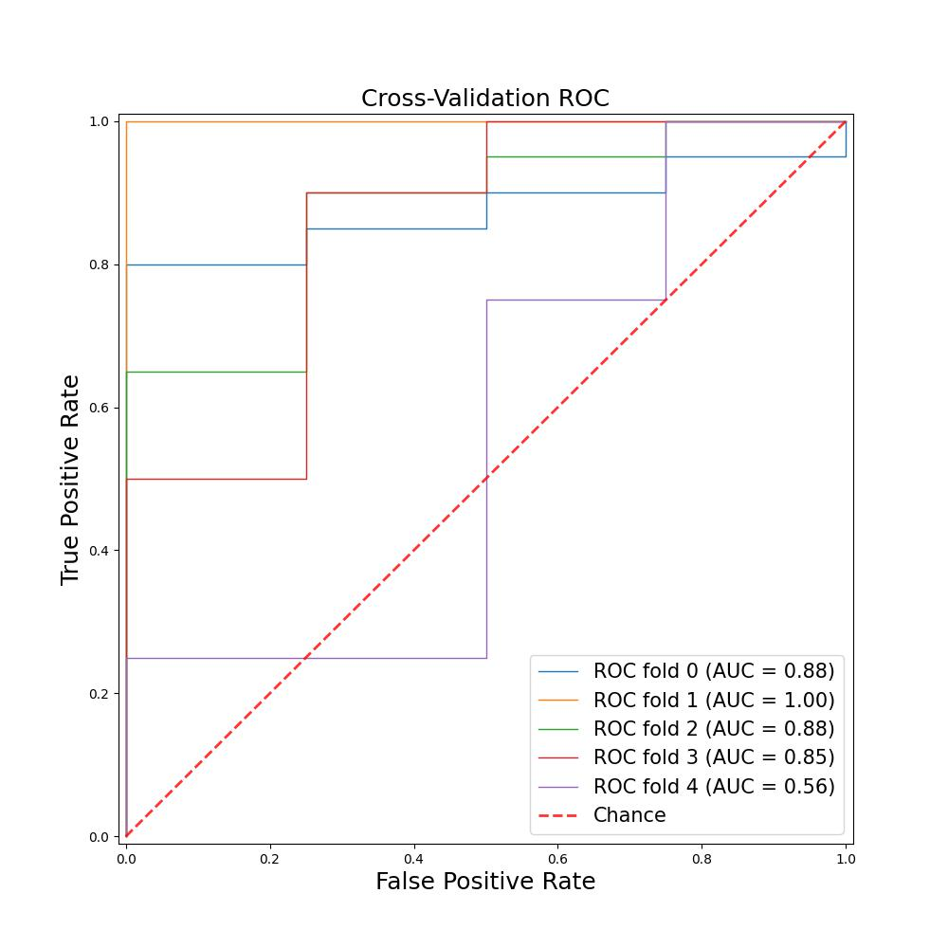
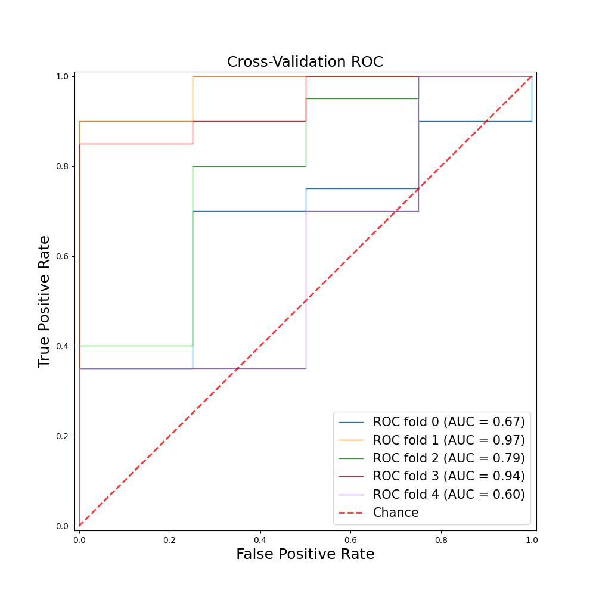
Random Forest Logistic Regression
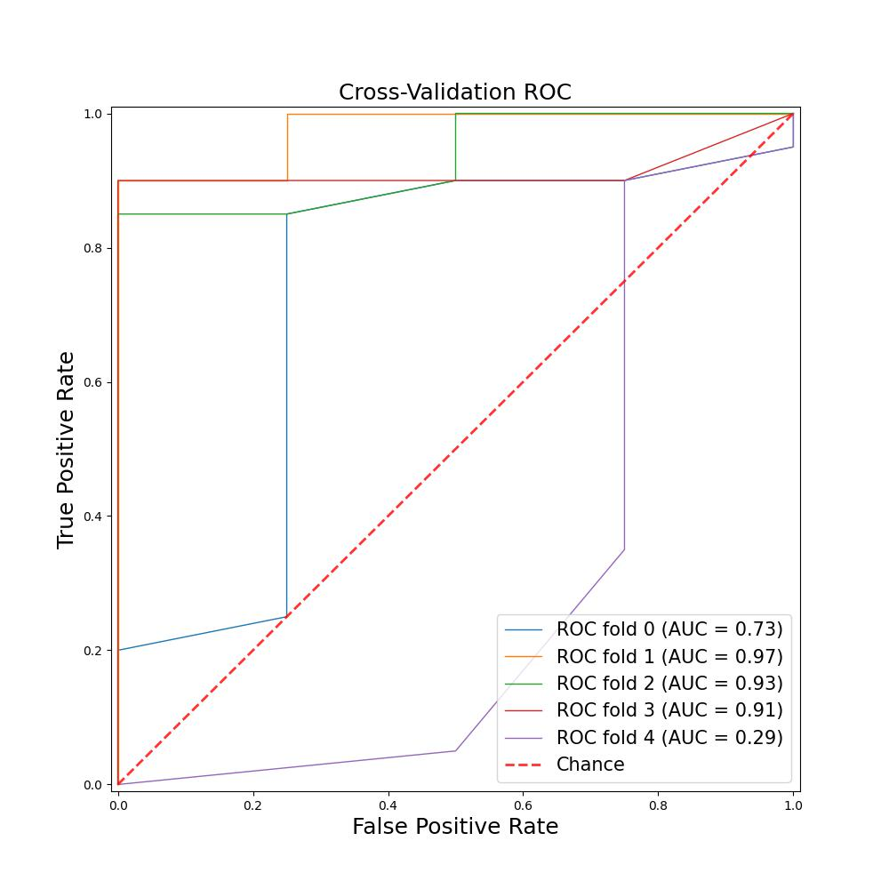
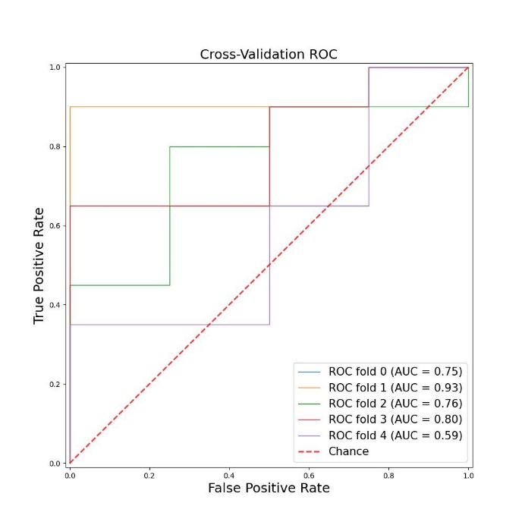

Multilayer Perceptron XGBoost

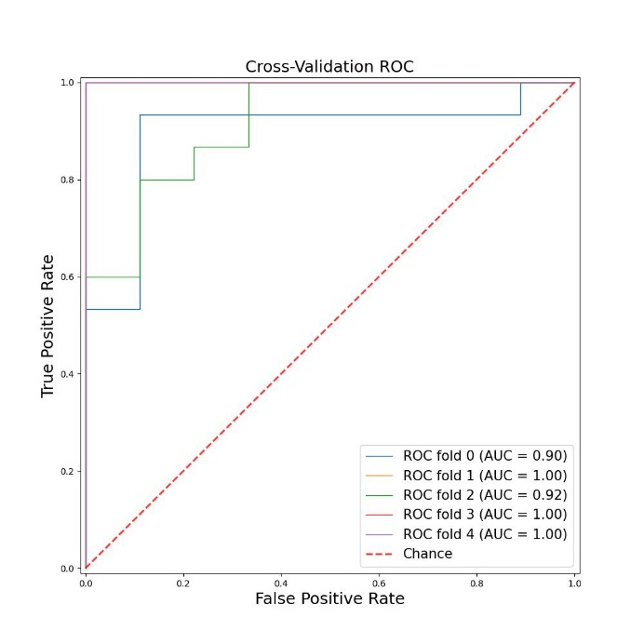
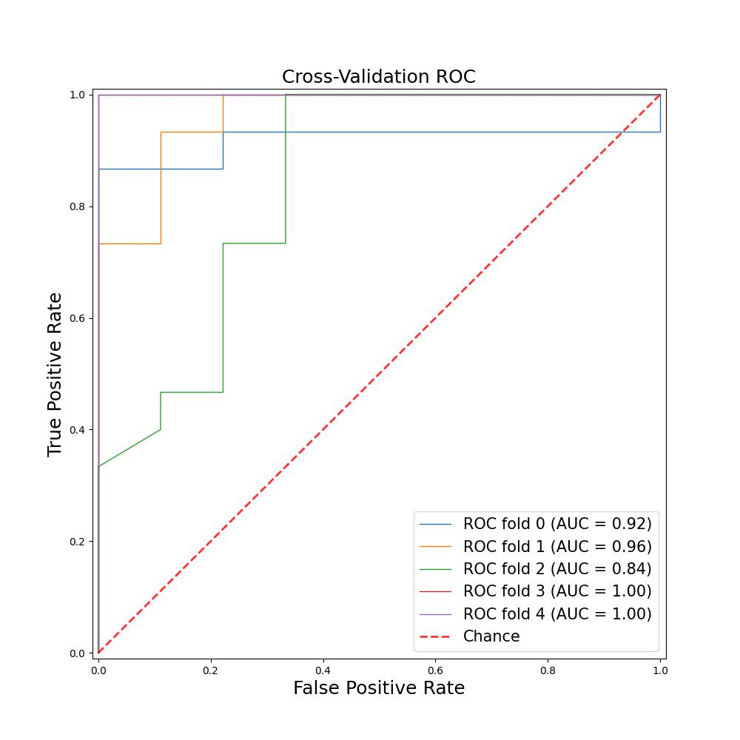
First-order model

Random Forest Logistic Regression

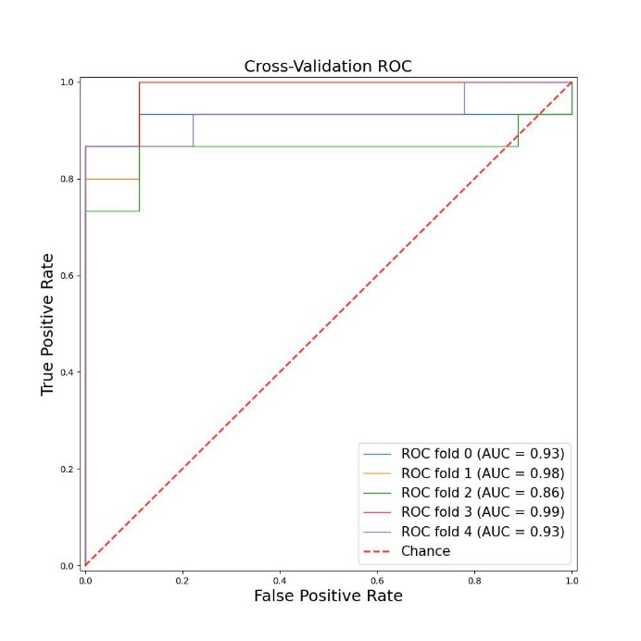
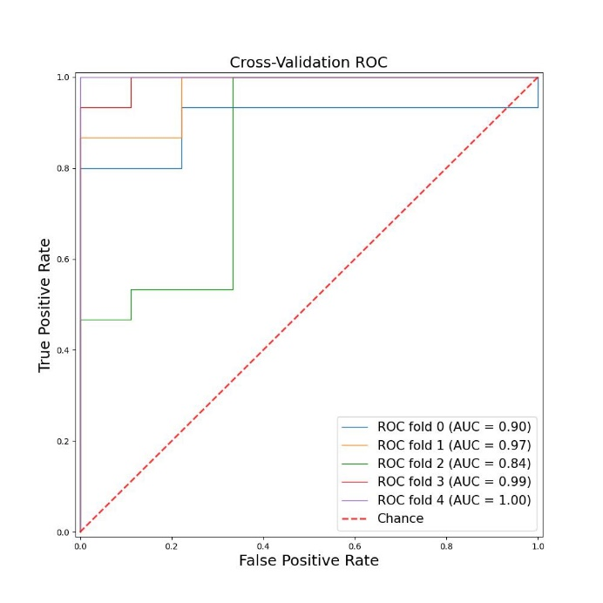

Multilayer Perceptron XGBoost

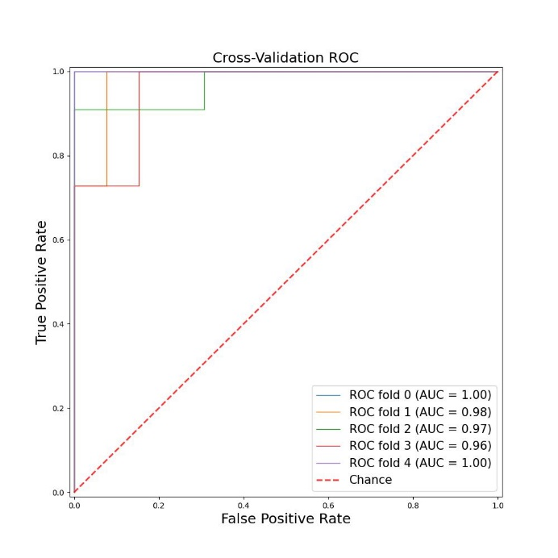
Second-order model
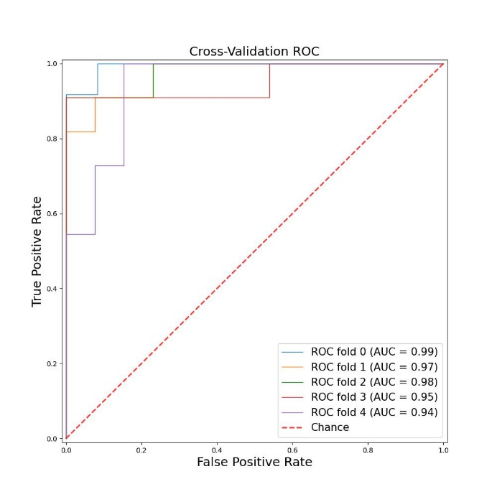

Random Forest Logistic Regression
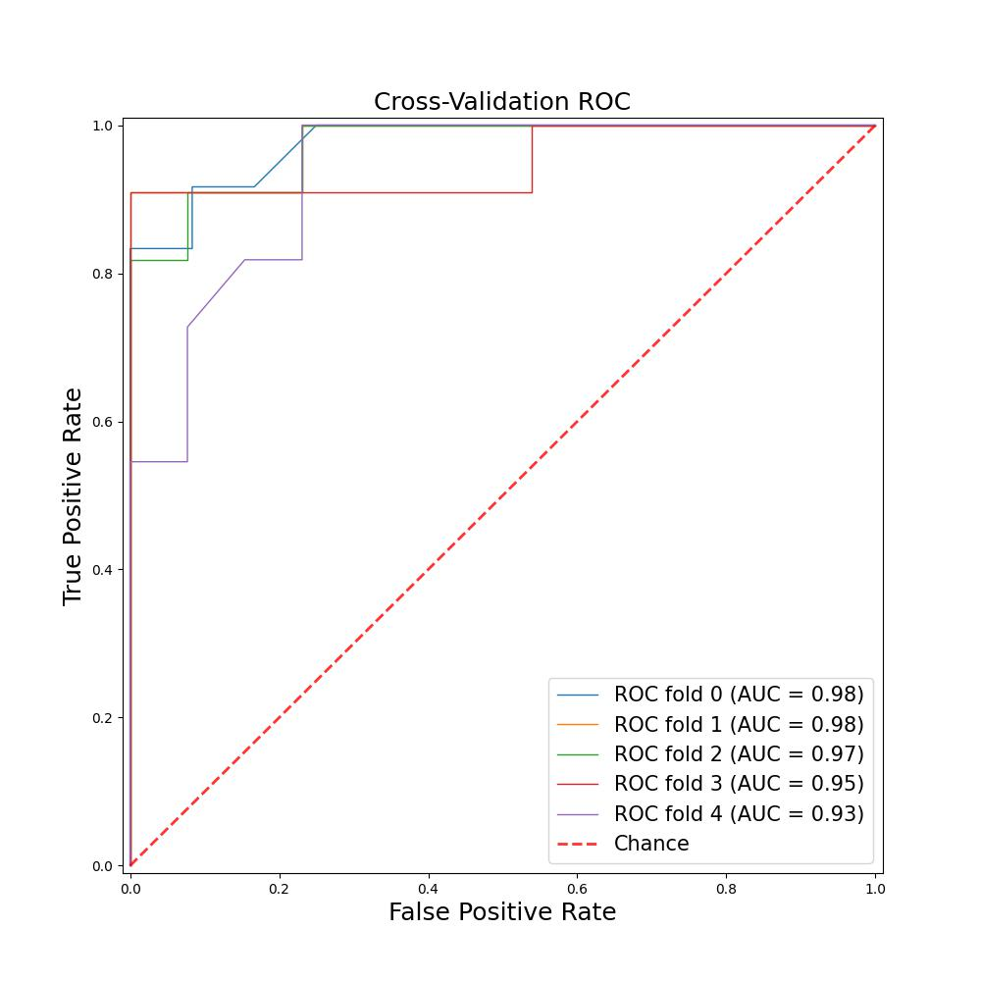
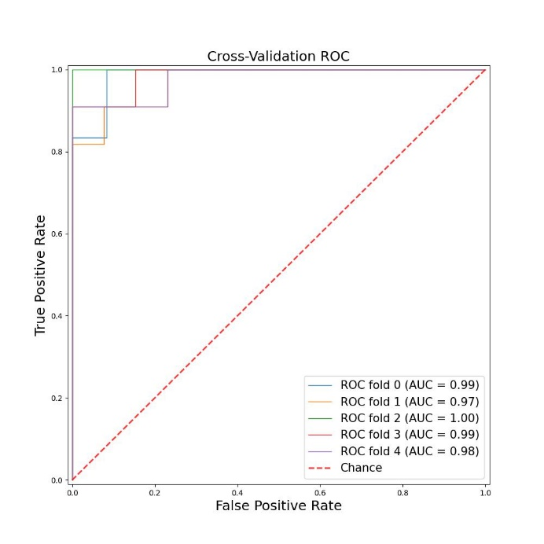

Multilayer Perceptron XGBoost

Third-order model

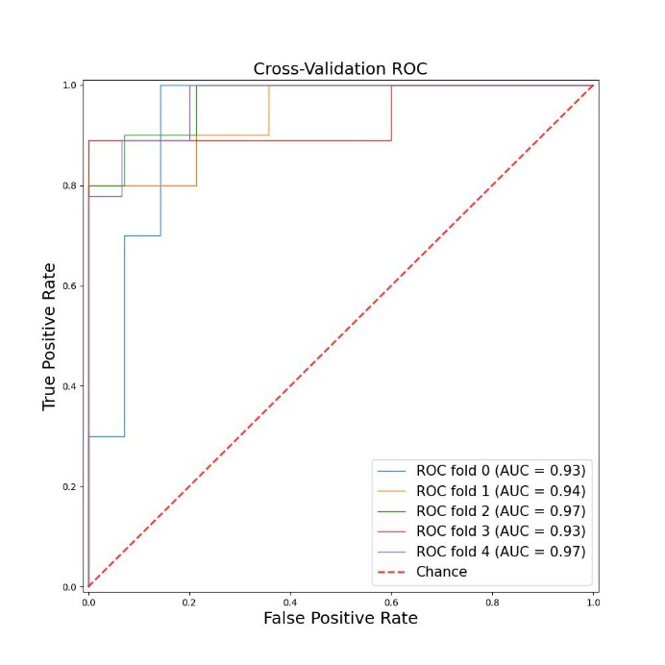
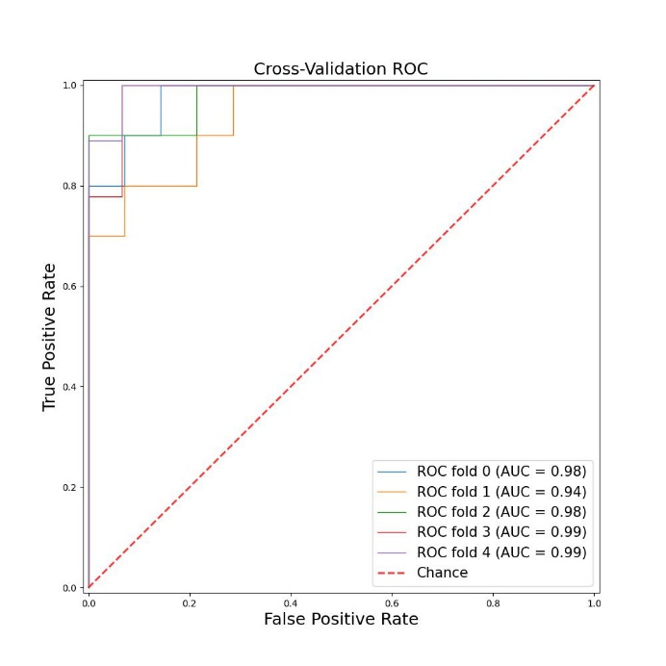

Random Forest Logistic Regression

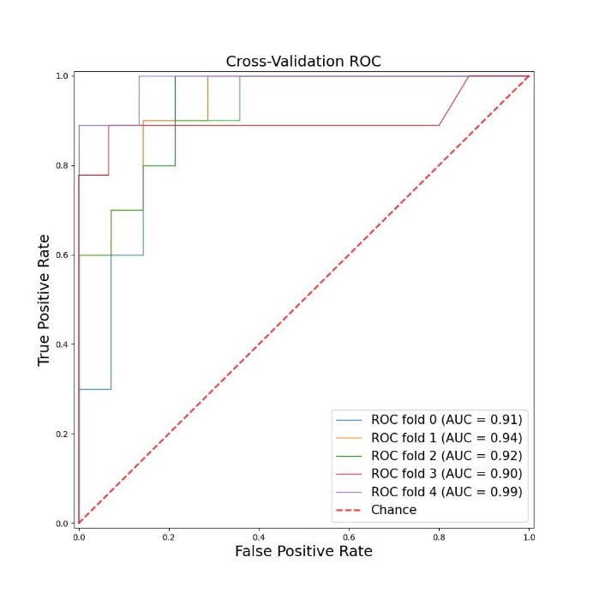
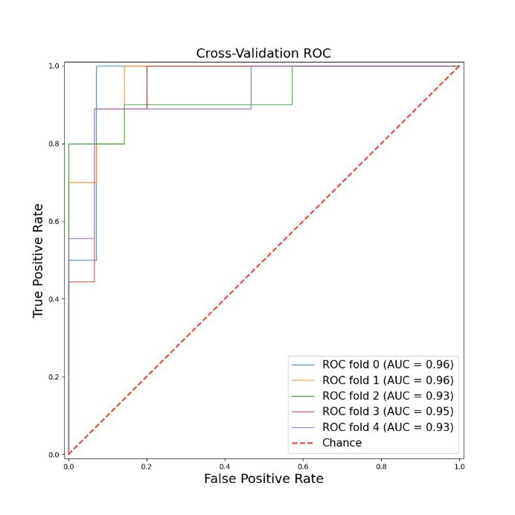

Multilayer Perceptron XGBoost

The ROC curve of each model on testing set
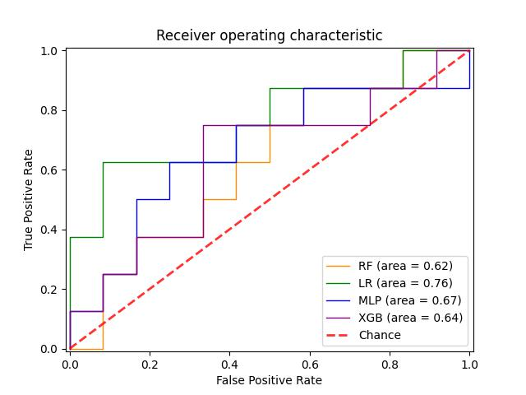

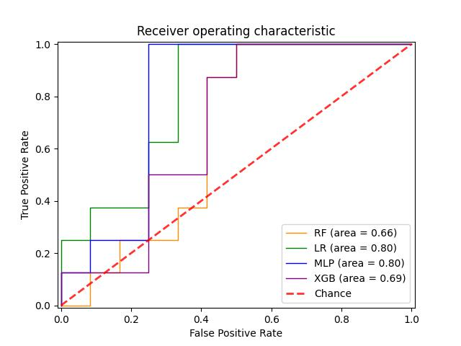
Morphology model First-order model

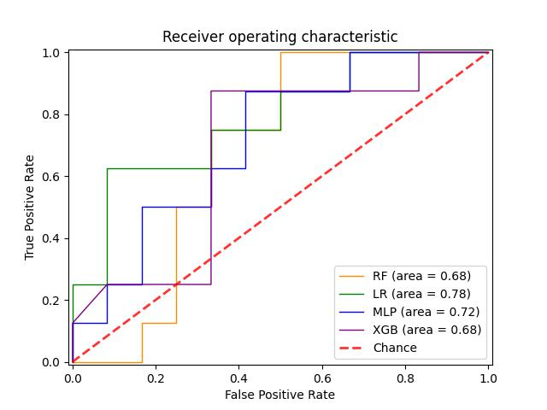
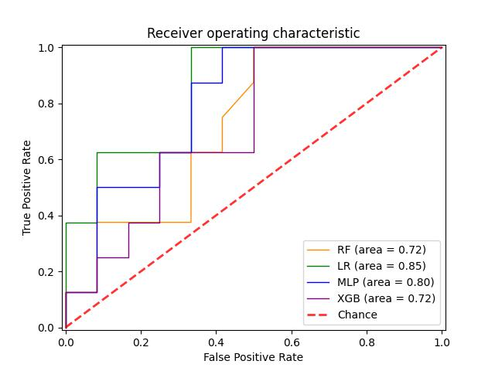
Second-order model Third-order model

Ⅳ The results of other classifiers of the comprehensive model

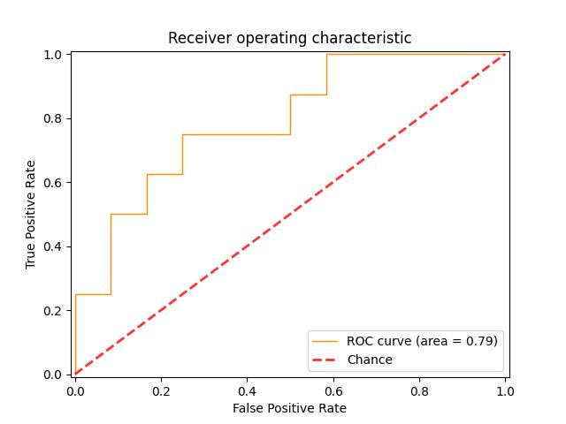
Random Forest

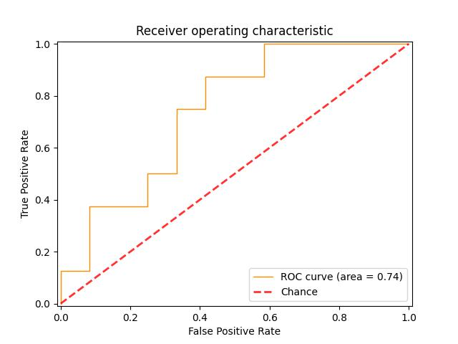
Multilayer Percentron

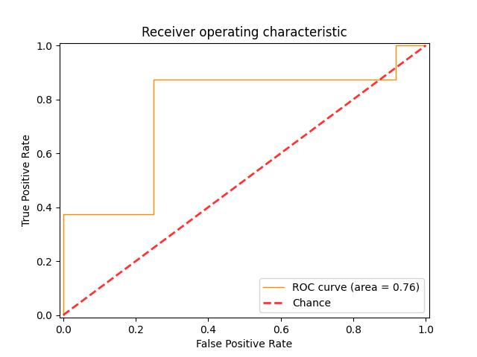
XGBoost

Ⅴ The algorithm of ROI segmentation and target slice selection
import cv2
import numpy as np
import nibabel as nib
from ipywidgets import interact, interactive, IntSlider, ToggleButtons
import matplotlib.pyplot as plt
import seaborn as sns
import pydicom
import os
import shutil
from PIL import Image
import pandas as pd
import pyclipper
def w_pic_read(image_path):
image_obj1 = nib.load(image_path)
image_affine=image_obj1.affine
page=image_obj1.shape[2]
return image_obj1, image_affine,page
def w_pic_save(image_path, image_data1,image_affine):
nib.save(nib.Nifti1Image(image_data1, image_affine),image_path)
def get_best_c(image_obj1, idx):
gray = image_obj1.get_fdata () [: idx]
gray_fin = image_obj1.get_fdata () [: idx]
image_data1=image_obj1.get_fdata ()
etVal, threshold = cv2.threshold(gray, 127, 255, cv2.THRESH_BINARY)
kernel = cv2.getStructuringElement(cv2.MORPH_RECT, (3, 3))
eroded = cv2.erode(threshold, kernel)
dilated = cv2.dilate(eroded, kernel)
Gaussian = cv2.GaussianBlur(dilated, (5, 5), 0)
binary = cv2.Canny(Gaussian.astype(np. uint8), 0, 1, apertureSize = 3)
contours, hierarchy = cv2.findContours(binary, cv2.RETR_TREE, cv2.CHAIN_APPROX_SIMPLE)
contours=list(contours)
cv2.imwrite('filepath’, Gaussian)
cv2.imwrite(' filepath ', binary)
drawing_img = np.zeros_like(binary)
cv2.imwrite(' filepath ', cv2.drawContours(drawing_img, contours, -1, 255, -1))

drawing_img = np.zeros_like(binary)
plt.figure(figsize=(30,30))
area = -1
arealist=-1
pic_max=np.percentile(gray, 97)
drawing_img = np.zeros_like(binary)
fork in range(len(contours)):
flag=0
hull= []
mask_10=-1000
lig= []
drawing_img = np.zeros_like(binary)
mask = cv2.drawContours(drawing_img, contours, k, 255, -1)
mask_10=np.percentile(gray [np.where (mask==255)], 97)
if cv2.contourArea(contours[k]) <=image_data1.shape[0] *image_data1.shape[1]/8 and np.amax(contours[k],axis=0)[0][0]>=np.shape(binary)[0]*0.5:
hull = cv2.convexHull(contours[k])
contours[k]=hull
mask = cv2.drawContours(drawing_img, contours,k, 255,-1)
mask_10=np.percentile(gray [np.where (mask==255)], 97)
if area<cv2.contourArea(contours[k]):
area=cv2.contourArea(contours[k])
arealist=k
print(arealist)
drawing_img = np.zeros_like(binary)
cv2.imwrite('filepath’, cv2.drawContours(drawing_img, contours,arealist, 255,-1))

drawing_img = np.zeros_like(binary)
mask = cv2.drawContours(drawing_img, contours,arealist, 255,-1)
gray1=gray.copy()
max_da=float ("{}”. format (gray1.max ()))
gray1[np.where (mask==0)]=80
cv2.imwrite('filepath’, gray1)
gray1[np.where (mask==0)]=max_da
return gray1, area,gray_fin

def equidistant_zoom_contour(contour, margin):
pco = pyclipper.PyclipperOffset()
pco.MiterLimit = 10
contour = contour [: 0, :]
pco.AddPath(contour, pyclipper.JT_MITER, pyclipper.ET_CLOSEDPOLYGON)
solution= []
if len(pco.Execute(margin))!=0:
solution = [pco.Execute(margin)[0]]
solution = np.array(solution).reshape(-1, 1, 2).astype(int)
return solution
def get_best_c_re(image_obj,gray_fin):
gray = image_obj
etVal, threshold = cv2.threshold(gray, 127, 255, cv2.THRESH_BINARY_INV)
kernel = cv2.getStructuringElement(cv2.MORPH_RECT, (3, 3))
eroded = cv2.erode(threshold, kernel)
dilated = cv2.dilate(eroded, kernel,iterations=2)
Gaussian = cv2.GaussianBlur(dilated, (5, 5), 0)
binary = cv2.Canny(Gaussian.astype(np. uint8), 0, 1, apertureSize = 3)
contours, hierarchy = cv2.findContours(binary, cv2.RETR_TREE, cv2.CHAIN_APPROX_SIMPLE)
contours=list(contours)
drawing_img = np.zeros_like(binary)
cv2.imwrite(' filepath’, cv2.drawContours(drawing_img, contours, -1, 255, -1))
cv2.imwrite(' filepath ‘, Gaussian)
area = -1
arealist=-1
drawing_img = np.zeros_like(binary)
fork in range(len(contours)):
mask_10=-1000
lig=[]
drawing_img = np.zeros_like(binary)
if area<cv2.contourArea(contours[k]):
area=cv2.contourArea(contours[k])
arealist=k
print (k, cv2.contourArea(contours[k]), area)
drawing_img = np.zeros_like(binary)
mask = cv2.drawContours(drawing_img, contours,arealist, 255,-1)
gray1=gray_fin.copy()
min_da=float ("{}”. format (gray1.min ()))
gray1[np.where(mask==0)]=80
if arealist! =-1:
equidistant=equidistant_zoom_contour(contours[arealist],-10)
if equidistant! =[]:
contours[arealist]=equidistant
mask = cv2.drawContours(drawing_img, contours,arealist, 255,-1)
gray2=gray_fin.copy()
min_da=float ("{}”. format (gray2.min ()))
gray2[np.where(mask==0)]=-1000
cv2.imwrite(' filepath ‘, gray2)
return gray2, area
def fill_pic(image_data1, gray1,idx):
'''gray_fin = image_obj1.get_fdata () [: idx]
kong=np.zeros_like(gray_fin)
image_data1=image_obj1.get_fdata ()
for i in range(image_data1.shape[-1]):
if i==idx:
image_data1[: i] =gray1
else:
image_data1[: i] =kong'''
image_data1[: idx] =gray1
return image_data1
path=' filepath '
path_out=' filepath '
fengefu=path [-1]
file_name=os.listdir(path)
file_name.sort()
file_name=['9yzb798.nii']
for i in file_name:
area_max=-1
if i.split('.')[-1]!='nii':
continue

image_path1=path+i
image_obj1, image_affine,page=w_pic_read(image_path1)
image_data1=np.zeros_like(image_obj1.get_fdata ())
light=pd. DataFrame(columns=['light_name','light_idx','light_k','light_con','is_con'])
light_chain=pd.DataFrame(columns=['start','end','chain'])

range1= [23]
for j in range1:
gray1, area,gray_fin=get_best_c(image_obj1,j)
gray1, area=get_best_c_re(gray1, gray_fin)

image_data1=fill_pic(image_data1, gray1,j)
if area==-1: continue
area_max=max(area_max,area)
if area <area_max*0.05 and j<0.5*page and area<image_data1.shape[0] *image_data1.shape[1]/100:
print(j)
area_max=-1
continue
if area<area_max*0.9 and j>0.5*page and area>image_data1.shape[0] *image_data1.shape[1]/25:
print(j)
break
etVal, threshold = cv2.threshold(gray1, 50, 255, cv2.THRESH_BINARY) #二值化
kernel = cv2.getStructuringElement(cv2.MORPH_RECT, (3, 3))
eroded = cv2.erode(threshold, kernel)
dilated = cv2.dilate(eroded, kernel)
Gaussian = cv2.GaussianBlur(dilated, (5, 5), 0)
binary = cv2.Canny(Gaussian.astype(np. uint8), 0, 1, apertureSize = 3)
contours, hierarchy = cv2.findContours(binary, cv2.RETR_EXTERNAL, cv2.CHAIN_APPROX_SIMPLE)
contours=list(contours)

if j==page-1:
fork in range(len(contours)):
if cv2.contourArea(contours[k])>area*0.5 or cv2.contourArea(contours[k])<2 or np.amin(contours[k],axis=0)[0][0]<=np.shape(binary)[0]*0.5:
continue
drawing_img=np.zeros_like(binary)
out_con = equidistant_zoom_contour(contours[k],5)
out_mask=cv2.drawContours(drawing_img, [out_con], -1, 255, -1)
gray_num=sum(gray1[np.where(out_mask!=0)]==0)
con_light={'light_name':str(j)+'_'+str(k),'light_idx’: j,'light_k':k,'light_con':contours[k],'is_con':0}
if gray_num>0:
light_chain1= {'start’: con_light['light_name'],'end’: con_light['light_name'],'chain’: [con_light['light_name']]}
light_chain=light_chain.append(light_chain1,ignore_index=True)
con_light['is_con’] =1
light=light.append(con_light,ignore_index=True)

else:
last=light.loc[light['light_idx’] ==j+1]
del_list= []
print(j)
fork in range(len(contours)):
flag=-1
if cv2.contourArea(contours[k])>area*0.5 or cv2.contourArea(contours[k]) <2 or np.amin(contours[k],axis=0)[0][0]<=np.shape(binary)[0]*0.5:
continue
drawing_img=np.zeros_like(binary)
out_con = equidistant_zoom_contour(contours[k],5)
out_con_mask=cv2.drawContours(drawing_img, [out_con], -1, 255, -1)
con_light={'light_name':str(j)+'_'+str(k),'light_idx’: j,'light_k':k,'light_con':contours[k],'is_con':0}
gray_num=sum(gray1[np.where(out_con_mask!=0)]==0)
if gray_num>0: con_light['is_con’] =1

if len(last)! =0:
for p in range(len(last)):
drawing_img1=np.zeros_like(binary)
check_mask=cv2.drawContours(drawing_img1, [last.iloc[p]['light_con']],-1, 255,-1)
check_mask[np.where(out_con_mask==0)]=0
if len(check_mask[np.where(check_mask!=0)])>0:
light_rep=light_chain.loc[light_chain['end’] ==last.iloc[p]['light_name']]
if len(light_rep) ==0: continue
del_list=del_list+[last.iloc[p]['light_name']]
light_rep['end’] =str(j)+'_'+str(k)
light_rep['chain’] =light_rep['chain']. apply (lambda x: x+[str(j)+'_'+str(k)])
light_chain=light_chain.append(light_rep)
flag=1
if flag==-1:
light_chain1= {'start’: con_light['light_name'],'end’: con_light['light_name'],'chain’: [con_light['light_name']]}
light_chain=light_chain.append(light_chain1,ignore_index=True)

light=light.append(con_light,ignore_index=True)
if len(del_list)! =0:
for q in range(len(del_list)):
light_chain=light_chain[light_chain.end! =del_list[q]]
light_chain['len’] =light_chain['chain']. apply (lambda x: len(x))
light_chain_fin=light_chain.loc[light_chain['len']>2]

image_path2=path+i.split(‘.’) [0] +'_test'+’. nii'
os.mkdir(path_out+i+fengefu)
image_path2=path_out+i+fengefu +i.split('.')[0]+'_test'+'.nii'
w_pic_save(image_path=image_path2, image_data1=image_data1,image_affine=image_affine)
shutil.copyfile(path+i , path_out+i.split('_')[0]+fengefu+i)

Ⅵ The algorithm of model construction and validation

import pandas as pd
import numpy as np
import matplotlib.pyplot as plt
from sklearn import datasets,model_selection
from collections import Counter
from imblearn.over_sampling import SMOTE
from sklearn.ensemble import RandomForestClassifier
from sklearn.model_selection import train_test_split
from sklearn.metrics import r2_score, mean_squared_error, confusion_matrix, accuracy_score, precision_score, recall_score, f1_score, roc_curve, auc
from sklearn import datasets,model_selection,preprocessing

def load_data(filepath):
df = pd.read_csv(filepath)
iris1 = df
X = iris1.iloc[::-2]
y = iris1.iloc[: -1]
minmax = preprocessing.MinMaxScaler().fit(X)
X = minmax.fit_transform(X)
return X, y

def external_validate(model, X_val, y_val, model_name):
print ("External Validation for", model_name, ":")
print (model.score(X_val, y_val))
print (confusion_matrix(y_val, model.predict(X_val)))
print (accuracy_score(y_val, model.predict(X_val)))
print (precision_score(y_val, model.predict(X_val)))
print (recall_score(y_val, model.predict(X_val)))
print (f1_score (y_val, model.predict(X_val)))
y_pred = model.predict_proba(X_val)[:, 1]
fpr_val, tpr_val, thresholds = roc_curve(y_val, y_pred, pos_label=1)
print ("AUC for external validation:", auc(fpr_val, tpr_val))
return fpr_val, tpr_val

def main ():
X_train, y_train = load_data('filepath')
train_data, test_data, train_label, test_label = model_selection.train_test_split(X_train, y_train, train_size=0.8)
smote = SMOTE ()
train_data, train_label = smote.fit_resample(train_data, train_label)

X_val, y_val = load_data('external_validation_filepath')

# Random Forest
forest = RandomForestClassifier(n_estimators=300, max_features=39,n_jobs=-1)
forest.fit(train_data, train_label)
print ("Random Forest Train Performance:")
print(forest.score(test_data,test_label))
print (confusion_matrix(test_label, forest.predict(test_data)))
print (accuracy_score(test_label, forest.predict(test_data)))
print (precision_score(test_label, forest.predict(test_data)))
print (recall_score(test_label, forest.predict(test_data)))
print (f1_score (test_label, forest.predict(test_data)))
y_pred_rf = forest.predict_proba(test_data)[:,1]
fpr_rf, tpr_rf, thresholds = roc_curve(test_label, y_pred_rf, pos_label=1)
print ("Random Forest Train AUC:", auc(fpr_rf, tpr_rf))
fpr_val_rf, tpr_val_rf = external_validate(forest, X_val, y_val, "Random Forest")

# ROC curve for test data
plt.figure(figsize=(10, 6))
lw = 2
plt.plot(fpr_rf, tpr_rf, color='darkorange',lw=lw, label='Random Forest Test ROC curve (area = %0.3f)' % auc(fpr_rf, tpr_rf))
plt.plot([0, 1], [0, 1], color='navy', lw=lw, linestyle='--')
plt.xlim([0.0, 1.0])
plt.ylim([0.0, 1.05])
plt.xlabel('False Positive Rate')
plt.ylabel('True Positive Rate')
plt.title('Random Forest Test Receiver operating characteristic example')
plt.legend(loc="lower right")
plt.show()

# ROC curve for validation data
plt.figure(figsize=(10, 6))
lw = 2
plt.plot(fpr_val_rf, tpr_val_rf, color='red',lw=lw, label='Random Forest External Validation ROC curve (area = %0.3f)' % auc(fpr_val_rf, tpr_val_rf))
plt.plot([0, 1], [0, 1], color='navy', lw=lw, linestyle='--')
plt.xlim([0.0, 1.0])
plt.ylim([0.0, 1.05])
plt.xlabel('False Positive Rate')
plt.ylabel('True Positive Rate')
plt.title('Random Forest External Validation Receiver operating characteristic example')
plt.legend(loc="lower right")
plt.show()

# Logistic Regression
from sklearn.linear_model import LogisticRegression
lr_clf = LogisticRegression(class_weight='balanced',multi_class='ovr')
lr_clf.fit (train_data, train_label)
print ("Logistic Regression Train Performance:")
print(lr_clf.score(test_data,test_label))
print (confusion_matrix(test_label, lr_clf.predict(test_data)))
print (accuracy_score(test_label, lr_clf.predict(test_data)))
print (precision_score(test_label, lr_clf.predict(test_data)))
print (recall_score(test_label, lr_clf.predict(test_data)))
print (f1_score(test_label, lr_clf.predict(test_data)))
y_pred_log = lr_clf.predict_proba(test_data)[:,1]
fpr_log, tpr_log, thresholds = roc_curve(test_label, y_pred_log, pos_label=1)
print ("Logistic Regression Train AUC:", auc(fpr_log, tpr_log))
fpr_val_log, tpr_val_log = external_validate(lr_clf, X_val, y_val, "Logistic Regression")

# ROC curve for test data
plt.figure(figsize=(10, 6))
lw = 2
plt.plot(fpr_log, tpr_log, color='darkorange',lw=lw, label='Logistic Regression Test ROC curve (area = %0.3f)' % auc(fpr_log, tpr_log))
plt.plot([0, 1], [0, 1], color='navy', lw=lw, linestyle='--')
plt.xlim([0.0, 1.0])
plt.ylim([0.0, 1.05])
plt.xlabel('False Positive Rate')
plt.ylabel('True Positive Rate')
plt.title('Logistic Regression Test Receiver operating characteristic example')
plt.legend(loc="lower right")
plt.show()

# ROC curve for validation data
plt.figure(figsize=(10, 6))
lw = 2
plt.plot(fpr_val_log, tpr_val_log, color='red',lw=lw, label='Logistic Regression External Validation ROC curve (area = %0.3f)' % auc(fpr_val_log, tpr_val_log))
plt.plot([0, 1], [0, 1], color='navy', lw=lw, linestyle='--')
plt.xlim([0.0, 1.0])
plt.ylim([0.0, 1.05])
plt.xlabel('False Positive Rate')
plt.ylabel('True Positive Rate')
plt.title('Logistic Regression External Validation Receiver operating characteristic example')
plt.legend(loc="lower right")
plt.show()

# Multi-layer Perceptron
from sklearn.neural_network import MLPClassifier
mlp = MLPClassifier(solver='lbfgs', alpha=5, hidden_layer_sizes=(45,39,10),max_iter=3000)
mlp.fit(train_data,train_label)
print ("Multi-layer Perceptron Train Performance:")
print(mlp.score(test_data,test_label))
print (confusion_matrix(test_label, mlp.predict(test_data)))
print (accuracy_score(test_label, mlp.predict(test_data)))
print (precision_score(test_label, mlp.predict(test_data)))
print (recall_score(test_label, mlp.predict(test_data)))
print (f1_score(test_label, mlp.predict(test_data)))
y_pred_mlp = mlp.predict_proba(test_data)[:,1]
fpr_mlp, tpr_mlp, thresholds = roc_curve(test_label, y_pred_mlp, pos_label=1)
print ("Multi-layer Perceptron Train AUC:", auc(fpr_mlp, tpr_mlp))
fpr_val_mlp, tpr_val_mlp = external_validate(mlp, X_val, y_val, "Multi-layer Perceptron")

# ROC curve for test data
plt.figure(figsize=(10, 6))
lw = 2
plt.plot(fpr_mlp, tpr_mlp, color='darkorange',lw=lw, label='Multi-layer Perceptron Test ROC curve (area = %0.3f)' % auc(fpr_mlp, tpr_mlp))
plt.plot([0, 1], [0, 1], color='navy', lw=lw, linestyle='--')
plt.xlim([0.0, 1.0])
plt.ylim([0.0, 1.05])
plt.xlabel('False Positive Rate')
plt.ylabel('True Positive Rate')
plt.title('Multi-layer Perceptron Test Receiver operating characteristic example')
plt.legend(loc="lower right")
plt.show()

# ROC curve for validation data
plt.figure(figsize=(10, 6))
lw = 2
plt.plot(fpr_val_mlp, tpr_val_mlp, color='red',lw=lw, label='Multi-layer Perceptron External Validation ROC curve (area = %0.3f)' % auc(fpr_val_mlp, tpr_val_mlp))
plt.plot([0, 1], [0, 1], color='navy', lw=lw, linestyle='--')
plt.xlim([0.0, 1.0])
plt.ylim([0.0, 1.05])
plt.xlabel('False Positive Rate')
plt.ylabel('True Positive Rate')
plt.title('Multi-layer Perceptron External Validation Receiver operating characteristic example')
plt.legend(loc="lower right")
plt.show()

# Extreme Gradient Boosting
from sklearn.neural_network import XGBClassifier
xgb = XGBClassifier(learning_rate =0.1,n_estimators=50,max_depth=5,min_child_weight=5,gamma=0,subsample=0.8,colsample_bytree=0.8,objective= 'binary:logistic',nthread=4,seed=42)
xgb.fit(train_data,train_label)
print ("Extreme Gradient Boosting Train Performance:")
print(xgb.score(test_data,test_label))
print (confusion_matrix(test_label, xgb.predict(test_data)))
print (accuracy_score(test_label, xgb.predict(test_data)))
print (precision_score(test_label, xgb.predict(test_data)))
print (recall_score(test_label, xgb.predict(test_data)))
print (f1_score(test_label, xgb.predict(test_data)))
y_pred_xgb = xgb.predict_proba(test_data)[:,1]
fpr_xgb, tpr_xgb, thresholds = roc_curve(test_label, y_pred_xgb, pos_label=1)
print ("Extreme Gradient Boosting Train AUC:", auc(fpr_xgb, tpr_xgb))
fpr_val_xgb, tpr_val_xgb = external_validate(xgb, X_val, y_val, "Extreme Gradient Boosting")

# ROC curve for test data
plt.figure(figsize=(10, 6))
lw = 2
plt.plot(fpr_xgb, tpr_xgb, color='darkorange',lw=lw, label='Extreme Gradient Boosting Test ROC curve (area = %0.3f)' % auc(fpr_xgb, tpr_xgb))
plt.plot([0, 1], [0, 1], color='navy', lw=lw, linestyle='--')
plt.xlim([0.0, 1.0])
plt.ylim([0.0, 1.05])
plt.xlabel('False Positive Rate')
plt.ylabel('True Positive Rate')
plt.title('Extreme Gradient Boosting Test Receiver operating characteristic example')
plt.legend(loc="lower right")
plt.show()

# ROC curve for validation data
plt.figure(figsize=(10, 6))
lw = 2
plt.plot(fpr_val_xgb, tpr_val_xgb, color='red',lw=lw, label='Extreme Gradient Boosting External Validation ROC curve (area = %0.3f)' % auc(fpr_val_xgb, tpr_val_xgb))
plt.plot([0, 1], [0, 1], color='navy', lw=lw, linestyle='--')
plt.xlim([0.0, 1.0])
plt.ylim([0.0, 1.05])
plt.xlabel('False Positive Rate')
plt.ylabel('True Positive Rate')
plt.title('Extreme Gradient Boosting External Validation Receiver operating characteristic example')
plt.legend(loc="lower right")
plt.show()

Ⅶ Settings of hyperparameters for various models
(1) Random Forest: n_estimators=300, max_features=39
(2) Logistic Regression: penalty =’L2’, class_weight='balanced'
(3) Multi-layer Perceptron: solver='lbfgs', alpha=5, hidden_layer_sizes= (45,39,10), max_iter=3000
(4) XGboost: learning_rate=0.1, n_estimators=50, max_depth=5, min_child_weight=5, gamma=0, subsample=0.8, colsample_bytree=0.8, objective= 'binary:logistic',nthread=4

