ELECTRONIC SUPPLEMENTARY MATERIAL

Subphenotyping prone position responders with machine learning

Maxime Fosset^{1,2,3,4#}, Dario von Wedel^{1,2,5#}, Simone Redaelli^{1,2,6,7#}, Daniel Talmor^{1,2}, Nicolas Molinari⁴, Julie Josse⁴, Elias N Baedorf-Kassis⁸, Maximilian S Schaefer^{1,2,9}, Boris Jung^{1,2,3,8}

¹Department of Anesthesia, Critical Care and Pain Medicine, Beth Israel Deaconess Medical Center, Harvard Medical School, Boston, MA, USA
²Center for Anesthesia Research Excellence (CARE), Beth Israel Deaconess Medical Center, Harvard Medical School, Boston, MA, USA
³Medical Intensive Care Unit and PhyMedExp, Montpellier University Hospital, Montpellier, France
⁴Desbrest Institute of Epidemiology and Public Health, University of Montpellier, INRIA, Montpellier, France
⁵Institute of Medical Informatics, Charité - Universitätsmedizin Berlin, Berlin, Germany
⁶School of Medicine and Surgery, University of Milano-Bicocca, Milan, Italy
⁷Department of Anesthesiology, Perioperative and Pain Medicine, Lahey Hospital and Medical Center, Burlington, MA, USA
⁸Department of Pulmonary, Critical Care & Sleep Medicine, Beth Israel Deaconess Medical Center, Harvard Medical School, Boston, MA, USA
⁹Department of Anesthesiology, Duesseldorf University Hospital, Duesseldorf, Germany
#Contributed equally to this work

E-Figure 1: Scree plot of the factorial analysis of mixed data and description of the clustering algorithm
E-Figure 2: Evolution of Respiratory System Compliance for the three clusters across stages of prone position
E-Figure 3: Evolution of Driving Pressure for the three clusters across stages of prone position
E-Figure 4: Evolution of Mechanical Power for the three clusters across stages of prone position
E-Figure 5: Evolution of PaO₂/FIO₂ratio for the three clusters across stages of prone position
E-Figure 6: Evolution of Ventilatory Ratio for the three clusters across stages of prone position
E-Figure 7: Kaplan-Meier curve of the survival probabilities for the three clusters
E-Figure 8: Missing values percentages for variables imputed through factorial analysis of mixed data
E-Table 1: Extract from the BIDMC protocol for Prone Position in the ICU
E-Table 2: Description of the cluster 1 with their variables
E-Table 3: Description of the cluster 2 with their variables
E-Table 4: Description of the cluster 3 with their variables
E-Table 5: Characteristics of the population and of the three clusters for the sub population with available esophageal pressure measurements
E-Table 6: Response rate for mortality, respiratory mechanics and oxygenation parameters by cluster and overall for the sub population with available esophageal pressure measurements
E-Table 7: Response rate for respiratory mechanics and oxygenation parameters by cluster and overall for the full population with a definition of improvement of at least 10 %
E-Table 8: Response rate to proning position adjusted for missing secondary outcomes
E-Table 9: Post-hoc power analysis for response rate
E-Table 10: Obstructive and restrictive lung diseases definition
E-Table 11: Mechanical power responders rate with Pressure-Controlled Ventilation equation

E-Figure 1: Scree plot of the factorial analysis of mixed data and description of the clustering algorithm

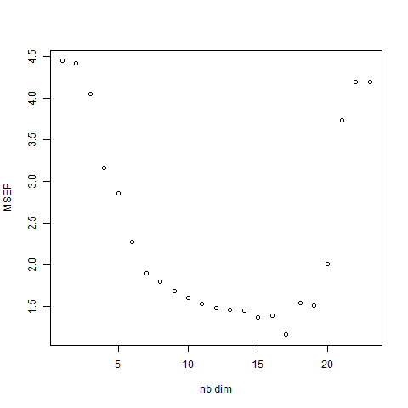
Scree plot for the number of dimensions:
A number of dimensions of 17 was chosen as the one with the lowest mean square error, meaning that most of the variance in the response variable is explained by a number of 17 components
MSEP = Mean Square Error of Prediction
Nb dim = Number of dimensions

Description of the clustering algorithm:
We used factorial analysis of mixed data, an extension of principal component analysis suited to both qualitative and mixed data. This approach allows to summarize the information by reducing the dimensionality of the data without losing important information. A new set of variables is created, so-called principal components (scores), which capture the maximum variance in the data. This scree plot with cross-validation was used to determine the optimal number of components. As the number of dimensions increases, the model’s predictive accuracy is improving, with the lower point at 17 dimensions. Increasing dimensions over this number might decrease the performance of the algorithm.
This denoising method serves as a preprocessing tool for the unsupervised clustering technique that we chose, that is, hierarchical ascending clustering.
The hierarchical clustering method was then used to define three clusters and was built by computing the Euclidean distance between individuals and using the Ward criterion to minimize the variance at each step of the construction of the algorithm and homogenize the clusters.
The optimal number of clusters was determined visually and through the between-cluster variance increase, when the number of clusters was increased by one.
The clusters are described in two ways.
First, for continuous variables, each variable was described by its mean, and a v-test was performed, with the p-value corresponding to the test of the following hypothesis:” The mean of the category is equal to the overall mean.”
This test compares the mean of a variable within a cluster to the global mean, accounting for variance and sample size. It does not require the assumption of normal data distribution, leveraging the central limit theorem for its approximation to normality in larger samples​.
For categorical variables, a χ2 test was performed between the categorical variables and the cluster variable, and a p-value less than 0.05 showing that the categorical variable was linked to the cluster variable.
Further, the link between the cluster and quantitative variables was also computed as the correlation ratio.

E-Figure 2: Evolution of Respiratory System Compliance for the three clusters across stages of prone position

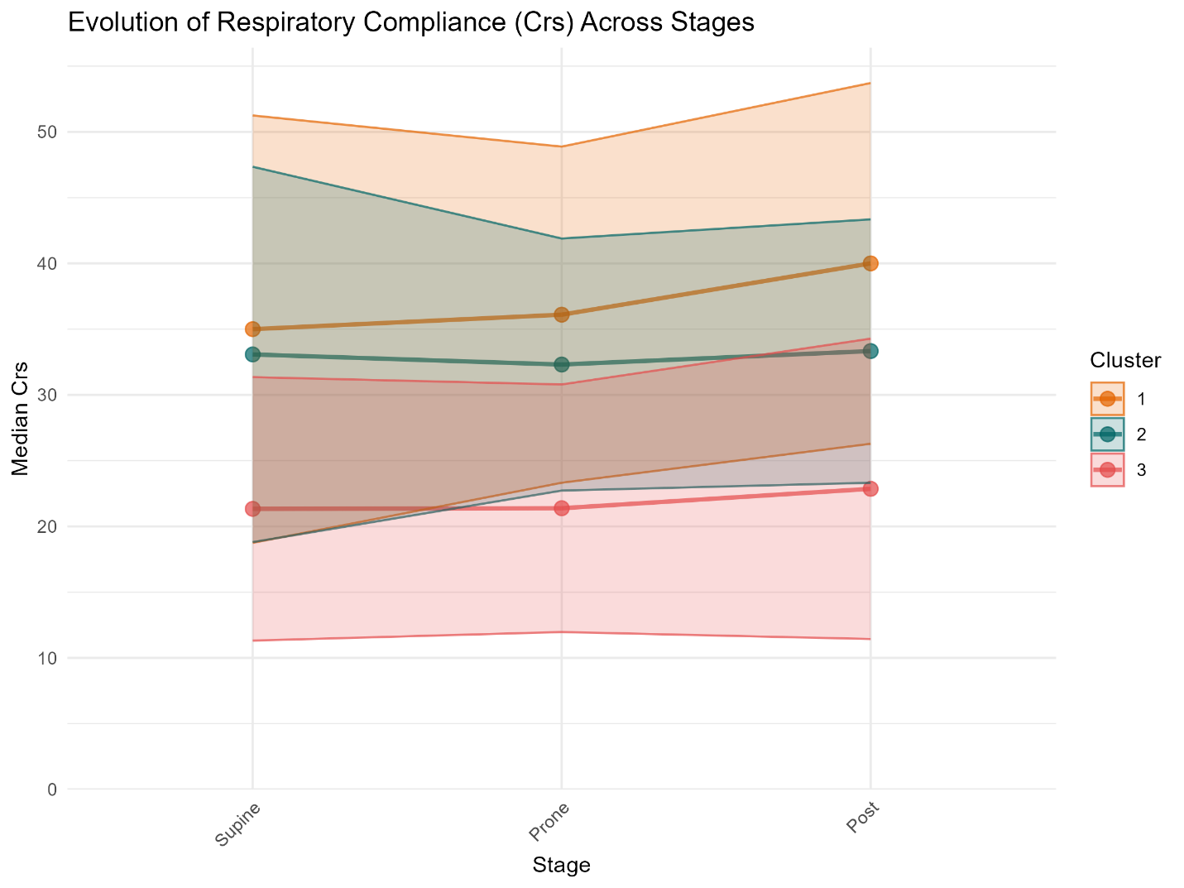

Temporal trends across three phases: baseline (Supine), intervention (Prone), and follow-up (Post). Each colored line represents the mean values across the study cohort for the respective clusters. The shaded regions around each line illustrate the 95% confidence intervals (CIs).

E-Figure 3: Evolution of Driving Pressure for the three clusters across stages of prone position

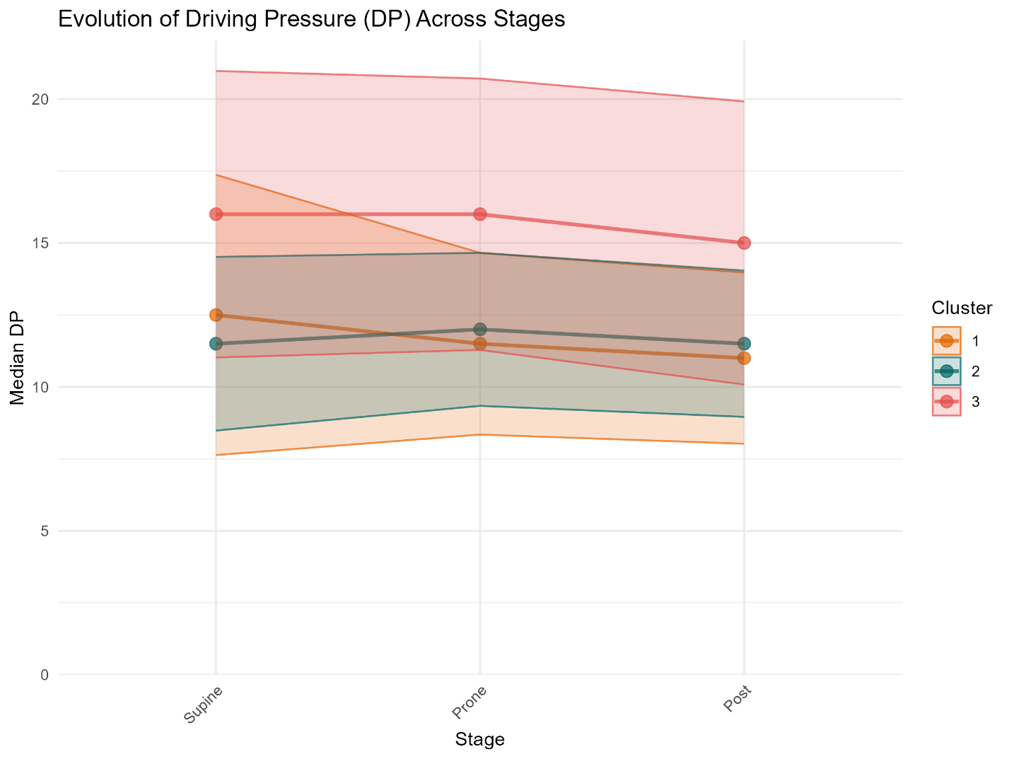

Temporal trends across three phases: baseline (Supine), intervention (Prone), and follow-up (Post). Each colored line represents the mean values across the study cohort for the respective clusters. The shaded regions around each line illustrate the 95% confidence intervals (CIs).

E-Figure 4: Evolution of Mechanical Power for the three clusters across stages of prone position

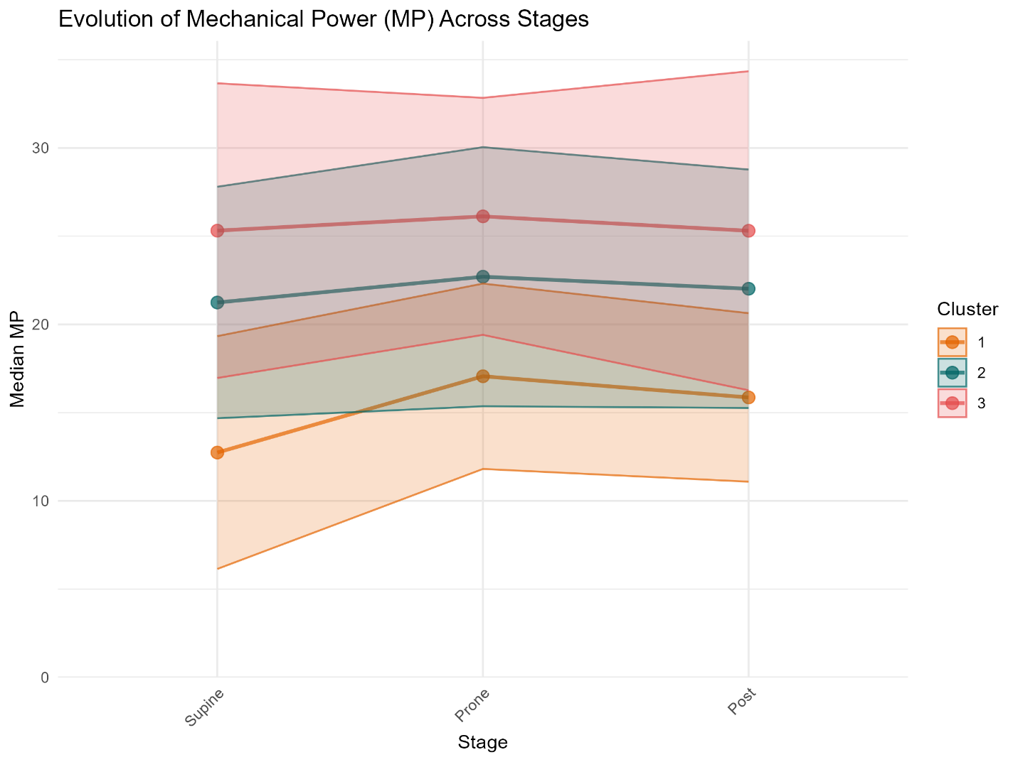

Temporal trends across three phases: baseline (Supine), intervention (Prone), and follow-up (Post). Each colored line represents the mean values across the study cohort for the respective clusters. The shaded regions around each line illustrate the 95% confidence intervals (CIs).

E-Figure 5: Evolution of PaO₂/FIO₂ratio for the three clusters across stages of prone position

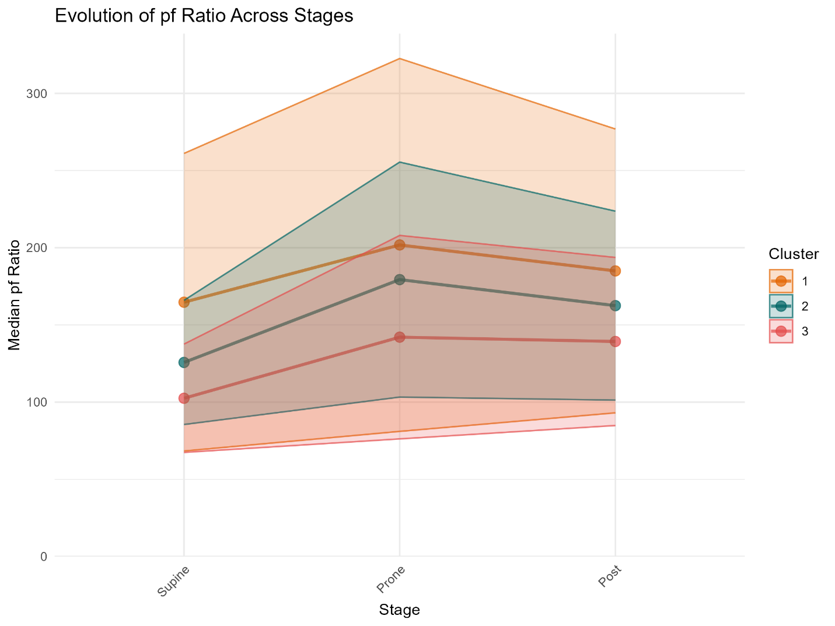

Temporal trends across three phases: baseline (Supine), intervention (Prone), and follow-up (Post). Each colored line represents the mean values across the study cohort for the respective clusters. The shaded regions around each line illustrate the 95% confidence intervals (CIs).

E-Figure 6: Evolution of Ventilatory Ratio for the three clusters across stages of prone position

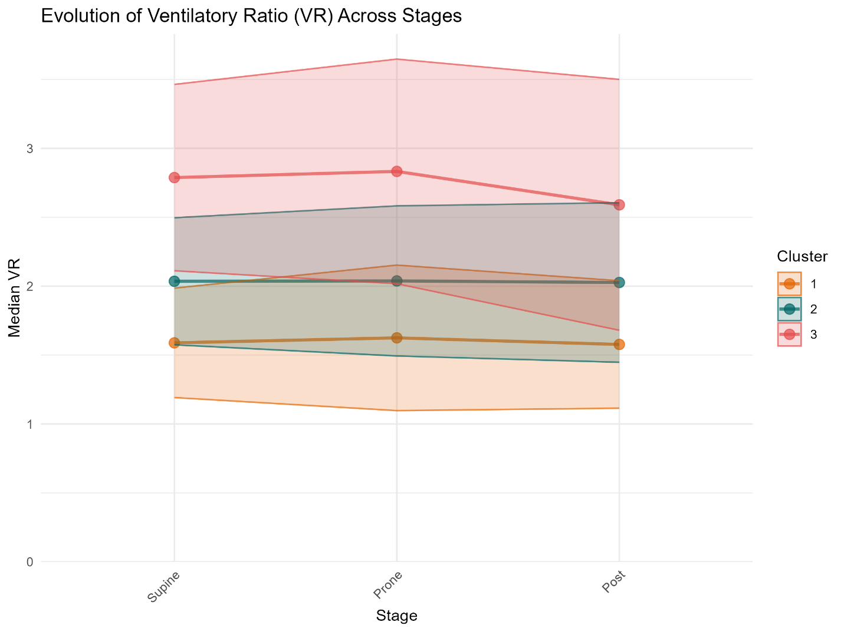

Temporal trends across three phases: baseline (Supine), intervention (Prone), and follow-up (Post). Each colored line represents the mean values across the study cohort for the respective clusters. The shaded regions around each line illustrate the 95% confidence intervals (CIs).

E-Figure 7: Kaplan-Meier curve of the survival probabilities for the three clusters

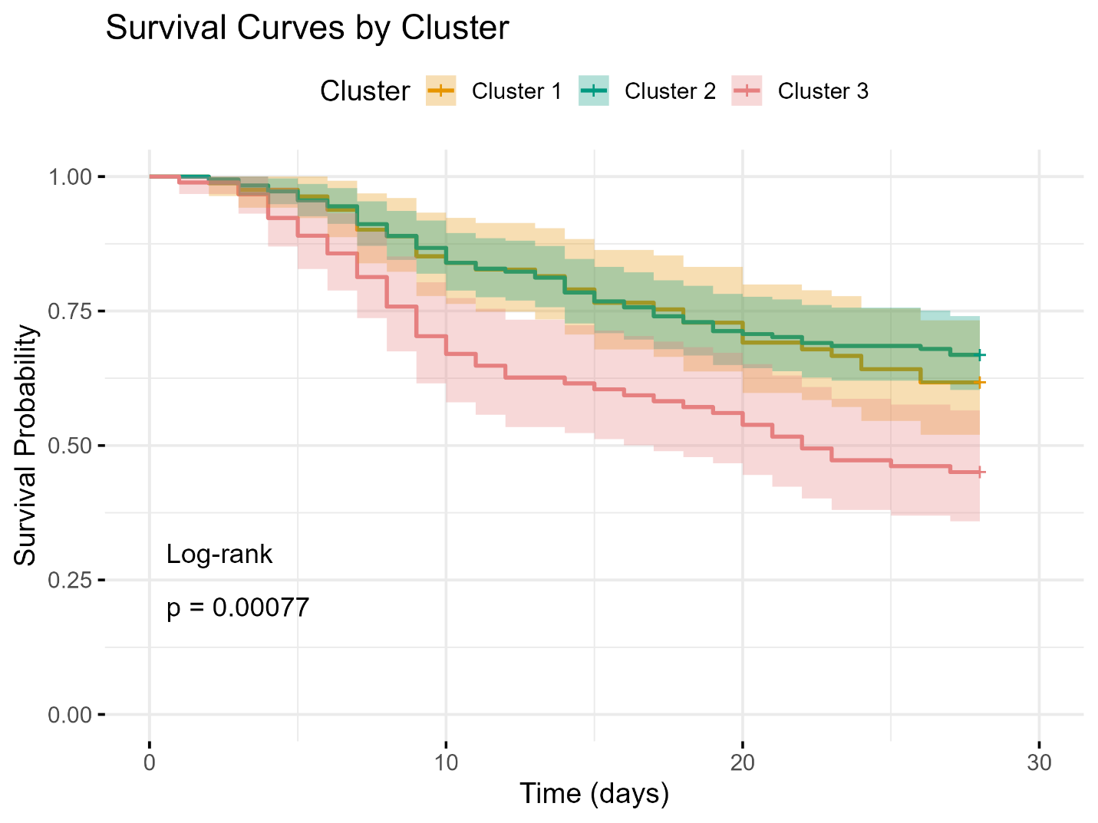

P-value shown is for the log rank test.

E-Figure 8: Missing values percentages for variables imputed through factorial analysis of mixed data

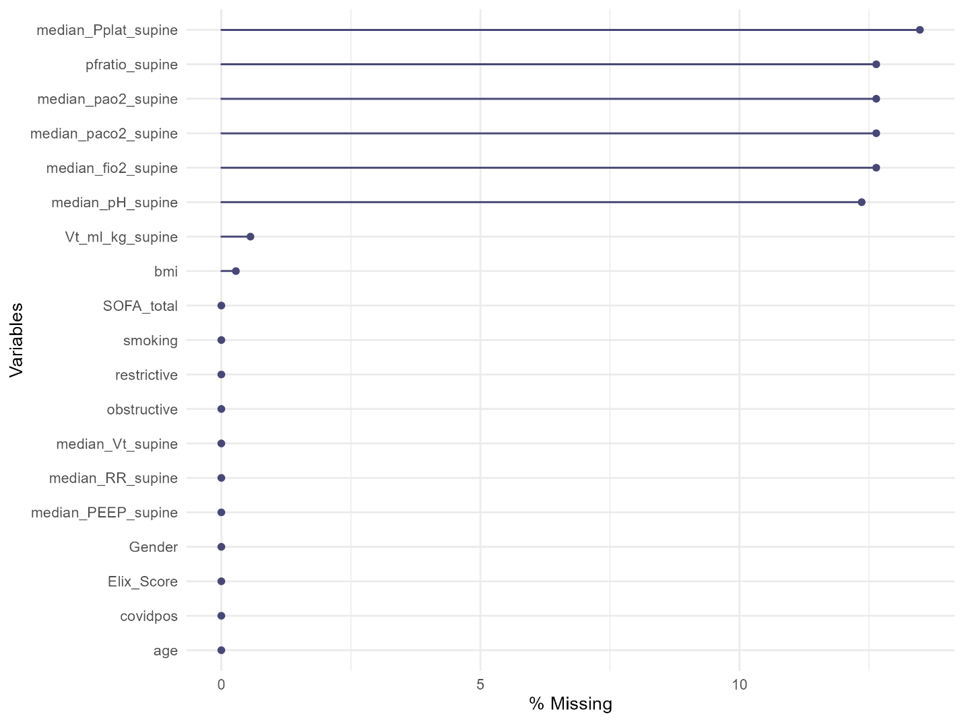

E-Table 1: Extract from the BIDMC protocol for Prone Position in the ICU

Policy Statement

• Physician or advance practice provider must order prone position

Indications

• Acute Respiratory Distress Syndrome (ARDS) with PaO2:FiO2 (P/F) ratio
<150mmHg and FiO2 >60% with PEEP ≥ 5
• Non-intubated patient with escalating oxygen requirements who is able to
self-prone
• Severe posterior wound management
• Sleep promotion/comfort for patients who sleep in the prone position at
baseline and are able to self-prone

Contraindications

• Unstable spine fractures
• Uncontrolled ICP
Precautions needed with the following patient populations:
• Open chest or unstable chest wall
• Extracorporeal membrane oxygenation (ECMO)
• Unstable pelvis, skull, or facial fracture(s)
• Open abdomen or distended abdomen and/or ischemic bowel
• Elevated ICP
• Cervical/skeletal traction in place
• Hemodynamic instability
• Weight > 160kg
• Pregnancy
• Bifurcated endotracheal tube (ETT) or tracheostomy
• Arm/shoulder injury

Complications

• Hemodynamic instability
• Catheter, tube, or drain dislodgement, displacement, or obstruction
• Pressure injury
• Peripheral nerve injury
• Corneal ulceration
• Facial/orbital edema

Recommendations

• Initiation of prone position for intubated patients with ARDS:
o Best within 24-36 hours of severe ARDS diagnosis, but up to eight
days after severe ARDS develops
• Duration of prone position for intubated patients with ARDS:
o It is recommended that a patient be proned for at least 16 consecutive
hours in a 24-hour period
• Discontinuation of prone position for intubated patients with ARDS:
o Patient improvement:
▪ When, four hours after being supinated, the patient's PaO₂/FIO₂ ratio is
≥ 150mmHg at FiO2 ≤60% and PEEP ≤10cm of water
o Patient does not tolerate treatment
▪ Decrease in PaO₂/FIO₂ ratio of >20% relative to the ratio in the supine
position (from x2 prone sessions prior)
▪ Unresolved hemodynamic instability
▪ Interruption of life sustaining therapy

E-Table 2: Description of the cluster 1 with their variables

Only the variables with significant link are showed, in descending order; variables are sorted according to the correlation ratio (between the quantitative variable and the cluster variable)

Variable | Mean in category | Standard deviation in category | Overall mean | Overall standard deviation | V.test value | p-value
PaO2/FIO2ratio (mmHg) | 184.2 | 95.8 | 135.3 | 63.3 | 7.9 | <0.001
Tidal Volume (ml) | 433.7 | 98.6 | 388.7 | 79.0 | 5.8 | <0.001
pH | 7.36 | 0.06 | 7.32 | 0.08 | 4.8 | <0.001
Elixhauser Score | 29.2 | 12.5 | 23.8 | 11.6 | 4.7 | <0.001
Tidal Volume per kg (ml/kg) | 6.6 | 1.3 | 6.2 | 0.9 | 4.5 | <0.001
PaO₂ (mmHg) | 103.6 | 37.3 | 92.9 | 26.8 | 4.1 | <0.001
Compliance (ml/ cmH₂O) | 37.3 | 16.1 | 32.9 | 14.9 | 3.0 | 0.003
BMI (kg/m²) | 28.2 | 7.2 | 32.6 | 8.5 | -5.3 | <0.001
PaCO₂ (mmHg) | 45.4 | 8.2 | 51.1 | 11.0 | -5.3 | <0.001
FiO₂ (%) | 62.5 | 17.5 | 74.5 | 17.7 | -6.9 | <0.001
Ventilation Ratio | 1.6 | 0.4 | 2.2 | 0.7 | -8.3 | <0.001
Plateau Pressure (cmH₂O) | 21.1 | 4.5 | 25.2 | 4.8 | -8.8 | <0.001
Respiratory Rate (breaths/min) | 21.1 | 4.4 | 26.0 | 5.1 | -9.9 | <0.001
Mechanical Power (J/min) | 12.6 | 6.6 | 20.8 | 8.5 | -10.0 | <0.001
PEEP (cmH₂O) | 7.9 | 2.9 | 11.8 | 3.9 | -10.3 | <0.001

E-Table 3: Description of the cluster 2 with their variables

Only the variables with significant link are showed, in descending order; variables are sorted according to the correlation ratio (between the quantitative variable and the cluster variable)

Variable | Mean in category | Standard deviation in category | Overall mean | Overall standard deviation | V.test value | p-value
PEEP (cmH₂O) | 13.2 | 2.8 | 11.8 | 3.9 | 7.0 | <0.001
Compliance (ml/ cmH₂O) | 35.8 | 14.2 | 32.9 | 14.9 | 3.8 | <0.001
pH | 7.34 | 0.07 | 7.32 | 0.08 | 3.7 | <0.001
Mechanical Power (J/min) | 22.1 | 6.5 | 20.8 | 8.5 | 2.8 | 0.005
BMI (kg/m²) | 33.5 | 7.7 | 32.6 | 8.5 | 2.1 | 0.040
PaO₂ (mmHg) | 89.4 | 22.0 | 92.9 | 26.8 | -2.5 | 0.013
PaO2/FIO2ratio (mmHg) | 126.4 | 40.1 | 135.3 | 63.3 | -2.7 | 0.007
Ventilation Ratio | 2.1 | 0.5 | 2.2 | 0.7 | -2.8 | 0.006
PaCO2 (mmHg) | 48.6 | 8.2 | 51.1 | 11.0 | -4.3 | <0.001
Elixhauser Score | 21.0 | 10.9 | 23.8 | 11.6 | -4.7 | <0.001
Driving Pressure (cmH₂O) | 11.7 | 3.0 | 13.4 | 4.6 | -7.2 | <0.001

E-Table 4: Description of the cluster 3 with their variables

Only the variables with significant link are showed, in descending order; variables are sorted according to the correlation ratio (between the quantitative variable and the cluster variable)

Variable | Mean in category | Standard deviation in category | Overall mean | Overall standard deviation | V.test value | p-value
Ventilation Ratio | 2.9 | 0.7 | 2.2 | 0.7 | 11.1 | <0.001
PaCO₂ (mmHg) | 61.1 | 11.9 | 51.1 | 11.0 | 10.0 | <0.001
Plateau Pressure (cmH₂O) | 29.5 | 4.1 | 25.2 | 4.8 | 9.9 | <0.001
Respiratory Rate (breaths/min) | 30.1 | 3.8 | 26.0 | 5.1 | 9.0 | <0.001
Driving Pressure (cmH₂O) | 17.0 | 5.0 | 13.4 | 4.6 | 8.7 | <0.001
FiO₂ (%) | 86.6 | 14.1 | 74.5 | 17.7 | 7.6 | <0.001
Mechanical Power (J/min) | 25.7 | 8.3 | 20.8 | 8.5 | 6.4 | <0.001
BMI (kg/m²) | 34.6 | 9.6 | 32.6 | 8.5 | 2.7 | 0.007
SOFA Score | 10.0 | 5.2 | 9.1 | 4.6 | 2.2 | 0.025
PEEP (cmH₂O) | 12.5 | 4.2 | 11.8 | 3.9 | 2.0 | 0.049
Tidal Volume per kg (ml/kg) | 5.9 | 0.8 | 6.2 | 0.9 | -3.9 | <0.001
Tidal Volume (ml) | 356.6 | 67.6 | 388.7 | 79.0 | -4.5 | <0.001
PaO2/FIO2ratio (mmHg) | 109.6 | 34.9 | 135.3 | 63.3 | -4.5 | <0.001
Compliance (ml/ cmH₂O) | 23.2 | 10.0 | 32.9 | 14.9 | -7.2 | <0.001
pH | 7.26 | 0.08 | 7.32 | 0.08 | -8.8 | <0.001

E-Table 5: Characteristics of the population and of the three clusters for the sub population with available esophageal pressure measurements
Characteristic | Overall  N = 173¹ | Cluster 1  N = 82¹ | Cluster 2  N = 46¹ | Cluster 3  N = 45¹
Age (years) | 58 (49, 66) | 61 (50, 69) | 52 (43, 61) | 60 (53, 67)
Gender (female) | 71 (41%) | 31 (38%) | 16 (35%) | 24 (53%)
COVID-19 Positive | 140 (81%) | 71 (87%) | 37 (80%) | 32 (71%)
Body Mass Index (BMI, kg/m²) | 33 (29, 38) | 31 (28, 35) | 38 (33, 47) | 31 (28, 38)
Elixhauser Comorbidity Score | 18 (11, 27) | 19 (9, 28) | 16 (10, 23) | 19 (14, 27)
Obstructive Lung Disease | 49 (28%) | 22 (27%) | 9 (20%) | 18 (40%)
Restrictive Lung Disease | 19 (11%) | 3 (3.7%) | 1 (2.2%) | 15 (33%)
Smoking Status | 65 (38%) | 32 (39%) | 16 (35%) | 17 (38%)
Total SOFA Score | 10 (7, 13) | 10 (6, 12) | 11.0 (10.0, 15) | 10 (4, 13)
Respiratory Rate (breaths/min) | 28 (24, 30) | 25 (23, 28) | 28 (25, 30) | 30 (26, 33)
Median PEEP (cmH₂O) | 12 (10, 15) | 12 (10, 14) | 16 (15, 20) | 12 (10, 12)
Median Tidal Volume (mL) | 370 (320, 420) | 380 (340, 420) | 400 (370, 465) | 320 (300, 360)
Median Plateau Pressure (cmH₂O) | 26 (24, 29) | 24 (22, 25) | 29 (27, 31) | 29 (27, 32)
Mechanical Power (J/min) | 22 (18, 27) | 20 (17, 22) | 30 (25, 34) | 23 (19, 26)
Median PaO₂ (mmHg) | 86 (76, 100) | 86 (76, 100) | 91 (79, 102) | 82 (72, 95)
Median FiO₂ (%) | 80 (60, 100) | 70 (60, 85) | 85 (70, 100) | 90 (80, 100)
PaO2/FIO2Ratio | 113 (91, 139) | 131 (100, 156) | 113 (96, 133) | 95 (83, 107)
Median PaCO₂ (mmHg) | 51 (44, 59) | 47 (42, 52) | 54 (47, 61) | 57 (50, 65)
Median pH | 7.32 (7.26, 7.37) | 7.35 (7.32, 7.4) | 7.29 (7.22, 7.34) | 7.3 (7.22, 7.32)
Driving Pressure (cmH₂O) | 13 (11, 15) | 11 (10, 13) | 12 (11, 13) | 18 (15, 20)
Respiratory System Compliance (mL/cmH₂O) | 30 (23, 38) | 33 (29, 41) | 34 (30, 39) | 20 (16, 23)
Tidal Volume per kg (mL/kg) | 6.1 (5.7, 6.4) | 6.1 (5.9, 6.4) | 6.3 (6, 6.9) | 5.7 (5.1, 6.1)
Ventilatory Ratio | 2.2 (1.8, 2.7) | 1.8 (1.6, 2.2) | 2.5 (2.2, 3.2) | 2.5 (2.1, 2.8)
Transpulmonary expiratory pressure (mmHg) | 1 (-0.5, 2) | 1.5 (0, 2) | 0.7 (-1, 2) | 1 (-0.9, 2)
Transpulmonary inspiratory pressure (mmHg) | 11 (8.5, 13) | 9.7 (7.8, 12.1) | 9.9 (7.7, 11.9) | 14.2 (12.6, 16.5)
Transpulmonary driving pressure (mmHg) | 10 (7.5, 12.5) | 8.8 (7, 10.3) | 9 (7.5, 10.5) | 13.6 (12.3, 16.2)
Lung compliance (mL/cmH₂O) | 38 (29, 49) | 45 (36, 57) | 45 (35, 49) | 24 (21, 29)
End Inspiratory Esophageal Pressure (mmHg) | 15.2 (12.5, 18) | 14 (11.5, 15.8) | 19 (17.2, 21.9) | 14.5 (11.7, 17)
End Expiratory Esophageal Pressure (mmHg) | 12.1 (9.7, 14.6) | 10.6 (8.6, 13) | 16 (14.1, 18.5) | 10.7 (8.7, 12.5)
Chest Wall Compliance (mL/cmH₂O) | 108 (68, 168) | 111 (74, 167) | 148 (101, 224) | 89 (58, 124)
Predicted Body Weight (kg) | 60 (52, 66) | 60 (55, 66) | 61 (55, 66) | 57 (50, 64)
¹Median (IQR); n (%)

When several measurements were available, the median was computed for each patient. Respiratory parameters were recorded in the supine position.

E-Table 6: Response rate for mortality, respiratory mechanics and oxygenation parameters by cluster and overall for the sub population with available esophageal pressure measurements

Responders are defined by a strictly positive increase or decrease in the parameter of interest

Characteristic | Overall  N = 173¹ | Cluster 1  N = 82¹ | Cluster 2  N = 46¹ | Cluster 3  N = 45¹ | p-value² | q-value³
Mortality By Day 28 | 72/173 (42%) | 27/82 (33%) | 17/46 (37%) | 28/45 (62%) | 0.004 | 0.040
Respiratory Compliance Responders | 72/170 (42%) | 35/81 (43%) | 18/45 (40%) | 19/44 (43%) | >0.9 | >0.9
Driving Pressure Responders | 73/170 (43%) | 33/81  (41%) | 20/45 (44%) | 20/44 (45%) | 0.9 | >0.9
Mechanical Power Responders | 74/170 (44%) | 34/81 (42%) | 22/45 (49%) | 18/44 (41%) | 0.7 | >0.9
PaO2/FIO2Ratio Responders | 132/169 (78%) | 64/80 (80%) | 36/46 (78%) | 32/43 (74%) | 0.8 | >0.9
Ventilatory Ratio Responders | 92/169 (54%) | 43/80 (54%) | 31/46 (67%) | 18/43 (42%) | 0.053 | 0.2
Transpulmonary Driving Pressure Responders | 66/118 (56%) | 30/50 (59%) | 19/33 (58%) | 17/34 (50%) | 0.7 | >0.9
Lung Compliance Responders | 63/118 (53%) | 29/50 (57%) | 18/33 (55%) | 16/34 (47%) | 0.7 | >0.9
Chest Wall Compliance Responders | 35/118 (30%) | 14/50 (27%) | 8/33 (24%) | 13/34 (38%) | 0.4 | >0.9
¹n (%)
²Pearson's Chi-squared test
³False discovery rate correction for multiple testing

E-Table 7: Response rate for respiratory mechanics and oxygenation parameters by cluster and overall for the full population with a definition of improvement of at least 10%

Responders are defined by an increase or decrease strictly greater than 10% in the parameter of interest
Characteristic | Overall, N = 353¹ | Cluster 1, N = 81¹ | Cluster 2, N = 181¹ | Cluster 3, N = 91¹ | p-value² | q-value³
Respiratory Compliance Responders | 69/313 (22%) | 11/54 (20%) | 39/175 (22%) | 19/84 (23%) | >0.9 | >0.9
Driving Pressure Responders | 72/313 (23%) | 15/54 (28%) | 38/175 (22%) | 19/84 (23%) | 0.6 | >0.9
Mechanical Power Responders | 62/313 (20%) | 10/54 (19%) | 34/175 (19%) | 18/84 (21%) | 0.9 | >0.9
PaO2/FIO2Ratio Responders | 217/296 (73%) | 26/43 (60%) | 133/169 (79%) | 58/84 (69%) | 0.032 | 0.2
Ventilatory Ratio Responders | 76/295 (26%) | 9/41 (21%) | 41/169 (24%) | 26/84 (31%) | 0.4 | >0.9
¹n (%)
²Pearson's Chi-squared test
³False discovery rate correction for multiple testing

E-Table 8: Response rate to proning position adjusted for missing secondary outcomes

Responders are defined by a strictly positive increase or decrease in the parameter of interest.

To account for patients with missing secondary outcome, for each secondary outcome and each patient, a weight was computed as the inverse of the probability of having missing data for the specific outcome. Probabilities of missing data were computed through multivariable logistic regression including the baseline covariates. Then a weighted Pearson’s chi-square test with Rao and Scott adjustment was performed to assess the difference between the proportions of responders.
Characteristic | Overall  N = 353¹ | Cluster 1  N = 81¹ | Cluster 2  N = 181¹ | Cluster 3  N = 91¹ | p-value²
Respiratory Compliance Responders | 128/313 (41%) | 21/54 (39%) | 71/175 (41%) | 36/84 (43%) | 0.7
Driving Pressure Responders | 129/313 (41%) | 22/54  (41%) | 70/175 (40%) | 37/84(44%) | 0.3
Mechanical Power Responders | 130/313  (42%) | 21/54 (39%) | 74/175 (42%) | 35/84 (42%) | 0.5
PaO2/FIO2Ratio Responders | 234/296 (79%) | 32/43  (74%) | 139/169 (82%) | 63/84 (75%) | 0.2
Ventilatory Ratio Responders | 144/295  (49%) | 22/41 (52%) | 83/169 (49%) | 39/84 (46%) | 0.8

¹n (%)
²Pearson's Chi-squared test with Rao and Scott adjustment

E-Table 9: Post-hoc power analysis for response rate

Statistic | Observed proportions | Expected proportions | Cohen’s w | Degrees of freedom | Significance level (α) | Power (1-β) | Total Sample Size) | Sample size per cluster
Value | 60%,50%,40% | 50%,50%,50% | 0.2 | 2 | 0.05 | 0.8 | 241 | 81

To evaluate the association between cluster membership and responder status, we calculated Cohen’s w to quantify the effect size based on observed responder proportions across the three clusters, with a decreasing number of responders for the cluster with the highest mortality (Cluster 1: 60%, Cluster 2: 50%, Cluster 3: 40%).
The expected proportions under the null hypothesis of no association were evenly distributed across clusters $(E=50\%)$.
Cohen’s w was computed as:
$$w=\sqrt{\sum{\frac{{\left(O_{i}-E_{i}\right)}^{2}}{E_{i}}}}$$
A subsequent power analysis, using a chi-square test with df=2, a significance level of α=0.05, and a target power of 1−β=0.8, estimated that a total sample size of 241 participants would be required to achieve sufficient power. Assuming equal distribution across clusters, this corresponds to a minimum of 81 participants per cluster.

E-Table 10: Obstructive and restrictive lung diseases definition

ICD-10 Code | Diagnostic Description
Obstructive Lung Diseases
J41.1 | Mucopurulent chronic bronchitis
J41.8 | Mixed simple and mucopurulent chronic bronchitis
J42 | Unspecified chronic bronchitis
J43.1 | Panlobular emphysema
J43.2 | Centrilobular emphysema
J43.8 | Other emphysema
J43.9 | Emphysema, unspecified
J44.0 | Chronic obstructive pulmonary disease with (acute) lower respiratory infection
J44.1 | Chronic obstructive pulmonary disease with (acute) exacerbation
J44.9 | Chronic obstructive pulmonary disease, unspecified
J45 | Asthma
J47.0 | Bronchiectasis with acute lower respiratory infection
J47.1 | Bronchiectasis with (acute) exacerbation
J47.9 | Bronchiectasis, uncomplicated
Restrictive Lung Diseases
D86.0 | Sarcoidosis of lung
M30.1 | Polyarteritis nodosa
M34.81 | Systemic sclerosis with lung involvement
M33.91 | Dermatopolymyositis, unspecified with respiratory involvement
M05.10 | Rheumatoid lung disease with rheumatoid arthritis of unspecified site
M32.13 | Lung involvement in systemic lupus erythematosus
J60 | Coalworker's pneumoconiosis
J61 | Pneumoconiosis due to asbestos and other mineral fibers
J62 | Pneumoconiosis due to dust containing silica
J63 | Pneumoconiosis due to other inorganic dusts
J64 | Unspecified pneumoconiosis
J65 | Pneumoconiosis associated with tuberculosis
J84.01 | Idiopathic pulmonary fibrosis
J84.02 | Idiopathic pulmonary alveolar proteinosis
J84.03 | Idiopathic non-specific interstitial pneumonitis
J84.09 | Other interstitial pulmonary diseases with fibrosis in diseases classified elsewhere
J84.841 | Lymphangioleiomyomatosis
J84.83 | Surfactant mutations of the lung
J84.89 | Other specified interstitial pulmonary diseases
Obstructive lung diseases were identified by the presence of ICD-10 codes associated with airflow obstruction (e.g., COPD, asthma, and bronchiectasis). Restrictive lung diseases were identified based on codes for interstitial lung diseases, pneumoconiosis, and systemic diseases with pulmonary involvement. These definitions were based on diagnostic coding in electronic health records (EHRs) used in this study.

E-Table 11: Mechanical power responders rate with Pressure-Controlled Ventilation equation

As a sensitivity analysis, we used the Pressure-Controlled Ventilation (PCV) equation of mechanical power described by Becher et al [1] for the overall population and the clusters.
$${MP}_{PCV}=0.098⋅RR⋅V_{T}⋅\left(ΔP_{insp}+PEEP\right)$$

Characteristic | Overall  N = 353¹ | Cluster 1  N = 81¹ | Cluster 2  N = 181¹ | Cluster 3  N = 91¹ | p-value²
Mechanical Power (PCV Equation) | 26.7 (21.6 – 33.1) | 17.7 (13.1-23.5) | 26.8 (23.3-31.8) | 33.9 (27.9 – 40.2)
Mechanical Power (PCV Equation) Responders | 146/353  (41%) | 31/81 (38%) | 74/181 (41%) | 41/91 (45%) | 0.66

¹n (%) or median (IQR)
² Chi-square test

REFERENCES

1. Becher T, van der Staay M, Schädler D, Frerichs I, Weiler N. Calculation of mechanical power for pressure-controlled ventilation. Intensive Care Med. 2019;45:1321‑3.

