Left ventricular unloading during extracorporeal cardiopulmonary resuscitation: a target trial emulation of the ELSO registry
Supplementary material
Ryan Ruiyang Ling, Ying Chen, Christopher Jer Wei Low, Cara Agerstrand, Prof Jae-Seung Jung,Shir-Lynn Lim, Prof Roberto Lorusso, Prof Thomas Mueller, Yohei Okada, Joseph E Tonna, Prof Kiran Shekar, Prof Daniel Brodie, Prof Graeme MacLaren, Kollengode Ramanathan.

Corresponding author:
Kollengode Ramanathan, FCICM
Cardiothoracic Intensive Care Unit, National University Hospital, National University Health System, Singapore, Singapore
surrkr@nus.edu.sg

Table of contents
Supplementary methods 3
Current Procedural Terminology (CPD®) codes to identify patients receiving LV unloading 3
Complications as classified by the Extracorporeal Life Support Organisation 3
Propensity score matching 4
Screening for variables for propensity score 4
Selection of variables in propensity score 4
Estimation of propensity score and matching of patients 5
Inverse probability of treatment weighting 5
Multiple imputation for missing data 5
Meta-analysis 5
Search strategy and selection criteria 5
Data synthesis 5
Target trial emulation framework 7
Supplementary results 9
Table S1. Demographics of overall cohort (unmatched) 9
Table S2. Characteristics of cardiac arrest. 9
Table S3. Outcomes of overall cohort 12
Table S4. Search strategy for systematic review and meta-analysis 13
Figure S1. Sensitivity analysis using inverse probability of treatment weighting. 14
Figure S2. Sensitivity analysis using complete case analysis to assess the robustness of imputation for missing data. 14
Figure S3. Emulation of target trial using the inclusion criteria of the ARREST trial 15
Figure S4. Emulation of target trial using the inclusion criteria of the Prague-OHCA trial 15
Figure S5. Emulation of target trial using the inclusion criteria of the INCEPTION trial 16
Figure S6. Subgroup analysis based on type of mechanical left ventricular unloading device, specifically (a) intra-aortic balloon pump and (b) mechanical left ventricular assist device. 17
Figure S7. Subgroup analysis based on the presenting rhythm, specifically (a) shockable and (b) non-shockable rhythms. 18
Figure S8. Subgroup analysis based on the location of cardiac arrest, specifically (a) out-of-hospital cardiac arrest and (b) in-hospital cardiac arrest rhythms. 19
Figure S9. Preferred Reporting Items for Systematic Reviews and Meta-analyses flowchart. 20
Figure S10. Meta-analysis summarising the evidence on left ventricular unloading and its association with 30-day mortality 21
Figure S11. Meta-analysis summarising the evidence on mechanical left ventricular assist device and its association with 30-day mortality 21
Figure S12. Meta-analysis summarising the evidence on intra-aortic balloon pump and its association with 30-day mortality 21

Supplementary methods

Current Procedural Terminology (CPD®) codes to identify patients receiving LV unloading
Intra-aortic balloon pump: 33967, 33970, 33973
Mechanical left ventricular assist device: 33976, 33990, 33991

Complications as classified by the Extracorporeal Life Support Organisation
Adapted from https://www.elso.org/registry/supportdocuments/eclscomplicationscode.aspx
Code | Description
101 | Mechanical: Oxygenator failure
102 | Mechanical: Raceway rupture
103 | Mechanical: Other tubing rupture
104 | Mechanical: Pump Failure
105 | Mechanical: Temperature Regulation Device Malfunction
114 | Mechanical: Clots: hemofilter
121 | Mechanical: Air in circuit
131 | Mechanical: Cannula problems
132 | Mechanical: Circuit change
133 | Mechanical: Clots and Air Emboli
134 | Mechanical: Thrombosis/Clots: circuit component
201 | Hemorrhagic: GI hemorrhage
203 | Hemorrhagic: Surgical site bleeding
222 | Hemorrhagic: Peripheral cannulation site bleeding
223 | Hemorrhagic: Mediastinal cannulation site bleeding
301 | Neurologic: Brain death
311 | Neurologic: Seizures: clinically determined
312 | Neurologic: Seizures Confirmed by EEG
321 | Neurologic: CNS Infarction (US or CT or MRI)
323 | Neurologic: Intraventricular CNS hemorrhage (US or CT or MRI)
324 | Neurologic: Intra/extra parenchymal CNS Hemorrhage (US or CT or MRI)
325 | Neurologic: CNS diffuse ischemia (CT/MRI)
326 | Neurologic: Neurosurgical intervention performed
401 | Renal: Creatinine 1.5 - 3.0
402 | Renal: Creatinine > 3.0
415 | Renal: Renal Replacement Therapy Required
502 | Cardiovascular: CPR/Chemical Code Required
504 | Cardiovascular: Cardiac arrhythmia
541 | Cardiovascular: Tamponade (blood)
544 | Cardiovascular: Tamponade (not blood)
601 | Pulmonary: Pneumothorax requiring treatment
602 | Pulmonary: Pulmonary hemorrhage
821 | Metabolic: Hyperbilirubinemia
822 | Metabolic: Moderate hemolysis
823 | Metabolic: Severe hemolysis
901 | Limb: Ischemia
902 | Limb: Compartment Syndrome
903 | Limb: Fasciotomy
904 | Limb: Amputation

Abbreviations: CNS: central nervous sytem, CPR: cardiopulmonary resuscitation, CT: computed tomography, EEG: electroencephalogram, GI: gastrointestinal, MRI: magnetic resonance imaging, US: ultrasound

Propensity score matching

Screening for variables for propensity score
We determined the potential confounders based on previous studies investigating LV unloading during ECPR, and the rescue-IHCA score, a global, externally validated score which has a decent prediction for mortality in patients receiving ECPR in IHCA. We selected the variables below (in bold) based on their applicability to the current population, and availability of data in the ELSO registry. In addition to the above, based on consensus between the authors, we also considered centre volume and experience as a covariate for adjustment in the propensity score.

Study | Covariates entered into propensity score model
Schrage 2020* | Age, sex, cause of cardiogenic shock**, previous cardiac arrest, ECPR, lactate, pH, heart rate , mean arterial pressure.
Thevathasan 2023 | Age, location of cardiac arrest (in-hospital vs out-of-hospital), initial presenting rhythm (shockable vs. non-shockable), SAVE (survival after venoarterial ECMO) score.
Unoki 2020 | Age, sex, witnessed cardiac arrest, bystander CPR, location (out-of-hospital cardiac arrest), shockable rhythm, aetiology of cardiac arrest (acute coronary syndrome vs others), time to ECPR
*Schrage 2020 investigated the use of mechanical LV unloading in the context of VA-ECMO for cardiogenic shock, of which a subgroup of patients received ECPR.
**We had taken aetiology of cardiac arrest as opposed to cause of cardiogenic shock.

Study | Covariates included in risk prediction model
Tonna 2022 | RESCUE-IHCA score:  Age, pre-existing renal insufficiency, time of day, illness category, presenting rhythm, duration of cardiac arrest (time to ECPR)

Selection of variables in propensity score
We determined the final set of covariates of adjustment based on a causal directed acyclic graph, which was constructed and agreed upon by the authors prior to data collection or analysis. The directed acyclic graph is shown below.
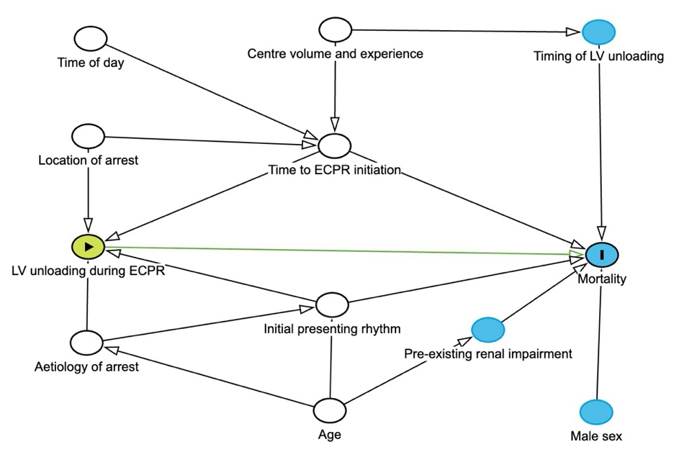

Estimation of propensity score and matching of patients
We predicted the conditional probability of receiving concurrent LV unloading using a multivariable logistic regression specifying LV unloading as the outcome for prediction. Thereafter, we matched patients who did and did not receive LV unloading in a 1:1 fashion using the nearest-neighbour method to form a cohort of matched pairs, and assessed covariate balance after matching. We considered a standardised mean difference of <0.1 as evidence of balance between both groups.

Inverse probability of treatment weighting
As a sensitivity analysis to the primary analysis (propensity score-matching), conventional inverse probability of treatment weighting (IPTW). The weights of each patient are derived as above, and the survival analysis is repeated, specifying the weight of each patient based on their propensity score.

Multiple imputation for missing data
We created 10 imputed datasets and combined them using between and within variance techniques. We specified 50 iterations, using the 50th iteration of each imputed dataset as the dataset for analysis. We used hierarchical predictive mean matching for binary and continuous variables, and polytomous regression for categorical variables.

In line with current publications and recommendations, we imputed 10 datasets, derived the propensity scores or matched the patients within each dataset, and estimated the association between LV unloading during ECPR and mortality, before pooling the results of the 10 datasets using between and within group statistics.

Meta-analysis

Search strategy and selection criteria
We searched MEDLINE via PubMed, Embase, and Scopus for articles published in English through 19 October 2024 using the following terms: “extracorporeal membrane oxygenation”, “cardiac arrest”, “unloading” or “balloon pump” or “microaxial pump” (full search strategy in Table S4). We included randomised controlled trials or propensity score-matched studies reporting on LV unloading during ECPR. We excluded any other study types, studies reporting on patients younger than 18 years, and non-human studies. RRL and CJWL screened the studies independently and in duplicate, collected the data, and assessed the risk of bias; conflicts were resolved by consensus.

Data synthesis
We extracted the 30-day mortality from each study. We assessed the risk of bias in the included studies using the Newcastle-Ottawa Scale for cohort studies, and the certainty of evidence using the Grading of Recommendations, Assessments, Development, and Evaluations (GRADE) approach. We did random-effects meta-analyses (Mantel-Haenszel method) for binary outcomes using the DerSimonian-Laird model, and present the outcomes of the meta-analysis using pooled odds ratios. We assessed statistical heterogeneity (inconsistency) as part of the GRADE approach, quantitatively using I2, tau-squared, and p-values from the Cochran's Q test, and qualitatively via visual inspection of forest plots. We assessed publication bias by visually inspecting funnel plots.

Target trial emulation framework
Component | Hypothetical randomised trial | Emulation
Eligibility | Adults aged ≥16 years receiving ECPR for cardiac arrest | Same as hypothetical trial
Treatment strategies | - ECPR with concurrent mechanical LV unloading, either with an intra-aortic balloon pump, or microaxial left ventricular assist device  - ECPR alone without concurrent mechanical LV unloading | Same as hypothetical trial
Treatment assignment | Patients are randomly assigned to one of the treatment strategies | We conducted a literature review and surveyed covariates used by prior studies, and devised a directed acyclic graph to derive potential covariates associated with mechanical LV unloading.  Based on this, we used propensity score adjustment and weighting to create two comparable arms in which the probability of assignment is as close as possible to random. We used a standardised mean difference
Blinding | The treating team was aware of the assigned treatment strategy | Same as hypothetical trial
Follow-up | Follow up started at the time of assignment to a treatment strategy (mechanical LV unloading or not), and ended with:  - Death  - Discharge alive  - 90 days after enrolment (censoring)  Whichever comes first | Same as hypothetical trial
Primary outcome | Survival time up to 90 days from ECMO initiation | Same as hypothetical trial
Causal contrast | Per protocol effect | Observational analogue of the per protocol effect
Statistical analysis | In the per-protocol analysis, patients are censored when they deviated from their assigned strategy. The per-protocol effect was estimated after adjusting for baseline variables associated with adherence to the assigned treatment strategy

Supplementary results

Table S1. Demographics of overall cohort (unmatched)
Characteristic | No LV unloading | LV unloading
Characteristic | N = 2,548 | N = 667
Sex
Female | 860 (34%) | 155 (23%)
Male | 1,688 (66%) | 510 (76%)
Age (Years) | 57 (44-66) | 59 (49-67)
Weight (kg) | 85 (70-100) | 89 (76-103)
Unknown | 82 | 9
Height (cm) | 172 (165-178) | 175 (167-180)
Unknown | 246 | 29
Body mass index (kg/m²) | 28 (25-34) | 29 (26-34)
Unknown | 263 | 31
Duration of ECMO run (hours) | 58 (15-126) | 93 (45-163)
Reasons for discontinuation of ECMO
Died or Poor Prognosis | 1,500 (60%) | 381 (58%)
ECLS Complication | 29 (1.2%) | 8 (1.2%)
Expected Recovery | 898 (36%) | 232 (35%)
Heart Transplant | 16 (0.6%) | 5 (0.8%)
Heart/Lung Transplant | 1 (<0.1%) | 0 (0%)
Lung Transplant | 2 (<0.1%) | 0 (0%)
Resource Limitation | 6 (0.2%) | 2 (0.3%)
Unknown | 19 (0.8%) | 4 (0.6%)
VAD | 25 (1.0%) | 22 (3.4%)
Missing | 52 | 13
Year of ECMO initiation
2020 | 608 (24%) | 112 (17%)
2021 | 498 (20%) | 121 (18%)
2022 | 730 (29%) | 195 (29%)
2023 | 712 (28%) | 239 (36%)
Comorbidities
Pregnancy | 38 (1.5%) | 5 (0.7%)
Trauma | 21 (0.8%) | 2 (0.3%)
Chronic kidney disease | 150 (5.9%) | 39 (5.8%)
Previous stroke | 40 (1.6%) | 7 (1.0%)
COPD | 68 (2.7%) | 8 (1.2%)
Massive bleeding prior to ECMO | 103 (4.0%) | 7 (1.0%)
Chronic heart failure | 256 (10.0%) | 89 (13.3%)
Vasoplegua | 111 (4.3%) | 12 (1.8%)
Centre characteristics
Number of ECPR cases per year | 7 (3-11) | 10 (5-31)
High volume centre | 601 (24%) | 289 (43%)
Type of unloading
IABP |  | 344 (52%)
LVAD |  | 323 (48%)
Abbreviations: ECMO: extracorporeal membrane oxygenation, ECPR: extracorporeal cardiopulmonary resuscitation, IABP: intra-aortic balloon pump, LVAD: left ventricular assist device

Table S2. Characteristics of cardiac arrest.
Characteristic | No LV unloading | LV unloading
Characteristic | N = 2,548 | N = 667
Precipitating Event
Cardiac | 1,963 (77%) | 586 (88%)
Non-Cardiac | 346 (14%) | 28 (4.2%)
Unknown | 239 (9.4%) | 53 (7.9%)
Presenting rhythm
Asystole | 334 (13%) | 55 (8.2%)
Pulseless Electrical Activity | 981 (39%) | 205 (31%)
Unknown | 146 (5.7%) | 32 (4.8%)
Unknown – Non Shockable | 36 (1.4%) | 7 (1.0%)
Unknown – Shockable | 44 (1.7%) | 14 (2.1%)
Ventricular Fibrillation | 763 (30%) | 254 (38%)
Ventricular Tachycardia - no pulse | 244 (9.6%) | 100 (15%)
Rhythm during ECMO cannulation
Asystole | 380 (15%) | 61 (9.1%)
High Degree Atrioventricular Block | 8 (0.3%) | 2 (0.3%)
Pulseless Electrical Activity | 818 (32%) | 179 (27%)
Sinus Bradycardia | 79 (3.1%) | 19 (2.8%)
Sinus Rhythm | 119 (4.7%) | 28 (4.2%)
Sinus Tachycardia | 114 (4.5%) | 20 (3.0%)
Supraventricular tachycardia | 11 (0.4%) | 12 (1.8%)
Unknown | 433 (17%) | 127 (19%)
Ventricular Fibrillation | 482 (19%) | 174 (26%)
Ventricular Tachycardia - no pulse | 104 (4.1%) | 45 (6.7%)
Location of cardiac arrest
In-hospital cardiac arrest | 1,876 (74%) | 468 (70%)
Out-of-hospital cardiac arrest | 672 (26%) | 199 (30%)
Location of in-hospital cardiac arrest
Ambulatory/Outpatient | 10 (0.5%) | 6 (1.3%)
Cath Lab | 403 (21%) | 154 (33%)
Delivery Room | 5 (0.3%) | 0 (0%)
Emergency Department | 347 (18%) | 75 (16%)
High Dependency Unit | 8 (0.4%) | 3 (0.6%)
Intensive Care Unit | 660 (35%) | 148 (32%)
Inpatient Ward | 165 (8.8%) | 32 (6.8%)
Interventional Radiology | 32 (1.7%) | 1 (0.2%)
Operating room | 182 (9.7%) | 35 (7.5%)
Other | 50 (2.7%) | 11 (2.4%)
Post-anaesthesia care unit | 14 (0.7%) | 3 (0.6%)
Unknown | 672 | 199
Percutaneous coronary intervention | 184 (7.2%) | 201 (30%)
Duration of cardiopulmonary resusciation | 40 (22-59) | 38 (21-55)
Number of epinephrine doses | 5.0 (3.0-9.0) | 5.0 (3.0-8.0)
Unknown | 246 | 59
Time of cardiac arrest
Morning | 1,310 (57%) | 352 (58%)
Afternoon | 714 (31%) | 177 (29%)
Night | 272 (12%) | 76 (13%)
Unknown | 252 | 62
PCI | 184 (11%) | 201 (30%)
Post-ECPR lactate (mmol/l) | 10.4 (6.3, 14.8) | 10.5 (6.6, 13.9)
Unknown | 714 | 103
Targeted temperature management
No Target | 465 (18%) | 84 (13%)
Targeted 32 - 36°C | 587 (23%) | 139 (21%)
Targeted 32 - 34°C | 288 (11%) | 114 (17%)
Targeted normothermia | 916 (36%) | 285 (43%)
Unknown | 292 (11%) | 45 (6.7%)

Table S3. Outcomes of overall cohort
Characteristic | No LV unloading | LV unloading
Characteristic | N = 2,548¹ | N = 667¹
Death at 90 days | 1,765 (69.3%) | 464 (69.6%)
Duration of ECMO (hours) | 58 (15-125.25) | 93 (45-162.5)
Hospital length of stay (days) | 8 (2-21) | 10 (3-23)
Disposition at discharge
Home | 337 (42%) | 73 (37%)
Other, Unknown | 57 (7.1%) | 3 (1.5%)
Transfer to hospice | 23 (2.9%) | 10 (5.0%)
Transfer to LTAC | 85 (11%) | 25 (13%)
Transfer to LTAC or Rehabilitation | 23 (2.9%) | 3 (1.5%)
Transfer to Rehabilitation | 164 (20%) | 61 (31%)
Transferred to another hospital | 118 (15%) | 25 (13%)
Unknown | 1,741 | 467
Abbreviations: LTAC: Long-term acute care.

Table S4. Search strategy for systematic review and meta-analysis.
Medline via Pubmed
No. | Search | Results
1. | Extracorporeal Membrane Oxygenation[MeSH] OR Extracorporeal Membrane Oxygenation[Title/Abstract] OR Extracorporeal Membrane Oxygenat*[Title/Abstract] OR Extracorporeal Life Support[Title/Abstract] OR ECMO[Title/Abstract] OR ECLS[Title/Abstract] OR Extracorporeal Circulat*[Title/Abstract] | 35,347
2. | Cardiopulmonary resuscitation[MeSH] OR CPR[Title/Abstract] OR Cardiopulmonary resuscitation[Title/Abstract] OR Cardiac life support[Title/Abstract] OR Heart Arrest[MeSH] OR Cardiac arrest[Title/Abstract] OR Asystole[Title/Abstract] OR Cardiopulmonary arrest[Title/Abstract] OR ECPR[Title/Abstract] OR Extracorporeal cardiopulmonary resuscitation[Title/Abstract] | 100,937
3. | randomized controlled trial[pt] OR controlled clinical trial[pt] OR randomized[Title/Abstract] OR placebo[Title/Abstract] OR drug therapy[sh] OR randomly[Title/Abstract] OR trial[Title/Abstract] OR groups[Title/Abstract] OR propensity[Title/Abstract] OR match[Title/Abstract] NOT (animals [MeSH] NOT humans [MeSH]) | 5,535,370
4. | Heart assist devices[MeSH] OR Assisted Circulation (MeSH) OR Impella[Title/Abstract] OR (microaxial[Title/Abstract] AND ventricular assist device[Title/Abstract]) OR (percutaneous[Title/Abstract] AND ventricular assist device[Title/Abstract]) OR Percutaneous Heart Pump [Title/abstract] OR PHP [Title/abstract] OR Intra-aortic balloon pump* [Title/abstract] OR IABP [Title/abstract] OR balloon pump* [Title/Abstract] OR unload* [Title/Abstract] | 31,624
5. | #1 AND #2 AND #3 AND #4 | 72

Embase
No. | Search | Results
1. | ‘Extracorporeal oxygenation’/exp OR ‘extracorporeal membrane oxygenation’:ti,ab OR ‘extracorporeal membrane oxygenat*’:ti,ab OR ‘extracorporeal life support’:ti,ab OR ‘ECMO’:ti,ab OR ‘ECLS’:ti,ab OR ’extracorporeal circulat*’:ti,ab | 69,813
2. | resuscitation/exp OR CPR:ti,ab OR ‘Cardiopulmonary resuscitation’:ti,ab OR ‘Cardiac life support’:ti,ab OR ‘Heart Arrest’/exp OR ‘Cardiac arrest’:ti,ab OR Asystole:ti,ab OR ‘Cardiopulmonary arrest’:ti,ab OR ECPR:ti,ab OR ‘Extracorporeal cardiopulmonary resuscitation’:ti,ab | 265,866
3. | 'crossover procedure':de OR 'double-blind procedure':de OR 'randomized controlled trial':de OR 'single-blind procedure':de OR (random* OR factorial* OR crossover* OR cross NEXT/1 over* OR placebo* OR doubl* NEAR/1 blind* OR singl* NEAR/1 blind* OR assign* OR allocat* OR volunteer* OR propensity OR match):de,ab,ti | 3,631,717
4. | ‘Assisted circulation’/exp OR ‘Heart assist device’/exp OR ‘Heart-Assist Device*’:ti,ab OR ‘Heart Assist device’:ti,ab OR ‘Impella’:ti,ab OR (‘microaxial’ AND ‘ventricular assist device’):ti,ab OR (‘percutaneous’ and ‘ventricular assist device’):ti,ab OR ‘Percutaneous Heart Pump’:ti,ab OR ‘PHP’:ti,ab OR ‘Intra-aortic balloon pump*’:ti,ab OR ‘IABP’:ti,ab OR ‘balloon pump*’:ti,ab OR ‘unload*’:ti,ab | 100,204
4. | #1 AND #2 AND #3 AND #4 | 324

Scopus
No. | Search | Results
1. | TITLE-ABS(“Extracorporeal Membrane Oxygenation” OR “Extracorporeal Membrane Oxygenat*” OR “Extracorporeal Life Support” OR “ECMO” OR “ECLS” OR “Extracorporeal Circulat*”) | 36,107
2. | TITLE-ABS(CPR OR “Cardiopulmonary resuscitation” OR “Cardiac life support” OR “Cardiac arrest” OR Asystole OR “Cardiopulmonary arrest” OR ECPR OR “Extracorporeal cardiopulmonary resuscitation”) | 82,573
3. | ( INDEXTERMS ( "clinical trials" OR "clinical trials as a topic" OR "randomized controlled trial" OR "Randomized Controlled Trials as Topic" OR "controlled clinical trial" OR "Controlled Clinical Trials" OR "random allocation" OR "Double-Blind Method" OR "Single-Blind Method" OR "Cross-Over Studies" OR "Placebos" OR "multicenter study" OR "double blind procedure" OR "single blind procedure" OR "crossover procedure" OR "clinical trial" OR "controlled study" OR "randomization" OR "placebo" ) ) OR ( TITLE-ABS-KEY ( ( "clinical trials" OR "clinical trials as a topic" OR "randomized controlled trial" OR "Randomized Controlled Trials as Topic" OR "controlled clinical trial" OR "Controlled Clinical Trials as Topic" OR "random allocation" OR "randomly allocated" OR "allocated randomly" OR "Double-Blind Method" OR "Single-Blind Method" OR "Cross-Over Studies" OR "Placebos" OR "cross-over trial" OR "single blind" OR "double blind" OR "factorial design" OR "factorial trial" OR propensity OR match) ) ) OR ( TITLE-ABS ( clinical AND trial* OR trial* OR rct* OR random* OR blind* ) ) | 10,549,526
4. | TITLE-ABS(“Assisted circulation” OR “Heart-assist device*” OR “heart assist device” OR impella OR (“microaxial” AND “ventricular assist device”) OR (“percutaneous” AND “ventricular assist device”) OR “percutaneous heart pump” or “PHP” OR “IABP” OR “Intra-aortic balloon pump*” OR “balloon pump*” OR “unload*”) | 92,207
5. | #1 AND #2 AND #3 and #4 | 95

Figure S1. Sensitivity analysis using inverse probability of treatment weighting.

Figure S2. Sensitivity analysis using complete case analysis to assess the robustness of imputation for missing data.

Figure S3. Emulation of target trial using the inclusion criteria of the ARREST trial

Figure S4. Emulation of target trial using the inclusion criteria of the Prague-OHCA trial

Figure S5. Emulation of target trial using the inclusion criteria of the INCEPTION trial

Figure S6. Subgroup analysis based on type of mechanical left ventricular unloading device, specifically (a) intra-aortic balloon pump and (b) mechanical left ventricular assist device.

A

B

Figure S7. Subgroup analysis based on the aetiology of cardiac arrest, specifically (a) cardiac and (b) non-cardiac.
A

B

Figure S8. Subgroup analysis based on the presenting rhythm, specifically (a) shockable and (b) non-shockable rhythms.

A

B

Figure S9. Subgroup analysis based on the location of cardiac arrest, specifically (a) out-of-hospital cardiac arrest and (b) in-hospital cardiac arrest rhythms.

A

B

Figure S10. Preferred Reporting Items for Systematic Reviews and Meta-analyses flowchart.

Figure generated by COVIDENCE®, a systematic review management software.
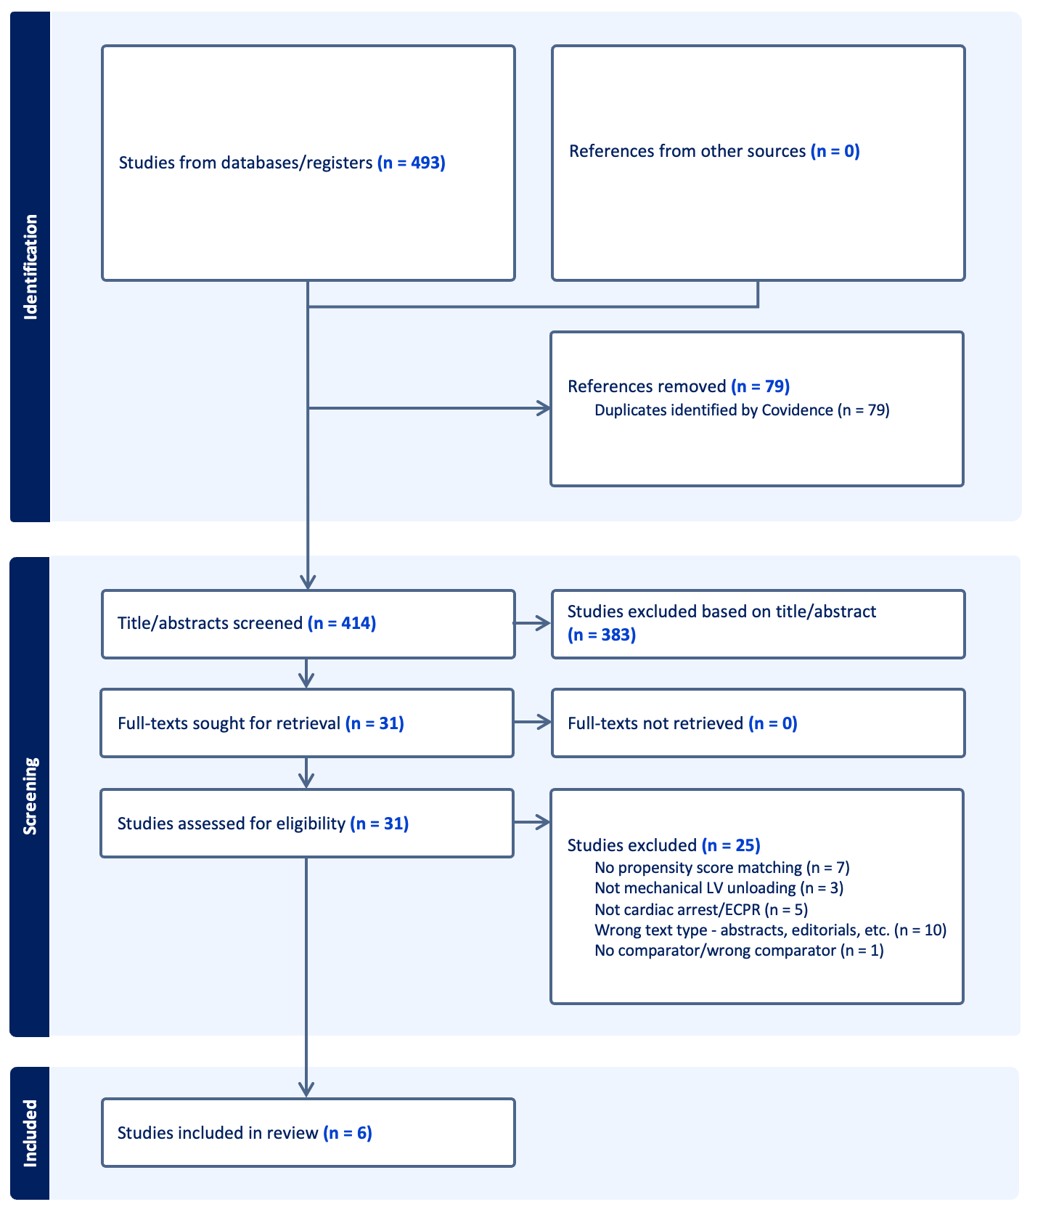

Figure S11. Meta-analysis summarising the evidence on left ventricular unloading and its association with 30-day mortality
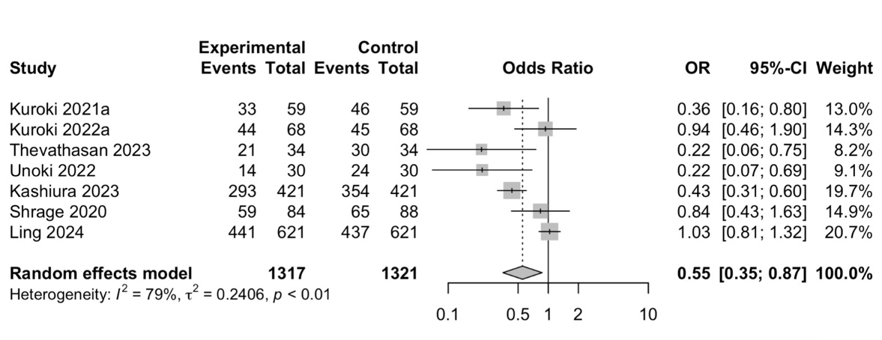

Figure S12. Meta-analysis summarising the evidence on mechanical left ventricular assist device and its association with 30-day mortality
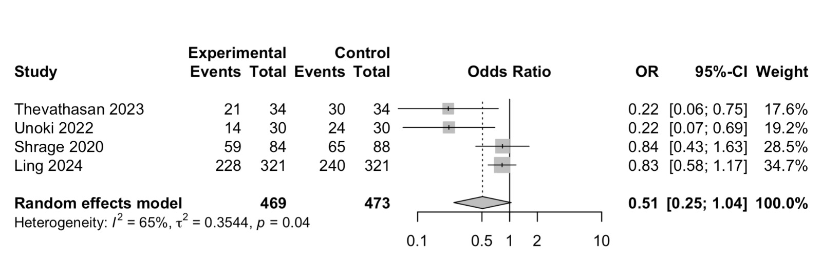

Figure S13. Meta-analysis summarising the evidence on intra-aortic balloon pump and its association with 30-day mortality
