Incidence and risk factors of weaning-induced pulmonary oedema: results from a multicentre, observational study
Rui SHI^{1,2,3}, Soufia AYED¹, Marion BEUZELIN⁵, Romain PERSICHINI⁶, Marie LEGOUGE⁷, Nello DE VITA⁸, Bruno LEVY⁹, Alexandra BEURTON¹⁰, Kishore MANGAL¹¹, Thomas HULLIN¹², Vincent LABBE¹³, Max GUILLOT¹⁴, Anatole HARROIS¹⁵, Maurizio CECCONI^{16,17}, Nadia ANGUEL^{1,2}, David OSMAN¹, Francesca MORETTO^{1,2}, Christopher LAI^{1,2}, Tài PHAM^{1,2,4}, Jean-Louis TEBOUL^{1,2}, Xavier MONNET^{1,2}
- Service de médecine intensive-réanimation, AP-HP, Hôpital de Bicêtre, DMU CORREVE, Université Paris-Saclay, France.
- FHU SEPSIS, Inserm UMR S_999, Groupe de recherche clinique CARMAS, Le Kremlin-Bicêtre, France.
- Department of Critical Care Medicine, The First Affiliated Hospital, Sun Yat-sen University, Guangzhou, Guangdong, China.
- Université Paris-Saclay, UVSQ Inserm U1018, Equipe d'Epidémiologie Respiratoire Intégrative, CESP, 94807, Villejuif, France.
- Service de réanimation polyvalente, Centre hospitalier de Dieppe, Dieppe, France
- Service de réanimation polyvalente, Hôpital Félix Guyon, Saint-Denis-de-la-Réunion, France
- Service de d’anesthésie-réanimation adultes, Centre hospitalier d'Orléans, Orléans, France
- Università del Piemonte Orientale, Dipartimento di Medicina Traslazionale, Novara, Italy.
- Médecine Intensive et Réanimation Brabois, CHRU Nancy, Nancy, France.
- AP-HP, Groupe Hospitalier Universitaire APHP-Sorbonne Université, site Pitié-Salpêtrière, Service de médecine intensive-réanimation (Département R3S), Paris, France
- Department of Critical Care Medicine Fortis Escorts Hospital, Jawahar Lal Nehru Marg, Malviya Nagar, Jaipur, Rajasthan, India.
- Service de réanimation polyvalente, Hôpital Sud-Essone, Etampes, France
- Service de réanimation, AP-HP, Groupe Hospitalier Universitaire APHP-Sorbonne Université, site Tenon, Paris, France
- Service de médecine intensive-réanimation, Hopital de Hautepierre, Hopitaux Universitaires de Strasbourg, Strasbourg, France.
- Service d'Anesthésie-Réanimation et Médecine Périopératoire, DMU Anesthésie-Réanimation Douleur, Université Paris-Saclay, AP-HP, Hôpital de Bicêtre, Le Kremlin-Bicêtre, France.
- Department of Anesthesiology and Intensive Care, IRCCS Humanitas Research Hospital, Milan, Italy.
- Department of Biomedical Science, Humanitas University, Milan, Italy.

Correspondence:
Dr. Rui SHI
1.Service de médecine intensive-réanimation, AP-HP, Hôpital de Bicêtre, DMU CORREVE, Université Paris-Saclay, France.
2.FHU SEPSIS, Inserm UMR S_999, Groupe de recherche clinique CARMAS, Le Kremlin-Bicêtre, France.
3.Department of Critical Care Medicine, The First Affiliated Hospital, Sun Yat-sen University, Guangzhou, Guangdong, China.
Email: rui.maya.shi@hotmail.com

Supplemental material
Contents
Table S1. Studies reported the incidence of weaning failure and weaning-induced pulmonary oedema 4
Table S2. List of participating centres 5
Table S3. Comparison between succeeded and failed spontaneous breathing trials 6
Table S4. Multilevel logistic regression analyses based on the presence of weaning failure 7
Table S5. Evolution of studied variables before and at the end of the spontaneous breathing trial 8
Table S6. Comparison of patient characteristics between patients with and without weaning-induced pulmonary oedema 9
Table S7. Comparison between the failed spontaneous breathing trials with and without weaning-induced pulmonary oedema 10
Table S8. Comparison between weaning success and failure regarding different types of intensive care units 11
Table S9. Comparison between the failed spontaneous breathing trials with and without weaning-induced pulmonary oedema regarding different types of intensive care units 11
Table S10. Comparison between weaning success and failure regarding different types of intensive care units 12
Table S11. Comparison between WIPO and no WIPO regarding different types of intensive care units 12
Appendix. Consensus process for diagnosing weaning induced pulmonary oedema 13
Table S12. Discussion timeline and results of the consensus discussions 14
Figure S1. Incidence of weaning failure and weaning-induced pulmonary oedema 15
Figure S2. Receiver operating characteristic curve showing the predictive ability of the regression model for the prediction of the risk of experiencing spontaneous breathing trial failure at least once. 16
Figure S3. Receiver operating characteristic curve showing the predictive ability of the regression model for the prediction of the risk of experiencing weaning-induced pulmonary oedema among patients who failed the spontaneous breathing trial at least once. 17
References 18

Table S1. Studies reported the incidence of weaning failure and weaning-induced pulmonary oedema
1st author and year of publication | Number of patients | Type of patients | Incidence  of weaning failure | Incidence of WIPO among failing or difficult-to-wean cases
Epstein 1995 [1] | 94 | ICU patients | 19% | 28%
Grasso 2007 [2] | 19 | COPD  (Difficult to wean) | 55% | 42%
Anguel 2008 [3] | 46 | Difficult to wean | NA | 52%
Lamia 2009 [4] | 39 | Difficult to wean | NA | 44%
Caille 2010 [5] | 117 | ICU patients | 20% | 87%
Cabello 2010 [6] | 14 | Difficult to wean | T-piece: 100% | 79%
Dres 2014 [7] | 21 | Difficult to wean | 81% | 72%
Dres 2015 [8] | 57 | Difficult to wean | 81% | 67%
Liu 2017 [9] | 81 | ICU patients | 45% | 59%
Bedet 2019 [10] | 208 | Difficult to wean | 64% | 60%/21%*
Goudelin 2020 [11] | 59 | COPD and/or HF | 20% | 100%
Dres 2021 [12] | 53 | Difficult to wean | 53% | 77%
Bagate 2021 [13] | 66 | Difficult to wean | 66% | 58%/11%*
COPD: chronic obstructive pulmonary disease; HF: heart failure; ICU: intensive care unit; WIPO: weaning-induced pulmonary oedema.
*Incidence of WIPO according to “liberal” and “conservative” definitions, respectively.

Table S2. List of participating centres
ID | Hospital | Department | City | Country
1 | Hôpital Bicêtre | Service de Médecine Intensive-Réanimation | Le Kremlin-Bicêtre | France
2 | Centre Hospitalier de Dieppe | Service de réanimation polyvalente | Dieppe | France
3 | Hôpital Félix Guyon | Service de réanimation polyvalente | Saint-Denis-de-la-Réunion | France
4 | Centre hospitalier d'Orléans | Service de d’anesthésie-réanimation adultes | Orléans | France
5 | Ospedale Maggiore della Carità di Novara | Dipartimento di Medicina Traslazionale | Novara | Italy
6 | Hôpital de Nancy-Brabois | Service de réanimation médicale | Nancy | France
7 | Hôpital de la Pitié-Salpêtrière | Service de Pneumologie, Médecine intensive Réanimation | Paris | France
8 | Eternal Hopital | Department of Medicine and Critical Care | Jaipur | India
9 | Hôpital Sud-Essone-Site d'Etampes | Service de réanimation polyvalente | Etampes | France
10 | Hôpital Tenon | Service de réanimation | Tenon | France
11 | Hopital de Hautepierre | Service de Medecine Intensive-Reanimation | Strasbourg | France
12 | Hôpital Bicêtre | Service d'anesthésie-réanimation | Le Kremlin-Bicêtre | France
13 | Humanitas Clinical and Research Center | Department of Anesthesiology and Intensive Care | Milan | Italy

Table S3. Comparison between succeeded and failed spontaneous breathing trials
Variables | Weaning success  N=417 | Weaning failure  N= 217 | p-value
Duration of MV before the SBT (days) | 5 (2-10) | 7 (4-12) | 0.001
Duration of weaning procedures (mins) | 60 (45-70) | 60 (35-62) | 0.008
SBT method (n, %)
T-piece | 214 (51) | 144 (66) | 0.000
PSV-PEEP | 59 (14) | 25 (12) | 0.354
PSV-ZEEP | 144 (35) | 48 (22.1) | 0.001
∆Body weight (kg) | 1 (-1-4.3) | 2 (-1-7.9) | 0.009
Fluid balance during the last 24hrs (mL) | 43 (-900.0-854.0) | -122 (-1137.5-854.5) | 0.296
Use of diuretics or RRT 24hrs before (n, %) | 146 (35) | 76 (35) | 0.170
Use of vasopressors (n, %) | 57 (13) | 33 (14) | 0.598
MV: mechanical ventilation; PEEP: positive end-expiratory pressure; PSV: pressure support ventilation; RRT: renal replacement therapy; SBT: spontaneous breathing trial; ZEEP: zero end-expiratory pressure.

Table S4. Multilevel logistic regression analyses based on the presence of weaning failure
 | Odds Ratio | 95%CI | P-value
(Intercept) | 0.22 | 0.100-0.507 | 0.000
Male | 0.69 | 0.448-1.059 | 0.090
Obesity | 0.74 | 0.470-1.179 | 0.208
SAPS II | 1.00 | 0.990-1.013 | 0.832
Hypertension | 1.30 | 0.842-2.012 | 0.235
COPD | 1.42 | 0.740-2.714 | 0.294
Previous cardiopathy | 1.16 | 0.731-1.835 | 0.532
ARDS | 2.81 | 1.684-4.682 | <0.001
T-piece | 2.01 | 1.291-3.137 | 0.002
SBP pre-SBT | 1.00 | 0.973-1.033 | 0.856
Weight gain | 1.03 | 1.001-1.059 | 0.0408
Use of diuretics | 1.11 | 0.720-1.710 | 0.639
ARDS: acute respiratory distress syndrome; COPD: chronic obstructive pulmonary disease. HTA: hypertension; SAPS II: simplified acute physiology score II; SBP: systolic blood pressure; SBT: spontaneous breathing trial.

Table S5. Evolution of studied variables before and at the end of the spontaneous breathing trial
Variables | WIPO- N=139 |  |  |  |  | WIPO+ N=79
Variables | before | after | N | p  after vs. before | △  (after-before) | before | after | N | p  after vs. before | △  (after-before) | p  WIPO+ vs. WIPO-
HR (beats/min) | 92±18 | 97±18 | 138 | <0.0001 | 5±11 | 92±18 | 101±22 | 79 | <0.001 | 9±15 | 0.013
SAP (mmHg) | 135±21 | 138±24 | 138 | 0.061 | 3±20 | 138±24 | 150±27 | 79 | 0.0001 | 12±3 | 0.006
DAP (mmHg) | 67±17 | 66±13 | 138 | 0.486 | -1±13 | 71±22 | 72±16 | 79 | 0.743 | 1±22 | 0.505
MAP (mmHg) | 89±15 | 90±14 | 138 | 0.619 | -1±13 | 93±14 | 98±17 | 79 | 0.011 | 1±22 | 0.505
CVP (mmHg) | 11±5 | 10±4 | 22 | 0.761 | 0±4 | 11±4 | 14±6 | 8 | 0.174 | 2±4 | 0.293
RR (breaths/min) | 23±6 | 26±7 | 136 | <0.0001 | 3±6 | 25±9 | 29±9 | 79 | <0.0001 | 4±7 | 0.253
PaO₂ (mmHg) | 90±22 | 78±23 | 133 | <0.0001 | -13±27 | 97±28 | 74±19 | 79 | <0.0001 | ’-23±30 | 0.014
Hb (g/dL) (n= 211) | 8.2±3.1 | 9.4±1.5 | 136 | <0.0001 | 1.1±3.4 | 8.9±1.8 | 9.9±1.5 | 48 | 0.0002 | 1.5±2.6 | 0.439
Plasma proteins (g/L) (n= 186) | 57±10 | 58±10 | 131 | <0.0001 | 0±7 | 56±7 | 61±8 | 48 | <0.0001 | 5±3 | <0.0001
E/e' (n= 216) | 8.7±3.9 | 9.0±3.8 | 132 | 0.142 | 0.3±2.6 | 8.8±3.2 | 10.7±4.9 | 79 | <0.0001 | 1.9±3.7 | 0.001
E/A (n= 216) | 1.0±0.3 | 1.1±0.4 | 92 | 0.022 | 0.1±0.3 | 1.1±0.4 | 1.1±0.4 | 30 | 0.430 | 0.1±0.4 | 0.727
CI (L/min/m2) (n= 59) | 3.5±1.0 | 3.8±1.0 | 32 | 0.038 | 0.25±0.65 | 4.3±3.8 | 4.6±4.2 | 27 | 0.022 | 0.35±0.75 | 0.585
GEDVi (ml/m2) (n= 59) | 717±150 | 709±166 | 20 | 0.441 | -60±242 | 679±201 | 734±177 | 17 | 0.168 | 55±157 | 0.100
CFI (/min) (n= 38) | 4.6±1.9 | 4.9±1.9 | 18 | 0.063 | 0.5±1.5 | 4.6±0.8 | 4.9±1.1 | 15 | 0.283 | 0.4±0.7 | 0.835
EVLWi (mL/kg) (n= 59) | 12±4 | 12±3 | 21 | 0.365 | 0±2 | 11±5 | 14±7 | 16 | 0.005 | 2±3 | 0.020
CI: cardiac index; CFI: cardiac function index; CVP: central venous pressure; DAP: diastolic arterial pressure; E/A: the ratio of early to late diastolic transmitral flow velocity; E/e': ratio of transmitral early filling velocity to early diastolic mitral annular tissue velocity; EVLWi: extravascular lung water index indexed for ideal body weight; GEDVi: global end-diastolic volume index indexed for body surface; Hb: haemoglobin; HR: heart rate; MAP: mean arterial pressure; PaO₂: arterial partial pressure of oxygen; RR: respiratory rate; SAP: systolic arterial pressure; WIPO: weaning-induced pulmonary oedema.

Table S6. Comparison of patient characteristics between patients with and without weaning-induced pulmonary oedema
Variables | WIPO-  N=441 | WIPO+  N=59 | p-value
Age (y.o.) | 65 (54-74) | 66 (59-75) | 0.607
Male (n, %) | 286 (64,9) | 35 (59,3) | 0.006
SOFA score | 8 (5-11) | 8 (6-11) | 0.621
SAPS II score | 51 (40-64) | 63 (43-72) | 0.259
BMI (kg/m²) | 26.5 (22.4-31.2) | 25.1 (23.0-31.0) | 0.706
Indication of intubation (n, %)
ARF/shock
Acute respiratory failure/sepsis/shock | 188 (43) | 38 (64) | 0.002
Septic shock without pneumonia | 52 (12) | 2 (3) | 0.051
Other shock types (hypovolaemic, cardiogenic, and vasoplegic non-septic) | 16 (4) | 3 (5) | 0.481
Neurological
Coma | 27 (6) | 2 (3) | 0.559
Stoke | 8 (2) | 1 (2) | 1.000
Status epilepticus | 15 (3) | 1 (2) | 0.707
Other neurological reasons (encephalopathy, delirium, etc.) | 24 (5) | 2 (3) | 0.756
Interventional procedure | 64 (15) | 4 (7) | 0.154
Resuscitated cardiac arrest | 23 (5) | 6 (10) | 0.136
Trauma | 22 (5) | 0 (0) | 0.094
Medical history (n, %)
COPD | 43 (10) | 16 (27) | 0.000
Hypertension | 241 (55) | 42 (71) | 0.016
Diabetes mellitus | 70 (16) | 12 (20) | 0.384
Previous cardiopathy | 143 (32) | 33 (56) | 0.000
LVEF at baseline (328 vs. 153) (%) | 57 (50-60) | 55 (45-60) | 0.223
ARDS (n, %) | 96 (21,8) | 21 (35,6) | 0.018
ICU mortality (n, %) | 51 (12) | 12 (20) | 0.056
ARDS: acute respiratory distress syndrome; ARF: acute respiratory failure; BMI: body mass index; COPD: chronic obstructive pulmonary oedema; ICU: intensive care unit; LVEF: left ventricular ejection fraction; SAPS II: simplified acute physiology score II; SBT: spontaneous breathing trial; SOFA: sequential organ failure assessment; WIPO: weaning-induced pulmonary oedema.

Table S7. Comparison between the failed spontaneous breathing trials with and without weaning-induced pulmonary oedema
Variables | WIPO-  N=138 | WIPO+  N=79 | p-value
Duration of MV before the SBT (days) | 6 (3-13) | 8 (4-11) | 0.311
Duration of weaning procedures (mins) | 60 (36-65) | 60 (32-60) | 0.361
SBT method (n, %)
T-piece | 90 (65.2) | 54 (68.4) | 0.638
PSV-PEEP | 18 (13.0) | 7 (8.7) | 0.353
PSV-ZEEP | 30 (21.7) | 18 (22.8) | 0.858
Weight gain (kg) | 2.0 (-1.1-8.3) | 2.9 (0-7.5) | 0.557
Fluid balance during the last 24hrs (mL) | -26 (-1150.0-991.3) | -124.0 (-1045.0-660.5) | 0.616
Use of diuretics or RRT 24hrs before (n, %) | 54 (39.1) | 34 (43.0) | 0.573
Use of vasopressors (n, %) | 28 (20.3) | 7 (8.7) | 0.028
MV: mechanical ventilation; PEEP: positive end-expiratory pressure; PSV: pressure support ventilation; RRT: renal replacement therapy; SBT: spontaneous breathing trial; WIPO: weaning-induced pulmonary oedema; ZEEP: zero end-expiratory pressure.

Table S8. Comparison between weaning success and failure regarding different types of intensive care units
Type of ICU | SBT | Weaning success (n,%) | Weaning failure (n,%) | p-value
Medical ICU (N=3) | 287 | 156 (54) | 131 (46) | <0.001
Surgical ICU (N=6) | 151 | 114 (75) | 37 (21) | <0.001
General ICU (N=4) | 196 | 147 (75) | 49 (25) | <0.001
ICU: intensive care unit; SBT:spontaneous breathing trial.

Table S9. Comparison between the failed spontaneous breathing trials with and without weaning-induced pulmonary oedema regarding different types of intensive care units
Type of ICU | Weaning failure | WIPO (n,%) | No WIPO (n,%) | p-value
Medical ICU (N=3) | 131 | 51 (39) | 80 (61) | <0.001
Surgical ICU (N=6) | 37 | 10 (27) | 27 (73) | <0.001
General ICU (N=4) | 49 | 18 (37) | 31 (63) | <0.001
ICU: intensive care unit; WIPO: weaning-induced pulmonary oedema.

Table S10. Comparison between weaning success and failure regarding different types of intensive care units
Type of ICU | SBT | weaning success (n, %) | SBT failure (n, %) | p-value
Medical ICU (N=3) | 287 | 156 (54) | 131 (46) | <0.001
Surgical ICU (N=6) | 151 | 114 (75) | 37 (21) | <0.001
Surgical ICU (N=6) | 151 | 114 (75) | 37 (21) | 0.915
General ICU (N=4) | 196 | 147 (75) | 49 (25) | 0.915
Medical ICU (N=3) | 287 | 156 (54) | 131 (46) | p<0.001
General ICU (N=4) | 196 | 147 (75) | 49 (25) | p<0.001
ICU: intensive care unit; SBT:spontaneous breathing trial.

Table S11. Comparison between WIPO and no WIPO regarding different types of intensive care units
Type of ICU | Weaning failure | WIPO (n, %) | No WIPO (n, %) | p-value
Medical ICU (N=3) | 131 | 51 (39) | 80 (61) | 0.184
Surgical ICU (N=6) | 37 | 10 (27) | 27 (73) | 0.184
Surgical ICU (N=6) | 37 | 10 (27) | 27 (73) | 0.342
General ICU (N=4) | 49 | 18 (37) | 31 (63) | 0.342
Medical ICU (N=3) | 131 | 51 (39) | 80 (61) | 0.787
General ICU (N=4) | 49 | 18 (37) | 31 (63) | 0.787
ICU: intensive care unit; WIPO: weaning-induced pulmonary oedema.

Appendix. Consensus process for diagnosing weaning induced pulmonary oedema

This consensus process aimed to evaluate included weaning failure cases by a five-expert panel, to discuss diagnostic criteria for diagnosing weaning induced pulmonary oedema (WIPO).
- Number of Cases Evaluated
Total Cases Reviewed: 217 cases of weaning failure cases were included in the evaluation.
- Diagnosis of WIPO
The expert panels will take into account following factors:
-Increases in haemoglobin and plasma protein concentration indicating haemoconcentration
-Increases in heart rate
-Increases in respiratory rate and effort during weaning
-Development of crackles on auscultation
-Hypoxia as indicated by pulse oximetry
-Increases of the E/A and E/e’ ratios at echocardiography
-Increases of the number of B-lines at lung ultrasound,
-Increases of extravascular lung water
-Increases of B-type natriuretic peptide,
-Changes in the electrocardiogram and/or troponin Ic dosage.

- Discussion timeline and results of the consensus discussions

Table S12. Discussion timeline and results of the consensus discussions
Timelines | No. of experts | Cases discussed | All experts agreed diagnosis of WIPO | Agreement>60% | Cannot achieve agreement | WIPO cases
2022 Mai 23 12:00-14:00 | 5 | 40 | 12 | 7 | 0 | 19
2022 June 7 12:00-14:00 | 5 | 40 | 6 | 6 | 0 | 12
2022 June 15 14:30-16:30 | 5 | 40 | 6 | 7 | 0 | 13
2022 June 21 15:30-17:00 | 5 | 40 | 10 | 3 | 0 | 13
2022 June 27 12:00-14:00 | 5 | 30 | 7 | 3 | 0 | 10
2022 July 6 15:30-17:00 | 5 | 27 | 8 | 4 | 0 | 12
WIPO: weaning-induced pulmonary oedema.

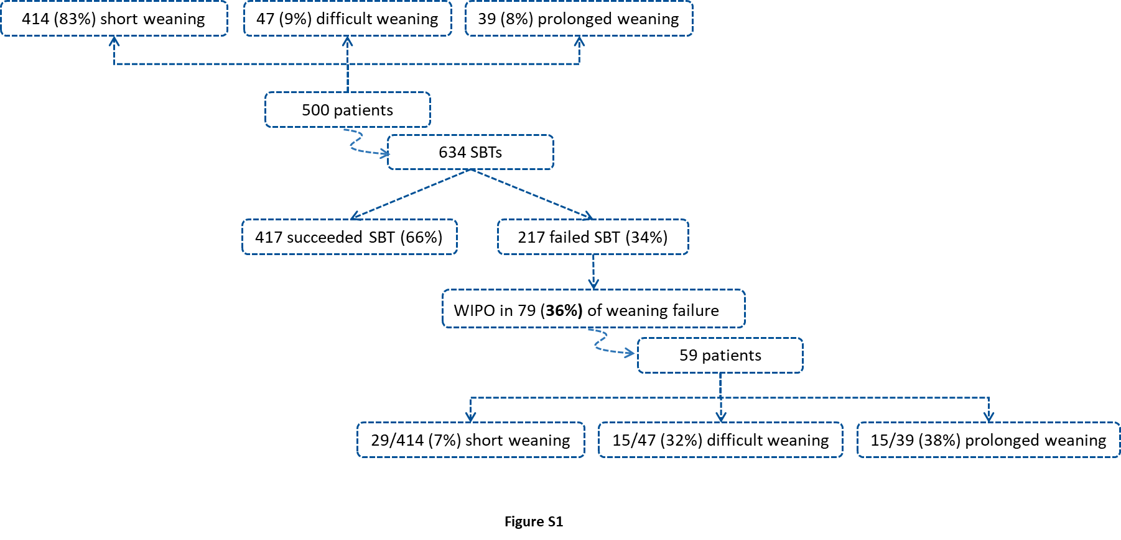
SBT: spontaneous breathing trial; WIPO: weaning-induced pulmonary oedema.

Figure S1. Incidence of weaning failure and weaning-induced pulmonary oedema

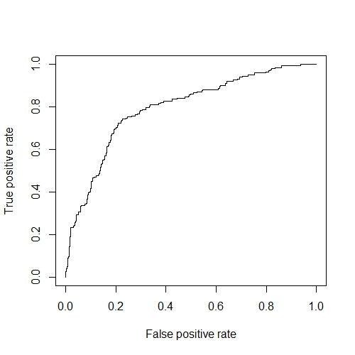
AUROC: 0.795 95% CI: 0.756-0.834
P<0.01 vs. AUROC=0.50

Figure S2. Receiver operating characteristic curve showing the predictive ability of the regression model for the prediction of the risk of experiencing spontaneous breathing trial failure at least once.

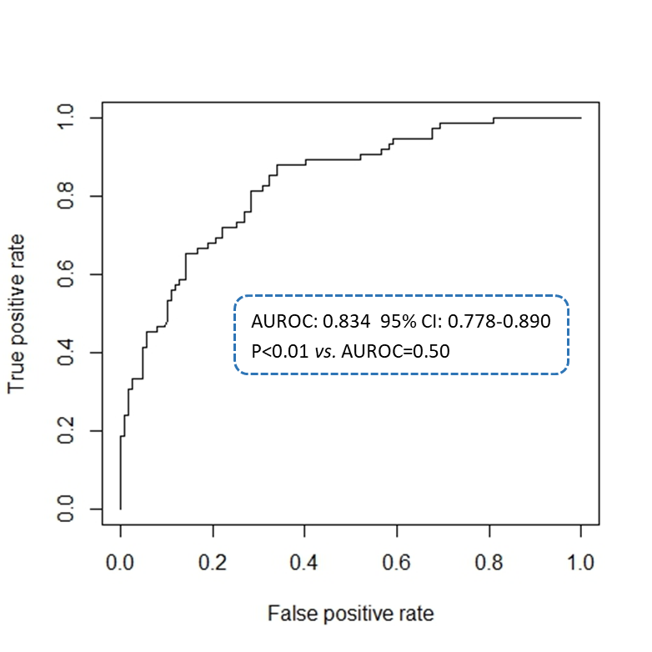

Figure S3. Receiver operating characteristic curve showing the predictive ability of the regression model for the prediction of the risk of experiencing weaning-induced pulmonary oedema among patients who failed the spontaneous breathing trial at least once.

References
1. Epstein SK, Ciubotaru RL, Wong JB: Effect of failed extubation on the outcome of mechanical ventilation. Chest. 1997, 112:186-192.
2. Grasso S, Leone A, De Michele M, Anaclerio R, Cafarelli A, Ancona G et al: Use of N-terminal pro-brain natriuretic peptide to detect acute cardiac dysfunction during weaning failure in difficult-to-wean patients with chronic obstructive pulmonary disease. Crit Care Med. 2007, 35:96-105.
3. Anguel N, Monnet X, Osman D, Castelain V, Richard C, Teboul JL: Increase in plasma protein concentration for diagnosing weaning-induced pulmonary oedema. Intensive Care Med. 2008, 34:1231-1238.
4. Lamia B, Maizel J, Ochagavia A, Chemla D, Osman D, Richard C et al: Echocardiographic diagnosis of pulmonary artery occlusion pressure elevation during weaning from mechanical ventilation. Crit Care Med. 2009, 37:1696-1701.
5. Caille V, Amiel JB, Charron C, Belliard G, Vieillard-Baron A, Vignon P: Echocardiography: a help in the weaning process. Crit Care. 2010, 14:R120.
6. Cabello B, Thille AW, Roche-Campo F, Brochard L, Gómez FJ, Mancebo J: Physiological comparison of three spontaneous breathing trials in difficult-to-wean patients. Intensive Care Med. 2010, 36:1171-1179.
7. Dres M, Teboul JL, Anguel N, Guerin L, Richard C, Monnet X: Extravascular lung water, B-type natriuretic peptide, and blood volume contraction enable diagnosis of weaning-induced pulmonary edema. Crit Care Med. 2014, 42:1882-1889.
8. Dres M, Teboul JL, Anguel N, Guerin L, Richard C, Monnet X: Passive leg raising performed before a spontaneous breathing trial predicts weaning-induced cardiac dysfunction. Intensive Care Med. 2015, 41:487-494.
9. Liu J, Shen F, Teboul JL, Anguel N, Beurton A, Bezaz N et al: Cardiac dysfunction induced by weaning from mechanical ventilation: incidence, risk factors, and effects of fluid removal. Crit Care. 2016, 20:369.
10. Bedet A, Tomberli F, Prat G, Bailly P, Kouatchet A, Mortaza S et al: Myocardial ischemia during ventilator weaning: a prospective multicenter cohort study. Crit Care. 2019, 23:321.
11. Goudelin M, Champy P, Amiel JB, Evrard B, Fedou AL, Daix T et al: Left ventricular overloading identified by critical care echocardiography is key in weaning-induced pulmonary edema. Intensive Care Med. 2020, 46:1371-1381.
12. Dres M, Rozenberg E, Morawiec E, Mayaux J, Delemazure J, Similowski T et al: Diaphragm dysfunction, lung aeration loss and weaning-induced pulmonary oedema in difficult-to-wean patients. Ann Intensive Care. 2021, 11:99.
13. Bagate F, Bedet A, Tomberli F, Boissier F, Razazi K, de Prost N et al: Critical illness-related corticosteroid insufficiency during difficult weaning from mechanical ventilation. Ann Intensive Care. 2021, 11:65.

