


Standard Operating Procedure for medication handling
S-number: S63213
Title protocol: Early administration of Vitamin C in patients with sepsis or septic shock in emergency departments: a multicenter, double blinded, randomized controlled trial: the C-EASIE trial.
Chief Investigator: Dr. Didier Desruelles

Flow of study medication
- Delivery of study medication by Ardena Gent NV to pharmacy
- Delivery of study medication by pharmacy to on-site temperature controlled room
- Storage in temperature controlled room
- Assignment of treatment kit to patient
- Administration of study medication
- Treatment kit sent back to study team
- Destruction of unused ampoules

- Delivery of study medication by Ardena Gent NV
Ardena Gent NV will deliver the treatment kits to the pharmacy of each site. The site provides the contact details, opening hours and address of the pharmacy. A first delivery is foreseen including 20 kits. It is the responsibility of the site to request a new delivery to the Sponsor when stock is running low (less than 5 kits). The Sponsor and site agree on a delivery date (approximately 5 days after first notification).
- Delivery of study medication by pharmacy to on-site temperature controlled room
Every delivery includes a temperature logger of Ardena (monitors the temperature during transport) and a shipment form. The study team/pharmacist that receives the study medication needs to complete the shipment form, sign and date it and send a digital copy back to Ardena. A few days later the study team will receive a signed copy from Ardena as well as the temperature log of the shipment. Provide these documents to the study team for filing in the Investigator Site File to ensure drug accountability.
A few screenshots from the shipment form:
- Check whether the identification of the shipped study medication is correct (compare left column with packaging material).
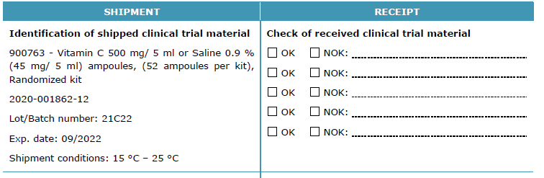
- Check whether your site has received the correct treatment kit IDs and whether the total number of treatment kits is correct.
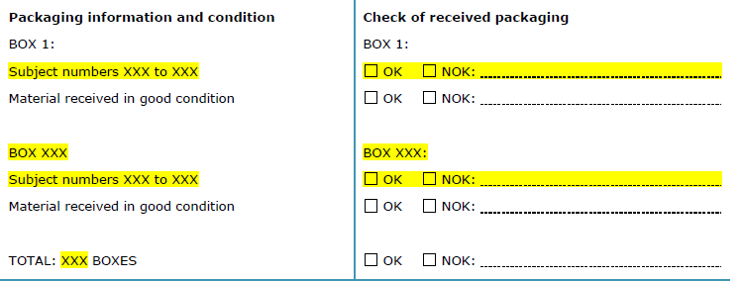
- Sign and date the form, and e-mail it to Ardena (Annelies.Paridaens@ardena.com).
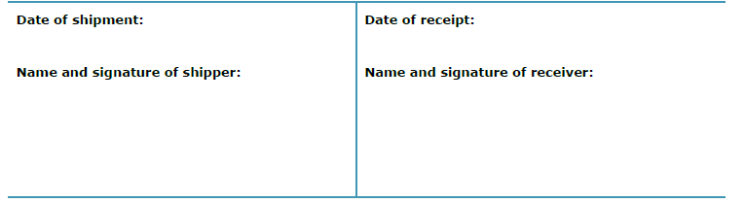
- Storage in a temperature controlled room
Treatment kits needs to be stored at room temperature (between 15 and 25°C). Always store the medication ampoules in the white packaging box to protect the ampoules from light. Extra labels will be provided by the Sponsor team during the Site Initiation Visit. As per GCP guidelines it is necessary that the storage room has limited access and has room temperature monitoring at all times. How to monitor the temperature?
- If the room has air conditioning, the technical service of the study site should be able to monitor the temperature of the site. This temperature log needs to be printed out biweekly and filed in the Investigator Site File.
- If the room is not air conditioned, a temperature logger should be installed in the room. If needed, the Sponsor will provide a logger. The temperature log needs to be printed out biweekly and filed in the Investigator Site File.
What to do in case of a temperature excursion?
- Relocate the medication as soon as possible to a room with a lower temperature (for example the hospital pharmacy).
- Place the medication in quarantine. Do not include new patients!
- Check the degree and the duration of the temperature excursion on the temperature logger.
- Inform the Sponsor as soon as possible by e-mailing ceasie@uzleuven.be and file all communication in the Investigator Site File.
- Based on stability information, the Sponsor will decide whether the medication can still be used or needs to be destroyed. File this communication in the Investigator Site File.

- Assignment of treatment kit to patient
  - Treatment kit
Treatment kits contain 52 ampoules of Vitamin C 500 mg/5 ml or 52 ampoules of Normal Saline 5 ml 9 mg/ml. The ampoules have identical sizes and are blinded by a cap and sticker for an identical look.
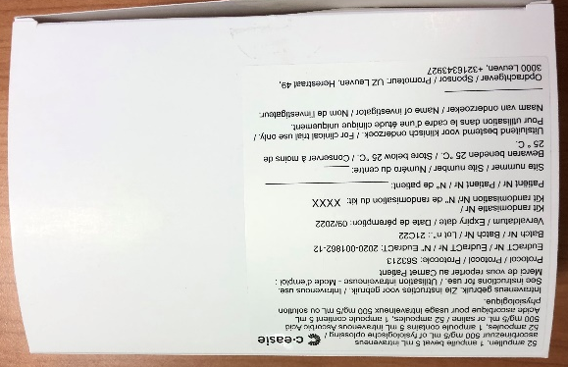
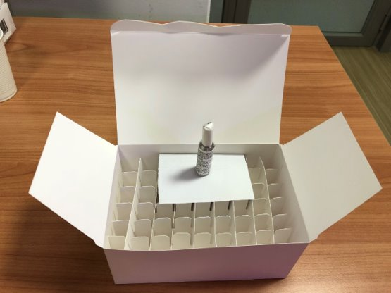
  - Assignment of treatment kit
After the informed consent form is signed and the patient is screened (please complete screening log see online training manual), the patient is randomized through www.randomize.net. Please do not forget to:
- Complete the subject identification log (see online training manual).
- Store the confirmation e-mail from www.randomize.net in the Investigator Site File.
- Write down the kit number and patient number in the electronic patient file.

- Administration of study medication
  - Administration
Patients need to receive 1.5 g of IV Vitamin C or placebo every 6 hours during 4 days. Study treatment should be initiated within 6 hours after ED presentation. To ensure that no administration of study treatment is missed, it is recommended that the Investigator prescribes all 16 doses at once (if possible).
Right before each administration, 3 ampoules of study medication need to be dissolved in 50 ml of NaCl 0.9%. The infusion bag needs to run through in 15 minutes. The infusion bags (50 ml) need to be provided by the study site (foreseen in the study budget, should not be charged to the patient). The Sponsor recommends that all infusion bags are added to the treatment kit prior to transport to the ward or ICU. The treatment kit always stays with the patient, and therefore moves from ward to ward.
In total, if the patient is not discharged before day 5, 48 ampoules need to be administered. The treatment kit contains 4 spare ampoules. All UNUSED ampoules need to be stored in the treatment kit to ensure drug accountability. All USED ampoules need to be thrown away for safety and hygiene purposes. After administration of all 16 doses, or in the event study treatment is stopped earlier, the treatment kit needs to be send back to the study team.

Nurses who administer the study medication DO NOT need to be logged in the Delegation of Responsibilities Log!
  - Administration instructions
To ensure correct study medication administration, the Sponsor provides a ‘treatment kit information leaflet’. It is the responsibility of the study team to add this document to the treatment kit so that bedside nurses and physicians on the ward are well informed of the study.
  - Registration
For each administration, the bedside nurse needs to complete the Drug Accountability Log. The Drug Accountability Log needs to be sent back to the study team together with the treatment kit after the last administration. It is the responsibility of the study team to add this document to the treatment kit so that logging is performed correctly.
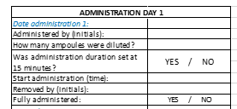

- Treatment kit sent back to study team
Used treatment kits and the accompanying Drug Accountability Logs need to be sent back to the study team. It is the responsibility of the study team to crosscheck the Drug Accountability Log, the number of unused vials and the medication registered in the electronic patient file. The medication balance section should then be completed by the study team. If the number of unused vials does not match the Drug Accountability Log and no logical explanation can be found (for example: broken ampoule reported by bedside nurse), this is considered as a protocol deviation and the Protocol Deviation Log needs to be completed.

- Destruction of unused ampoules
After the CTC trial monitor has visited the site and has checked the drug accountability, used treatment kits can be destroyed. Unused ampoules can be sent to your local pharmacy for destruction. Please file all documentation of destruction in the Investigator Site File. The study site receives budget from the Sponsor for maximum two destructions throughout the trial.

