Supplementary materials
Appendix 1
PRISMA 2009 Checklist
Section/topic | # | Checklist item | Reported on page #
TITLE
Title | 1 | Identify the report as a systematic review, meta-analysis, or both. | 1
ABSTRACT
Structured summary | 2 | Provide a structured summary including, as applicable: background; objectives; data sources; study eligibility criteria, participants, and interventions; study appraisal and synthesis methods; results; limitations; conclusions and implications of key findings; systematic review registration number. | 1
INTRODUCTION
Rationale | 3 | Describe the rationale for the review in the context of what is already known. | 1
Objectives | 4 | Provide an explicit statement of questions being addressed with reference to participants, interventions, comparisons, outcomes, and study design (PICOS). | 2
METHODS
Protocol and registration | 5 | Indicate if a review protocol exists, if and where it can be accessed (e.g., Web address), and, if available, provide registration information including registration number. | 2
Eligibility criteria | 6 | Specify study characteristics (e.g., PICOS, length of follow-up) and report characteristics (e.g., years considered, language, publication status) used as criteria for eligibility, giving rationale. | 2
Information sources | 7 | Describe all information sources (e.g., databases with dates of coverage, contact with study authors to identify additional studies) in the search and date last searched. | 2, Supplementary Appendix 2
Search | 8 | Present full electronic search strategy for at least one database, including any limits used, such that it could be repeated. | Supplementary Appendix 2
Study selection | 9 | State the process for selecting studies (i.e., screening, eligibility, included in systematic review, and, if applicable, included in the meta-analysis). | 2
Data collection process | 10 | Describe method of data extraction from reports (e.g., piloted forms, independently, in duplicate) and any processes for obtaining and confirming data from investigators. | 2
Data items | 11 | List and define all variables for which data were sought (e.g., PICOS, funding sources) and any assumptions and simplifications made. | 2
Risk of bias in individual studies | 12 | Describe methods used for assessing risk of bias of individual studies (including specification of whether this was done at the study or outcome level), and how this information is to be used in any data synthesis. | 2
Summary measures | 13 | State the principal summary measures (e.g., risk ratio, difference in means). | 2
Synthesis of results | 14 | Describe the methods of handling data and combining results of studies, if done, including measures of consistency (e.g., I²) for each meta-analysis. | 2
Risk of bias across studies | 15 | Specify any assessment of risk of bias that may affect the cumulative evidence (e.g., publication bias, selective reporting within studies). | 2
Additional analyses | 16 | Describe methods of additional analyses (e.g., sensitivity or subgroup analyses, meta-regression), if done, indicating which were pre-specified. | 2
RESULTS
Study selection | 17 | Give numbers of studies screened, assessed for eligibility, and included in the review, with reasons for exclusions at each stage, ideally with a flow diagram. | 3
Study characteristics | 18 | For each study, present characteristics for which data were extracted (e.g., study size, PICOS, follow-up period) and provide the citations. | 3
Risk of bias within studies | 19 | Present data on risk of bias of each study and, if available, any outcome level assessment (see item 12). | 3, Figure 2
Results of individual studies | 20 | For all outcomes considered (benefits or harms), present, for each study: (a) simple summary data for each intervention group (b) effect estimates and confidence intervals, ideally with a forest plot. | 3
Synthesis of results | 21 | Present results of each meta-analysis done, including confidence intervals and measures of consistency. | 3-7
Risk of bias across studies | 22 | Present results of any assessment of risk of bias across studies (see Item 15). | 3, Figure 2
Additional analysis | 23 | Give results of additional analyses, if done (e.g., sensitivity or subgroup analyses, meta-regression [see Item 16]). | 4-7
DISCUSSION
Summary of evidence | 24 | Summarize the main findings including the strength of evidence for each main outcome; consider their relevance to key groups (e.g., healthcare providers, users, and policy makers). | 7
Limitations | 25 | Discuss limitations at study and outcome level (e.g., risk of bias), and at review-level (e.g., incomplete retrieval of identified research, reporting bias). | 9
Conclusions | 26 | Provide a general interpretation of the results in the context of other evidence, and implications for future research. | 9
FUNDING
Funding | 27 | Describe sources of funding for the systematic review and other support (e.g., supply of data); role of funders for the systematic review. | 9

Appendix 2
Search strategy
2024.11.9 pubmed
("Acute Kidney Injury"[MeSH Terms] OR ("acute"[All Fields] AND "kidney"[All Fields] AND "injury"[All Fields]) OR "Acute Kidney Injury"[All Fields] OR ("acute"[All Fields] AND "kidney"[All Fields] AND "injuries"[All Fields]) OR "acute kidney injuries"[All Fields] OR ("Acute Kidney Injury"[MeSH Terms] OR ("acute"[All Fields] AND "kidney"[All Fields] AND "injury"[All Fields]) OR "Acute Kidney Injury"[All Fields] OR ("kidney"[All Fields] AND "injuries"[All Fields] AND "acute"[All Fields]) OR "kidney injuries acute"[All Fields]) OR ("Acute Kidney Injury"[MeSH Terms] OR ("acute"[All Fields] AND "kidney"[All Fields] AND "injury"[All Fields]) OR "Acute Kidney Injury"[All Fields] OR ("kidney"[All Fields] AND "injury"[All Fields] AND "acute"[All Fields]) OR "kidney injury acute"[All Fields]) OR ("Acute Kidney Injury"[MeSH Terms] OR ("acute"[All Fields] AND "kidney"[All Fields] AND "injury"[All Fields]) OR "Acute Kidney Injury"[All Fields] OR ("acute"[All Fields] AND "renal"[All Fields] AND "injury"[All Fields]) OR "acute renal injury"[All Fields]) OR ("Acute Kidney Injury"[MeSH Terms] OR ("acute"[All Fields] AND "kidney"[All Fields] AND "injury"[All Fields]) OR "Acute Kidney Injury"[All Fields] OR ("acute"[All Fields] AND "renal"[All Fields] AND "injuries"[All Fields]) OR "acute renal injuries"[All Fields]) OR ("Acute Kidney Injury"[MeSH Terms] OR ("acute"[All Fields] AND "kidney"[All Fields] AND "injury"[All Fields]) OR "Acute Kidney Injury"[All Fields] OR ("renal"[All Fields] AND "injuries"[All Fields] AND "acute"[All Fields]) OR "renal injuries acute"[All Fields]) OR ("Acute Kidney Injury"[MeSH Terms] OR ("acute"[All Fields] AND "kidney"[All Fields] AND "injury"[All Fields]) OR "Acute Kidney Injury"[All Fields] OR ("renal"[All Fields] AND "injury"[All Fields] AND "acute"[All Fields]) OR "renal injury acute"[All Fields]) OR ("Acute Kidney Injury"[MeSH Terms] OR ("acute"[All Fields] AND "kidney"[All Fields] AND "injury"[All Fields]) OR "Acute Kidney Injury"[All Fields] OR ("renal"[All Fields] AND "insufficiency"[All Fields] AND "acute"[All Fields]) OR "renal insufficiency acute"[All Fields]) OR ("Acute Kidney Injury"[MeSH Terms] OR ("acute"[All Fields] AND "kidney"[All Fields] AND "injury"[All Fields]) OR "Acute Kidney Injury"[All Fields] OR ("acute"[All Fields] AND "renal"[All Fields] AND "insufficiencies"[All Fields]) OR "acute renal insufficiencies"[All Fields]) OR ("Acute Kidney Injury"[MeSH Terms] OR ("acute"[All Fields] AND "kidney"[All Fields] AND "injury"[All Fields]) OR "Acute Kidney Injury"[All Fields] OR ("renal"[All Fields] AND "insufficiencies"[All Fields] AND "acute"[All Fields])) OR ("Acute Kidney Injury"[MeSH Terms] OR ("acute"[All Fields] AND "kidney"[All Fields] AND "injury"[All Fields]) OR "Acute Kidney Injury"[All Fields] OR ("acute"[All Fields] AND "renal"[All Fields] AND "insufficiency"[All Fields]) OR "acute renal insufficiency"[All Fields]) OR ("Acute Kidney Injury"[MeSH Terms] OR ("acute"[All Fields] AND "kidney"[All Fields] AND "injury"[All Fields]) OR "Acute Kidney Injury"[All Fields] OR ("kidney"[All Fields] AND "insufficiency"[All Fields] AND "acute"[All Fields])) OR ("Acute Kidney Injury"[MeSH Terms] OR ("acute"[All Fields] AND "kidney"[All Fields] AND "injury"[All Fields]) OR "Acute Kidney Injury"[All Fields] OR ("acute"[All Fields] AND "kidney"[All Fields] AND "insufficiencies"[All Fields]) OR "acute kidney insufficiencies"[All Fields]) OR ("Acute Kidney Injury"[MeSH Terms] OR ("acute"[All Fields] AND "kidney"[All Fields] AND "injury"[All Fields]) OR "Acute Kidney Injury"[All Fields] OR ("kidney"[All Fields] AND "insufficiencies"[All Fields] AND "acute"[All Fields])) OR ("Acute Kidney Injury"[MeSH Terms] OR ("acute"[All Fields] AND "kidney"[All Fields] AND "injury"[All Fields]) OR "Acute Kidney Injury"[All Fields] OR ("acute"[All Fields] AND "kidney"[All Fields] AND "insufficiency"[All Fields]) OR "acute kidney insufficiency"[All Fields]) OR ("Acute Kidney Injury"[MeSH Terms] OR ("acute"[All Fields] AND "kidney"[All Fields] AND "injury"[All Fields]) OR "Acute Kidney Injury"[All Fields] OR ("kidney"[All Fields] AND "failure"[All Fields] AND "acute"[All Fields]) OR "kidney failure acute"[All Fields]) OR ("Acute Kidney Injury"[MeSH Terms] OR ("acute"[All Fields] AND "kidney"[All Fields] AND "injury"[All Fields]) OR "Acute Kidney Injury"[All Fields] OR ("acute"[All Fields] AND "kidney"[All Fields] AND "failures"[All Fields]) OR "acute kidney failures"[All Fields]) OR ("Acute Kidney Injury"[MeSH Terms] OR ("acute"[All Fields] AND "kidney"[All Fields] AND "injury"[All Fields]) OR "Acute Kidney Injury"[All Fields] OR ("kidney"[All Fields] AND "failures"[All Fields] AND "acute"[All Fields])) OR ("Acute Kidney Injury"[MeSH Terms] OR ("acute"[All Fields] AND "kidney"[All Fields] AND "injury"[All Fields]) OR "Acute Kidney Injury"[All Fields] OR ("acute"[All Fields] AND "renal"[All Fields] AND "failure"[All Fields]) OR "acute renal failure"[All Fields]) OR ("Acute Kidney Injury"[MeSH Terms] OR ("acute"[All Fields] AND "kidney"[All Fields] AND "injury"[All Fields]) OR "Acute Kidney Injury"[All Fields] OR ("acute"[All Fields] AND "renal"[All Fields] AND "failures"[All Fields]) OR "acute renal failures"[All Fields]) OR ("Acute Kidney Injury"[MeSH Terms] OR ("acute"[All Fields] AND "kidney"[All Fields] AND "injury"[All Fields]) OR "Acute Kidney Injury"[All Fields] OR ("renal"[All Fields] AND "failures"[All Fields] AND "acute"[All Fields])) OR ("Acute Kidney Injury"[MeSH Terms] OR ("acute"[All Fields] AND "kidney"[All Fields] AND "injury"[All Fields]) OR "Acute Kidney Injury"[All Fields] OR ("renal"[All Fields] AND "failure"[All Fields] AND "acute"[All Fields]) OR "renal failure acute"[All Fields]) OR ("Acute Kidney Injury"[MeSH Terms] OR ("acute"[All Fields] AND "kidney"[All Fields] AND "injury"[All Fields]) OR "Acute Kidney Injury"[All Fields] OR ("acute"[All Fields] AND "kidney"[All Fields] AND "failure"[All Fields]) OR "acute kidney failure"[All Fields]) OR "Acute Kidney Injury"[MeSH Terms]) AND ((("electronical"[All Fields] OR "electronically"[All Fields] OR "electronics"[MeSH Terms] OR "electronics"[All Fields] OR "electronic"[All Fields]) AND ("alert"[All Fields] OR "alerted"[All Fields] OR "alerting"[All Fields] OR "alertness"[All Fields] OR "alerts"[All Fields])) OR (("electronical"[All Fields] OR "electronically"[All Fields] OR "electronics"[MeSH Terms] OR "electronics"[All Fields] OR "electronic"[All Fields]) AND ("alert"[All Fields] OR "alerted"[All Fields] OR "alerting"[All Fields] OR "alertness"[All Fields] OR "alerts"[All Fields]) AND ("system"[All Fields] OR "system s"[All Fields] OR "systems"[All Fields])) OR "E-Alert"[All Fields] OR "E-Alerts"[All Fields])
2024.11.9 the Cochrane
【Acute Kidney Injury] OR(Kidney Failure, Acute OR Acute Kidney Failures OR Kidney Failures, Acute OR Acute Kidney Failure OR Acute Renal Failure OR Acute Renal Failures OR Renal Failures, Acute OR Renal Failure, Acute OR Kidney Insufficiency, Acute OR Renal Insufficiency, Acute OR Acute Renal Insufficiencies OR Renal Insufficiencies, Acute OR Kidney Insufficiencies, Acute OR Acute Kidney Insufficiencies OR Acute Kidney Insufficiency OR Acute Renal Insufficiency OR Renal Injuries, Acute OR Acute Kidney Injuries OR Kidney Injuries, Acute OR Acute Renal Injuries OR Renal Injury, Acute OR Acute Renal Injury OR Kidney Injury, Acute)】AND (Electronic Alert OR Electronic Alert System OR E-Alert OR E-Alerts)

Appendix 3
Author(s):
Question: AKI e-alert compared to usual care for adult hospitalized patients
Setting:
Bibliography:
Certainty assessment |  |  |  |  |  |  | № of patients |  | Effect |  | Certainty | Importance
№ of studies | Study design | Risk of bias | Inconsistency | Indirectness | Imprecision | Other considerations | AKI e-alert | usual care | Relative  (95% CI) | Absolute  (95% CI) | Certainty | Importance
in-hospital mortality of RCTs
6 | randomised trials | not serious | not serious | not serious | not serious | none | 758/5741 (13.2%) | 731/5936 (12.3%) | RR 1.04  (0.94 to 1.14) | 5 more per 1,000  (from 7 fewer to 17 more) | ⨁⨁⨁⨁  High | IMPORTANT
in-hospital mortality of non-RCTs
6 | non-randomised studies | not serious | not serious | not serious | not serious | none | 5561/53893 (10.3%) | 3451/29023 (11.9%) | RR 0.92  (0.88 to 0.96) | 10 fewer per 1,000  (from 14 fewer to 5 fewer) | ⨁⨁◯◯  Low | IMPORTANT
Mixed mortality of RCTs
8 | randomised trials | not serious | not serious | not serious | not serious | none | 2620/20403 (12.8%) | 2534/20370 (12.4%) | RR 1.02  (0.97 to 1.07) | 2 more per 1,000  (from 4 fewer to 9 more) | ⨁⨁⨁⨁  High | IMPORTANT
Mixed mortality of non-RCTs
10 | non-randomised studies | not serious | not serious | not serious | not serious | none | 11183/74814 (14.9%) | 10397/54502 (19.1%) | RR 0.94  (0.91 to 0.96) | 11 fewer per 1,000  (from 17 fewer to 8 fewer) | ⨁⨁◯◯  Low | IMPORTANT
Receipt of RRT- RCTs
8 | randomised trials | not serious | not serious | not serious | not serious | none | 679/10799 (6.3%) | 606/10911 (5.6%) | RR 1.13  (1.02 to 1.26) | 7 more per 1,000  (from 1 more to 14 more) | ⨁⨁⨁⨁  High | IMPORTANT
Receipt of RRT -non-RCTs
5 | non-randomised studies | not serious | seriousª | not serious | not serious | none | 625/10476 (6.0%) | 551/10390 (5.3%) | RR 1.08  (0.87 to 1.36) | 4 more per 1,000  (from 7 fewer to 19 more) | ⨁◯◯◯  Very lowª | IMPORTANT
renal recovery of RCTs
3 | randomised trials | not serious | not serious | not serious | not serious | none | 983/1756 (56.0%) | 1159/2010 (57.7%) | RR 1.00  (0.95 to 1.06) | 0 fewer per 1,000  (from 29 fewer to 35 more) | ⨁⨁⨁⨁  High | IMPORTANT
renal recovery of non-RCTs
2 | non-randomised studies | not serious | not serious | not serious | not serious | none | 1025/1355 (75.6%) | 885/1932 (45.8%) | RR 1.61  (1.42 to 1.83) | 279 more per 1,000  (from 192 more to 380 more) | ⨁⨁◯◯  Low | IMPORTANT
AKI progression of RCTs
4 | randomised trials | not serious | not serious | not serious | not serious | none | 1523/8713 (17.5%) | 1511/8588 (17.6%) | RR 0.99  (0.93 to 1.06) | 2 fewer per 1,000  (from 12 fewer to 11 more) | ⨁⨁⨁⨁  High | IMPORTANT
AKI progression of non-RCTs
2 | non-randomised studies | serious^{b} | seriousª | not serious | not serious | none | 1557/9344 (16.7%) | 1880/9396 (20.0%) | RR 0.85  (0.77 to 0.94) | 30 fewer per 1,000  (from 46 fewer to 12 fewer) | ⨁◯◯◯  Very low^{a,b} | IMPORTANT
nephrologist consultation of RCTs
8 | randomised trials | not serious | not serious | not serious | not serious | none | 1868/10799 (17.3%) | 1737/10911 (15.9%) | RR 1.09  (0.99 to 1.20) | 14 more per 1,000  (from 2 fewer to 32 more) | ⨁⨁⨁⨁  High | NOT IMPORTANT
nephrologist consultation-non-RCTs
5 | non-randomised studies | serious^{c} | very serious^{d} | not serious | not serious | none | 13462/55395 (24.3%) | 7379/31689 (23.3%) | RR 1.29  (0.89 to 1.87) | 68 more per 1,000  (from 26 fewer to 203 more) | ⨁◯◯◯  Very low^{c,d} | NOT IMPORTANT
the rate of discontinuation of potentially nephrotoxic medications
6 | non-randomised studies | serious^{e} | not serious | not serious | not serious | none | 1467/11290 (13.0%) | 1318/11681 (11.3%) | RR 1.20  (1.13 to 1.28) | 23 more per 1,000  (from 15 more to 32 more) | ⨁◯◯◯  Very low^{e} | IMPORTANT
drug review rate
2 | non-randomised studies | not serious | not serious | not serious | not serious | none | 7312/10282 (71.1%) | 8595/14416 (59.6%) | RR 1.19  (1.17 to 1.21) | 113 more per 1,000  (from 101 more to 125 more) | ⨁⨁◯◯  Low | IMPORTANT
Length of stay-RCTs
6 | randomised trials | not serious | not serious | not serious | not serious | none | 10014 | 9880 | - | MD 0.04 higher  (0.14 lower to 0.22 higher) | ⨁⨁⨁⨁  High | NOT IMPORTANT
Length of stay -non-RCTs
9 | non-randomised studies | not serious | very serious^{d} | not serious | not serious | none | 66415 | 46607 | - | MD 0.04 lower  (0.68 lower to 0.59 higher) | ⨁◯◯◯  Very low^{d} | NOT IMPORTANT
AKI document-RCT
5 | randomised trials | not serious | very serious^{d} | not serious | not serious | none | 3331/5950 (56.0%) | 2749/5756 (47.8%) | RR 1.35  (1.06 to 1.72) | 167 more per 1,000  (from 29 more to 344 more) | ⨁⨁◯◯  Low^{d} | IMPORTANT
AKI document-non-RCT
2 | non-randomised studies | not serious | very serious^{d} | not serious | not serious | none | 437/874 (50.0%) | 455/942 (48.3%) | RR 1.13  (0.66 to 1.92) | 63 more per 1,000  (from 164 fewer to 444 more) | ⨁◯◯◯  Very low^{d}
CI: confidence interval; MD: mean difference; RR: risk ratio

Explanations
a. I2>50%
b. 1 of 2 enrolled studies have high risk of bias
c. 2 enrolled non-RCTs are moderate risk of bias (overall 2 of 5)
d. I2>75%
e. 3 enrolled non-RCTs are high risk of bias (overall 3 of 6)
The importance of a study is an objective assessment made by the raters based on the previous items of study design, risk of bias, inconsistency, indirectness, imprecision, other considerations, number of patients, effect, and certainty. Studies with a design of RCT, low risk of bias, low inconsistency (heterogeneity between study results, assessed by I², with I²< 50% defined as low inconsistency), low indirectness (the study population, intervention, control measures, and outcome indicators are directly related to the target issue), low imprecision (if the confidence interval (CI) of the study results is too wide, it will lead to higher uncertainty of the results), no other prominent issues (such as a low possibility of publication bias or other potential biases), large sample size (RCTs with < 50 patients included are defined as having a small sample size), meaningful effect size, and high certainty are more likely to be assessed as important.

Appendix 4. Reasons for Excluding Full-Text Screening Studies
Number | First author, Year | Title | Reason for exclusion
1 | Biswas, 2018 | Identification of Patients Expected to Benefit from Electronic Alerts for Acute Kidney Injury | Duplicate trial
2 | Shi, 2022 | The rate of acute kidney injury (AKI) alert detection by the attending physicians was associated with the prognosis of patients with AKI | Duplicate trial
3 | Chen-Xu, 2024 | Impact of electronic AKI alert/care bundle on AKI inpatient outcomes: a retrospective single-center cohort study | Lack of raw data on AKI deaths
4 | Barker, 2021 | Electronic alerts for acute kidney injury across primary and secondary care | Lack of AKI patient number
5 | Awdishu, 2016 | The impact of real-time alerting on appropriate prescribing in kidney disease: a cluster randomized controlled trial | Lack of AKI patient number
6 | Holmes, 2016 | Acute Kidney Injury in the Era of the AKI E-Alert | No control group
7 | Holmes, 2018 | Utility of electronic AKI alerts in intensive care: A national multicentre cohort study | No control group
8 | Holmes, 2021 | Acute kidney injury demographics and outcomes: changes following introduction of electronic acute kidney injury alerts—an analysis of a national dataset | No control group
9 | Kolhe, 2016 | A simple care bundle for use in acute kidney injury: a propensity score-matched cohort study | No control group
10 | Thomas, 2021 | The Acute Kidney Outreach to Prevent Deterioration and Death trial: a large pilot study for a cluster-randomized trial | No control group
11 | Baird, 2020 | Impact of electronic alerts for acute kidney injury on patient outcomes: interrupted time-series analysis of population cohort data | No control group
12 | Porter, 2014 | A real-time electronic alert to improve detection of acute kidney injury in a large teaching hospital | No control group
13 | Prendecki, 2016 | Improving outcomes in patients with Acute Kidney Injury: the impact of hospital based automated AKI alerts | No control group
14 | Barton, 2020 | Acute Kidney Injury in Primary Care: A Review of Patient Follow-Up, Mortality, and Hospital Admissions following the Introduction of an AKI Alert System | No control group
15 | Flynn, 2015 | A simple electronic alert for acute kidney injury | No control group
16 | Wallace, 2014 | Use of an electronic alert to identify patients with acute kidney injury | No control group
17 | Haase-Fielitz, 2020 | The Effects of Intensive Versus Routine Treatment in Patients with Acute Kidney Injury | No control group
18 | Sawhney, 2016 | KDIGO-based acute kidney injury criteria operate differently in hospitals and the community-findings from a large population cohort | No control group
19 | Purvis, 2018 | DEVELOPMENT AND IMPLEMENTATION OF AN ACUTE KIDNEY INJURY E-ALERT SYSTEM IN ACUTE MEDICAL RECEIVING UNITS IN GLASGOW | No eligible outcome
20 | Tollitt, 2018 | Improved management of acute kidney injury in primary care using e-alerts and an educational outreach programme | No eligible outcome
21 | Aiyegbusi, 2018 | Impact of introducing electronic acute kidney injury alerts in primary care | No eligible outcome
22 | Pyart, 2016 | Acute Kidney Injury Electronic Alert Triggered Intervention Improves Length of Stay | No eligible outcome
23 | Baker, 2021 | Electronic alerts for acute kidney injury across primary and secondary care | No eligible outcome
24 | Connell, 2019 | Implementation of a Digitally Enabled Care Pathway (Part 1): Impact on Clinical Outcomes and Associated Health Care Costs | No eligible outcome
25 | Qian, 2021 | ACUTE KIDNEY INJURY (AKI) ELECTRONIC ALERTS AND AKI CARE BUNDLE PROJECT | No eligible outcome
26 | Sawhney, 2015 | Maximising Acute Kidney Injury Alerts--A Cross-Sectional Comparison with the Clinical Diagnosis | No eligible outcome
27 | Kothari, 2018 | Impact of Daily Electronic Laboratory Alerting on Early Detection and Clinical Documentation of Acute Kidney Injury in Hospital Settings | No eligible outcome
28 | Wu, 2022 | An Early Warning System for the Differential Diagnosis of In-Hospital Acute Kidney Injury for Better Patient Outcome: Study of a Quality Improvement Initiative | No eligible outcome
29 | Ugwuowo, 2020 | Real-Time Prediction of Acute Kidney Injury in Hospitalized Adults: Implementation and Proof of Concept | No eligible outcome
30 | Hazara, 2017 | The Use of Automated Electronic Alerts in Studying Short-Term Outcomes Associated with Community-Acquired Acute Kidney Injury | No eligible outcome
31 | Spencer, 2021 | The impact of e-alerts on inpatient diagnosis and management of acute kidney injury | No eligible outcome

Supplementary Table 1. Characteristics of included e-alerts

Study | Alert type | Intensity of the alert response | Trigger threshold | Recipient | Frequency | Content | Control group | Additional intervention
Al-Jaghbeer 2018 | The CDSS posted possible AKI next to the corresponding serum creatinine value in the hospital’s EMR | Moderate | An increase of 50% or 0.3 mg/dL or more from a baseline creatinine defined as the lowest value in the past 12 months | Clinician | A 48-hour rule with a 4-hour buffer for reporting | (1) the reference creatinine used for the alert and how it was derived, (2) the stage of AKI according to the KDIGO classification system (see Supplemental Table 4), and (3) a prompt to consult renal medicine or intensive care (with corresponding pager numbers provided) | The usual care group did not receive any alerts | Clinical decision support systems (CDSS) within the electronic medical record (EMR)
Atia 2023 | Sent into the EHR, full integration into the EHR | Moderate | An increase of 50% or 0.3 mg/dL or more from a baseline creatinine defined as either the lowest value in the last 7 days or the median value in the last 365 days | Clinicians | NA | The AKI stage and the level of severity | Received the usual standard of care | The AKI alert informed doctors that Guidance for AKI management was available and directed them to help pages.
Aklilu 2024 | Entered into the progress notes section of the patient’s EHR. requesting a cosignature or forwarding a copy of the note to the clinicia’s personal EHR inbox. | Strong | A 50% increase in serum creatinine values within 7 days from baseline or an absolute 0.3 mg/dL rise in serum creatinine values from baseline within a 48-h period | The KAT (physician and pharmacist) | Within an hour | NA | The usual care group had recommendations made by the KAT prior to randomization, but these recommendations were never delivered to the care team. | The KAT provided a set of recommendations focused on evaluation and management of AKI that was individualized for each patient
Colpaert 2012 | Every AKI alert was notified to the intensivists’ Digital Enhanced Cordless Technology (DECT) telephone, a short e-mail message appeared on the DECT screen | Weak | A urine output of < 0.5 mL/kg/hour for 6 h or a 50% increase in serum creatinine from baseline defined as manually record or calculated value based on an assumed glomerular filtration rate of 75 mL/min per 1.72 m2 by the Modification of Diet in Renal Disease equation | Intensivists | When the call carrying the AKI alert was not answered by the physician, it was repeated once after 10 mins | The name of the patient, the bed number, the new RIFLE class, and the criterion that was responsible for the alert, urinary output, or serum creatinine concentration | The usual care group did not receive any alerts | Residents received an educational course on AKI in the ICU
Hodgson 2018 | Were flagged RED, with care bundles generated  Moderate | Strong | Serum creatinine increase of 1.5 from baseline value or absolute value 4 mg/dL for CA-AKI; increase 1.5 from admission value or 0.3 mg/dL within a rolling 48 h during the first seven days of admission for HA-AKI | Ward physicians, nurses, health care assistants and pharmacists, together with the critical care outreach nurse team | NA | Patient tile indicating presence and stage of AKI, baseline SCr and care bundle task status; electronic observation chart with AKI status (present or at risk) in top right of screen with link to SCr results; graph of SCr; AKI care bundle. SCr–serum creatinine | With no alert | Electronic clinical prediction rule (CPR) and a care bundle
Halmy 2021 | Informed by phone; an automated message was sent through the in-hospital electronic mailing system | Weak | Urinary TIMP-2×IGFBP7 positive and eGFR decline > 25% in patients who had received major abdominal or vascular surgery of > 4 h and had to be admitted to the ICU | The ICU team; clinicians | NA | Results of (TIMP-2 × IGFBP7); the patient ID, location in the hospital, eGFR before surgery, last eGFR, and the drop in the eGFR as percentage | Without an e-alert | Intervention recommendations and an alert for nephrology follow-up
Iwers 2023 | An internal email with information about the patient’s identity, department, creatinine increase, and the AKI stage | Weak | HA-AKI: 0.3 mg/dL or 50% increase in serum creatinine between hospital admission and highest serum creatinine within 48 h or 7 days, respectivelyCA-AKI: on admittance or within 48 h of admission, a 33% decrease in serum creatinine from baseline within 7 days | Ward physician | When a patient with AKI was identified | Information about the patient’s identity, department, creatinine increase, and the AKI stage | A lamp icon in the hospital’s SAP work system indicated potential AKI,receiving standard care for AKI | The KDIGO AKI care bundle, all patients received an information flyer and a kidney passport to record, together with the general practitioner, renal function values, enabling monitoring of these parameters
Kotwal 2023 | Disruptive Alert in EMR | Moderate | Serum creatinine > 1.5 times or > 0.3 mg/dL of baseline creatinine defined as 365-day median value or lowest value during the 7 days prior to admission | Clinicians | Triggered whenever the EMR record of a patient with AKI was opened | STOP Kidney Attack Assessment Required!  This patient has an Acute Kidney Injury. Please complete an AKI Management Plan. | Patients in control hospitals received the usual standard of care and none of the intervention bundle | An integrated clinical decision support [tool, Sepsis, Toxin, Optimise blood pressure - Prevent harm in Acute Kidney Injury(‘STOP-AKI care bundle’)]
Li 2024 | Sent messages to the mobile telephones of clinicians | Weak | An increase of 50% or 0.3 mg/dL or more from a baseline creatinine defined as lowest value in the past 7 days | Clinicians | If a patient triggered multiple alerts of AKI, the message was sent up to a maximum of 3 times | Greetings, the patient in bed [number], in the [ward name] ward, admitted on [date], has a serum creatinine result of [SCr value] from the [date] test time. Based on the creatinine result, acute kidney injury is probable to occur. Acute kidney injury requires optimization of hemodynamics, discontinuation of unnecessary nephrotoxic drugs, and adjustment of antimicrobial drug dosage and dialysis if necessary. Please be vigilant and handle it accordingly. Thank you! For diagnosis and treatment inquiries, please contact the nephrology consultation service at the kidney consultation phone number [number] | Did not send messages | A care bundle accompanied the AKI alert and consisted of general, nonindividualized, and nonmandatory AKI management measures.
McCoy 2010 | Descriptive text in a commonly viewed alert section of the interface. When a provider clicked the alert text, a popup window appeared | Strong | Displayed when providers launched an order entry session on a patient who had a 0.5 mg/dL increase in serum creatinine | Providers | Persisted for 48 hours, or longer if the serum creatinine continued to change by 0.5 mg/dl within 48 hours | A graph of recent serum creatinine and recently recorded urine output, in addition to recommendations about which medications should be discontinued, dose-adjusted, or considered for changes | The usual care group did not receive any alerts | No
Niemantsverdrie 2023 | - The e-alert outcome was sent to and presented in our EHR as an additional ‘measurement’ in the laboratory test results page, and (2) a laboratory technician phoned the physician to notify that the requested PCr measurement triggered the e-alert | Moderate | An increase of 0.3 mg/dL within 48 h or 50% within seven days from a baseline creatinine defined as lowest value in the past 7 days or most recent value before the 7 days to a maximum of one year | Treating physicians | When a patient’s PCr measurements generated multiple e-alerts within one week, only the first AKI episode would be communicated by phone, yet all would be displayed in the EHR | The requested PCr measurement triggered the e-alert | No outcome was shown when the alert’s outcome was negative (no AKI) | No
Park 2018 | A pop-up window when patient’s electronic medical record (EMR) was opened | Strong | An increase of 50% or 0.3 mg/dl or more from a baseline creatinine defined as lowest value within 2 weeks before the admission or first value measured during hospitalization | Physicians | When physicians opened the patient’s electronic medical record (EMR) the following morning | “(Mild/Moderate/Severe) acute kidney injury (stage X). Do you want to send a consultation request to nephrology division?” | The usual care group did not receive any alerts | No
Pou 2019 | A pop-up window | Moderate | When a new nephrotoxic drug was added to a patient’s prescription or when a patient suffering an KDIGO AKI event while taking a nephrotoxic drug | Clinician | NA | Information regarding the patient’s kidney function as well as other nephrotoxic drugs that had been prescribed increase in serum creatinine, possible acute renal injury. Check nephrotoxic drug use. | Neither Passive nor interruptive alerts were activated or visualised by clinicians | A CDSS which provided kidney function and nephrotoxic drug information
Selby 2019 | Also adopted an active element to the alert in that the duty biochemist would telephone AKI stage 2 and 3 results to the clinical areas from which the blood tests were sent | Strong | KDIGO AKI with a baseline value defined as either the lowest in the last 7 days or a median of values from the preceding 8 to 365 days depending on availability of previous results | Health care professionals | Alerts being released to clinicians at the point when the hospital was randomized to introduce the intervention | The patient had sustained AKI and the stage of AKI, and it included an advice message advising a clinical response/review of the patient and sign posting of local AKI resources (guidelines and care bundles) | With no alert | An AKI care bundle containing individual elements pertaining to assessment, investigation, and basic management of AKI; An educational program to raise awareness and knowledge of AKI in health care workers
Thomas 2014 | The alert messaging system sent an alert | Moderate | A ≥ 75% rise in creatinine from the previous value recorded for that patient, without any use of a baseline within a particular timeframe | Nephrologists (consultants and senior trainees) and senior nephrology nurses | Once | A ≥75% rise in creatinine from the previous creatinine value recorded for that patient | No intervention was made | Outreach calls, recommendating investigations, volume or fluid management and drugs
Tome 2023 | A non-interruptive alert and a link to a care bundle were issued in the patient’s EMR | Strong | An increase of ≥ 0.3 mg/dL within 48 h or a ≥ 1.5 times increase within 7 days from the baseline defined as lowest value within the 6 months prior to admission or the first value after admission | Medical and nursing staff | After the diagnosis of AKI | “Warning: probable acute kidney injury” | The AKI electronic alert ran in the background and was not being reported to clinicians | The care bundle and Training sessions on electronic alerts and AKI
Wilson 2015 | Sent via text-page by the hospital’s existing text-paging system，Wireless communication transfer protocol or sent via simple mail transfer protocol | Weak | At least 0.3 mg/dL greater than the lowest value that occurred in the previous 48 h or 50% greater than the lowest value that occurred in the previous 7 days | Covering provider (an intern, resident, or nurse practitioner) and unit pharmacist | Alerts were batched to be sent hourly, ensuring no more than a one-hour delay between an AKI-defining creatinine result and provider notification. | “[Initials], [Room Number], has been identified as having acute kidney injury (AKI) based upon the latest creatinine value. Please take appropriate diagnostic and therapeutic measures. THIS ALERT DOES NOT FIRE FOR ALL PATIENTS WITH AKI. For more information, please visit [internal study website].” | The usual care group did not receive any alerts | Random follow-up phone calls
Wu 2017 | Send an early warning reminder pop-up window | Moderate | An increase of 50% in 7 days or 0.3 mg/dlL in 48 h or more from a baseline creatinine defined as lowest value in the past 7 days or last 30, 90 or 365 days | NA | NA | NA | The usual care group did not receive any alerts | No
Wu 2018 | A pop-up window is received on the instrument's dashboard | Moderate | An increase of 50% in 7 days or 0.3 mg/dlL in 48 h or more from a baseline creatinine defined as lowest value in the past 7 days or last 30, 90 or 365 days | NA | NA | NA | The usual care group did not receive any alerts | No
West Midlands Acute Medicine Collaborative 2019 | An automated screening process reports AKI and its stage alongside the creatinine result | Strong | At least 50% increase in creatinine within 7 days or a 0.3 mg/dL increase within 48 h with baseline creatinine defined as the lowest value recorded within 3 months | Study team and clinicians | NA | AKI and its stage alongside the creatinine result | Those without an e-alert | No
Wilson 2021 | An electronic health record based “pop-up” alert for acute kidney injury with an associated acute kidney injury order | Moderate | An increase in creatinine 0.3 mg/dL within 48 h or 1.5 times the lowest measured creatinine within the previous 7 days of admission to hospital | “Providers”—which included interns, residents, fellows, attending physicians, nurse practitioners, and physician’s assistants | Alerts were displayed each time the chart was opened | The alert contained an option to add acute kidney injury to the patient’s problem list, and also a link to an acute kidney injury order set | Patients randomized to the usual care group generated “silent” alerts, which did not display to providers but were tracked | The set included options for blood and urine testing and kidney imaging
Wilson 2023 | A “pop-up” electronic alert | Moderate | At least 50% increase in creatinine within 7 days or a 0.3 mg/dL increase within 48 h among individuals exposed to one or more of three classes of medications of interest | Providers (MD, DO, PA, or APRN, regardless of whether a primary or consulting provider) | Display once per provider on a 24-h basis | Consider clinical indication for the following medications! It included information regarding the patient’s creatinine level and trend and enumerated the class of MOI and specific MOI that was currently ordered | Patients randomized to the control group were identified via a silent alert (not shown to providers, but logged in the system), and received usual care. | It also provided a direct link to the order entry system to allow for potential discontinuation of the listed medication.

Supplementary Table 2. Clinical outcome reported of each study
Study | Mortality | Receipt of RRT | AKI Progression | AKI recovery | Los | Medication review | contrast, and other nephrotoxin administration | Nephrology consult | AKI recognition | Fluid assessment | documentation of AKI
Al-Jaghbeer 2018 | √ | √ | NA | NA | √ | NA | √ | √ | NA | NA | NA
Atia 2023 | √ | √ | √ | NA | √ | NA | √ | NA | NA | √ | NA
Aklilu 2024 | √ | √ | √ | NA | √ | √ | √ | √ | NA | NA | NA
Colpaert 2012 | √ | √ | √ | √ | NA | NA | NA | NA | NA | √ | NA
Hodgson 2018 | √ | NA | NA | NA | √ | NA | √ | NA | √ | NA | √
Halmy 2021 | √ | √ | NA | √ | √ | NA | NA | NA | √ | NA | NA
Iwers 2023 | √ | √ | NA | NA | √ | NA | √ | √ | NA | √ | √
Kotwal 2023 | √ | NA | NA | NA | √ | √ | √ | √ | NA | NA | √
Li 2024 | √ | √ | √ | √ | √ | √ | √ | √ | √ | √ | √
McCoy 2010 | NA | NA | NA | NA | NA | √ | √ | NA | NA | NA | NA
Niemantsverdrie 2023 | NA | NA | NA | NA | NA | NA | √ | NA | NA | NA | NA
Park 2018 | √ | NA | NA | √ | √ | NA | NA | √ | √ | NA | NA
Pou 2019 | NA | NA | NA | NA | NA | NA | √ | NA | NA | NA | NA
Selby 2019 | √ | NA | √ | NA | √ | √ | NA | NA | √ | √ | NA
Thomas 2014 | √ | √ | NA | NA | √ | √ | √ | NA | NA | √ | NA
Tome 2022 | √ | √ | √ | NA | √ | √ | NA | √ | √ | NA | NA
Wilson 2015 | √ | √ | NA | NA | √ | √ | NA | √ | NA | √ | √
Wu 2017 | √ | √ | NA | √ | NA | NA | NA | √ | √ | NA | NA
Wu 2018 | √ | √ | NA | √ | NA | NA | NA | √ | √ | NA | NA
West Midlands Acute Medicine Collaborative 2019 | NA | NA | NA | NA | NA | NA | √ | NA | NA | NA | √
Wilson 2021 | √ | √ | √ | NA | √ | √ | √ | √ | NA | √ | √
Wilson 2023 | √ | √ | √ | NA | √ | √ | √ | √ | NA | NA | NA
Note: Abbreviations: AKI Acute kidney injury, RRT Renal replacement therapy, Los length of stay

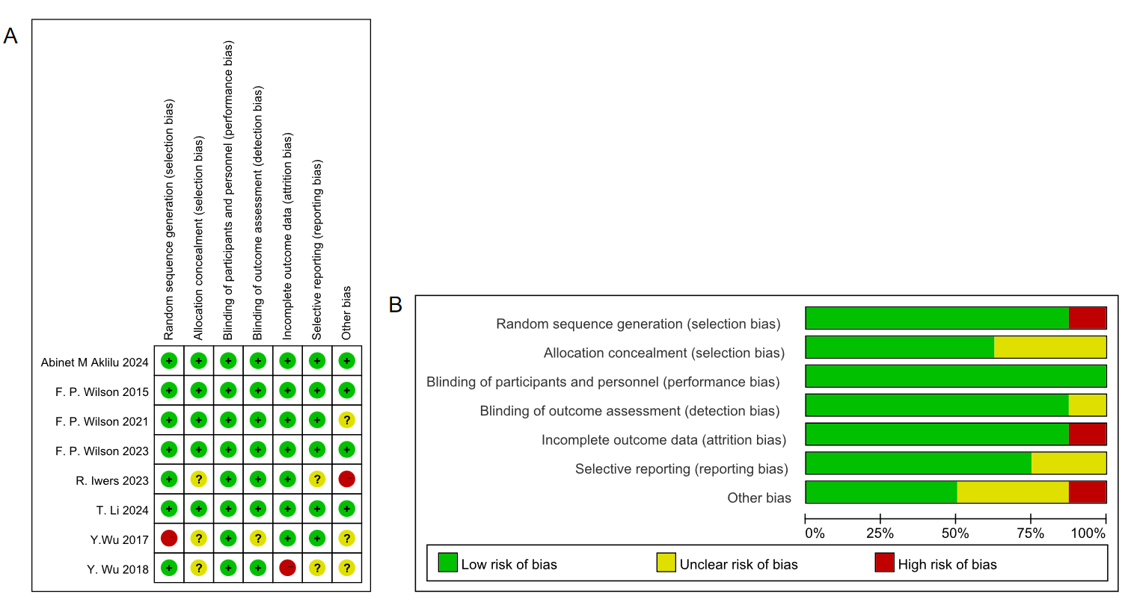
Supplementary Fig. 1 Risk of bias summary of included RCT studies
A Risk of bias details of each study by Cochrane Risk of Bias Tool;
B Risk of bias details by Cochrane Risk of Bias Tool

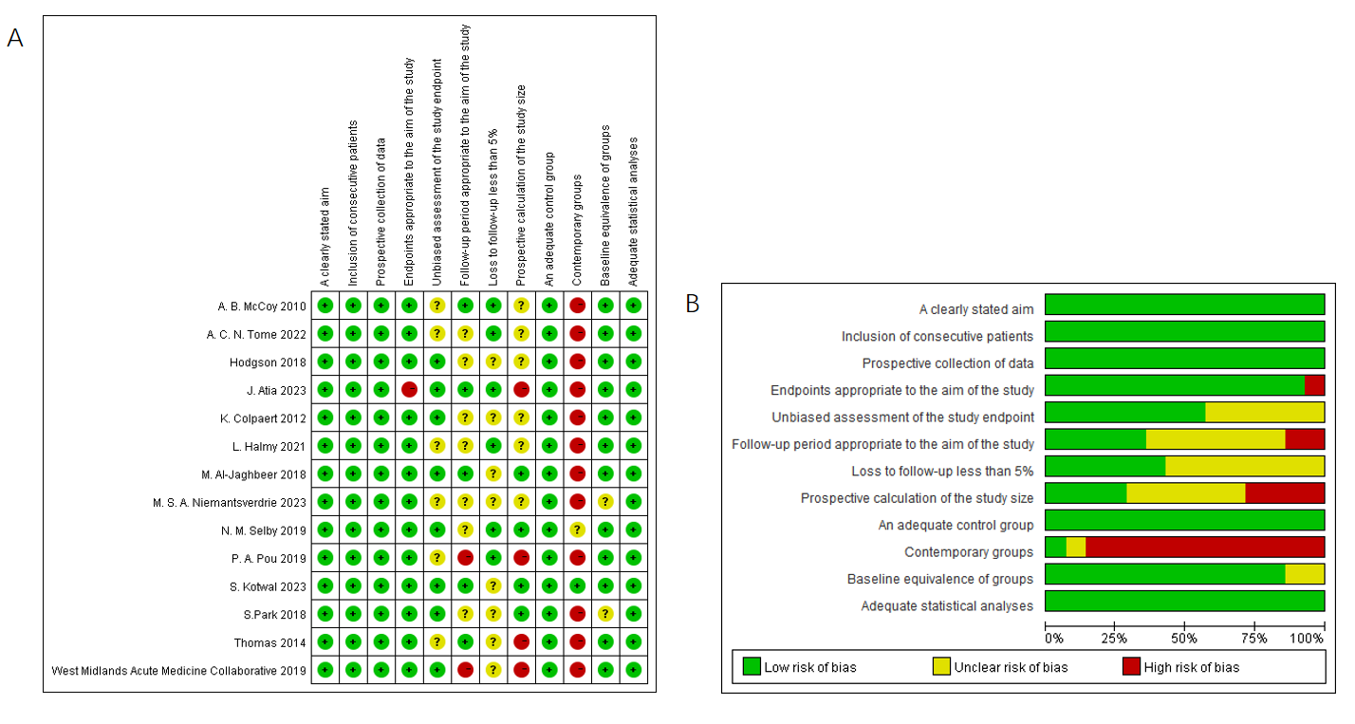
Supplementary Fig. 2 Risk of bias summary of included non-RCT studies
A Risk of bias details of each study by methodological index for non-randomized studies (MINORS);
B Risk of bias summary by MINORS;

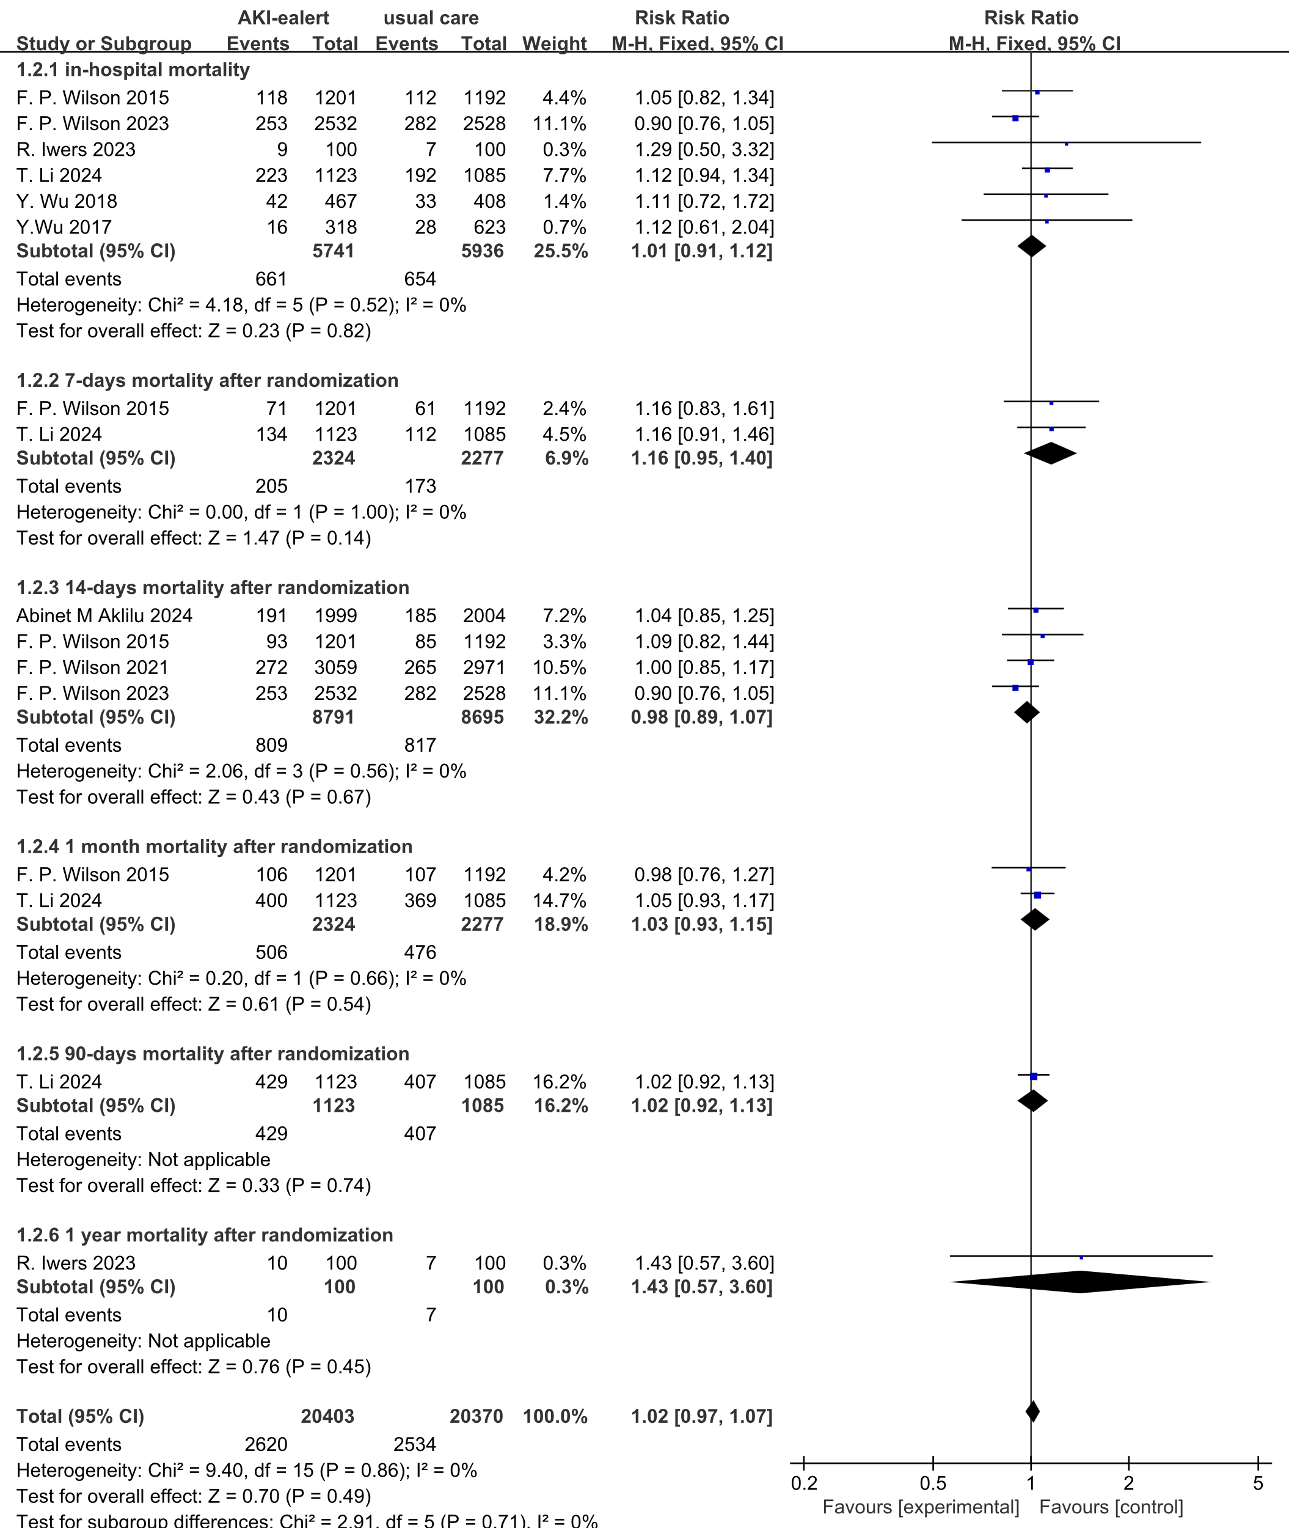
Supplementary Fig. 3 Mortality observed at different time points of RCTs

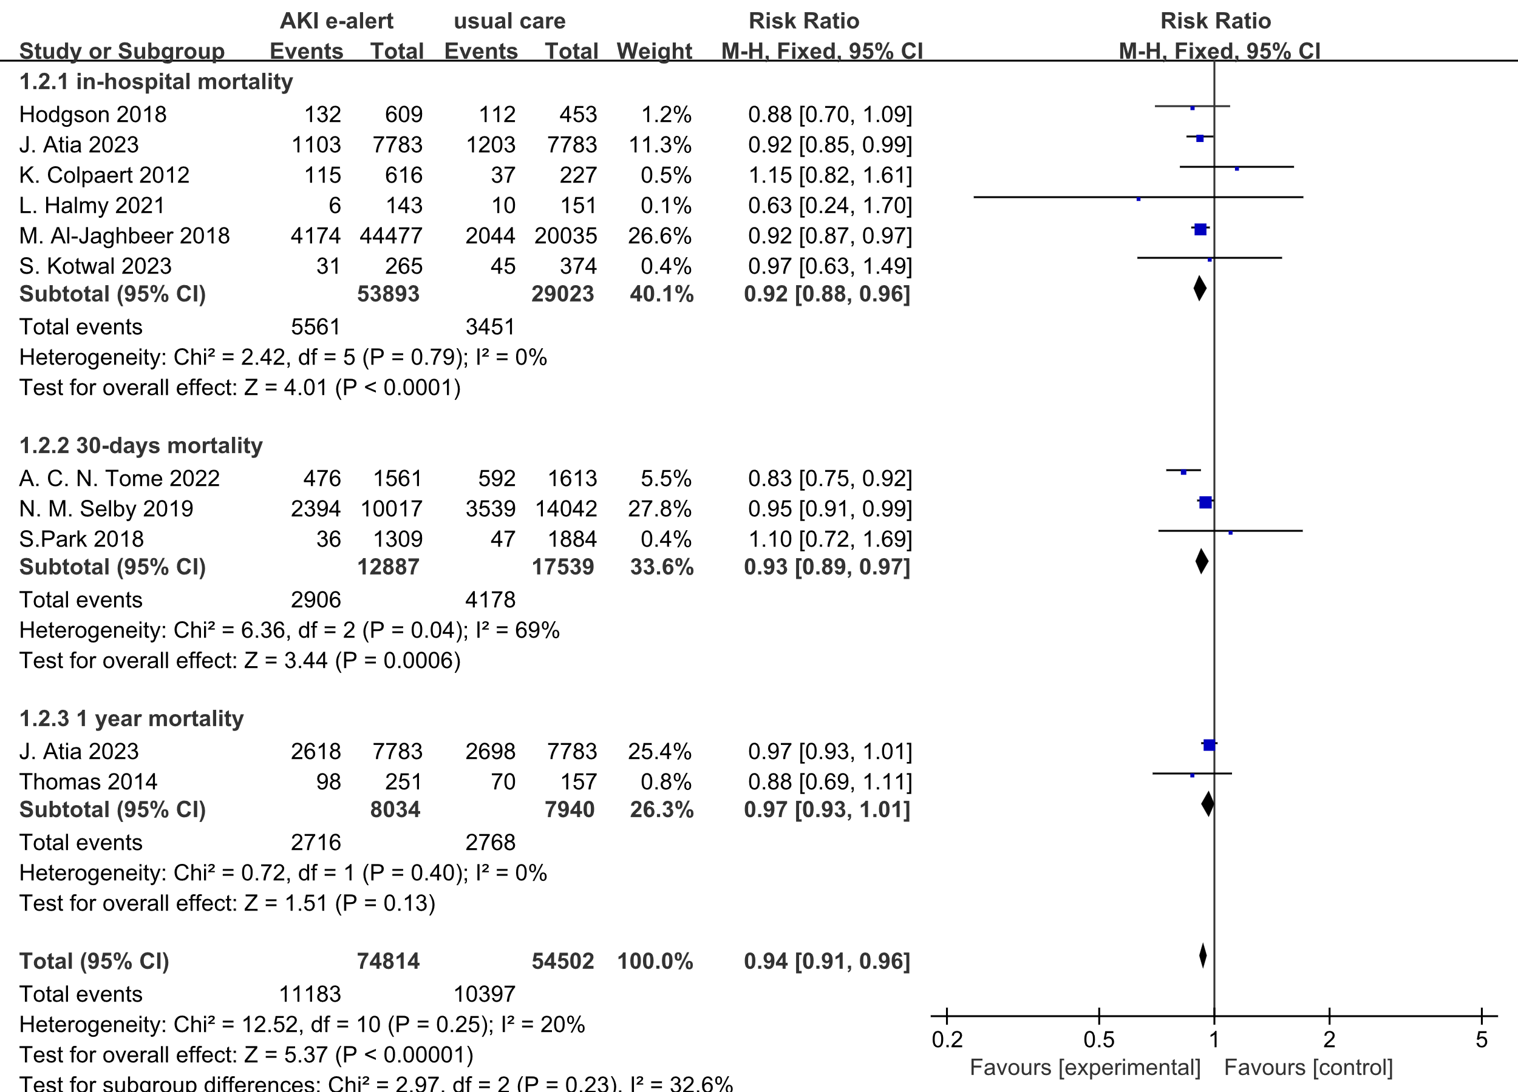
Supplementary Fig. 4 Mortality observed at different time points of non-RCTs

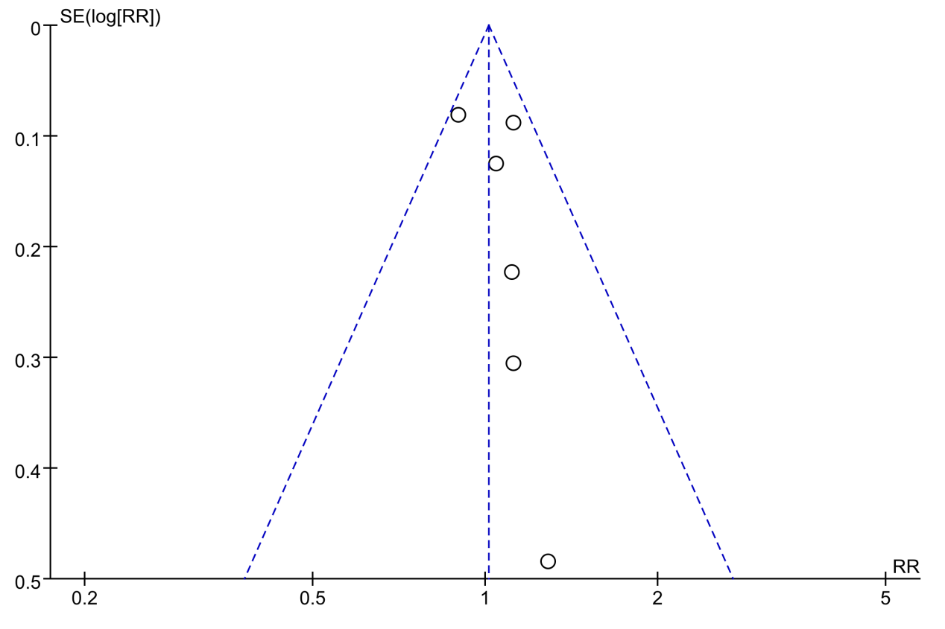
Supplementary Fig. 5 Funnel plot of in-hospital mortality on RCTs

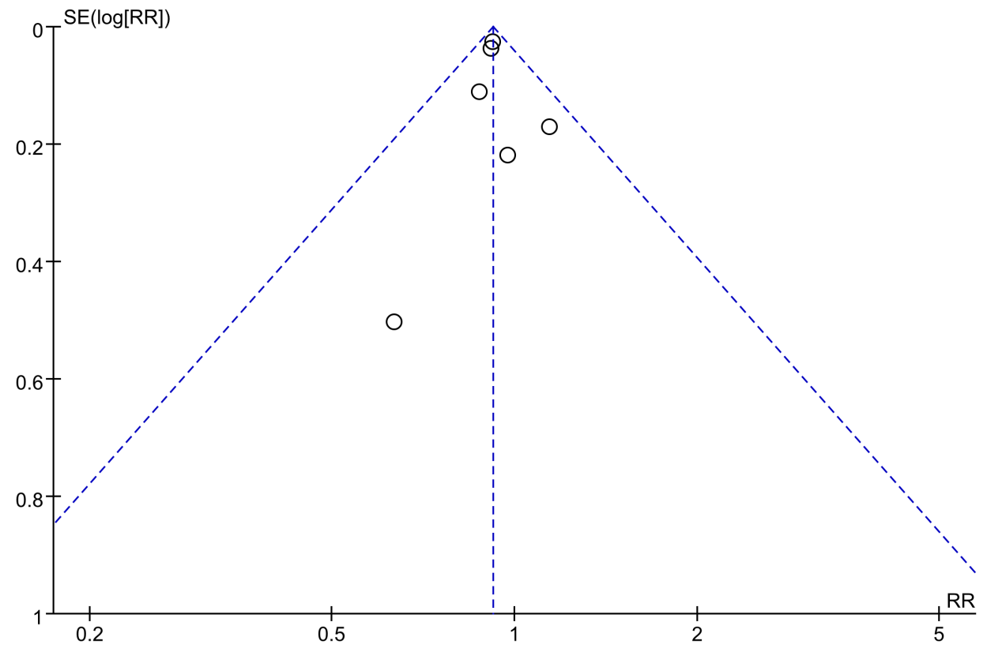
Supplementary Fig. 6 Funnel plot of in-hospital mortality on non-RCTs

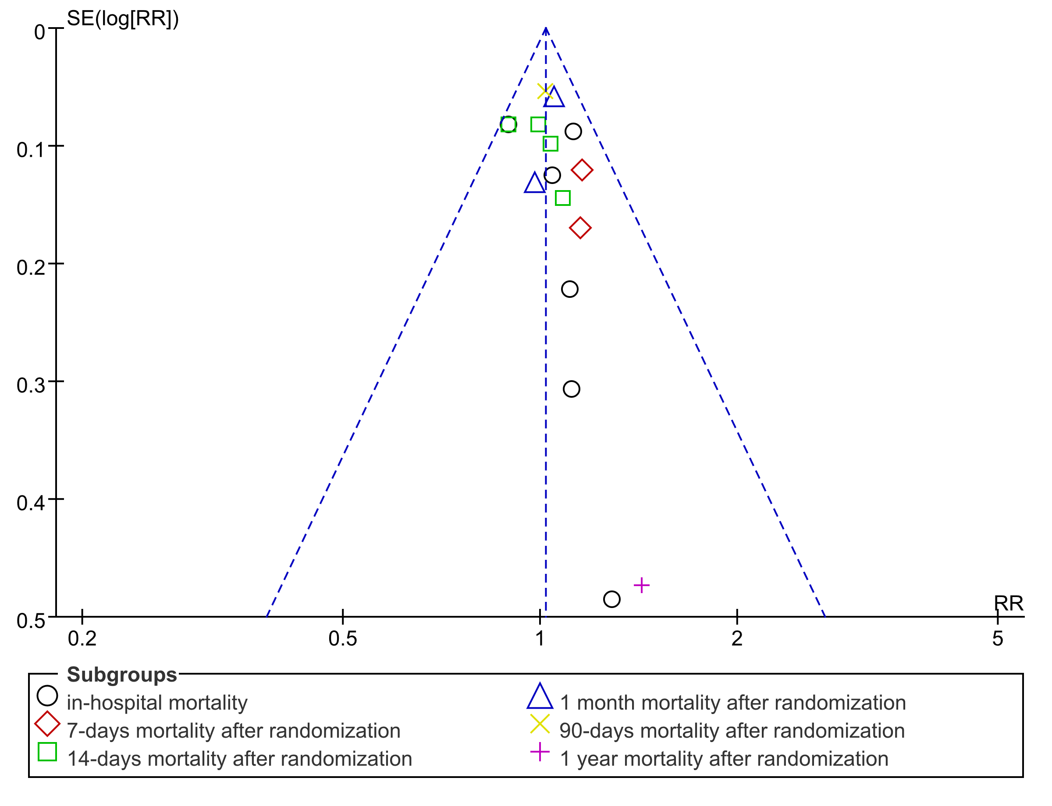
Supplementary Fig. 7 Funnel-plot of RCTs mortality at all stages

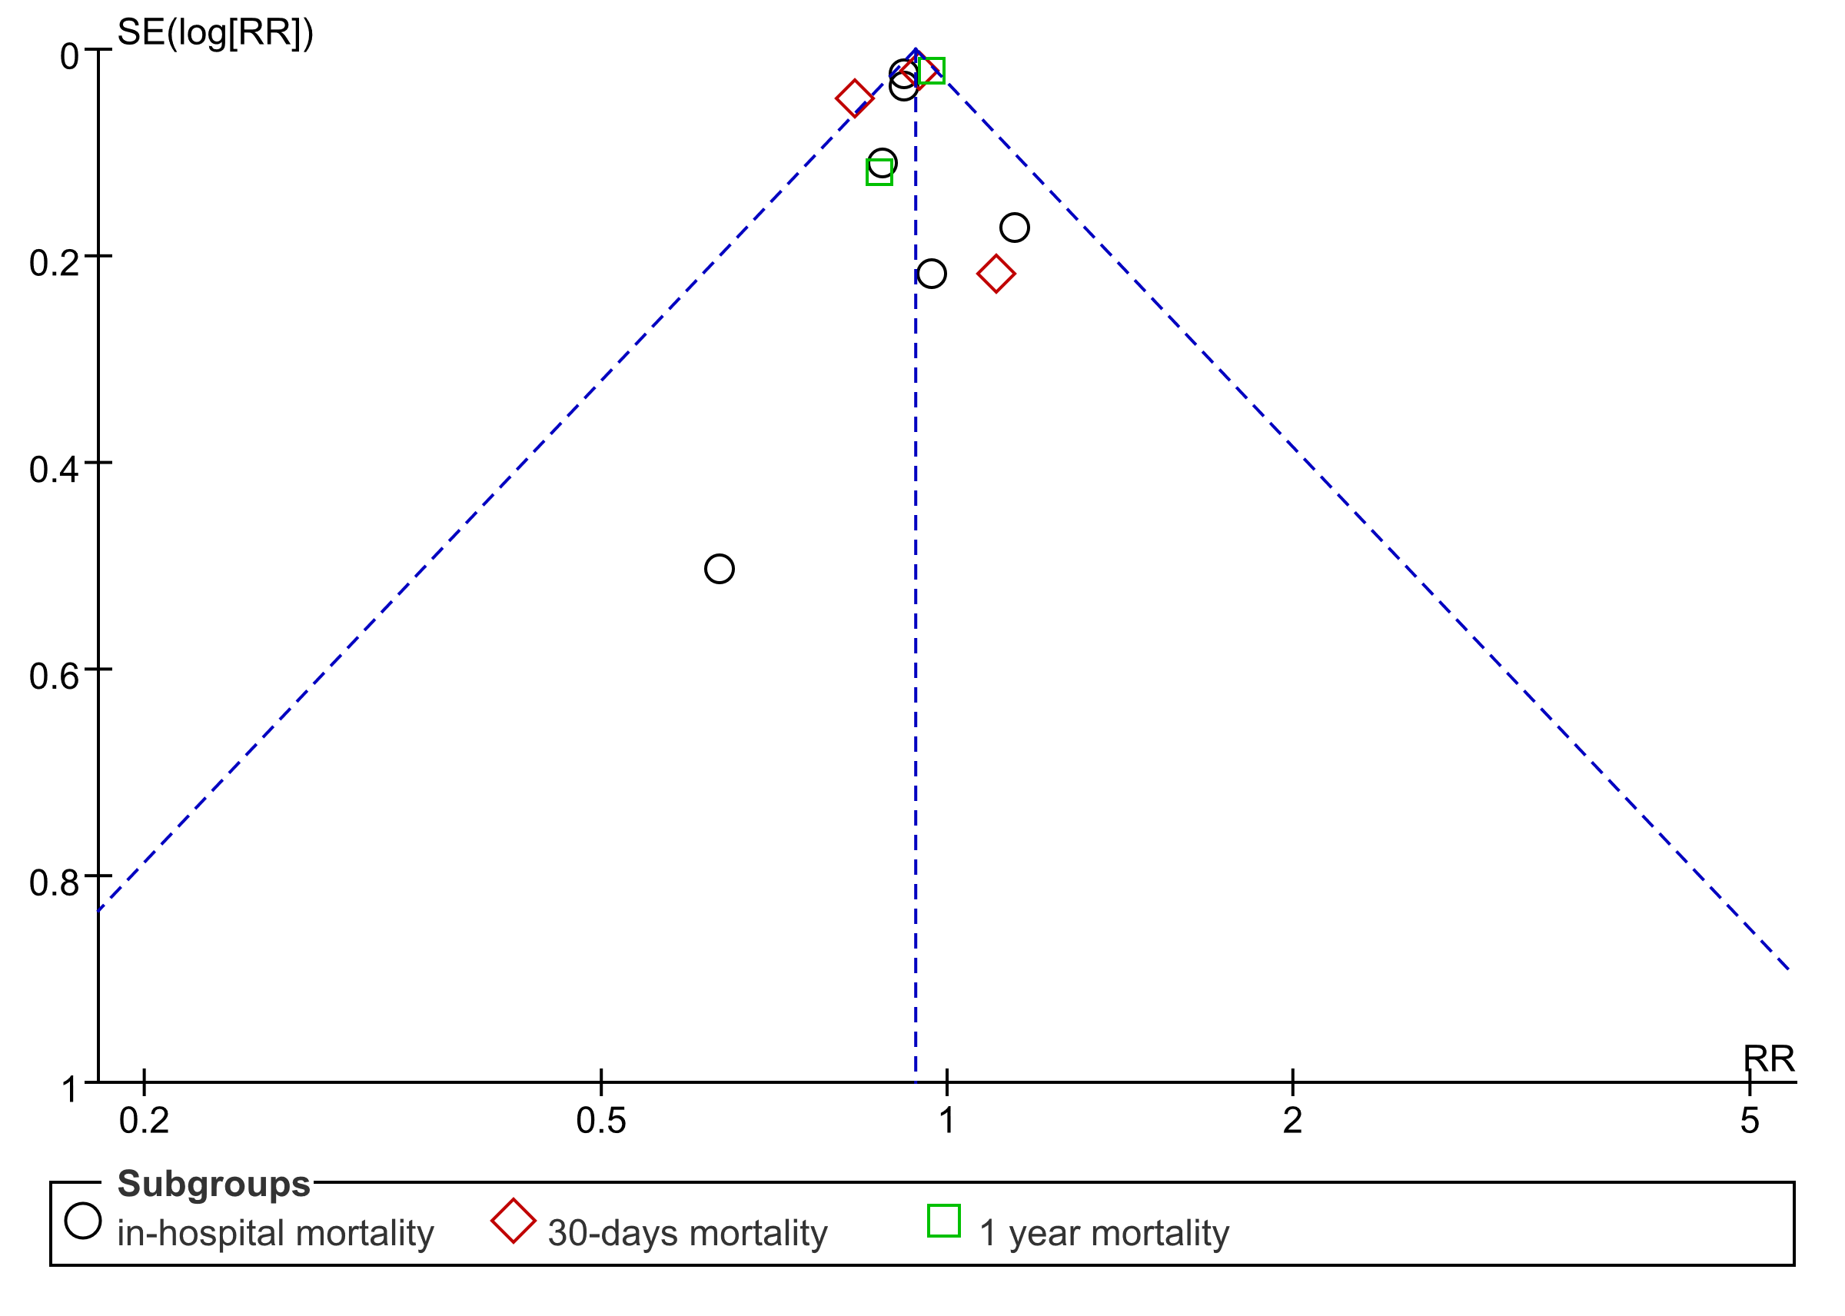
Supplementary Fig. 8 Funnel-plot of non-RCTs mortality at all stages

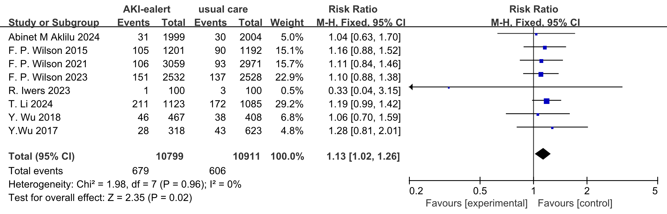
Supplementary Fig. 9 Forest plot of RRT usage on RCTs

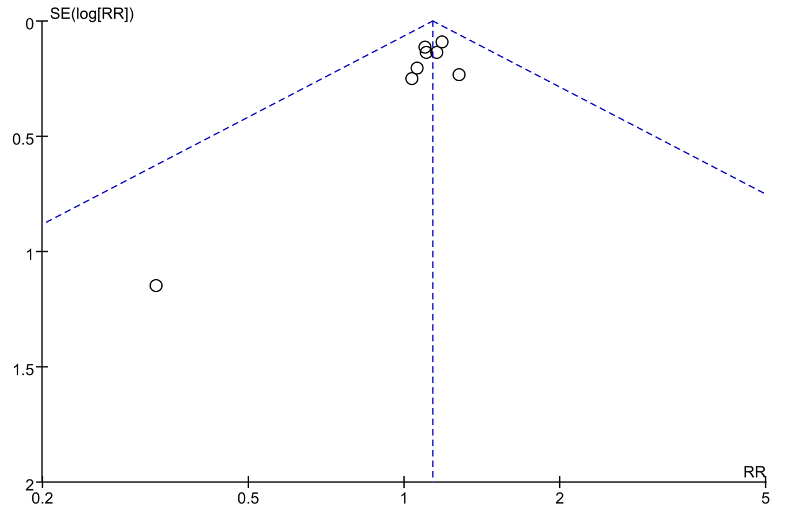
Supplementary Fig. 10 Funnel plot of RRT usage on RCTs

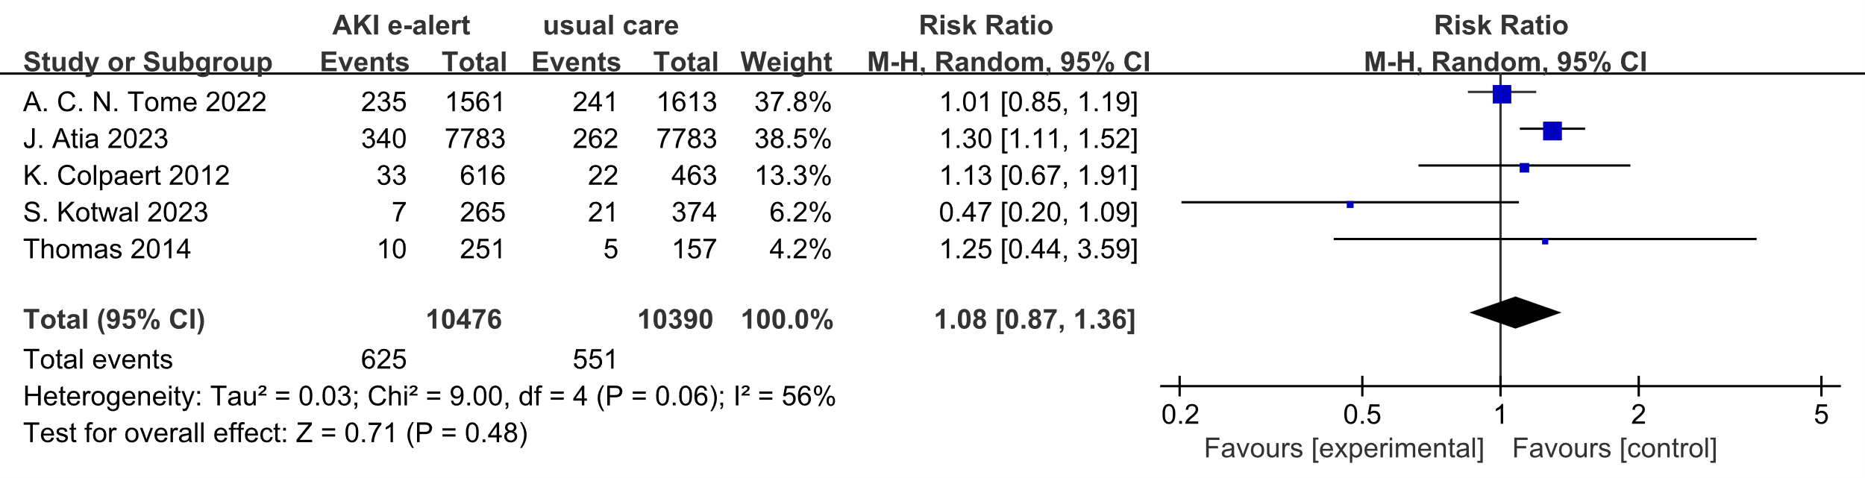
Supplementary Fig. 11 Forest plot of RRT usage on non-RCTs

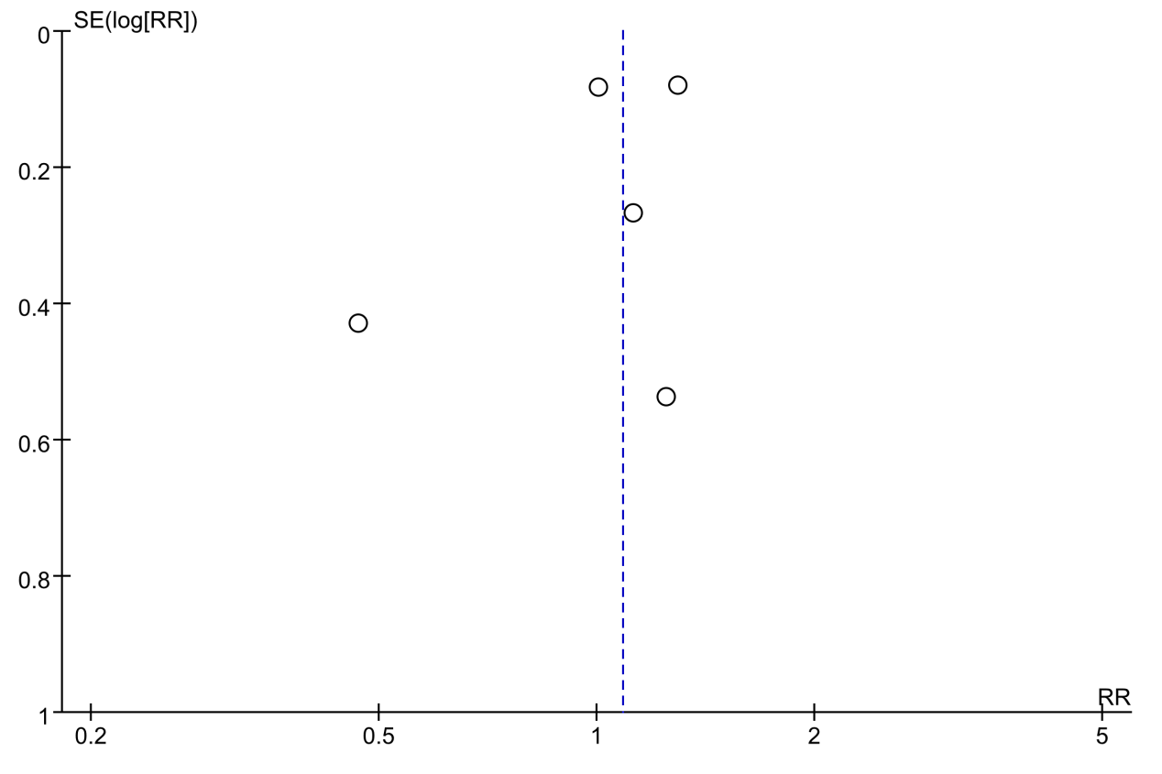
Supplementary Fig. 12 Funnel plot of RRT usage on non-RCTs

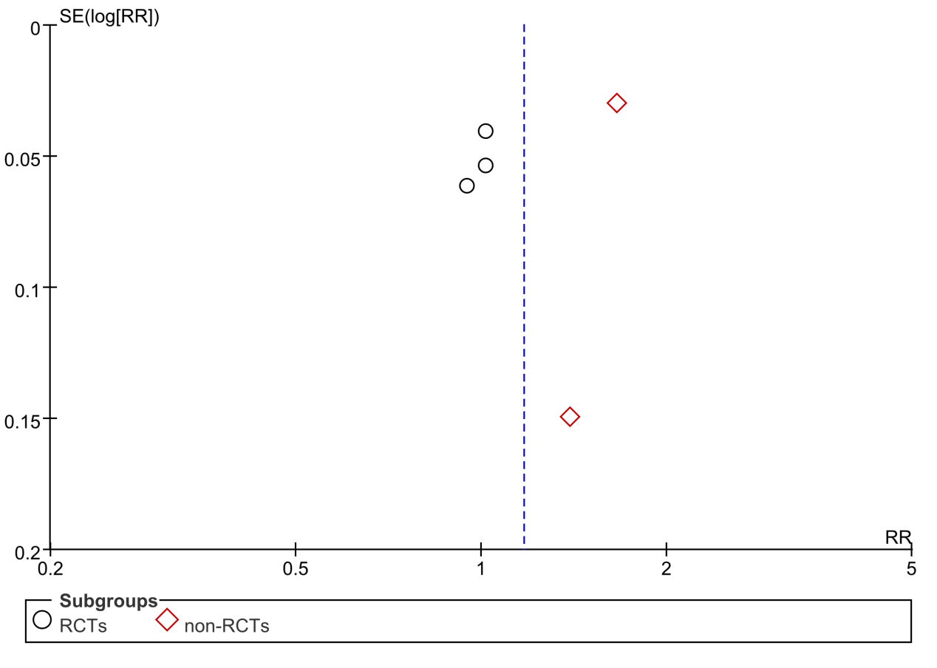
Supplementary Fig. 13 Funnel plot of renal recovery on RCTs and non-RCTs

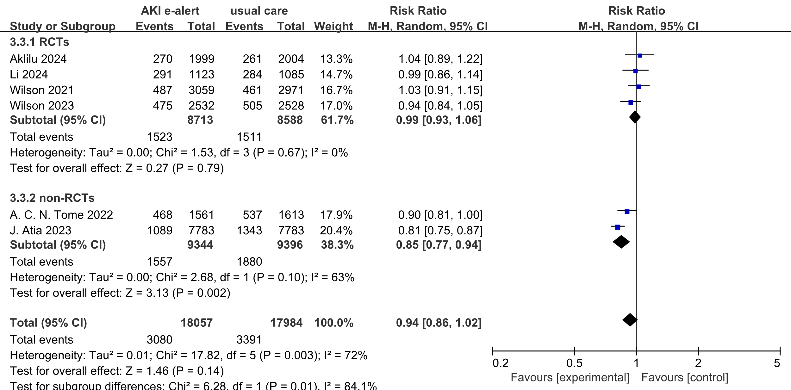

Supplementary Fig. 14 Forest plot of AKI progression on RCTs and non-RCTs

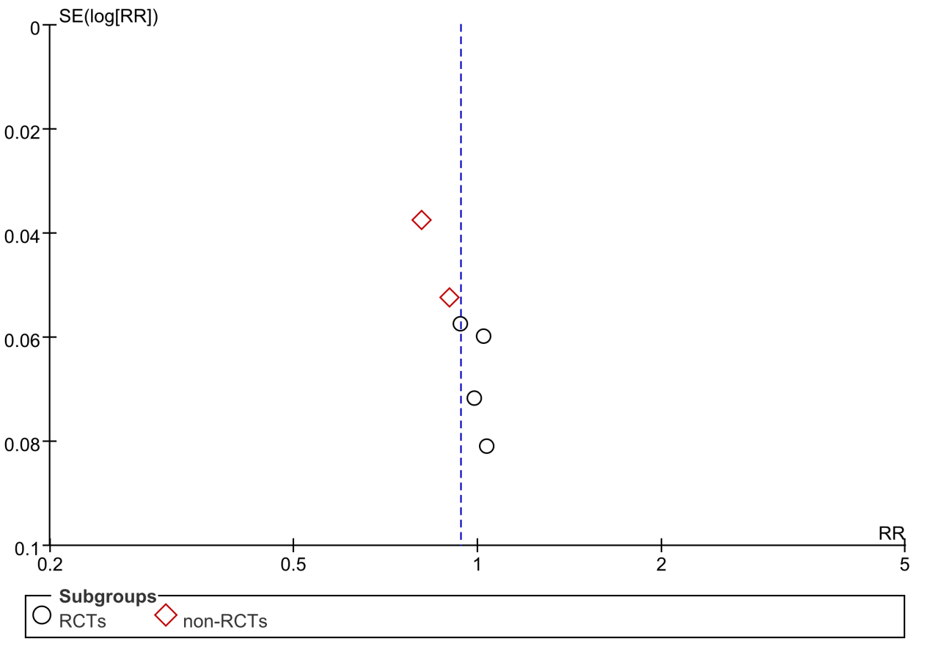
Supplementary Fig. 15 Funnel plot of AKI progression on RCTs and non-RCTs

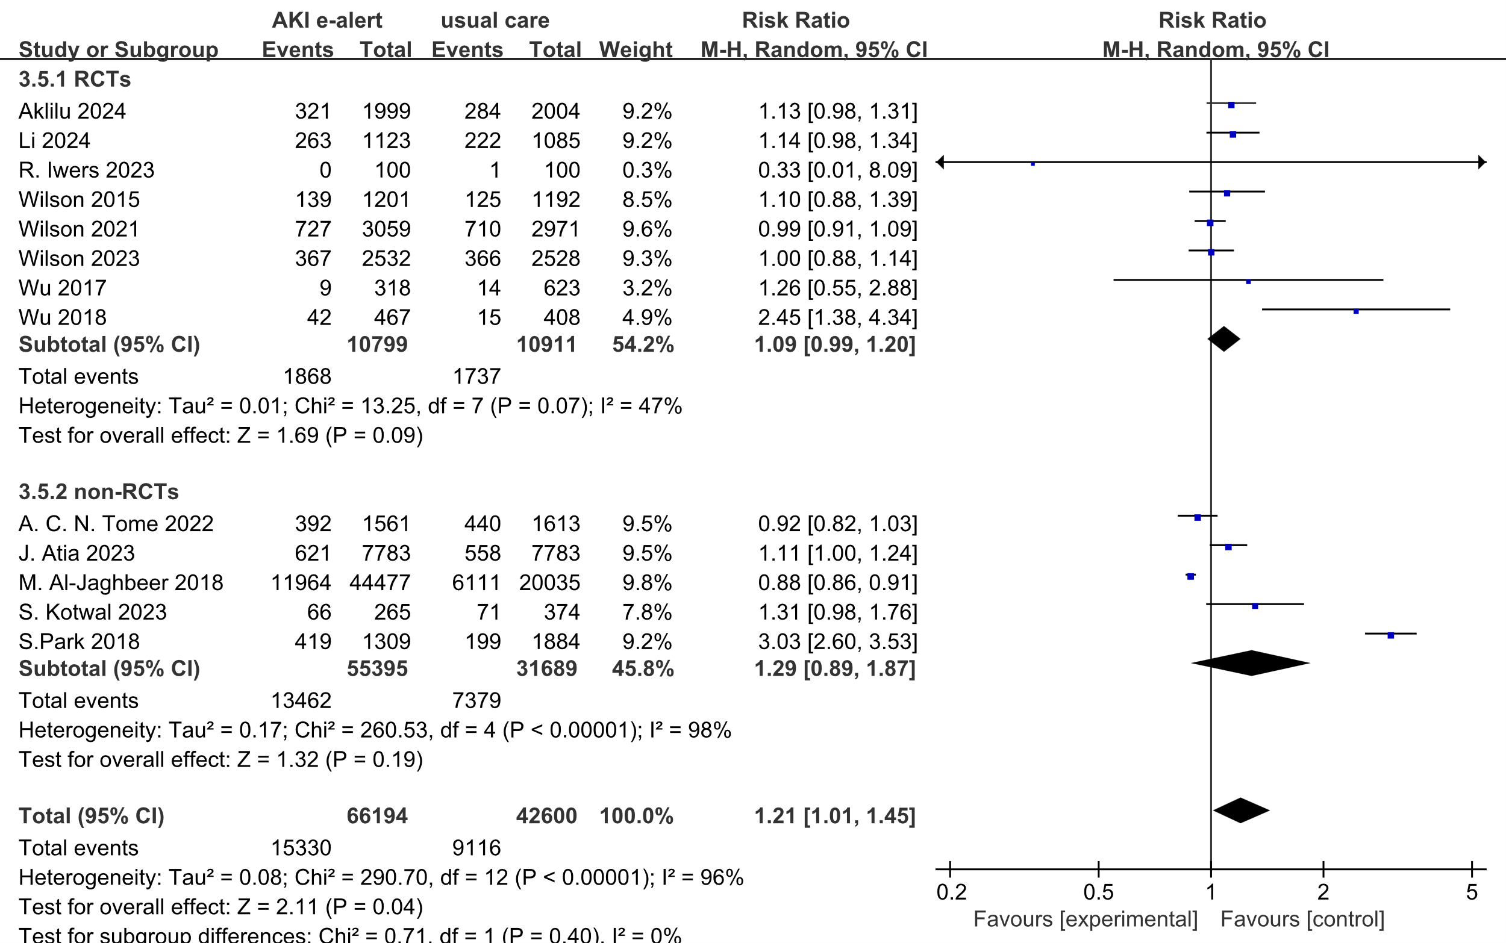
Supplementary Fig. 16 Forest plot of nephrologist consultation on RCTs and non-RCTs

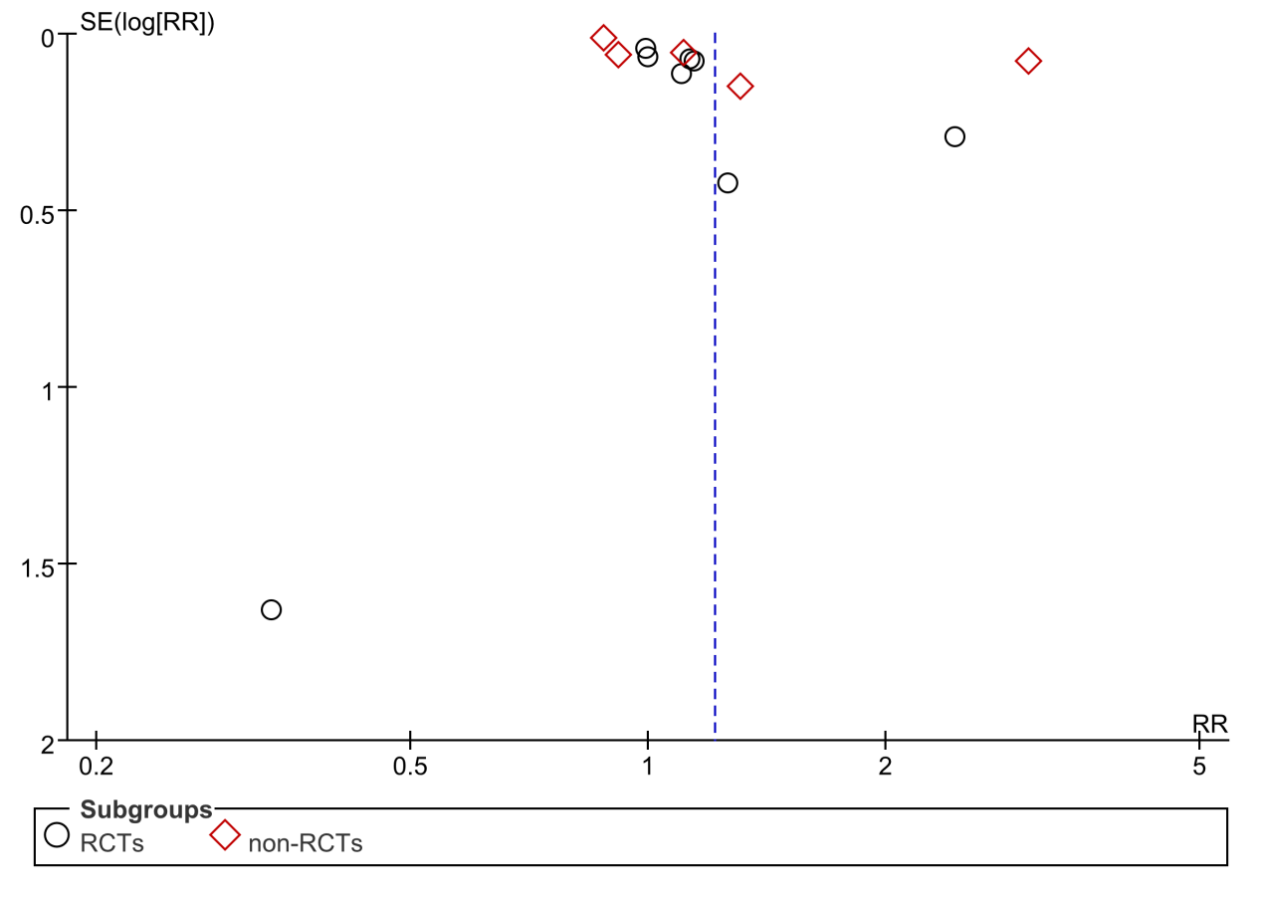
Supplementary Fig. 17 Funnel plot of nephrologist consultation on RCTs and non-RCTs

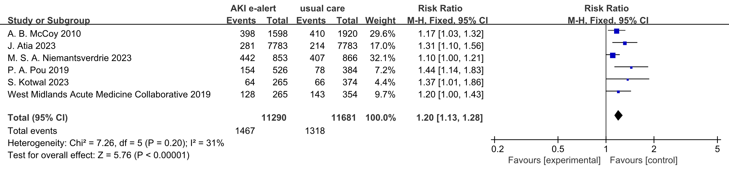
Fig. 18 Forest plot of discontinuation of potentially nephrotoxic medications on non-RCTs

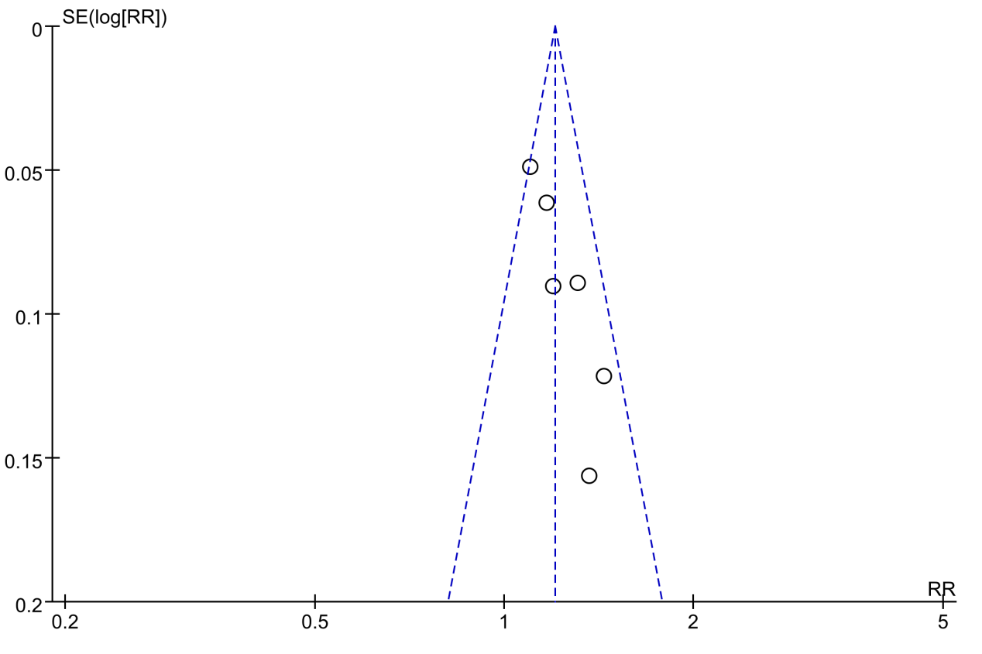
Supplementary Fig. 19 Funnel plot of discontinuation of potentially nephrotoxic medications on non-RCTs

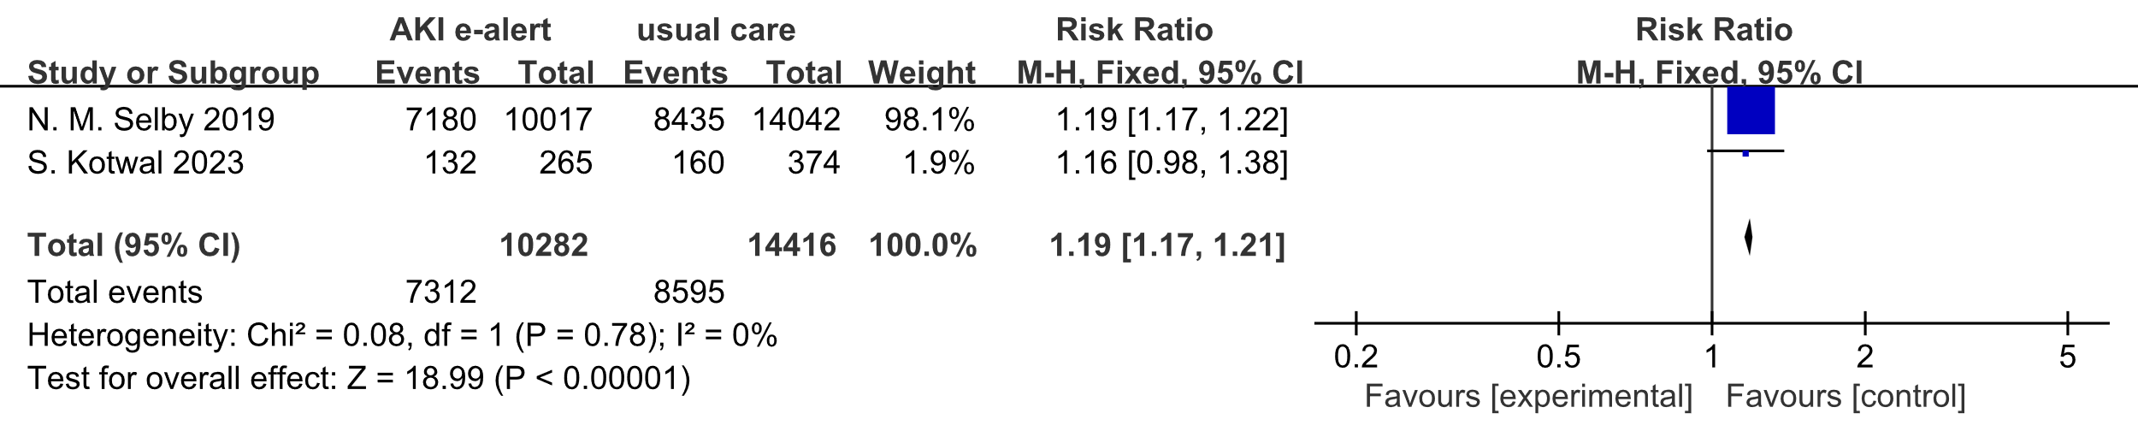

Supplementary Fig. 20 Forest plot of drug review rate on non-RCTs

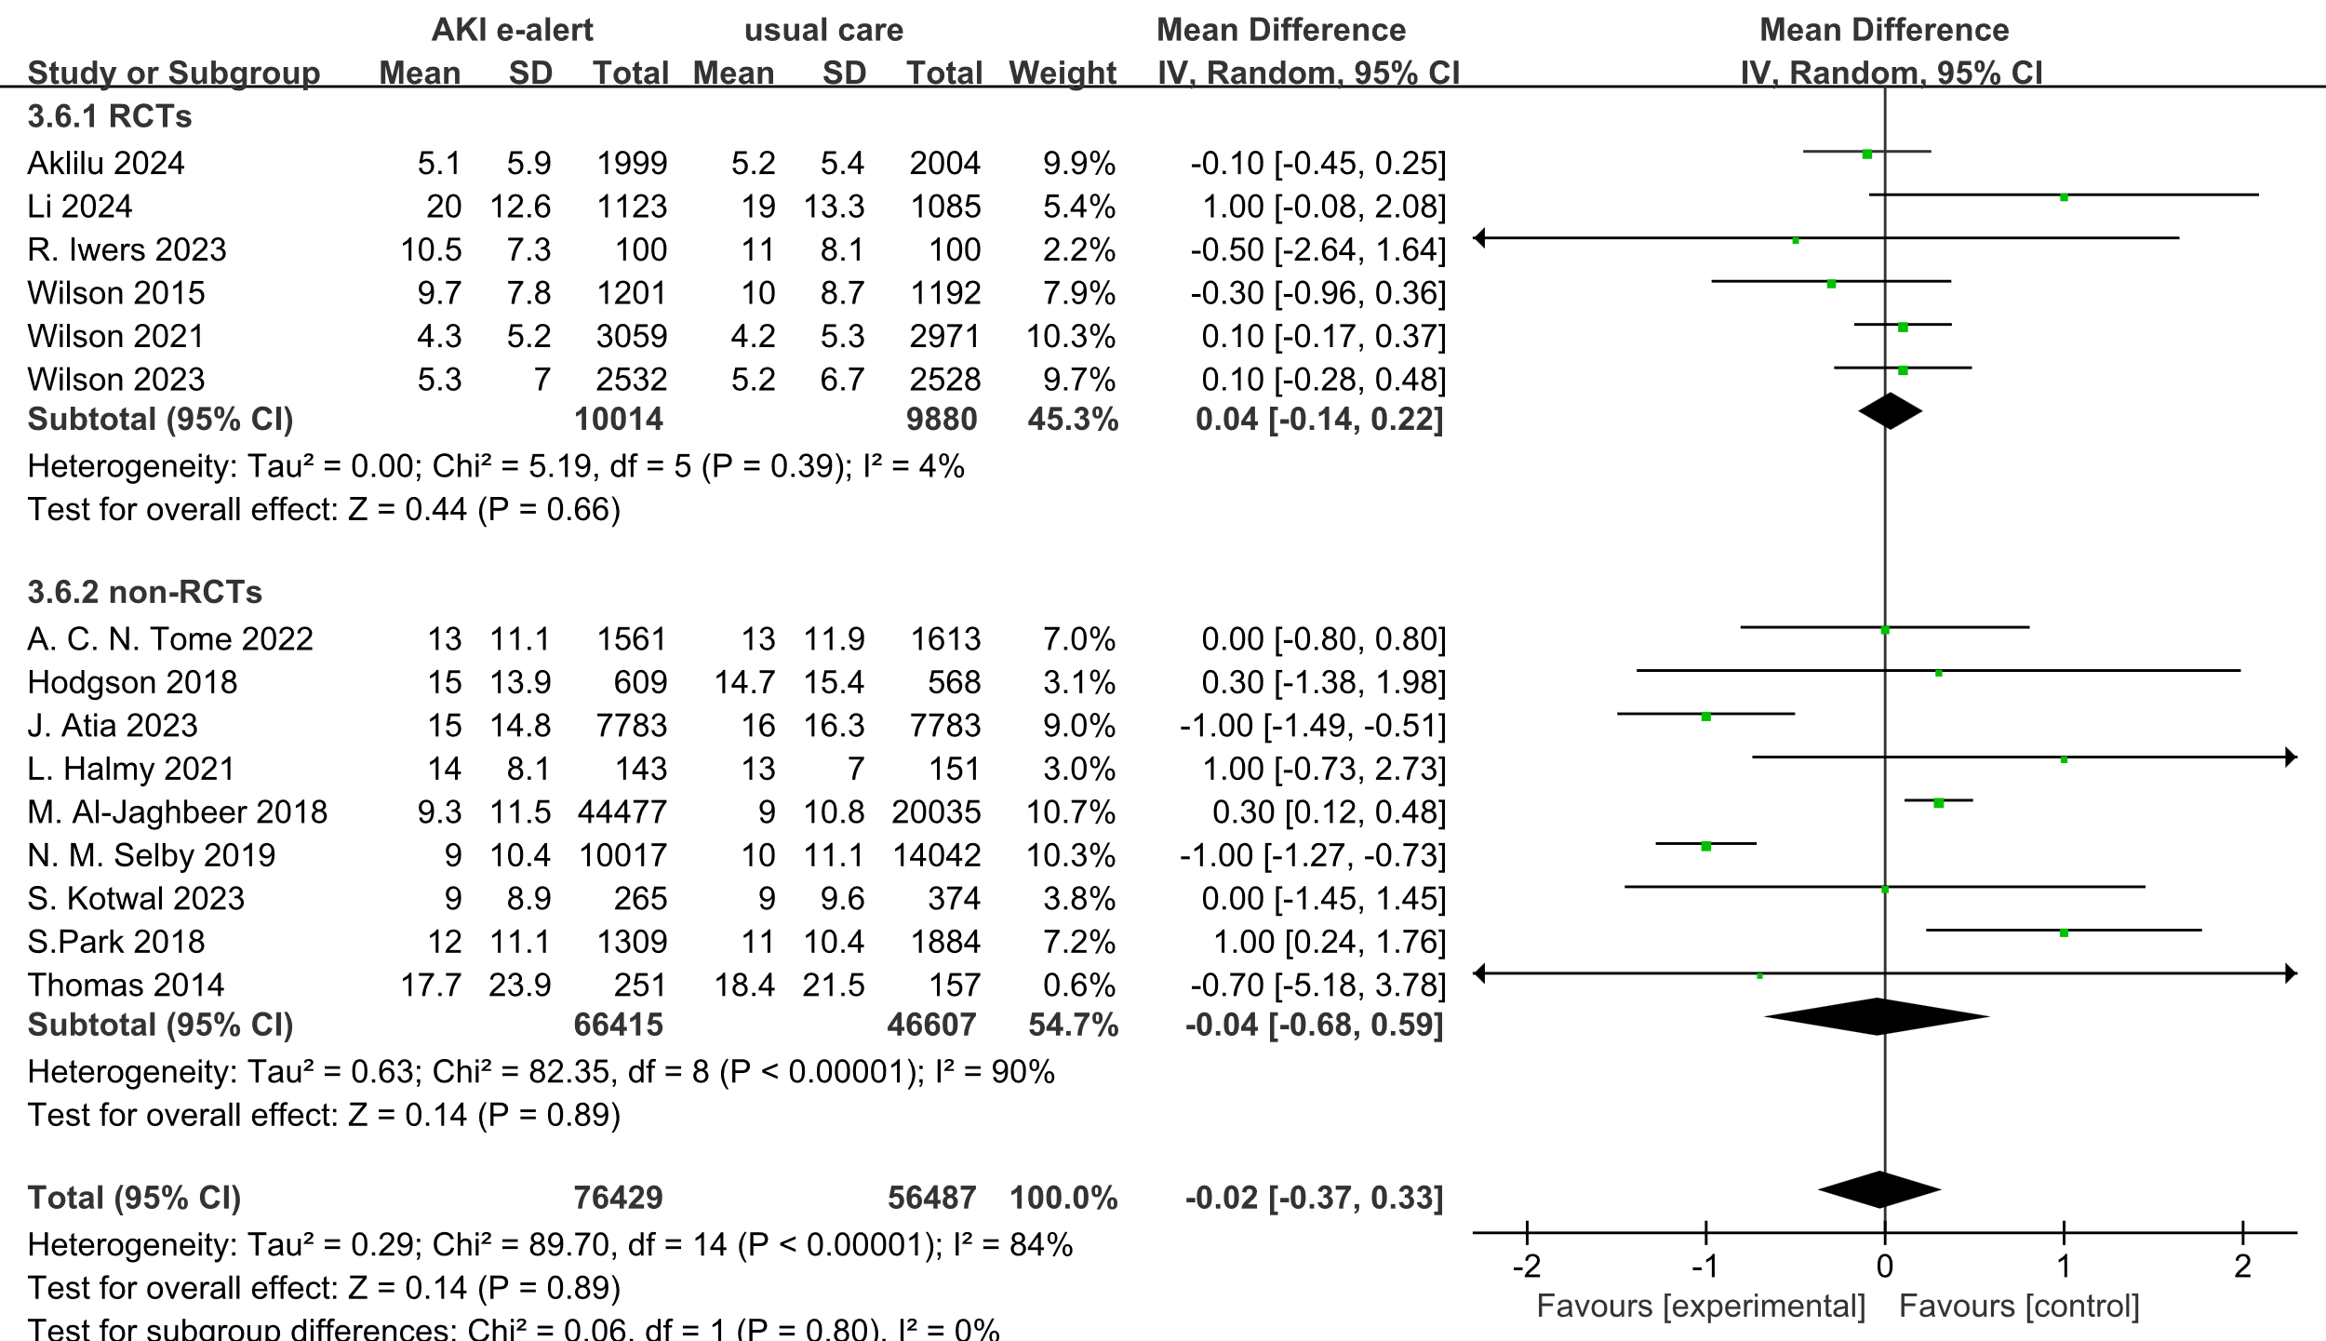
Supplementary Fig. 21 Forest plot of length of hospital stay on RCTs and non-RCTs

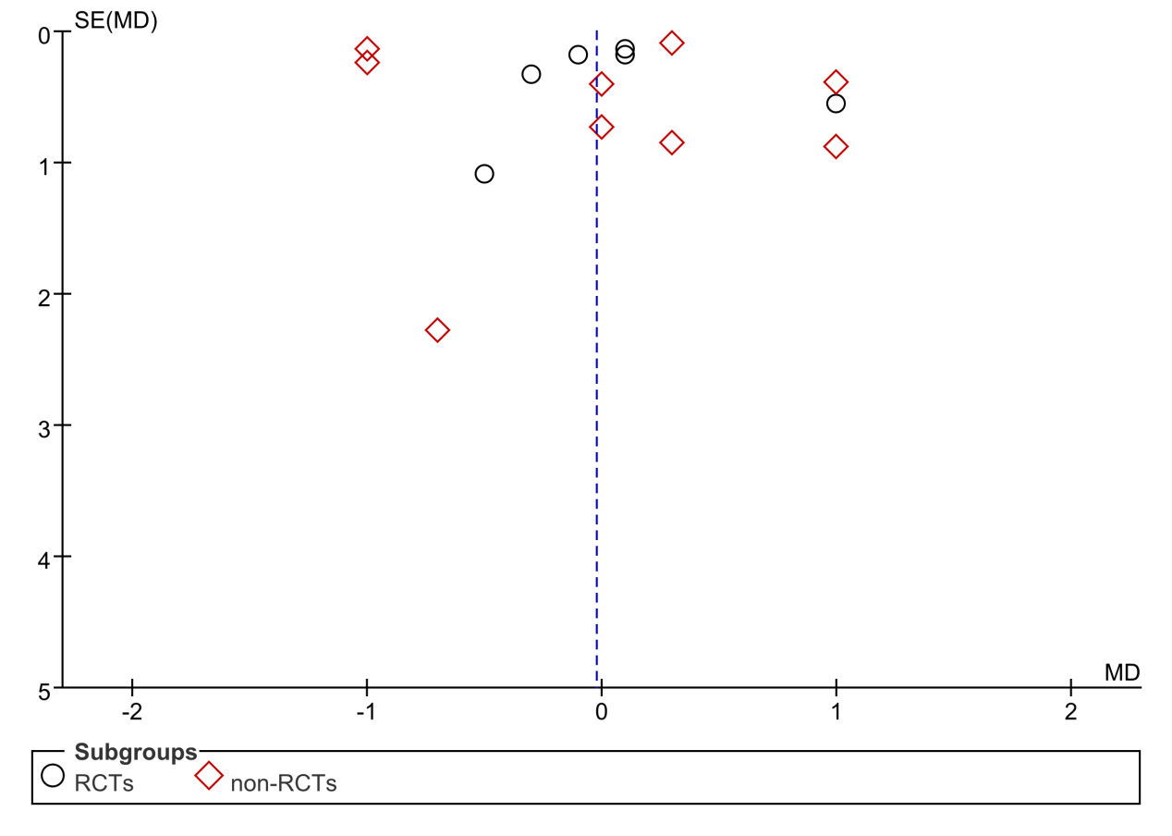
Supplementary Fig. 22 Funnel plot of length of stay on RCTs and non-RCTs

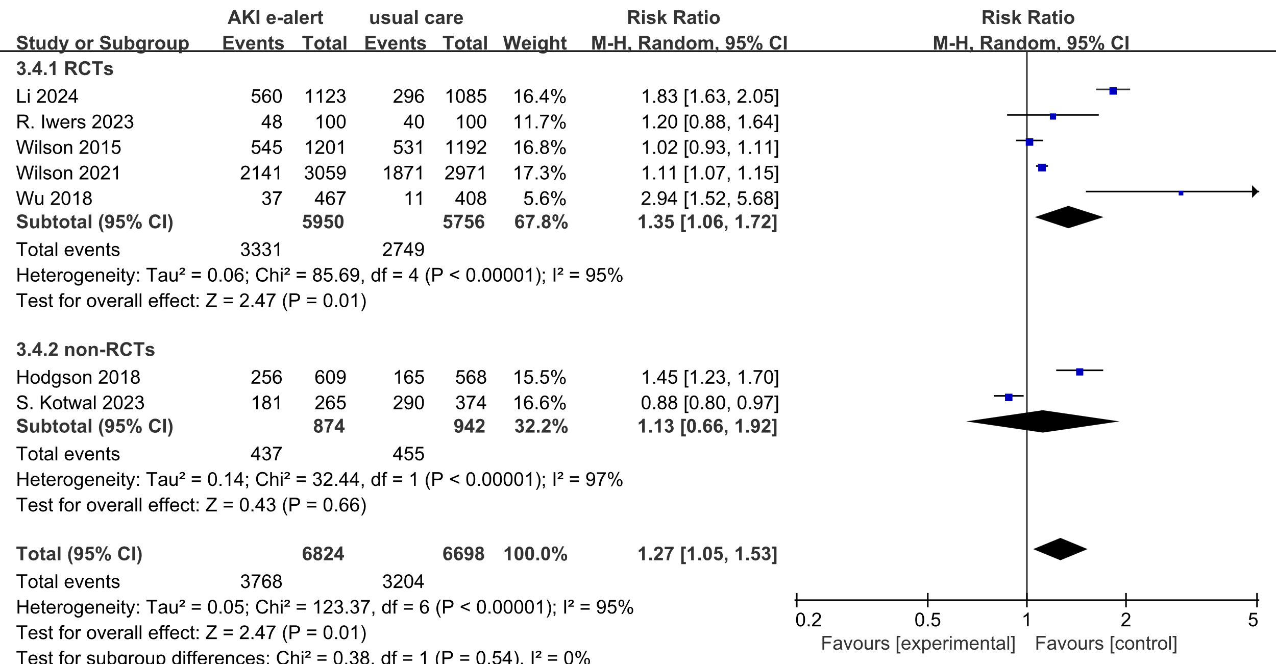
Supplementary Fig. 23 Forest plot of AKI documentation on RCTs and non-RCTs

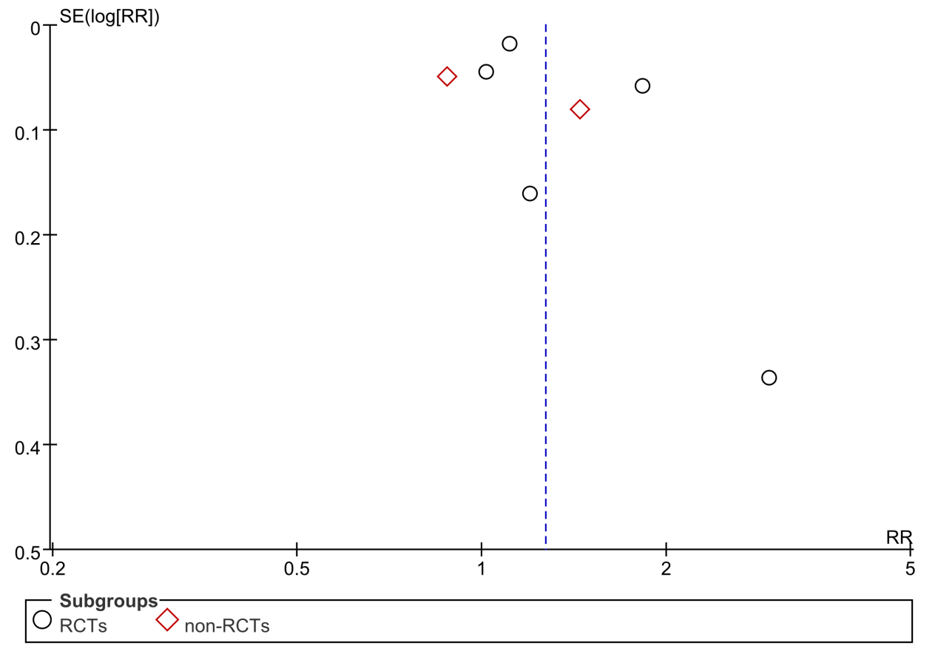
Supplementary Fig. 24 Funnel plot of AKI documentation on RCTs and non-RCTs

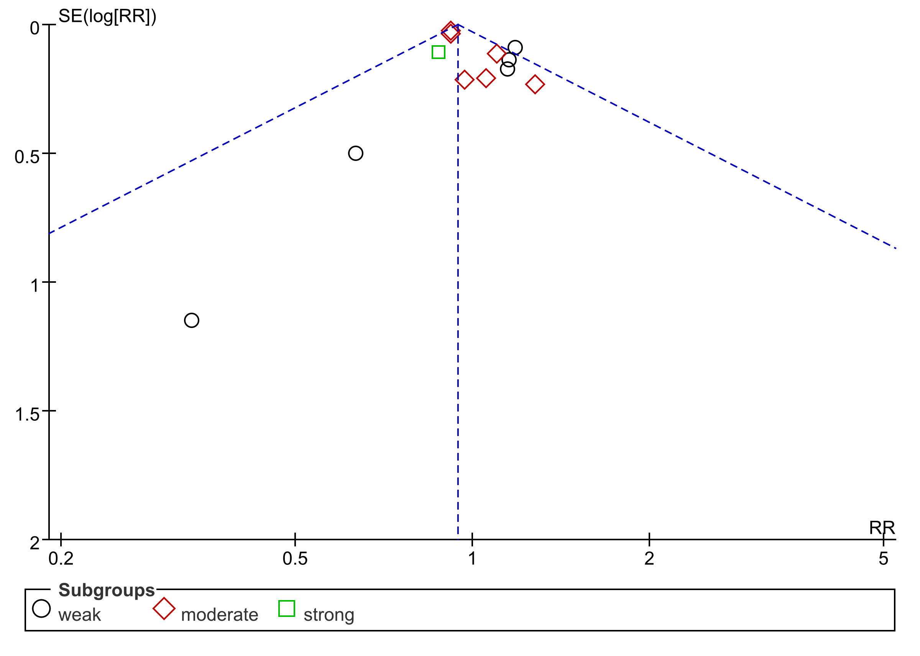

Supplementary Fig. 25 Funnel plot of alert response intensity for subgroup analysis on in-hospital mortality
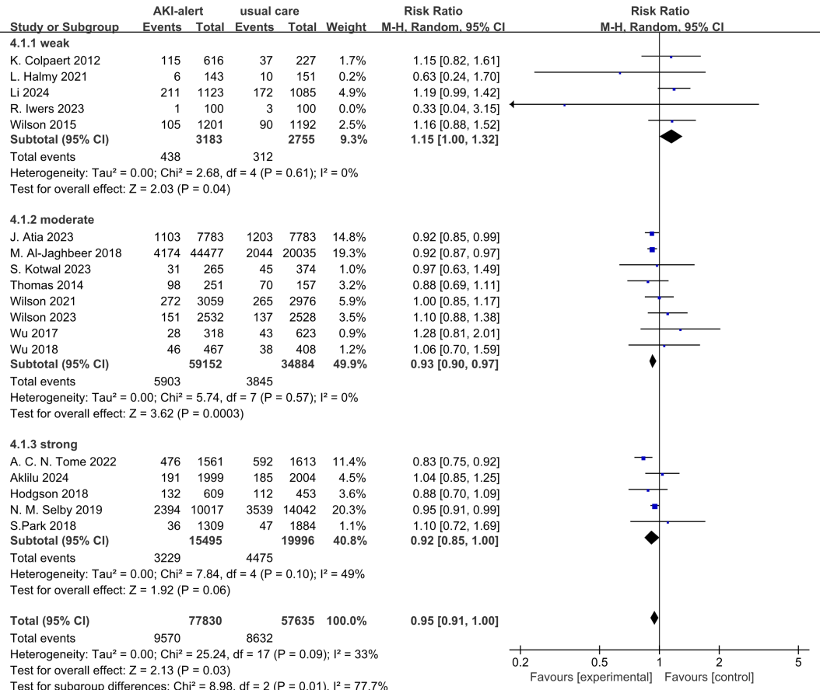
Supplementary Fig. 26 Forest plot of alert response intensity for subgroup analysis of mortality using random-effects model (sensitivity analysis)
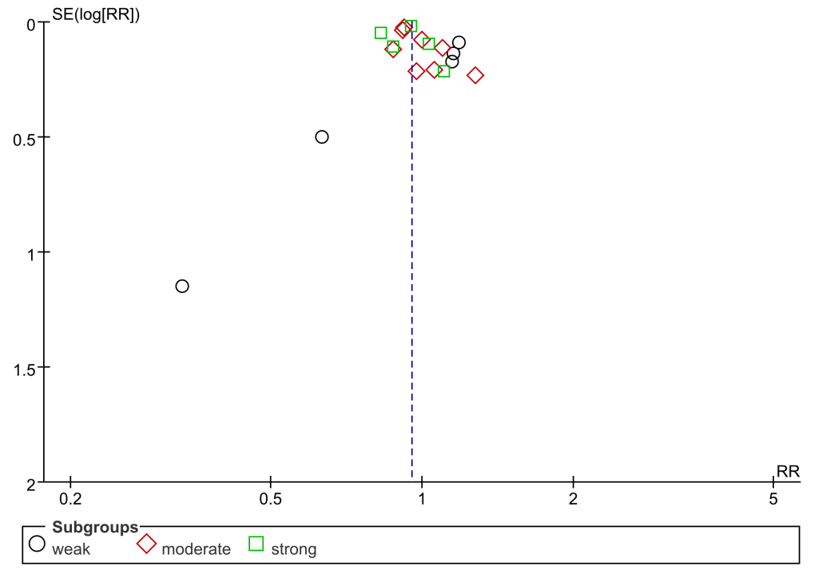
Supplementary Fig. 27 Funnel plot of alert response intensity for subgroup analysis on mortality using random-effects model

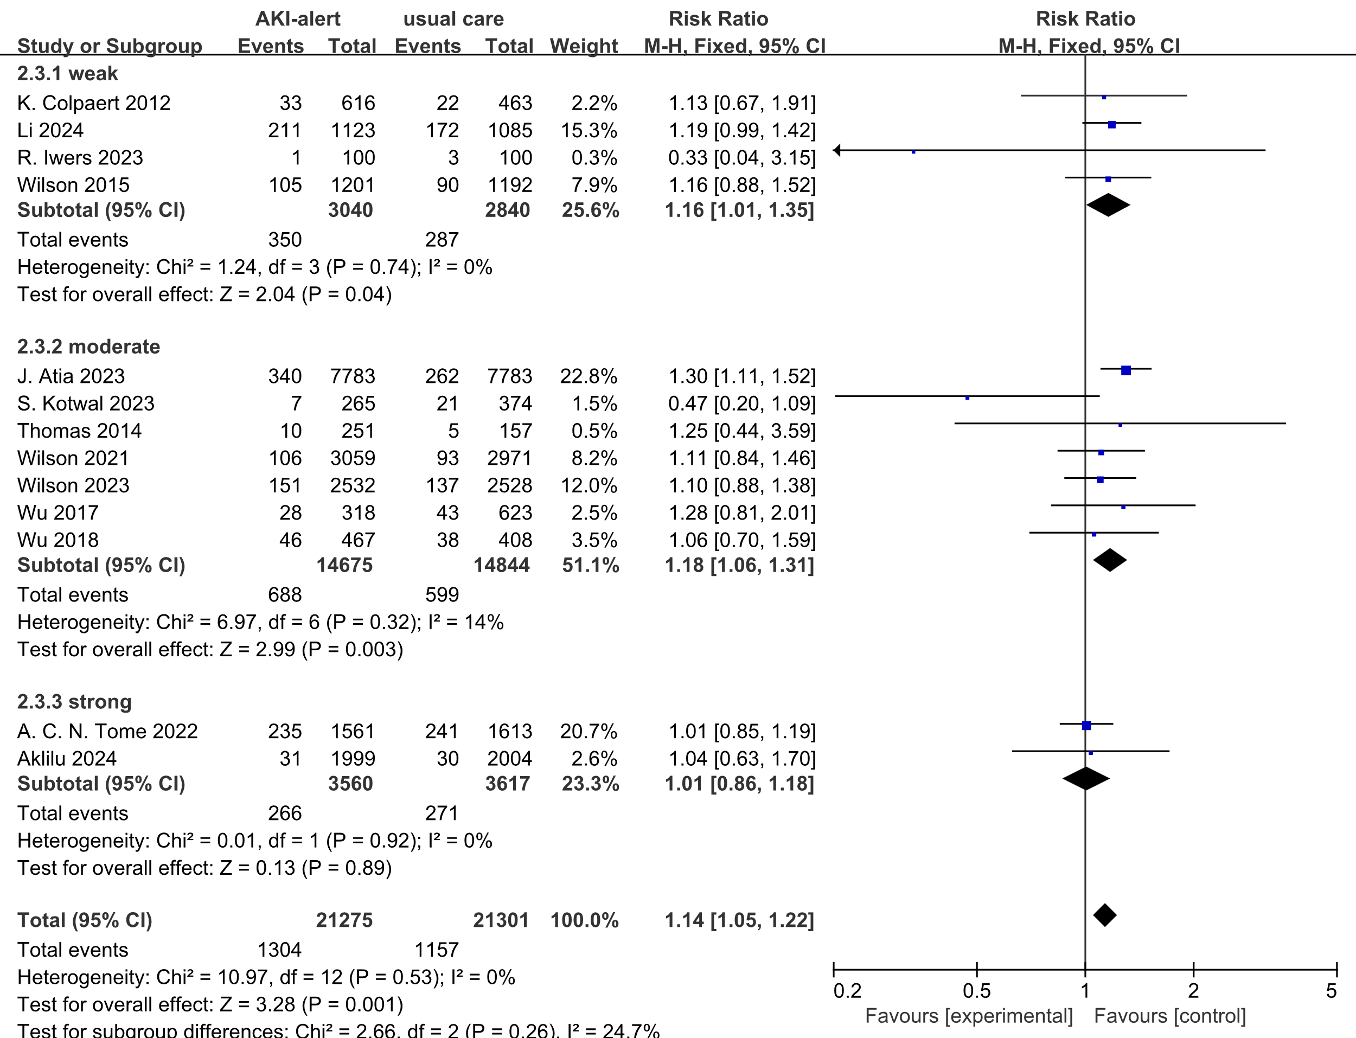
Supplementary Fig. 28 Forest plot of alert response intensity for subgroup analysis of RRT usage

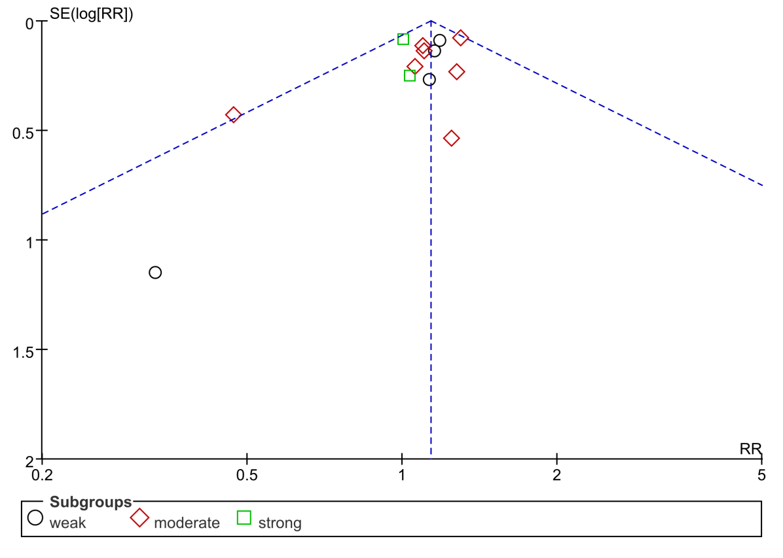
Supplementary Fig. 29 Funnel plot of subgroup analysis on RRT usage

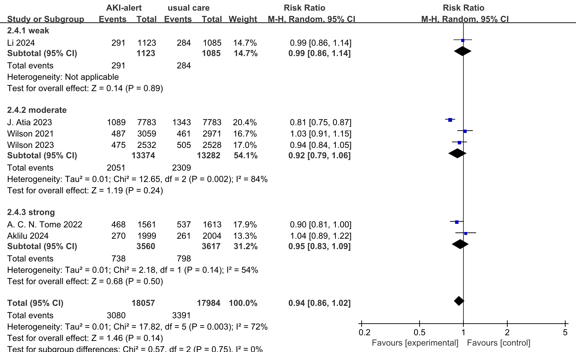
Fig. 30 Forest plot of alert response intensity for subgroup analysis of AKI progression

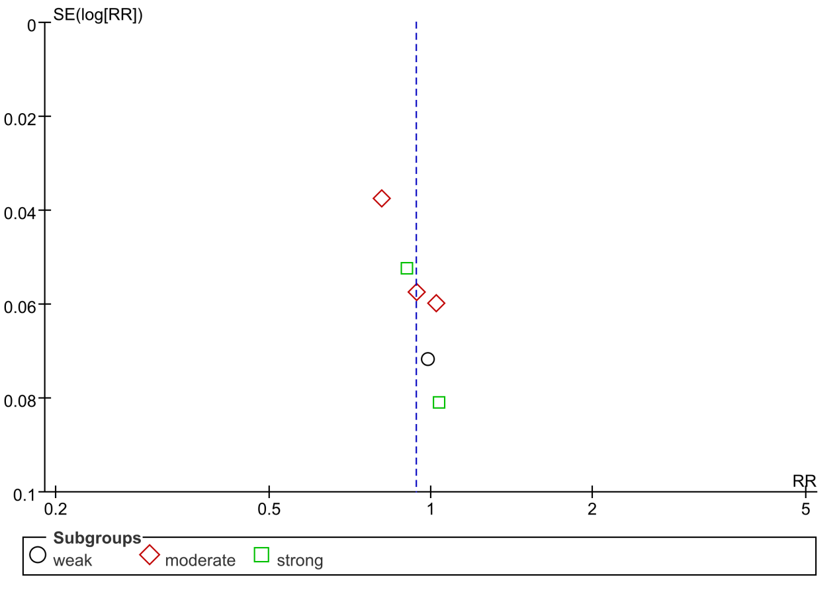
Supplementary Fig. 31 Funnel plot of subgroup analysis on AKI progression

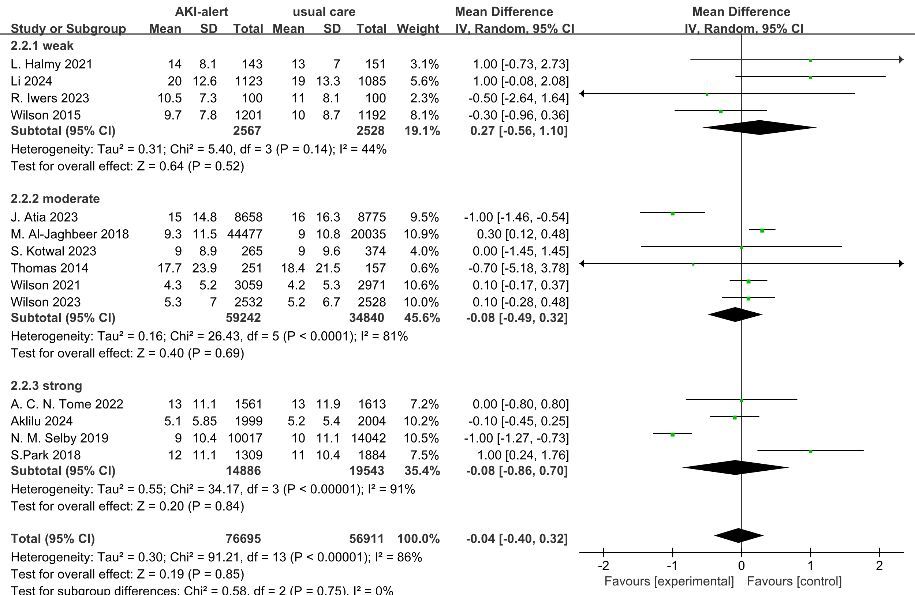
Supplementary Fig. 32 Forest plot of alert response intensity for subgroup analysis of length of stay

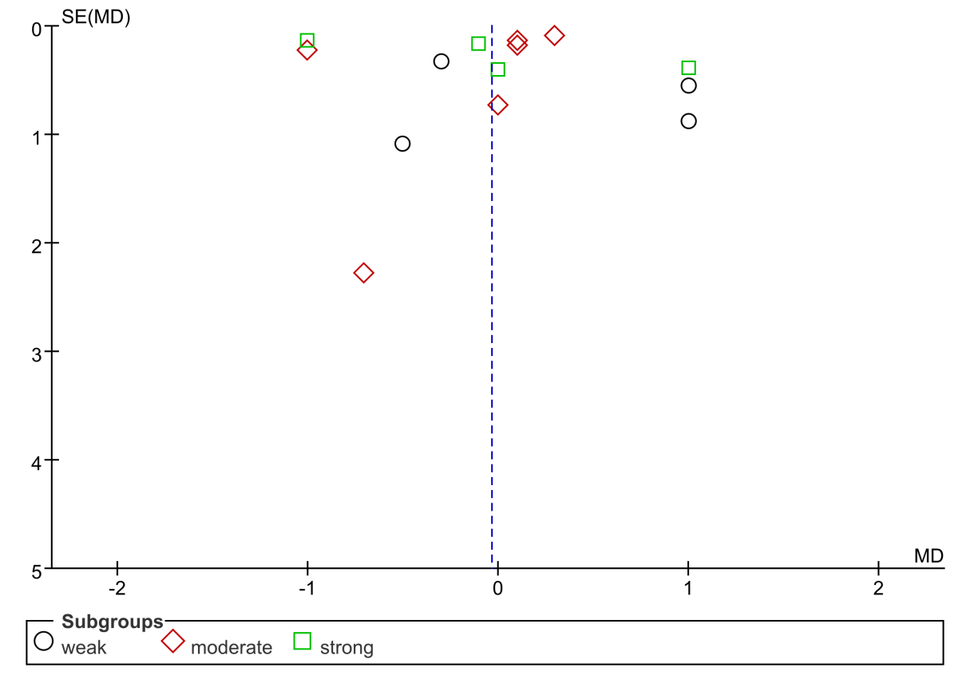
Supplementary Fig. 33 Funnel plot of subgroup analysis on length of stay

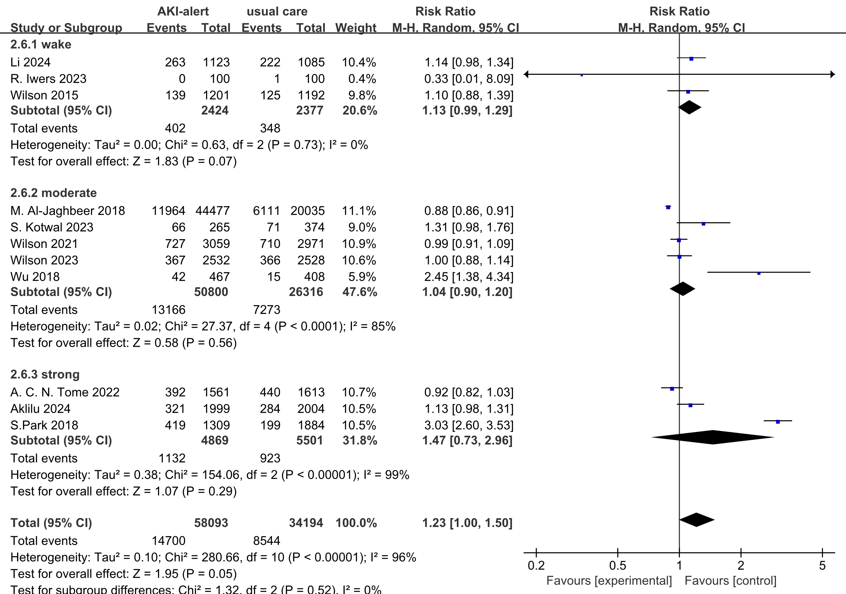
Supplementary Fig. 34 Forest plot of alert response intensity for subgroup analysis of nephrology consultation

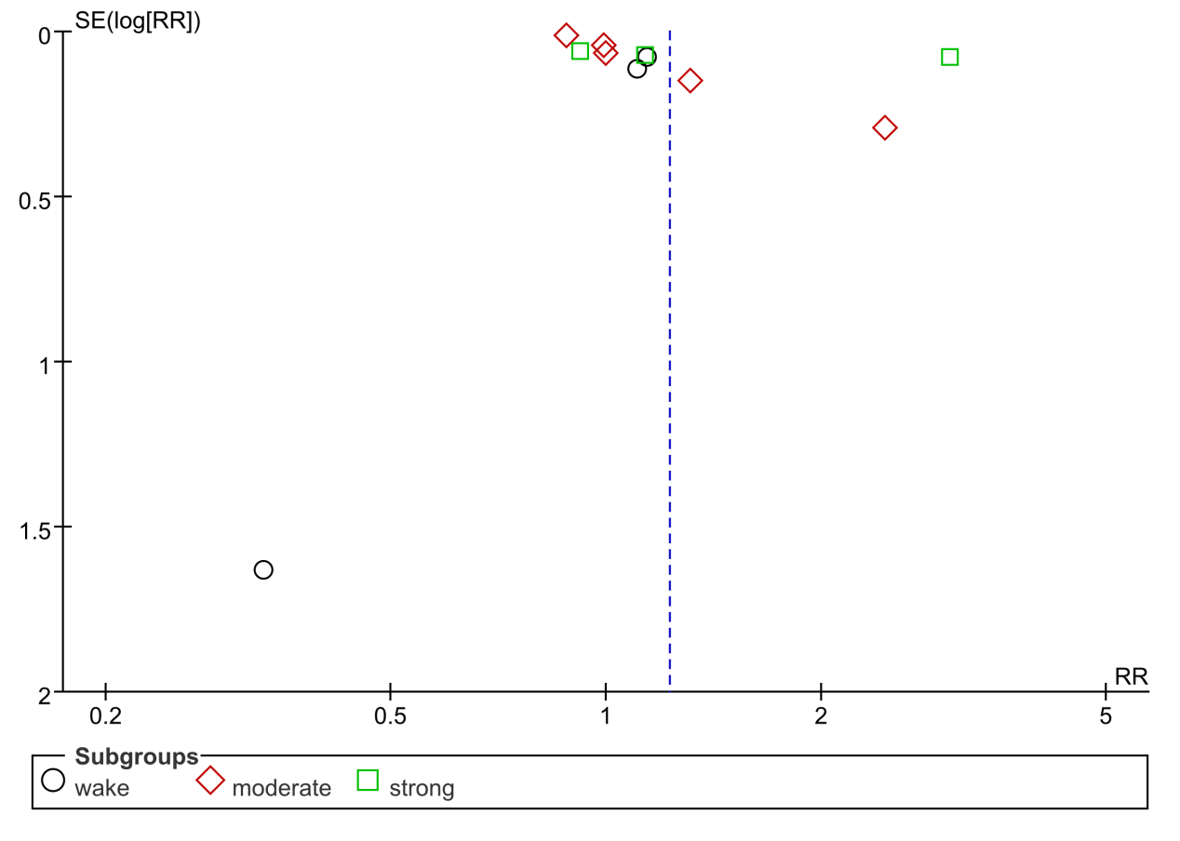
Supplementary Fig. 35 Funnel plot of subgroup analysis on nephrology consultation

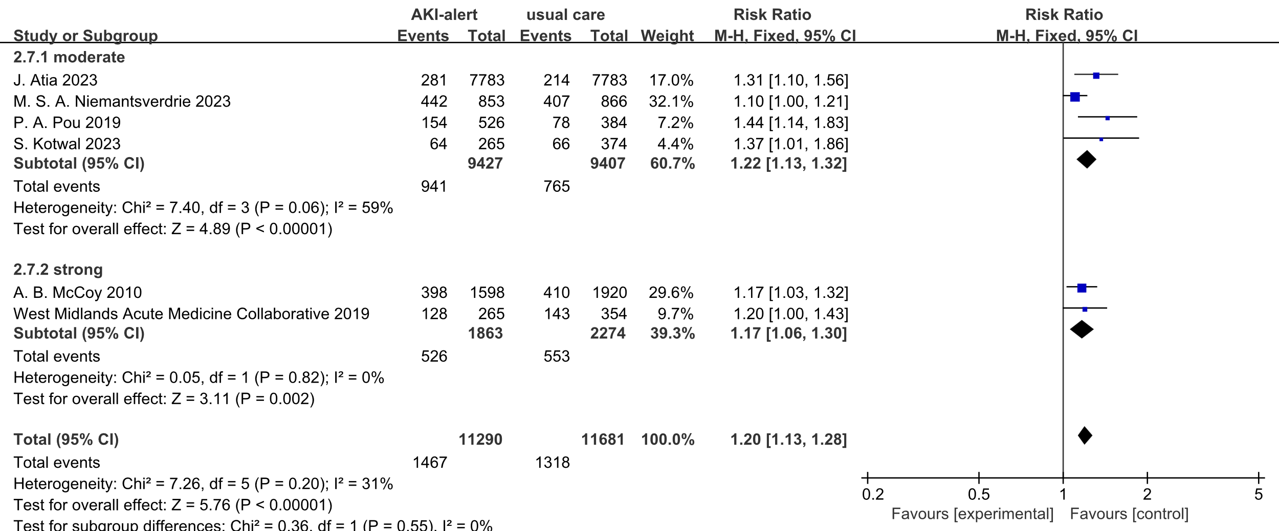
Supplementary Fig. 36 Forest plot of alert response intensity for subgroup analysis of rate of discontinuation of nephrotoxic drugs

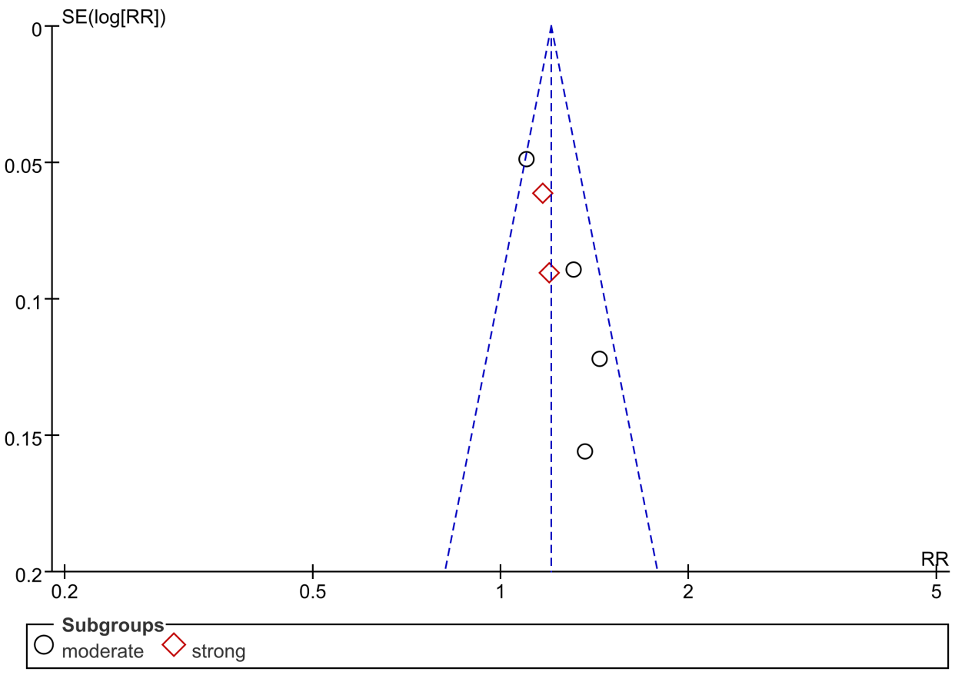
Supplementary Fig. 37 Funnel plot of alert response intensity for subgroup analysis on rate of discontinuation of nephrotoxic drugs
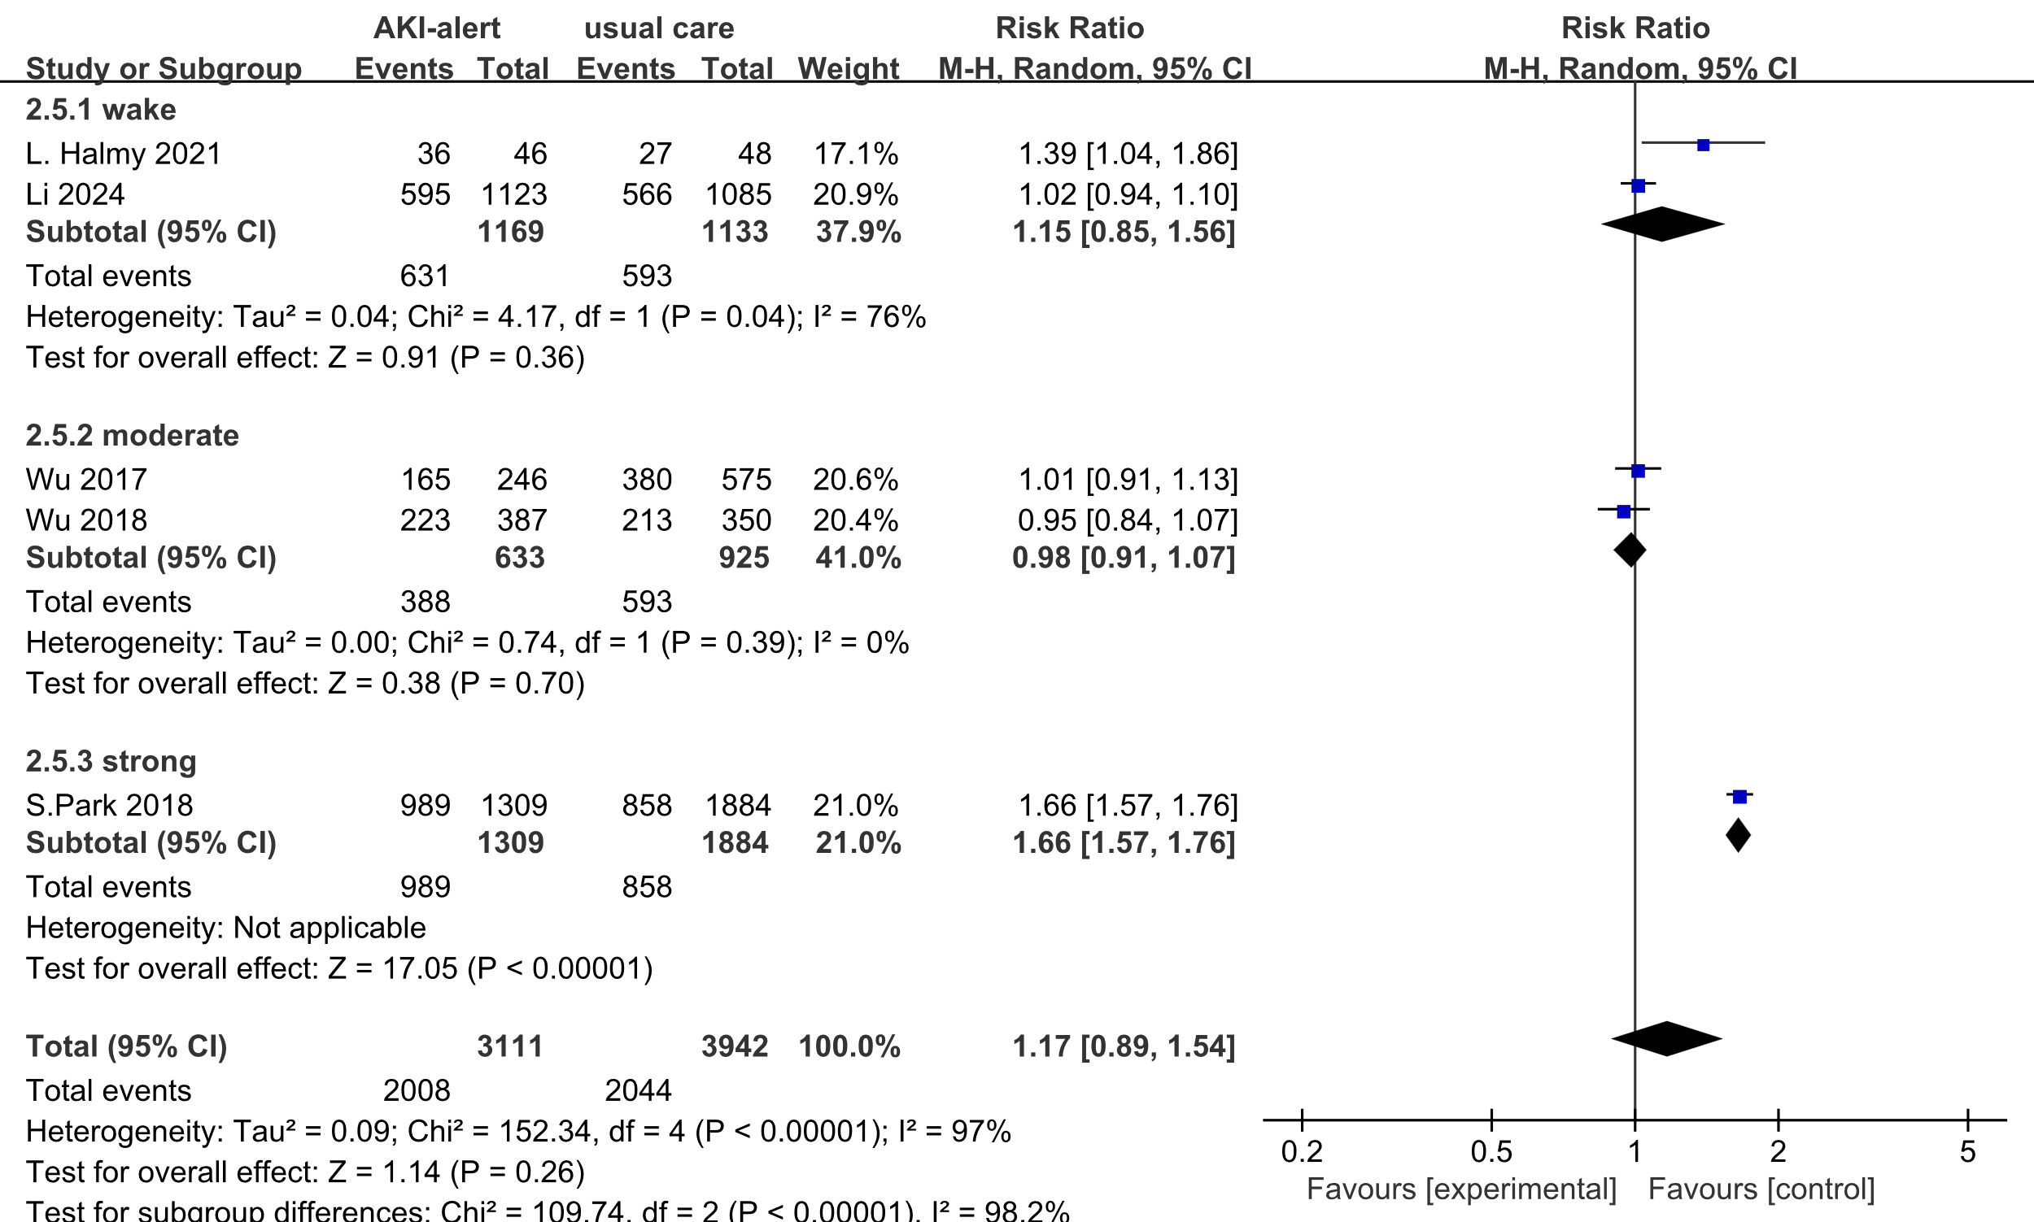
Supplementary Fig. 38 Forest plot of alert response intensity for subgroup analysis of renal recovery

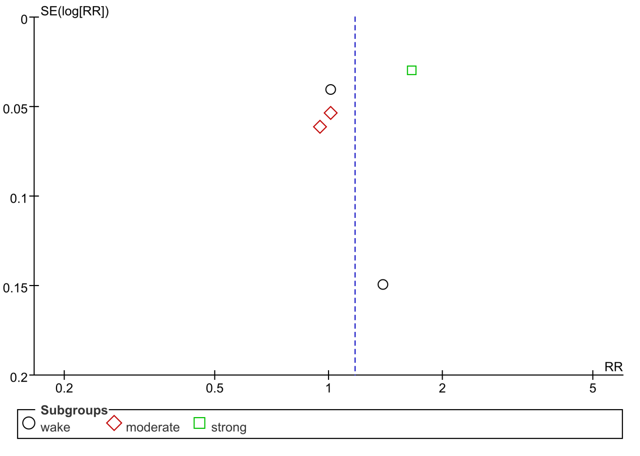
Supplementary Fig. 39 Funnel plot of subgroup analysis on renal recovery

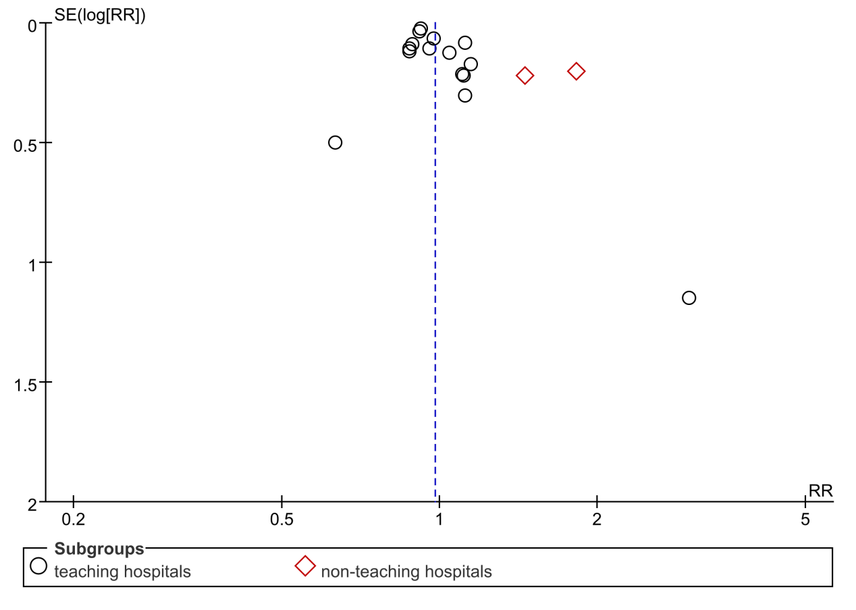
Supplementary Fig. 40 Funnel plot of hospital institution-type for subgroup analysis of mortality

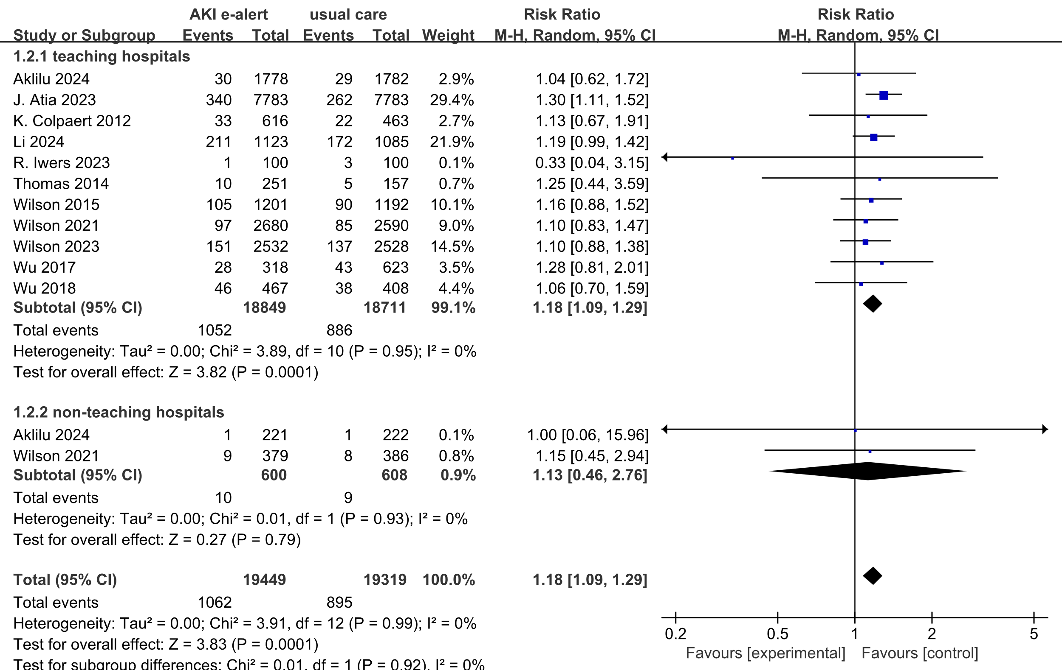
Supplementary Fig. 41 Forest plot of hospital institution-type for subgroup analysis of RRT usage

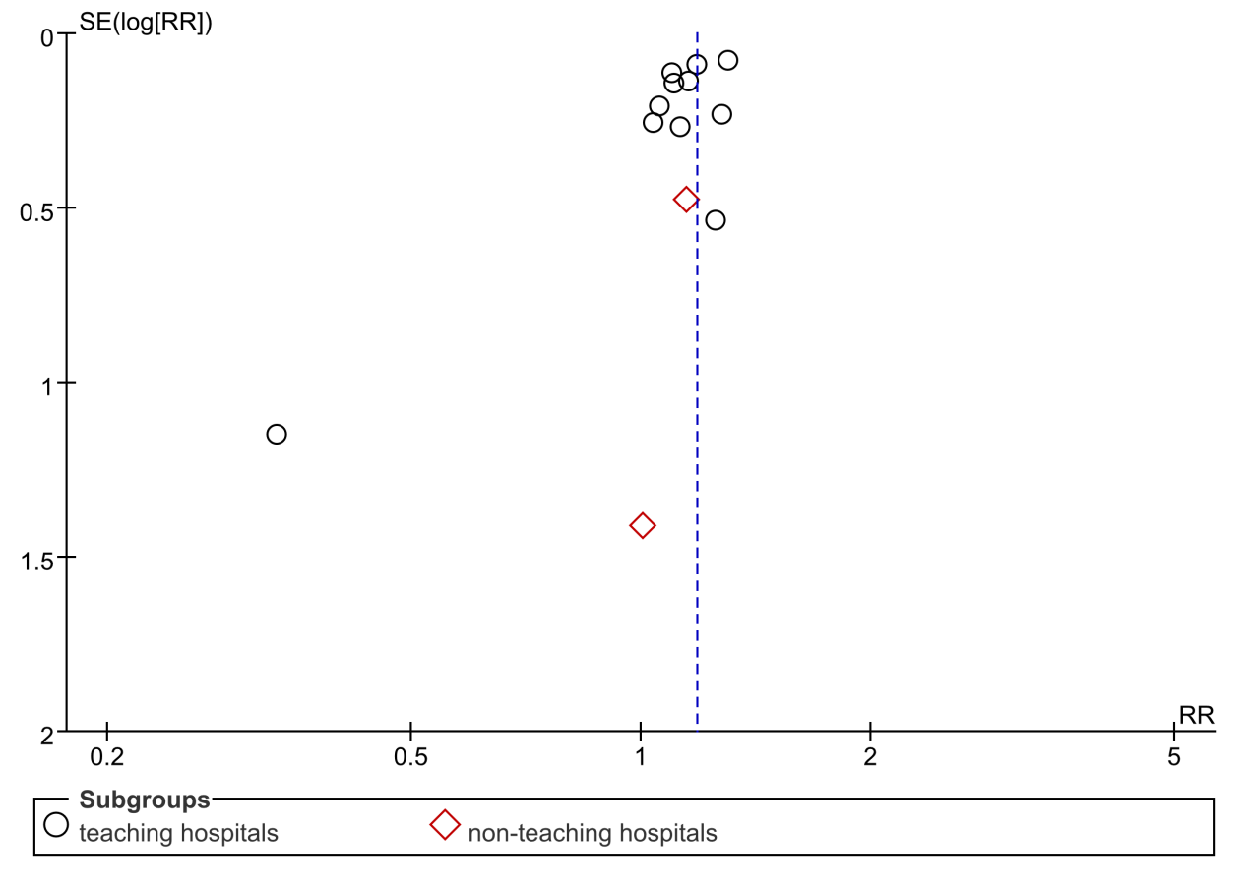
Supplementary Fig. 42 Funnel plot of hospital institution-type for subgroup analysis of RRT usage
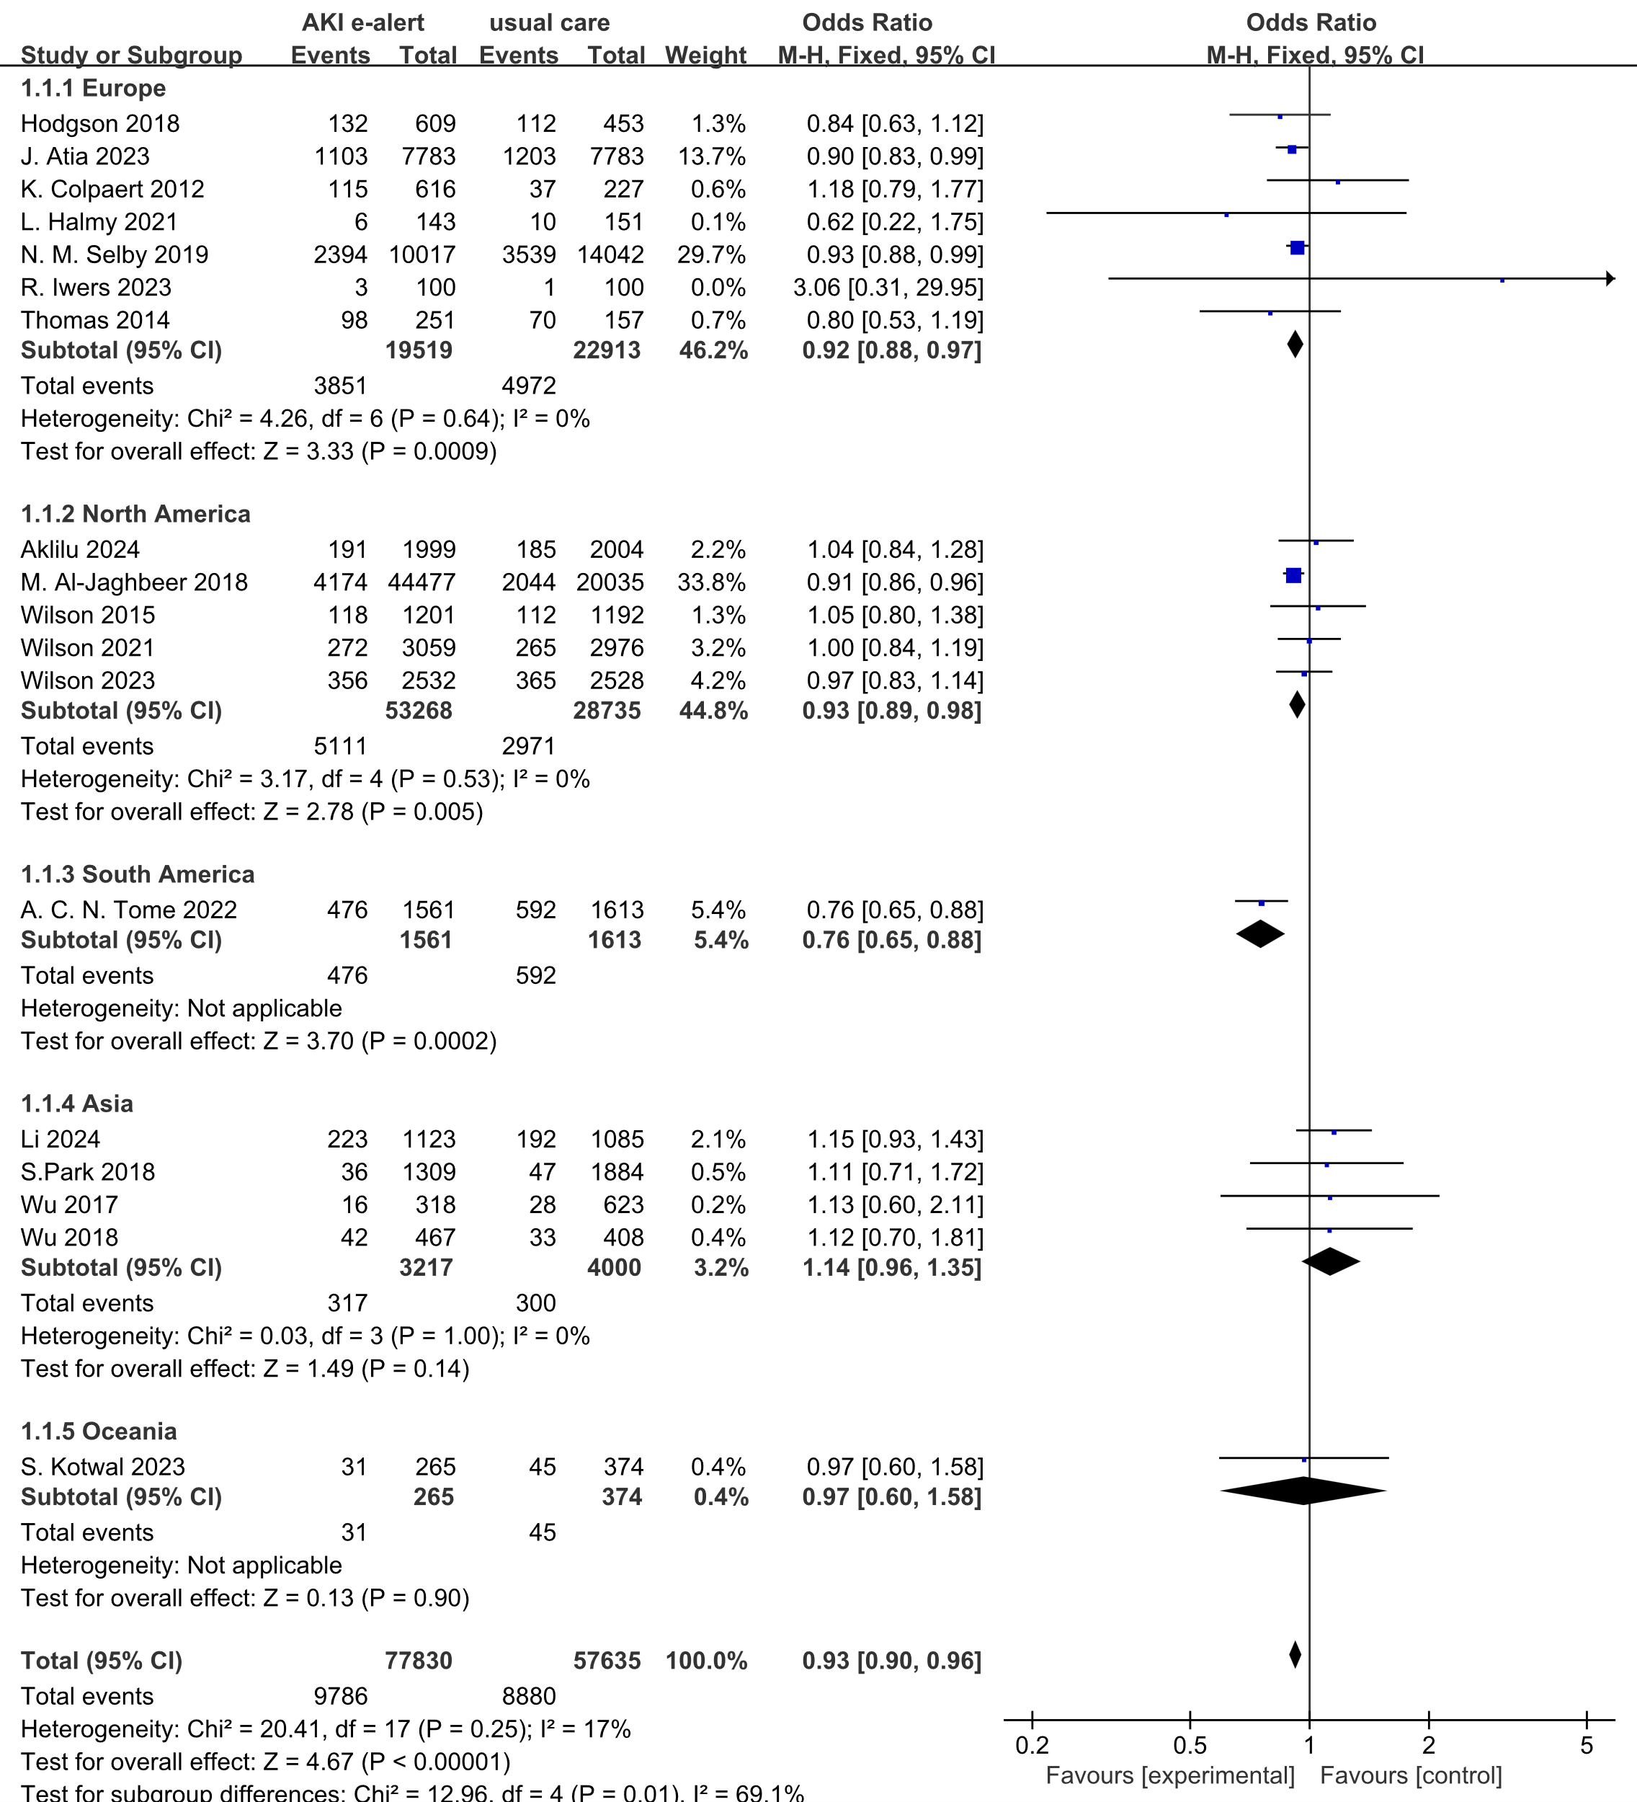
Supplementary Fig. 43 Forest plot of hospital geographic region for subgroup analysis of mortality

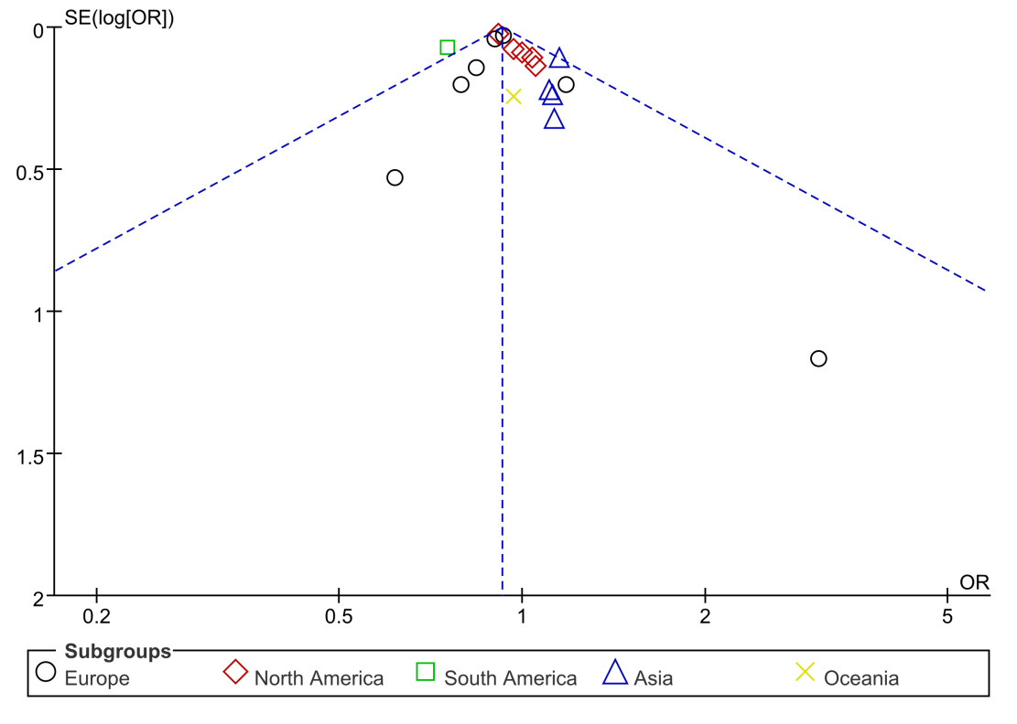
Supplementary Fig. 44 Funnel plot of hospital geographic region for subgroup analysis of mortality

