Exploring the Association Between Computed Tomography (CT)-Derived Skeletal Muscle Mass and Short- and Long-Term Mortality in Critically Ill Patients: A Systematic Review and Meta-Analysis
Valeria A. Bertoni Maluf¹, François R. Herrmann², Alexandra Platon^{,3,4}, A. Mendes², Y. M. Dupertuis¹, Aude De Watteville⁵, Claudia P. Heidegger^{4,5,6}, Laurence Genton ^{1,4}

Supporting information table 1: Search strategy
Supporting information table 2: Reasons for exclusion of studies after full-text screening (n=33)
Supporting information table 3: Cut-off values for determining low skeletal muscle mass
Supporting information table 4: Overall mortality and LOS in the included studies (n=35)
Supporting information table 5: ICU mortality and skeletal muscle mass (n=6)
Supporting information table 6: Hospital mortality and skeletal muscle mass (n=16)
Supporting information table 7: 28-day & 30-day mortality and skeletal muscle mass (n=17)
Supporting information table 8: 90-day mortality and skeletal muscle mass (n=3)
Supporting information table 9: 6-month mortality and skeletal muscle mass (n=4)
Supporting information table 10: 1-year mortality and skeletal muscle mass (n=5)
Supporting information table 11: Other mortality and skeletal muscle mass (n=4)

Supporting information figure 1: Assessment of methodological quality of cohort studies. Mortality was the outcome assessed for critical appraisal and therefore question 6 was not considered as all patients were alive at the time of CT scan. A study was considered to have a low risk of bias if it received 6 or more “low” responses, an unclear risk if it received 4-5 “low” responses and a high risk if it received only 0-3 “low” responses.
Supporting information 2: Number of studies conducted in different countries on four continents.

Supporting information figure 3: Meta-analysis of low muscle mass (MM) and short-term (ICU, hospital, 28- and 30-day) mortality in critically ill patients. Studies ranked by sex-specific cut-offs.
Supporting information figure 4: Funnel plot for studies investigating the association between low muscle mass and short-term mortality in critically ill patients.
Supporting information figure 5: Meta-analysis of low muscle mass (MM) and long-term (90-days, 6-months, 1-year) mortality in critically ill patients. Studies ranked by sex-specific cut-offs.
Supporting information figure 6: Funnel plot for studies investigating the association between low muscle mass and long-term mortality in critically ill patients.

Supporting information table 1: Search strategy
Embase:
('skeletal muscle'/exp OR 'muscle atrophy'/exp OR 'low muscle mass'/exp OR 'muscle weakness'/de OR 'muscle quality index'/de OR 'muscle quality'/exp OR 'body composition'/de OR (((muscle OR muskle OR muscular) NEAR/1 (mass OR weakness OR skeletal OR atrophy OR quality OR trunk)):ti,ab,kw) OR ‘body composition’:ab,ti,kw OR sarcopenia:ti,ab,kw OR 'icuacquired weakness':ti,ab,kw OR 'icu-acquired weakness':ti,ab,kw OR IMAT:ti,ab,kw) AND ('ct scanner'/de OR 'x-ray tomography'/exp OR 'tomography'/exp OR tomography:ab,ti,kw OR ((CT NEAR/2 ('x-ray' OR scan*)):ti,ab,kw)) AND ('mortality'/de OR 'length of stay'/de OR infection/de OR 'survivor'/de OR survival:ti,ab,kw OR mortality:ti,ab,kw OR death:ti,ab,kw OR 'hospital length of stays':ti,ab,kw OR 'stay length*':ti,ab,kw OR ((hospital NEAR/1 stay*):ti,ab,kw) OR infections:ti,ab,kw) AND ('intensive care'/exp OR 'intensive care unit'/exp OR 'critically ill patient'/exp OR ((critical NEAR/1 (illness* OR care)):ti,ab,kw) OR ((intensive NEAR/1 care):ti,ab,kw) OR 'critically ill':ti,ab,kw) AND 'article'/it
Pubmed:
("muscle, skeletal"[MeSH Terms] OR "Muscular Atrophy"[MeSH Terms] OR "Cachexia"[MeSH Terms] OR "muscle skeletal"[Title/Abstract] OR "Muscular Atrophy"[Title/Abstract] OR "Cachexia"[Title/Abstract] OR "Muscle mass"[Title/Abstract] OR "Muscle weakness"[Title/Abstract] OR "Skeletal muscle"[Title/Abstract] OR "Muscle wasting"[Title/Abstract] OR "Sarcopenia"[Title/Abstract] OR "Muscle atrophy"[Title/Abstract] OR "Low muscle mass"[Title/Abstract] OR "ICU-acquired weakness"[Title/Abstract] OR "Muscle quality"[Title/Abstract] OR "IMAT"[Title/Abstract] OR "Body composition"[Title/Abstract] OR "Trunk muscle"[Title/Abstract]) AND ("tomography, x ray"[MeSH Terms] OR "Tomography"[MeSH Terms:noexp] OR "tomography scanners, x ray computed"[MeSH Terms] OR "Tomography"[Title/Abstract] OR "CT scan*"[Title/Abstract]) AND ("Mortality"[MeSH Terms] OR "Infections"[MeSH Terms] OR "Survivors"[MeSH Terms] OR "Death"[MeSH Terms] OR "Length of Stay"[MeSH Terms] OR "Stay Length"[Title/Abstract:~4] OR "Stays Length"[Title/Abstract:~4] OR "hospital Stay Length"[Title/Abstract:~2] OR "hospital Stays Length"[Title/Abstract:~2] OR "Mortality"[Title/Abstract] OR "Death"[Title/Abstract] OR "Hospital length of stays"[Title/Abstract] OR "Stay Length"[Title/Abstract] OR "Stay Lengths"[Title/Abstract] OR "Hospital Stay"[Title/Abstract] OR "Hospital Stays"[Title/Abstract] OR "ICU stay"[Title/Abstract] OR "Infections"[Title/Abstract] OR survival[tiab]) AND ("critical care"[MeSH Terms] OR "Intensive Care Units"[MeSH Terms] OR "Critical Illnesses"[All Fields] OR "critical care"[Title/Abstract] OR "Intensive care unit"[Title/Abstract] OR "Intensive Care"[Title/Abstract] OR "Critically ill patient"[Title/Abstract] OR "Critically Ill"[Title/Abstract] OR "Intensive care unit"[Title/Abstract] OR "Illness Critical"[Title/Abstract] OR "Illnesses Critical"[Title/Abstract] OR "Unit Intensive Care"[Title/Abstract] OR ICU[Title/abstract] OR "ICU Intensive"[Title/Abstract] OR "Care Units"[Title/Abstract])

Supporting information table 2: Reasons for exclusion of studies after full-text screening (n=34)
Study reference | Reason for exclusion
Antonarelli et al. 2022 (1), Bodolea et al. 2022 (2), Guo et al. 2022 (3), Jaitovich et al. 2019 (4), Jaitovich et al. 2020 (5), Kardas et al. 2022 (6), Moon et al. 2021 (7), Poros et al. 2021 (8), Sabatino et al. 2023 (9), Yuan et al. 2021 (10), Zhi et al. 2019 (11) | Level other than lumbar (n=11)
Elfassy et al. 2020 (12); Giani et al. 2022 (13); Ju et al. 2020 (14); Khan et al. 2022 (15); Kou et al. 2019 (16); Malle et al. 2021 (17); Proksh et al. 2021 (18); Vigneron et al. 2022 (19) | No CT during hospital stay or on admission (n=8)
Akahoshi et al. 2016 (20); Armstrong et al. 2022 (21); Branea et al. 2023 (22); Brewster et al. 2014 (23); Herault et al. 2023 (24); Zhang et al. 2020 (25) | Another outcome (n=6)
Dusseaux et al. 2019 (26); Kashani et al. 2017 (27); Tazerout et al. 2022 (28); Kolck et al. 2022 (29) | Mortality related to muscle mass loss (n=4)
Barreto et al. 2019 (30); de Hoogt et al. 2018 (31) | CT not available in all patients (n=2)
Faron et al. 2020 (32); Dal et al. 2022 (33) | Muscle mass not available (n=2)
Wang et al. 2023 (34) | Assessment of skeletal muscle quality only (SMD and IMAT) and the primary outcome was a composite outcome consisting of all-cause mortality, or prolonged ICU stay (>28 days), whichever came first (n=1)
IMAT: Intermuscular adipose tissue; SMD: skeletal muscle density.

Supporting information table 3: cut-off values for determining low skeletal muscle mass
Study reference | Muscle parameter | For men | For women | References for cut-offs
Akan et al. 2024 (35)  Cox et al. 2021 (36)  Kaplan et al. 2016 (37)  Meyer et al. 2024 (38) | L3 SMI | <52.4 cm²/m² | <38.5 cm²/m² | Cancer patients (39)
Hwang et al. 2019 (40)  Moisey et al. 2013 (41) | L3 SMI | <55.4 cm²/m² | <38.9 cm²/m² | Cancer patients (42)
Ji et al. 2018 (43) | L3 SMI | <40.8 cm²/m² | <34.9 cm²/m² | Cancer patients (44)
Osuna-Padilla et al. 2022 (45) | L3 SMI | BMI <30 kg/m²: <52.3 cm²/m²  BMI ≥30 kg/m^{2:} <54.3 cm²/m² | BMI <30 kg/m²: <38.6 cm²/m²  BMI ≥30 kg/m^{2:} <46.6 cm²/m² | Cancer patients (46)
Seo et al. 2019 (47) | L3 SMI | BMI <25 kg/m²: <43.0 cm²/m²  BMI ≥25 kg/m^{2:} <53 cm²/m² | <41.0 cm²/m² regardless of BMI | Cancer patients (48)
Baggerman et al. 2020 (49)  Bear et al. 2021 (50)  Darden et al. 2023 (51) | L3 SMI | <41.6 cm²/m² | <32.0 cm²/m² | Healthy Caucasian population (52)
Damanti et al. 2022 (53)  Oh et al. 2022 (54) | L3 SMI | <45.4 cm²/m² | <34.4 cm²/m² | Healthy US population (55)
Kim et al. 2024 (56) | L3 SMI | <39.3 cm²/m² | <27.7 cm²/m² | Healthy Korean population (57)
Mangana del Rio et al. 2023 (58) | L3 SMI | <50 cm²/m² | <39 cm²/m² | Patients with liver disease (59,60)
Ng et al. 2019 (61) | L3 SMI | <46.5 cm²/m² | <35.3 cm²/m² | ROC curve of study population
Toledo et al. 2018 (62) | L3 SMI | <55.27 cm²/m² | <40.13 cm²/m² | ROC curve of study population
Lin et al. 2024 (63) | L3 SMI | 34.8 cm²/m² | 34.8 cm²/m² | ROC curve of study population
Xi et al. 2021 (64) | L3 SMI | <42.08 cm²/m² | <37.35 cm²/m² | Lowest sex-specific SMI quartile of study population
Emekli et al. 2023 (65) | L3 SMI | <35.95 cm²/m² | <34.55 cm²/m² | Lowest sex-specific SMI quartile of study population
Loosen et al. 2020 (66) | L3 SMI | <76.9 mm²/cm | <76.9 mm²/cm | Median L3 SMI of study population
Fuchs et al. 2018 (67) | L3 SMI | NA | NA | NA
Beypinar et al. 2021 (68) | L3 SMI  L3 PMI | NA | NA | NA
Lee et al. 2018 (69) | L3 PMI | <545 mm²/m² | <385 mm²/m² | Cancer patients (70)
Akkoc et al. 2020 (71) | L3 PMI | NA | NA | NA
Okada et al. 2021 (72) | L3-L4 PMI | <0.68 | <0.68 | Lowest PMI tertile of study population
Joyce et al. 2020 (73)  Looijaard et al. 2016 (74)  Weijs et al. 2014 (75) | L3 SMA | <170 cm² | <110 cm² | ROC curve defined by Weijs et al. 2014 (75)
Damanti et al. 2022 (53) | L3 SMA | <144.3 cm² | <92.2 cm² | Healthy US population
Shibahashi et al. 2017 (76) | L3 SMA | 45.2 cm² | 39.0 cm² | ROC curve of study population
Tee et al. 2021 (77) | L4 PMI | 675.30 mm²/m² | 491.27 mm²/m² | 2 SD below mean PMI
Ebbeling et al. 2013 (78) | L4 PMI | <0.83 | <0.83 | Median L4 PMI of study population
Yeh et al. 2018 (79) | L4-L5 PMA | 626 mm² | 626 mm² | Lowest PMA tertile of study population
Rossi et al. 2021 (80) | L3-L4 PMA | NA | NA | NA
L3, L4: Level of the third, fourth lumbar vertebra, respectively; NA: not available; SD: standard deviations; SMA: skeletal muscle area; SMI: skeletal muscle index; PMA: psoas muscle area; PMI: psoas muscle index; ROC: receiver operating characteristic; US: United States.

Supporting information table 4: Overall mortality and length of stay (LOS) in all patients in the included studies (n=35)
Study reference | Mortality n (%) | Length of stay (LOS) (Mean ± SD or median (IQR))
Akan et al. 2024 (35) | ICU mortality 36 (38.7%) | ICU LOS 27.8±29.7 if low SMI, 15.1±17 if normal SMI  Hospital LOS 33.0±31.2 if low SMI, 23.8±21.3 if normal SMI
Akkoc et al. 2020 (71) | Hospital mortality 20 (22.5%) | NA
Baggerman et al. 2020 (49) | ICU mortality 45 (29%)  Hospital mortality 59 (38.1%) | ICU LOS 5 (1-14)  Hospital LOS 21 (11-38)
Bear et al. 2021 (50) | ICU survival 181 (84.2%)  ICU mortality 34 (15.8%)  6-month survival 173 (80.5%) | UCI LOS 21 (14-32)  Hospital LOS 23 (16-33)
Beypinar et al. 2021 (68) | Mortality 9 (25%) | NA
Cox et al. 2021 (36) | Hospital mortality 4 (8.5%)  30-day mortality 4 (8.5%) | ICU LOS 7 (3-17)  Hospital LOS 15 (8-23)
Damanti et al. 2022 (53) | UCI mortality 22 (27.2%)  Hospital mortality 28 (34.6%) | ICU LOS 17 (IQR NA)  Hospital LOS 37 (IQR NA)
Darden et al. 2023 (51) | Hospital mortality 40 (26.7%)  1-year mortality 68 (45.3%) | ICU LOS 1 (0.7-2.0)  Hospital LOS 6 (4-10)
Ebbeling et al. 2013 (78) | Mortality 23 (13%) | ICU LOS 7 (4–16)  Hospital LOS 17 (10–26)
Emekli et al. 2023 (65) | Hospital mortality 223 (44.8%) | ICU LOS 7.5 (5-13)  Hospital LOS 11 (6-17)
Fuchs et al. 2018 (67) | Mortality within 30 days of extubation 15 (7%) | NA
Hwang et al. 2019 (40) | Hospital mortality 45 (20%) | NA
Ji et al. 2018 (43) | 30-day mortality 57 (24.2%) | Hospital LOS 23 (16-43) if visceral obesity, 20 (11-29) if sarcopenic obesity, 19 (12-30) if sarcopenia, 17 (11-29) if no sarcopenia or visceral obesity
Joyce et al. 2020 (73) | ICU mortality 18 (6.5%)  30-day mortality 37 (13.3%) | ICU LOS, hours 60 (32-114)  Hospital LOS, hours 264 (144-467)
Kaplan et al. 2016 (37) | Hospital mortality 42 (9.3%)  1-year-mortality 33 (8.1%) | ICU LOS 3.2 (1.6-5.3) if low muscle mass + osteopenia, 2.5 (1.4-5.0) if low muscle mass 2.7 (1.6-5.7) if osteopenia, 2.7 (1.5-4.8) if preserved muscle mass and bone density  Hospital LOS 7 (5-11) if low muscle mass + osteopenia; 7 (4-12) if low muscle mass; 6 (5-10) if osteopenia; and 7 (5-11) if preserved muscle mass and bone density
Kim et al. 2024 (56) | 28-day mortality 301 (48.7%) | NA
Lee et al. 2018 (69) | 28-day mortality 45 (16.4%)  6-month mortality 71 (25.9%) | NA
Lin et al. 2024 (63) | 28-day mortality 59 (26.3%) | NA
Looijaard et al. 2016 (74) | ICU mortality 84 (17.1%)  Hospital mortality 132 (26.9%)  6-month mortality 165 (35.6%) | ICU LOS 13 (7–23)  Hospital LOS 35 (19-59).
Loosen et al. 2020 (66) | ICU mortality (28.8%)  30-day mortality (26.6%)  180-day mortality (51.5%)  1-year mortality (60.4%) | UCI LOS 11 (range 1-147)  Hospital LOS 32 (range 3-199)
Mangana del Rio et al. 2023 (58) | 28-day mortality 80 (41.7%) | NA
Meyer et al. 2024 (38) | 24h mortality 36 (7.6%)  30-day mortality 104 (22%) | ICU LOS 8 (3-22)
Moisey et al. 2013 (41) | Overall mortality 40 (27%) | NA
Ng et al. 2019 (61) | ICU mortality 46 (20.2%)  Hospital mortality 66 (28.9%) | Hospital LOS 16 (10.0-28.8)
Oh et al. 2022 (54) | 28-day mortality 120 (10%)  1-year mortality 278 (31%)  Overall mortality 431 (48%) | Hospital LOS 18.8± 20.5 if non-sarcopenic, 20.5±37.9 if sarcopenic
Okada et al. 2021 (72) | Hospital mortality 51 (20.1%)  90-day mortality 55 (21.6%) | ICU LOS 3 (1-7)
Osuna-Padilla et al. 2022 (45) | ICU mortality 21 (24%) | Hospital LOS 28 (19-47)
Rossi et al. 2021 (80) | 28-day mortality 27 (17.6%) | NA
Seo et al. 2019 (47) | 28-day mortality 18 (10.3%) | NA
Shibahashi et al. 2017 (76) | ICU mortality 44 (29%)  Hospital mortality 14 (10%)  Overall mortality 58 (39%) | Hospital LOS 27 (range 7-51)
Tee et al. 2021 (77) | Overall mortality 56 (6%) | ICU LOS 4.7±7.4  Hospital LOS 15.5±14.7
Toledo et al. 2018 (62) | Hospital mortality 26 (26%) | Hospital LOS 15 (9.7-23.0)
Weijs et al. 2014 (75) | ICU mortality 45 (18.8%)  28-day mortality (15.8%  Hospital mortality (28.8%) | ICU LOS 16 (9-28)  Hospital LOS 41 (22-65).
Xi et al. 2021 (64) | 28-day mortality 6 (1.3%)  90-day mortality 22 (4.9%) | ICU LOS 8 (3-20) if low skeletal muscle mass, 5 (1-11) if normal skeletal muscle mass  Hospital LOS 22 (11-38) if low skeletal muscle mass, 14 (9-24)
Yeh et al. 2018 (79) | Hospital mortality 29 (21%) | ICU LOS 11.5 (8.0-19.5)  Hospital LOS 21 (14.0-34.0)
ICU: intensive care unit; IQR: Interquartile range; LOS: length of stay. SMI: skeletal muscle index. NA: not available.
Supporting information table 5: ICU mortality and skeletal muscle mass (n=6)
Reference | Muscle parameter | ICU mortality rate | Muscle mass size in deceased patients vs. survivors | ICU Mortality risk
Akan et al. 2024 (35) | L3 SMI | ↓ SMI: 49.1%  Normal SMI: 23%  P=0.02 | NA | NA
Bear et al. 2021 (50) | L3 SMI | Survival rate:  ↓ SMI: 80%  Normal SMI: 85.1%  P=0.41 | NA | SMI (per 10 cm²) OR: 1.0, CI 0.7–1.4; P=0.99  ↓ SMI_{categorical} OR: 1.4, CI 0.6–3.3; P=0.41
Loosen et al. 2020 (66) | L3 SMI | NA | Deceased: 75 mm²/cm  Survivors:78 mm²/cm  P≥0.05 | NA
Ng et al. 2019 (61) | L3 SMI | ↓ SMI 28.9%  Normal SMI: 11.4%  P<0.01 | NA | NA
Damanti et al. 2022 (53) | L1-L2 or L3 SMI | NA | NA | SMI_{continuous} aOR: 0.98, CI 0.92-1.06; P=0.68 (age, sex, BMI)  SMI_{continuous} aOR: 0.96, CI 0.93-0.99; P=0.03 (age, sex, FI)
Damanti et al. 2022 (53) | L1-L2 or L3 SMA | NA | NA | SMA_{continuous} aOR: 0.99, CI 0.96-1.01; P=0.31 (age, sex, BMI)  SMA_{continuous} aOR: 1.01, CI 0.98-1.02; P=0.93 (age, sex, FI)
Joyce et al. 2020 (73) | L3 SMA | ↓ SMA: 5.3%  Normal SMA: 8.9%  P=0.19 | NA | NA
↓: low; BMI: Body mass index; FI: frailty index; L1, L2 and L3: Level of the first, second, and third lumbar vertebra, respectively; SMI: skeletal muscle index; SMA: skeletal muscle area. NA: not available.
Categorial: muscle as categorical variable; Continuous: muscle as continuous variable; Univariate HR: hazard ratio; aHR: adjusted hazard ratio; Univariate OR: odds ratio; aOR: adjusted odds ratio; Adjustments are shown in brackets; CI: 95% confidence interval.
Supporting information table 6: Hospital mortality and skeletal muscle mass (n=16)
Reference | Muscle parameter | Hospital mortality rate | Muscle mass size in deceased patients vs. survivors (mean±SD or median (IQR)) | Hospital mortality risk
Darden et al. 2023 (51) | L3 SMI | ↓ SMI: 38%  Normal SMI: 23%  P=0.12 | NA | ↓ SMI_{categorical} aHR: 1.33, CI 0.64-2.76; P=0.44 (age, SOFA, APACHE II)
Osuna-Padilla et al. 2022 (45) | L3 SMI | ↓ SMI: 22%  Normal SMI: 27%  P=0.61 | NA | NA
Cox et al. 2021 (36) | L3 SMI | ↓ SMI: 17.4%  Normal SMI: 0%  P=0.04 | NA | NA
Baggerman et al. 2020 (49) | L3 SMI | ↓ SMI:50%  Normal SMI: 32.7%  P=0.04 | NA | ↓ SMI_{categorical} aOR: 1.6, CI 0.734–3.328; P=0.25 (CRI, COPD, cancer, age)
Ng et al. 2019 (61) | L3 SMI | ↓ SMI: 38.6%  Normal SMI: 19.3%  P<0.01 | NA | ↓ SMI_{categorical} OR: 2.276, CI 1.024-5.056; P=0.043  ↓ SMI_{categorical} aOR: 2.415, CI 1.159-5.032; P<0.01 (SOFA)  ↓ SMI_{categorical} in Men aOR: 3.077, CI 1.48-8.248; P=0.03 (SOFA)  ↓ SMI_{categorical} in Women aOR: 4.478, CI 1.330-15.082; P=0.02 (SOFA)
Hwang et al. 2019 (40) | L3 SMI | ↓ SMI: 25%  Normal SMI: 18%  P=0.18 | NA | ↓ SMI_{categorical} aOR: 0.98, CI 0.43-2.27; P≥0.05 (age, GCS, diagnosis of TBI, ISS, L-LI)
Toledo et al. 2018 (62) | L3 SMI | Men  ↓ SMI: 15.6%  Normal SMI 7.7%  P=0.66.  Women  ↓ SMI: 57.1%  Normal SMI: 15.4%  P=0.03 | Deceased: 36.71±14.68 cm²/m²  Survivors: 45.78±13.53 mm²/cm²  P=0.01. | NA
Kaplan et al. 2016 (37) | L3 SMI | ↓ SMI and osteopenia:8.1%  ↓ SMI: 11.4%.  Osteopenia: 10.4%  No low SMI and osteopenia: 7.5%  P=0.61 | NA | NA
Moisey et al. 2013 (41) | L3 SMI | ↓ SMI: 32%  Normal SMI: 14%  P=0.02 | NA | Survival in hospital:  SMI_{continuous} OR: 0.93, CI 0.875-0.997; P=0.03 (age, sex, ISS)
Akkoc et al. 2020 (71) | L3 PMI | NA | Deceased: 4.1 cm²/m²  Survivors: 6.2 cm²/m²  P≤0.05 | L3 PMI_{continuous} OR 0.26, CI 0.12-0.55; P≤0.05
Shibahashi et al. 2017 (76) | L3 SMA | NA | Deceased: 36.8 (30.1-43.2) cm²  Survivors: 43.3 (36.5-50.9) cm²  P<0.01 | SMA_{continuous} aOR: 0.94, CI 0.90-0.97; P=<0.001 (sex, APACHE II)  60-80 years SMA_{continuous} (cm²) aOR: 0.96, CI 0.92-0.99; P=0.03 (sex, APACHE II)  >80 years SMA_{continuous} (cm²) aOR: 0.89, CI 0.81-0.98; P=0.02 (sex, APACHE II)  ↓ SMA_{categorical} OR: 3.27, CI 1.61-6.63; P<0.01  ↓ SMA_{categorical} aHR: 2.55, CI 1.43-4.56; P<0.01 (sex, APACHE II)
Weijs et al. 2014 (75) | L3 SMA | ↓ SMA: 38.2%  Normal SMA:12.5%  P<0.01 | NA | NA
Emekli et al. 2023 (65) | L1 SMI | Men  ↓ SMI: 40.9%  Normal SMI: 10.9%  P≤0.001  Women  ↓ SMI: 33.3%  Normal SMI 18.8%;  P=0.01 | Men  Deceased: 37.82 (31.03-43.95) cm²/m² Survivors: 46.1 (41.08-52.32) cm²/m²  P<0.01  Women  Deceased: 38.73 (31.18-45.74) cm²/m² Survivors: 41.73 (35.97-48.39) cm²/m²  P<0.01 | ↓ SMI_{categorical} aOR: 2.03, CI 1.14-3.61; P=0.02 (age, CT severity in COVID-19 pneumonia, ↓diaphragm diameter, ↓ bone mineral density, HTA, CVD, heart failure, malignancy, fasting blood glucose, CRP, platelet count, D-dimer)
Damanti et al. 2022 (53) | L1-L2 or L3 SMI | NA | NA | SMI_{continuous} HR: 0.96, C.I 0.94-0.99; P<0.01
Damanti et al. 2022 (53) | L1-L2 or L3 SMA | NA | NA | SMA_{continuous} HR: 0.98, C.I 0.96-0.99; P=0.02  SMA_{continuous} aβ: 0.98, CI 0.96-1.13; P=0.56 (age, sex, BMI)
Ebbeling et al. 2013 (78) | L4 PMI | ↓ PMI: 16%  Normal PMI: 10%  P=0.26 | NA | ↓ PMI_{categorical} OR 1.66, CI 0.68-4.05; P=0.27.  ↓ PMI_{categorical} aOR: 1.2, CI 0.44-3.26; P=0.72 (age, comorbidities, AIS)
Yeh et al. 2018 (79) | L4-L5 PMA | PMA tertile 1 (lowest): 20%  PMA tertile 2: 26%  PMA tertile 3: 19%  P=0.76 | NA | NA
↓: low; AIS: Abbreviated Injury Scale; APACHE II: acute physiology and chronic health evaluation; BMI: body mass index; COPD: chronic obstructive pulmonary disease; CRI: chronic renal insufficiency; CRP: C-reactive protein; CVD: cardiovascular disease; GCS: Glasgow Coma Scale; HTA: hypertension; ISS: Injury Severity Score; L1, L2, L3, L4 and L5: level of the first, second, third, fourth and fifth lumbar vertebra, respectively; L-LI: life-limiting illnesses; SMI: skeletal muscle index; SMA: skeletal muscle area; SOFA: sequential organ failure assessment; PMA: Psoas muscle area; PMI: Psoas muscle index; PMI: psoas muscle index; NA: not available; TBI: Traumatic Brain Injury.
Categorical: muscle as categorial variable; Continuous: muscle as continuous variable; Univariate HR: hazard ratio; aHR: adjusted hazard ratio; Univariate OR: odds ratio aOR: adjusted odds ratio; Adjustments are shown in brackets; CI: 95% confidence interval.
Supporting information table 7: 28-day & 30-day mortality and skeletal muscle mass (n=17)
Reference | Muscle parameter | 28 & 30-day mortality rate | Muscle mass size in deceased patients vs. survivors (mean±SD or median (IQR)) | 28 & 30 mortality risk
Lin et al. 2024 (63) | L3 SMI | NA | Deceased: 39.68±3.25 cm²/m²  Survivors: 42.71±4.28 cm²/m²  P<0.01 | NA
Kim et al. 2024 (56) | L3 SMI | ↓ SMI: 66.1%  Normal SMI: 31.2%  P<0.01 | Deceased: 28.7 (23.8-36.4) cm²/m²  Survivors: 38.9 (32.8-44.6) cm²/m²  P<0.01 | ↓ SMI_{categorical} HR: 2.66, CI 2.09-3.38; P<0.001  ↓ SMI_{categorical} aHR: 1.83, CI 1.42-2.38; P<0.001 (age, sex, CRI, SOFA, APACHE II, time from acute kidney injury diagnosis to CRRT initiation)
Meyer et al. 2024 (38) | L3 SMI | ↓ SMI: 25%,  Normal SMI: 13.6%  P=0.01 | Deceased: 57.1 (48.03-65.03) cm²/m²  Survivors: 57.75 (51.5-64.33) cm²/m²  P=0.11 | ↓ SMI_{categorical} HR: 1.85, CI 1.18-2.89; P=0.008  ↓ SMI_{categorical} aHR: 2.84, CI 1.38-5.85; P=0.004 (age, ASA ≥ III, BMI, ISS, GCS, visceral and sarcopenic obesity)
Mangana del Rio et al. 2023 (58) | L3 SMI | NA | NA | SMI_{continuous} OR: 0.96, CI 0.93-0.99; P=0.04  SMI_{continuous} aOR: 0.97, CI 0.93-1.00; P=0.06 (sex, aetiology, reason for ICU admission, CLIF-C ACLF-lactate score)  ↓ SMI_{categorical} OR: 3.20, CI 1.68-6.09; P=0.0004  ↓ SMI_{categorical} aOR: 2.76, CI 1.07–7.11; P=0.02 (sex, aetiology, reason for ICU admission, CLIF-C ACLF-lactate score)
Oh et al. 2022 (54) | L3 SMI | ↓ SMI: 13.76%  Normal SMI: 6.43%  P<0.01 | NA | ↓ SMI_{categorical} HR: 2.230, CI 1.444-3.442; P<0.001  ↓ SMI_{categorical} aHR: 2.116, CI 1.312-3.412; P=0.002 (age, sex, CCI, SOFA, serum albumin, CRP)  SMI_{continuous} (per 1 cm²/m² increase) HR: 0.96, CI 0.942-0.99; P=0.006  SMI_{continuous} (per 1 cm²/m² increase) aHR 0.969, CI 0.945-0.994; P=0.01 (age, sex, CCI, SOFA, serum albumin, CRP)
Cox et al. 2021 (36) | L3 SMI | ↓ SMI: 17.4%,  Normal SMI: 0%  P=0.04 | NA | NA
Xi et al. 2021 (64) | L3 SMI | ↓ SMI: 0.9%  Normal SMI: 1.5%  P=0.567 | NA | NA
Loosen et al. 2020 (66) | L3 SMI | NA | Deceased: 75 mm²/cm  Survivors:78 mm²/cm  P≥0.05 | NA
Seo et al. 2019 (47) | L3 SMI | ↓ SMI: 83.3%  Normal SMI: 86.6%  P=0.70 | NA | NA
Toledo et al. 2018 (62) | L3 SMI | NA | NA | ↓ SMI_{categorical} aHR: 2.74, CI 1.02–7.35; P=0.04 (SAPS 3, age)
Fuchs et al. 2018 (67) | L3 SMI | NA | Deceased: 46.9±10.7 cm²/m²  Survivors: 58.5±15.3 cm²/m²  P<0.01 | SMI_{continuous} aOR: 0.94, CI 0.890–0.995; P=0.033 (age, CCI, APACHE II)
Ji et al. 2018 (43) | L3 SMI | ↓ SMI and visceral obesity: 44.2%  Normal SMI and no visceral obesity: 7.8%  P<0.01 | NA | ↓ SMI_{categorical} and visceral obesity HR: 6.8, CI 2.6–17.8; P<0.001  ↓ SMI_{categorical} and visceral obesity aHR: 4.6; CI 1.7-12.8; P=0.003 (age, use of vasopressor, mixed organism, APACHE II)  ↓ SMI_{categorical} and visceral obesity aHR: 4.2, CI 1.5-11.6; P=0.007 (age, use of vasopressor, mixed organism, SOFA)  ↓ SMI_{categorical} HR: 4.0, CI 1.5–10.9; P=0.006  ↓ SMI_{categorical} aHR: 2.7, CI 0.9–7.5; P=0.065 (age, use of vasopressor, mixed organism, APACHE II)  ↓ SMI_{categorical} aHR: 2.3, CI 0.8–6.6; P=0.129 (age, use of vasopressor, mixed organism, SOFA)
Kaplan et al. 2016 (37) | L3 SMI | ↓ SMI and osteopenia:4.4%  ↓ SMI: 1.4%  Osteopenia: 2.3%  No low SMI and osteopenia: 0%  P=0.05 | NA | NA
Lee et al. 2018 (69) | L3 PMI | ↓ PMI: 27.3%  Normal PMI: 12.2%  P<0.01 | Deceased: 477.8 mm²/m²  Survivors: 572.7 mm²/m²  P=0.01 | ↓ PMI_{categorical} OR: 2.70, CI 1.40–5.22; P=0.01.  ↓ PMI_{categorical} aOR: 2.79, CI 1.35–5.74; P=0.01 (neoplasm, CRP, albumin, pneumonia, SOFA)
Joyce et al. 2020 (73) | L3 SMA | ↓ SMA: 14.8%  Normal SMA: 10.0%  P=0.18 | NA | SMA_{continuous} aOR: 0.98, CI 0.97–0.99; P=0.004 (CRRT)
Weijs et al. 2014 (75) | L3 SMA | ↓ SMA: 21.7%  Normal SMA: 5.7%  P<0.01 | NA | NA
Rossi et al. 2021 (80) | L3-L4  PMA | NA | Deceased: 17.59±9.34 cm²  Survivors: 16.46±9.40 cm²  P=0.573 | NA
↓: low; ACLF: acute-on-chronic liver failure; APACHE II: acute physiology and chronic health evaluation; ASA: American Society of Anesthesiologists classification; CCI: Charlson co-morbidity index; CLIF-C: chronic liver failure consortium; CRI: chronic renal insufficiency; CRP: C-reactive protein; CRRT: continuous renal replacement therapy; GCS: Glasgow Coma Scale; ISS: injury severity score; L3, L4: Level of the third, fourth lumbar vertebra, respectively; SMI: skeletal muscle index; SMA: skeletal muscle area; PMA: Psoas muscle area; PMI: psoas muscle index; SOFA: sequential organ failure assessment; NA: not available
Categorical: muscle as categorial variable; Continuous: muscle as continuous variable; Univariate HR: hazard ratio; aHR: adjusted hazard ratio; Univariate OR: odds ratio aOR: adjusted odds ratio; Adjustments are shown in brackets; CI: 95% confidence interval
Supporting information table 8: 90-day& 100-day mortality and skeletal muscle mass (n=3)
Study reference | Muscle parameter | 90-day mortality rate | Muscle mass size in deceased patients vs. survivors (mean±SD or median (IQR)) | 90-day mortality risk
Okada et al. 2021 (72) | L3-L4 PMI | PMI tertile 1 (lowest): 29.4%  PMI tertile 2: 21.4%  PMI tertile 3: 14.0% | PMI tertile 1 (lowest): 0.54 (0.44-0.62) cm²/cm²  PMI tertile 2: 0.80 (0.73-0.85) cm²/cm²  PMI tertile 3: 1.11 (1.00-1.32) cm²/cm² | PMI of tertile 1 as reference value  PMI_{categorical} tertile 2  OR: 1.68, CI 0.75-3.75  aOR: 2.40, CI 0.93-6.15 (age, sex, infection site, SOFA, CCI)  PMI_{categorical} tertile 3  OR: 2.57, CI 1.19-5.54  aOR: 3.67, IC 1.39-9.68 (age, sex, infection site, SOFA, CCI)
Shibahashi et al. 2017 (76) | L3 SMA | NA | Deceased: 36.8 (30.1, 43.2) cm²  Survivors: 43.3 (36.2-50.9) cm²  P<0.01 | Survival 100 days after admission  ↓ SMA_{categorical} OR: 0.37 (CI 0.23-0.50)  Normal SMA_{categorical} OR: 0.70 (CI 0.54-0.81)  P≤0.01
Xi et al. 2021 (64) | L3 SMI | ↓ SMI: 3.6%  Normal SMI: 5.3%  P=0.73 | NA | NA
↓: low; L3, L4: Level of the third, fourth lumbar vertebra, respectively; SMI: skeletal muscle index; SMA: skeletal muscle area; PMI: psoas muscle index; NA: not available.
Categorical: muscle as categorial variable; Continuous: muscle as continuous variable; Univariate HR: hazard ratio; aHR: adjusted hazard ratio; Univariate OR: odds ratio aOR: adjusted odds ratio; Adjustments are shown in brackets; CI: 95% confidence interval
Supporting information table 9: 6-month mortality and skeletal muscle mass (n=4)
Study reference | Muscle parameter | 6-month mortality rate | Muscle mass size in deceased patients vs. survivors (mean±SD or median (IQR)) | 6-month mortality risk
Bear et al. 2021 (50) | L3 SMI | Survival:  ↓ SMI 73.3%  Normal SMI: 82.1%  P=0.187 | NA | SMI (per 10 cm²) OR: 0.9, CI 0.7–1.3; P=0.710  ↓ SMI_{categorical} OR: 1.7, CI 0.8–3.6; P=0.19
Loosen et al. 2020 (66) | L3 SMI | NA | Deceased: 72.65 mm²/cm  Survivors: 79.05 mm²/cm  P=0.01 | NA
Lee et al. 2018 (69) | L3 PMI | ↓ PMI: 41.6%  Normal PMI: 19.8%  P<0.01 | NA | ↓ PMI_{categorical} OR 2.88, CI 1.62-5.11; P<0.01  ↓ PMI_{categorical} aOR 2.83, CI 1.50–5.37; P<0.01 (diabetes mellitus, neoplasm, pneumonia, SOFA)
Looijaard et al. 2016 (74) | L3 SMI | NA | Deceased: 40.4±9.9 cm²/m²  Survivors: 46.6±10. cm²/m²  P<0.01 | NA
Looijaard et al. 2016 (74) | L3 SMA | ↓ SMA: 83.0%  Normal SMA: 54.5%  P<0.01 | Deceased: 120.3±33.0 cm²  Survivors: 143.5±38.9 cm²  P<0.01 | NA
↓: low; L3, L4: Level of the third, fourth lumbar vertebra, respectively; SMI: skeletal muscle index; SMA: skeletal muscle area; PMA: Psoas muscle area; PMI: psoas muscle index; NA: not available.
Categorical: muscle as categorial variable; Univariate HR: hazard ratio; aHR: adjusted hazard ratio; Univariate OR: odds ratio aOR: adjusted odds ratio; Adjustments are shown in brackets; CI: 95% confidence interval.
Supporting information table 10: 1-year mortality and skeletal muscle mass (n=5)
Study reference | Muscle parameter | 1-year mortality rate | Muscle mass size in deceased patients vs. survivors (mean±SD or median (IQR)) | 1-year mortality risk
Darden et al. 2023 (51) | L3 SMI | ↓ SMI: 71%  Normal SMI: 38%  P<0.01 | NA | One-year survival:  ↓ SMI_{categorical} HR: 2.4, CI 1.44-3.9; P<0.01  One-year Mortality:  ↓ SMI_{categorical} aHR: 1.90, CI 1.14-3.19; P=0.01 (age, SOFA, APACHE II)
Oh et al. 2022 (54) | L3 SMI | ↓ SMI: 41.77%  Normal SMI; 21.69%  P<0.01 | NA | ↓ SMI_{categorical} vs. None HR: 2.189, CI 1.720-2.787; P<0.001  ↓ SMI_{categorical} aHR: 1.679, CI 1.291-2.182; P<0.001 (age, sex, CCI, SOFA, serum albumin)  SMI (per 1 cm²/m² increase) HR: 0.976, CI 0.963-0.99; P=0.001.  SMI (per 1 cm²/m² increase) aHR: 0.978, CI 0.964-0.992; P<0.01 (age, sex, CCI, SOFA, serum albumin)
Cox et al. 2021 (36) | L3 SMI | ↓ SMI: 34.9%  Normal SMI: 4.2%  P<0.01 | NA | Early death (death <14 days from sepsis onset)/CCI:  Baseline low SMI_{categorical} OR: 11.87, CI 1.88-74.9; P<0.01. AUC 0.880, CI 0.781-0.979  CCI OR: 1.49, CI 1.08-2.06 ; P=0.01. AUC 0.880, CI 0.781-0.979  Early death/CCI:  Baseline SMI_{categorical} OR: 0.9, CI 0.82-0.99; P=0.03. AUC 0.846, CI 0.732-0.961  CCI OR: 1.55, CI 1.14-2.11 ; P<0.01. AUC 0.846, CI 0.732-0.961  Death or dismal functional status at 1 year:  Baseline SMI_{categorical} OR: 0.89, CI 0.80-0.99; P=0.04. AUC 0.867, CI 0.759-0.974  CCI OR : 8.29, CI 1.14-2.28; P<0.01. AUC 0.867, CI 0.759-0.974
Loosen et al. 2020 (66) | L3 SMI | NA | Deceased: 74.05 mm²/cm  Survivors: 79.81mm²/cm  P<0.05 | NA
Kaplan et al. 2016 (37) | L3 SMI | ↓ SMI and osteopenia: 16.2%  ↓ SMI only: 11.5%  Osteopenia only: 9.3%  No low SMI or osteopenia: 0.7%  P<0.01 | NA | Survival  No ↓ SMI_{categorical} or osteopenia [Reference] HR: 26.7, CI 3.4-206.7; P=0.002  No ↓ SMI_{categorical} or osteopenia aHR: 9.4, CI 1.2-75.4; P=0.03 (age, sex, comorbidities)  ↓ SMI_{categorical} only HR: 17.9, CI 2.4-134.4; P=0.005 ↓ SMI_{categorical} only aHR: 10.3, CI 1.3-78.8; P=0.03(age, sex, comorbidities)  Osteopenia only HR: 14.4, CI 1.6-128.7; P=0.02  Osteopenia only aHR: 11.9, CI 1.3-107.4; P=0.03 (age, sex, comorbidities)
↓: low; CCI: chronic critical illness; L3, L4: Level of the third, fourth lumbar vertebra, respectively; SMI: skeletal muscle index; SMA: skeletal muscle area; PMA: Psoas muscle area; PMI: psoas muscle index; NA: not available.
Categorical: muscle as categorial variable; Continuous: muscle as continuous variable; Univariate HR: hazard ratio; aHR: adjusted hazard ratio; Univariate OR: odds ratio aOR: adjusted odds ratio; Adjustments are shown in brackets; CI: 95% confidence interval.

Supporting information table 11: Other mortality and skeletal muscle mass (n=4)
Study reference | Muscle parameter | Mortality rate | Mortality risk or survival
Beypinar et al. 2021 (68) | L3 PMI  L3 SMI | NA | Overall survival (OS):  PMI, Mdn OS (days): male low, 14 d; female high, Not Reached (NR); P=0.010.  SMI, Mdn OS (days): male low, NR; female high, NR; P=0.18.
Loosen et al. 2020 (66) | L3 SMI | NA | Overall Survival  ↓ SMI_{categorical} HR: 1.850, CI 1.259-2.719; P=0.002  ↓ SMI_{categorical} aHR: 1.762, CI 1.160-2.678; P=0.008 (age, leucocyte count, CRP, bilirubin, hemoglobin)
Oh et al. 2022 (54) | L3 SMI | Overall mortality  ↓ SMI: 62.16%,  Normal SMI: 35.74%  P<0.001. | ↓ SMI_{categorical} vs. Non HR: 2.3, CI 1.859-2.734; P<0.001  ↓ SMI_{categorical} aHR: 1.7, CI 1.381-2.102; P<0.001 (age, sex, CCI, SOFA, serum albumin)  SMI_{continuous} (per 1 cm²/m² increase) HR: 1.0, CI 0.964-0.986; P<0.001  SMI_{continuous} aHR: 1.0, CI 0.963-0.986; P<0.001 (age, sex, CCI, SOFA, serum albumin)
Tee et al. 2021 (77) | L4 PMI | Overall mortality  ↓ PMI: 14.8%  Normal PMI: 9.5%  P=0.321. | NA
↓: low; L3, L4: Level of the third, fourth lumbar vertebra, respectively; SMI: skeletal muscle index; PMI: psoas muscle index; NA: not available.
Categorical: muscle as categorial variable; Continuous: muscle as continuous variable; Univariate HR: hazard ratio; aHR: adjusted hazard ratio; Univariate OR: odds ratio aOR: adjusted odds ratio; Adjustments are shown in brackets; CI: 95% confidence interval

Supporting information figure 1
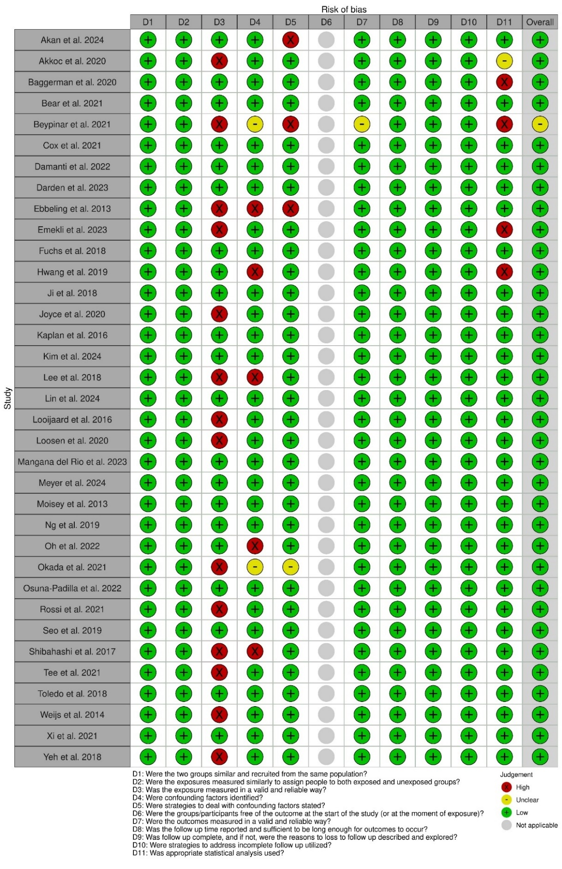
Assessment of methodological quality of cohort studies
Mortality was the outcome assessed for critical appraisal and therefore question 6 was not considered as all patients were alive at the time of CT scan. A study was considered to have a low risk of bias if it received 6 or more “low” responses, an unclear risk if it received 4-5 “low” responses and a high risk if it received only 0-3 “low” responses.
Supporting information figure 2

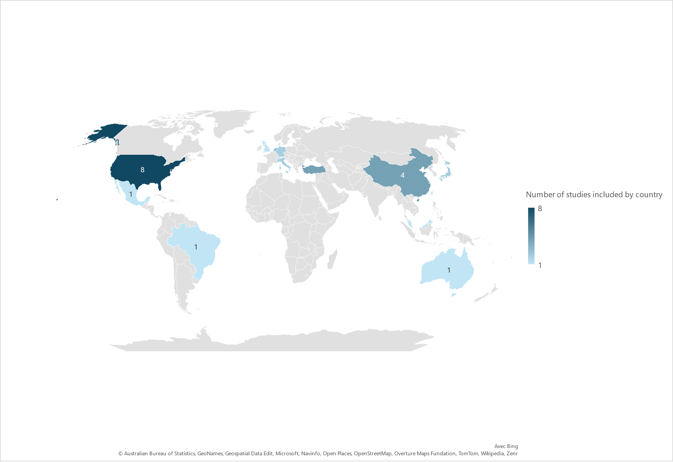

Continent | N° of countries
Asia | 15
America | 10
Europe | 9
Oceania | 1

Number of studies conducted in different countries on four continents

Supporting information figure 3
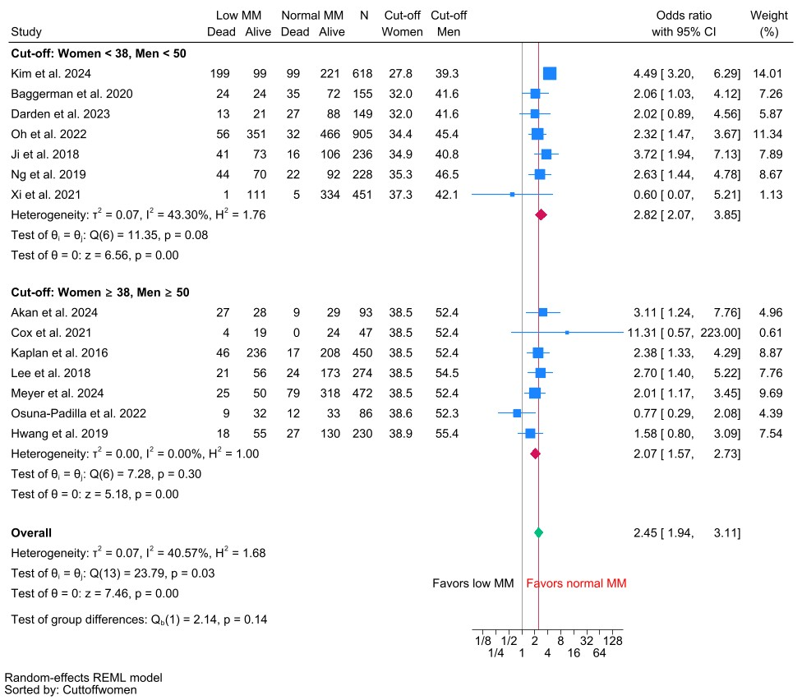
Meta-analysis of low muscle mass (MM) and short-term (ICU, hospital, 28- and 30-day) mortality in critically ill patients. Studies ranked by sex-specific cut-offs

Supporting information figure 4
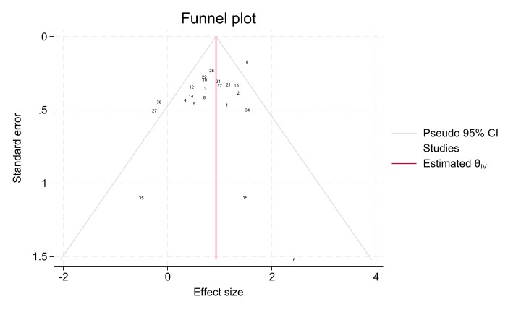
Funnel plot for studies investigating the association between low muscle mass and short-term mortality in critically ill patients

Supporting information figure 5
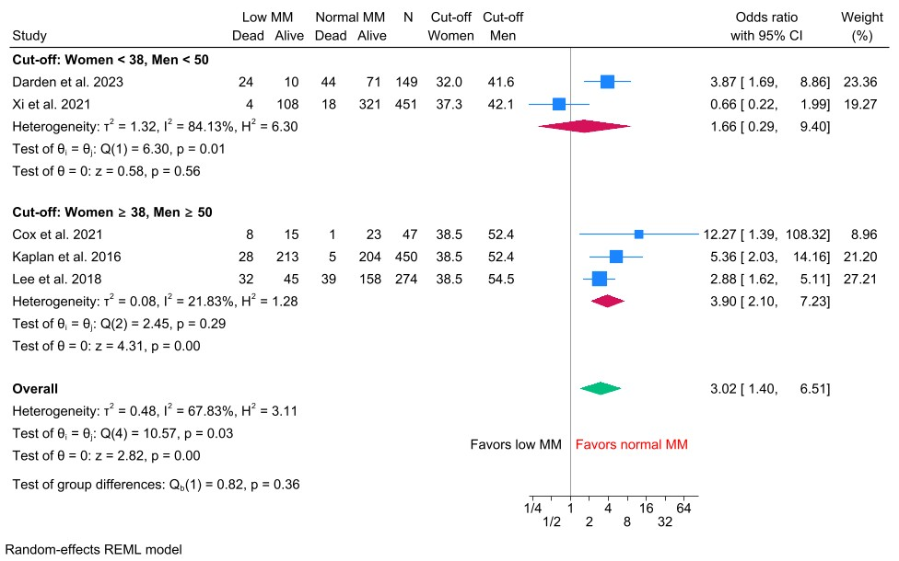
Meta-analysis of low muscle mass (MM) and long-term (90-days, 6-months, 1-year) mortality in critically ill patients. Studies ranked by sex-specific cut-offs

Supporting information figure 6

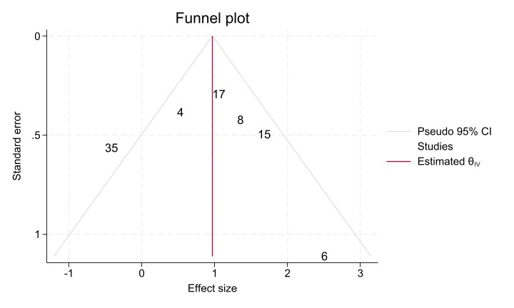
Funnel plot for studies investigating the association between low muscle mass and long-term mortality in critically ill patients

REFERENCES
1. Antonarelli M, Fogante M. Chest CT-Derived Muscle Analysis in COVID-19 Patients. Tomogr Ann Arbor Mich. 2022;8(1):414‑22.
2. Bodolea C, Nemes A, Avram L, Craciun R, Coman M, Ene-Cocis M, et al. Nutritional Risk Assessment Scores Effectively Predict Mortality in Critically Ill Patients with Severe COVID-19. Nutrients [Internet]. 2022;14(10). Disponible sur: https://www.embase.com/search/results?subaction=viewrecord&id=L2016796105&from=export
3. Guo K, Cai W, Chen Y, Shi Y, Xu Z, Chen C. Skeletal muscle depletion predicts death in severe community-acquired pneumonia patients entering ICU. Heart Lung. 2022;52((Guo K.; Chen Y.; Shi Y.; Xu Z.; Chen C., chenchengshui@wmu.edu.cn) Department of Pneumology, the First Affiliated Hospital of Wenzhou Medical University, Zhejiang province, China):71‑5.
4. Jaitovich A, Khan MMHS, Itty R, Chieng HC, Dumas CL, Nadendla P, et al. ICU Admission Muscle and Fat Mass, Survival, and Disability at Discharge. Chest. févr 2019;155(2):322‑30.
5. Jaitovich A, Dumas CL, Itty R, Chieng HC, Khan MMHS, Naqvi A, et al. ICU admission body composition: skeletal muscle, bone, and fat effects on mortality and disability at hospital discharge—a prospective, cohort study. Crit Care. déc 2020;24(1):566.
6. Kardas H, Thormann M, Bär C, Omari J, Wienke A, Pech M, et al. Impact of Pectoral Muscle Values on Clinical Outcomes in Patients with Severe Covid-19 Disease. In Vivo. 2022;36(1):375‑80.
7. Moon SW, Kim SY, Choi JS, Leem AY, Lee SH, Park MS, et al. Thoracic skeletal muscle quantification using computed tomography and prognosis of elderly ICU patients. Sci Rep. 6 déc 2021;11(1):23461.
8. Poros B, Becker-Pennrich AS, Sabel B, Stemmler HJ, Wassilowsky D, Weig T, et al. Anthropometric analysis of body habitus and outcomes in critically ill COVID-19 patients. Obes Med [Internet]. 2021;25((Poros B.; Becker-Pennrich A.S.; Wassilowsky D.; Weig T.; Hinske L.C.; Zwissler B.; Hoechter D.J., dominik.hoechter@med.uni-muenchen.de) Department of Anesthesiology, LMU Klinikum, University Hospital, Ludwig-Maximilians-University, Munich, Marchioninistr. 15, Munich, Germany). Disponible sur: https://www.embase.com/search/results?subaction=viewrecord&id=L2013467309&from=export
9. Sabatino A, Pacchiarini MC, Regolisti G, Ciuni A, Sverzellati N, Lesignoli M, et al. The impact of muscle mass and myosteatosis on mortality in critically ill patients with Sars-Cov2-related pneumonia. Clin Nutr ESPEN. 2023;58((Sabatino A., alice.sabatino86@gmail.com; Pacchiarini M.C.; Fiaccadori E.; Di Mario F.) Nephrology Unit, Parma University Hospital, Parma, Italy):409‑15.
10. Yuan G, Zhang J, Mou Z, Luo J, Xie Y. Acute reduction of erector spinae muscle cross-sectional area is associated with ICU-AW and worse prognosis in patients with mechanical ventilation in the ICU. Med U S [Internet]. 2021;100(47). Disponible sur: https://www.embase.com/search/results?subaction=viewrecord&id=L2016443242&from=export
11. Zhi J, Shan Q, Liang L, Liu H, Huang H. Low skeletal muscle area as a prognostic marker for chronic obstructive pulmonary disease in elderly patients admitted to ICU. Sci Rep. 2019;9(1):19117.
12. Elfassy MD, Ferreyro BL, Rozenberg D, Sklar MC, Mathur S, Detsky ME, et al. Association of Thoracic Computed Tomographic Measurements and Outcomes in Patients with Hematologic Malignancies Requiring Mechanical Ventilation. Ann Am Thorac Soc. juill 2021;18(7):1219‑26.
13. Giani M, Rezoagli E, Grassi A, Porta M, Riva L, Famularo S, et al. Low skeletal muscle index and myosteatosis as predictors of mortality in critically ill surgical patients. Nutrition. sept 2022;101:111687.
14. Ju S, Choi SM, Park YS, Lee CH, Lee SM, Yoo CG, et al. Rapid Muscle Loss Negatively Impacts Survival in Critically Ill Patients With Cirrhosis. J Intensive Care Med. juill 2020;35(7):663‑71.
15. Khan S, Benjamin J, Maiwall R, Tripathi H, Kapoor PB, Shasthry V, et al. Sarcopenia is the independent predictor of mortality in critically ill patients with cirrhosis. J Clin Transl Res. 29 juin 2022;8(3):200‑8.
16. Kou HW, Yeh CH, Tsai HI, Hsu CC, Hsieh YC, Chen WT, et al. Sarcopenia is an effective predictor of difficult-to-wean and mortality among critically ill surgical patients. Lazzeri C, éditeur. PLOS ONE. 8 août 2019;14(8):e0220699.
17. Malle O, Maurer D, Wagner D, Schnedl C, Amrein S, Pieber T, et al. Morphometric parameters of muscle and bone in critically ill patients: Post hoc analysis of the VITdAL-ICU trial. Wien Klin Wochenschr. juin 2021;133(11‑12):529‑35.
18. Proksch DM, Kelley KM, White S, Burgess JR. Identification of Sarcopenia in Elderly Trauma Patients: The Value of Clinical Competency and Experience. Am Surg. mars 2022;88(3):339‑42.
19. Vigneron C, Laousy O, Chassagnon G, Vakalopoulou M, Charpentier J, Alexandre J, et al. Assessment of Functional and Nutritional Status and Skeletal Muscle Mass for the Prognosis of Critically Ill Solid Cancer Patients. Cancers [Internet]. 2022;14(23). Disponible sur: https://www.embase.com/search/results?subaction=viewrecord&id=L2020509622&from=export
20. Akahoshi T, Yasuda M, Momii K, Kubota K, Shono Y, Kaku N, et al. Sarcopenia is a predictive factor for prolonged intensive care unit stays in high-energy blunt trauma patients. Acute Med Surg. 2016;3(4):326‑31.
21. Armstrong W, Costa C, Poveda L, Miller AN, Ambrosini A, Hsu FC, et al. Effects of muscle quantity and bone mineral density on injury and outcomes in older adult motor vehicle crash occupants. Traffic Inj Prev. 2022;23(sup1):S86‑91.
22. Branea OE, Vlad AG, Pui M, Becica DA, Becica ME, Budeanu AR, et al. Total Psoas Area and Psoas Density Assessment in COVID-19 Patients Using CT Imaging - Could Muscle Mass Alteration During Intensive Care Hospitalization be Determined? J Crit Care Med Univ Med Si Farm Din Targu-Mures. oct 2023;9(4):218‑29.
23. Brewster DJ, Strauss BJ, Crozier TM. Measuring visceral fat, subcutaneous fat and skeletal muscle area changes by computed tomography in acute pancreatitis: a retrospective, single-centre study. Crit Care Resusc J Australas Acad Crit Care Med. 2014;16(1):42‑7.
24. Herault A, Lévêque E, Draye-Carbonnier S, Decazes P, Zduniak A, Modzelewski R, et al. High prevalence of pre-existing sarcopenia in critically ill patients with hematologic malignancies admitted to the intensive care unit for sepsis or septic shock. Clin Nutr ESPEN. 2023;55((Herault A.; Grall M.; Tamion F.) Intensive Care Unit, Charles Nicolle University Hospital, Rouen, France):373‑83.
25. Zhang XM, Zhang WW, Yu XZ, Dou QL, Cheng ASK. Comparing the performance of SOFA, TPA combined with SOFA and APACHE-II for predicting ICU mortality in critically ill surgical patients: A secondary analysis. Clin Nutr. sept 2020;39(9):2902‑9.
26. Dusseaux MM, Antoun S, Grigioni S, Béduneau G, Carpentier D, Girault C, et al. Skeletal muscle mass and adipose tissue alteration in critically ill patients. Bianchi C, éditeur. PLOS ONE. 13 juin 2019;14(6):e0216991.
27. Kashani KB, Frazee EN, Kukrálová L, Sarvottam K, Herasevich V, Young PM, et al. Evaluating Muscle Mass by Using Markers of Kidney Function: Development of the Sarcopenia Index. Crit Care Med. 2017;45(1):e23‑9.
28. Tazerout S, Martinez O, Monsonis B, Millet I, Taourel P, Capdevila X, et al. Acute post-traumatic muscle atrophy on CT scan predicts prolonged mechanical ventilation and a worse outcome in severe trauma patients. Injury. 2022;53(7):2501‑10.
29. Kolck J, Rako ZA, Beetz NL, Auer TA, Segger LK, Pille C, et al. Intermittent body composition analysis as monitoring tool for muscle wasting in critically ill COVID-19 patients. Ann Intensive Care [Internet]. 2023;13(1). Disponible sur: https://www.embase.com/search/results?subaction=viewrecord&id=L2024288964&from=export
30. Barreto EF, Poyant JO, Coville HH, Dierkhising RA, Kennedy CC, Gajic O, et al. Validation of the sarcopenia index to assess muscle mass in the critically ill: A novel application of kidney function markers. Clin Nutr. juin 2019;38(3):1362‑7.
31. de Hoogt PA, Reisinger KW, Tegels JJW, Bosmans JWAM, Tijssen F, Stoot JHMB. Functional Compromise Cohort Study (FCCS): Sarcopenia is a Strong Predictor of Mortality in the Intensive Care Unit. World J Surg. juin 2018;42(6):1733‑41.
32. Faron A, Kreyer S, Sprinkart AM, Muders T, Ehrentraut SF, Isaak A, et al. CT fatty muscle fraction as a new parameter for muscle quality assessment predicts outcome in venovenous extracorporeal membrane oxygenation. Sci Rep. 2020;10(1):22391.
33. Dal HC, Dolek BA, Beyoğlu MA, Acar D, Gozukara MG, Turan S. Evaluation of diaphragm thickness to predict intubation requirement and mortality in critical COVID-19 patients. Saudi Med J. oct 2022;43(10):1120‑7.
34. Wang S, Wang M, Jiang L, Zhao X. Low skeletal muscle quality extracted from CT is associated with poor outcomes in severe acute pancreatitis patients. Eur J Radiol. 23 nov 2023;170:111215.
35. Akan B, Gokcinar D, Damgaci L, Cakir E, Ozer H, Turan IO. Sarcopenia Detected in Aged Patients in Intensive Care Units Is Associated with Poor Prognosis. Aging Med Healthc. 2024;15(1):22‑7.
36. Cox MC, Booth M, Ghita G, Wang Z, Gardner A, Hawkins RB, et al. The impact of sarcopenia and acute muscle mass loss on long‐term outcomes in critically ill patients with intra‐abdominal sepsis. J Cachexia Sarcopenia Muscle. oct 2021;12(5):1203‑13.
37. Kaplan SJ, Pham TN, Arbabi S, Gross JA, Damodarasamy M, Bentov I, et al. Association of Radiologic Indicators of Frailty With 1-Year Mortality in Older Trauma Patients: Opportunistic Screening for Sarcopenia and Osteopenia. JAMA Surg. 15 févr 2017;152(2):e164604.
38. Meyer HJ, Dermendzhiev T, Hetz M, Osterhoff G, Kleber C, Denecke T, et al. Body composition parameters in initial CT imaging of mechanically ventilated trauma patients: Single-centre observational study. J Cachexia Sarcopenia Muscle. 26 août 2024;
39. Prado CM, Lieffers JR, McCargar LJ, Reiman T, Sawyer MB, Martin L, et al. Prevalence and clinical implications of sarcopenic obesity in patients with solid tumours of the respiratory and gastrointestinal tracts: a population-based study. Lancet Oncol. juill 2008;9(7):629‑35.
40. Hwang F, McGreevy CM, Pentakota SR, Verde D, Park JH, Berlin A, et al. Sarcopenia is Predictive of Functional Outcomes in Older Trauma Patients. Cureus [Internet]. 14 nov 2019 [cité 4 août 2023]; Disponible sur: https://www.cureus.com/articles/17973-sarcopenia-is-predictive-of-functional-outcomes-in-older-trauma-patients
41. Moisey LL, Mourtzakis M, Cotton BA, Premji T, Heyland DK, Wade CE, et al. Skeletal muscle predicts ventilator-free days, ICU-free days, and mortality in elderly ICU patients. Crit Care. 2013;17(5):R206.
42. Mourtzakis M, Prado CMM, Lieffers JR, Reiman T, McCargar LJ, Baracos VE. A practical and precise approach to quantification of body composition in cancer patients using computed tomography images acquired during routine care. Appl Physiol Nutr Metab. oct 2008;33(5):997‑1006.
43. Ji Y, Cheng B, Xu Z, Ye H, Lu W, Luo X, et al. Impact of sarcopenic obesity on 30-day mortality in critically ill patients with intra-abdominal sepsis. J Crit Care. août 2018;46:50‑4.
44. Zhuang CL, Huang DD, Pang WY, Zhou CJ, Wang SL, Lou N, et al. Sarcopenia is an Independent Predictor of Severe Postoperative Complications and Long-Term Survival After Radical Gastrectomy for Gastric Cancer: Analysis from a Large-Scale Cohort. Medicine (Baltimore). mars 2016;95(13):e3164.
45. Osuna-Padilla IA, Rodríguez-Moguel NC, Rodríguez-Llamazares S, Orsso CE, Prado CM, Ríos-Ayala MA, et al. Low muscle mass in COVID-19 critically-ill patients: Prognostic significance and surrogate markers for assessment. Clin Nutr. déc 2022;41(12):2910‑7.
46. Caan BJ, Meyerhardt JA, Kroenke CH, Alexeeff S, Xiao J, Weltzien E, et al. Explaining the Obesity Paradox: The Association between Body Composition and Colorectal Cancer Survival (C-SCANS Study). Cancer Epidemiol Biomarkers Prev. 1 juill 2017;26(7):1008‑15.
47. Seo DW, Kim KW, Sohn CH, Ryoo SM, Kim YJ, Shin A, et al. Progressive loss of muscle mass could be an adverse prognostic factor of 28-day mortality in septic shock patients. Sci Rep. 11 nov 2019;9(1):16471.
48. Martin L, Birdsell L, MacDonald N, Reiman T, Clandinin MT, McCargar LJ, et al. Cancer Cachexia in the Age of Obesity: Skeletal Muscle Depletion Is a Powerful Prognostic Factor, Independent of Body Mass Index. J Clin Oncol. 20 avr 2013;31(12):1539‑47.
49. Baggerman MR, van Dijk DPJ, Winkens B, van Gassel RJJ, Bol ME, Schnabel RM, et al. Muscle wasting associated co-morbidities, rather than sarcopenia are risk factors for hospital mortality in critical illness. J Crit Care. avr 2020;56:31‑6.
50. Bear DE, MacGowan L, Elstad M, Puthucheary Z, Connolly B, Wright R, et al. Relationship Between Skeletal Muscle Area and Density and Clinical Outcome in Adults Receiving Venovenous Extracorporeal Membrane Oxygenation. Crit Care Med. 1 avr 2021;49(4):e350‑9.
51. Darden N, Sharma S, Wu X, Mancini B, Karamchandani K, Bonavia AS. Long-term clinical outcomes in critically ill patients with sepsis and pre-existing low muscle mass: a retrospective cohort study. BMC Anesthesiol [Internet]. 2023;23(1). Disponible sur: https://www.embase.com/search/results?subaction=viewrecord&id=L2025451874&from=export
52. van der Werf A, Langius JAE, de van der Schueren MAE, Nurmohamed SA, van der Pant KAMI, Blauwhoff-Buskermolen S, et al. Percentiles for skeletal muscle index, area and radiation attenuation based on computed tomography imaging in a healthy Caucasian population. Eur J Clin Nutr. févr 2018;72(2):288‑96.
53. Damanti S, Cristel G, Ramirez GA, Bozzolo EP, Da Prat V, Gobbi A, et al. Influence of reduced muscle mass and quality on ventilator weaning and complications during intensive care unit stay in COVID-19 patients. Clin Nutr. déc 2022;41(12):2965‑72.
54. Oh HJ, Kim JH, Kim HR, Ahn JY, Jeong SJ, Ku NS, et al. The impact of sarcopenia on short‐term and long‐term mortality in patients with septic shock. J Cachexia Sarcopenia Muscle. août 2022;13(4):2054‑63.
55. Derstine BA, Holcombe SA, Ross BE, Wang NC, Su GL, Wang SC. Skeletal muscle cutoff values for sarcopenia diagnosis using T10 to L5 measurements in a healthy US population. Sci Rep. 27 juill 2018;8(1):11369.
56. Kim IY, Ye BM, Kim SR, Lee DW, Lee SB. Sarcopenia is independently associated with mortality and recovery from dialysis in critically ill patients with sepsis-induced acute kidney injury receiving continuous renal replacement therapy. Kidney Res Clin Pract [Internet]. 2 mai 2024 [cité 9 déc 2024]; Disponible sur: http://krcp-ksn.org/journal/view.php?doi=10.23876/j.krcp.24.015
57. Yoon JK, Lee S, Kim KW, Lee JE, Hwang JA, Park T, et al. Reference Values for Skeletal Muscle Mass at the Third Lumbar Vertebral Level Measured by Computed Tomography in a Healthy Korean Population. Endocrinol Metab. 30 juin 2021;36(3):672‑7.
58. Mangana del Rio T, Sacleux SC, Vionnet J, Ichaï P, Denys A, Schneider A, et al. Body composition and short-term mortality in patients critically ill with acute-on-chronic liver failure. JHEP Rep [Internet]. 2023;5(8). Disponible sur: https://www.embase.com/search/results?subaction=viewrecord&id=L2025075946&from=export
59. Carey EJ, Lai JC, Sonnenday C, Tapper EB, Tandon P, Duarte-Rojo A, et al. A North American Expert Opinion Statement on Sarcopenia in Liver Transplantation. Hepatology. 2019;70(5):1816‑29.
60. Carey EJ, Lai JC, Wang CW, Dasarathy S, Lobach I, Montano‐Loza AJ, et al. A multicenter study to define sarcopenia in patients with end‐stage liver disease. Liver Transpl. mai 2017;23(5):625‑33.
61. Ng CC, Lee ZY, Chan WY, Jamaluddin MF, Tan LJ, Sitaram PN, et al. Low Muscularity as Assessed by Abdominal Computed Tomography on Intensive Care Unit Admission Is Associated With Mortality in a Critically Ill Asian Population. J Parenter Enter Nutr. 2020;44(3):425‑33.
62. Toledo DO, Carvalho AM, Oliveira AMRR, Toloi JM, Silva AC, Francisco de Mattos Farah J, et al. The use of computed tomography images as a prognostic marker in critically ill cancer patients. Clin Nutr ESPEN. juin 2018;25:114‑20.
63. Lin C, Zhang J, Wang C, Lian W, Liu Y. The impact of skeletal muscle index at the third lumbar spine on nosocomial deterioration and short-term prognosis in acute pancreatitis: a retrospective observational study. PeerJ [Internet]. 2024;12(4). Disponible sur: https://www.embase.com/search/results?subaction=viewrecord&id=L2032305913&from=export
64. Xi F, Tan S, Gao T, Ding W, Sun J, Wei C, et al. Low skeletal muscle mass predicts poor clinical outcomes in patients with abdominal trauma. Nutrition [Internet]. 2021;89((Xi F.; Gao T.; Yu W., yuwenkui622@163.com) Department of Intensive Care Unit, Affiliated Drum Tower Hospital, Medical School of Nanjing University, Nanjing, Jiangsu Province, China). Disponible sur: https://www.embase.com/search/results?subaction=viewrecord&id=L2011714216&from=export
65. Emekli E, Bostancı Can EZ. Prognostic Value of Diaphragm Diameter, Muscle Volume, and Bone Mineral Density in Critically Ill COVID-19 Patients. J Intensive Care Med. 2023;38(9):847‑55.
66. Loosen SH, Schulze-Hagen M, Püngel T, Bündgens L, Wirtz T, Kather JN, et al. Skeletal Muscle Composition Predicts Outcome in Critically Ill Patients. Crit Care Explor. août 2020;2(8):e0171.
67. Fuchs G, Thevathasan T, Chretien YR, Mario J, Piriyapatsom A, Schmidt U, et al. Lumbar skeletal muscle index derived from routine computed tomography exams predict adverse post-extubation outcomes in critically ill patients. J Crit Care. avr 2018;44:117‑23.
68. Beypinar I, Bayav M, Ucan A, Efe S. The effect of body composition on prognosis in critically ill covid-19 patients. Ann Clin Anal Med. 2021;12(6):680‑4.
69. Lee Y, Park HK, Kim WY, Kim MC, Jung W, Ko BS. Muscle Mass Depletion Associated with Poor Outcome of Sepsis in the Emergency Department. Ann Nutr Metab. 2018;72(4):336‑44.
70. Fearon K, Strasser F, Anker SD, Bosaeus I, Bruera E, Fainsinger RL, et al. Definition and classification of cancer cachexia: an international consensus. Lancet Oncol. mai 2011;12(5):489‑95.
71. Akkoc I, Toptas M, Yalcin M, Demir E, Toptas Y. Psoas Muscle Area Measured with Computed Tomography at Admission to Intensive Care Unit: Prediction of In-Hospital Mortality in Patients with Pulmonary Embolism. BioMed Res Int [Internet]. 2020;2020((Akkoc I., ibrakkoc@gmail.com; Toptas M., dr.mehmettoptas@hotmail.com; Demir E., drerendemir@gmail.com) Departments of Anesthesiology and Reanimation, Haseki Training and Research Hospital, University of Health Sciences, Istanbul, Turkey). Disponible sur: https://www.embase.com/search/results?subaction=viewrecord&id=L2005360125&from=export
72. Okada Y, Kiguchi T, Okada A, Iizuka R, Iwami T, Ohtsuru S. Predictive value of sarcopenic findings in the psoas muscle on CT imaging among patients with sepsis. Am J Emerg Med. sept 2021;47:180‑6.
73. Joyce PR, O’Dempsey R, Kirby G, Anstey C. A retrospective observational study of sarcopenia and outcomes in critically ill patients. Anaesth Intensive Care. 2020;48(3):229‑35.
74. Looijaard WGPM, Dekker IM, Stapel SN, Girbes ARJ, Twisk JWR, Oudemans-van Straaten HM, et al. Skeletal muscle quality as assessed by CT-derived skeletal muscle density is associated with 6-month mortality in mechanically ventilated critically ill patients. Crit Care. déc 2016;20(1):386.
75. Weijs PJ, Looijaard WG, Dekker IM, Stapel SN, Girbes AR, Straaten H, et al. Low skeletal muscle area is a risk factor for mortality in mechanically ventilated critically ill patients. Crit Care. 2014;18(1):R12.
76. Shibahashi K, Sugiyama K, Kashiura M, Hamabe Y. Decreasing skeletal muscle as a risk factor for mortality in elderly patients with sepsis: A retrospective cohort study. J Intensive Care [Internet]. 2017;5(1). Disponible sur: https://www.embase.com/search/results?subaction=viewrecord&id=L614017527&from=export
77. Tee YS, Cheng CT, Wu YT, Kang SC, Derstine BA, Fu CY, et al. The psoas muscle index distribution and influence of outcomes in an Asian adult trauma population: an alternative indicator for sarcopenia of acute diseases. Eur J Trauma Emerg Surg Off Publ Eur Trauma Soc. déc 2021;47(6):1787‑95.
78. Ebbeling L, Grabo DJ, Shashaty M, Dua R, Sonnad SS, Sims CA, et al. Psoas:lumbar vertebra index: central sarcopenia independently predicts morbidity in elderly trauma patients. Eur J Trauma Emerg Surg. févr 2014;40(1):57‑65.
79. Yeh DD, Ortiz-Reyes LA, Quraishi SA, Chokengarmwong N, Avery L, Kaafarani HMA, et al. Early nutritional inadequacy is associated with psoas muscle deterioration and worse clinical outcomes in critically ill surgical patients. J Crit Care. 2018;45((Yeh D.D., dxy154@miami.edu) Ryder Trauma Center, DeWitt Daughtry Family Department of Surgery, University of Miami Miller School of Medicine, United States):7‑13.
80. Rossi AP, Gottin L, Donadello K, Schweiger V, Brandimarte P, Zamboni GA, et al. Intermuscular Adipose Tissue as a Risk Factor for Mortality and Muscle Injury in Critically Ill Patients Affected by COVID-19. Front Physiol [Internet]. 2021;12((Rossi A.P., andrea.rossi@hotmail.it; Brandimarte P.; Zamboni M.) Department of Medicine, Geriatrics Division, University of Verona, Verona, Italy). Disponible sur: https://www.embase.com/search/results?subaction=viewrecord&id=L635070383&from=export

