Additional file 10. Sensitivity analysis assessing the diagnostic performance of the R/I ratioventilator to identify high recruiters using alternate definitions of recruitment with CT
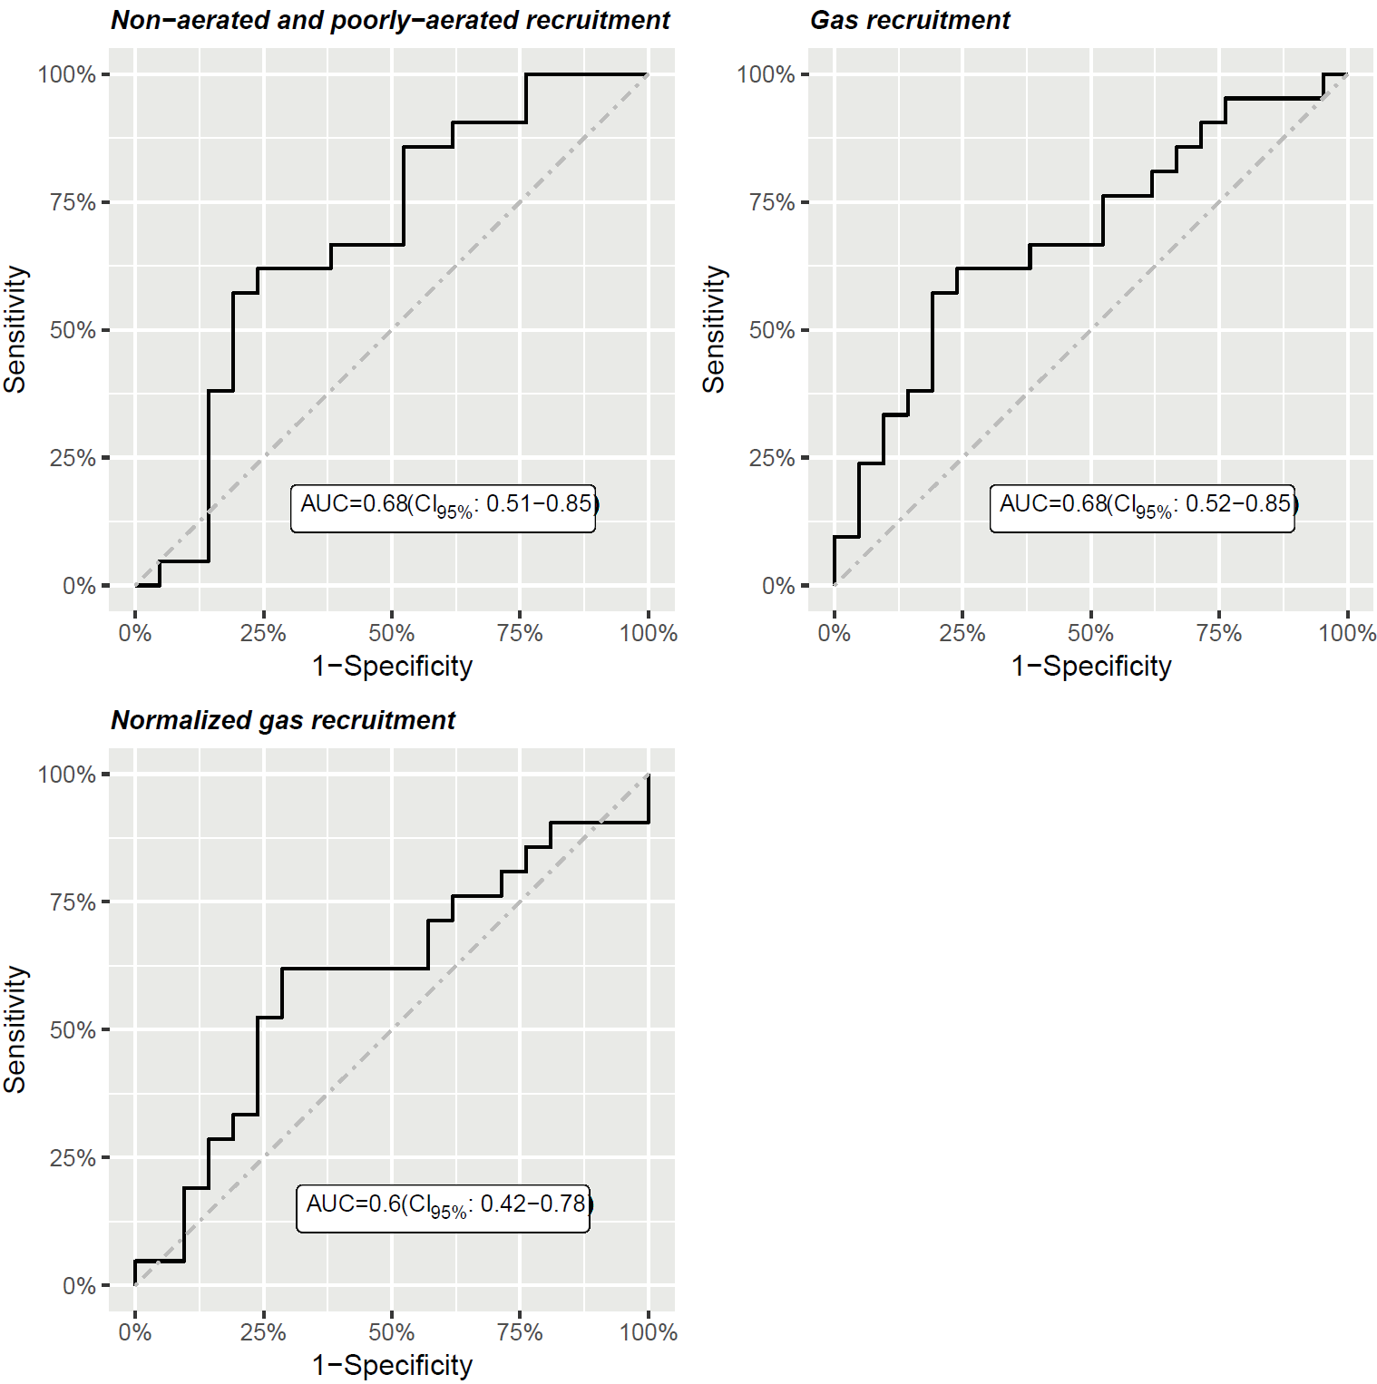

ROC curve (bold line), line of no-discrimination (dashed line) and area under the ROC curve (with its 95% confidence interval).
For each definition of recruitment, high recruiters were defined as patients with values above the median value.

