Additional file 11. Sensitivity analysis excluding the patient with R/I ratio_{ventilator} below -0.5.

Figure 1. Relationships between respiratory mechanics variables and CT-derived variables
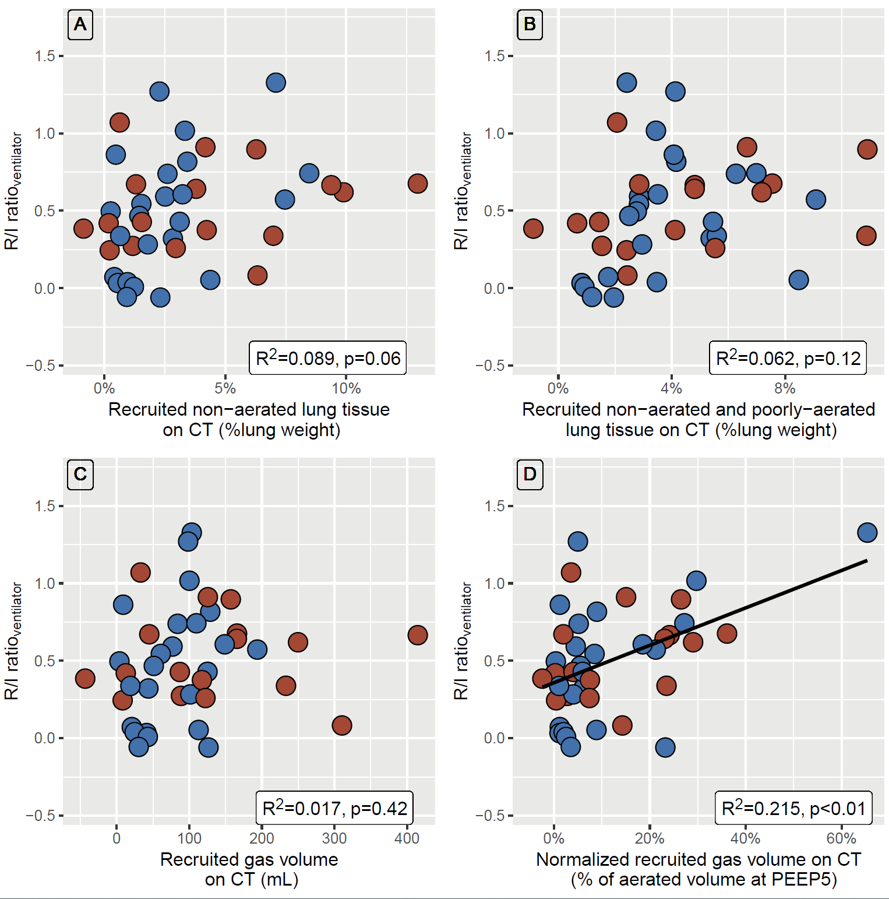
Data points are individual values. Blue and red circles represent patients with or without airway opening pressure greater than 5 cm H₂O, respectively, Black line is regression line.
Panel A represents the relationship between R/I ratio_{ventilator} and recruited non-aerated lung tissue weight assessed on computed tomography.
Panel B represents the relationship between R/I ratio_{ventilator} and both non-aerated and poorly aerated recruited lung tissue weight assessed on computed tomography.
Panel C represents the relationship between R/I ratio_{ventilator} and recruited gas volume assessed on computed tomography.
Panel D represents the relationship between R/I ratio_{ventilator} and normalized recruited gas volume assessed on computed tomography.
CT denotes computed tomography; PEEP, positive end-expiratory pressure; R², coefficient of determination of the linear regression; and R/I ratio_{ventilator}, recruitment-to-inflation ratio assessed with the ventilator.

Figure 2. Diagnostic performance of the recruitment-to-inflation ratio assessed with the ventilator to identify lung recruitability.
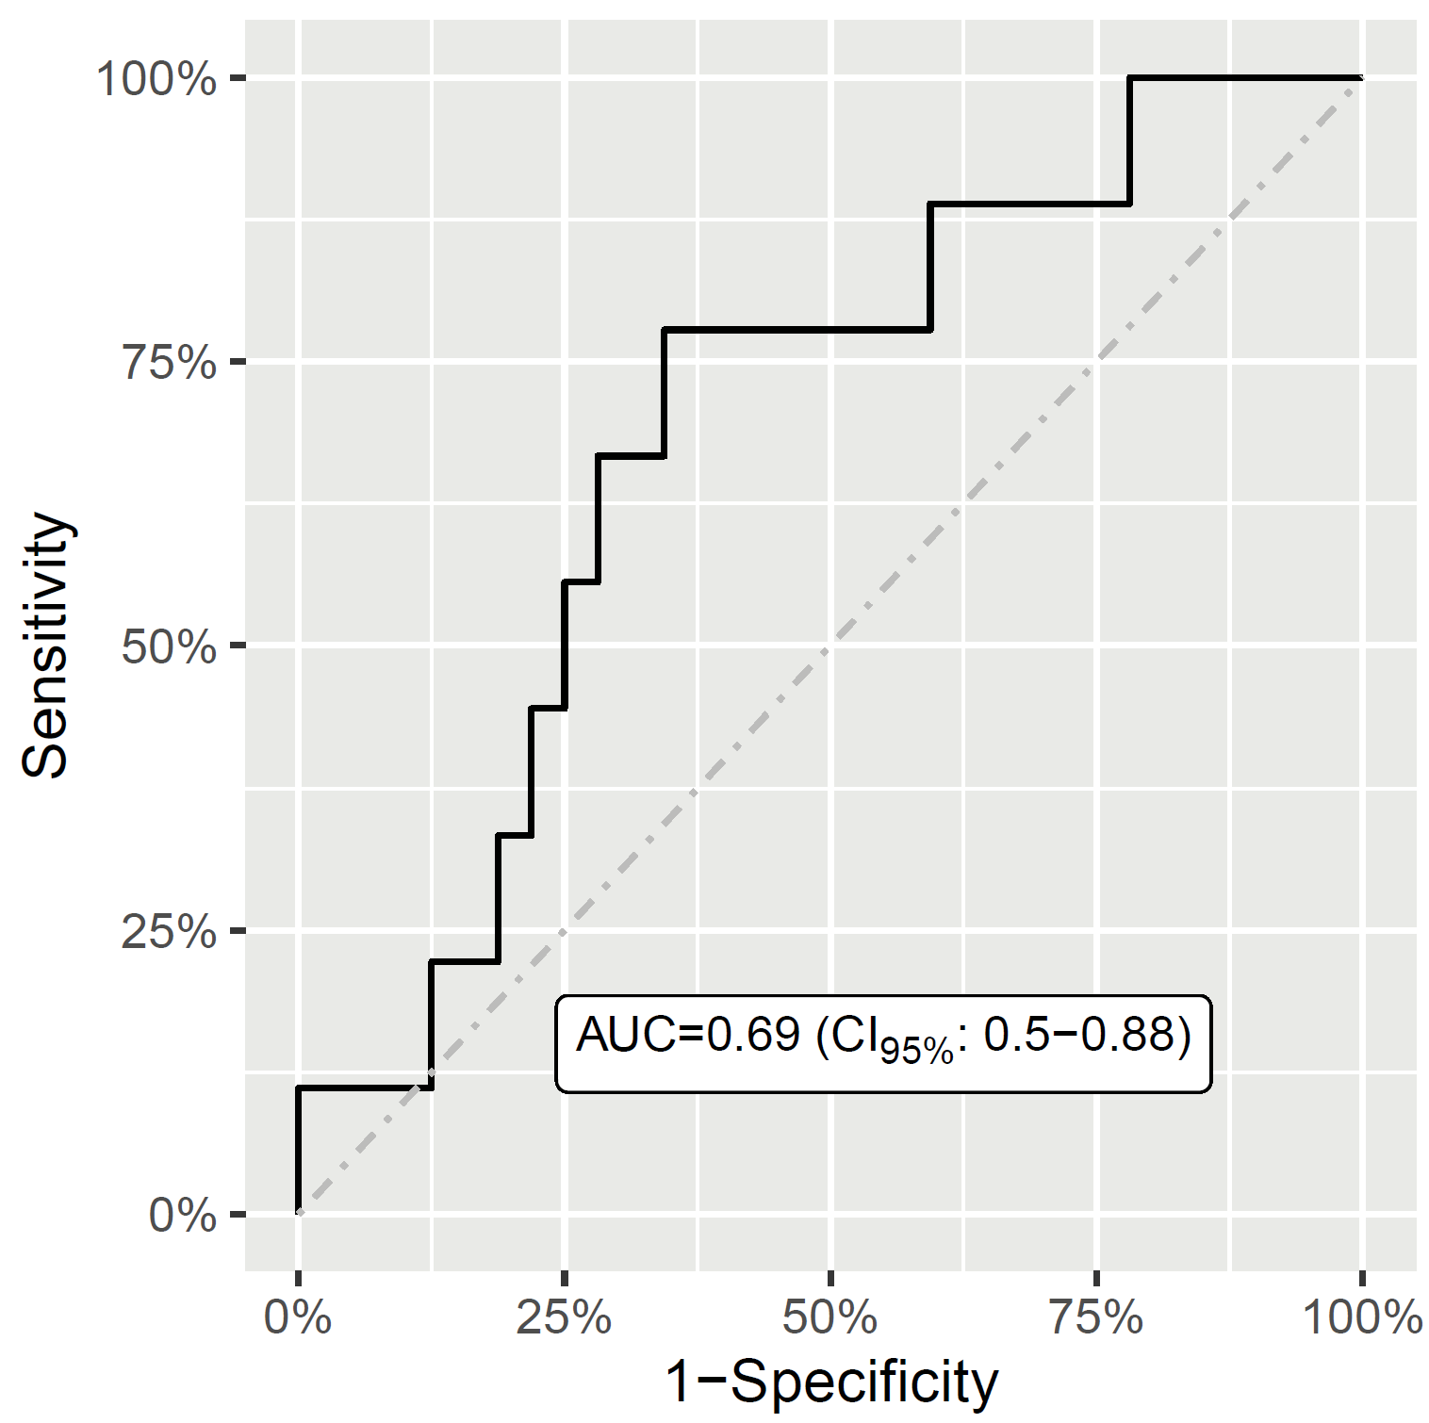
ROC curve (bold line), line of no-discrimination (dashed line) and area under the ROC curve (with its 95% confidence interval).

