Supplemental file 1. Study flow chart.
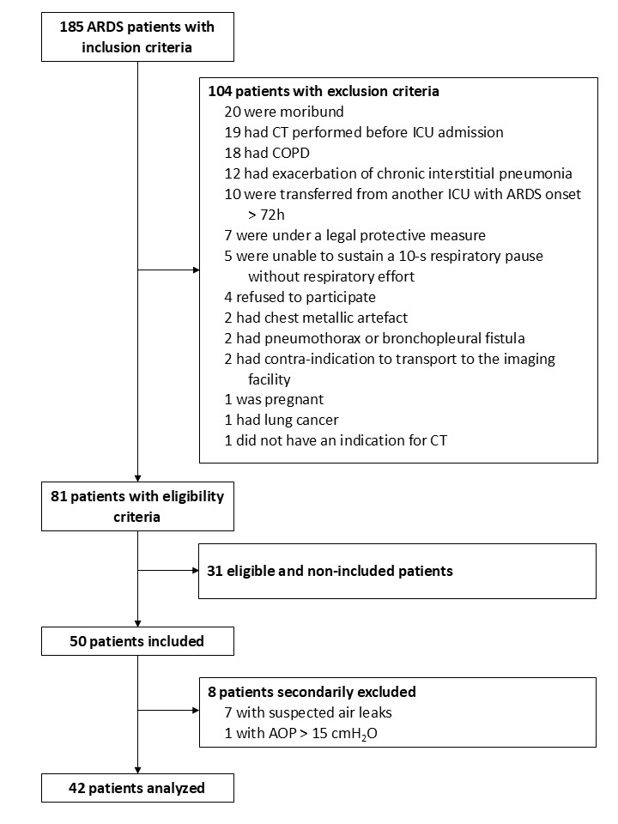
AOP denotes airway opening pressure; ARDS, acute respiratory distress syndrome; COPD, chronic obstructive pulmonary disease; CT, computed tomography; and ICU, intensive care unit.

