Additional file 5. Relationship between tissue and gas recruitment on computed tomography
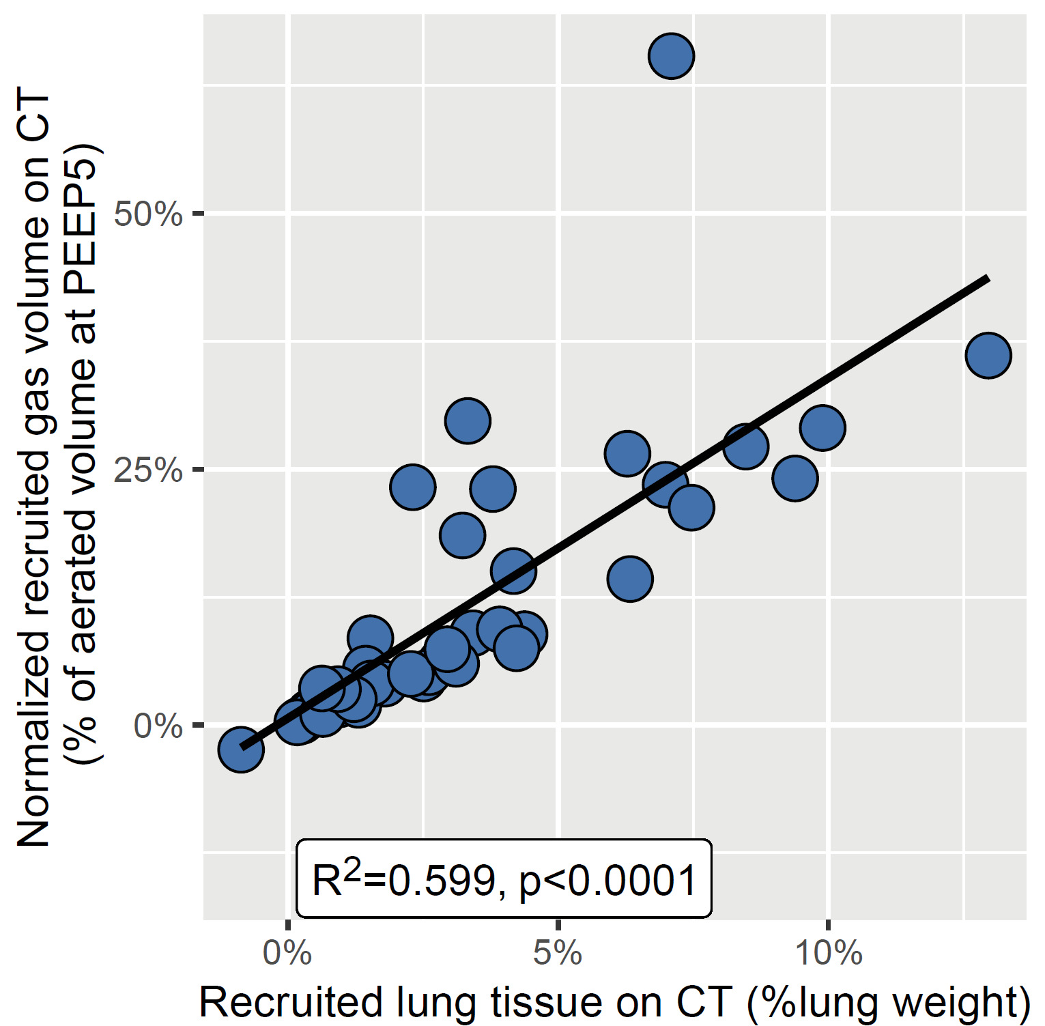

Data points are individual values. Black line is regression line.
CT denotes computed tomography; PEEP, positive end-expiratory pressure; and R², coefficient of determination of the linear regression.

